Extracting forms from observation

Working from the provided studio setup, you are tasked to look, observe and identify emerging shapes and forms.

AM

Working in the specific colours palette from the food is happiness trend, you will be screen printing with cut newsprint stencils and quick layering techniques.

The session will be led and instructed, allowing you to work through an advanced creative enquiry to create a range of starting points that feed a live brief and your personal direction.

PM

To identify highlights from the morning session that can be explored as separations for screen printing and action the separation process through re-drawing and decision making before exposing the artwork to silk screen.

Additional Tasks: Research (this should be informing your learning, relating to the session, of interest to you and connected to your outcomes).

- Identify and look up at least 6 artists, ensure that you try to look at work that contains food as iconography, uses colour blocking as a technique, explores tabletop styling and has a hand drawn feel.
Brigette Riley (for colour blocks of spots, stripes)
Charlotte farmer (prints/ printmaker and illustrator)
Harriet Popham (prints/ printmaker and illustrator)
Sarah Fennell-Fox (Textile printer for use of stencils as a technique)

Search out illustrators

- Record your findings and print 3 different images from the 6 artists that you have looked at and are inspired by, then add to your sketchbook.

- Expand on your findings, note key points about the images, colour, process, technique, media used (small notes, no large chunks of text needed). You should be questioning the relevance of the imagery and how it relates to the learning so far.

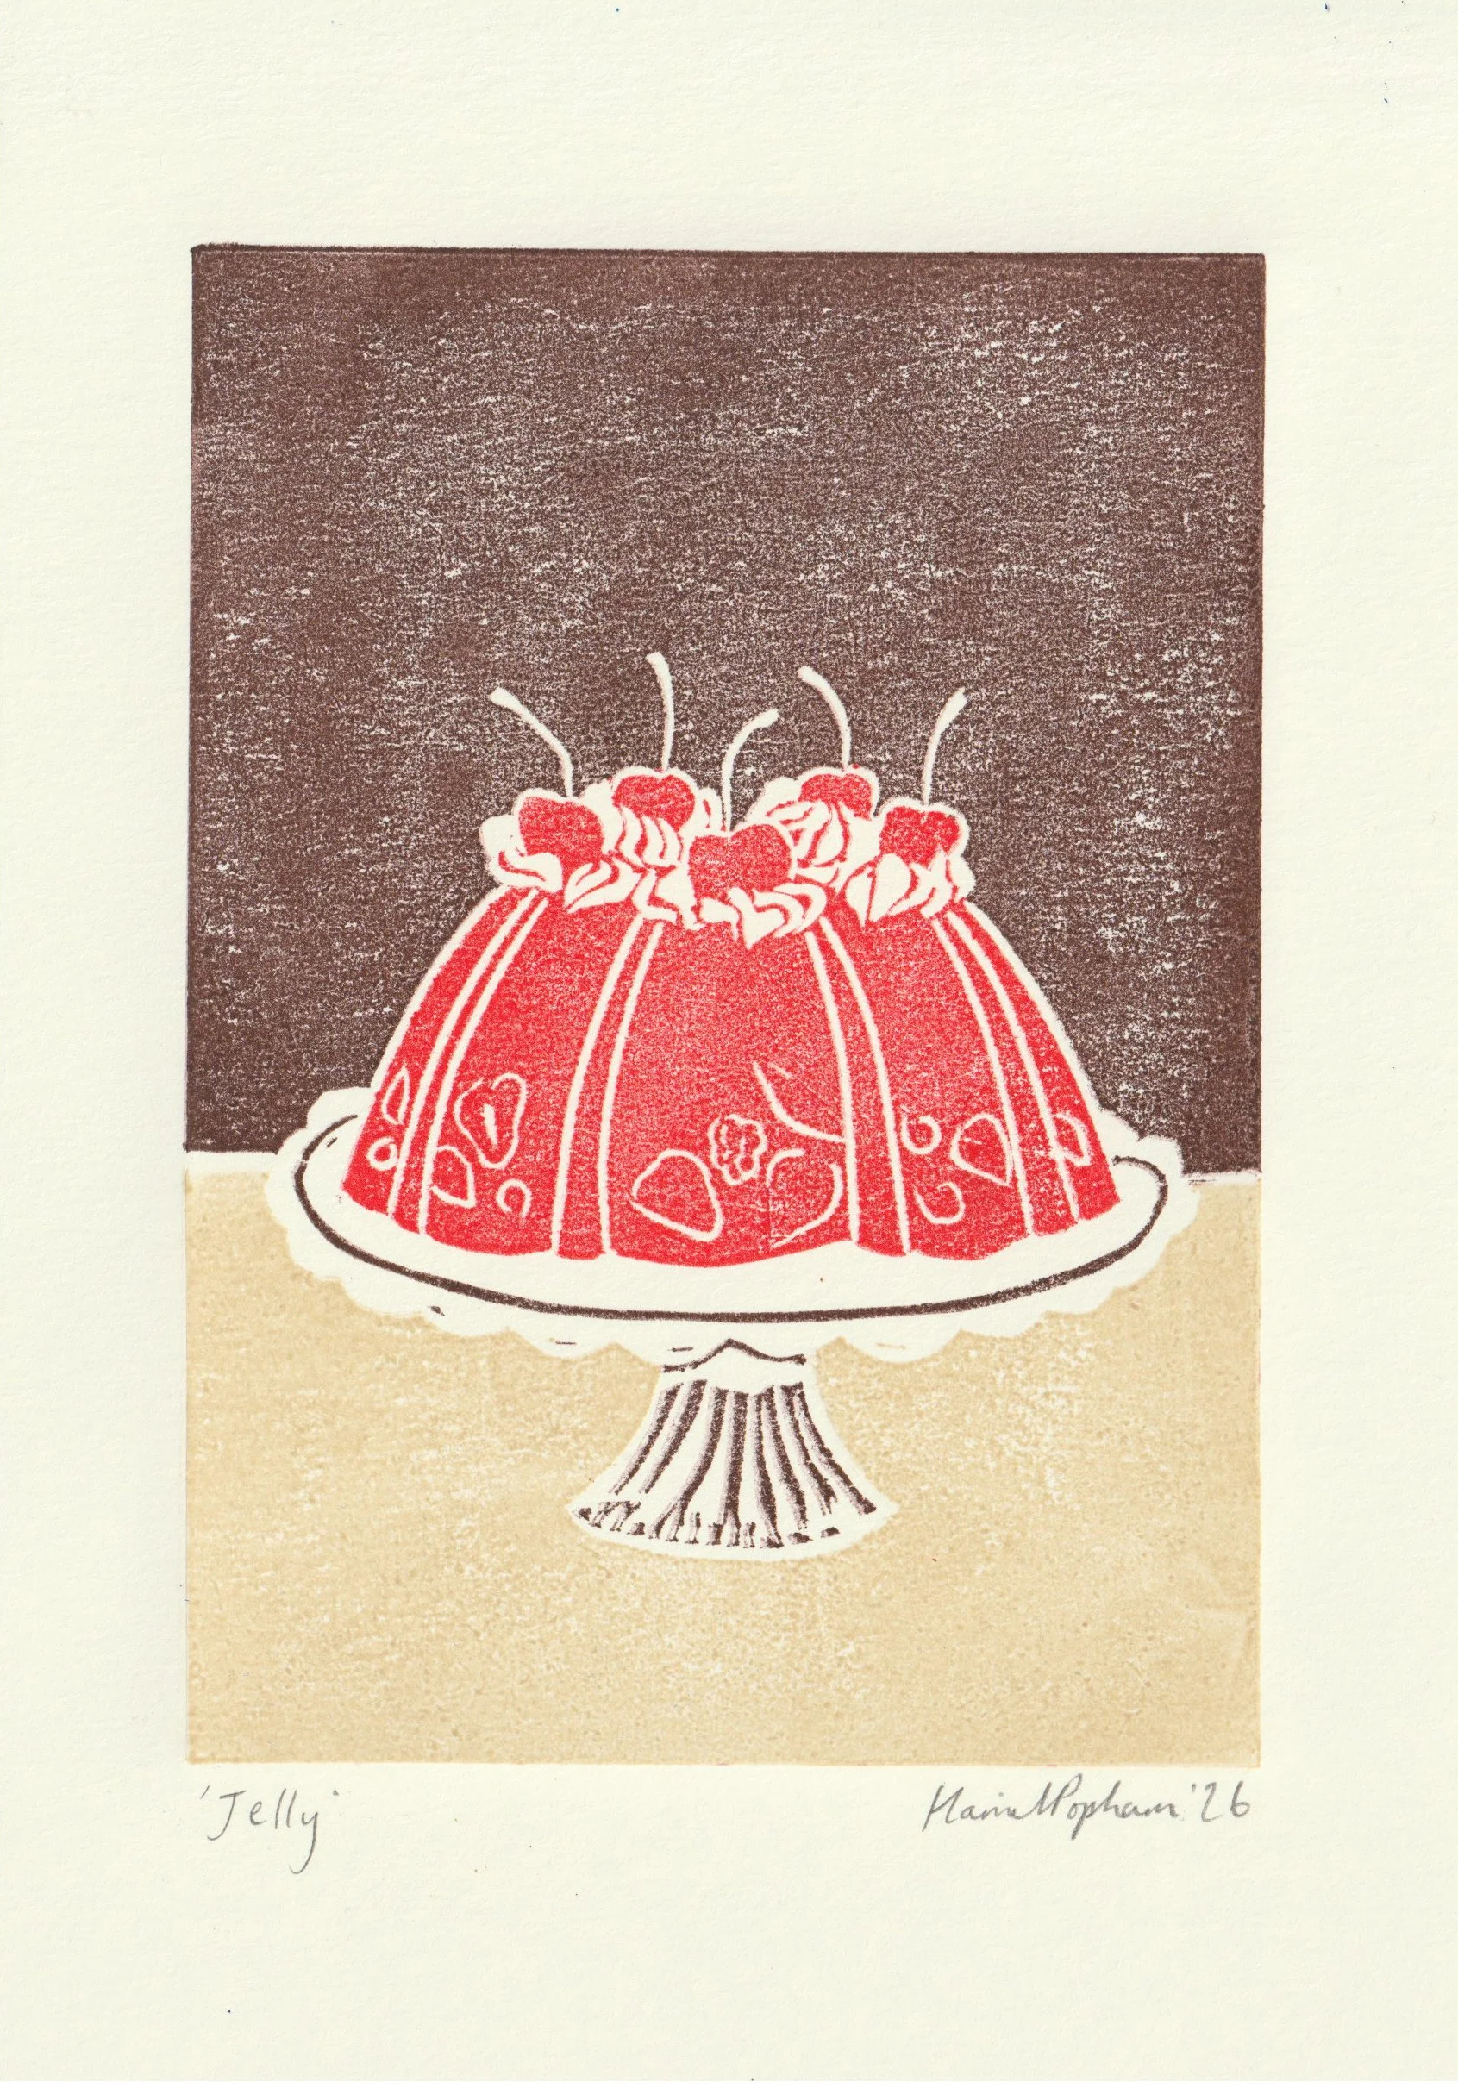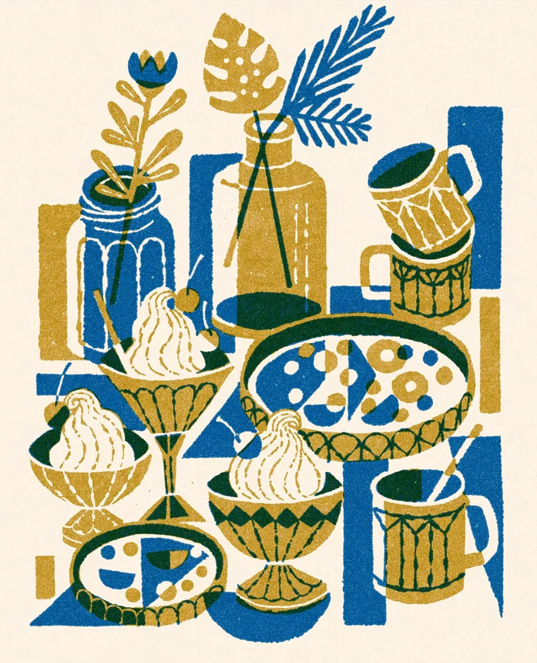
Harriett Popham Jovaney Hollingsworth

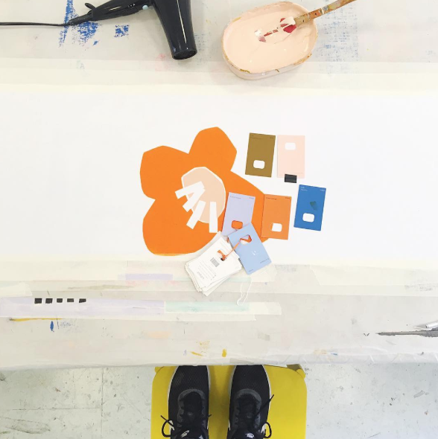
Sarah Fennell-Fox

To extend the session; continue to work on your drawing and painting, to extend the body of work and find newness, difference and individuality in your imagery.

