An examination of the word length effect

Introduction
The Phonological loop is a component of working memory. The phonological loop allows us to retain information over a short period of time , it consists of the phonological loop store which retains information phonologically, and also consists of a rehearsal type activity, which enables one to remember by going over and repeating the word or number then avoiding decay. ( Baddeley, 1986) The Phonological loop allows us to learn languages and helps us to increase our vocabulary. Hitch suggested “The phonological loop is a component that holds and manipulates auditory information over short periods of time. For example, if one tried to remember a telephone number by repeating it over and over in the few moments before dialing, this effort would take place in the phonological loop”. This store holds sound information, verbal and acoustic for 1.5-2 seconds, this sound information will fade if not rehearsed. Maintenance will then be activated in the short term memory which is able to hold information for around 20 seconds. It is suggested that longer words that may take more time to articulate are recalled more poorly than shorter words. It is believed that the short term memory store has limited capacity , so when a new word comes into your head, the previous word then goes through what is known as decay. (studybuff) The digit span test has suggested that the number of digits you can remember depends on the language you speak. So for example some languages have words that are longer or shorter than others. In English, we can remember more words with less syllables, than maybe Italian words with more syllables. Looking at the “ Word length effect” (Baddeley 1975) has shown that this memory span does better remembering short words than long words.

Aim
The aim of this study was to explore the word length effect.
Rational
Studying the Word length effect and how we contain information is important. We can then see how the brain works regarding memory, processing information and holding information and for how long. Different words can be easier to remember, for example, words with two syllables are easier to remember in word length effect than words containing 3 or 4 syllables. During this word length experiments we can then measure how the brain processes and recalls information. This is important to gain understanding regarding individuals’ memory, whether it is being tested for participants of a certain age, or participants who may have some impairment, or some brain damage, in general it helps us to understand how the brain works during these experiments.
Hypothesis
This study will show that participants will recall shorter words with less syllables than they will recall longer words with more syllables (one tailed)
Methodology
Design
A within subject’s design was used. There was one independent variable with two conditions: The independent variable was the length of the words (long and short). There was one Dependent variable: The dependent variable was the number of words recalled (out of 12) . Participants took part in both conditions of the experiment.
Participants
A convenience sample of 34 participants completed both conditions of the study: 2 were male and 32 female. Ages ranged from 18-49 years ( Median= 25.36, SD =3.41) Participants were all undergraduate students from West Wales. All participants were naïve to the purpose of the experiment.
See Appendix 3 for participant information sheet and consent form.
Materials
15 long words, one example would be proximity.
15 short words, one example would be desk, pen and paper.
Words were presented on a large blue screen.
Letter size was 72 in font “Ariel”
Transition was 2 seconds (presented every 2 seconds)
Procedure
Students were asked to memorize words given on a board presented every 2 seconds and write down as many words as they can, beginning with the long words, followed by the short words.
See Appendix 2 for procedures

Results
The following results present the findings for the word length effect.
See Appendix 3: Raw data to view raw data.
Chart 1
Median scores for long and short words

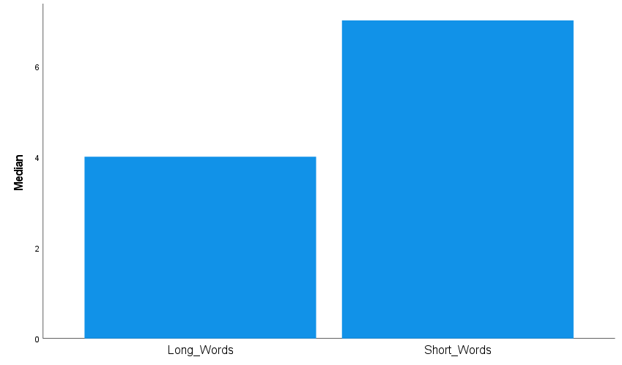

Chart one shows that short words were recalled more than long words. The median score for long words was 4 (the standard deviation for that was 1.35). The median score for short words was 7 (the standard deviation for that was 2.75).
(SD = 1.35)
(SD = 2.75)

To examine if the median scores for both conditions are significantly different to the probability of .05, the non-parametric Wilcoxon statistical test was carried out.
A Wilcoxon signed-rank test showed a significant difference between the long and short word conditions (Z = -4.98, p <0.001). Median recall scores for short words were significantly better than for long words (Median: 7 and 4, respectively).

Hypothesis
The results indicate that the hypothesis that participants will recall significantly more short words than long words (one tailed hypothesis) was supported and provides support for the word length effect.

References
References Research methods report.
Phonological loop:

https://d1wqtxts1xzle7.cloudfront.net/44295481/The_Phonological_Loop_as_a_Language_
Baddeley, A., Gathercole, S., & Papagno, C. (1998). The phonological loop as a language learning device. Psychological review, 105(1), 158.

Studybuff (2023) What is an example of phonological loop.
https
https://studybuff.com/what-is-an-example-of-phonological-loop/
Working memory (2015) Memory at work.
https://workingmemoryrst.wordpress.com/

Memory | Definition, Retrieval, & Forgetting | Britannica
Britannica, T. Editors of Encyclopaedia (2023, March 9). memory. Encyclopedia Britannica. https://www.britannica.com/science/memory-psychology

Appendices
1.Word list table

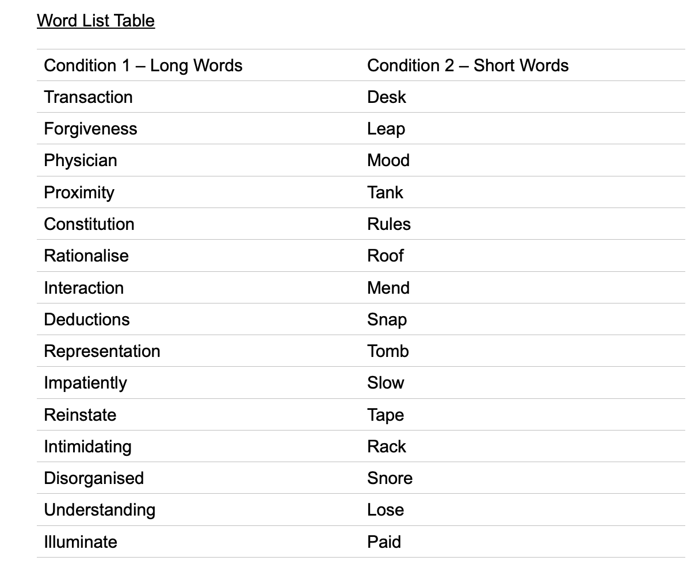

2.Standarlised procedures
Standardised procedures
To ensure that all participants have the same experience, researchers should ensure that they are all tested:
- In the same place, with the same equipment and materials placed in the same way.
- Under the same conditions, so the level of lighting, noise and heat remains the same for all
participants.
- At roughly the same time of day, as people may behave differently if tested at nine o'clock in the morning rather than five o'clock at night.
- Given identical standardized instructions in exactly the same way

Standardized Instructions: these are given in the chosen location and there may be more than one set for different (IV) conditions of the investigation. The standardized instructions are important, as each participant must receive the same instructions so they understand what to do in the study. Also, it ensures that each participant is treated the same and should help eliminate experimenter effects. You can read the instructions to the participant(s), or let them read the instructions themselves.
Standardised procedure for the word length effect study
An opportunity sample of students was used. Presumptive consent was gained.
The following instructions were presented verbally:
- Participants were asked to sit quietly facing the projector screen situated on the wall in front of them.
- You will take part in a short memory task.
- Please ensure that you have a pen and paper in front of you.
- Can you all see the screen and text on the power point clearly?
- You will be presented with 2 word lists – consisting of 15 words each.
- Following the first list – you will be asked to write any words remembered from the list (in any order). The next 15 words were presented in the same way.
- Participants received the long words first followed by the short words. They had 90 seconds to recall and write down the words from list one and list two.
- Words were presented in the middle of a blue screen every 2 seconds, for 1 second.
- The font was Arial, white, size 72.
- Participants were thanked for their participation.
- Participants were fully debriefed regarding the aim and hypotheses of the experiment.
Following the making of the accuracy of recalled words, raw data was analysed using a Wilcoxon signed-rank test on SPSS 26.

3.information sheet and informed consent form


Centre for Psychology and Counselling

Study Consent Form
I understand that this research study is being carried out by a 3rd year Psychology Student for their dissertation, and that taking part in this study will involve memorizing a series of words beginning with short followed by long to test the word length effect.
This study will take approximately 15 minutes to complete.
I understand that participation in this study is voluntary, and I am free to withdraw participation during or at the end of the study without giving a reason. I understand that once I leave the study, I will not be able to withdraw my data, as it will be anonymized. I am aware that if I have concerns about the study, I can discuss these concerns with the researcher at any time during or after the study. I understand that I will be provided with the contact details of the research supervisor at the end of the study, should I have any concerns.
I understand that the information provided by me will be held confidentially, with a code assigned in place of my name. These data will be stored indefinitely in accordance with the Data Protection Act.
I also understand that at the end of the study I will be provided with a debrief form and the opportunity to discuss any issues with the researcher.

I, ___________________________________(NAME) consent to participate in the study conducted by Theresa Kiernan, Centre for Psychology and Counselling, University of Wales Trinity Saint David, under the supervision of Charlotte Greenway.

Participant Signature:________________________________________________
Date:___________________
Name and signature of researcher taking consent
___________________________________________________________________

Study Information Sheet
This document provides key information regarding the study and provides details about what will be expected of you as a participant. Therefore, please read this information carefully before providing consent to take part.
During this study you will be required to do the following:
- Complete a demographics form detailing your age and gender
- Complete a 30-item paper based questionnaire measuring anxiety
  - Further instructions on how to complete this will be provided at the top of the questionnaire

- You will then be presented with a list of 30 words on the computer screen
  - Each word will be presented individually for five seconds and your task is to simply read the word
  - Whilst the words are being presented, you will be required to listen to a piece of music played through a set of headphones

- Once all of the words have been displayed, you will then be given ten minutes to complete as much of a jigsaw puzzle as you can

- After the ten minutes is up, you will be required to complete the anxiety questionnaire again.

- You will then be required to write down as many of the words as you can remember on the piece of paper provided. You will have two minutes to complete this task. Once the two minutes is up, that will be the end of the study
At the end of the study you will be debriefed by the researcher and you will be provided with the study debrief sheet.
If you feel you would be uncomfortable answering personal questions about your anxiety levels, you are advised not to take part in this study.
Due to this research involving an auditory component, you must be capable of listening to music through headphones in order to take part.
If you have any questions, please ask the researcher now.
If you are happy to take part in this study, please read and sign the consent form.

4.Debrief sheet
Study Debrief Sheet
(words underlined and in italics should be changed to fit your specific study)
Study Title
Thank you for taking part in the study.
The aim of this study was to explore …… We specifically wanted to find out whether ……….
If you wish to withdraw your data from the study, you must tell the researcher now. After this point, all of your data will be anonymised and we will not be able to trace it back to you.
If taking part in this study has raised any questions, please speak to the researcher on put your name and student email address here or contact the academic supervisor insert supervisor contact here, name and email.
Thank you once again for taking time to participate in this study.
Put your name here
Put your programme of study here
(BSc Applied Psychology, or BSc Psychology, or BSc Psychology and Counselling)
University of Wales Trinity Saint David

5.Raw data (scores)

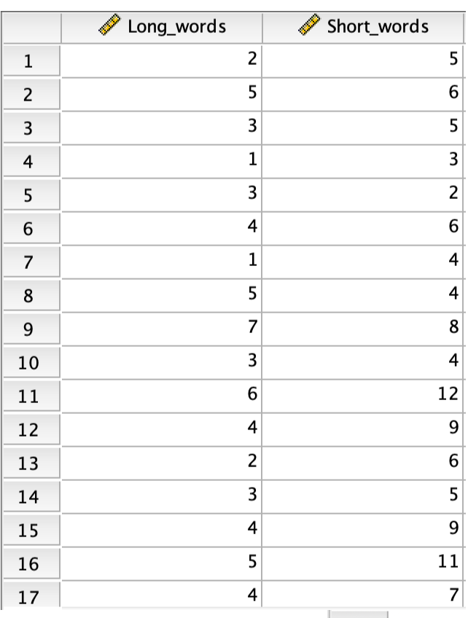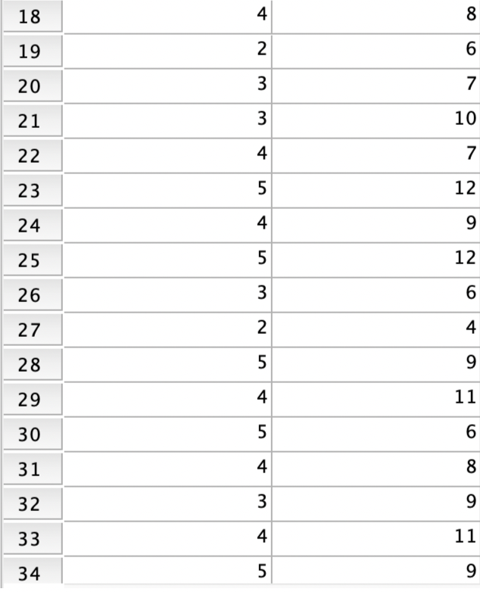

6.SPSS results (Wilcoxon

