Political news story.

Here is the link to my presentation: https://youtu.be/by5EENaj0YE?feature=shared
Not only rail strikes. No, it is much more than that!

Impact it had on the sector?

As BBC News (2022) states the rail strike to hit Wales will be the biggest in 30 years. As Dong, K (2023) says that over 10 thousand workers would be on strike across the uk. More than 10% were running as normal services due to the unions and the rail bosses being unable to agree on a pay increase. As the Prime Minister said that the pay increase would not be feasible across the board (BBC News. (2022). People lose trust in the transport for Wales due to this reason. Davies, T. (2022) states she will need to go home by train and it is making her very “anxious” as she goes on to say that it would be 2 hours and a half to drive home. People use transport for Wales to travel back and forth to work. The people rely on the trains to be there on time but they're not there at all!

Transport for Wales is owned by the Welsh government.

Swansea is Cardiff's link to West Wales. If Swansea were on strike that would mean that there would be no other way to get to West Wales without walking and maybe driving. Driving longer distances equals more carbon emissions which is worse for climate change.

Events being held in the new area in Swansea were affected by people not coming from south Wales due to people not wanting to risk it and then having to pay extra to stay in a hotel overnight.

The demographic of the trainline is a wide audience which is the whole general public. From young to old and from groups to singles.

The impact this has had:
- Lack of trust in government bodies.
- People only used them when needed.
- Tickets are reasonably priced The lack of rail connections to West Wales.
- Local economy
- Local communities affected
- Educational programs affect - university students unable to get the train to and from.
- Business - due to people not being able to get to work and the job they need to do.
- Lack of communication with the traveler- leaving it very last minute to say the train has been canceled or delayed.

Delays/ cancellations -
Anything east from Swansea there are trains every 30-40 minutes so cancellations are not that bad. Compared to if the visitor is traveling west a train is every 1-2 hours wait.

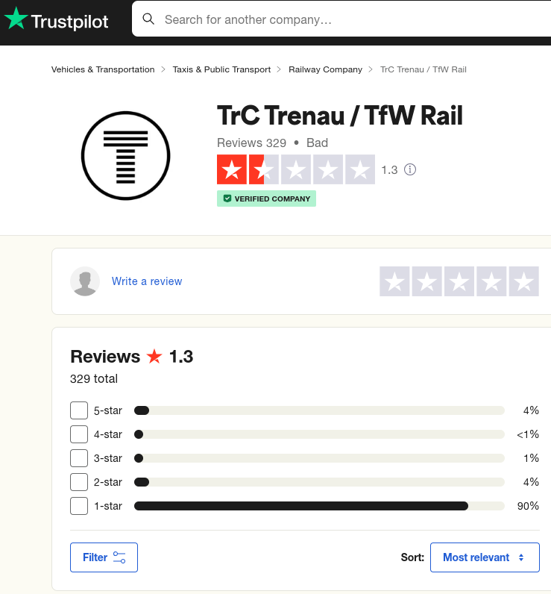 Trustpilot. (2024).

On trust pilote, the rating is 1.3 with 329 reviews with 90% of them being 1 star rating.

Who are RMT - They are the union that is trying to fight for an increase the pay for the job roles thst they do and the Welsh Government is not listening to the voices and opinions of the employees therefore they left the workers with no other action to take except going on strike and that's what most of the workers did for a short period of time. Until the employees couldn’t afford to be off for any longer without being paid (RMT website (2024).

Mick lynch is the nations officer for the RMT union and has been for the quarter of his working life. His job as a union officer he must have the employee's best interests at heart and want the best for them Gall, G (2024). He would have been in changer of the brake out of rail strikes.

Considering the rail strikes from the other perspective, the government. On the Welsh government website (2024) it shows that the Bill of Rights has been read for the second time and there are still ongoing investigations. The Bill of Rights (1689) is a declaration of rights that the citizens of the country have. As Drakeford, M (2023) says they have read the Bill on the strikes actions and disagree with the aims of the bill. The aims of the strike bill are that the employees of any sector have a right to strike and the senedd believe that the Bill will not help and that the industry and the union come up with a resolution (Drakeford, M (2023).

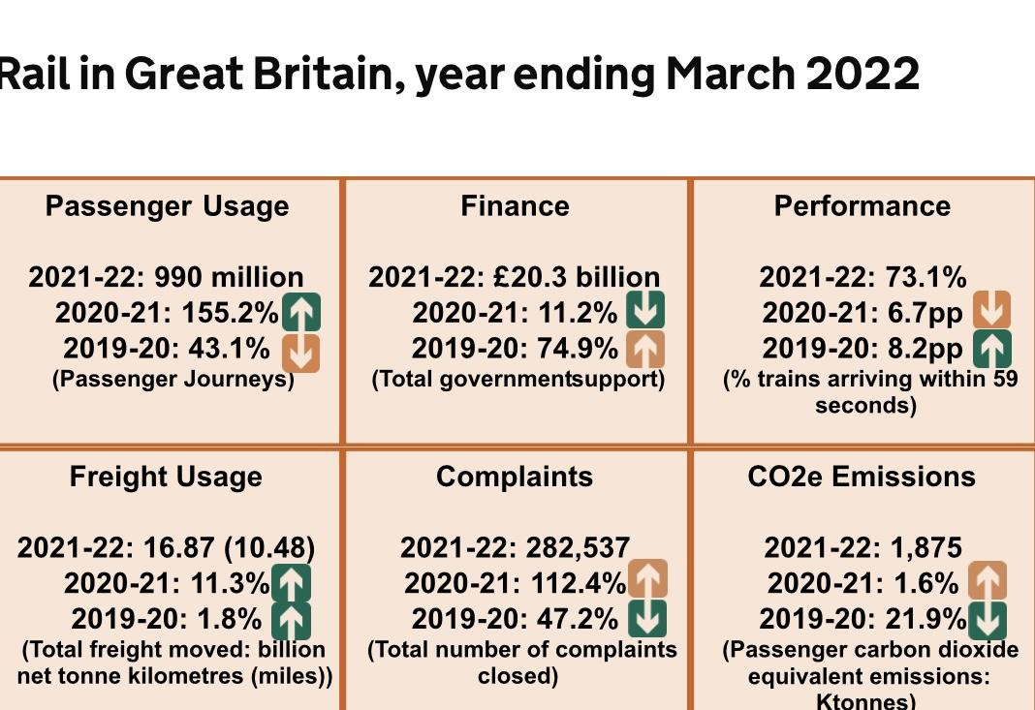
Gov. Uk. (2022).
I could not find the fingers in 2023.
990 million passengers on the rail journeys in 2022.
20.3billion supported by the government.
Performance had dropped to 73.1% from previous years.
Increase in complaints were 112.4% and this report come out in March 2022. Before all the rail strike in the summer.
1875 kilotonnes of Carbon dioxde which has increased

As National Rail (2024) states “trains are one of the most eco-friendly ways to travel”l. The meaning of Eco-friendly is not as harmful to the environment or trying to improve the environment - Campbell, B. et al (2015)

Come to a conclusion of what your insights are and what you recommend for the future. -

Make the transport links better - on twitter they have announced that they are building a new railway station and trying to improve the rail network. The company that will be doing the redevelopments would be network rail. Network rail (2024) is the public sector that does all the development and maintenance for the whole of Great Britain.

This video shows there are improvements happening to the network line and to benefit the traveler.

The Uk parliament (2023) states that the Welsh government is responsible for any work and funding that network rail would need to make the rail line better. They have started the development in south wales but realsitcely they should be looking at west wales and what they can improve and develop to make the trains. not more than 2 stops a day to come to destinations such as Pembroke as is shown on the trainline app (2024).
Video footage from twitter. (2024)

Tfw has a new app that can be downloaded to any device and it will have all the latest news, prior to the train arriving - Tfw rail app. (2023).



Transport for Wales (2024) says the development of the metro is that the early stages

Reference list -
Adobe shock website. (2024). Thank you picture. Available from; https://stock.adobe.com/search?k=thank+you [accessed on 17th of January, 2024].

A little company. (2018). My blog- community. Available from; https://alittlecampy.com/fostering-community-spirit-anywhere/ [accessed on 17th of January, 2024].

BBC news. (2022). Rail strikes: Wales hit by biggest rail strike in 30 years. Available from; Wales hit by biggest rail strike in 30 years - BBC; [accessed on 17th of January, 2024].

Britannica website. (2024). Available from;https://www.britannica.com/topic/Parliament [accessed on 17th of January, 2024].

Campbell, B. et al. (2015). Consumer Perceptions of Eco-friendly and Sustainable Terms. Agricultural and Resource Economics Review, 44(1), pp.21–34.
Channel television. (2018). Breaking news. Available from;https://youtu.be/1oO3GDAyHCc?si=9TEb4IZlVq6_sB5P [accessed on 17th of January, 2024].
Davies, K . (2022). Rail strikes - interview with Teresa Davies. Available from; https://www.bbc.co.uk/news/uk-wales-61867135.amp [accessed on 17th of January, 2024].

Derry journal. (2022). Picture of mick lynch. Available from; https://www.derryjournal.com/news/politics/mick-lynch-sends-solidarity-message-to-derry-and-urges-big-turnout-for-we-demand-better-rally-3929751 [accessed on 17th of January, 2024].

Dong, K. (2023). Examining Public Perceptions of UK Rail Strikes: A Text Analytics Approach Using Twitter Data. Pp 101-114.

Drakeford, M (2023). Welsh government. Available from: https://www.gov.wales/sites/default/files/publications/2023-02/letter-strikes-mininum-service-levels-bill.pdf [accessed on 17th of January, 2024].

Gall, G. (2024). Working for the union; mick lynch. P.p 70-85.

Gov. Uk. (2022). Rail network; rail fact sheet: 2022. Available from; Rail factsheet: 2022 - GOV.UK. [accessed on 17th of January, 2024].

Istock photo. (2024). Available from; https://www.istockphoto.com/photos/cancellation [accessed on 17th of January, 2024].

iTV news. (2023). Half of the rail line to be closed during the strike. Available from; https://youtu.be/1t48XlXVf_s?si=Xf4AR5G51-rDfsSO and https://youtu.be/Fah_kTiYetw?si=db3SJRZ--CSAsRQH [accessed on 17th of January, 2024].

Nation Cymru. (2022). Don’t travel this Saturday unless your journey is essential, transport for Wales tells rail passengers. Available from; https://nation.cymru/news/rail-strikes-transport-wales-august/ [accessed on 17th of January, 2024].

National rail. (2024). Travel information. Available from; https://www.nationalrail.co.uk/travel-information/sustainability/ [accessed on 17th of January, 2024].

Network rail. (2024). Who we are. Available from:https://www.networkrail.co.uk/ [accessed on 17th of January, 2024].

Rail Advent. (2023). Union survey points to safety concerns by Network rail staff. Available from; https://www.railadvent.co.uk/2023/12/union-survey-points-to-safety-concerns-by-network-rail-staff.html/amp [accessed on 17th of January, 2024].

RMT website. (2024). About us. Available from;https://www.rmt.org.uk/about/ [accessed on 17th of January, 2024].

Reuters (2022). UK rail strikes to go ahead as scheduled - trade union. Available at: https://www.reuters.com/world/uk/uk-rail-strikes-go-ahead-scheduled-trade-union-2022-12-07/. [accessed on 17th of January, 2024].

Shutterstock. (2024). Conclusion pictures. Available from;https://www.shutterstock.com/search/conclusion-word [accessed on 17th of January, 2024].

Swansea arena. (2024). Swansea arena pictures. Available from;https://www.google.co.uk/search?client=safari&sca_esv=599416871&hl=en-gb&sxsrf=ACQVn09BHVGmWJ4i-C11w-stPNxZj0_m8Q:1705572496413&q=swansea+arena&tbm=isch&source=lnms&sa=X&ved=2ahUKEwii86XW2OaDAxU-TkEAHa_YC28Q0pQJegQIBxAB&biw=390&bih=659&dpr=3#imgrc=KtOBHEapO8HXpM [accessed on 17th of January, 2024].

Swansea train station. (2024). Available from; https://www.google.co.uk/search?client=safari&sca_esv=599416871&hl=en-gb&sxsrf=ACQVn0_hFAAfj27y23vPiQyeF_E0FCwSTg:1705572266749&q=swansea+train+station&tbm=isch&source=lnms&sa=X&ved=2ahUKEwi1nuTo1-aDAxXKWUEAHRHqCoMQ0pQJegQIChAB&biw=390&bih=659&dpr=3#imgrc=HCYl0y-bnUeKKM [accessed on 17th of January, 2024].

The Bill of Rights. (1689). Available from: The Bill of Rights [
Trainline app (2024). Carmarthen to Pembroke. Available from: Trainline app [accessed on 17th of January, 2024].

Transport for Wales.(2024). Swansea bay and west wales metro. Available from; https://tfw.wales/projects/metro/swansea-bay-metro [accessed on 17th of January, 2024].

Trustpilot. (2024). TFW rail. Available from: https://uk.trustpilot.com/review/www.tfwrail.wales [accessed on 17th of January, 2024].

Tfw rail app. (2023). Latest news. Available from; Travel advice – 30 September and 4 October [accessed on 17th of January, 2024].

Unsplash. (2024). Train platforms
https://unsplash.com/s/photos/train-platform [accessed on 17th of January, 2024].

Uk parliament. (2023). Railway infrastructure in wales. Railway infrastructure in Wales - The House of Commons Library. [accessed on 17th of January, 2024].

Video footage from twitter. (2024). Available from; pic.twitter.com/j0pk695aFU [accessed on 17th of January, 2024].

Visit wales. (2024). Senedd picture. Available from;https://www.google.com/imgres?imgurl=https://visitwalesimages.thedms.co.uk/eandapics/MW/vlarge/1100330_1_1.jpg&imgrefurl=https://www.visitwales.com/attraction/visitor-centre/senedd-1702982&h=1440&w=1920&tbnid=DJcxOtgSvZFZLM&tbnh=194&tbnw=259&usg=AI4_-kTe_LdAAGrByHCVO-7EANpoE_W49A&vet=1&docid=H5wWSH3WGZtsmM [accessed on 17th of January, 2024].

Voice wales. (2023). Mick lynch in south wales - video. Available from;https://youtu.be/HVLHNc8nsaQ?si=KjqtNt9y7CSRm3kr [accessed on 17th of January, 2024].

WelshlabourTV. (2021). Tories' great train robbery. [accessed on 17th of January, 2024].

