
Obsessive-Compulsive and Related Disorders in ICD-11:
Classification, Diagnosis, Treatment, and Current Issues
Written Assignment (Report)
Name: Nalini Vellaswamy
Student Number: 2334340
Programme: BSc (Hons) Health and Social Care
Module: Psychological Classifications and Provisions
Module Code: BMHP6029

Contents
Introduction 3
Classification and Diagnosis in ICD-11 3
Treatment and Rehabilitation 5
Standard Treatment Approaches 5
Rehabilitation in ICD-11 and Practice 6
Current Debates and Emerging Issues 6
Debates About Classification 6
Neurodivergence and Reclassification Issues 6
Impact on Practice and Policy 7
Recommendations 7
Conclusion 8
Reference List 9

Introduction
Obsessive-compulsive and related disorders (OCRD) are a group of mental disorders classified within ICD-11. These disorders are characterised by distressing and disruptive symptoms consisting of intrusive thoughts, obsessive ideas, and compulsions or excessive behavioural acts that interfere with social functioning, occupation, and other areas of well-being (Stein et al., 2016). ICD-11 includes OCD, body dysmorphic disorder, hoarding disorder, trichotillomania, excoriation disorder, olfactory reference disorder, and hypochondriasis (Mataix-Cols et al., 2017). Use of the word "disorder" implies that these are clinical problems, whereas other ICD terms may refer to problems that are not clearly abnormal or clinical. The terms used in classification affect how clinicians interpret clients' presentations, influence how individuals view their own suffering, contribute to social stigma, determine eligibility for treatment, and shape service provision (World Health Organization, 2019).
A key feature of OCRD is that it causes clinically relevant functional impairment in areas of daily life such as work, relationships, and education; symptoms may persist for years and lead to major distress (Stein et al., 2016). Although the disorders within OCRD have individually different characteristics, a core feature in most is the individual's compulsion to engage in repeated thoughts and behaviours even while recognising them as irrational. This report presents an understanding of the classification, diagnosis, management, and recent debates concerning OCD within the wider context of OCRD, together with recommendations for practice and policy. Particular attention is directed at OCD as the principal and most frequently encountered disorder within the OCRD grouping. The report consists of sections on classification and diagnosis, treatment and rehabilitation, current debates and emerging issues, and conclusions and recommendations.

Classification and Diagnosis in ICD-11
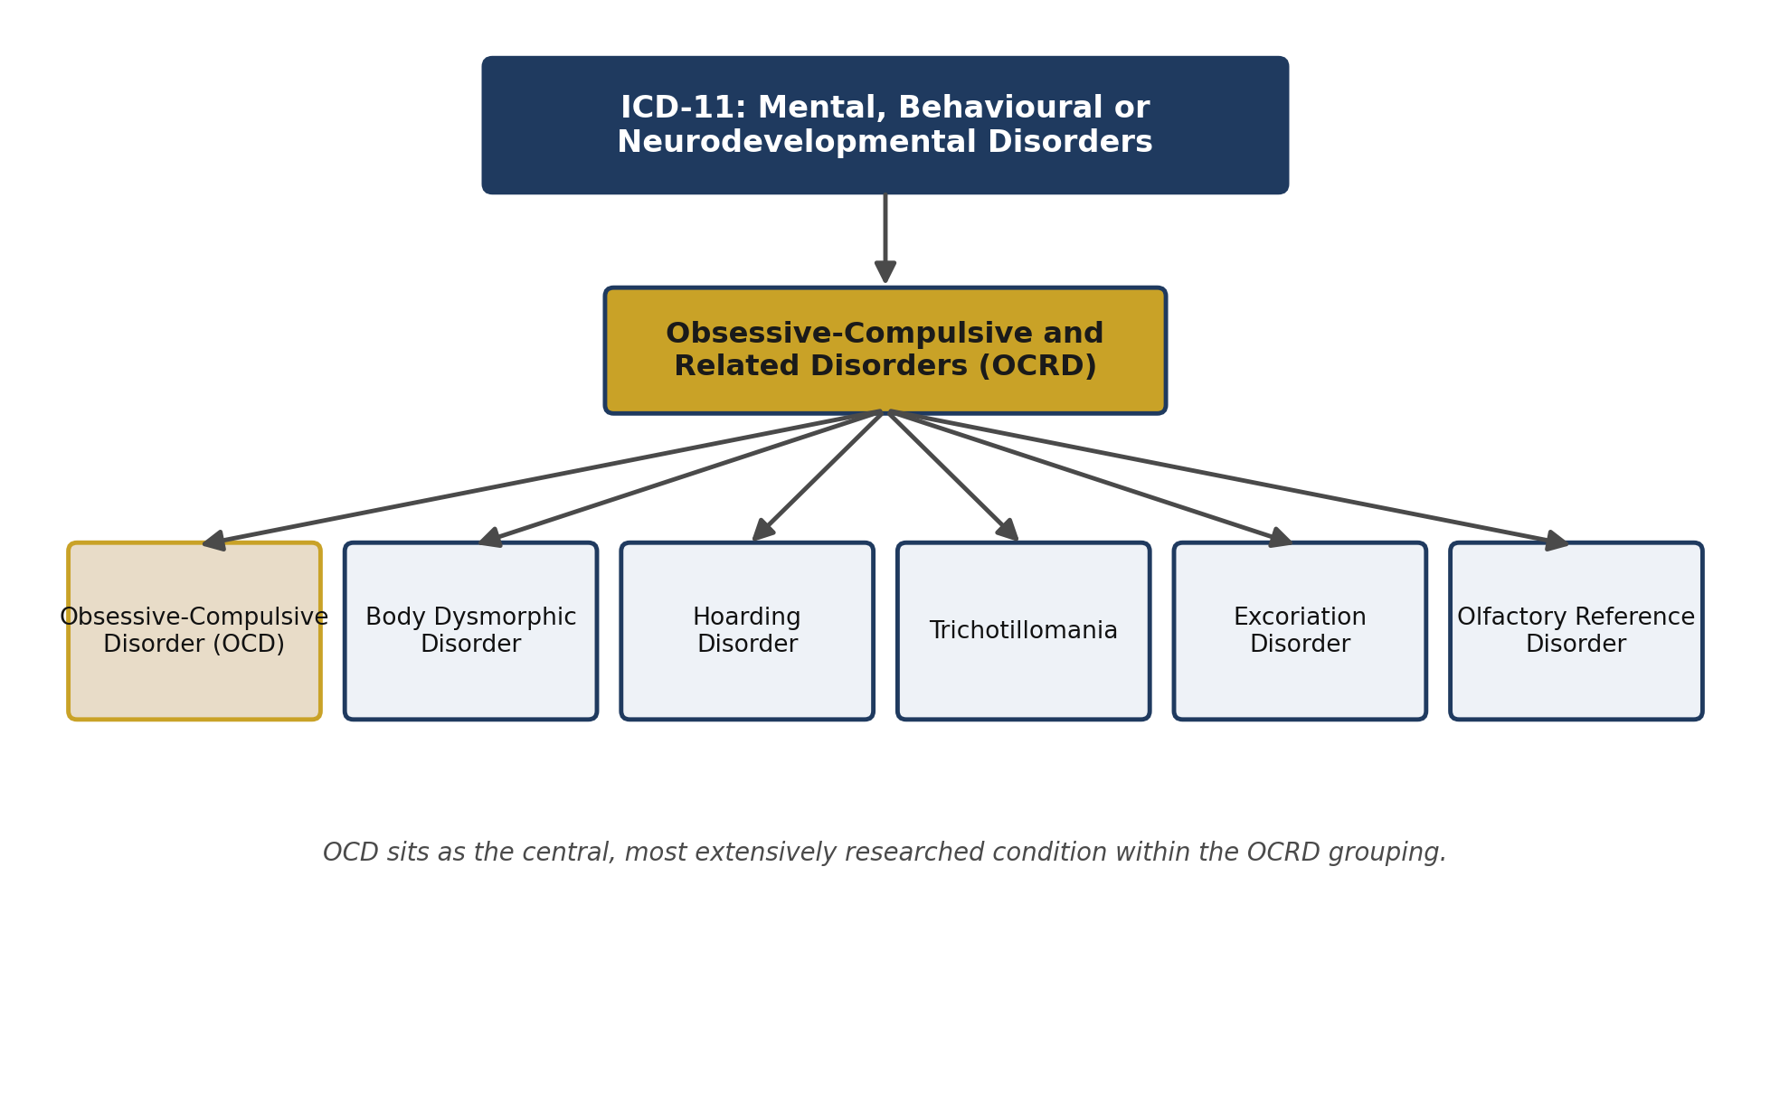
Figure 1: Classification of OCRD within ICD-11, showing OCD as the central disorder within the wider grouping.
In ICD-11, OCRD falls within the chapter on mental, behavioural, and neurodevelopmental disorders, unlike previous versions of the catalogue which linked OCD with the anxiety disorders group. These conditions are grouped together due to various shared criteria, such as recurrent thoughts, urges, or behaviours that individuals find difficult to control (World Health Organization, 2019). The main disorder is OCD, listed under code 6B20 in the ICD-11 browser (World Health Organization, 2022), and characterised by obsessions and/or compulsions. Obsessions are defined as intrusive thoughts, images, or urges that cause distress, while compulsions are repetitive behaviours or mental acts that an individual performs in an attempt to alleviate anxiety or prevent perceived harm (World Health Organization, 2019).
Significantly, the individual usually attempts to prevent, suppress, or neutralise obsessive thoughts, and the ritual is in excess of what seems necessary. Other characteristics include significant ritualistic behaviour, excessive cleaning, and a drive to complete repetitive routines. Other disorders in the grouping demonstrate similarities in repetition or preoccupation, though not in their specific subject matter. Body dysmorphic disorder consists of a preoccupation with perceived physical flaws or defects; hoarding disorder involves continued difficulty discarding items regardless of their actual value, due to a perceived need to save them and associated distress at their loss; and trichotillomania and excoriation disorder involve repetitive hair-pulling and skin-picking. Despite wide differences in content, these disorders are grouped together in ICD-11 because they share features of excessive, compulsive or ritualistic patterns of behaviour that interfere with functioning, as well as a common neurocognitive profile (Mataix-Cols et al., 2017).
ICD-11 requires persistent symptoms causing either a clinically significant level of distress or clinically significant impairment in occupational, educational, or other important areas of life. This is more clinically inclusive and removes, to some degree, the emphasis on rigid diagnostic time limits (Bracha, Bracha and Johnson, 2018). Unlike ICD-10, ICD-11 allows a more pragmatic approach, placing much greater weight on clinical judgement when deciding whether an unusual or excessive case meets the criteria (MRCPsych, 2022). Assessment probes the content and controllability of intrusive thoughts or repetitive actions, and the emotional impact of these experiences on the individual's life and functioning. Insight is a major diagnostic specifier: some individuals acknowledge their obsessional and compulsive beliefs as unreasonable, while others firmly believe their concerns are legitimate, and both are recognised within ICD-11 through differing levels of insight (Mataix-Cols et al., 2017). Assessment of insight helps inform the most effective choice of treatment, as individuals with poorer insight are likely to require more psychoeducation before responding effectively to exposure-based work.

Treatment and Rehabilitation

Standard Treatment Approaches
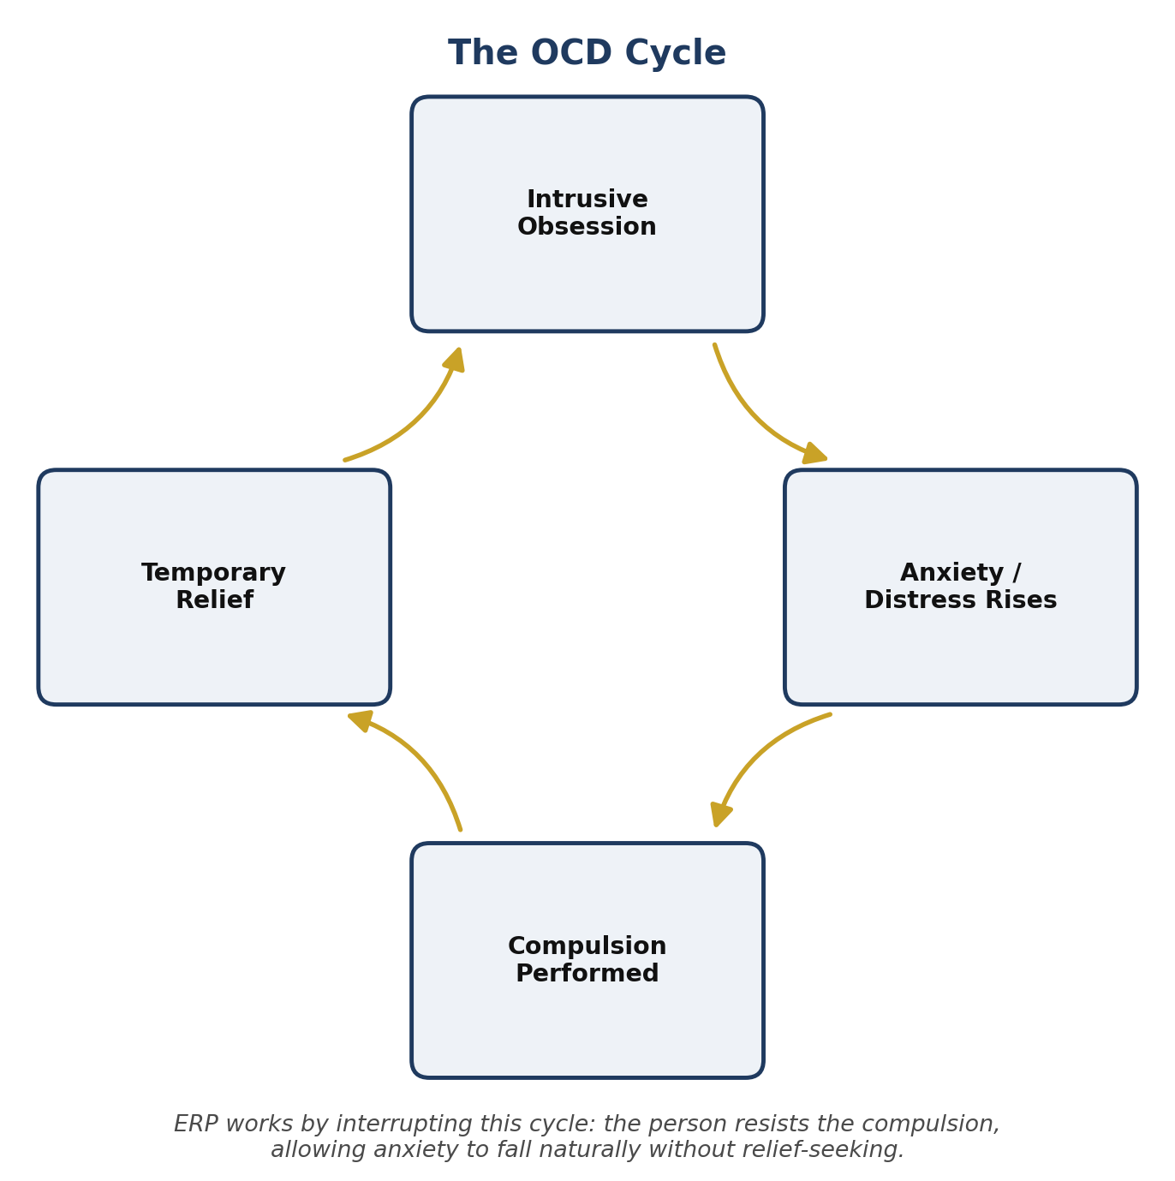
Figure 2: The OCD cycle. ERP treatment works by interrupting this cycle at the compulsion stage.
The treatments applied for OCD and related disorders are psychological therapy, medication, or both. Cognitive-behavioural therapy is considered the most effective psychological treatment for OCD, especially exposure and response prevention (ERP), in which the individual is encouraged to confront situations, objects, or ideas that cause anxiety while refraining from performing compulsive behaviours, allowing anxiety to decrease through habituation (Rosa-Alcázar et al., 2020).
Medication in the form of selective serotonin reuptake inhibitors (SSRIs) may also be employed, sometimes in conjunction with therapy or alternatively when therapy is unavailable. SSRIs can alleviate the severity of obsessive and compulsive thoughts and may facilitate engagement in psychological therapy by lowering resting levels of anxiety. They are particularly indicated for moderate to severe symptoms and when therapy alone has been unsuccessful (Fineberg et al., 2020). This stepped-care position is similar to the treatment approach outlined by NICE (2005).
However, there are limits to both treatments. ERP requires a willingness from the patient to endure short-term anxiety and to refrain from compulsive behaviours; if someone feels unsupported or overwhelmed, or if therapy is not consistent enough, this can lead to early termination of treatment. Side effects and the time SSRIs take to become effective can also be problematic. Some OCRDs do not appear to respond to conventional treatments: conditions such as hoarding disorder and body-focused repetitive behaviour disorders require specialist behavioural therapies based around habit-reversal training rather than the ERP strategies designed for OCD (Selles, Bechor and Storch, 2019).

Rehabilitation in ICD-11 and Practice
ICD-11 does not set out a strict rehabilitation programme, but rehabilitation is a vital part of clinical practice regardless. The main aim of rehabilitation is to return a person to their everyday life, whether that involves going back to work or school, rebuilding relationships, or re-establishing habits around self-care. Psychoeducation is one of the main components of structured rehabilitation, alongside relapse prevention, family intervention, and building a person's confidence, all of which continue as formal treatment ends. Families often unconsciously reinforce compulsions by giving reassurance or physically carrying out rituals, a pattern known as family accommodation. Rehabilitation can therefore include guidance on how to reduce this systematically without the individual feeling unsupported, for example by gradually giving less reassurance. This is particularly important where a person has experienced symptoms for a long time, since deep habits of avoidance and accommodation build up over a longer period (Pinto, Greenberg and Simpson, 2022).

Current Debates and Emerging Issues

Debates About Classification
There is ongoing debate regarding whether OCRD is the right conceptual fit and whether it has the greatest clinical value. In favour of the category, it identifies commonly shared phenomenological features that distinguish these from other disorders, including repetition and difficulties with control, and it helps create standardisation across treatment programmes (Stein et al., 2016). Conversely, a problem with classifying these disorders into one category is the heterogeneity within it. OCD is fear-driven, whereas hoarding disorder focuses on difficulties with attachment rather than fear, and body dysmorphic disorder centres on perceived bodily features. These conditions are distinct from one another with regard to cognition, neurobiology, cause, treatment options, and expected outcome (Stein et al., 2016).

Neurodivergence and Reclassification Issues
A growing area of concern centres on the overlap between OCRD symptoms and neurodivergent conditions such as autism. Repetitive behaviours are found in both autism and OCD, yet in autism many forms are non-compulsive and would not meet the criteria for OCD. Many autistic individuals engage in repetitive behaviours for the purpose of self-soothing or sensory seeking, whereas in OCD compulsions are performed to reduce anxiety. These seemingly equivalent behaviours therefore represent very different processes, which increases the chance of diagnostic error (Hollander, Pallanti and Zohar, 2021). This risk is heightened because clinical settings are usually limited in time and because standard measures were not developed to capture autistic presentations accurately.
Such overlap has prompted arguments that diagnostic criteria need to account explicitly for cognitive diversity. Some researchers argue for dimensional approaches that measure severity, impairment, and insight along a continuum rather than relying solely on categorical distinctions. The aim is to avoid over-pathologising ordinary autistic behaviour while still ensuring that genuine co-occurring OCD is identified and treated in autistic individuals, who may describe and experience their symptoms differently from non-autistic patients. The consequences of getting this distinction wrong are significant in both directions: an autistic person whose self-regulatory behaviours are misread as compulsions may be offered ERP that is distressing and ineffective, while an autistic person with genuine OCD whose symptoms are dismissed as characteristic of autism may be left without treatment altogether.

Impact on Practice and Policy
These discussions have clear implications for mental health practice and policy in terms of broader diagnostic categorisation, training guidelines for practitioners, and greater flexibility in mental healthcare with a stronger emphasis on person-centred approaches. They recognise the importance of developing support beyond short-term interventions aimed solely at symptom remission, particularly for those whose symptoms sit at the boundary of both conditions. Policy may need to be reformulated to improve access to longer-term specialist treatments such as ERP, particularly outside city centres, alongside modification of diagnostic systems to accommodate neurodivergent profiles rather than treating them as an add-on.

Recommendations
Several practical recommendations emerge from the issues surrounding classification, management, and ongoing debate. First, clinician training needs to be improved, particularly with regard to differential diagnosis skills, so that OCD, tic disorders, and autistic repetitive behaviours can be correctly identified, avoiding misdiagnosis and ensuring appropriate treatment plans. Second, the availability of therapy needs to be greatly expanded, extending provision beyond specialist centres so that CBT and ERP are more widely accessible. Third, rehabilitation needs to begin alongside therapy rather than only after symptom remission, in order to promote functional recovery within work, educational, and relational domains. Fourth, research into neurodivergent groups is needed, since relatively little is known about how OCRD presents in autism, and effective treatment cannot be planned without this knowledge. Finally, treatment plans need to be individualised according to each person's insight, comorbidities, and cultural background rather than applying a uniform approach to everybody.

Conclusion
ICD-11 groups OCRD as a set of disorders characterised by intrusive thoughts, repetitive behaviours, and subjective distress, within which OCD is the most common and most researched example. Treatment is most helpful when evidence-based cognitive-behavioural treatment such as ERP is combined with pharmacological support where medically indicated; however, both remain associated with known limitations regarding patient tolerability, access to treatment, and relevance for less common OCRD presentations. Although not detailed within ICD-11 itself, recovery-oriented support is key to long-term outcomes and works better when initiated early alongside treatment rather than only at a later point. The ongoing discussion regarding classification and neurodivergence highlights how this area of clinical and academic interest continues to evolve. Improvements should focus on a more rigorous approach to differential diagnosis, a more individualised approach to treatment, enhanced proactive recovery-oriented support, and continued research into presentations and optimal approaches for OCRD in diverse neurodivergent populations.

Reference List
Bracha, A.S., Bracha, H.S. and Johnson, R. (2018) 'ICD-11 and the future of obsessive-compulsive disorder classification', World Psychiatry, 17(3), pp. 372–373.
Fineberg, N.A., Dell’Osso, B., Albert, U., Maina, G., Geller, D., Carmi, L., Sireau, N., Walitza, S., Grassi, G. and Pallanti, S. (2020) 'Early intervention for obsessive-compulsive disorder and body dysmorphic disorder: a review', Current Psychiatry Reports, 22(8), pp. 1–12.
Hollander, E., Pallanti, S. and Zohar, J. (2021) 'Obsessive-compulsive and related disorders: diagnostic and therapeutic issues', Dialogues in Clinical Neuroscience, 23(1), pp. 5–15.
Mataix-Cols, D., Andorfer, S., Sánchez-Meca, J. and de la Cruz, L.F. (2017) 'The classification of obsessive-compulsive and related disorders in ICD-11', Journal of Affective Disorders, 220, pp. 11–17.
MRCPsych (2022) 'ICD-11 criteria for obsessive-compulsive disorder (6B20)'. Available at: https://www.mrcpsych.uk/2022/05/icd-11-criteria-for-obsessive.html (Accessed: 1 August 2026).
National Institute for Health and Care Excellence (NICE) (2005) Obsessive-compulsive disorder and body dysmorphic disorder: treatment. London: NICE.
Pinto, A., Greenberg, B.D. and Simpson, H.B. (2022) 'Obsessive-compulsive and related disorders: a clinical update', Psychiatric Clinics of North America, 45(2), pp. 225–242.
Rosa-Alcázar, A.I., Sanchez-Meca, J., Gomez-Conesa, A. and Marin-Martinez, F. (2020) 'Psychological treatment of obsessive-compulsive disorder: a meta-analysis', Clinical Psychology Review, 78, 101855.
Selles, R.R., Bechor, M. and Storch, E.A. (2019) 'Treatment of body-focused repetitive behaviour disorders', Current Treatment Options in Psychiatry, 6(2), pp. 93–106.
Stein, D.J., Kogan, C.S., Atmaca, M., Fineberg, N.A., Fontenelle, L.F., Matsunaga, H., Chamberlain, S.R. and Lochner, C. (2016) 'The classification of obsessive-compulsive and related disorders in the ICD-11', Journal of Affective Disorders, 190, pp. 663–674.
World Health Organization (2019) ICD-11 for Mortality and Morbidity Statistics. Geneva: WHO.
World Health Organization (2022) 'Obsessive-compulsive disorder', in ICD-11 Browser. Available at: https://icd.who.int/ (Accessed: 1 August 2026).

