Jack Harley-Walsh - 1702264

BA 2 Automotive & Transport Design
Vehicle Technology 2
Paul Morrow

M5X01364
Vehicle Structure & Aero
10.04.19

Generative Design
Generative design is a process where designers gather as many variables as possible from the habitat that the product being designed will inhabit; such as different materials and conditions and add restrictions such as cost restrictions. This gathered data is then put into an algorithm-based software which rapidly generates thousands of proposals, before selecting the most appropriate design for the criteria set (Mechanica Solutions, 2018).
Pros
Once generative design is fully introduced into the automotive industry there will be a massive change in production efficiency for the better. As generative design is a process which 3D prints objects, there is no material wastage which saves the company money. In comparison to human manufacturing it is far superior for the company as the production line will not rely on human intervention, meaning that there will be less mistakes, which means fewer faulty products, giving the company a reliable brand image. Also, this may reduce company expenditure as unlike humans, machines do not need a holiday or paid leave. Machines will also produce components faster and keep up with demand without its productivity declining.
The nature of the structure created by generative design will allow future chassis of vehicles to be just as strong, if not stronger than the chassis of today and lighter as there will be no excess material. This is beneficial as the vehicle will be propelling less mass, thus using less energy, meaning it can travel further using less fuel/electricity making the car far more efficient in terms of consumption.
Thanks to how generative design structures are created, future vehicles will become safer in an accident as crumple zones can be programmed into the structure of the chassis, which means the impact forces can be absorbed more efficiently.
It generates thousands of designs in minutes, as it does this it incorporates the engineering structural integrity of the shape as well as the stress testing. Once the proposal is picked the file can be uploaded to a 3D printing machine where it can be made straight away. (New Equipment Digest,2018).
Generative design allows a lot of freedom within the design which means the end product can be tailored to a customer’s requirements, making the product more bespoke. It does this by giving the user of the software the ability to set loose or strict requirements for the product, filling in the blanks and creating a product to the user’s requirements.
Cons
Because generative design is a process where form follows function, the products it creates aren’t very appealing to look at. For example, Airbus, using generative design have just created some new partitions which are very structurally sound. However, partition covers had to be used as the partitions in their natural forms weren’t very pleasing to the eye (Starts, 2016).
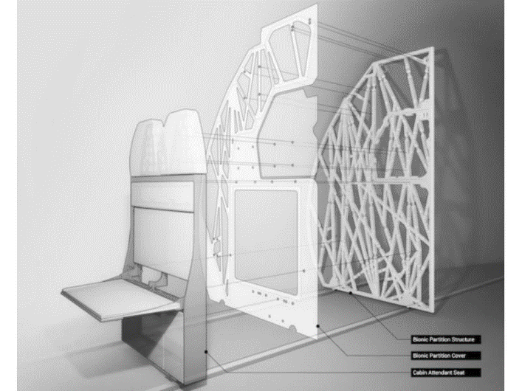

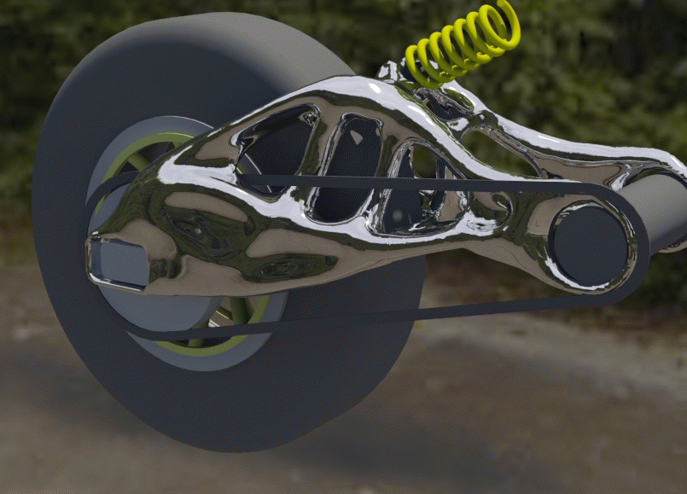
Without a designer’s input
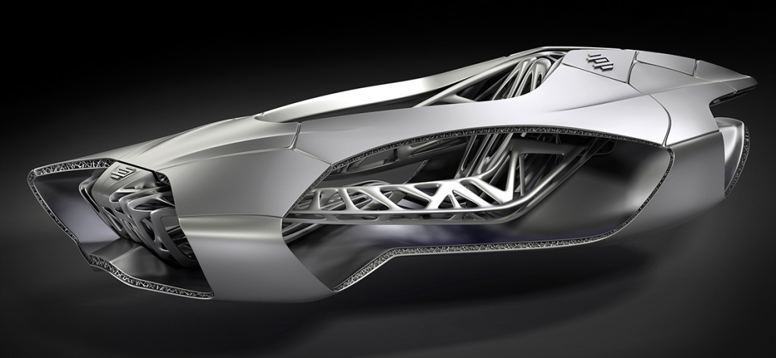
With a designer’s input
Generative design is a new technology, and as with other new technologies issues may occur in the early stages of use. For example, in the process of gathering data for generative design to use, there is room for human error, which could compromise the final design.
The current method of making metal generative design components is 3D printing which is a very fast process for making small simple components. However, applying this process to the car industry of today where many components are large and complex it would simply be too slow in comparison to the high-volume production processes used currently. For example, punching body panels such as wings and bonnets which takes seconds (3DEO 2017).
Although generative design is very capable on its own, it still needs the intervention of designers which can adapt the shape of the generative design so that it is aesthetical, and the intervention of engineers to set the parameters for the software to work to.
Steel monocoque chassis
Pros
As metals go, steel is cheap meaning that it is cost effective for companies who use it for mass production. Steel is useful for mass production as it's great to work with due to its malleability.
It is quick to manufacture in mass quantities thanks to steel’s ductility, which allows the material to be stamped into shape without any fracturing, allowing large panels of the vehicles such as the bonnet and roof to be made as one single piece (Chatterjee, 2019).
A steel monocoque chassis is safe in a crash as it uses a lot of crumple zones which can be built into the structure. The tensile strength of steel means that it is highly resistant to fracture or breakage, which is useful for this type of chassis due to it undergoing a high amount of torsional stress (Chatterjee, 2019).
A monocoque chassis has more space efficiency than a body-on chassis layout, as it does not have a separate frame and takes up less space meaning it doesn’t intrude into the passenger space, making a more comfortable environment.
Material wastage is kept to a minimum using the stamping process to build this chassis. This is where a male and female side of a mould clamp either side of the steel sheet in order to create a panel such as the door or boot lid. This method will get as many panels out of one sheet as possible, and the remains are then melted down to create a new sheet.
Cons
Steel is a heavier material in comparison to aluminium (which can also be used for chassis), which means that it affects the performance and fuel efficiency of the vehicle. The performance is affected as the engine must work harder reducing acceleration and breaking distances. It also negatively affects the vehicle in the corners as the weight pulls the vehicle out of line. More fuel is used due to the engine working harder because of the weight of the vehicle. (Autozine.org, 2019).
This process may be unsuitable for use by small companies as it is not cost effective to produce a low volume of vehicles using this method. The high set-up costs for tooling such as stamping machines, expensive mouldings and robots mean this method is only suitable for mass-production (Autozine.org, 2019).
As monocoque chassis are made of steel they may be prone to rusting, particularly in cold climates or in areas by the sea where the salt reacts with the metal. This is bad as it will reduce the lifespan of the product before requiring repairs.

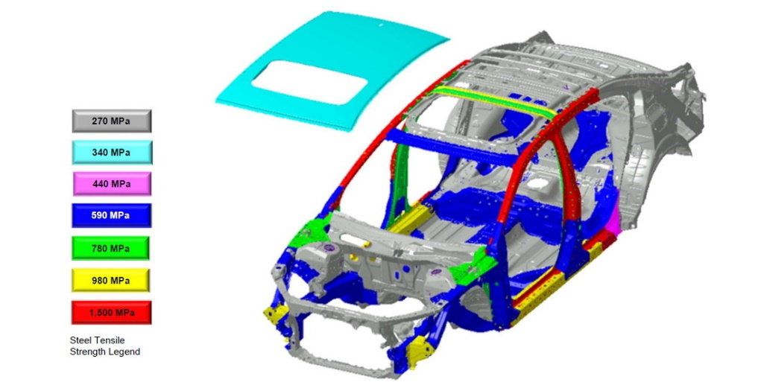

Aerodynamics
Aerodynamics is the scientific study of how air flows around and inside objects. It is also known as Fluid Dynamics as air moves like a fluid. Aerodynamics is the displacement of an object travelling through the air which gives resistance called drag. All vehicles have a Coefficient of drag value called Cd, this is a measurement of air resistance on a vehicle (drag), this measurement allows the comparison of Cd efficiency of one vehicle to another. Cd can be used to work out the amount of drag there is upon a vehicle at different speeds.
We need to consider aerodynamics in car design as it helps improve the performance of the cars efficiency by reducing drag which in turn allows vehicles to travel at greater speeds with a better fuel economy and handling characteristics. When a vehicle travels at speed the air flow around and through has a bigger effect on acceleration, top speed, fuel efficiency and handling.
To reduce the Cd value of a vehicle there are several measures needed, such as the vehicles frontal area/grill, having a smaller ground clearance and a sharply angled windscreen. These changes will minimise the frontal impact on air, minimise airflow under the vehicle and minimise pressure build up at the front. The benefits is it gives better acceleration, higher top speed and a lower fuel consumption.
A vehicle’s body design is a key factor effecting its aerodynamic performance, aspects will either force the vehicle down on the road increasing traction or will create lift if the car body shape generates a low-pressure area above. The most aerodynamic shape in nature is the tear drop the closer a design is to this the more fuel efficient it can be.
Although, the tear drop shape is very aerodynamic in the air, it is not as efficient on the ground for a motor vehicle due to practicality and ground effect.
Drag is not the only consideration in aerodynamics, lift and downforce also come into play. Lift is the force that opposes the weight of an object and raises it into the air and downforce presses an object towards the ground.
‘According to Bernoulli’s principle, for a given volume of air, the higher the velocity the air molecules are travelling, the lower the pressure becomes. Likewise, for a given volume of air the lower the velocity of the air molecules, the higher the pressure becomes. This applies to air in motion across a still body, or to a vehicle in motion, moving through relatively still air.’ (Build Your Own Race Car! 2015).
A front air dam on a vehicle stops air flowing underneath it creating a vacuum. This low-pressure area underneath the vehicle in conjunction with the higher pressure above the front and top creates a downforce at the front. An air dam alone means air soon enters from the sides and equalises the pressure underneath diminishing the downforce so adding side skirts the low-pressure area can be extended to cancel this effect. Air molecules will naturally flow to lower pressure areas evening out pressure. Compressed air molecules will move out of a high-pressure are in front of a vehicle and move to the sides top and bottom.
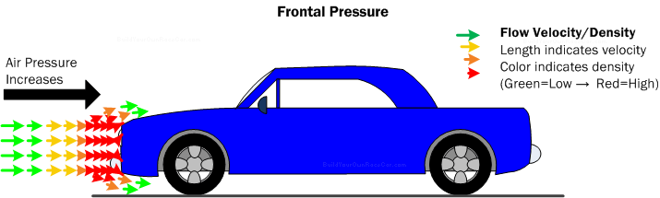
(https://www.buildyourownracecar.com/race-car-aerodynamics-basics-and-design/)

A vehicle’s ground clearance and angle of attack into air has an influence on drag. Size and shape of the nose needs to be smooth, small and downward sloping to cut a small hole into the air. Minimising frontal area is important and easier than reducing the Cd. However, to taper the nose symmetrically pressure builds up under the front of the vehicle producing lift forces therefore the downward slope creates a low drag coefficient and negative lift.
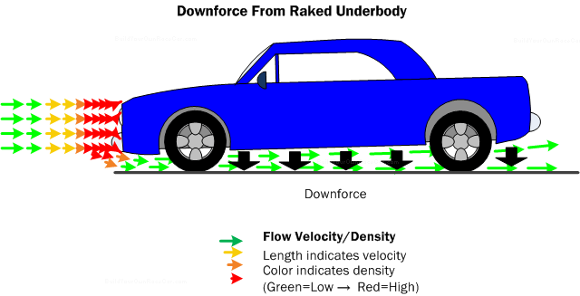
(https://www.buildyourownracecar.com/race-car-aerodynamics-basics-and-design/2/)

The Venturi tunnel is the underside of high-performance vehicle which is designed to create downforce. It does this as the underside of the vehicle is shaped like an inverted wing which causes the airflow underneath to increase in speed and density which then expands creating a low-pressure area to give down force.
Diffusers work in a similar way to the Venturi tunnel’s but instead of the whole of the underside being curved it is just the rear end of the vehicle. Another way to help create downforce is by placing the exhaust outlets in line with the ground creating greater airflow through the diffuser.
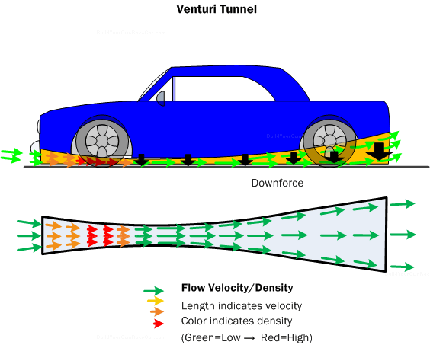
(https://www.buildyourownracecar.com/race-car-aerodynamics-basics-and-design/4/)

The faster a vehicle goes the greater the rear vacuum drag increases due to flow detachment. This is the area immediately behind the rear window and boot. It responds like a vacuum due to the air molecules not being able to fill the space as quickly as the car can make it due to its low pressure. As a result, a continuous vacuum sucks in the opposite direction of the car. The flow detachment is reduced by elongating the body behind the rear axle and by making the rear window have a long gentle sloping gradient so that the flow detachment has a smooth transition reducing the rear vacuum. This is body converging, which reduces turbulence and drag. At the rear end of the vehicle a small wake area is desirable and made by a steep gradient, but this will add an increase on drag. The back end or the tail of the vehicle needs to have a similar shape to follow the shape through. This reduces the area of flow detachment.
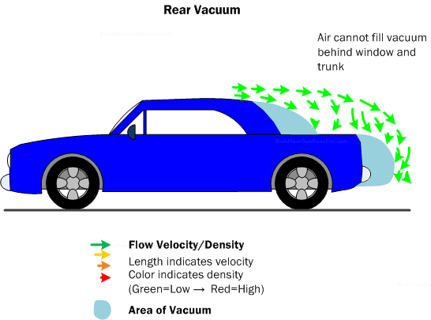
(https://www.buildyourownracecar.com/race-car-aerodynamics-basics-and-design/)

Components on a vehicle such as door handles, and wing mirrors also have an effect on aerodynamics. The shape of them needs to have flow detachment in mind to reduce the turbulence which could affect the neighbouring air flow around the body of the vehicle.
Vehicles which have open wheels will create a lot of drag and turbulence the solution to solving this problem is covering the wheel in body work. However, in certain areas of motorsports this is not allowed and instead converging flares are used behind the open wheel, this gives the maximum benefit.
Spoilers are used mostly on sports saloon cars to provide downforce to counteract the lifting effect upon the body of the vehicle which is caused by the natural shape of it. A spoiler acts like an air barrier which rapidly changes the direction of the horizontally travelling air into vertically travelling air, this creates downforce.
Too much down force causes drag having a negative effect on the car’s efficiency and too much lift the car becomes unstable at speeds effecting its handling performance.
The most effective method for solving the problem would be active aero, which are aerodynamic aids such as spoilers that can automatically adjust to the vehicles aerodynamics needs at any given point. However active aero is too expensive to have on ordinary family cars, to solve the problem on these cars fins and wings are placed towards the rear of the car which are used to keep the car stable at speed. ‘The airflow over a car is filled with high- and low-pressure areas, the sum of which indicate that the car body either naturally creates lift or downforce’. (Build Your Own Race Car! 2015).
The information above shows that aerodynamic designs have a positive effect on the performance characteristics of automobile making them more fuel efficient and improving acceleration, breaking and handling.

Bibliography

Generative Design
Autodesk.com. (2018). Generative Design at Airbus | Customer Stories | Autodesk. [online] Available at: https://www.autodesk.com/customer-stories/airbus [Accessed 10 Apr. 2019].

Fryer, T. (2018). Could generative design signal the death of the engineer? [online] Theiet.org. Available at: https://eandt.theiet.org/content/articles/2017/09/could-generative-design-signal-the-death-of-the-engineer/ [Accessed 10 Apr. 2019].

GE Additive. (2019). Metal Additive Manufacturing Materials. [online] Available at: https://www.ge.com/additive/additive-manufacturing/information/metal-additive-manufacturing-materials [Accessed 10 Apr. 2019].

Mecanica Solutions Inc. (2018). CATIA FUND. – Long Island. [online] Available at: http://www.mecanicasolutions.com/generative-design-design-the-future/ [Accessed 10 Apr. 2019].

New Equipment Digest. (2018). What Generative Design Is and Why It’s the Future of Manufacturing. [online] Available at: https://www.newequipment.com/research-and-development/what-generative-design-and-why-its-future-manufacturing [Accessed 10 Apr. 2019].

STARTS PRIZE. (2016). Bionic Partition: Generative Design for Aerospace. [online] Available at: https://starts-prize.aec.at/en/bionic-partition/ [Accessed 10 Apr. 2019].

3DEO (2017). Pros and Cons of 3D Printing Metal Components. [online] 3deo.co. Available at: https://news.3deo.co/metal-3d-printing/pros-cons-3d-printing-metal-components [Accessed 10 Apr. 2019].

Monocoque
AerMech. (2009). AerMech. [online] Available at: http://aermech.com/chassis-frames/ Chatterjee,T 2019 [Accessed 10 Apr. 2019].

Autozine.org. (2019). AutoZine Technical School - Chassis. [online] Available at: https://www.autozine.org/technical_school/chassis/tech_chassis.htm [Accessed 10 Apr. 2019].

Chatterjee, T. (2019). Properties of Steel. [online] ScienceStruck. Available at: https://sciencestruck.com/steel-properties.

Aerodynamics
Build Your Own Race Car! (2015). Car Aerodynamics Basics, How-To & Design Tips ~ FREE! [online] Available at: https://www.buildyourownracecar.com/race-car-aerodynamics-basics-and-design/3/ [Accessed 9 Apr. 2019]. In-text citation: (Build Your Own Race Car!, 2015)

https://www.howstuffworks.com/hsw-contact.htm (2009). How Aerodynamics Work. [online] HowStuffWorks. Available at: https://auto.howstuffworks.com/fuel-efficiency/fuel-economy/aerodynamics.htm [Accessed 9 Apr. 2019].

Hucho, Ahmed, Hucho, Wolf-Heinrich, and Ahmed, Syed R. Aerodynamics of Road Vehicles : From Fluid Mechanics to Vehicle Engineering. London: Butterworths, 1987. Print.

Society of Automotive Engineers, and SAE International. Investigations into Vehicle Aerodynamics. Warrendale, Pa.: Society of Automotive Engineers, 1995. Print. SP-1078

Society of Automotive Engineers, and SAE International. Vehicle Aerodynamics Design and Technology. Warrendale, Pa.: Society of Automotive Engineers, 2001. Print. SAE Special Publication ; SP-1600

