A Strategic Change Plan
Leading Digital and Electric Transformation at Vauxhall Motors in a Volatile Automotive Market
Student name: Diana Maria Boboc
Student ID number: 2324060
Programme: BA (Hons) Leadership and Management Skills for the Workplace
Module: Leading and Implementing Change (LIC) - LCLM6003
Module Leaders: Nadeem Mirza and Sujeewa Herath
Assignment: A Strategic Change Plan

Table of Contents
Table of Contents 1
Executive Summary 1
1. Introduction 1
2. Organisational Background and Environmental Change 1
2.1 Recent history of Vauxhall and Stellantis 1
2.2 PESTLE analysis 1
2.2.1 Political 1
2.2.2 Economic 1
2.2.3 Social 1
2.2.4 Technological 1
2.2.5 Legal 1
2.2.6 Environmental 1
2.3 Digital disruption, digitalisation and artificial intelligence 1
3. Change Management Models 1
3.1 Lewin's three-step model 1
3.2 Kotter's eight-step model 1
3.3 The ADKAR model 1
3.4 Critical comparison of the models 1
4. Leadership, Culture and Resistance to Change 1
4.1 Leadership styles: from Tavares to Filosa 1
4.2 Leadership's role in managing change 1
4.3 Organisational culture 1
4.4 Resistance to change 1
5. Proposed Strategic Change Management Plan 1
5.1 Proposed change and objectives 1
5.2 Change approach and phasing 1
5.3 Financial plan 1
5.4 Communication plan 1
5.5 Evaluation plan 1
6. Conclusion 1
Reference List 1

Executive Summary
This report examines Vauxhall Motors, the United Kingdom's oldest surviving car brand and part of the Stellantis group, as a case study in strategic change management within the automobile sector. Vauxhall's recent history spans Groupe PSA's 2017 acquisition of the brand from General Motors, the 2021 PSA-FCA merger that created Stellantis, the £100 million conversion of Ellesmere Port into the UK's first electric-vehicle-only plant, and the contested closure of the Luton van factory in 2025. Together these events illustrate how digitalisation, electrification and regulatory change - principally the UK's Zero Emission Vehicle mandate - are reshaping a mature manufacturer operating inside a much larger multinational group.
The report first analyses Vauxhall's operating environment using a PESTLE framework and considers the impact of digital disruption, digitalisation and artificial intelligence. It then applies three established change management models - Lewin's (1947) three-step model, Kotter's (1996) eight-step model and Hiatt's (2006) ADKAR model - to two contrasting recent episodes of change: the relatively consultative transformation of Ellesmere Port and the more contested closure of Luton. The leadership transition from Carlos Tavares to Antonio Filosa is then evaluated through Bass's (1985) transformational-transactional lens, and the influence of organisational culture is assessed using Cameron and Quinn's (2011) Competing Values Framework. Building on this analysis, Section 5 proposes a strategic change management plan - the Vauxhall UK Change Readiness and Digital Capability Programme - with defined objectives, a financial plan, a communication plan and an evaluation framework, designed to close the gap this report identifies between Vauxhall's technical change capability and its capability to manage the human and communicative side of large-scale change.

1. Introduction
Automobile manufacturers operating in the United Kingdom currently face a rare convergence of pressures: an accelerating, government-mandated shift to electric powertrains, the digitalisation of both vehicles and factories, tightening emissions legislation, and volatile international trade conditions. Having been asked by the board to advise on a strategic response to these pressures as Senior Strategic Manager, this report uses Vauxhall Motors as its case organisation. Founded in London in 1857 as a marine engine manufacturer and producing its first motorcar in 1903, Vauxhall is the United Kingdom's oldest surviving vehicle brand (Stoneacre, 2025). It was sold by General Motors to Groupe PSA in 2017 and has, since January 2021, formed part of Stellantis N.V., the multi-brand group created by the merger of PSA and Fiat Chrysler Automobiles (Stellantis, 2021).
This ownership history matters for a change management report because Vauxhall no longer sets its own strategic direction; it implements decisions taken at group level, competing internally with sister plants across Europe and North America for investment and product allocation (Motor1, 2021). Any change plan for the brand must therefore be understood within the wider governance, culture and resource-allocation logic of a fourth-largest global automaker, not simply as a stand-alone national business.
The report responds directly to the five elements requested by the board. Section 2 introduces Vauxhall in more depth and analyses how internal and external change - including digital disruption, digitalisation and artificial intelligence - has affected the company, using a PESTLE framework. Section 3 evaluates established change management models and applies them to two recent, contrasting episodes of change at Vauxhall: the 2021-2023 conversion of Ellesmere Port to all-electric production, and the 2024-2025 closure of the Luton van plant. Section 4 evaluates how that change was led, applying leadership theory to the transition from chief executive Carlos Tavares to Antonio Filosa, and assesses the influence of organisational culture and employee resistance. Section 5 then develops an original strategic change management plan, with clear objectives, a financial plan, a communication plan and an evaluation plan, aimed at helping Vauxhall's UK operations respond more effectively to the environment described in Section 2. Throughout, the analysis draws on academic literature on change management, leadership and organisational culture, combined with recent trade press, government and industry-body sources, so that the recommendations are grounded in established theory as well as current sector conditions rather than in either alone.

2. Organisational Background and Environmental Change

2.1 Recent history of Vauxhall and Stellantis
Vauxhall's recent history is best understood as a sequence of ownership and strategic changes largely originating outside the brand itself. General Motors sold Opel and Vauxhall to Groupe PSA in August 2017, ending ninety years of American ownership (NationalWorld, 2023). PSA then merged with Fiat Chrysler Automobiles in January 2021 to form Stellantis, now the world's fourth-largest vehicle manufacturer, housing fourteen brands from Peugeot and Citroën to Jeep and Maserati (Motor1, 2021; Stellantis, 2021). For Vauxhall, this has meant operating inside a much larger, platform-sharing organisation in which UK plants compete internally against sister factories for future investment.
Two UK manufacturing sites illustrate how that internal competition has played out very differently. At Ellesmere Port, Stellantis committed £100 million in 2021 to retool a sixty-year-old site - previously producing the Astra - so that it became the UK's first plant dedicated solely to battery-electric vehicles, ending combustion-engine production in April 2022 and beginning EV output in September 2023 (Fleet News, 2023; Chester and District Standard, 2022). Case-study evidence published by the Trades Union Congress indicates that, although this transition reduced headcount, it retained most workers' terms and conditions through direct negotiation with Unite, including a one-off retention payment, which contributed to the plant's survival (Trades Union Congress, n.d.). At Luton, by contrast, Stellantis announced in November 2024 that van production would cease, citing the cost of complying with the UK's Zero Emission Vehicle mandate; the 120-year-old factory formally closed in the second quarter of 2025 with around 1,100 job losses, and machinery was transferred to Ellesmere Port (AM Online, 2025; Motor1, 2025). The closure drew sustained criticism from Unite the union and from Luton Borough Council, both of which argued that Stellantis had prioritised group profitability over its long-serving UK workforce (Luton Borough Council, 2025; GB News, 2025). By January 2026, the vacated Luton site was already the subject of a proposed £400 million redevelopment into a commercial and industrial park, underlining how quickly physical assets, though not necessarily livelihoods, can be repurposed once a closure decision is made (GB News, 2026).
These UK-level events sit within a much larger group-level reset. Carlos Tavares, Stellantis's founding chief executive and architect of an ambitious all-electric strategy, resigned unexpectedly in December 2024 following boardroom disagreements and a sharp deterioration in profitability (CNBC, 2025; NBC News, 2025). After a six-month search, Antonio Filosa, a twenty-five-year Stellantis veteran who began his career as a night-shift supervisor, was confirmed as chief executive from June 2025 (Motor1, 2025; Fleet News, 2025). In February 2026, Filosa announced that Stellantis would record approximately €22.2 billion in charges as it scaled back battery-electric vehicle plans - including cancelling the electric Ram 1500 and exiting a Canadian battery joint venture - and rebalanced its range towards hybrid and internal-combustion models, describing this as correcting an "over-estimating of the pace of the energy transition" (Electrive, 2026; Just Auto, 2026). Figure 1 summarises the composition of this reset. This group-wide recalibration, alongside comparable pull-backs by Ford and General Motors, forms the immediate strategic context within which any UK change plan for Vauxhall must now be designed.
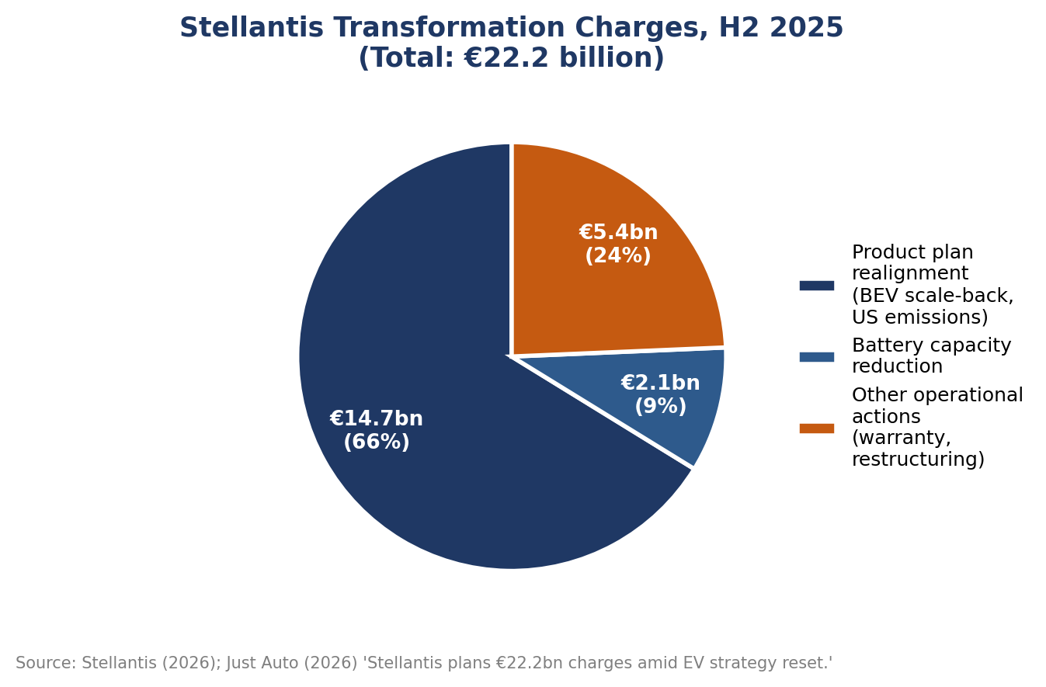
Figure 1. Composition of Stellantis's €22.2 billion transformation charge, announced February 2026. Source: compiled by the author from Just Auto (2026) and Electrive (2026).

2.2 PESTLE analysis
Table 1 summarises Vauxhall's external environment using the PESTLE framework, originally developed by Aguilar (1967) as a means of systematically scanning the macro-environment factors that lie beyond an individual organisation's direct control. Each factor is then examined in turn below, since a single summary table cannot on its own support the critical, evidence-based analysis this report requires.
Factor | Key issues affecting Vauxhall / Stellantis
Political | UK Zero Emission Vehicle (ZEV) mandate requiring rising annual proportions of zero-emission sales (22% in 2024, 33% in 2026, 80% by 2030); Labour government's April 2025 reconfirmation of the 2030 petrol/diesel sales ban, with added flexibilities; continued Brexit-related rules-of-origin friction with the EU, the UK's largest export market (Electrifying.com, 2025; Electric Car Scheme, 2026; SMMT, 2026a).
Economic | US tariffs on vehicle exports; record UK industrial energy prices; a weak commercial-vehicle market; UK vehicle production fell 15.5% in 2025 to its lowest level since the 1950s, with the Luton closure alone driving a 70.6% fall in commercial-vehicle output (SMMT, 2026a; Automotive World, 2026).
Social | Persistent consumer caution over electric vehicle price and range despite rising fleet demand; workforce and community identity built around century-old manufacturing sites such as Luton, which shapes how restructuring is perceived locally (Hyphen, 2024).
Technological | Connected, software-defined vehicles; Industry 4.0 manufacturing automation; artificial intelligence in quality control and predictive maintenance; growing cyber-security exposure, illustrated sector-wide by the six-week ransomware shutdown at Jaguar Land Rover in 2025 (Llopis-Albert, Rubio and Valero, 2021; Automotive World, 2026).
Legal | UK redundancy consultation requirements applying to the Luton closure; ZEV mandate penalties of up to £15,000 per non-compliant vehicle sold; evolving EU 'Made in Europe' content rules affecting UK-built exports (What Car, 2026; SMMT, 2026a).
Environmental | Group-wide commitment to carbon neutrality by 2038 and a halved carbon footprint by 2030; Ellesmere Port's electrification cut the site's physical footprint by 60% while improving energy efficiency (Aboutcamp BtoB, 2022; Fleet News, 2023).
Table 1. PESTLE analysis of Vauxhall's external operating environment, 2026.

2.2.1 Political
Political factors are dominated by the UK's Zero Emission Vehicle mandate, which required 22% of new car sales to be zero-emission in 2024, rising to 33% in 2026 and 80% by 2030, with fully zero-emission sales mandated from 2035 (Electrifying.com, 2025). The Labour government reconfirmed the underlying 2030 petrol and diesel sales ban in April 2025, while adding flexibilities such as extended borrowing and credit transfer between manufacturers to ease the transition (Electric Car Scheme, 2026). Brexit-related rules-of-origin requirements continue to create friction with the EU, still the UK's largest export market for vehicles, and government support schemes such as the Electric Car Grant and the wider Industrial Strategy are being used to offset some of this political and regulatory pressure (SMMT, 2026a).

2.2.2 Economic
Economically, Vauxhall is operating in one of the most difficult periods the UK automotive sector has faced in decades. US tariffs on vehicle exports, record UK industrial energy prices and a weak commercial-vehicle market combined in 2025 to push total UK vehicle production down 15.5% to its lowest level since the 1950s (SMMT, 2026a; Automotive World, 2026). Vauxhall's own restructuring was a direct and significant contributor to this national picture: the Luton closure alone drove a 70.6% fall in UK commercial-vehicle output, as Figure 2 illustrates below. At the same time, electric and hybrid vehicles reached a record 41.7% share of UK output in 2025, showing that the economic pain of the transition and its longer-term commercial opportunity are occurring simultaneously rather than sequentially (SMMT, 2026a).
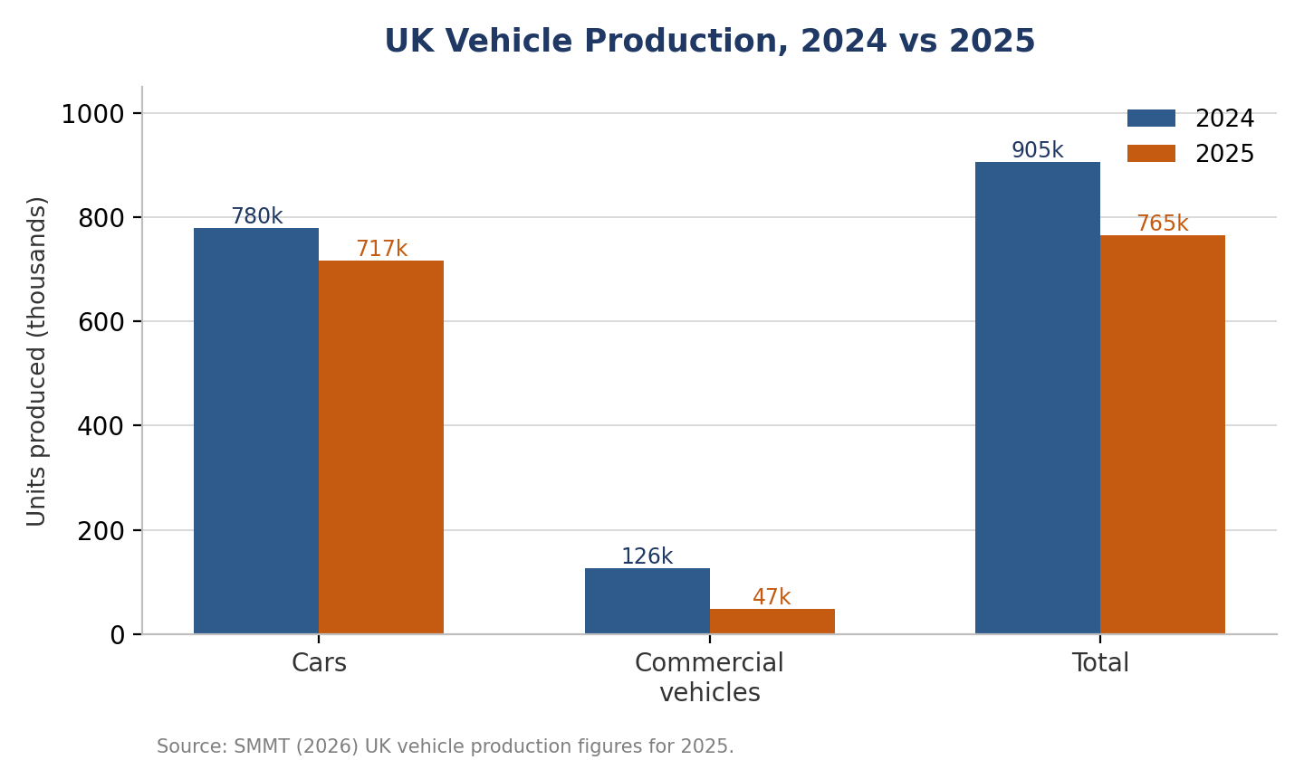
Figure 2. UK vehicle production, 2024 vs 2025, showing the sharp fall in commercial-vehicle output that coincided with the Luton closure. Source: compiled by the author from SMMT (2026a).

2.2.3 Social
Socially, consumer caution about electric vehicle price and range persists even as fleet demand grows, keeping overall EV adoption below government targets (What Car, 2026). Just as importantly, Vauxhall's UK plants carry a strong local social identity: Luton workers and their union representatives described the closure of a 120-year-old factory in terms of community loss and betrayal rather than purely commercial logic, reflecting how deeply manufacturing employment is embedded in local identity in towns such as Luton (Hyphen, 2024; GB News, 2025). Any change plan must treat this social dimension as seriously as the commercial one.

2.2.4 Technological
Technologically, the sector is being reshaped by connected and software-defined vehicles, Industry 4.0 manufacturing automation, and artificial intelligence applied to quality control, predictive maintenance and, increasingly, customer-facing services (Llopis-Albert, Rubio and Valero, 2021). Cyber-security has emerged as a related and equally serious technological risk: the six-week ransomware shutdown at Jaguar Land Rover in 2025 shows how a single digital incident can affect an entire national production statistic (Automotive World, 2026). Section 2.3 examines these technological and digital factors in more depth, given their direct relevance to the change plan developed later in this report.

2.2.5 Legal
Legally, UK redundancy consultation requirements applied directly to the Luton closure process, and manufacturers now face ZEV mandate penalties of up to £15,000 for every non-compliant vehicle sold above their allotted quota (What Car, 2026). Evolving EU 'Made in Europe' content proposals also threaten to tighten the rules of origin that UK-built vehicles must meet to retain tariff-free access to the EU market, adding further legal and compliance complexity for a manufacturer that exports the majority of its UK output (SMMT, 2026a).

2.2.6 Environmental
Environmentally, Stellantis has committed the whole group to carbon neutrality by 2038 and to halving its carbon footprint by 2030 against a 2021 baseline (Aboutcamp BtoB, 2022). Vauxhall's Ellesmere Port site already demonstrates what this can mean in practice: its conversion to all-electric production cut the plant's physical footprint by 60% while improving energy efficiency (Fleet News, 2023). These environmental commitments give Vauxhall's UK operations a clear long-term direction of travel, even though, as Section 2.1 shows, the pace at which the group pursues that direction is now being actively renegotiated.

2.3 Digital disruption, digitalisation and artificial intelligence
Digital disruption is affecting Vauxhall on three distinct levels simultaneously, and a change plan that addresses only one of them will be incomplete. First, the vehicle itself is becoming a software-defined, connected product, requiring capabilities - over-the-air updates, telematics, in-car artificial intelligence - that sit closer to those of a consumer-technology firm than to those of a traditional car maker; Llopis-Albert, Rubio and Valero (2021) describe digital technology as actively "disrupting traditional business models" throughout the automotive sector, driven partly by the same electrification pressures documented in Section 2.1. Second, manufacturing itself is being transformed through Industry 4.0 automation and artificial intelligence: Ellesmere Port's electrification added a new battery-assembly shop and used automated quality-inspection systems while reducing the site's physical footprint by 60 per cent and improving energy efficiency (Fleet News, 2023), a pattern of automation-led consolidation now visible across Stellantis's wider European network. Third, digital risk has become a strategic vulnerability in its own right rather than a background IT concern: the September 2025 ransomware attack that halted production at Jaguar Land Rover, the UK's largest automotive employer, for six weeks contributed materially to the sector's worst production year in decades (Automotive World, 2026), a clear reminder that cyber-resilience now belongs alongside product and workforce strategy in any serious change plan.
Taken together, these three layers of disruption show that a change plan confined to plant-level retooling, as at Ellesmere Port, addresses only part of the challenge facing Vauxhall. Workforce digital capability, cyber-security and data governance also require deliberate, planned change management attention; this is a theme returned to directly in the strategic change management plan developed in Section 5.

3. Change Management Models
Organisational change management has been described as increasingly essential to competitive survival, yet also as a field whose theories are frequently "contradictory" and "supported by unchallenged hypotheses" (By, 2005, p.369). This section applies three influential models - Lewin's three-step model, Kotter's eight-step model and the ADKAR model - to Vauxhall's Ellesmere Port and Luton transitions introduced in Section 2.1, before offering a critical comparison of their combined usefulness.

3.1 Lewin's three-step model
Lewin (1947) conceptualised change as a movement between three states - unfreezing, changing and refreezing - resting on his wider field theory view of behaviour as a "quasi-stationary equilibrium" of driving and restraining forces. Applied to Ellesmere Port, the model fits reasonably well. Unfreezing occurred through sustained consultation with Unite during 2021, in which the union's own analysts were given access to wider benchmarking data, building a shared understanding that the Astra's model cycle was ending and that inaction risked closure (Trades Union Congress, n.d.). Changing involved the physical retooling of the site and retraining staff for battery-assembly roles. Refreezing was then supported by negotiated terms, including a one-off retention payment, that stabilised the new arrangement and, in Lewin's own terms, made the new equilibrium "relatively secure against change" (Lewin, 1947, p.35). At Luton, by contrast, the model exposes a weakness: reporting from the site suggests employees experienced the closure as a rapid, top-down decision rather than a managed unfreezing process (Hyphen, 2024), which is consistent with the scholarly caution that Lewin's original three phases, as commonly taught today, may have been distilled and simplified by later writers rather than fully intended by Lewin himself (Cummings, Bridgman and Brown, 2016).

3.2 Kotter's eight-step model
Kotter (1996), building on his earlier Harvard Business Review analysis of why transformation efforts fail (Kotter, 1995), proposed eight sequential steps beginning with establishing urgency and a guiding coalition and ending with anchoring change in culture. The Luton case shows several of these steps operating in isolation rather than as the coherent sequence Kotter intended. Stellantis clearly established a sense of urgency, citing the significant cost of ZEV mandate compliance (Motor1, 2025), and it communicated a vision for Ellesmere Port as the group's UK commercial-vehicle hub, backed by a further £50 million of investment (GB News, 2026). However, the model's earlier emphasis on building a guiding coalition and generating broad buy-in appears markedly weaker: Unite's general secretary described the closure as a "betrayal" of a workforce that had "delivered every target asked of them" (GB News, 2025), suggesting the coalition for change did not extend convincingly to the workforce or the local community, despite government ministers becoming directly involved in discussions (AM Online, 2025). This gap is consistent with Kotter's (1995) own original finding that transformation efforts most often fail not at the urgency stage but through insufficiently powerful coalitions and under-communicated vision - precisely the steps Luton appears to illustrate.

3.3 The ADKAR model
Where Lewin and Kotter focus primarily on the organisation, Hiatt's (2006) ADKAR model - Awareness, Desire, Knowledge, Ability, Reinforcement - centres on the individual, reflecting the principle that "organizational change can only happen when individuals change" (Prosci, n.d.). Applied to the roughly 1,100 employees affected at Luton, the model exposes a specific gap between its first two stages: workers may well have developed awareness of the ZEV mandate's cost pressures, yet accounts from Luton describe a workforce that felt devastated rather than one that had internalised any personal desire to relocate to Ellesmere Port, some 180 miles away (Hyphen, 2024). By comparison, the Ellesmere Port transition supported the later stages of ability and reinforcement more directly, through structured retraining for battery-assembly roles and reinforcement via retained terms and conditions (Trades Union Congress, n.d.). This contrast suggests that Stellantis's UK change capability is considerably more mature at the plant-retooling level than at the individual workforce-transition level - a distinction the strategic change plan in Section 5 addresses directly through its upskilling objective.

3.4 Critical comparison of the models
No single model is sufficient on its own, and applying any one in isolation risks overstating how linear and consensual organisational change really is. Burnes (2004) and By (2005) both note that established change theories tend to assume either planned, sequential change, as in Lewin and Kotter, or continuous, emergent change, and that real organisational change - such as Stellantis's group-wide EV reset happening concurrently with two very different UK plant stories - rarely fits one pattern cleanly. The McKinsey 7S framework (Peters and Waterman, 1982) adds a useful complementary lens by treating shared values as the element around which structure, systems, skills, staff and style must all align; judged against 7S, the Luton closure suggests a misalignment between Stellantis's stated strategy of continued UK manufacturing commitment and its systems for engaging staff and unions in that strategy, even where structure and skills - the retraining pathway into Ellesmere Port - appear to have been reasonably well designed. Table 2 summarises this comparison across the four frameworks.
Model | Primary focus | Demonstrated at Vauxhall | Main limitation
Lewin's three-step model (Lewin, 1947) | Organisational states: unfreeze, change, refreeze | Reasonably well illustrated at Ellesmere Port through consultation, retooling and negotiated stabilisation | Assumes a stable end-state; original three phases may be a later simplification of Lewin's own work (Cummings, Bridgman and Brown, 2016)
Kotter's eight-step model (Kotter, 1996) | Sequential organisational leadership of change | Urgency and vision steps evident at Luton; coalition-building and buy-in steps weak | Assumes a single powerful coalition can be built; less suited to multi-stakeholder, adversarial contexts
ADKAR (Hiatt, 2006) | Individual transition: awareness, desire, knowledge, ability, reinforcement | Ability/reinforcement stronger at Ellesmere Port; awareness/desire gap evident among Luton workers | Focuses on the individual and can under-weight structural, group-level or cultural barriers
McKinsey 7S (Peters and Waterman, 1982) | Alignment of strategy, structure, systems, skills, staff, style and shared values | Highlights a strategy-systems misalignment at Luton despite reasonable structure/skills planning | Diagnostic rather than sequential; offers less specific guidance on implementation steps
Table 2. Comparison of change management models applied to Vauxhall's Ellesmere Port and Luton transitions.

4. Leadership, Culture and Resistance to Change

4.1 Leadership styles: from Tavares to Filosa
Burns (1978) distinguished transactional leadership, based on an exchange of rewards for performance, from transformational leadership, which raises followers' motivation by appealing to shared values and a common vision; Bass (1985) later operationalised transformational leadership around idealised influence, inspirational motivation, intellectual stimulation and individualised consideration. Carlos Tavares, who led the PSA-FCA merger and set Stellantis's original, ambitious electrification targets, is widely described in the trade press as a demanding, metrics-driven leader whose resignation followed unresolved "disagreements with the board" over performance and strategic direction (NBC News, 2025) - characteristics more consistent with a transactional style centred on cost discipline and target-setting than with the relationship-building typically associated with transformational leadership. His successor, Antonio Filosa, has been described by colleagues as an "engaging, collective leader" who began his career on a night shift in a paint shop and has explicitly prioritised rebuilding relationships with "dealers, unions and suppliers" (NBC News, 2025; Fleet News, 2025) - language that aligns far more closely with Bass's (1985) individualised consideration and idealised influence.

4.2 Leadership's role in managing change
This contrast in style plausibly shaped how the two UK cases were led. The Ellesmere Port transition, negotiated during 2021-2022 while Tavares was chief executive but managed locally with direct union involvement, still achieved a comparatively cooperative outcome (Trades Union Congress, n.d.), suggesting that local plant leadership and industrial-relations practice can partially offset a more transactional group-level style. The Luton closure, announced in the same Tavares era but concluding into Filosa's tenure, instead drew sustained criticism for its top-down character (GB News, 2025). Under Filosa, Stellantis's subsequent February 2026 strategy reset was explicitly framed around correcting "previous poor operational execution" and making customers, rather than an internally-set electrification timetable, "our guiding star" again (Electrive, 2026; Just Auto, 2026) - rhetoric that signals an intended shift towards a more transformational, relationship-repairing style, consistent with Kotter's (1996) view that leadership, as distinct from management, is the factor most often missing from failed transformations. Notably, Vauxhall's own UK sales performance improved markedly in early 2026, with the brand climbing from sixth to fourth place in the combined car-and-van market and posting a nineteen per cent rise in retail sales year-to-date (Stellantis Media, 2026), as shown in Figure 3. While this recovery cannot be attributed to leadership style alone, it is at minimum consistent with a period of rebuilt confidence following the disruption of 2024-2025, and it remains too early in 2026 to fully evaluate whether Filosa's stated approach will be sustained through further group-wide restructuring.
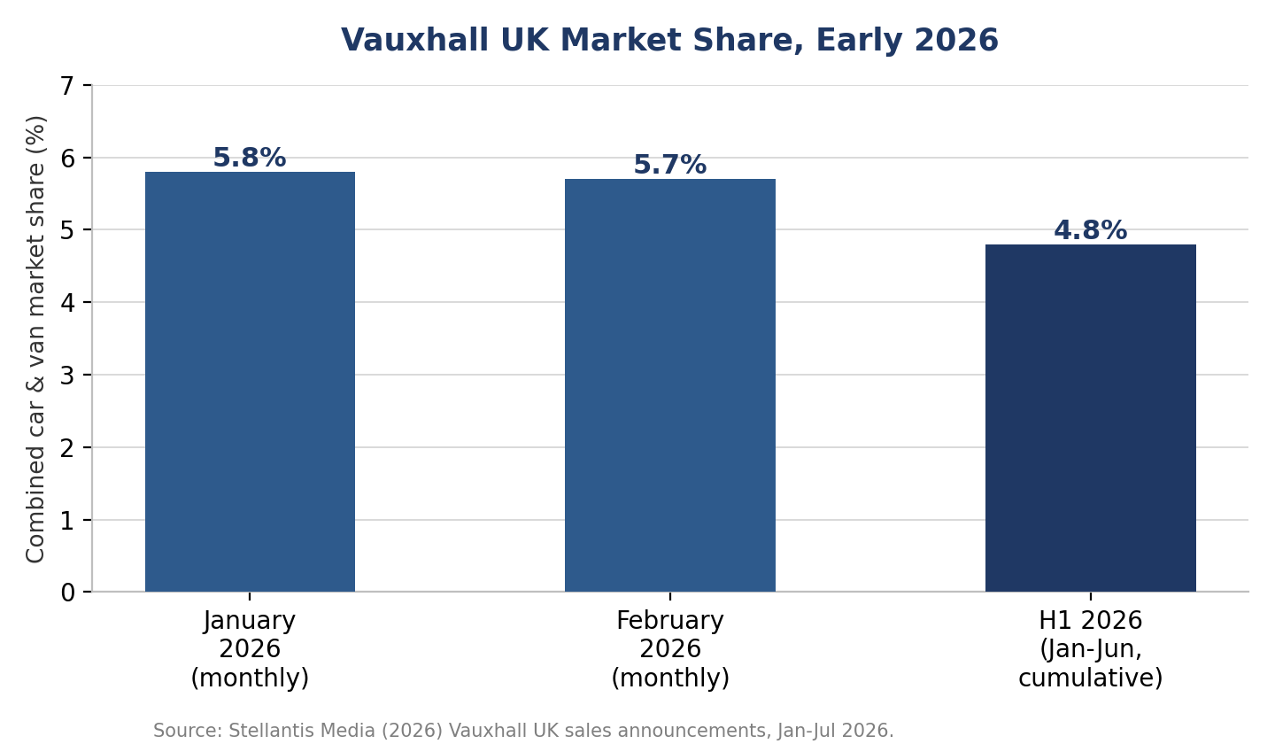
Figure 3. Vauxhall's UK combined car-and-van market share, early 2026, showing a positive trajectory following the leadership transition and the 2025 restructuring. Source: compiled by the author from Stellantis Media (2026).

4.3 Organisational culture
Cameron and Quinn's (2011) Competing Values Framework distinguishes four culture types - Clan, Adhocracy, Market and Hierarchy - according to whether an organisation emphasises flexibility or stability, and an internal or external focus. Stellantis, formed from a merger explicitly designed to achieve global scale and cost efficiency (Il Sole 24 Ore, 2026), exhibits strong Market-culture characteristics: a results- and competition-orientation clearly visible in its rapid, profitability-driven decisions on both Luton and the 2026 EV reset. Vauxhall's UK operations, by contrast, carry a much longer local history - Ellesmere Port's sixty-plus years of Astra production, Luton's 120 years of continuous manufacturing - that sits closer to Clan-culture characteristics of workforce loyalty, tradition and local identity (Fleet News, 2023; AM Online, 2025). Schein (2010) argues that mergers and acquisitions routinely force a confrontation between an acquired unit's existing cultural assumptions and a parent's imposed ones, and that unresolved tension of this kind is a common underlying source of resistance to change. The gap between Stellantis's Market-driven decision style and Vauxhall's more Clan-oriented plant cultures offers a plausible cultural explanation for why the Luton closure, in particular, generated such strong local and union reaction, compared with the more measured response at Ellesmere Port.

4.4 Resistance to change
Oreg's (2003) model of dispositional resistance to change identifies routine-seeking, emotional reaction, cognitive rigidity and short-term focus as individual drivers of resistance, alongside contextual factors such as trust in management and the quality and amount of information provided during a change process. Union and community reactions to the Luton closure display several of these features clearly: an emotional response to the loss of a 120-year manufacturing identity, and a perception - reflected directly in Unite's "betrayal" framing (GB News, 2025) - of low trust in management's information and underlying intent. Read through Oreg's (2003) framework, resistance at Luton appears not as irrational opposition to necessary change but as a predictable response to a process that scored poorly on the communication and involvement factors that both Kotter (1996) and the more favourable Ellesmere Port precedent show can, in principle, be actively and deliberately managed.

5. Proposed Strategic Change Management Plan
Sections 3 and 4 suggest that Vauxhall's UK operations manage the technical side of change - plant retooling, product transition - more effectively than the human and communicative side, particularly where closures rather than conversions are involved, and that this gap is linked to a Market-dominant group culture and, historically, a more transactional style of group leadership. The plan below responds directly to this gap. It does not attempt to prevent further restructuring, which is likely to remain a feature of a rapidly electrifying sector, but instead to ensure that when restructuring is necessary, it is preceded by the kind of standing consultation, digital capability investment and transparent communication that distinguished Ellesmere Port's relatively successful transition from Luton's more contested one.

5.1 Proposed change and objectives
The proposed initiative, the Vauxhall UK Change Readiness and Digital Capability Programme, has four SMART objectives to be achieved within eighteen months of launch:
- Establish a standing UK Change and Communications Board, with formal Unite representation, operational within three months, to be consulted before any future site-level restructuring announcement is finalised.
- Achieve ninety per cent completion of a digital and electric-vehicle technical upskilling pathway for UK manufacturing and aftersales staff within twelve months, directly addressing the Ability gap identified in Section 3.3.
- Improve employee trust scores relating to change communication, measured through an annual engagement survey, by at least fifteen percentage points within eighteen months.
- Deliver the programme within an agreed budget envelope with no more than five per cent variance, reviewed on a quarterly basis by the Change and Communications Board.

5.2 Change approach and phasing
The plan deliberately blends Kotter's (1996) organisation-level sequencing with Hiatt's (2006) individual-level ADKAR reinforcement, reflecting the critical comparison in Section 3.4 that neither model alone is sufficient for a context involving both group strategy and individual workforce transition. Table 3 sets out an indicative phased timeline aligned to both models.
Phase | Timeframe | Key activities | Change-model stage
1. Foundation | Months 1-3 | Establish Change and Communications Board with Unite representation; conduct baseline digital-skills and trust audit across UK sites | Kotter: urgency, coalition / ADKAR: awareness
2. Mobilisation | Months 4-6 | Launch upskilling pathway; publish shared vision statement for UK manufacturing co-developed with the Board | Kotter: vision, communication / ADKAR: desire, knowledge
3. Delivery | Months 7-12 | Roll out digital and EV-technical training; pilot quarterly town-hall briefings at each UK site; early-win reporting | Kotter: short-term wins, empowerment / ADKAR: knowledge, ability
4. Consolidation | Months 13-18 | Independent mid-point review (month 9) actioned; extend successful practices; embed Board into standard governance | Kotter: consolidate gains, anchor in culture / ADKAR: reinforcement
Table 3. Indicative phased implementation timeline for the Vauxhall UK Change Readiness and Digital Capability Programme.

5.3 Financial plan
Table 4 outlines an indicative financial plan for the programme. Costings are illustrative rather than definitive, but they are scaled against Stellantis's own recent pattern of UK manufacturing investment - £100 million for Ellesmere Port's initial EV conversion and a further £50 million announced in 2024 (Fleet News, 2023; GB News, 2026) - so that the proposal is proportionate to what the group has shown itself willing to commit to UK sites, rather than aspirational.
Investment area | Estimated cost (Year 1) | Funding source | Timing
Change and Communications Board (secretariat, external facilitation, Unite engagement) | £0.4m | Group restructuring budget allocation | Months 1-18
Digital and EV-technical upskilling pathway (training design and delivery) | £2.1m | Apprenticeship/training levy plus government Industrial Strategy co-funding | Months 4-12
Engagement survey, trust measurement and independent review | £0.3m | Group restructuring budget allocation | Months 1, 9, 18
Contingency (5%) | £0.14m | Group restructuring budget allocation | As required
Total indicative Year 1 investment | £2.94m | - | -
Table 4. Indicative financial plan for Year 1 of the programme.
Funding is proposed from three complementary sources: a small reallocation from Stellantis's own group-level restructuring budget, which already runs into billions of euros following the H2 2025 transformation charge (Just Auto, 2026), so that the amounts above represent a negligible proportion of existing group spend; a bid to UK government mechanisms that already support automotive transition, including the Industrial Strategy and Electric Car Grant (SMMT, 2026c); and Vauxhall's own apprenticeship and training-levy entitlement. Payback is expressed in the non-financial objectives set out in Section 5.1 - trust, retention and upskilling - rather than in a projected financial return, consistent with change-management literature's caution against over-financialising outcomes that are fundamentally behavioural in nature (By, 2005).

5.4 Communication plan
Table 5 sets out the communication plan, directly addressing the guiding-coalition and vision-communication weaknesses identified at Luton in Section 3.2.
Stakeholder | Key message | Channel | Frequency | Owner
UK manufacturing employees | Rationale for change, upskilling opportunities, and how the Change Board gives employees a voice before decisions are finalised | Town-hall briefings; team briefings; intranet | Quarterly, plus ad hoc for major announcements | Site HR Director
Unite the union | Early sight of proposals via the standing Board, before public announcement | Board meetings; formal consultation | Monthly Board meetings | UK HR Director
Local councils and MPs | Investment plans, timelines and community impact | Briefing letters; scheduled meetings | At each major milestone | UK Communications Lead
Dealers and suppliers | Product and technology roadmap; supply-chain implications | Partner briefings; account management | Bi-annual | Vauxhall Managing Director
UK Group leadership | Programme progress against KPIs and budget | Board papers; quarterly review | Quarterly | Change and Communications Board Chair
Table 5. Communication plan for the Vauxhall UK Change Readiness and Digital Capability Programme.

5.5 Evaluation plan
Consistent with Kotter's (1996) final step of anchoring change in culture and Hiatt's (2006) reinforcement stage, the programme will be evaluated on a quarterly cycle against the key performance indicators in Table 6, with an independent mid-point review at month nine and a full evaluation at month eighteen feeding directly into the following year's plan.
KPI | Target | Measurement method | Review point
Employee trust score (change communication) | +15 percentage points | Annual engagement survey, benchmarked against 2026 baseline | Months 9 and 18
Upskilling pathway completion | 90% of eligible staff | Training-provider completion records | Monthly, reported quarterly
Change Board consultation prior to restructuring announcements | 100% of relevant announcements | Board meeting minutes and sign-off log | Continuous
Budget variance | Within 5% | Quarterly finance reporting | Quarterly
Employee retention during any future site transition | Improvement versus Luton baseline | HR exit and retention data | At each transition event
Table 6. Evaluation plan and key performance indicators.

6. Conclusion
Vauxhall's recent history demonstrates that strategic change in the UK automobile sector is rarely a single, discrete event: it is a continuous negotiation between group-level electrification and cost strategy, UK-specific regulation such as the Zero Emission Vehicle mandate, and local workforce and community relationships built over a century of manufacturing. The Ellesmere Port and Luton cases show that the same parent company can manage broadly comparable change - the transition of a manufacturing site to a new production model - with markedly different outcomes, depending on the degree of genuine consultation, the leadership style in evidence, and the alignment between group culture and local culture. Established models - Lewin, Kotter and ADKAR - each illuminate part of this picture but, applied uncritically, risk treating change as more linear and consensual than the evidence from Luton suggests it has actually been.
The change plan proposed in Section 5 therefore focuses not on preventing further restructuring, but on ensuring that when restructuring is necessary, it is preceded by standing consultation, meaningful digital-capability investment, and transparent, multi-stakeholder communication of the kind that Ellesmere Port shows is achievable within this group. Under new group leadership that has explicitly committed to rebuilding trust with employees, unions and dealers, and against a backdrop of improving UK sales performance in early 2026, Vauxhall now has a credible - if time-limited - opportunity to embed this capability before the next phase of an already rapidly electrifying and increasingly digital sector requires it again.

Reference List

- Aboutcamp BtoB (2022) Vauxhall ends ICE vehicle production at Ellesmere Port ahead of £100m investment to become first Stellantis plant to produce electric models only. Available at: https://www.aboutcampbtob.eu/vauxhall-ends-ice-vehicle-production-at-ellesmere-port-ahead-of-100m-investment-to-become-first-stellantis-plant-to-produce-electric-models-only/ (Accessed: 18 July 2026).
- Aguilar, F.J. (1967) Scanning the Business Environment. New York: Macmillan.
- AM Online (2025) 'Stellantis confirms closure of Vauxhall plant in Luton', AM Online, 6 February. Available at: https://www.am-online.com/news/stellantis-confirms-closure-of-vauxhall-plant-in-luton (Accessed: 18 July 2026).
- Automotive World (2026) 'SMMT: UK vehicle production hit 73-year low in 2025', Automotive World, 29 January. Available at: https://www.automotiveworld.com/news/smmt-uk-vehicle-production-hit-73-year-low-in-2025/ (Accessed: 18 July 2026).
- Bass, B.M. (1985) Leadership and Performance Beyond Expectations. New York: Free Press.
- Burnes, B. (2004) Managing Change: A Strategic Approach to Organisational Dynamics. 4th edn. Harlow: Prentice Hall.
- Burns, J.M. (1978) Leadership. New York: Harper & Row.
- By, R.T. (2005) 'Organisational change management: A critical review', Journal of Change Management, 5(4), pp.369-380. Available at: https://www.tandfonline.com/doi/full/10.1080/14697010500359250 (Accessed: 18 July 2026).
- Cameron, K.S. and Quinn, R.E. (2011) Diagnosing and Changing Organizational Culture: Based on the Competing Values Framework. 3rd edn. San Francisco, CA: Jossey-Bass.
- Chester and District Standard (2022) 'Vauxhall celebrates 60 years of manufacturing at Ellesmere Port', Chester and District Standard, 11 April. Available at: https://www.pesmedia.com/vauxhall-ellesmere-port-11042022 (Accessed: 18 July 2026).
- CNBC (2025) 'Auto: Stellantis appoints North America boss Antonio Filosa as new CEO', CNBC, 28 May. Available at: https://www.cnbc.com/2025/05/28/auto-stellantis-appoints-north-america-boss-antonio-filosa-as-new-ceo.html (Accessed: 18 July 2026).
- Cummings, S., Bridgman, T. and Brown, K.G. (2016) 'Unfreezing change as three steps: Rethinking Kurt Lewin's legacy for change management', Human Relations, 69(1), pp.33-60.
- Electric Car Scheme (2026) Labour confirms 2030 petrol and diesel car ban and ZEV mandate. Available at: https://www.electriccarscheme.com/blog/labour-to-reinstate-2030-ice-car-ban (Accessed: 18 July 2026).
- Electrifying.com (2025) What is the ZEV mandate? Available at: https://www.electrifying.com/blog/article/zev-mandate-what-is-it-and-will-it-mean-incredible-ev-deals-later-this-year (Accessed: 18 July 2026).
- Electrive (2026) 'Stellantis writes off €22.2 billion in electric vehicle business', Electrive, 6 February. Available at: https://www.electrive.com/2026/02/06/stellantis-writes-off-e22-2-billion-in-electric-vehicle-business/ (Accessed: 18 July 2026).
- Fleet News (2023) 'Stellantis reopens Ellesmere Port as new EV factory', Fleet News, 5 September. Available at: https://www.fleetnews.co.uk/news/latest-fleet-news/electric-fleet-news/2023/09/05/stellantis-reopens-ellesmere-port-as-new-ev-factory (Accessed: 18 July 2026).
- Fleet News (2025) 'New chief executive announced at Stellantis to succeed Carlos Tavares', Fleet News, 28 May. Available at: https://www.fleetnews.co.uk/news/new-chief-executive-announced-at-stellantis-to-succeed-carlos-tavares (Accessed: 18 July 2026).
- GB News (2025) 'Vauxhall owner Stellantis confirms Luton factory closure with 1,100 jobs set to be lost - 'Total disgrace'', GB News, 5 February. Available at: https://www.gbnews.com/lifestyle/cars/vauxhall-stellantis-luton-factory-closure-job-losses-reaction (Accessed: 18 July 2026).
- GB News (2026) 'Vauxhall Luton factory receives major £400million update after closure caused 1,100 job losses', GB News, 22 January. Available at: https://www.gbnews.com/lifestyle/cars/vauxhall-luton-factory-update-stellantis-closure (Accessed: 18 July 2026).
- Hiatt, J. (2006) ADKAR: A Model for Change in Business, Government and Our Community. Loveland, CO: Prosci Research.
- Hyphen (2024) 'Luton's Muslim Vauxhall workers 'devastated' by plant closure', Hyphen, 20 December. Available at: https://hyphenonline.com/2024/12/20/lutons-muslim-vauxhall-workers-devastated-by-plant-closure/ (Accessed: 18 July 2026).
- Il Sole 24 Ore (2026) 'Stellantis, 5 years since the merger between Fca and Psa. The history of the group', Il Sole 24 Ore, 14 January. Available at: https://en.ilsole24ore.com/art/stellantis-5-years-fca-and-psa-merger-group-history-AIqRnor (Accessed: 18 July 2026).
- Just Auto (2026) 'Stellantis plans €22.2bn charges amid EV strategy reset', Just Auto, 9 February. Available at: https://www.just-auto.com/news/stellantis-plans-e22-2bn-charges/ (Accessed: 18 July 2026).
- Kotter, J.P. (1995) 'Leading change: Why transformation efforts fail', Harvard Business Review, 73(2), pp.59-67.
- Kotter, J.P. (1996) Leading Change. Boston, MA: Harvard Business School Press.
- Lewin, K. (1947) 'Frontiers in group dynamics: Concept, method and reality in social science; social equilibria and social change', Human Relations, 1(1), pp.5-41.
- Llopis-Albert, C., Rubio, F. and Valero, F. (2021) 'Impact of digital transformation on the automotive industry', Technological Forecasting and Social Change, 162, 120343. Available at: https://www.sciencedirect.com/science/article/abs/pii/S0040162520311690 (Accessed: 18 July 2026).
- Luton Borough Council (2025) Luton council furious at Vauxhall closure confirmation. Available at: https://m.luton.gov.uk/Page/Show/news/Pages/Luton-council-furious-at-Vauxhall-closure-confirmation.aspx (Accessed: 18 July 2026).
- Motor1 (2021) 'FCA-PSA merger officially finalized: Hello, Stellantis!', Motor1, 16 January. Available at: https://www.motor1.com/news/466615/fca-psa-merger-official-stellantis/ (Accessed: 18 July 2026).
- Motor1 (2025) 'Stellantis has finally replaced Carlos Tavares', Motor1, 28 May. Available at: https://www.motor1.com/news/760898/stellantis-new-ceo-antonio-filosa/ (Accessed: 18 July 2026).
- NationalWorld (2023) 'Who owns Vauxhall? Stellantis' ownership explained after Brexit comments', NationalWorld, 17 May. Available at: https://www.nationalworld.com/lifestyle/cars/who-owns-vauxhall-stellantis-ownership-explained-which-other-car-brands-does-company-own-4145921 (Accessed: 18 July 2026).
- NBC News (2025) 'New Stellantis CEO faces slew of challenges, vows to avoid 'mediocrity'', NBC News, 23 June. Available at: https://www.nbcnews.com/business/autos/new-stellantis-ceo-faces-slew-challenges-vows-avoid-mediocrity-rcna214592 (Accessed: 18 July 2026).
- Oreg, S. (2003) 'Resistance to change: Developing an individual differences measure', Journal of Applied Psychology, 88(4), pp.680-693. Available at: https://pubmed.ncbi.nlm.nih.gov/12940408/ (Accessed: 18 July 2026).
- Peters, T.J. and Waterman, R.H. (1982) In Search of Excellence: Lessons from America's Best-Run Companies. New York: Harper & Row.
- Prosci (n.d.) The Prosci ADKAR® Model. Available at: https://www.prosci.com/methodology/adkar (Accessed: 18 July 2026).
- Schein, E.H. (2010) Organizational Culture and Leadership. 4th edn. San Francisco, CA: Jossey-Bass.
- SMMT (2026a) 'Tough year for Auto but new models and Industrial Strategy can deliver growth', Society of Motor Manufacturers and Traders, 29 January. Available at: https://www.smmt.co.uk/tough-year-for-auto-but-new-models-and-industrial-strategy-can-deliver-growth/ (Accessed: 18 July 2026).
- SMMT (2026c) 'UK vehicle production falls but foundations set for recovery', Society of Motor Manufacturers and Traders, 6 November. Available at: https://www.smmt.co.uk/uk-vehicle-production-falls-but-foundations-set-for-recovery/ (Accessed: 18 July 2026).
- Stellantis (2021) The merger of FCA and Groupe PSA has been completed. Available at: https://www.stellantis.com/en/news/press-releases/2021/january/the-merger-of-fca-and-groupe-psa-has-been-completed (Accessed: 18 July 2026).
- Stellantis Media (2026) Vauxhall achieves total market share of 4.8% in first half of 2026. Available at: https://www.media.stellantis.com/uk-en/vauxhall/press/vauxhall-achieves-total-market-share-of-4-8-in-first-half-of-2026 (Accessed: 18 July 2026).
- Stoneacre (2025) 'The history of Vauxhall Motors Limited - 1857 to today', Stoneacre, 1 May. Available at: https://www.stoneacre.co.uk/blog/vauxhall-history (Accessed: 18 July 2026).
- Trades Union Congress (n.d.) Electric vehicle transition at Vauxhall Ellesmere Port, UK. Available at: https://www.tuc.org.uk/workplace-guidance/case-studies/electric-vehicle-transition-vauxhall-ellesmere-port-uk (Accessed: 18 July 2026).
- What Car (2026) 'ZEV mandate: 33% of new cars must be electric this year', What Car, 28 March. Available at: https://www.whatcar.com/advice/buying/what-is-the-zev-mandate/n26196 (Accessed: 18 July 2026).

