

Programme: Master of Business Administration

Module: Strategic Management

Module code: LCMB7003

Assignment Title: Individual report on a critical analysis of the
strategic management practices of Amazon

Student Name: Deep Jitubhai Viththani

Student ID: 2508635

Lecturer Name : Hoang Nguyen

Date of Submission: 30th April 2026

Word Count: 5043

Table of Contents
Table of Contents 1
Section 1 3
1. Organisational Context and Overview 3
1.1 Overview of Amazon Organisation 3
1.2 Industry where Amazon operates 4
2. External and Internal Environment Analysis 6
2.1 PESTLE Analysis to Identify the Impact of the External Factors On the Strategic Decision of Amazon 6
2.2 Porter’s Five Forces to Evaluate Challenges Faced by Amazon in the External Environment 7
2.3 Use of Porter’s Diamond Model to Identify Critical Success Factors of Amazon 9
2.4 VRIO to Evaluate the Strategic Capabilities of Amazon 10
2.5 Contribution of the Internal Strengths of Amazon to its Competitive Advantages 11
3. CSR and Sustainability objectives 12
3.1 The CSR Strategy of Amazon Corporation 12
3.2 Alignment of the Amazon’s Strategies with Business Objectives 13
4. Comprehensive and holistic view of the organisation 14
4.1 Use of Balance Scorecard 14
5. Strategic Choices and Implementation 17
5.1 Business-Level Strategic Choice Available for Amazon 17
5.2 Corporate-Level Strategic Choice Available for Amazon 17
5.3 Recommendation and Justification behind the choices 17
5.4 Assessment of the process used by Amazon to manage the Change 18
5.5 Impact of the Change on Strategic Implementation 18
6. Strategic Evaluation and Recommendations 18
6.1 The Current Strategy of Amazon by using SWOT Analysis 18
6.2 The Current Strategy of Amazon by using Ansoff 19
6.3 Recommendations for Amazon 20
6.4 Justification for the Recommendation 20
Section 2 21
Gibbs reflective Cycle 21
Description 22
Perceptions 22
Evaluation 22
Analysis 23
Conclusion 23
Action 24
References 25
Appendices 32
Appendix 1: Political Stability Index of the USA 32
Appendix 2: Economic Growth of the USA 32
Appendix 3: Technology Usage in Different Sectors of the USA 33

Section 1

1. Organisational Context and Overview

1.1 Overview of Amazon Organisation
Jeff Bezos founded Amazon as an online bookstore in 1994, and now it has become the largest internet retail company globally. By 2000, the organisation had expanded into an online marketplace and started selling a huge range of products and services (Mercadel and Trudy, 2024). The corporate headquarters is located in Seattle, Washington, and Amazon has remained a dominant firm within e-commerce, streaming video, cloud computing, and other markets. In 2002, AWS (Amazon Web Services) was launched by the organisation that started providing cloud computing services (Refer to Figure 1). Amazon Prime was launched in 2005, and it has started to provide a subscription-based service to customers (Morano, 2024). In this way, the organisation Amazon has launched multiple services from its establishment to date by prioritising innovation.
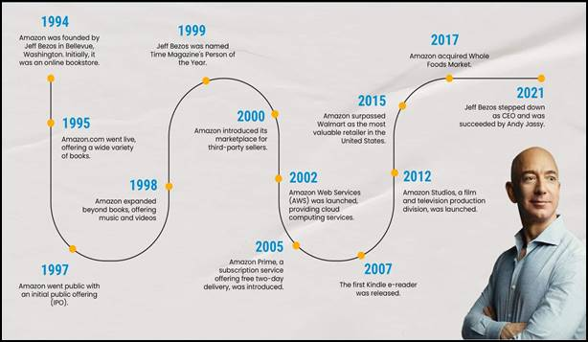
Figure 1: History of Amazon
(Source: Morano, 2024)
The mission of Amazon is:
“To be the Earth’s most customer-centric company” (Business Model Analyst, 2023).

While the vision of Amazon is to:
be Earth’s most-consumer-centric company, “to build a place where people come to find and discover anything they might want to buy online” (Business Model Analyst, 2023).
The business of Amazon is mainly based on the Internet and e-commerce, and is fully focused on the consumers with its logistics system. Recently, Amazon has been the third US company holding the largest share of the online advertising market (Sala, 2024). The growth of the organisation. Amazon allows almost all retailers to sell in the market throughout the world.

1.2 Industry where Amazon operates
Amazon operates within the e-commerce and cloud computing industry and has a significant presence in technology and digital streaming as well. The global e-commerce market size has been estimated at approximately $33.91 trillion in the year 2025 and is projected to reach almost $155.98 trillion in 2023 (Refer to Figure 2). This has indicated a constantly growing CAGR of around 21.6% from the year 2026 to 2033 because of the constant expansion of the internet penetration and the smartphone adoption too (Grand View Research, 2024).
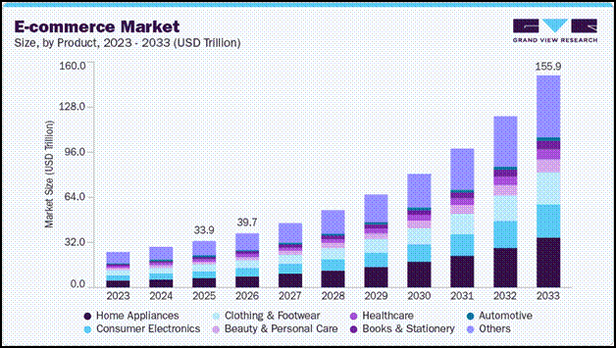
Figure 2: E-Commerce Market
(Source: Grand View Research, 2024)
The key competitors of Amazon are mainly including the companies like Walmart Inc, Microsoft Corp, and Costco Wholesale Group (Globaldata, 2026). Amazon hit almost $717 billion in net sales revenue throughout the world in 2025 because of its global scope, and became the most valuable brand globally. The United States has become the centre for Amazon businesses that have contributed almost $490 billion of the net sales of the company in the country (Ou, 2026). Amazon has the ability to keep shoppers engaged with its ecosystem and a huge variety of products.

2. External and Internal Environment Analysis

2.1 PESTLE Analysis to Identify the Impact of the External Factors On the Strategic Decision of Amazon
Factors | Analysis | Impact
Political | - The political index in the USA is very low at -0.10 (Global Economy, 2023) [Refer to Appendix 1].  - The US government has implemented the strategies of Anti-corruption and proving transparency in the system (US Department of State, 2024). | Unfavourable
Economic | - In 2025, the US GDP Growth is now at 2.8 index and slowed at the end of the year (World Bank, 2026) [Refer to Appendix 2].  - The USA’s financial openness index is 2.290 (Global Economy, 2026). | Unfavourable
Social | - The USA’s employed population is 57.4% (World Economics, 2026).  - The USA has social developmental factors such as inequality and discrimination within people (BBC, 2026). | Unfavourable
Technological | - The USA has improved technological usage in every sector, such as railway, air, commercial and others (Our World in Data, 2024). [Refer to Appendix 3]  - The USA has the leading position in the world on technology Adaptation (Deloitte, 2025). | Favourable
Legal | - The USA has data protection laws, labour laws and trade policies for businesses.  - Besides, it has the Foreign corruption Act, anti-boycott laws (ITA, 2026). | Favourable
Environmental | - The USA has reduced GHG emissions from different sources (United States Environmental Protection Agency, 2025).  - The USA has increased the usage of renewable sources for energy generation (OECD, 2025). | Favourable
Table 1: PESTLE Analysis
Analysis: The USA’s Political condition is not stable, which is why the company can face a few issues in business expansion. However, the USA provides transparency about the system performances, which makes the situation favourable for them. According to Trading Economics (2025), the USA’s GDP growth from the services sector is USD17529.70 billion in the last year. USA’s economic growth is also slow, and the economic situation id note favourable for the business. The USA has a higher unemployment rate and the existence of social discrimination in society, thus the social factor is not Favourable. Different sectors in the USA have integrated new technologies into their operations. The market of cybersecurity, AI and other advanced technologies is growing rapidly, making the technological situation favourable.Legal factors of the USA are favourable for the business because of their accurate compliance with ethical business purposes. The USA has rich sources of water bodies and natural lands that enhance its environmental scenarios. The USA focuses on the sustainability practices for decreasing pollution and climate change. It has also integrated renewable energy consumption to preserve the natural resources and reduce waste generation.

2.2 Porter’s Five Forces to Evaluate Challenges Faced by Amazon in the External Environment
Five Forces | Impact on Amazon | Level of Threats
Threat of New Entrants | - The industry faces huge barriers in brand value and logistic network due to the presence of Amazon (Akin, 2024). | Moderate
Bargaining Power of Suppliers | - The suppliers of this industry also highlight some power, which has led to a massive sales volume (Oliveira et al., 2025). | Low
Bargaining Power of Buyers | - Customers have high power in low switching costs when comparing the pricing strategies (Akin, 2024). | High
Threat of Substitutes | - High availability of options in purchasing methods (Oliveira et al., 2025). | High
Competitive Rivalry | - The online retail market leverages a highly competitive environment within the industry (Akin, 2024). | High
Table 2: Porter’s Five Forces of Amazon
Analysis:
Table 2 depicts that Amazon may face a moderate level of threats from new entrants due to high limitations in the logistics network. Amazon highlights a strong brand value within the online retail market (Onggowidjojo and Ellitan, 2023). Amazon offers high competition due to its exclusive delivery speed and pricing strategies. On the other hand, the bargaining power of suppliers highlights that Amazon may face a low issue due to its massive volume of sales across the global market (The Hindu, 2026). The bargaining power of buyers highlights a high level of threats to Amazon by highlighting the low switching costs and easy access for comparison of the pricing of the products. The threat of substitutes also highlights that there is high availability for alternative buying options, including physical stores and online presence (Onggowidjojo and Ellitan, 2023). The competitive rivalry factor highlights that key players of the retail market, such as Walmart, Target, and eBay, may create a strong competitive environment for Amazon. Amazon may highlight its strong brand value, yet this company also face a huge competition within the market.

2.3 Use of Porter’s Diamond Model to Identify Critical Success Factors of Amazon
Porter’s Diamond Model highlights Amazon's global dominance in e-commerce. This leverages the intense domestic demand, strong supporting industries and a relentless firm strategy (Onggowidjojo and Ellitan, 2023). Figure 3depicts Porter’s Diamond Model, and the factors of this framework are discussed below:
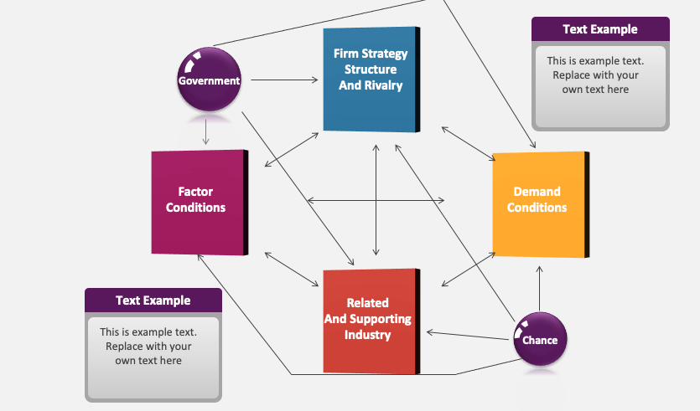
Figure 3: Porter’s Diamond Model
(Source: Collidu, 2024)
Factor Conditions: This factor of this framework helped Amazon to focus on its technological innovation and infrastructure. This company involves vision and AI in its logistics delivery. The development of AWS of this company also falls under a significant technological advantage (Abbes, 2025). Amazon also emphasises its skilled labour and capital by fostering a creative, innovative and highly educated workforce within the USA.
Demand Condition: The demand condition of this company highlights its local market sophistication. Amazon provides a sophisticated customer base, which invites a high customer demand for faster and more convenient services (Tolstoy et al., 2020). Moreover, this company introduces its premium service, including Amazon Prime with a digital content subscription across the global market. Additionally, this organisation also focuses on customer feedback to implement improvements in its service continuously.
Related and Supporting Industries: Amazon also emphasises supplier and ecosystem clusters by focusing on the advanced tech logistics, robust digital and content ecosystem (Li and Tayi, 2024). Moreover, this company also focuses on the third-party sellers positively.
Firm Strategy, Structure, and Rivalry: The excessive competition in the retail and tech industry led the company to face an intense competition for incorporating innovation, cost leadership strategy, long-term strategy and diversification (Keelson et al., 2024). Amazon prioritises long-term growth in the market share expansion across the global retail market.

2.4 VRIO to Evaluate the Strategic Capabilities of Amazon
VRIO Analysis is a strategic tool for the evaluation of internal resources of an organisation by identifying the four main resources that help to leverage a competitive advantage (Murcia et al., 2022). Figure 4 highlights the four main resources of this framework. The key resources of Amazon are AWS, Prime Membership Ecosystem, Global Brand Value and Advertising Segment. This organisation also focuses on its culture of customer-centricity for its continuous improvement in terms of innovation.
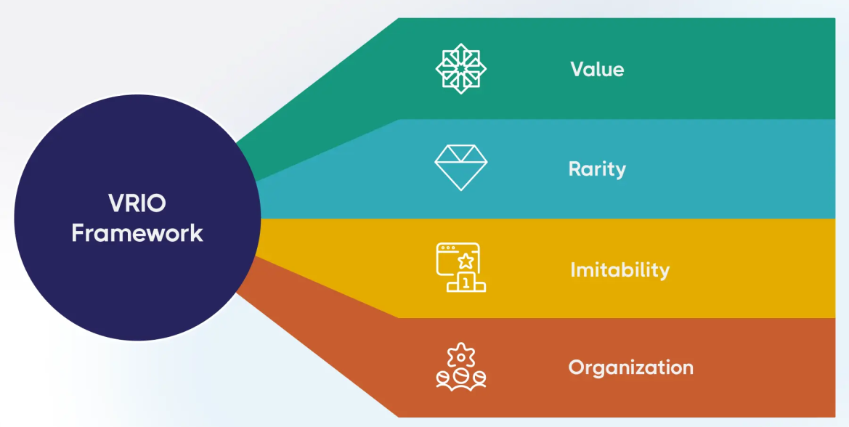
Figure 4: VRIO Analysis
(Source: Messineo, 2024)
Resources | Value | Rare | Inimitable | Organized | Competitive Advantage
Global Brand Reputation | ✓ | ✓ | ✓ | ✓ | Sustainable Advantage
Prime Membership Program | ✓ | ✓ | ✓ | ✓ | Sustainable Advantage
Amazon Web Services | ✓ | ✓ | ✓ | ✓ | Sustainable Advantage
Advertising Segment | ✓ | ✓ | X | ✓ | Temporary Advantage
Table 3: VRIO Analysis of Amazon
(Source: Self-developed)
Analysis
Table 3 depicts that the global brand reputation of Amazon fosters a sustainable advantage due to its high brand value and image (Yu et al., 2022). On the other hand, this company introduces its Prime Membership Ecosystem, which maintains high customer loyalty and retention effectively (McKinsey & Company, 2024). This resource of the company offers a significant sustainable advantage. On the other hand, Amazon Web Services (AWS) brings a huge revenue to the company in its exclusive infrastructure by allowing a sustained competitive advantage (Steele and Priti, 2022). Lastly, the advertising segment of Amazon is valuable, rare and organised. This resource of this company is not inimitable, which brings a temporary advantage for Amazon (Brewis et al., 2023). Overall, the key resources of this company state a sustainable competitive advantage, but only in the advertising segment does this company possess a temporary advantage. These resources are valuable, rare and well organised.

2.5 Contribution of the Internal Strengths of Amazon to its Competitive Advantages
Amazon has a strong brand power to foster convenient and reliable features. This company also incorporates a strong presence in e-commerce, cloud computing and digital services. Amazon usually focuses on the customer-centric approach, which helps it to gain a high customer retention rate and sustained prime subscription (Watanabe et al., 2022). Moreover, this company also leverages its operational excellence and logistics network (Escandon-Barbosa and Salas-Paramo, 2025). Moreover, this company also fosters its technological innovation and data-driven decision-making processes through diversification.
Amazon has the ability to create a strong balance sheet within the organisation through providing enough cash flow, sales and funding for the company. According to Nguyen (2026), Amazon is expected to invest $200 billion yearly e to improve the organisational structure of its. It works very well and provides effective marketing to produce sales and earn billions from it. According to WSJ (2026), Amazon’s cash and short-term investment capability was $123,329 million in the year 2025. Amazon’s capital expenditure while growing revenue and profit is very high, that makes stronger its balance sheet in the market.

3. CSR and Sustainability objectives

3.1 The CSR Strategy of Amazon Corporation
Amazon strives to harness the scale and innovative spirit of the firm to help in building strong communities now and for upcoming generations. The organisation invests in communities where they stay and work and further helps to accurately generate economic growth while also working with multiple community partners in order to build impactful programs (Amazon, 2023). The organisation used to invest in land conservation and restoration initiatives in order to mitigate the carbon emissions across the business and supply chain, and to preserve the natural world as well. At the same time, within the AWS data centres of Amazon, the company has invested in projects that aim to decrease the carbon footprint. Furthermore, Figure 5indicates that almost 1.5 billion packages of Amazon were delivered by electric delivery vehicles at a global level (Amazon, 2024). Amazon also use initiatives to reduce the use of single-use plastic delivery for packaging in areas where it exists.
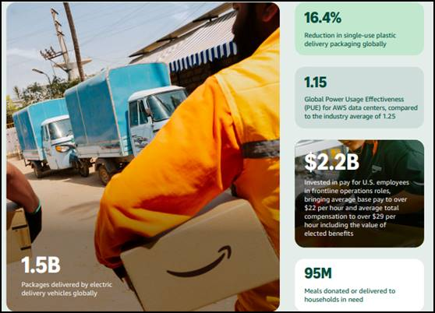
Figure 5: Sustainability Initiatives of Amazon
(Source: Amazon, 2024)
Amazon also uses sustainable sources like recycled water and harvests rainwater and then discharges water directly back into its communities. Amazon has a commitment that is about making AWS water positive by the year 2030: returning more water to both the environment and communities than the company uses within its data centre operations (Aboutamazon, 2026). Around 18B+ litres of water are expected to be retuned ever year to the local communities by the water replenishment efforts of Amazon an almost 72.5K hectares of land have been protected and restored too (Aboutamazon, 2026). Measuring the CSR is a complex process because it involves evaluating the overall impact of the activities of the company that have a direct impact on both society and the environment.

3.2 Alignment of the Amazon’s Strategies with Business Objectives
The strategies of Amazon are aligned with the business objectives of Amazon. For example, Amazon has engaged in multiple philanthropic activities in order to support communities throughout the world. Additionally, the firm has also launched a number of programs to provide benefits to the various disadvantaged communities. These include donations to multiple charitable organisations. For example, it has been identified that in 2020, Amazon donated more than $215 million in cash and provided in-kind donations to provide assistance to numerous non-profit organisations globally (Kelk, 2023). The commitment of Amazon to sustainable practices and other activities demonstrates the dedication of the organisation to create a positive impact on the environment and society.

4. Comprehensive and holistic view of the organisation

4.1 Use of Balance Scorecard
Perspectives | Strategic Objectives | Key Performance Indicators (KPIs) | Key Initiatives
Financial | Increase revenue and profitability | - Revenue growth rate  - Net profit margin  - ROIon major investments | - Advertising Profitability  - Expand high-margin third-party sellers’ services
Customer | Enhance customer loyalty | - Customer satisfaction score (CSAT)  - Prime Membership Growth  - Net Promoter Score | - Increase Prime adoption  - Main high NPS
Internal Process | Leverage Logistics and Innovation | - Order Fulfilment Time  - Same-Day Delivery  - Third-Party Sellers Metrics | - Implement more same-day delivery  - Improve warehouse automation
Learning and Growth | Improve Workforce and Digital Capabilities | - Employee retention rate  - AI and Machine Learning Adoption  - New Product Patents | - High invest AI and machine learning  - New product patents
Table 4: Balance Scorecard
(Source: Self-developed)
Analysis:
Financial: The financial segment of Amazon highlights its strategic objectives, in its financial segment focuses on revenue and profitability increment. The key performance indicators (KPIs) of this company to achieve the strategic objective may involve the revenue growth rate, net profit margin and lastly, ROI on major investments. According to Alonge et al. (2024), it has heavily expanded its high-margin services. This company has increased its Third-Party Sellers in 2024 constantly (Refer to Figure 6).
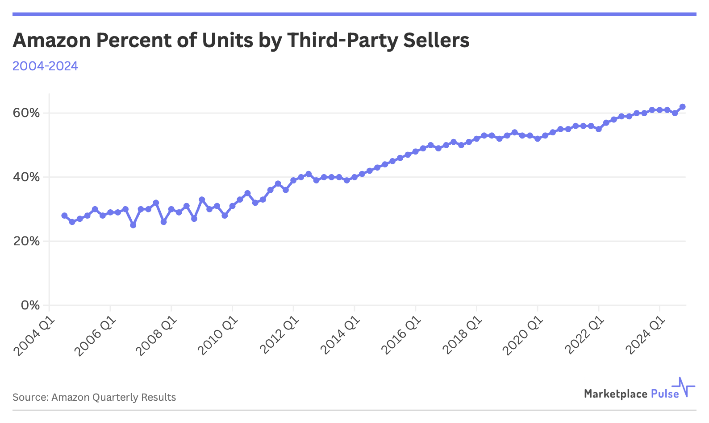
Figure 6: Amazon Steers Third-Party Seller Share
(Source: Donovan, 2025)
Customer: In terms of customer segment, Amazon focuses on its customer loyalty by enhancing the customer satisfaction score, prime membership growth and net promoter score. These key performance indicators of Amazon can help to increase the adoption of Prime by maintaining a high NPS (Davidson and Rajeswari, 2025). This company also exceeded its NPS by fostering a strong customer sentiment, and Figure 7 depicts the satisfaction level for Amazon Prime.
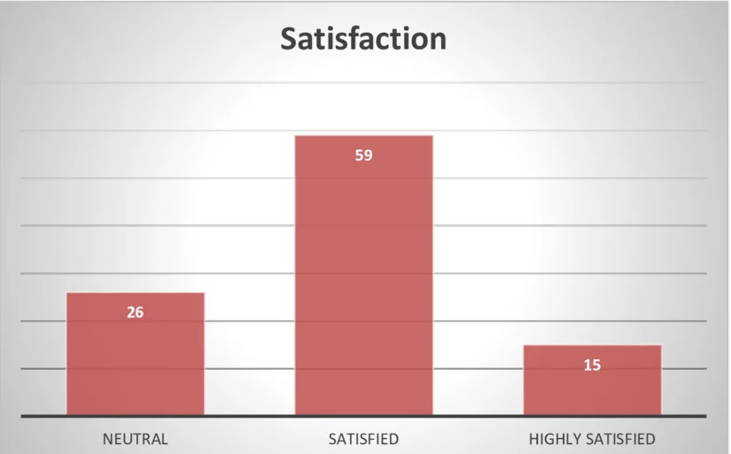
Figure 7: Consumer Satisfaction for Amazon Prime
(Source: Saiprasad and Meenakshi, 2022)
Internal Process: The internal process of Amazon leverages its priority on logistics and innovation. This company highlights its key performance indicators, including order fulfilment time, same-day delivery and also third-party seller metrics. This company needs to adopt some key initiatives, such as the implementation of more same-day deliveries and the improvement of warehouse automation (Onggowidjojo and Ellitan, 2023). This company also increased its same-day delivery to 70% of growth in early 2026 (Versbach and Gans, 2024). Moreover, Amazon also focuses on the regionalisation, rural expansion, AI robotics and automated packaging.
Learning and Growth: The learning and growth of Amazon help to improve the workforce and digital capabilities effectively. Moreover, Amazon focuses on the employee retention rate, AI and machine learning adoption and lastly, new product patents (Shankar, 2024). Sarkar (2024) also stated that this company also focuses on the investment of $1.2 billion in upskilling of its workforce, involving more than 300,000 employees. This company is also breaking down the key initiatives by focusing on the customer perspective, internal processes and learning and growth.

5. Strategic Choices and Implementation

5.1 Business-Level Strategic Choice Available for Amazon
The strategy of Amazon particularly combines the cost leadership with differentiation that enables the organisation to accurately maintain competitive advantages even in the global market. The cost efficiency of Amazon is mainly achieved by economies of scale, optimised logistics, and automation. On the other hand, this further ensures affordable pricing for the Amazon customer. While differentiation particularly arises from exclusive services of the firm, such as Amazon Prime, personalised recommendations, along with the highly advanced logistics ecosystem, help in enhancing the customer experience (Julin and Gopalakrishnan, 2025). This dual strategy helps in strengthening customer loyalty, expanding market reach and sustaining Amazon’s leadership within retail as well as technology sectors.

5.2 Corporate-Level Strategic Choice Available for Amazon
The corporate business structure of Amazon is a functional one that mainly focuses on several business components and their functions as bases for accurately defining interactions and for reporting relationships. Both diversification and international expansion are paramount in the business of Amazon, which are the key sources in making its position more significant in the market. Amazon has been successful in creating new revenue streams by diversifying its businesses (Springer, 2025). Amazon has diversified its business that is even beyond the core e-commerce segment and has continued to accurately explore several opportunities to enter new markets and industries. This expansion decision is further strongly aligned with the company’s vision of being the most consumer-centric company throughout the world.

5.3 Recommendation and Justification behind the choices
Differentiation has become essential for Amazon for sellers who aim to stand out within the constantly evolving and competitive market. Differentiation is not only helpful in enhancing the product visibility, but it also helps in increasing the sales of the company. Products that stand out by innovation or quality have the ability to attract more clicks and help convert into sales (Mana, 2024). Along with that, differentiation has a positive impact on the overall perceived value of the product, that allow for customer loyalty. However, the algorithms of Amazon have favoured the products with the conversion rates as well as better reviews.

5.4 Assessment of the process used by Amazon to manage the Change
Change Management is regarded as an important part of the organisation’s operational excellence. Amazon's aim to meet the goal of being customer-centric has been the main focus, and it has used strategies to achieve it. Amazon has enhanced its operations security by effectively using delegated administration in order to permit a specific user to use automation documents with IAM permissions. In addition to this, the firm also monitors the automation progress and execution information through effectively using the Systems Manager Console (Amazon, 2026). The approach of Amazon to managing change has been blended with multiple strategies that allow for continuous evolution in the business and help in meeting the objective of being the most customer-centric business worldwide.

5.5 Impact of the Change on Strategic Implementation
The change management process of Amazon is ultimately enabling the organisation to achieve its long-term strategic objectives through automating multiple tasks. This strong focus on customer centricity within the business is crucial to assist the organisation in supporting its goal.The main focus, which is on automated and small changes, will be crucial for the organisation, as it is helpful in decreasing the business risks and helps with quick adaptation to any changes in the industry (Martin, 2024). Customer convenience has been prioritised by Amazon, which has always prioritised the benefits for consumers through providing fast and reliable delivery.

6. Strategic Evaluation and Recommendations

6.1 The Current Strategy of Amazon by using SWOT Analysis
Strengths  ●Amazon's key strength mainly lies in its Brand Power.  ●Amazon has a strong balance sheet Bousquin, 2026). | Weaknesses  ●One issue mainly lies in market saturation (Bousquin, 2026).  ●Another weakness mainly lies in heavy dependency on third-party sellers (Kestenbaum, 2021).
Opportunities  - One major opportunity for the organisation is expansion into several emerging markets  - Diversification of services can attract a new customer base and help in gaining additional revenue | Threats  - The major threat Amazon may face is due to the intense competition from companies like Walmart in retail and Microsoft in cloud services.  - Another major threat the organisation, Amazon, may face is protocol violations (Goldberg, 2026).
Table 5: SWOT Analysis

6.2 The Current Strategy of Amazon by using Ansoff
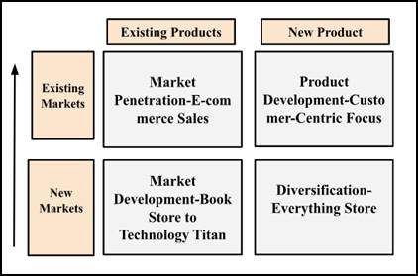
Figure 8: Ansoff Matrix
(Source: Self-created)
Diversification: Diversification is considered the best strategy for Amazon that will help it manage its competitive position in the highly competitive market.The ability of Amazon to keep growth opportunities, mainly including grocery, private labels, different logistics and generative AI, is making it the organisation more valuable (Ahmed, 2025). Diversifying the product range and service range of Amazon is beneficial for the company as it can help in attracting a huge range of consumers and can increase its revenue as well.Diversification is the key strategy for Amazon that will also allow Amazon to meet its objective of being the most customer-centric organisation at a global level.

6.3 Recommendations for Amazon
Proactive Compliance & Transparency: The firm, Amazon, needs to prioritise proactive compliance and ensure more transparency within its business practices. The brand can accurately ensure transparency that will help to engage directly with the customer through the Amazon app. Consumers can scan the effect by using the Amazon Shopping App and can enhance the content, like product ranking and promotional messaging (JD Supra, 2025). This further helps in adding a specific level of customer, which is specifically valuable for the high-end products and goods that are constantly counterfeited.
Decrease Reliance on Third-Party Seller: Decreasing the heavy reliance on third-party (3P) sellers is essential for Amazon, which is further helpful in emphasising the higher margin and premium inventory. This will assist in mitigating brand damage and help to deal with any counterfeits.3P sellers have utilised Amazon and many other marketplaces to sell the products directly to the customers, but it has been seen that there were multiple unauthorised 3P sellers (GreyScout, 2022). Hence, it becomes essential for Amazon to decrease its reliance on them in its business practices.

6.4 Justification for the Recommendation
The compliance & transparency recommendation is justified for Amazon, which allows the organisation to deal with the issues and help to enhance processes. For example, organisations like Microsoft have built companies as well as an ethics program, particularly on three pillars which are prevention, detection and remediation (Microsoft, 2022). Another recommendation that has been given to Amazon is to decrease reliance on third-party sellers, which is also beneficial for Amazon. For example, Nike has announced that it is going to stop selling its product to several retailers (Monteros, 2022). Nike has decided to cut ties with many retailers that have decreased reliance on other sellers at Nike.

Section 2

Gibbs reflective Cycle
Gibb’s reflective cycle is a well-structured approach that is associated with reflective learning and allows a person to learn different things, even from one's experience. An individual can use this framework in which the employees learn things from accurately analysing the past actions as well as multiple sections. This framework was developed in 1988 by a famous professor, Graham Gibbs, and consists of six key stages (Harmon, 2024). The six key stages as per Gibbs’ Reflective Cycles are mainly including Description, Feelings, Evaluation, Analysis, Conclusion and Action (Refer to Figure 9).
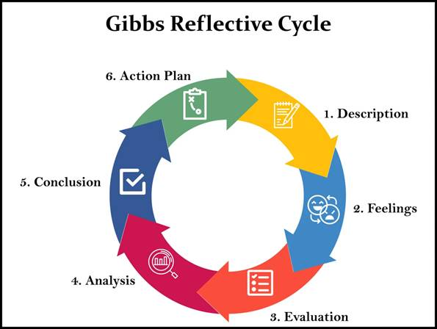
Figure 9: Gibbs reflective Cycle
(Source: McLeod, 2025)

Description
This reflective assessment is beneficial for me as it has provided me with the opportunity to analyse the experience that I have gone through while doing the assignment on Amazon. I have been assigned to prepare a strategic report on the strategic management practices of Amazon. In this report, I have greatly focused on both internal and external environmental factors that have a direct impact on the business practices of the organisation. The report has been divided into a few specific sub-sections, which mainly focus on multiple environmental factors, the sustainability objectives of the Amazon, along with the different theories and frameworks that are helpful in analysing the scenarios at Amazon.

Perceptions
The report on Amazon has given me the opportunity to analyse my skills and knowledge, as it was about analysing multiple frameworks. However, I was really excited about completing this report, as in this report I have to write about both internal and external factors by using the relevant frameworks. However, I was not only excited while preparing the report, but I also felt really nervous as I was conscious of the result. Due to the nervousness, I was confused about what to do next, but when I started writing about the organisational context, it gave me motivation to go ahead with the whole report. There were many frameworks, and I was curious how the framework could help to identify both strengths and weaknesses of the company.

Evaluation
I have prepared the report on Amazon, and it has become a great experience for me as it has allowed me to find out both the strengths and gaps in my work. However, I have been able to find out both my weaknesses and my strengths because of the past experiences that I have faced while making the report. I have dealt with a situation where one of my teammates has started feeling nervous and has decided to quit due to multiple responsibilities. However, at this station, I communicated with that classmate and understood the situation, and at that moment, I realised that I haveinterpersonal skills that assisted me to cooperate with that person. I have also identified the issues and found out the root cause behind the problems, which allows me to know that I also possess Problem-solving skills.
The other moment that I also went through was when I found difficulties in managing multiple tasks and became confused about which things needed to be done. I have found a major gap in me, which was the lack of effective decision-making skills, and due to that, I was not able to use the technique to make proper decisions. Decision-making skills are essential to help to make informed decisions in multiple circumstances (Bright Network, 2026). Another gap I also recognised is that I have to write about multiple frameworks, and this has caused tension in my mind about how to proceed with multiple frameworks. Additionally, I started to become nervous again, which has caused a negative impact on the time given for me to prepare the report. In this situation, I identified that I also lack effective stress management skills. Stress managementmainly involves using different techniques to manage overall stress levels (Robinson and Smith, 2025).I was not able to achieve engagement in the technique to decrease the stress in any situation.

Analysis
I have used multiple frameworks while preparing the report that have assisted me in increasing my knowledge and ability to find out the factors that can affect businesses. For example, PESTLE analysis has assisted me in finding out the external factors that have directly affected the business practices of Amazon (Libguides, 2025). In addition to that, I have also used Porter’s Five Forces, which has allowed me to analyse the recent situation of the industry where Amazon is operating. I have found issues in finding the overall effect of the challenges that Amazon has. However, I have also used the SWOT analysis framework, which helped in highlighting both the strengths and weaknesses of Amazon. I have found issues as I was not only asked to discuss the framework but also to analyse the impact of the model on the business practices. In addition to that, I have also discussed the CSR strategy of Amazon, which has increased my awareness about the importance of sustainability initiatives. I have gained information on how the sustainability initiatives of the firm can help create a positive image of the brand in the industry.

Conclusion
This reflective report has allowed me to go through the experience of preparing a report on Amazon. This reflective learning has allowed me to know what positive things exist in me that can allow me to perform better. At the same time, this reflective learning also helps me to know what gas exists in me that needs to be addressed within a short duration. However, this reflective analysis has been the key area in highlighting both my strengths and weaknesses that may help me in my future activities as well. After analysing my weaknesses, I am going to prepare an action plan that will help me to deal with the issues. At the same time, it will also help me to enhance the weak areas and provide me with ways to deal with further issues and circumstances. The action plan will help me to provide the ways that need to be prioritised in the future.

Action
Skills | Key Activities | Supportive Person | Time Frame
Stress management skill | Regular exercise, like deep breathing and meditation | Family Members and friends | 3 months
Decision-making skills | Brainstorming and Fostering Collaboration | Mentor and friend | 4 months
Table 6: Action Plan

References
Abbes, I. (2025). Strategic pathways for innovation and sustainability in digital transformation: Insights from leading global companies. Social Sciences & Humanities Open, [online] 12, pp.101906–101906. doi:https://doi.org/10.1016/j.ssaho.2025.101906.
Aboutamazon (2026). Protecting Natural Resources. Available at: https://sustainability.aboutamazon.com/natural-resources.
Ahmed, G. (2025). Why Amazon’s (AMZN) Diversification Strategy Keeps It on Wall Street’s Radar. Available at: https://finance.yahoo.com/news/why-amazon-amzn-diversification-strategy-212627287.html.
Akin, M.S. (2024). Enhancing e-commerce competitiveness: A comprehensive analysis of customer experiences and strategies in the turkish market. Journal of Open Innovation: Technology, Market, and Complexity, 10(1), pp.1–16. doi:https://doi.org/10.1016/j.joitmc.2024.100222.
Alonge, E.O., Dudu, F. and Babatunde, O. (2024). Utilizing advanced data analytics to boost revenue growth and operational efficiency in technology firms. International Journal of Frontiers in Science and Technology Research, 7(2), pp.039–059. doi:https://doi.org/10.53294/ijfstr.2024.7.2.0056.
Amazon (2024). Amazon Sustainability Report. Available at: https://sustainability.aboutamazon.com/2024-amazon-sustainability-report.pdf.
Amazon (2026). Change Management - AWS Systems Manager Operational Capabilities. Available at: https://docs.aws.amazon.com/es_es/whitepapers/latest/aws-systems-manager-operational-capabilities/change-management.html.
Amazon. (2023). Communities. Available at: https://sustainability.aboutamazon.com/communities.
BBC (2026). What are the social and economic issues in the USA? - Social and economic issues in the USA - National 5 Modern Studies Revision - BBC Bitesize. [online] BBC Bitesize. Available at: https://www.bbc.co.uk/bitesize/guides/zywkrwx/revision/1 [Accessed 27 Mar. 2026].
Bousquin, J. (2026). Construction prices spiked at ‘staggering’ rate to begin 2026. Available at: https://finance.yahoo.com/sectors/energy/articles/construction-prices-spiked-staggering-rate-163800288.html [Accessed 27 Mar. 2026].
Brewis, C., Dibb, S. and Meadows, M. (2023). Leveraging big data for strategic marketing: A dynamic capabilities model for incumbent firms. Technological Forecasting and Social Change, [online] 190(122402), p.122402. doi:https://doi.org/10.1016/j.techfore.2023.122402.
Bright Network. (2026). Decision-making skills: Definitions & examples. Available at: https://www.brightnetwork.co.uk/graduate-career-advice/key-career-skills/decision-making-skills-definitions-examples/.
Business Model Analyst. (2023). Amazon Mission and Vision Statement. Available at: https://businessmodelanalyst.com/amazon-mission-and-vision-statement [Accessed 27 Mar. 2026].
Collidu (2024). Porter’s Diamond. [online] Collidu.com. Available at: https://www.collidu.com/presentation-porters-diamond [Accessed 27 Mar. 2026].
Davidson, J.D. and Rajeswari, P.S. (2025). A Case Study on How Amazon Uses Personalization to Win Back Prime Subscription Lapsers. Journal of Information Technology Teaching Cases, 1(1). doi:https://doi.org/10.1177/20438869251325244.
Deloitte (2025). Sustaining America’s technology preeminence. [online] Deloitte Insights. Available at: https://www.deloitte.com/us/en/insights/industry/government-public-sector-services/america-pole-position-future-technology-predictions.html [Accessed 27 Mar. 2026].
Donovan, B. (2025). Amazon Steers Third-Party Seller Share To All-Time High. [online] Marketplace Pulse. Available at: https://www.marketplacepulse.com/articles/amazon-steers-third-party-seller-share-to-all-time-high [Accessed 27 Mar. 2026].
Escandon-Barbosa, D. and Salas-Paramo, J. (2025). Driving success: Leveraging strategic decision-making and digital technology for sustainable performance". Journal of Open Innovation: Technology, Market, and Complexity, [online] p.100536. doi:https://doi.org/10.1016/j.joitmc.2025.100536.
Global Economy (2023). USA Political stability - data, chart. [online] Available at: https://www.theglobaleconomy.com/USA/wb_political_stability/ [Accessed 27 Mar. 2026].
Global Economy (2026). USA economic indicators | TheGlobalEconomy.com. [online] TheGlobalEconomy.com. Available at: https://www.theglobaleconomy.com/USA/ [Accessed 27 Mar. 2026].
Globaldata (2026). Amazon.com Inc - Company Profile. Available at: https://www.globaldata.com/company-profile/amazoncom-inc/competitors/.
Goldberg, J. (2026). Why Amazon’s Biggest Competitive Challenge May Not Be Another Retailer. Available at: https://www.forbes.com/sites/jasongoldberg/2026/02/15/amazons-andy-jassy-just-named-his-biggest-threat-its-not-a-retailer/.
Grand View Research (2024). E-commerce market size, share, trends | global industry report, 2025. Available at: https://www.grandviewresearch.com/industry-analysis/e-commerce-market.
GreyScout. (2022). How to Beat Unauthorized Third-Party Sellers In 2023. Available at: https://greyscout.com/how-to-compete-with-third-party-sellers-in-2023/ [Accessed 27 Mar. 2026].
Harmon, A. (2024). Gibbs’ reflective cycle . [online] EBSCO Information Services, Inc. | Available at: https://www.ebsco.com/research-starters/education/gibbs-reflective-cycle.
ITA (2026). Other Legal Considerations. [online] www.trade.gov. Available at: https://www.trade.gov/other-legal-considerations [Accessed 27 Mar. 2026].
JD Supra. (2025). Amazon Strengthens Brand Protection for Trademark Owners: Key Updates in 2025 | JD Supra. Available at: https://www.jdsupra.com/legalnews/amazon-strengthens-brand-protection-for-7994692/ [Accessed 27 Mar. 2026].
Julin, S., and Gopalakrishnan. P (2025). AMAZON-COST LEADERSHIP, DIFFERENTIATION VIA LOGISTICS, PRIME MEMBERSHIP. Peer Reviewed & Indexed Journal. ISSN -2348-0653. http://admin.ijbarr.com/downloads/3110202513.pdf
Keelson, S.A., Cúg, J., Amoah, J., Petráková, Z., Addo, J.O. and Jibril, A.B. (2024). The Influence of Market Competition on SMEs’ Performance in Emerging Economies: Does Process Innovation Moderate the Relationship? Economies, [online] 12(11), p.282. doi:https://doi.org/10.3390/economies12110282.
Kelk, P. (2023). Evaluating Amazon’s Ethical and Corporate Social Responsibility Strategy.. https://www.researchgate.net/publication/387020741
Kestenbaum, R. (2021). The Risks Keep Growing For Amazon Third-Party Sellers. Available at: https://www.forbes.com/sites/richardkestenbaum/2021/06/14/the-risks-keep-growing-for-amazon-third-party-sellers/.
Li, J. and Tayi, G.K. (2024). Optimistic Third-Party Sellers in E-Commerce Supply Chains. Systems, 12(10), pp.409–409. doi:https://doi.org/10.3390/systems12100409.
Libguides (2025). Industry Research: PESTEL Analysis. [online] Washington State University. Available at: https://libguides.libraries.wsu.edu/c.php?g=294263&p=4358409.
Mana (2024). Product Differentiation on Amazon: How to Stand Out. Available at: https://mana-analytics.com/en/differentiation-products-amazon/ [Accessed 27 Mar. 2026].
Martin, M. (2024). Amazon’s Customer-Centric Strategy: The Key to Sustained Growth and Market Leadership. [Available at: https://martinmawo.com/amazons-customer-centric-strategy-the-key-to-sustained-growth-and-market-leadership/.
McKinsey & Company (2024). Members only: Delivering greater value through loyalty and pricing | McKinsey. [online] www.mckinsey.com. Available at: https://www.mckinsey.com/capabilities/growth-marketing-and-sales/our-insights/members-only-delivering-greater-value-through-loyalty-and-pricing [Accessed 27 Mar. 2026].
McLeod, S. (2025). Gibbs Reflective Cycle. Available at: https://www.simplypsychology.org/gibbs-reflective-cycle.html.
Mercadel and Trudy (2024). Amazon (company) | EBSCO. Available at: https://www.ebsco.com/research-starters/business-and-management/amazon-company.
Messineo, R. (2024). VRIO Analysis: The Framework to Identify Competitive Advantages. [online] ClearPoint Strategy. Available at: https://www.clearpointstrategy.com/blog/vrio-framework [Accessed 27 Mar. 2026].
Microsoft (2022). Microsoft Code of Conduct | Ethics & Compliance. Available at: https://www.microsoft.com/en-us/legal/compliance.
Monteros, M. (2022). As Nike cuts ties with retailers, competitors look to take its place in wholesale. Available at: https://www.modernretail.co/retailers/as-nike-cuts-ties-with-retailers-competitors-look-to-take-its-place-in-wholesale/.
Morano, H. (2024). From A to Z: The Complete History of Amazon.com. Available at: https://www.ecomcrew.com/from-a-to-z-the-complete-history-of-amazon-com/.
Murcia, N.N.S., Ferreira, F.A.F. and Ferreira, J.J.M. (2022). Enhancing strategic management using a ‘quantified VRIO’: Adding value with the MCDA approach. Technological Forecasting and Social Change, 174(1), p.121251. doi:https://doi.org/10.1016/j.techfore.2021.121251.
Nguyen, K.P. (2026). Amazon Launches $37 Billion Bond Sale as AI Spending Surges. [online] Yahoo Finance. Available at: https://finance.yahoo.com/news/amazon-launches-37-billion-bond-182607720.html [Accessed 27 Mar. 2026].
OECD (2025). Environment at a Glance: United States. [online] Oecd.org. Available at: https://www.oecd.org/en/publications/environment-at-a-glance-country-notes_59ce6fe6-en/united-states_6ddcb98e-en.html [Accessed 27 Mar. 2026].
Oliveira, F., Belitski, M. and Perez-Vega, R. (2025). Sales digitization and sales process optimisation for firm performance: Evidence from European firms. Technological Forecasting and Social Change, 217, pp.124172–124172. doi:https://doi.org/10.1016/j.techfore.2025.124172.
Onggowidjojo, V. and Ellitan, L. (2023). Strategies for Achieving Competitive Advantage: The Case of Amazon. [online] ResearchGate. Available at: https://www.researchgate.net/publication/374155748_Strategies_for_Achieving_Competitive_Advantage_The_Case_of_Amazon [Accessed 27 Mar. 2026].
Ou, X. (2026). Amazon - statistics & facts. Available at: https://www.statista.com/topics/846/amazon/#topicOverview.
Our World in Data (2024). Technology and infrastructure diffusion in the United States. [online] Our World in Data. Available at: https://ourworldindata.org/grapher/technology-infrastructure-diffusion-us [Accessed 27 Mar. 2026].
Robinson, L. and Smith, M. (2025). Stress management: Techniques & strategies to deal with stress. Available at: https://www.helpguide.org/mental-health/stress/stress-management.
Saiprasad, K. and Meenakshi, A. (2022). A study on amazon prime video services in Chennai evaluating consumer preferences over others. International journal of health sciences, pp.1524–1535. doi:https://doi.org/10.53730/ijhs.v6ns5.8995.
Sala, E. (2024). Lift Group | Amazon and its business model and growth. Available at: https://www.liftingroup.com/en/expertise/business-model-amazon/.
Shankar, S. (2024). A STUDY ON AMAZON’S DIGITAL SKILLS REVOLUTION: EMPOWERING EMPLOYEES THROUGH UPSKILLING 2025. [online] Available at: https://www.researchgate.net/publication/378591791_A_STUDY_ON_AMAZON [Accessed 27 Mar. 2026].
Springer, A. (2025). Amazon’s Corporate Structure: Exploring Hierarchy and Management Style. Available at: https://www.functionly.com/orginometry/amazon-corprate-structure.
Steele, K. and Priti, P. (2022). Leveraging the Power of AWS to Increase Market Share | AWS Cloud Operations & Migrations Blog. [online] aws.amazon.com. Available at: https://aws.amazon.com/blogs/mt/leveraging-the-power-of-aws-to-increase-market-share/ [Accessed 27 Mar. 2026].
The Hindu (2026). Amazon shares plunge as AI costs climb. [online] The Hindu. Available at: https://www.thehindu.com/sci-tech/technology/amazon-shares-plunge-as-ai-costs-climb/article70598482.ece [Accessed 27 Mar. 2026].
Tolstoy, D., Nordman, E.R., Hånell, S.M. and Özbek, N. (2020). The development of international e-commerce in retail SMEs: An effectuation perspective. Journal of World Business, [online] 56(3), p.101165. doi:https://doi.org/10.1016/j.jwb.2020.101165.
Trading Economics (2025). United States GDP Growth Rate. [online] Tradingeconomics.com. Available at: https://tradingeconomics.com/united-states/gdp-growth [Accessed 27 Mar. 2026].
United States Environmental Protection Agency (2025). Sources of Greenhouse Gas Emissions. [online] United States Environmental Protection Agency. Available at: https://www.epa.gov/ghgemissions/sources-greenhouse-gas-emissions [Accessed 27 Mar. 2026].
US Department of State (2024). Anti-Corruption and Transparency - United States Department of State. [online] United States Department of State. Available at: https://2021-2025.state.gov/policy-issues/anti-corruption-and-transparency [Accessed 27 Mar. 2026].
Versbach, P.A. and Gans, J. (2024). Interplay between Amazon Store and Logistics. European Competition Journal, [online] 20(2), pp.460–497. doi:https://doi.org/10.1080/17441056.2024.2312494.
Watanabe, C., Akhtar, W., Tou, Y. and Neittaanmäki, P. (2022). A New Perspective of Innovation toward a non-contact Society - Amazon’s Initiative in Pioneering Growing Seamless Switching. Technology in Society, 69(2), p.101953. doi:https://doi.org/10.1016/j.techsoc.2022.101953.
World Bank (2026). World Bank Open Data. [online] World Bank Open Data. Available at: https://data.worldbank.org/indicator/NY.GDP.MKTP.KD.ZG?end=2024&locations=US&start=1961&view=chart [Accessed 27 Mar. 2026].
World Economics (2026). United States’s Social Factors ESG | Data | on World Economics. [online] World Economics. Available at: https://www.worldeconomics.com/ESG/Social/United%20States.aspx [Accessed 27 Mar. 2026].
WSJ (2026). AMZN | Amazon.com Inc. Annual Balance Sheet - WSJ. [online] www.wsj.com. Available at: https://www.wsj.com/market-data/quotes/AMZN/financials/annual/balance-sheet [Accessed 27 Mar. 2026].
Yu, W., Hassan, A. and Adhikariparajuli, M. (2022). How Did Amazon Achieve CSR and Some Sustainable Development Goals (SDGs)—Climate Change, Circular Economy, Water Resources and Employee Rights during COVID-19? Journal of Risk and Financial Management, 15(8), p.364. doi:https://doi.org/10.3390/jrfm15080364.

Appendices

Appendix 1: Political Stability Index of the USA
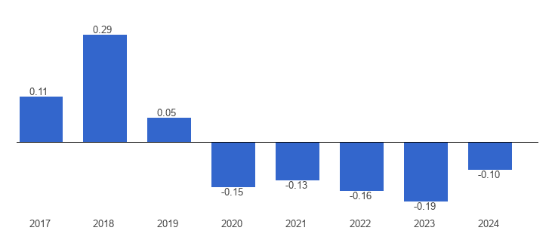
Figure 10: USA’s Political Stability
(Source: Global Economy, 2023)

Appendix 2: Economic Growth of the USA
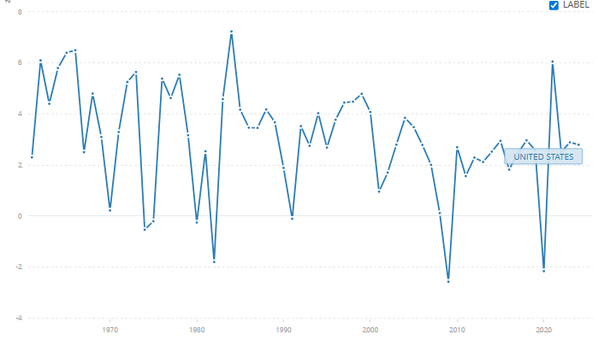
Figure 11: Economic Growth of the USA
(Source: World Bank, 2026)

Appendix 3: Technology Usage in Different Sectors of the USA
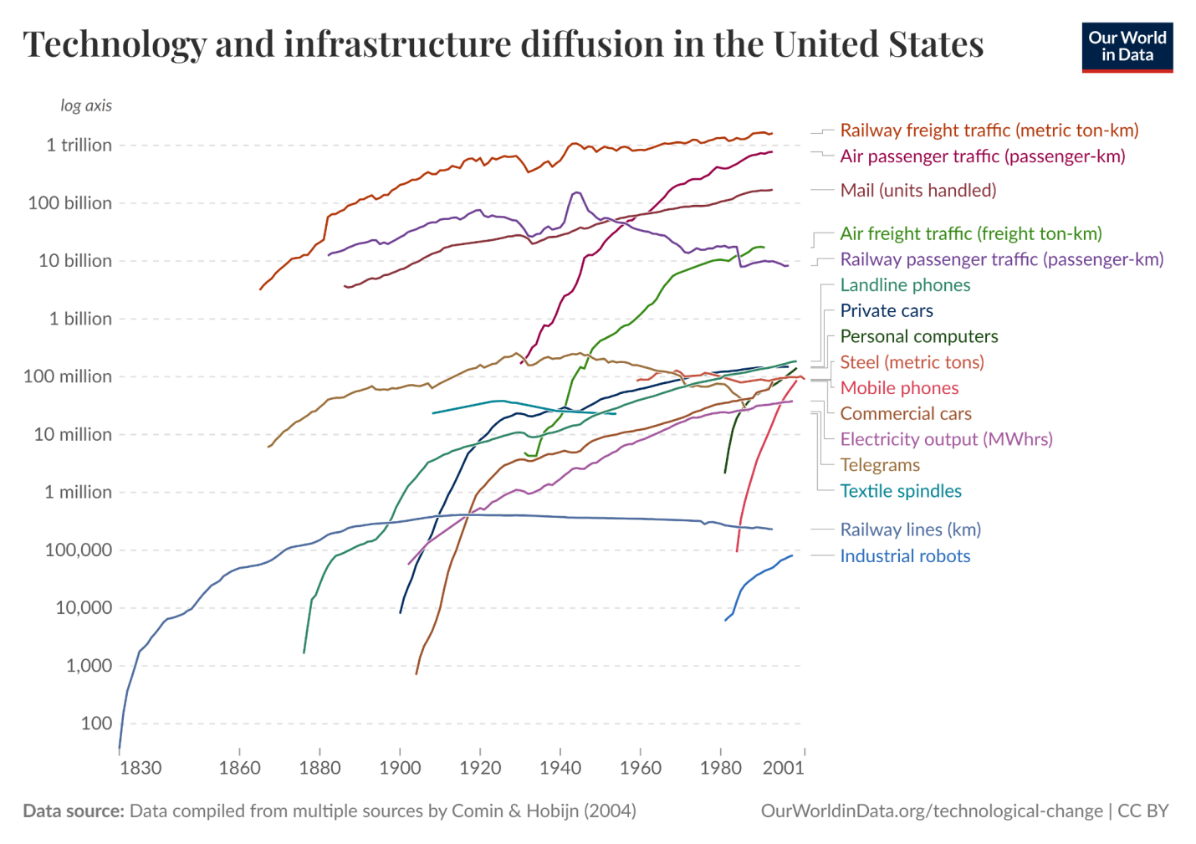
Figure 12: Technology Usage in Different Sectors
(Source: Our World in Data, 2024)

