Psychology In Health and Social Care
Assignment II

Student name: | CHANTHY KHUON
Student ID: | 2129753
Module name: | Psychology In Health and Social Care
Module code: | LCHS4006
Lecturer name: | Bianca Sanfilippo
Research Top: | Reflective Report on Psychological Life Span
Deadline | 5th May 2023

Table of Content Page
- Introduction…………………………………………………………Page 3
- The Definition of Eight Stages Lifespans Theory.….………..Page 4-5
- The Social Learning Theory ……………………………….…….Page 6
- My Most Excited Lifespan Phenomenon………………….……Page 6
- Three Approaches Critical Discussion…………..…………….Page 7
- Conclusion…………………………………………………………...Page 7
- References……………………………………………………………Page 8

- Introduction
There are so many theories and conflicts about psychology developments such as
Erik Erikson, Freud Sigmund, Jean Piaget and etc.
My group chose the Erick Erickson’s theory to talk about because it is very interested and easy to understand. We were talking about the adulthood the age of 40-65 (generativity Vs Stagnation). First, we need to understand what psychology development means? According to Erik Erikson’s theory psychology development is a lifespan experiences through eight stages. Each stages impact differently based on the way of living and environment around each stage. For example, if kids born in a drug environment or violent society, when they grow up it could lead them to use drug or to use violent later in the future. And then when they reach the age of 40 to 60+, they start to look back and regret what they have done in lifespan experience. Down below is the table that describe about Erickson’s psychology development crisis during each stage.

- The Definition of Eight Stages Lifespans Theory
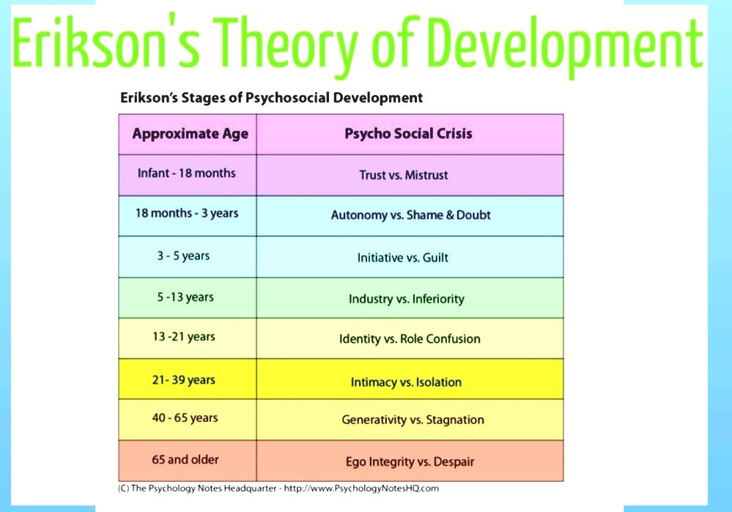
The first stage is called infancy classify from birth to 18 months old. This is very important stage in human life span because it can shape the human personality. For example, in this stage there is a conflict between trust and mistrust. Normally baby in this stage is depending on caregiver or mother. When the baby cries, that means baby wants something like food or toy to play and mother always give to make the baby stop crying., but if the baby is crying and mother don’t give him/her food as normal, baby start not to trust mother anymore. Baby is like white paper, if you don’t put anything dirty in that white paper it will never change the colour. But if you put any colour on it, it will change eventually. This is the same way then we raise the baby. Well feed, giving affection and make the baby feel comfortable is the best way to archive the brighter future for being a human.
The second stage is called Autonomy Versus Shame and Doubt from the age of 18 months to 3 years old. In this stage kid starts to feel a little bit of independent. For instance, if the kid wants to do something, he/she wants to do it by him/herself. If the result is good, they will feel confident, but if the result is failed, they will face shame or doubt and lack of confident.
The third stage is called Initiative versus Guilt from the age of 3 years to 5 years old. Children in this stage start to show off their power through playing directly and making friends via social interaction.
The fourth stage is called Industry and inferiority from the age of 5 to 11 years old. Children in this age start going to gain the knowledge and academic demand. Through the achievement or any successful academic, children will feel pride, and in opposite if the children didn’t receive any accomplishment, they will feel inferiority. So, the parents or teachers need to praise and encourage them more often so that they can try their best to get success in any skill they able to do.
The fifth stage is crucial stage and called Identity versus Role confusion. Considered from the age of 13 to 21 years old. Teenagers at this age can personally identify themselves by developing and keep continue to influence behaviour as who they are. Success leads to ability to stay true to themselves. And the those who failure drugged themselves to role confusion and a weakness could happened in this stage of life span.
The sixth stage is called Intimacy versus Isolation. Identify as age of 21 to 39 years old. After they teenager period came, now they turn to young adult who will face the feeling of intimacy, loving and start to look for a relationship with other people. During this age exploring a personal relationship is a need to them. Those people who reach to a strong commitment, their relationship will be secure and enduring. And for those who have poor sense of commitment in relationship are more likely to face a struggling and loneliness, depression, and emotional isolation.
The seventh stage is counted from the age of 40 to 65 years old, and it called Generativity versus Stagnation. Erickson believed that after finding relationship, people in this age need to create a family and think what they can do to benefit to other and leave legacy for the next generation. For those who formed a good family can leave a good role model for the young generation but for those who failed in forming a family could feel unproductive, regret, and want to be isolated from the world.

The last eighth stage and the last stage is called Integrity versus Despair. From the age of 65 and above. When it comes to final stage of anything, as human being we always looking back what we have done in the past good or bad. This is one of the life span that Erickson’s theory is difference from others. People who can succeeded and fulfilled their goals will feel wisdom and proud of what they have done. And for those who didn’t will feel regret, bitterness, and despair.

Eric Erickson’s theory believe that society factor is the main impact on psychology development of human lifespan. According to his theory, I have seen around 85 percent is true. What environment people brought up could influence lifespan accordingly. Erickson keep in mind that developing personality in a predetermined can sharp peoples’ lives through the eight stages of his theory.
He believes that the person who faced the psychosocial crisis which could have positive or negative result in personality development.
According to the theory failure to any stage could result differently but could be also can be sort it later.

- The Social Learning Theory
Social learning theory is the study that happened through observation, modelling,
imitation and is influence by many factors such as emotion, attitude, attention, and motivation. The theory focuses on the interaction of cognitive and environment that impact on how people learn. For example, from my lifespan experienced when I was at high school, there are many teachers, but I really like one of the mathematic teachers. I like her character and they way she taught the students. So, I committed to myself when I finished my general knowledge. I want to become like her. Later, when I finished my high school, I started my career as a kindergarten teacher at private school. And I took her as my role model. I had got so many compliments and rewards from the students’ parents. After I learned about this social learning theory, I can look back to my experiences during my lifespans.

- My Most Excited Lifespan Phenomenon

Since I was born till now, I am 36-year-old I have faced so many. Life spans
experiences. When I look back to my past there are so many regrets things, I should not have done it. And there are also so many great life span experiences that I learned and used it from those experiences. For instance, I felt embarrassed to have a poor life that I should not felt in that way, that poor life made me stronger and try to fight for life. One of my greatest excited lifespans was when the time that I entered to the England. It was life changing for me because England is developed country is way too far difference from my country. I was so excited, and I couldn’t believe myself I was in England. Before I came here, I was wondering is the sky in England like Cambodia. I didn’t believe the weather is cold. I found out I must learn everything from the scratch. My life completely changes, I must adopt to new people, new place, new food, new job, new society, and environment. Finally, I could get fund to study in England which is very privileged to me to get a great opportunity.
- Three Approaches Critical Discussion
As a health care professional learning about psychology is very important because as
I am going to work with people in difference range of age and condition able to understand about they mental, feeling, and all the causes through their lifespan is beneficiary. I may face difference type of people behaviour, but I will use all the three approaches into practice such as behaviourism, the social learning, and the humanistic approach. If I have a chance to work with children, I will use the behaviourism approach because I think I could receive a good result. And for I will use social learning to inspire the people I am going to work with. I will play the best role model for them.

- Conclusion
Through this module I have learned a lot about psychology theories as before I
always wonder why my friend wants to learn about psychology. When I get to know why it is important to learn about psychology, it makes me interested into it. Comparing to my own country and in England, learning psychology here is necessary for all the sectors in the developed country like England, number of people who need health care is very high and demanded. Whereas my country needs to learn psychology in education sector only. There are so many psychology theories and approaches that I can take into practice when I get a job as health and social care professional. It can help me to sharp my future career become better and better.

7. References
- Cherry, K. (2022) How people develop a sense of generativity vs. stagnation, VerywellMind. Available at: https://www.verywellmind.com/generativity-versus-stagnation-2795734 (Accessed: March 13, 2023).
- Cherry, K. (2022) Erikson’s Stages of Development. URL: https://www.verywellmind.com/erik-eriksons-stages-of-psychosocial-development-2795740 [17 March 2023].
- Erikson by social Mclead Published 2008, updated 2013.
- Orenstein, G. and Lewis, L. (2022) Erikson’s stages of psychosocial development - NCBI bookshelf, Erikson’s Stages of Psychosocial Development. Statpearls . Available at: https://www.ncbi.nlm.nih.gov/books/NBK556096/ (Accessed: March 15, 2023).
- Physical Development: Age 45–65 (no date). URL: https://www.cliffsnotes.com/study-guides/psychology/development-psychology/physical-cognitive-development-4565/physical-development-age-4565 [17 March 2023].
- Physical Development in Middle Adulthood – Individual and Family Development, Health, and Well-being (no date). URL: https://iastate.pressbooks.pub/individualfamilydevelopment/chapter/physical-development-in-middle-adulthood/ [17 March 2023].
- Ready, B. (2012) Aging and Emotions | Psychology Today. URL: https://www.psychologytoday.com/us/blog/your-quality-life/201208/aging-and-emotions [17 March 2023].
- Weiss, L. A., Westerhof, G. J. and Bohlmeijer, E. T. (2020) Emotional and Social Development in Middle Adulthood. PLoS ONE, 11(6).
- (Simplyspychology,2023 ) Erik Erikson’s 8 Stages Of Psychosocial Development. Available at:Erik Erikson's 8 Stages of Psychosocial Development - Simply Psychology (Accessed: 31 March 2013 )
- (Verywellmind,2023) Biography of Erik Erikson (1902-1994) Available at: Biography of Psychologist Erik Erikson (verywellmind.com) (Accessed: 31 March 2013

