

Assessment 1 – Reading Task Template
Danielle Martinato.
PART 1: Upload your photo of your A3 in-class notes here:
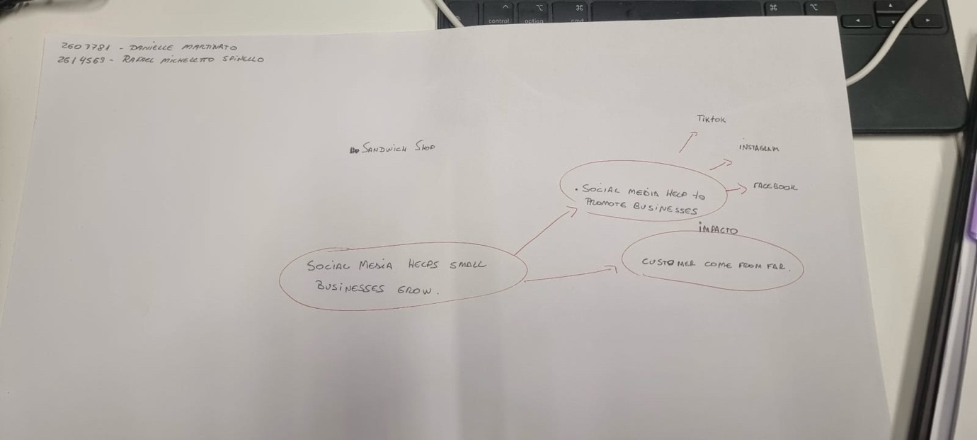

PART 2:
- Answer every question below in 1-3 full sentences.
- Use your own words. Do not use generative AI to answer these questions.
- Include a specific detail from the text when asked.
REMINDER
- The main idea is the overall message of the whole text.
- A key point helps to explain the main idea.
- A specific detail or example from the text shows that the key point is true.

- What is the main idea of the whole text?
Social media helps small business grow.

- What is one key point that supports the main idea, and which specific example from the text shows this?
Its chicken shop became popular after one video viral in TikTok because with social media get more customer.

- What is a different key point that supports the main idea, and which specific example from the text shows this?
Must the time the social media helps the small business sell more around the Uk and abroad.

- Which part of the text do you think is most important, and why?
Social media platforms such as TikTok and Instagram have made it easier than ever to get noticed by the world.
Because the people travels from Cyprus and Channel Islands to visit Krystalls Boutique only because then seen in the social media.

Reflection:
- What did you find difficult in this task (including in-class components), and why was it difficult?
For me special was difficult because I need more time to process all the information in my mind and because the language barrier

- What helped you with this difficulty, and how did it help you?
With the teacher explanations and taking notes help me to understand a little better.

