Student name: Cristina-Elena Enache
Student number: 2026057
Module code: BMHP 5015
Module: Changemakers: Building your Personal Brand for Sustainable Employment

Assignment Title: E-Portfolio Evidence of Learning

Table of Contents
Cover Letter 2
Pitch for a TV Show 7
Reference 10

Cover Letter

Cristina-Elena Enache
Social Worker
Mob: 07706739567 | Email: enachecristinaelena@yahoo.ro | Address: Pembroke Avenue, 19, WV22JY

23 October 2022
To,
Ms Ann Johnsen
Designation
Health Care Association
Address:
Highfield Rd, 23
Birmingham
B284NJ
Tel: 016584521565
Email: hc@association.co.uk

Dear Ms. Ann,
In response to your job posting for a Medical Social Worker at your facility, kindly accept the CV I am providing. I bring to your company a wide range of skills and several years of experience in the social work industry, both of which would be great assets for your company.
I have been able to have a thorough grasp of all the laws and standards governing healthcare on both a national and state level because of my experience working as a medical social worker. Since I always upheld patient confidentiality and privacy, this understanding has been helpful in all of my contacts with patients, families, medical professionals, and other social workers.
I feel that the wide range of expertise I offer to your business will be beneficial. I have developed my skills in medical examination, treatment planning, and laying a solid basis for the role of healthcare worker throughout the course of my medical career. I have exceptional decision-making abilities thanks to my ability to collaborate, my focus on other people, and my compassion.
I have the ability to build trusting patient connections through good listening and problem-solving techniques, which has allowed me to give patients the highest quality treatment in a variety of medical settings. In addition, I have developed effective working connections with companies that sell medical equipment, counsellors, case managers, state health agencies, and other parties involved in the ongoing medical treatment of people with mental illnesses. I am eager to support your team's efforts by bringing my abilities in interpersonal communication and talent. My dedication to creating trusting business connections has been a valuable tool throughout my career as an engaging communicator with experience in patient care.

I have included a few of my professional accomplishments and credentials that, in my opinion, most convincingly show that I am qualified to fill the position you are hiring for:
- Coordinated all home care programmers for patients who were discharged from (Organization Name).

- Prepared patient psychosocial evaluations and created tailored social service plans for (Organization Name) with the assistance of my management.

- Aided in the planning of patient care conferences to inform medical professionals such as doctors, nurses, and others about the social and emotional effects of sickness on patients and their families at (Organization Name).

- Attended workshops on social and mental health issues which include Supporting Parents-Supporting Children (2020) and Disabilities and Mental Health Training (2019).

- Achieved First Class Degree in Health and Social Care from (Institution Name).

- Volunteer at the local sports club (Name of the Local Sports Club).
One of my best skills is the way I can work with people from different backgrounds to accomplish the healthcare goals of each patient. To ensure that every patient in your institution receives the follow-up care necessary to meet their individual requirements, I will keep using my administrative, organisational, and communication abilities in addition to my understanding of healthcare assessment and discharge processes. In addition to that, I have achieved a First Class Degree in Health and Social Care from (Institute Name) which has allowed me to look at a broader horizon than many others in the medical field.

To get a more detailed breakdown of my professional background and achievements, please check the included copy of my CV. Whenever it is most convenient for you, please give me the chance to interview. I want to talk about how my characteristics and upbringing make me a good fit for the position of health and social worker.
I am very much eager to talk to you about this role in person.
Thank you for considering my application.

Sincerely yours,

Cristina

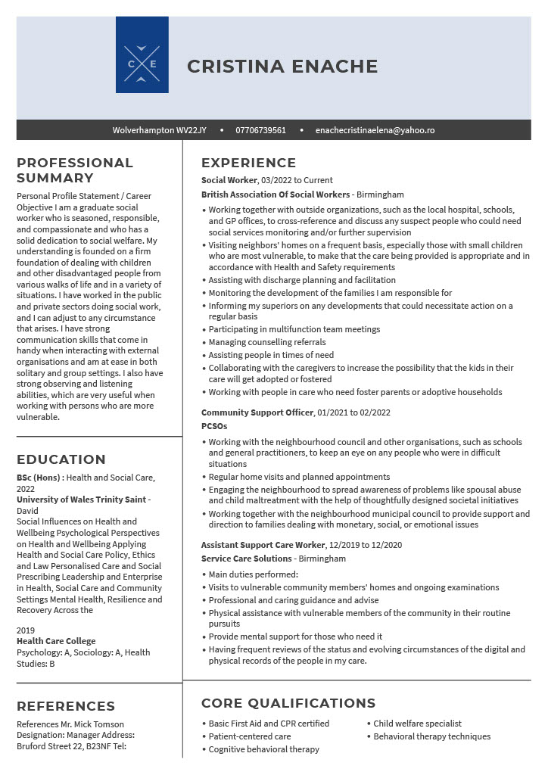

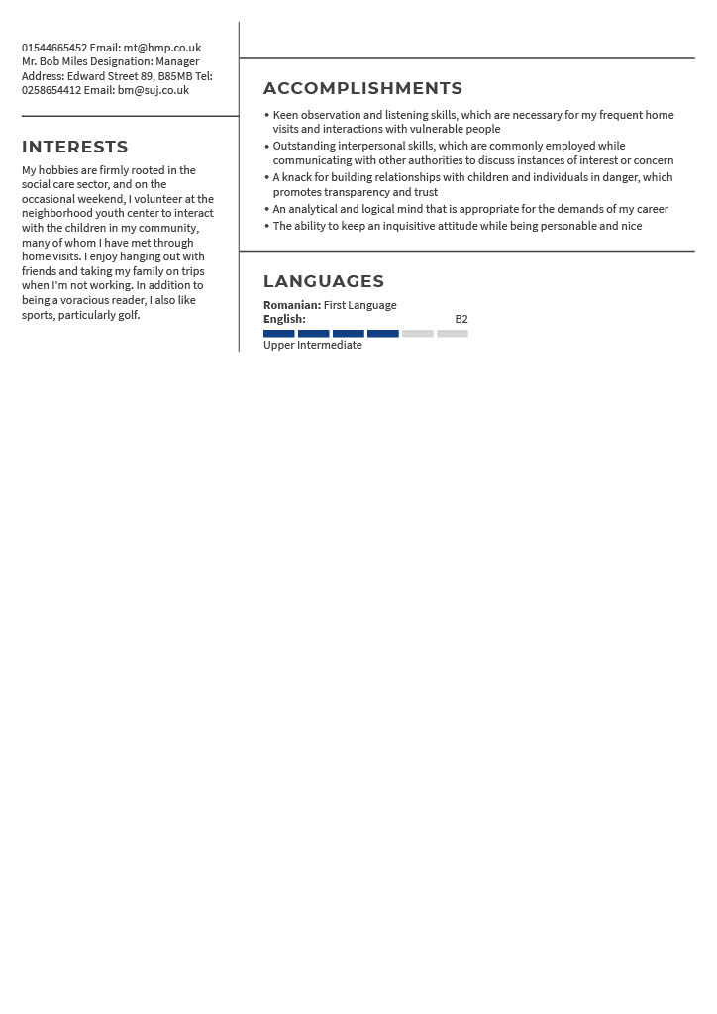

Pitch for a TV Show

Title: Health Warrior

Description: Health Warrior follows the story of a Health and Social Worker Intern Emily, at King’s College Hospital in London. The story shows her journey from being an Intern to becoming one of the most successful Health and Social Workers in the hospital. In the series, the main characters include Tony and Anna two friends of Emily as well as Doctor Richard who is Emily’s mentor. Another important character includes Joe, Emily’s father. Joe has been suffering from Alzheimer’s disease and he is the reason that Emily chose this profession. The show will have 4 episodes in the First season with an approximate length of each episode being 40-45 minutes and will be shown on TV from 24th – 27th November at 7:00 PM. Each episode will feature a new medical story while in the background the journey of Emily for becoming a medical professional will be shown.

Target Audience: For the target audience they can be anyone from the age of 18 to 60. Young people might want to watch this show if they have an interest in becoming a social worker. Aged people will watch this show because of the subject and entertainment purposes.

Location: Most of the part of the series will be shot at King’s College Hospital and in the surrounding areas of London. For showing scenes of operation and surgery, separate stages will be used since the actual operating theatre can be contaminated due to external forces.

Execution: Most of the shooting at the Hospital will take place from 4:00 PM to 10 PM since during the day, the hospital will be busy and it might be difficult to shoot for various reasons. However, other scenes can be shot anytime depending on the script.

Motives & Impact of the Show: The show will be designed in such a manner, which will not only show the specific medical cases in each show but will provide a deep explanation of the problems and solutions for handling such cases. Moreover, a significant part of the show will focus on the learning and experience of Emily, which will help the audience to be more aware of social and mental health as well as encourage the younger generation to join this profession.

Justification: This TV show should be produced by your company because it will be a bit different from other medical shows. Previous shows used to focus on the personal lives of doctors, nurses, and other healthcare professionals while giving less emphasis on the medical aspect of the show. However, this show will focus more on the professional characteristics of a healthcare professional. While watching the show, the audience will get a real-life feeling of what it’s like to become a health and social worker as they follow the adventures of Emily.

Advantage: Firstly, this show offers educational value compared to the diversity of amusement programmes. It means that young people and college students interested in a career in the health and social care sector may also be drawn to this programme. The second benefit of the programme is that it might increase public awareness of the importance of social and mental health. Finally, by raising the TV channel's ratings, this show can boost its popularity.
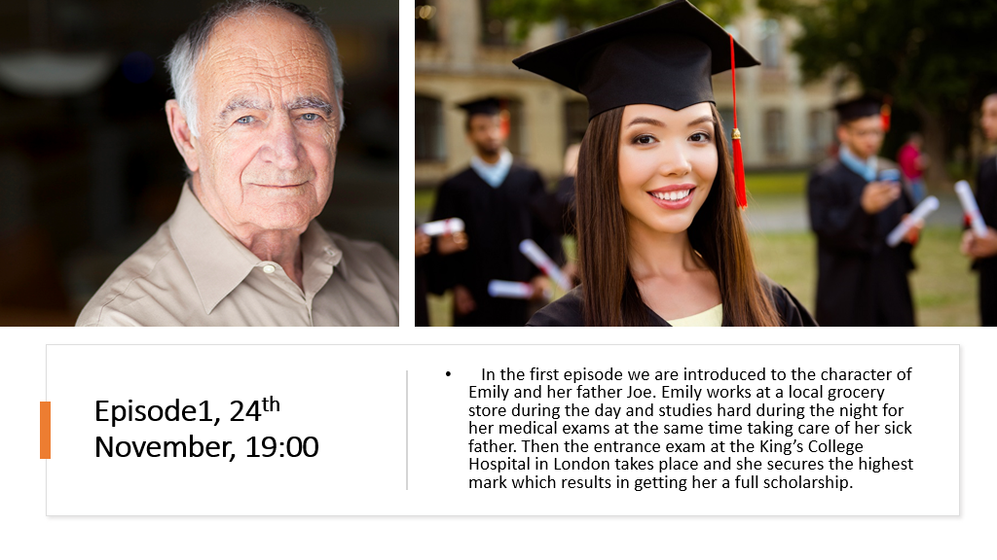

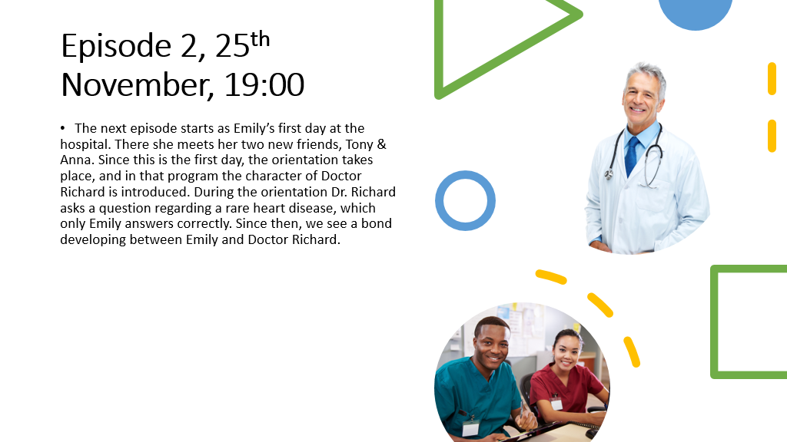





Reference

Kobiruzzaman, M.M. (2019). TV Program Proposal: How To Write Proposal, Instruction & Sample -. [online] Communication Means Sharing Information. Available at: https://newsmoor.com/tv-program-proposal-how-to-write-proposal-instruction-sample/.
Medical Social Worker Cover Letter Examples (n.d.). Medical Social Worker Cover Letter Example + Skills. [online] JobHero. Available at: https://www.jobhero.com/cover-letter/examples/medical/social-worker [Accessed 2 Nov. 2022].
Medical Social Worker Cover Letter Examples & Writing Tips (2022). Medical Social Worker Cover Letter Examples & Writing Tips. [online] CLIMB. Available at: https://climbtheladder.com/medical-social-worker-cover-letter/ [Accessed 2 Nov. 2022].
Social Work Cover Letter Example (2020). Social Work Cover Letter Example | Resume Genius. [online] resumegenius.com. Available at: https://resumegenius.com/cover-letter-examples/social-work-cover-letter-sample [Accessed 2 Nov. 2022].
Straub, J. (2020). How to Pitch a TV Show (Step-by-Step Guide) | Boords. [online] boords.com. Available at: https://boords.com/blog/how-to-pitch-a-tv-show.
Waqas, N. (n.d.). Proposal for Morning show. www.academia.edu. [online] Available at: https://www.academia.edu/4970671/Proposal_for_Morning_show [Accessed 2 Nov. 2022].
www.cvplaza.com. (n.d.). Social Worker CV Template + Tips and Download – CV Plaza. [online] Available at: https://www.cvplaza.com/cv-examples/social-worker-cv-template/ [Accessed 2 Nov. 2022].
‌

