0

Coursework

Subject: Internet Protocols

Assignment Part1: IPv6 Research
Assignment Part2: Network Architecture

Student name: Martin Zhulyov
Student ID: 1912950

Contents
1.Introduction 4
2.History of IPv6 4
3. IPv6 Addressing 4
3.1 Addressing Model 5
3.2 Preferred Format 5
3.2.1 Rule 1: Omit Leading Zeros 6
3.2.2 Rule 2 - Double Colon 6
3.3 Text representation of Address Prefixes 6
3.5 Unicast Addresses 7
3.6 Anycast Addresses 7
3.7 Multicast Addresses 8
4. IPv6 Subnetting 8
4.1 Subnet, using the subnet ID 8
5.Conclusion 9
6.References 9
Part2: Network Architecture 10
Part 2, Section1: Introduction 10
Part 2, Section 2: Task: Design an IP addressing scheme for Faculty of Architecture, Computing, and Engineering. 10
2.1 Determining the IP address range which has to be used. 10
2.2 Determining the subnetting scenario 11
2.3 Creating the basic picture of the architecture. 11
2.4 Creating the subnets. 12
Section3: Assigning the subnets to each of the buildings 12
3.1School of applied computing 12
3.2School of Automotive Engineering 14
3.3School of Architecture, Built and Natural Environment 14
3.4School of Engineering, Manufacturing, and Logistics. 15
3.5Routers networks. 15
3.6 Remaining unused networks. 15
3.7 Calculating the Broadcast address 15
3.8 Default gateways 16
3.9 IPv6 deployment for the 6 Servers and between MP and ISP. 16
Section 4: Topology projection 18
4.1 School of Applied Computing 19
4.2 School of Architecture, Built and Natural environment 20
4.3 School of Engineering, Manufacturing, and Logistic 21
4.4 School of Automotive Engineering 22
4.5 Overall Structure 23
4.6 MP, ISP, and Cloud connection 24

1.Introduction
The following coursework has the purpose to display information for the basic structure of IPv6. It aims to provide the individual who is reading it with advanced information about what it is made of and how it works. Each part was deeply analyzed and interpreted to the point where the meaning of the content is remaining the same.

2.History of IPv6
American Registry for Internet Numbers, (n.d.), states that in the late 80s, IETF figured out that the effect of the internet growth over the IPv4 address protocol was increasing progressively. This led to higher consumption of IPv4 address numbers. For the next several years, several IETF working groups took action to create a successor, which will be removed the disadvantages IPv4 has. After solid work and processing wide range of variants, IETF presented the basis of IPv6 protocols, included in the IETF Draft Standard in December 1998. Nearly one year after, IANA deployed first IPv6 addresses to ARIN and the other Regional Internet Registries . ARIN followed their steps soon after that.

3. IPv6 Addressing

Hinden, R., and S. Deering (2003) suggest that IPv6 addresses are 128-bit in length.
All recognizable IPv6 addresses are:

- “Unicast: An identifier for a single interface. A packet sent to a unicast address is delivered to the interface identified by that address.” (Hinden, R., and S. Deering (2003))

- “Anycast: An identifier for a set of interfaces (typically belonging
to different nodes). A packet sent to an anycast address
is delivered to one of the interfaces identified by that
address (the "nearest" one, according to the routing
protocols' measure of distance).” (Hinden, R., and S. Deering (2003))

- “Multicast: An identifier for a set of interfaces (typically belonging to different nodes). A packet sent to a multicast address is delivered to all interfaces identified by that address.” (Hinden, R., and S. Deering (2003))

IPv6 addresses don't contain the broadcast address as its function is being done by multicast addresses.

3.1 Addressing Model
Hinden, R., and S. Deering (2003) also state that IPv6 are not accredited to nodes, but interfaces. An IPv6 unicast address is being assigned to a single interface. Interfaces of different nodes may use unicast address for successful identification.
It is a mandatory requirement for all the interfaces to contain link-local unicast address. It is allowed a single interface to have more than one unicast, anycast, and multicast addresses or scope.
IPv6 is using the same model as IPv4, where a subnet prefix is recognized with one link. One link can contain multiple subnet prefixes

3.2 Preferred Format
Cisco Networking Academy (n.d.) points that Every IPv6 address is written by consisting four hexadecimal values for each “z” if its address is z:z:z:z:z:z:z:z. The term octet refers to eight bits of an IPv4 address. Hextet is an unassociated term used to indicate a block of sixteen bits or four hexadecimal digits. Each "z" is a single hextet which is 16 bits or four hexadecimal digits.
Using the preferred format, the IPv6 is being written by using all 32 hexadecimal digits. This is not the ideal method for representing the IPv6 address.
These are examples of IPv6 address in the preferred format:
• 1303 : 0ff1 : 3013 : 11a4 : ddcf : 1010 : 1001: cf13
• 2025 : 0fd1 : 3013 : 0001 : c012 : 9aff : dd9a: dcac
• 1001 : 0db3 : abcd : 1013 : 2323 : 3434 : 3334: 0000
• fd96 : 1717 : 0001 : 0200 : 0000 : 5300 : 98bc: cdef
• df30 : 1818 : 0003 : 0100 : 912b : ff3d : fd3c : 1001

There are two rules which could be used to be reduced the number of numbers in the IPv6 address.

3.2.1 Rule 1: Omit Leading Zeros
Cisco Networking Academy (n.d.) concludes that this rule helps reducing the notation of IPv6 addresses by removing any leading zeros in any hextet. Here are two examples of ways to omit leading zeros:
01ab is 1ab
00cd is cd
Example for “Omid Leading Zeros” technique is:
Preferred - 3003 : 00b8 : 0000 : 1111 : 0010 : 0000 : 0000 : 0200
After “Omid Leading Zeros” - 3003:b8:0:1111:10:0:0:200

3.2.2 Rule 2 - Double Colon
Cisco Networking Academy (n.d.) states that this rule is to help to reduce the notation of IPv6 addresses by adding a double colon (::).
For example, 1325:db7:fcdf:1:0:0:0:1 (leading 0s omitted) could be represented as 1325:db8:fcdf:1::1. Here the double colon is used to replace all the three hextets, containing only zeros. The double colon must be used only once in the address, otherwise, the result will be more than 1 possible address. Example of incorrect use of a double colon is:
1001:5::fcdf::1

3.3 Text representation of Address Prefixes
Cisco Networking Academy (n.d.) suggests that the prefix length in IPv6 is indicating the network portion and it is stated in /x notation.
It ranges from 0 to 128. But there are recommended prefix length. The recommended IPv6 prefix length is /64, as shown in the figure.
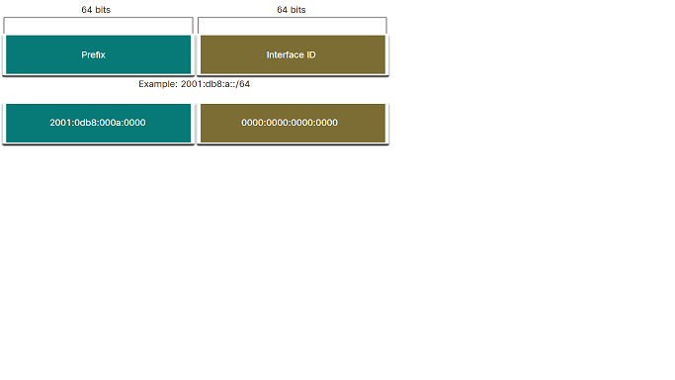
The figure is taken from netacad.com

It is highly recommended 64-bit interface ID’s to be used for most networks. This is because stateless address autoconfiguration (SLAAC) uses 64 bits for the interface ID. The subnetting becomes a lot easier to be created and managed when using this 64-bit interface ID's.

3.5 Unicast Addresses
“IPv6 unicast addresses are aggregable with prefixes of arbitrary bit-length. An IPv6 unicast address uniquely identifies an interface on an IPv6-enabled device. A packet sent to a unicast address is received by the interface which is assigned that address. Similar to IPv4, a source IPv6 address must be a unicast address. The destination IPv6 address can be either a unicast or a multicast address” ( Hinden, R., and S. Deering (2003)
The types of recognizable addresses in IPv6 are:
- Global unicast;
- Site-local unicast;
- Link-local unicast.

3.6 Anycast Addresses
Hinden, R., and S. Deering (2003) state that when an IPv6 is existing in more than one interface , it is named anycast address. It belongs to different nodes.. Nearest interface, who has anycast address is receiving packet sent to anycast group.

These are the restrictions for IPv6 anycast:

- ”An Anycast address cannot play the role of the source address of an IPv6 packet and therefore it must not be used as a source address.” (Hinden, R., and S. Deering (2003)).
- “An Anycast address may be assigned to an IPv6 router, but it must never be assigned to an IPv6 host.” (Hinden, R., and S. Deering (2003)).

3.7 Multicast Addresses
Cisco Networking Academy (n.d.) concludes the following IPv6 Multicast:
- Well-known IPv6 multicast addresses - They are assigned and reserved for predefined groups of devices. They are used to reach a group of devices running a common protocol of service. There are two recognizable IPv6 assigned multicast groups:
- Ff02::1 all-nodes – In this group, all IPv6 enabled devices are joined. When a packet is sent to this group, all IPv6 interfaces on the link or network are receiving it. The effect is identical to broadcast address in IPv4
- Ff02::2 all-routers – All routers are joined in this multicast group. When a packet is sent to this group, all IPv6 routers on this link or network are processing and receiving the packet.
- Solicited-node multicast addresses –it is similar to an all-nodes multicast address. But it has an advantage over all-nodes multicast address. The advantage is that it is mapped to a special Ethernet multicast address. This allows the frame to be filtered by the Ethernet NIC by examining the destination MAC address without processing it to IPv6.

4. IPv6 Subnetting
Cisco Networking Academy (n.d.) states that Subnetting in IPv4 aims to use the address spaces effectively. But IPv6 provides many more addresses than IPv4. The reasons IPv6 subnetting is used are:
- To prevent unnecessary traffic;
- To have an effective and flexible network design;
- To provide an easy route summarization.

4.1 Subnet, using the subnet ID
Cisco Networking Academy (n.d.) concludes that recall that with IPv4, bits must be borrowed from the host portion for subnets to be created. This is because IPv6 is a successor and close related to IPv4. But IPv6 was designed with subnetting in mind. That’s why a separate subnet ID field in the IPv6 GUA is used to create subnets. As shown in the figure below, the subnet ID field is located between the Global Routing Prefix and the interface ID.

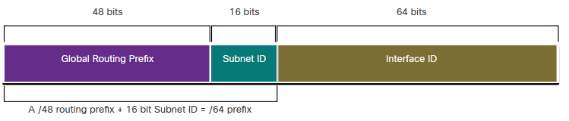
The figure is taken from netacad.com

16-bit subnet ID creates 65536 subnets.

5.Conclusion
In this article have been analyzed the basics of IPv6. Its structure Is developed very well and allows many more PC’s to be connected in a network around the World. Its design is so advanced that we may never need any other addressing protocol to be invented. It also is designed to make the connections easier and predictable. It is surpassing IPv4 in many aspects. It has a much larger address space (340 undecillion), compared to 4.2 billion in IPv4 which allows each person to have billions of IPv6 possible addresses for every device they own.

6.References
American Registry for Internet Numbers, 1997, ‘The history of IPv6’. Available at: <https://www.arin.net/resources/guide/ipv6/history/?cv=1> (Accessed 17 April 2020).
Cisco Networking Academy, n.d., ‘IPv6 Addressing’, Available at <https://contenthub.netacad.com/itn> (Accessed 15 April 2020).
Hinden, R., and S. Deering, “IPv6 Addressing Architecture”, RFC 3513, April 2003. Available at: <https://tools.ietf.org/html/rfc3513> (Accessed 19 April 2020).

Part2: Network Architecture

Part 2, Section1: Introduction
This coursework has the purpose to show a basic understanding of:
- Ipv4 addressing
- Subnetting
- Ipv6 addressing
- Network Topology

Each segment has been deeply analyzed to be delivered a satisfactory outcome. The job done is fully tailored to the task.

Part 2, Section 2: Task: Design an IP addressing scheme for Faculty of Architecture, Computing, and Engineering.

2.1 Determining the IP address range which has to be used.

Pointing from the total amount of the end devices into this network, the most cost-effective IP address would be 4096 hosts in range. Let's conclude that an ISP is providing IP address Class B, which is 128.1.0.0/20. It can be seen, that the ISP has already divided this IP address to 16 subnetworks(because class B IP addresses have subnet mask 255.255.0.0 or 16 network bits, but we can see that the ISP had added 4 more bits to make it /20). The range of the given network is the first subnetwork from this 128.1.0.0/20 which is:
128.1.0.0/20 to 128.1.15.255/20
This range provides space for 2¹² – 2 = 4096 – 2 = 4094 hosts. (Each network has two reserved spaces – one for the network and one for the broadcast).

2.2 Determining the subnetting scenario

Pointing from the task description, it could be seen, that there is no Laboratory with more than 245 end devices, and based on that /24 (with 255.255.255.0 subnet mask) subnetworks will be used. Also, the number of end devices is uneven for the rooms in each building. To make the IP address usage more efficient, and minimize the congestion between the networks, a VLSM technique will be used.
What is VLSM?
Cisco Networking Academy (n.d.) suggests that Variable-Length Subnet Masking refers to “subnetting subnets”, which means that VLSM allows an IP address space to be divided into several subnets of different sizes.

2.3 Creating the basic picture of the architecture.

Each of the four buildings will have the following:
- One router for each room, which will be corresponding with the Floor Router;
- One floor router, which will be attached to the surrounding Floor routers;
- Two main routers, which will be attached to the each of the floor routers, between each other and with the surrounding main routers from the other three buildings; (Placing two main routers is increasing the effectivity of the processing the information, as the data from the building can be transmitted unaffected if failure occur in each of the main routers.);

- One core router which will be attached to the two main routers.

The connection between the Buildings:
It will be established through connections between the Main routers and the Core routers, located in each of the buildings
Connection to the MP, ISP, and the Internet(the Cloud):
Each of the four core routers will be attached to the Multiprotocol Router. It will be laid in the center of the topology.
The Multiprotocol Router itself will be connected to the ISP (Internet Service Provider) router.
The ISP router will be connected to the Cloud (The Internet).

2.4 Creating the subnets.
The IP address range provided by the ISP will be class B. Normally class B IP addresses have 255.255.0.0 subnet mask. This means that each subnet allows space for 2¹⁶ – 2 = 65536 – 2 = 65534 usable IP addresses. Let’s say that ISP has divided 128.1.0.0/16 network to 16 subnetworks by adding 4 bits to the subnet mask and making it /20 (the new subnet mask will be 255.255.255.240) and provides one of those /20 subnetworks (128.1.0.0/20) to the University project. This subnet ranges from 128.1.0.0 to 128.1.15.255 with 2¹² – 2 = 4094 usable host IP addresses.
128.1.0.0/20 will be divided into four subnets by adding two bits. The new subnet mask will be /22 or 11111111.11111111.11111100.00000000 or 255.255.252.0. The created subnets are as follows:
128.1.0.0/22
128.1.4.0/22
128.1.8.0/22
128.1.12.0/22
Each of the four subnets has a total amount of 2¹⁰ – 2 = 1024 – 2 = 1022 free IP host addresses.

Section3: Assigning the subnets to each of the buildings

3.1School of applied computing
It contains 10 rooms each with various hosts. The test center Lab and the open-access Lab will be included in the building and the number of the rooms will become 12 in total. VLSM subnetting will be deployed for optimizing the IP address usage.
The first /22 subnetwork (128.1.0.0) will be taken and divided into 4 subnets by adding two bits to the subnet mask. The new subnets will be:
128.1.0.0/24
128.1.1.0/24
128.1.2.0/24
128.1.3.0/24

128.1.0.0/24 network will be given 1 more network bit and it will be divided into two /25 (255.255.255.128 Subnet mask) subnetworks.
128.1.0.0/25 will be assigned to lab 308, which contains 120 Pc’s in total. The GigabitEthernet interface for the router, connected to that room will be the first usable host IP address from this network or 128.1.0.1/25. Each of the 120 PC’s will be given the next usable host addresses (up to 128.1.0.121/25). The default gateway that each PC will have for exiting from this network will be the GigabitEthernet interface IP address of the router (128.1.0.1/25). This scenario will be made analogically for each next Lab.
Please note that the/27 network which contains 30 usable host IP addresses cannot be assigned to Lab with 30 PCs because 1 more IP address for the GigabitEthernet Router interface is needed. The same scenario is for Labs with 6,14, 62, 126, 254 PCs, but there are no such Labs in the task.

The remaining 128.1.0.128/25 network will be given 1 more network bit and It will be divided into two networks with subnet mask 255.255.255.192, each of which will contain 62 usable host IPs.

128.1.0.128/25 will be assigned to Lab301. It contains 50PCs.
128.1.0.192/25 will be assigned to Lab306. It contains 40PCs.

128.1.1.0/24 will be divided into four /26 subnetworks.

128.1.1.0/26 will be assigned to Lab 410. It contains 40PCs.
128.1.1.64/26 will be assigned to Lab 412. It contains 36PCs.
128.1.1.128/26 will be assigned to Lab 411. It contains 30PCs.
128.1.1.192/26 will be divided into two /27 networks (each subnetwork supports 30 usable host IPs) and each subnetwork will be assigned respectively to:
128.1.1.192/27 - Lab305 (20PCs)
128.1.1.224/27 - Test Centre room (15PCs, 1 IP phone, and 1 web camera);

128.1.2.0/24 will be assigned to the open-access lab which contains 240PCs in total and 5 printers;

128.1.3.0/24 will be divided to various length subnets, as follows:
128.1.3.0/26 – Lab 302 (30pcs);
128.1.3.64/26 – Lab 303 (30pcs);
128.1.3.128/27 – Staff room (25pcs).
The remaining two subnetworks 128.1.3.160/27 and 128.1.3.192/26 will be given respectively 3 and 4 more subnet mask bits and will be divided to:
128.1.3.160/30 has 8 networks with 2² – 2 = 2 usable host IPs;
128.1.3.192/30 has 16 networks with 2² – 2 = 2 usable host IPs.
Those 24 networks will be used for the serial connections between the Routers in the whole structure. More /30 subnetworks will be created in case of a lack of them.
This scenario can be done with each of the other three buildings remaining small networks (/26 or /27).

3.2School of Automotive Engineering
The subnetting for this building will proceed analogically as the one for the University Building. We have used all of the 4 subnets, which we created through borrowing 2 bits from 128.1.0.0/22. Now the next /22 subnetwork (128.1.4.0) will be taken and will be divided into four /24 subnets with 254 usable IP hosts each.
128.1.4.0/24 will be divided through VLSM as follows:
128.1.4.0/25 – Lab 301 (80pcs);
128.1.4.128/26 – Lab 206 (55pcs);
128.1.4.192/26 – Lab 102 (35pcs).

128.1.5.0/24 will also be divided through VLSM as follows:
128.1.5.0/26 – Lab 103 (30pcs);
128.1.5.64/27 – Lab 205 (20pcs);
128.1.5.96/27 – CAD Lab (20pcs);
128.1.5.128/27 – Staff Lab (20Pcs);
128.1.5.160/27 Lab 101 (25pcs).

3.3School of Architecture, Built and Natural Environment
The next /24 networks will be taken and will be divided using VLSM as follows:
128.1.6.0/26 – Lab 409 (60pcs);
128.1.6.64/26 – Lab 410 (45pcs);
128.1.6.128/27 – Lab 202 (25pcs);
128.1.6.160/27 – Lab 408 (28pcs);
128.1.6.192/27 – Lab 205 (28pcs).
Network 128.1.6.0/24 will be evenly divided into four subnetworks by adding two bits to the subnet mask.
128.1.6.0/26 – Lab 404 (35pcs);
128.1.6.64/26 – Staff Lab (32pcs);
128.1.6.128/26 – Lab 404 (35pcs);
128.1.6.192/26 – Lab 201 (54pcs).

3.4School of Engineering, Manufacturing, and Logistics.
128.1.7.0/25 – Lab 208 (90pcs);
128.1.7.128/26 – Lab 206 (50pcs);
128.1.7.192/27 – Lab 105 (25pcs);
128.1.7.224/27 – Staff Lab (18pcs);

128.1.8.0/26 – Lab 103 (30pcs);
128.1.8.64/26 – Lab 102 (30pcs);
128.1.8.128/26 – Lab 102 (35pcs).

3.5Routers networks.
The connection between the routers will be made by splitting the remaining subnetworks spaces in the four buildings into /30 subnetworks. Those networks are containing two available host IP addresses, one network address, and one Broadcast address.
For example
All of those /30 networks will be dispersed through the routers.

3.6 Remaining unused networks.
The unused network space is:
128.1.9.0/24 – 254 Hosts
128.1.10.0/24 – 254 hosts
128.1.11.0/24 – 254 hosts
128.1.12.0/22 – 2¹⁰ – 2 = 1022 hosts

3.7 Calculating the Broadcast address
Each network must have IP specially assigned for the Broadcast. Each network from this presentation will be given a Broadcast address. This address will be the last usable address from each network. For example:
The Broadcast address for 128.1.0.0/25 will be 128.1.0.127

3.8 Default gateways
The Default gateways are needed for a packet to exit a network it is produced in. For each room, the default gateway will be the IP address, assigned to the gigabit ethernet interface to the particular router, allocated in that room.
For example, 128.0.1.0/25 will have 128.0.1.1/25 as a default gateway for each end device, located within this network.

3.9 IPv6 deployment for the 6 Servers and between MP and ISP.
As seen from the projection of the University Building, the six servers are attached to two switches and those two switches are attached to two routers. Each Router's interface will need an IPv6 address from a different IPv6 network. A separate IPv6 network is needed for the connection between MP and ISP.
A Global Unicast address will be assigned for the links between MP and ISP, and between the two routers with three servers attached to each of them. To assign appropriate IPv6 addresses, a EUI-64 address calculation will be deployed. It is using the device's MAC address to create the link-local address and the host portion of the IPv6 Global Unicast address so they all can be logically connected.
- Serial 0/0/0 of ISP will be given Global Unicast address as follows:
If its mac address is 0000.0000.0001, it will be converted to 64 bit 0200:00FF:FE00:0000:0001. Then the link-local address will be fe80::0200:00FF:fe00:0000:0001. And following the logic, the IPv6 64-bit interface will be assigned with the 64bit converted MAC address 2001:db8:1337:1:0200:00FF:FE00:0000:0001/64 (2001:db8:1337:1 – this is the 16bits network ID).
Serial 0/0/0 of MP will follow the same logic and the addresses will look as follows:
MAC: 0000.0000.0002
MAC 64 bit: 0200:00FF:FE00:0000:0002
LLA: fe80::0200:00FF:FE00:0000:0002
GUA: 2001:db8:1337:1:0000:00FF:FE00:0002
It could be seen how the MAC address is used for the design of a unique IPv6 address.

- Each from the two routers alongside the three servers that are connected to will be joined into a node-solicited multicast group. This allows each packet destined to that network, to be received exactly to the device that it is sent for.
The two routers will be given two separate /64 IPv6 global unicast networks:
- Router 1 interface g0/0 will be assigned the following IPv6 address:
MAC: 0000.0000.0003
LLA: fe80::0200:00FF:FE00:0000:0003
GUA: 2001:db8:1337:2:0200:00FF:FE00:0000:0003/64
Server 1:
MAC: 0000.0000.0004
LLA: fe80::0200:00FF:FE00:0000:0004
GUA: 2001:db8:1337:2:0200:00FF:FE00:0000:0004/64
Server 2:
MAC address: 0000.0000.0005
LLA: fe80::0200:00FF:FE00:0000:0005
GUA: 2001:db8:1337:2:0200:00FF:FE00:0000:0005/64
Server 3:
MAC: 0000.0000.0006
LLA: fe80::0200:00FF:FE00:0000:0006
GUA: 2001:db8:1337:2:0200:00FF:FE00:0000:0006/64
All three servers will use the link-local address on Router 1 as a default gateway for exiting the network.
- Router 2: The following link-local and global unicast addresses will be assigned to interface g0/0 (logically manufactured from the MAC address):
MAC: 0000.0000.0007
LLA: fe80::0200:00FF:FE00:0000:0007
GUA: 2001:db8:1337:3:0200:00FF:FE00:0000:0007/64
Server 4:
MAC: 0000.0000.0008
LLA: fe80::0200:00FF:FE00:0000:0008
GUA: 2001:db8:1337:3:0200:00FF:FE00:0000:0008/64
Server 5:
MAC: 0000.0000.0009
LLA: fe80::0200:00FF:FE00:0000:0009
GUA: 2001:db8:1337:3:0200:00FF:FE00:0000:0009/64
Server 6:
MAC: 0000.0000.000a
LLA: fe80::0200:00FF:FE00:0000:000a
GUA: 2001:db8:1337:3:0200:00FF:FE00:0000:000a/64

All three servers will be assigned the link-local address of Router 2 as their default gateway address for exiting the network.

Section 4: Topology projection

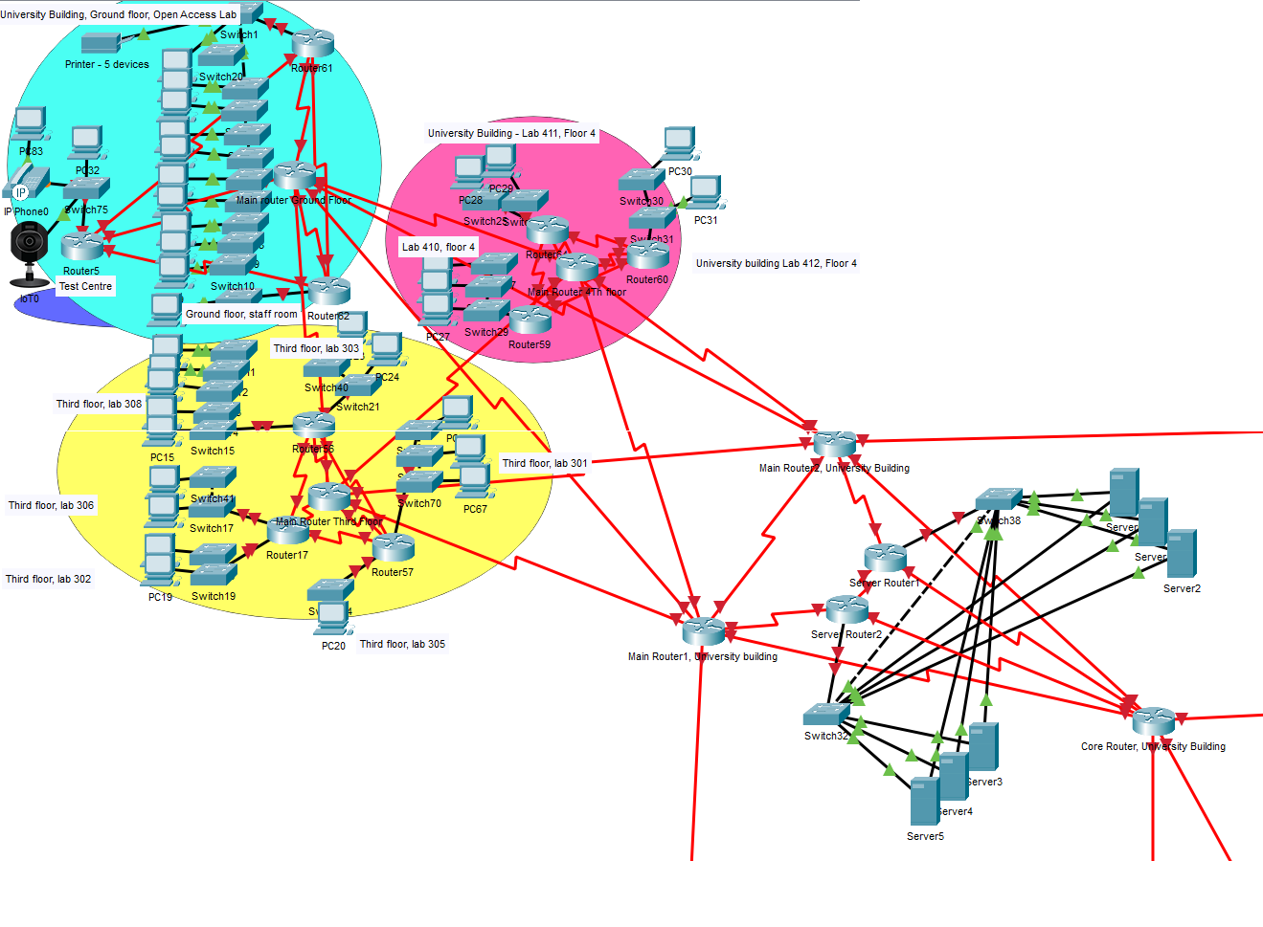
4.1 School of Applied Computing

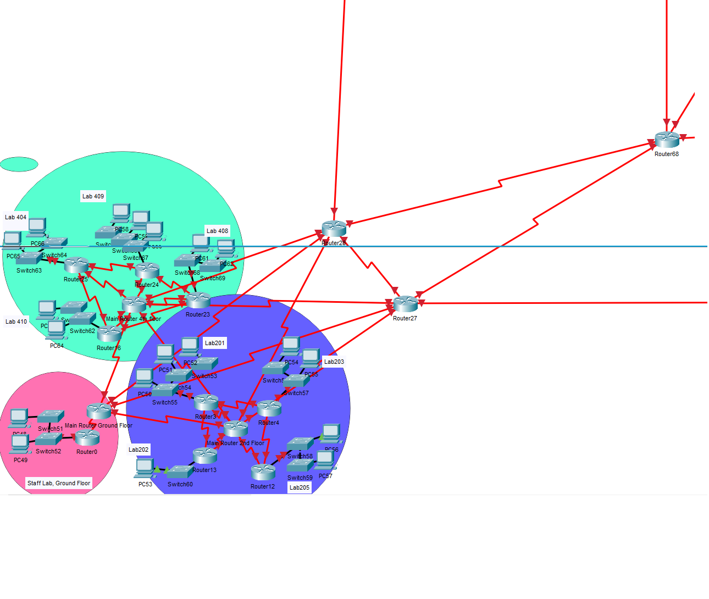
4.2 School of Architecture, Built and Natural environment

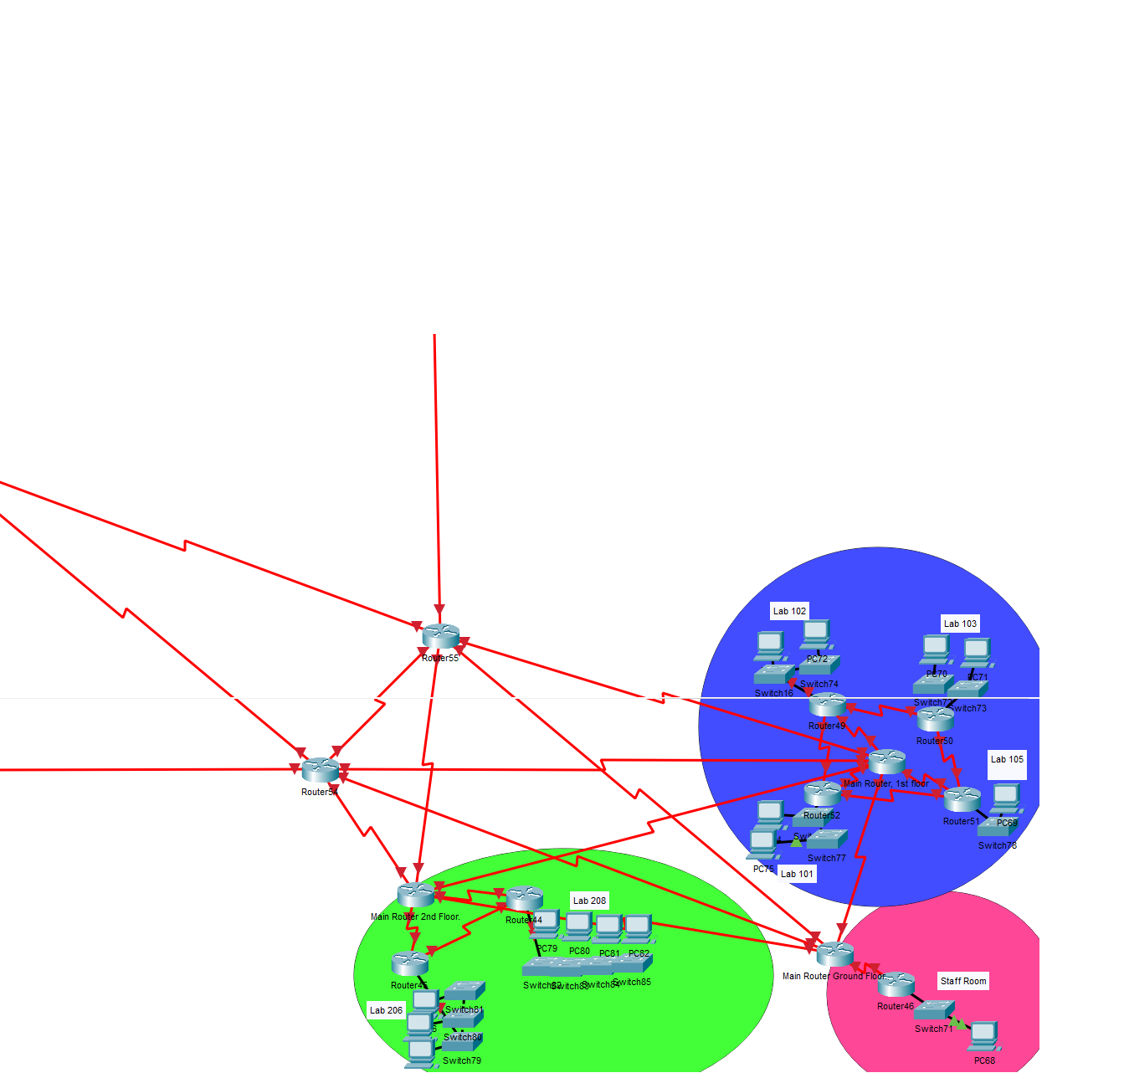
4.3 School of Engineering, Manufacturing, and Logistic

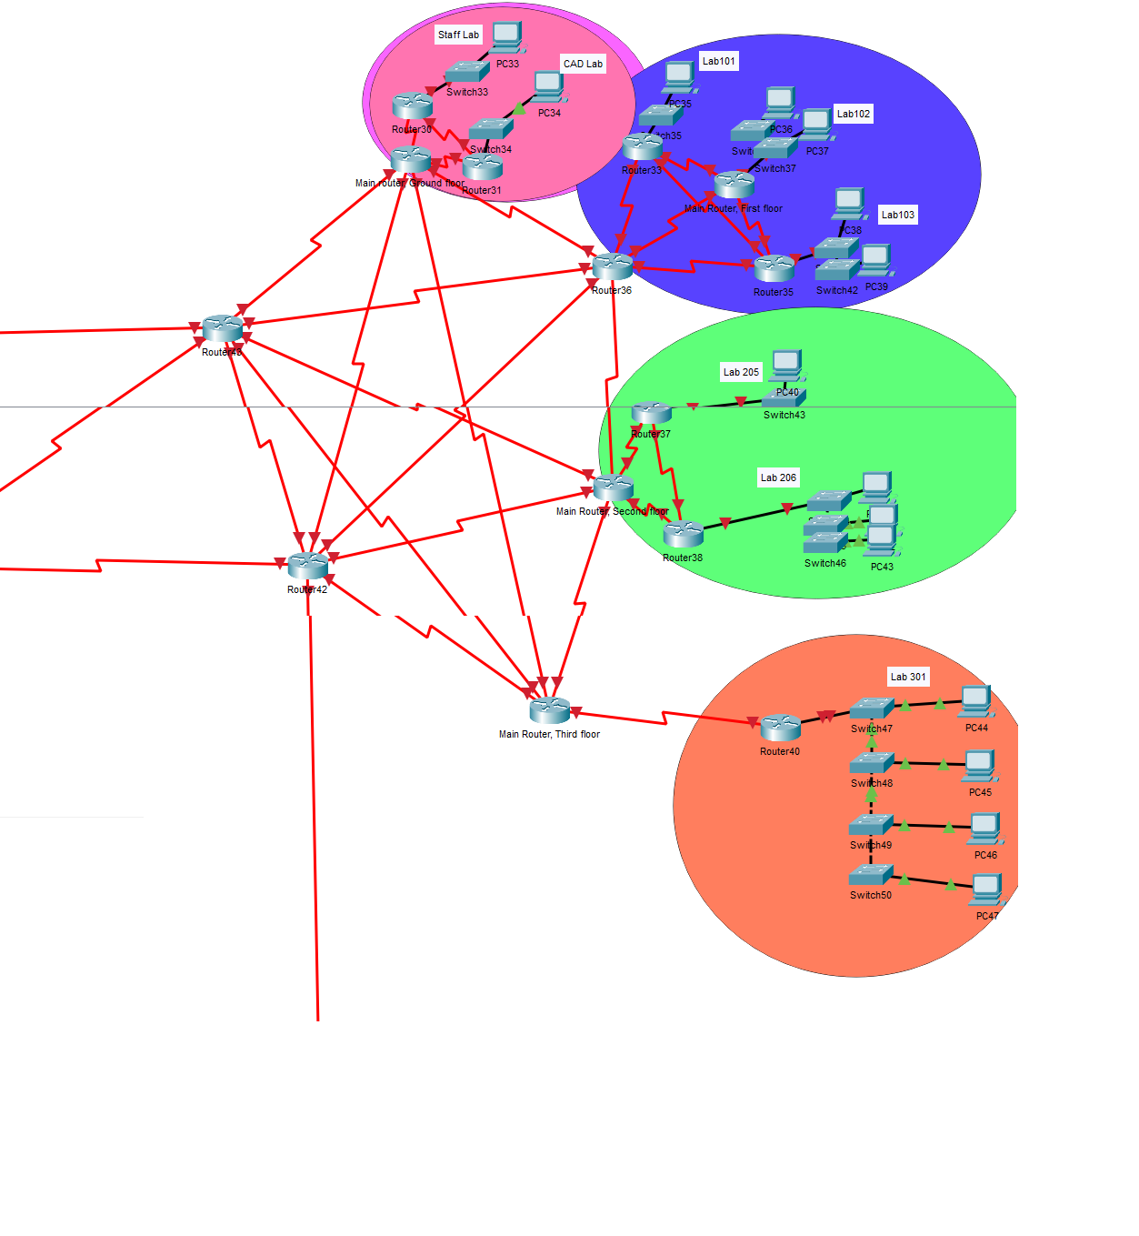
4.4 School of Automotive Engineering

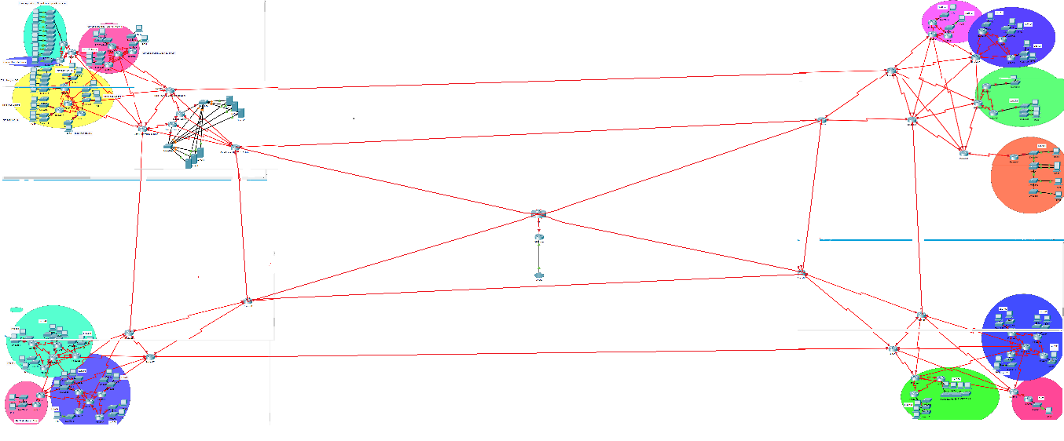
4.5 Overall Structure

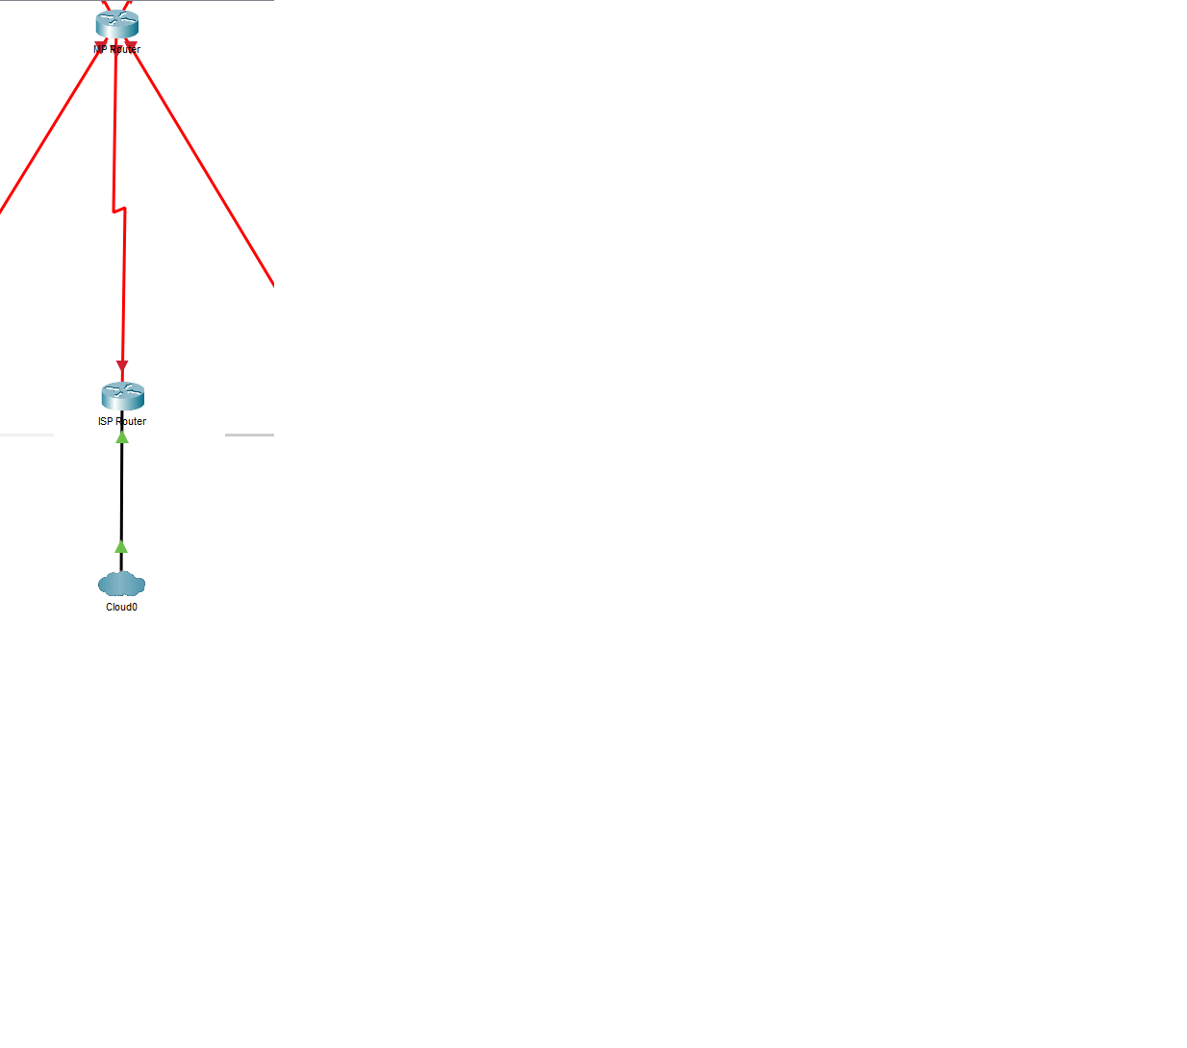
4.6 MP, ISP, and Cloud connection

