
Learning log report
Llanelli
BA Business and Management
Distinctiveness & Regeneration - BMSP4005 - Lecturer: Anthony Burns/Jessica Shore Due Date: 15/03/19
Alexander Apps (1806320)
1806320@student.UWTSD.ac.uk
Llanelli’s Distinctiveness
Introduction

What makes one place distinct from another? What would be the prime specifics, and quintessence’s that would make in effect Honolulu a pale and forgettable place when that lifestyle is compared with Antarctica! Or Antarctica compared to Mars.
Llanelli has a few ubiquities that are unique to this corner of Terra Firma. Historical and natural characteristic’s that are a singular intaglio on the natural face of this land. Llanelli’s part was played well in the industrial revolution and Llanelli, now maintains a sustainable direction for local industry with a willing need for environmental perpetuance.
Llanelli’s Coat of Arms (Council, 2018)

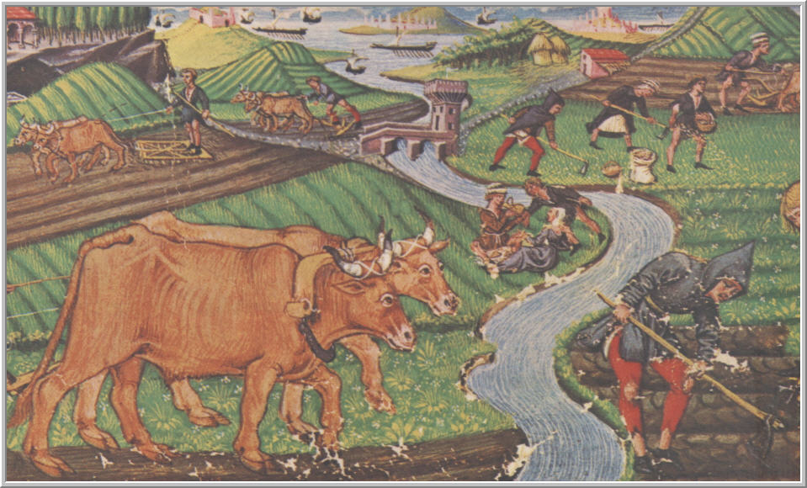
An Artist’s rendition of an Agrarian Society, Pre-Industrial revolution (ageofexplorationweb)

Llanelli Before the Industrial Revolution
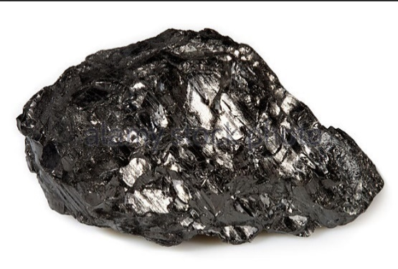
Before the Industrial Revolution Llanelli was an Agrarian society with great unemployment (J. Hannan, 2019). From 1700-1750 most of the inhabitants were trading in “sea coal”, and had no investment, prior to the Industrial Revolution. Estates required large amounts of man-power to farm and society at this time had power limits, due to the technological limitations, of the pre-mechanical age.
Anthracite: One of the most valuable forms of coal (agefotostock, 2019)
What changed?
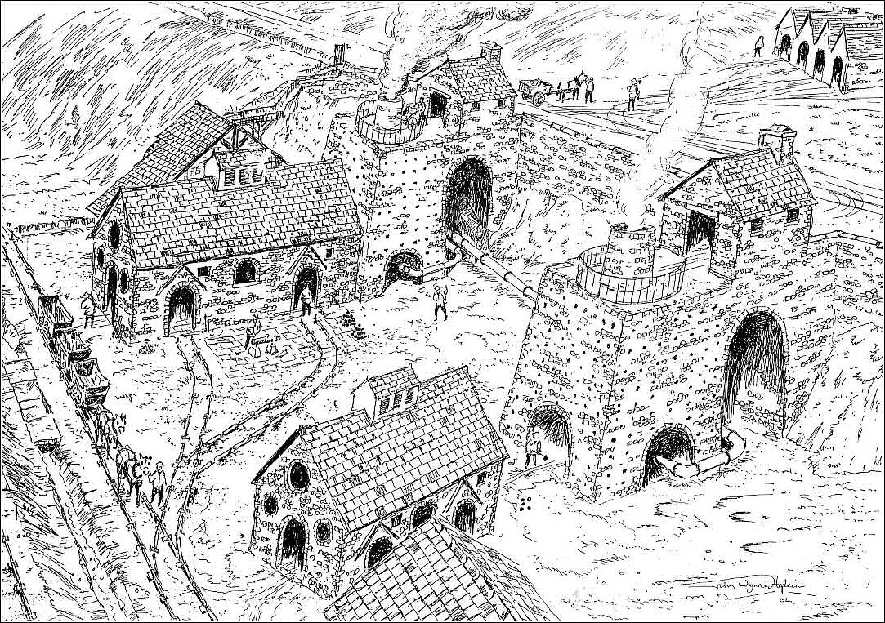
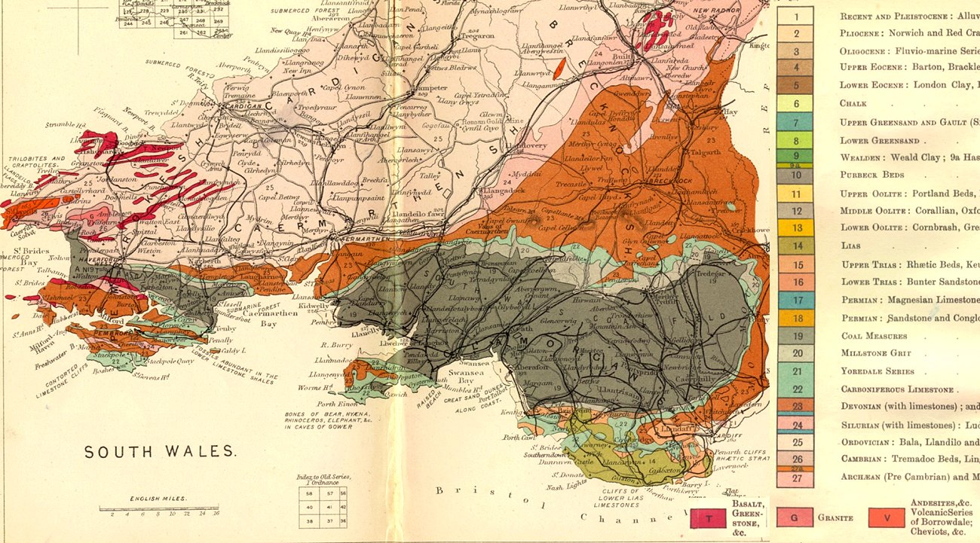
Llanelli directly benefited from the carboniferous age, having large deposits of Anthracite. Anthracite is a very valuable form of coal, capable of producing a higher level of energy output due to the possession of a 97% carbon density. In 1797 Alexander Raby arrived in Llanelli followed shortly by many other industrialists and secured a 91-year lease to mine the coal under the Straedy estate. He is credited with the industrial development of Llanelli. Leading to collieries, a forge, Raby’s furnace (Ephgrave, 2019) for metal work, docks and transportation of coal by rail. In 150 years, Britain was industrialised and by 1895 Llanelli was a major industrial hub. Local railways were powered by Llanelli’s coal. At the height of the coal boom (1880’s - 1913), South Wales produced 57,000,000 tons of coal per year employing 232,000 miners in 620 mines (Agor, 2019) and Coal was shipped as far as South America. By 1920, 271,000 men worked as coal miner’s in Wales, now a prosperous industry. But Coal is a poisonous chalice. Pneumoconiosis a lung disease (Seaton, 2016), brought medical attention to mining particularly in South Wales. The Atlee government (Prime Minister 1945 - 1951), had to confront this creeping menace; since 1.2 million men were involved in coal mining 20% of the population at the end of 1920, they required compensation each year and by 1936, 241 mines were decommissioned along with 141,000 jobs in South Wales. Seaton surmised “[it] is an irony of history that this research outcome coincided with the terminal decline of the UK coal industry” (IBID). The cost of domestic coal production was increasing. Coal use for home and industry also created great smog’s over cities and was known to correlate with an inordinate number of older people’s deaths. The side effects of the industry were adding to the death toll in the mining workforce and at the end of the Second World War, the coal industry lapsed in to recession which was accompanied by foreign investments in their coal industries and the global and domestic co-dependence of an insurgent Oil industry. Although there was a demand for coal the war was darkly psychosomatic, the industry was nationalised in 1947 destroying the private market. Welsh coal exports were down to 750,000 tons and would need to be advanced in technology, engender mercantile investment and create better safety practises; this would not save the coal industry in Wales. With a rapidly expanding Oil and air travel industry, it led to the death of 50 collieries from 1957 – 1964, there was some respite with OPEC’s formation in the 1970’s, but by the 1980’s the domestic coal industry was leprous. Lamentably the miner’s strike of 84’ was not enough to dent the ‘Dreadnaught of Azrael’ (The Angel of Death), from obliterating the largest employer within Wales. Llanelli lost this industry. Now, with this loss, regeneration is so essential for this town whatever future form it takes.
Picture of Raby’s Furnace (Heritage)
Below: The massive coal shelf that extends thru South Wales created during the Devonian period roughly 390 – 290 Million years ago, Anthracite becomes more abundant the further west you progress (West, 2012)
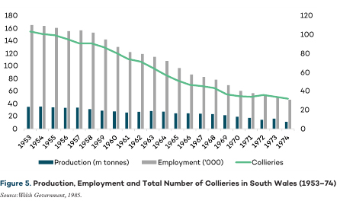
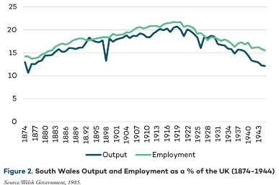
Above: The eventual decline in Coal output (Report, 2017)
Above: The loss of mines in South Wales thoughout the 20th century (Report, 2017)

Trostre Steel Works
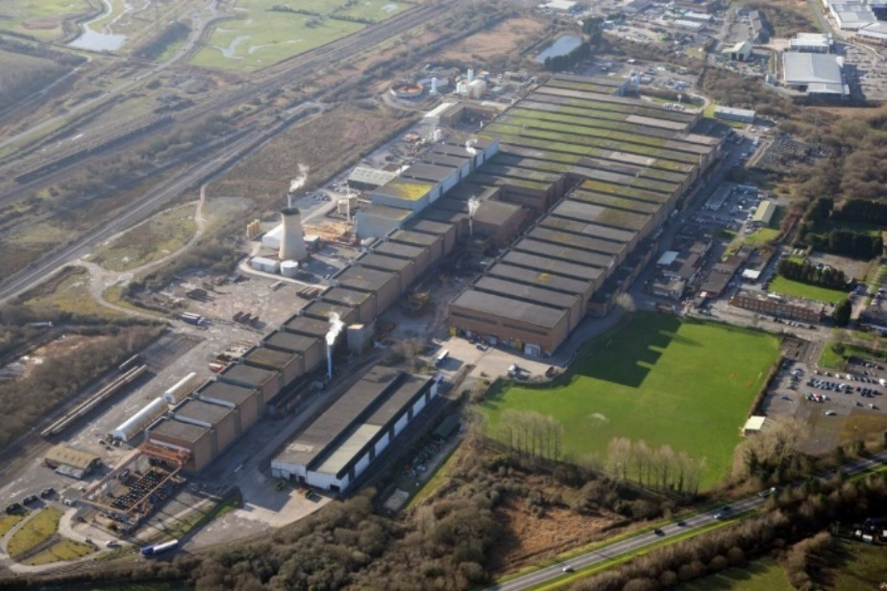
Tata Steel-Works in Trostre, further adds to the industrial sustainability and distinct industrial quality that Llanelli has acquired. Established in 1947 (coflein, 2012), this company employs 600 workers (N. Jones, 2019), creating most of the tin cans used for food in Europe. Port Talbot sends processed coiled steel to Trostre on Tata’s own rail network. The Trostre works are essential for Tata’s survival and with China dumping cheap steel on the world market…; any governmental protective strategy needs to include Port Talbot steel works thus protecting Trostre. If Llanelli’s Steel Works suffered an unfortunate closure Llanelli may not be able to recreate an additional industry of such great industrial character thus denying jobs and money for the local economy. The steel works is a beacon in Llanelli and has had great attention and investment from companies and corporations worldwide. Could anyone imagine Trostre without this steel works, if so, Llanelli would lose some of her primary distinctiveness and her future industrial sustainability. As of now, this industrial corset, is still needed for a high-level of industrial sustenance.
Tata Steel works at Trostre in Llanelli (coflein, 2012)
The Llanelli Wet-Lands

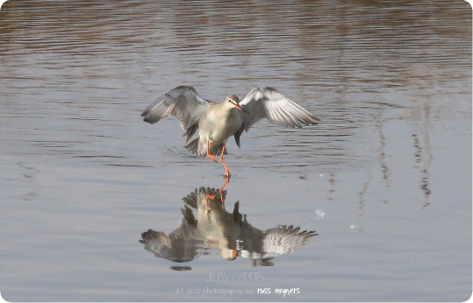
True distinctiveness is found in nature. The Wetlands is a salt marsh that is currently home to 57 different varies of birds (S. Rees, 2019). Financed by the Wildfowl and Wetlands Trust (WWT, 2019) the wetlands have become the definition of local distinctiveness within Llanelli. A sculptured Svengali for plant and animal life in the region. It marked a remarkable development of unused farmland to become a sustainable tourist destination that attracts roughly 70,00 people per year as of 2018. This creates a massive footfall in the area providing jobs and local tourism vital to continued regeneration. This huge stream of revenue is vital to Llanelli and helps boost interest in other areas. Uniquely beneficial without her Llanelli would lose jobs and revenue essential for any continued investment within Llanelli. The wetlands continue to rise in popularity which greatly benefits Llanelli’s regenerative trajectory.
Some of the Species spotted in February 2019 (Trust, 2019)
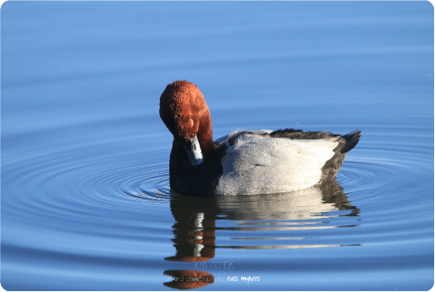
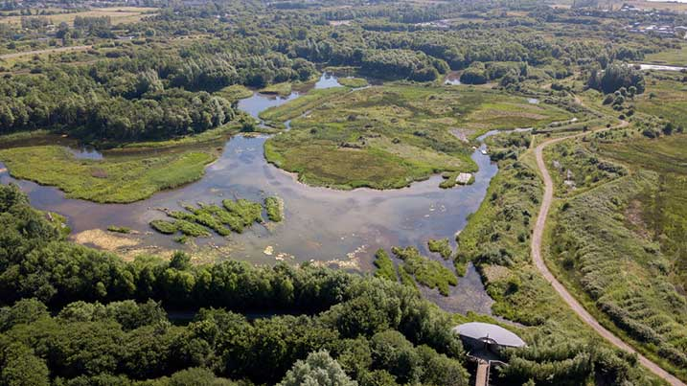
An Aerial view of the Llanelli Wetlands (Trust, 2019):Area’s like these help to keep local money in the Llanelli economy, essential to the sustainment of a good economic future, domestically
Conclusion

Llanelli is moribund. Sadly, many regeneration projects, since the fall of the mining sector have failed. She shares a distinct solipsistic history, yet lamentably, she has lost much of her industrial character. Paradoxically she hasn’t succumbed to this industrial wound. Llanelli has the potential to become an economic hub once more. But she must have investment, which she desperately needs. This could only come from the good-will of the people, politicians have had their chance, and failed. Just use the enticement of possible tax-free deductions, until Llanelli’s economic pathology becomes August. Lugubriously, Llanelli exists as a slumbering phoenix. The industrial revolution was not engineered because of a government plan for distinctiveness… how could they manage that. Her new distinctive character now lies in her nebulous future. From the flames of coal to a 21st century digital revolution, which one will create the brightest light of distinctive regeneration.

Bibliography
agefotostock. (2019). anthracite-coal. Retrieved from agefotostock: https://www.agefotostock.com/age/en/Stock-Images/anthracite-coal.html
ageofexplorationweb. (n.d.). What are the causes/effects of the Commercial Revolution? Retrieved from ageofexplorationweb: https://ageofexplorationweb.wordpress.com/what-are-the-causeseffects-of-the-commercial-revolution/
Agor. (2019, February 5). Development of the Coal Industry. Retrieved from Agor: http://www.agor.org.uk/cwm/themes/life/economy/
coflein. (2012). TROSTRE STEELWORKS, LLANELLI. Retrieved from coflein: https://coflein.gov.uk/en/site/300213/details/trostre-steelworks-llanelli
Council, L. R. (2018). community development fund. Retrieved from Llanelli Rural Council: https://www.llanelli-rural.gov.uk/community-development-fund-deadline-passed/lrc-crest/
Ephgrave, R. (2019). A Brief History of Raby's Furnace. Retrieved from Llanelli Community Heritage: https://www.llanellich.org.uk/projects/buildings/97-a-brief-history-of-rabys-furnace
Hannan, J. (2019). Guest lecturer - The Roots of Modern Llanelli, January 29th, 2019
Heritage, L. C. (n.d.). A Brief History of Raby's Furnace. Retrieved from Llanelli Community Heritage: https://www.llanellich.org.uk/projects/buildings/97-a-brief-history-of-rabys-furnace
Jones, N. (2019). Guest lecturer - Tata Steel, Port Talbot and Trostre Steelworks, 19th February 2019
Rees, S. (2019). Guest lecturer - Llanelli Wetland's, 19th February, 2019
Report, G. (2017). The End of Coal Mining in South Wales: Lessons lLearned from Industrial Transformation. Geneva: Global Studies Initiative.
Seaton, A. (2016). Farewll King Coal. British Medical Journal, 364 - 366.
Trust, W. a. (2019). Llanelli Wetland Centre. Retrieved from Wildfowl and Wetlands Trust: https://www.wwt.org.uk/wetland-centres/llanelli/
West, I. (2012, July 12). Geology of Great Britain - An Introduction with Geological Maps. Retrieved from soton: http://www.soton.ac.uk/~imw/Geology-Britain.htm
WWT. (2019). Experoence Llanelli Wetlands Centre. Retrieved from WWT: https://www.wwt.org.uk/wetland-centres/llanelli/experience/

