
Mechanical Engineering
FT Dynamics
ACMA5010
James Minton
2204900
Date of report: 01/12/2024

Contents
1 Introduction 4
2 Research 5
2.1 Development 5
2.1.1 Early Days 5
2.1.2 Mid-20th Century 5
2.1.3 Modern Day 5
2.2 Materials 5
2.2.1 Asbestos and Steel 5
2.2.2 Sintered Metal and Alloys 6
2.2.3 Composite Material 6
2.2.4 Polymers and Elastomers 6
2.2.5 Spring metals: High Carbon Steel and Stainless Steel 6
3 Applications 7
3.1 Small Engine Applications 7
3.1.1 Recreational vehicles 7
3.1.2 Industrial machinery 7
3.1.3 Scooters and Mopeds 7
3.2 Working Conditions 8
3.2.1 Rotational Speed 8
3.2.2 Load and Torque 8
3.2.3 Friction and Wear 8
3.2.4 Temperature and Heat Dissipation 8
3.2.5 Environmental conditions 8
3.3 Advantages and Disadvantages 9
3.4 Electromagnetic Clutches 10
4 Task B 11
5 Conclusion 18
6 References 19
7 Appendix 20

Introduction
This report has been written to discuss the ways are a centrifugal clutch operates as well as the advantages and disadvantages of a centrifugal clutch system. These types of clutches use centrifugal forces to engage the frictional material on a shoe to the outer surface of the drum providing power to an output shaft.

Research

Development
Centrifugal clutch systems use the centrifugal force to automatically engage and disengage depending on engine speed.

Early Days
Early designs for centrifugal clutches were simple using series of friction shoes and pads attach to a rotating hub these friction shoes and pads would expand outwards due to centrifugal forces and would then contact the inner sleeve of a drum as speed increases (Child,2021)

Mid-20th Century
With grow in different industries the need for more reliable and durable centrifugal clutches grew, mid-20th century saw introduction to improved friction materials including asbestos and sintered metals these gave improved heat resistance and durability under load
Further material research allowed the replacement of asbestos with composite materials due to health and environment concerns leading to safer clutches. The newer material gave improved friction characteristics and longer operational life (Lee & Yun, 2019).

Modern Day
When CAD software was introduced, engineers were able to optimize the components with extreme precision leading to more efficient designs, with the greater technologies real world conditions could be simulated to see what stresses the clutches would be under in different applications and environments (Thompson & Patel, 2017). Modern centrifugal clutches have adjustable weight mechanisms as well as variable friction pads to control friction characteristic.

Materials

Asbestos and Steel
Early materials used in centrifugal clutches were Asbestos and Steel, Asbestos was used mostly for the friction lining because of its high heat resistance and durability with its ability to maintain effective friction over long periods of time. Asbestos also allowed a high speed and torque to be delivered without risk of degrading (Budynas & Nisbett, 2014). Due to the health risk associated with Asbestos it would soon be replaced with safer material.
Steel was used mostly for the drum and housing due to their high strength and durability properties while under load.

Sintered Metal and Alloys
With the decline in Asbestos, sintered metals became the choice for the frictional surface for centrifugal clutches, sintered metals are made by compressing and hearing metal powders, usually copper and steel to make a strong durable and heat resistance material. Sintered materials have good frictional characteristics and a long service life.
Sintered alloys also have the advantage of being tailored to have specific characteristics for example copper-based alloys are used in high temperature applications due to their good thermal conductivity.

Composite Material
Composite materials are being more in modern centrifugal clutches in place of asbestos and sintered metals. Composites are usually made up of synthetic fibre, resins and fillers which can be made to meet specific needs for frication, wear and durability. These materials are valued for being lightweight and stable under thermal situations. (Thompson & Patel, 2017).
Some composites will use ceramic particle to improve the heat resistance of a component, which will increase the clutch’s lifespan by decreasing glazing or degradation under heavy use, these ceramic composites are partially useful where frequent clutch cycling or heavy loads are used as they have consistent and reliable characteristics across a range of operating conditions. (Lee & Yun, 2019).

Polymers and Elastomers
Mostly only used in low-load applications, usually used for frictional components only. With their low effectiveness at high temperature or heavy loads polymer and elastomers have the advantage of a low cost to weight ratio making them good for lightweight applications where durability is less of a focus, some high-performance polymers like reinforced nylon can offer a good balance of durability and affordability for a more medium duty application (Zhang & Chen, 2018).
Polymers also have natural damping characteristics to reduce noise and vibration, increasing operating comfort for the user.

Spring metals: High Carbon Steel and Stainless Steel
Springs is centrifugal clutches control the speed at which the frictional pads engage the surface of the clutch and are made from high carbon steel or stainless steel. High carbon steel has high resilience and strength while stainless steel has more corrosion resistance so will be used in more corrosive environments (Budynas & Nisbett, 2014).
Both these materials have high fatigue resistance, which for situation where the clutch is engaged and disengaged frequently.

Applications

Small Engine Applications
Centrifugal clutches are used in small engines like the ones found in lawnmower, chainsaws and leaf blowers, which allows the engine to idle without transferring power to the blade or chain until a certain RPM is reached, not only increasing the safety aspect of the equipment but also the life cycle of it as well. (Childs, 2021).

Recreational vehicles
Mini-bikes and go-karts both use centrifugal clutches proving a simple and cost-effective way of delivering power to the wheels as well as making the operation of the vehicle easier.
By eliminating the need for a manual clutch or transmission help keep the vehicle lightweight and affordable while reducing maintenance.

Industrial machinery
Industrial equipment such as pumps and conveyor belts where load can change and intermittent operation is needed, for example the centrifugal clutches in pumps allow for a smooth start up preventing sudden load shocks that could cause damage to the motor (Thompson & Patel, 2017).
Centrifugal clutches in conveyor belts also allow smooth start up while under load without causing abrupt jerks that might affect the material handling.

Scooters and Mopeds
Centrifugal clutches are very common in small capacity sized vehicles like scooters and mopeds, as engine speed increases the clutch engages allowing the vehicle to moving without the need for a manual gear shift, this is very advantageous in stop and go traffic this type of system also allows for ease of maintenance and reliability. (Lee & Yun, 2019)

Working Conditions
The conditions that affect the performance of a centrifugal clutch are rotational speed, load, friction, temperature and environment.

Rotational Speed
Centrifugal clutches operate based on the speed at which the drive shaft rotates, at lower speeds the clutch remains disengaged alloying the engine to idle without transferring power to the driven shaft, once the drive shaft speeds increase the friction wights overcome their spring tension and extend in turn engaging the clutch. (Budynas & Nisbett, 2014)

Load and Torque
The load applied to the clutch changes both is engagement characterises and wear rate, the higher the load and torque the more the clutch must withstand the frictional force without slipping.

Friction and Wear
Friction is a huge factor in clutch operation as it effects the effective of torque transfer between the driving and driven shafts, the frictional material must be able to provide good grip without having excessive wear when in operation. (Cundiff, 2001).
Wear rates increase when the clutch is in operation especially in excessive heat or load, increased wear on the friction material will lead to slippage and failure of torque transfer.

Temperature and Heat Dissipation
Heat is generated through friction caused by the engagement of the clutch when operating, as the frictional material contacts the out surface of the clutch a rapid increase in temperature will occur that if not properly dissipated will cause warping, glazing and wear. (Childs, 2021).
Efficient heat dissipation like ventilation grills or high conductivity friction materials help maintain steady heat dissipation.

Environmental conditions
Environment hazards like dust, moisture and corrosive agents can significantly affect a clutches performance, especially in outdoor or industrial settings, these hazards can clog or damage the friction surfaces leading to faster wear and inconsistent performance. (Thompson & Patel, 2017).
To mitigate these issues centrifugal clutches that operate in harsh environment are usually sealed to protect the internal components, as well as using material with corrosion resistant properties like stainless steel (Lee & Yun, 2019).
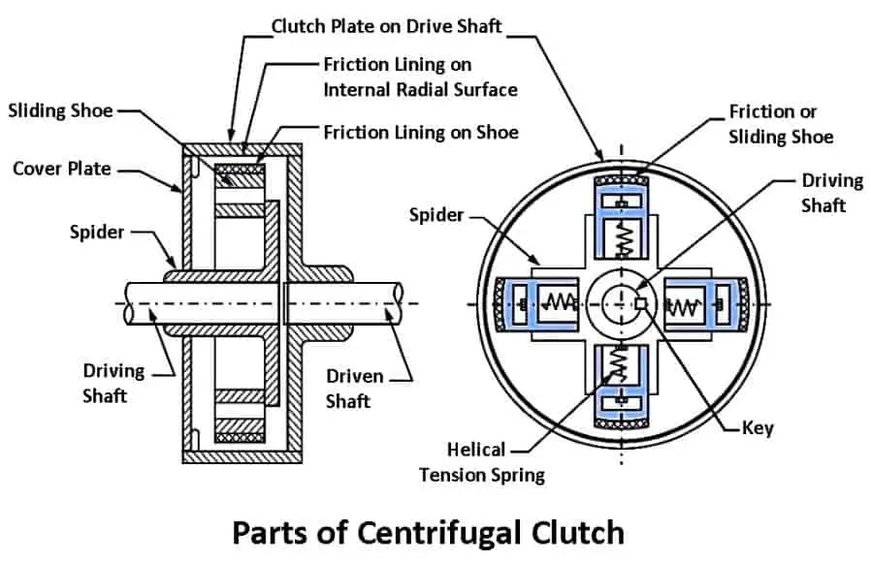
Figure 1 diagram of a Centrifugal Clutch sourced from https://www.theengineerspost.com/centrifugal-clutch/

Advantages and Disadvantages
Advantages:
- Straightforward design
- Simple and reliable
- Smooth acceleration
- More affordable
- Lightweight
- Simple installation
- Low maintenance
Disadvantages:
- Only engages at specific RPM
- Limited torque capacity
- Not adjustable
- Lack of slip ability

Electromagnetic Clutches
Electromagnetic clutches are a big part modern manufacturing as they allow for efficient and precise control of machinery, these clutches use electromagnet forces to engage and disengage the mechanical components.
Advantages:
- Precise Control
- Speed and Efficiency
- Reduced Wear
- Programmable Control
Applications:
Automated Assembly lines-where precise and rapid engagement are needed allowing the machinery to stop start and change speeds very quickly.
Robotics and CNC Machines-relying on electromagnetic clutches to control the movement of the cutting piece and tool arms.
Robotics need to have a controlled torque delivery as they are required to handle delicate components as well as perform high force tasks.
Textile Industry- electromagnetic clutches are used a lot in automated process of the textile industry such as Weaving, Knitting and cutting of fabric. Weaving and knitting require the timed engagement and disengagement of components allowing different fabrics to be woven.

Task B
Task B
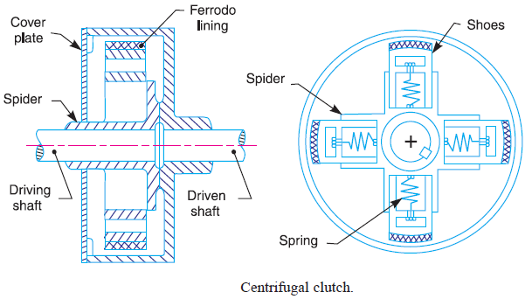

Consider the centrifugal clutch above that comprises of four ‘shoes’ symmetrically attached to the ‘spider’. Each shoe with its friction lining has a mass of 275 grams and is attached by means of a linear mechanical spring with a stiffness value of 7.5 kN/m. The coefficient of friction of the material attached to the shoes is 0.35. The centre of mass of each of the shoes is at a radius of 95 mm from the shaft centres in the rest position shown above, i.e. can be considered as the distance to ‘edge’ of shoes and have a clearance distance of 9 mm to the outer drum. The outer drum has a wall thickness of 4 mm.

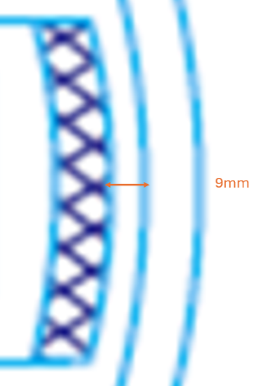
1.What is the diameter of the outer drum?
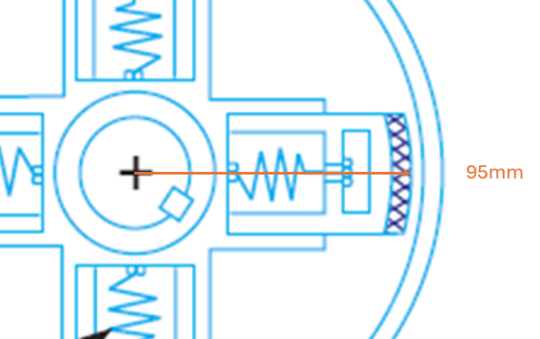
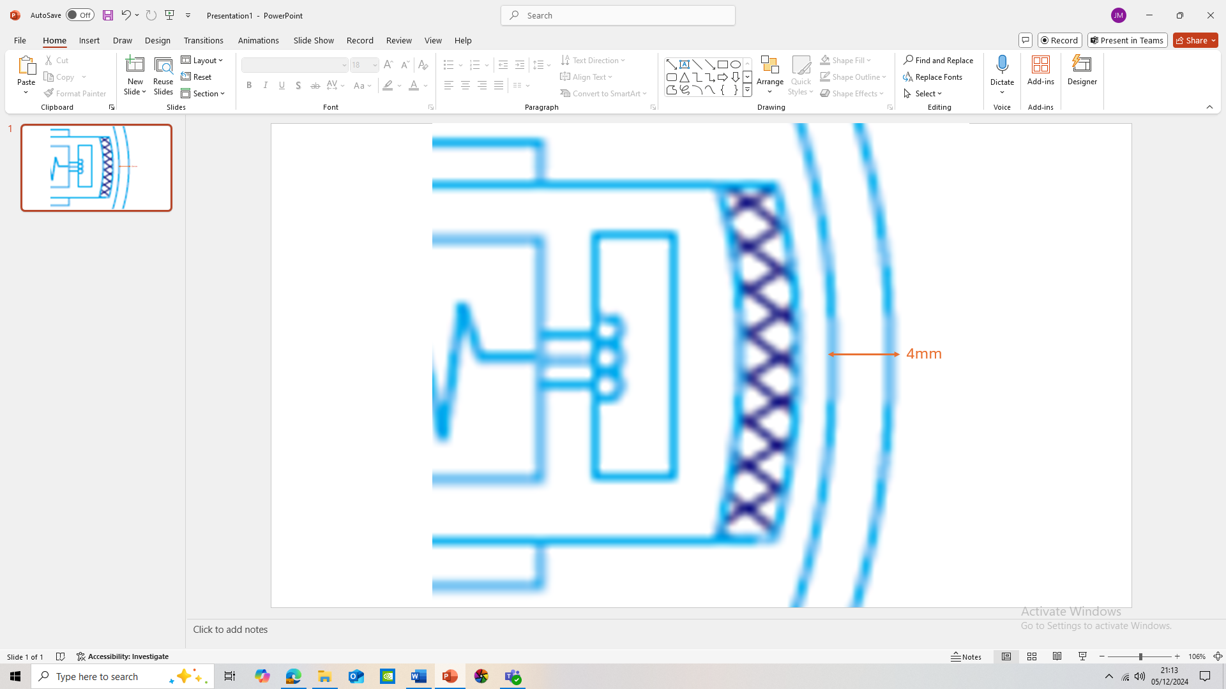

To calculate the diameter of the drum the following data needs to be used:
The radius to the shoes = 95mm
The clearance distance of the shoes = 9mm
The wall thickness = 4mm

Therefore, the outer radius of the drum is $95mm+9mm+4mm=108mm$

Equation to find the diameter:
Diameter is $r\text{×2 =108mm×2=216mm}$

Diameter in Meters = $216×{10}^{-3}M$

2.Determine the engagement speed of the centrifugal clutch in RPM

To find speed at which the shoes engage the drum the forces acting on the components need to be found, the clutch engages once the centrifugal forces overcomes the spring forces causing the clutch shoes to move outwards.
Data given:
Mass of shoe: $m=275g=0.275kg$

Spring stiffness:$k=7.5KN/M$ = $7500N/M$
Radius from the shoe: $r=0.095M$

Shoe clearance: $x=0.009M$

Equation for centrifugal and spring force:
Centrifugal force: $Fc=m∙r∙ω^{2}$ where $ω$ = angular velocity
Spring force: $Fs= κ∙x=7500×0.009=67.5N$

When the clutches engage the centrifugal forces equals the spring forces
$$Fc=Fs$$

$$m⋅r⋅ω^{2}=k⋅x$$

$$ω^{2}= \frac{k⋅x​}{m⋅r}= \frac{7500×0.009}{0.275×0.095 }$$

$$ω^{2}= \frac{67.5}{0.026125}=2583.5$$

$$ω=\sqrt{2583.5}=50.38 rad/s$$

$$RPM=ω⋅\frac{60}{2π}$$

$$RPM=50.38×\frac{60}{2π}=484.7 RPM$$

Rounded to the nearest whole value = 485 RPM

3.Calculate the radial force acting on the clutch face when the driving shaft is rotating at a speed of 550 RPM.

To find the radial force acting on the clutch when the shaft is rotating the equation for centrifugal force needs to be used, radial force is the centrifugal force of the shoes to the clutch surface.

Data given:
Mass of shoe: $m=275g=0.275kg$
Radius from the shoe: $r=0.095M$
Rotational speed: $N=550RPM$

Equation to put RPM into angular velocity:
$$ω=2π⋅\frac{N}{60}$$

$$ω=2π×\frac{550}{60}$$

$$ω=57.59 rad/s$$

Centrifugal radial force: $Fr=m∙r∙ω^{2}$
$$Fr​=0.275×0.095×(57.59)2$$
$$Fr​=0.275×0.095×3316.3$$
$$Fr​=86.7N$$

4.At the driving shaft speed of 550 RPM, what will be the value of torque transmitted to the driven shaft?

When finding the torque transmitted to the driving shaft the following needs to be considered the radial force of the clutch shoes, the coefficient of friction and the radius where the forces are applied.

Data given:
Radial force per shoe: $Fr​=86.7N$
Coefficient of friction: $μ=0.35$
Radius from the shoe: $r=0.095M$
Number of shoes: $n=4.$

Frictional force equation for each shoe:
Frictional force: Ff
$$Ff​=μ⋅Fr​$$
$$Ff​=0.35×86.7$$
$$Ff​=30.35N$$

Total friction equation:
Total friction: Ft
$$Ftotal​=n⋅Ff$$
$$Ftotal​=4×30.35$$
$$Ftotal​=121.4N$$

Torque: T
$$T=Ftotal​⋅r$$
$$T=121.4×0.095$$
$$T=11.53Nm.$$

5.plot on a suitable graph the transmitted torque at the driven shaft against driving shaft speed, from 450 RPM to 700 RPM in increments of 25 RPM.

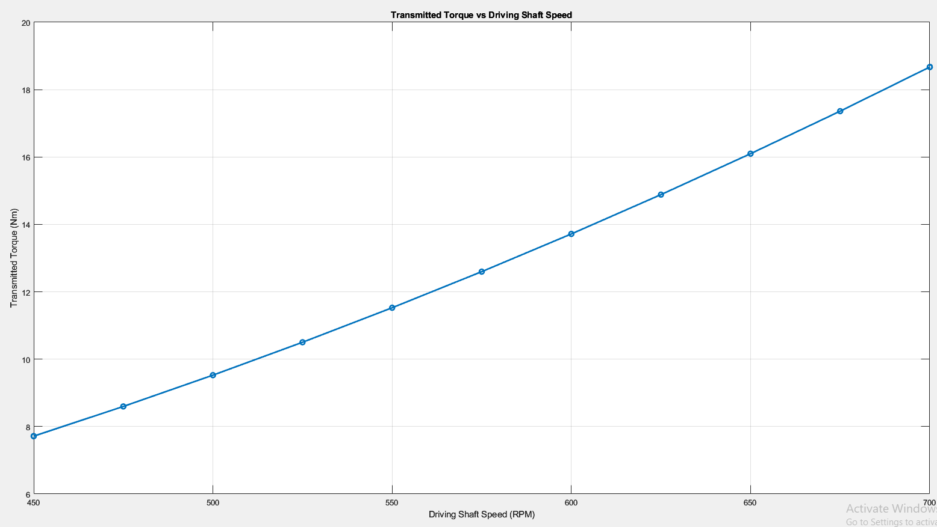
Figure 2 a graph showing transmitted torque against the driving shaft speed

As seen in (Figure 2) the torque(N/m) increases as the driving shaft accelerating in angular velocity (RPM), the transmitted torque increases due to the dependence on the square of the angular velocity $\left(ω^{2}\right)$

6.coefficient of friction of 0.3 and 0.4

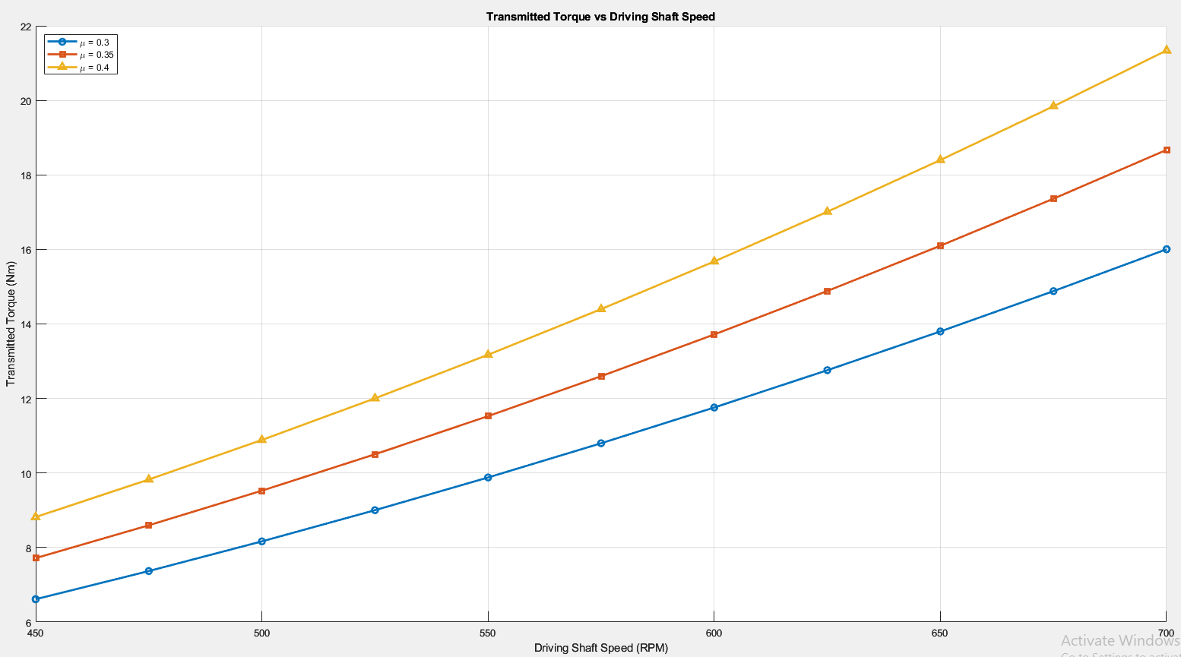
Figure 3 a graph showing the different transmitted torques when the coefficient is changed

Change in coefficient of friction u:
The changing of the coefficient of friction ($μ$) will drastically affect the toque applied to the clutch, an increase in the coefficient in friction will also increase the frictional force (Ff) of the clutch shoes, resulting in an increase in the torque delivery. However usually a higher coefficient will result in faster wear and higher heat generation, having a low ($μ$) value will also decrease the torque capabilities of the clutch that could result in slippage when a load is applied.

7.what is the angular acceleration of the drum to achieve the maximum possible torque?

To calculate the angular acceleration $(α)$ of the clutch to achieve the maximum torque $(T$) the torque equation is used.

Data given:
Mass of the drum: $md​=750g=0.75kg$
Diameter of the drum: $d=0.216M$
Torque: $T=18.67 Nm$

Torque, inertia and radius of gyration equations:
$T=I∙α$ $I=mk^{2}$ $k^{2}=\frac{d^{2}}{8}$
$$k^{2}=\frac{{0.216}^{2}}{8}=5.832×{10}^{-3}M$$

$$I=0.75×\left(5.832×{10}^{-3}\right)=4.374{×10}^{-3}{kg∙m}^{2}$$

$T=(4.374×{10}^{-3})×α$ $α=\frac{18.67}{4.374×{10}^{-3}}=4268.40 rad/s^{2}$

7.diameter of 17.5 mm and a constant tangential braking force of
500 N was applied to the driven shaft, determine the maximum possible angular

To find the angular acceleration $\left(α\right)$ for the drum with a constant tangential force $(Ft)$ is applied by the driven shaft the torque and braking relationship as well as the moment of inertia: $(I)$.

Data given:
Tangential braking force: $Ft=500 N$
Diameter of driven shaft: $d=17.5mm=0.0175m$
Radius of driven shaft: $r=\frac{d}{2}= \frac{0.0175}{2}=0.00875m$
Moment of inertia of the drum: $I=4.374{×10}^{-3}{kg∙m}^{2}$

Equation for braking torque $(Tb)$:
$$Tb=Ft∙r$$
$$Tb=500×0.00875$$
$$Tb=4.375Nm$$

Angular acceleration equation $(α)$:
$Tb=I∙α$ $α=\frac{Tb}{I}$ $α=\frac{4.375}{4.374{×10}^{-3}}=1000 rad/s^{2}$

Conclusion
Centrifugal clutches are needed in a variety of mechanical systems, performing an effective solution for torque transfer using the rational speed of a drive shaft. These clutches provide smooth engagement and disengagement while increasing operation efficiency with minimum wear.

References

• Budynas, R. G., & Nisbett, J. K. (2014). Shigley’s Mechanical Engineering Design (10th ed.). McGraw-Hill Education.
• Childs, P. R. N. (2021). Mechanical Design (3rd ed.). Butterworth-Heinemann.
• Lee, D., & Yun, S. (2019). "Performance Analysis of Centrifugal Clutch in Small Engines." Journal of Mechanical Science and Technology, 33(12), 5973-5981.
• Thompson, A. L., & Patel, R. K. (2017). "A Study of Centrifugal Force and Its Impact on Clutch Performance." Mechanical Engineering Review, 45(2), 134-142.
• Zhang, Q., & Chen, H. (2018). "Optimization of Centrifugal Clutch Design Parameters Using Simulation Models." International Journal of Automotive Technology, 19(3), 453-461.

Appendix
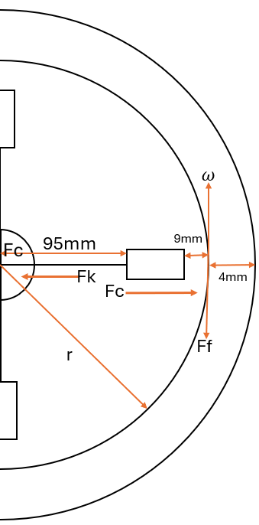
Equations used:
$$Fc=m∙r∙ω^{2}$$
$$Fs= κ∙x$$
$$RPM=ω⋅\frac{60}{2π}$$

$$ω=2π⋅\frac{N}{60}$$

$$Ff​=μ⋅Fr$$

$$Ftotal​=n⋅Ff$$

$$T=Ftotal​⋅r$$

$T=I∙α$ $I=mk^{2}$ $k^{2}=\frac{d^{2}}{8}$

