Digital skill and Research Method
Application of digital technology on improving workplace efficiency and business performance of Aldi.

Contents
Introduction: 3
Company overview: 3
Aim: 4
Objectives: 4
Literature review: 4
Research methodology: 6
Sampling: 6
Ethical consideration: 7
Data collection and interpretation: 7
Survey questionnaire: 7
Survey result: 8
Interpretation: 9
Question no. 1: 9
Question no 2: 10
Question no. 3: 10
Question 4: 12
The result of the qualitative research: 12
Impact on sales generation and business performance: 13
Findings of the research: 14
Conclusion: 15
References 16
Appendix I: 17

Introduction:
UK is already a global tech hub contributing 8.3% to the GDP of the country in 2010 with the help of online retail stores and e-commerce(Publications.parliament.uk, 2019). The increasing usage of the internet by the prospects from all ages has also contributed to this new horizon of communication creating a virtual world. To be a digital world leader, the country should secure the use of technology, investing in infrastructure, cyber-security, and digital skill of the employees and managers maintaining technology-job fit. However, almost 93% of the large and small enterprises are trying to ensure the use of digital technology to improve their performance at the workplace that ultimately contributes to the workplace efficiency to enhance customer service standard. The following discussion will assess the impact of digital technology on improving the work efficiency of Aldi.

Company overview:
Aldi is the market leader among discount retailers of the UK and it is actually originated from Germany operating in the UK with 7.6% market share (in 2018) and its annual turnover has exceeded 50 billion euro globally and in the UK and Irish arm its revenue was 11.3 billion euros at the end of 2017 that is 16% more than the previous year. However, the retail chain is operating with 10,00 stores and it has established 2,500 more stores in the UK in 2018. Aldi follows EDLP process to maintain their cost leadership attracting the prospects with the help of price penetration and it has been successful to this purpose as 65% of the UK customers has visited the stores of Aldi once at least(Aldi.com, 2019).

Aim:
The aim of this research is to focus on the application of digital technology on improving workplace efficiency and business performance of Aldi.

Objectives:
Whether the usage of digital devices at the workplace has improved the performance of the employees of Aldi
Whether cloud collaboration has contributed to the efficiency of database management of the company across the stores
Whether augmented reality and virtual reality will contribute to the sales growth of the store improving the operational efficiency
Whether Omni-channel marketing will be congenial to ensure the appropriate communication strategy contributing to the concentrated marketing strategy of the company

Literature review:
As stated by Murdoch and Fichter(2017), digital technology refers to the electronic equipment and applications using information as numeric code It works with the breakdown of messages creating signals and forms of communication using a string of information that is called binary code. However, according to Bajaj, et al.(2010), the retail industry has been blessed with the involvement of digital technology and it has helped in ensuring efficiency in supply chain management, inventory management, database management, store management, marketing program and most significant human resource management. As per Benjamin and Potts (2018), the face and voice recognition, cloud services have contributed to the store management avoiding the error rate while service encounter. The VMI and EDI system has contributed to ensuring the efficiency in managing inventory as well as the supply chain management. According to Brown and Davis (2014), cloud collaboration has helped in database management and stock management across the stores with inventory tracking shipping details, stock availability, and automated order fulfillment strategy. However, the flatter organizational structure created by the communication technology has reduced the layer in the power distribution establishing informal communication process and leading the employees with full employee engagement and taking the organizational objectives as the personal objectives as opined by (Duffy, 2013). In the marketing program, the usage of an online survey and other data analysis tools are contributing to the marketing research and help to evaluate the market position of the company along with the feasibility test. The social media marketing is a new term that is contributing to the eternal communication of the retail stores to ensure efficient customer handling and maintaining interactive, and continuous communication between the company and the customers as per Gradmann et al (2011). However, office automation has improved workplace productivity reducing the cost of operation and information processing. However, there is the controversy that the lack of digital skill of the employees is suffering the retailers to maintain the technology-job fit, and the short term absenteeism is contributing to the efficiency of human resource productivity as stated by Handley (2018). Moreover, the involvement of technology is contributing to the operational cost with the huge installation and maintenance cost. According to Hillier and Lieberman (2015), netiquette is also contributing to the decrease in customer satisfaction because of late response and not understanding the actual psychological condition of the customers. The following research is going to draw a conclusion on the application of the digital technology to improve workplace efficiency and business performance of Aldi consider both arguments.

Research methodology:
The research problem is a marketing research problem that will assess the contribution of the application of digital technology in retail stores like Aldi to improve workplace efficiency (Turban, and Volonino, 2015). It is conclusive research that is going draw a conclusion on the contradictory statement related to the efficiency of digital technology in improving the work efficiency and business performance. However, to evaluate the aim and draw decision on the objectives selected before, the researcher needs to operate both the qualitative and the quantitative research using data collected from the primary and secondary data sources. The primary data will be collected from the direct interview, online survey and test marketing. On the other hand, the secondarydata will be collected from the annual report, sales report, employee performance report, and other financial analysis of the retail chain(Malhotra, 2017). The primary data will be helpful to assess the confidential factors and take the subjective decision and the quantitative research method will be more applicable to this purpose.

Sampling:
Both the qualitative and quantitative research will be operated with the help of 50 respondents who are chosen with the probability sampling like simple random sampling. The respondents are the employees from different stores of the retail chain in London and it is also a limitation for the research as it cannot include all the stores of the company. however, face to face interview, focus group discussion, test marketing, online survey, and observation method will be used to communicate and collect primary data from the respondents.

Ethical consideration:
While performing the survey and research, the researcher will be concerned about the privacy of the retail chain and the research must not harm their brand image and organizational policy to communicate with the employees and consumers. The internal information must not be revealed damaging the personality of this retail brand. However, to ensure the credibility of the information and job security of the employees or the respondents the researcher(Chisnall, 2015).

Data collection and interpretation:
To collect the primary data from the direct interview, online and personal survey, and observation, the researcher needs to create a comprehensive questionnaire focusing on the achievement of the research objectives. The following questionnaire will be used to collect the necessary information using the five-dimensional survey.

Survey questionnaire:
Questions | Strongly agreed | Agreed | Neutral | Disagreed | Strongly disagreed
The usage of digital devices at the workplace has improved the performance of the employees of Aldi
Cloud collaboration has contributed to the efficiency of database management of the company across the stores
Augmented reality and virtual reality will contribute to the sales growth of the store improving the operational efficiency
Omni-channel marketing will be congenial to ensure the appropriate communication strategy contributing to the concentrated marketing strategy of the company
Table 1: survey questionnaire

Survey result:
Data has been collected from fifty respondents with the help of a simple random sampling method and the following result has been found.
Questions | Strongly agreed | Agreed | Neutral | Disagreed | Strongly disagreed
1 | 15 | 10 | 5 | 10 | 10
2 | 20 | 10 | 10 | 5 | 5
3 | 20 | 15 | 5 | 5 | 5
4 | 20 | 20 | 3 | 2 | 5

Interpretation:
With the help of Microsoft Excel, the collected primary of the quantitative research is going to be assessed in the following discussion.

Question no. 1:
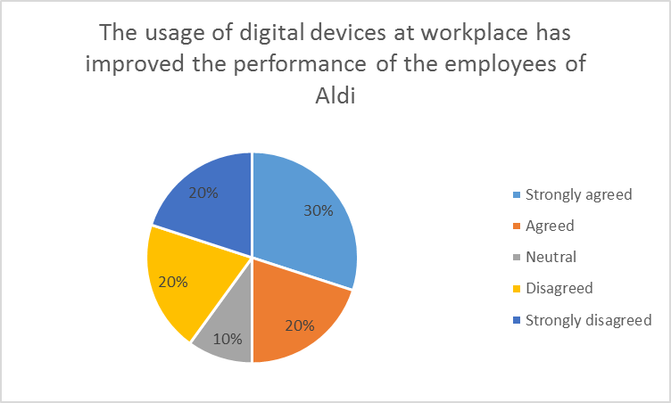
Figure 1: the survey result of the first question
The survey has shown that the employee productivity will be improved if the company allows using digital devices at the workplace as it will work as the digital assistance of the employees improving their efficiency to perform their responsibility in an error-free way as opined by 60% of the respondents. It also a sign of empowerment and unstructured nature of tasks that encourages the employee engagement (Benjamin, and Potts, 2018). On the contrary, 40% of respondents have stated that this will not contribute to the efficacy rather hamper it as the short term absenteeism can cause less responsiveness among the employees that ultimately deteriorate the customer satisfaction.

The question no 2:
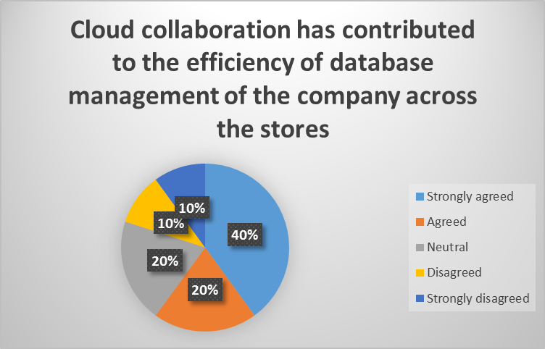
Figure 2: the survey result of the second question
The survey result proves that 80% of the respondents think that the cloud services will improve the work efficiency as it will help to provide the information about the stock, shelves, along with managing the database of all stores. It will be helpful to reduce the lost sale with cross inventory because of the available data updated automatically(Brown and Davis, 2014). However, the rest 20% has thought that it is a complex way of managing data that will increase the cost of training and development program or the recruitment cost of the skilled employees.

Question no. 3:

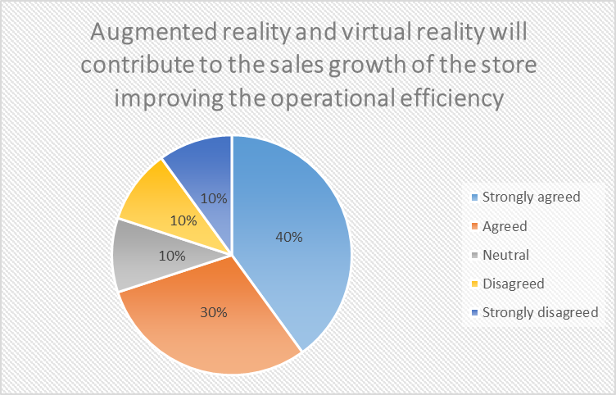
Figure 3: the result of the third question
80% of the respondents have opined that the augmented reality will be helpful to increase the service of the stores and help the customer to examine the products without its physical presence. The virtual reality will contribute to the online retail store of Aldi. The rest of the respondents has opposed with the strategy as it has high installment cost and maintenance cost is also high that will reduce the efficiency of the economies of scale and experience curve of the retail chain (Duffy, 2013).

Question 4:
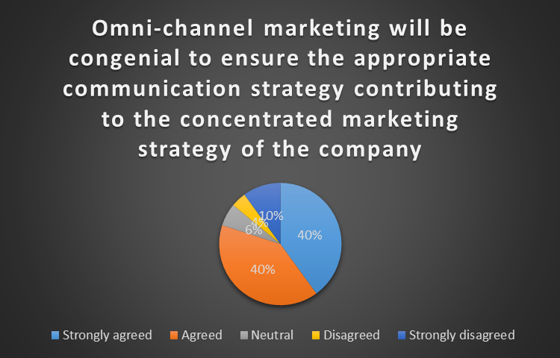
Figure 4: the result of the fourth question

86% of the respondents believe that the omnichannel marketing program will be helpful to communicate the consistent information to the prospects with the help f increasing use of social media. The social media marketing will also be helpful to maintain interactive communication with the customers and leading a social life with them creating a stronger relationship that will contribute to the customer equity (Gradmann, et al., 2011). The rest 15% has disagreed as the increasing dominance of social media is going to reduce the appeal of the other communication tools of the promotional program reducing the efficiency of IMC.

The result of the qualitative research:
The qualitative research has been performed with the help of the secondary data collected from their annual report, employee performance report and the primary data from observation and focuses on group discussion. The result has shown that the respondents think that the permission of using digital devices help them to make their responsibility easier and the digital assistance helps them to schedule their tasks and perform them at the right time in a right way. The cloud collaboration has helped to manage the big data and create a connection among the stores across the border even. The augmented reality and the virtual reality is two new addition of the retailer that will contribute to the in-store service along with the cost leadership factors as they will help the customers to examine the product before purchasing with the needed information without the human interaction (Handley, 2018). The Omni-channel marketing program will help the company to ensure the efficiency of the integrated marketing program.

Impact on sales generation and business performance:
The retail chain is enjoying the highest sales growth in the retail industry of the UK of 12%, even Tesco has failed to ensure this growth rate. The digital technology has helped the company to achieve this success contributing to maintaining the cost leadership along with the increase in the services and facilities at the store and after marketing program has been improved also. The sales growth of the company in the last four has proven the statement.
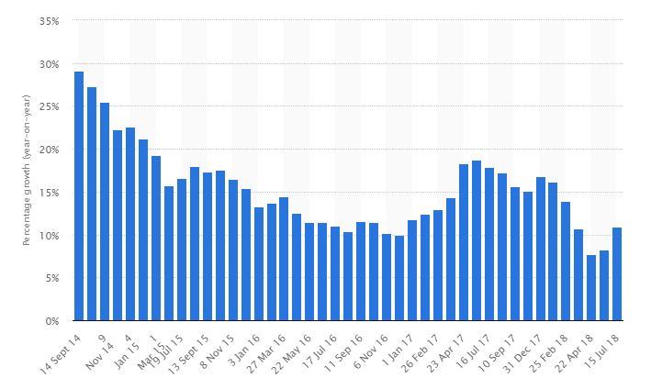
Figure 5: sales growth of Aldi
Source:(The Guardian. 2018)
The company has enjoyed the highest sales growth in 2014 with the introduction of digital technology at the workplace that differentiated their service from other. The growth has slowed down but improved also gradually (the Guardian. 2018).

Findings of the research:
The research has found that the usage of digital device at the workplace improves the employee productivity creating a tendency of empowerment that contributes to their human transaction and engagement to the organizational objective. The cloud services help to remove the lost sale rate creating the cross inventory and virtual inventory for the retail chin along with efficient and automatically updated database management. The augmented reality and the virtual reality will help Aldi to improve the in-store service contributing to their experience marketing strategy. Lastly, Omni-channel communication will be helpful to improve the efficiency of the IMC maintaining the consistency of the message provided.

Conclusion:
The above research has focused on the application of digital technology in improving work efficiency and business performance. It has been found that digital technology is highly appreciated by the respondents as it has reduced the burden of tasks and complexity of information processing along with improving the internal marketing and external marketing program of Aldi. The social media marketing augmented reality, and the virtual reality is the new addition of technology in the retail industry that can help the retailer to differentiate them for the competitors.

References
Aldi.com. (2019). Welcome to ALDI. [online] Available at: https://www.aldi.com/ [Accessed 9 Jan. 2019].
Bajaj, C., Tuli, R. and Srivastava, N. (2010). Retail management. Delhi: Oxford University Press.
Benjamin, K. and Potts, H. (2018). Digital transformation in government: Lessons for digital health?. DIGITAL HEALTH, 4, p.205520761875916.
Brown, A. and Davis, N. (2014). Digital technology, communities and education. London: RoutledgeFalmer.
Chisnall, P. (2015). Marketing research. London: McGraw-Hill.
Duffy, B. (2013). Remake, remodel. Urbana, IL: University of Illinois Press.
Malhotra, N. (2017). Marketing Research. Pearson Education Limited.
Murdoch, D. and Fichter, R. (2017). From Doing Digital to Being Digital. International Journal of Adult Vocational Education and Technology, 8(4), pp.13-28.
Publications.parliament.uk. (2019). [online] Available at: https://publications.parliament.uk/pa/cm201617/cmselect/cmsctech/270/270.pdf [Accessed 9 Jan. 2019].
the Guardian. (2018). Aldi | Business | The Guardian. [online] Available at: https://www.theguardian.com/business/aldi [Accessed 20 Dec. 2018].
the Guardian. (2018). Technology in retail | Media Network | The Guardian. [online] Available at: https://www.theguardian.com/media-network/series/technology-in-retail [Accessed 20 Dec. 2018].
Turban, E. and Volonino, L. (2015). Information technology for management. Hoboken, N.J.: Wiley.

Appendix I:
Survey Form:
Serial no.
Title: Application of digital technology on improving workplace efficiency and business performance of Aldi.
Dear,
I am operating research on the application of digital technology on improving workplace efficiency and business performance of Aldi.I am humbly requesting you to cooperate me providing your significant opinion filling the following form.
Thank you.
Questions | Strongly agreed | Agreed | Neutral | Disagreed | Strongly disagreed
The usage of digital devices at the workplace has improved the performance of the employees of Aldi
Cloud collaboration has contributed to the efficiency of database management of the company across the stores
Augmented reality and virtual reality will contribute to the sales growth of the store improving the operational efficiency
Omni-channel marketing will be congenial to ensure the appropriate communication strategy contributing to the concentrated marketing strategy of the company

