
Applied Leadership and Management in the Workplace
Module Assignment Submission
Student Name: | REBECCA FORSHAW
Student Number: | 223820
Module No: | BMSK5013
Module Title: | Knowledge & information Management Skills

Statement of Confirmation of Authenticity
By the act of making this submission, the student declares that this is the work of the student named above. The work has not, in whole or in part, been knowingly presented elsewhere for assessment, or where assessment has been built on a previous assessment, this has been identified. Where materials have been used from other sources it has been properly acknowledged. If this statement is untrue, the student acknowledges that an assessment offence has been committed.
Attention is drawn to the plagiarism and unfair practice policies of both the University and of ILM.

Table of Contents
Introduction 3
Explain the relationship between individual knowledge and organization knowledge. 5
Apply analysis and modelling techniques to identify knowledge assets. 6
Evaluate actual and potential knowledge assets. Provide a rationale for capturing and managing knowledge 8
Demonstrate an understanding of important knowledge management processes in the context of organisational development 10
Provide a framework for establishing a knowledge management culture 13
Explain the contribution knowledge assets have on an organisation. 14
Evaluate the knowledge requirements for the organisation. 15
Evaluate the organisations framework for enabling knowledge sharing. 16
Recommend improvements to the current framework. 17
What factors specific to this particular workplace context should be considered? 18
Are there any key knowledge management processes currently not in operation that could be applied? 19
What steps would you take to further develop a framework for establishing a knowledge management culture? 19
Conclusion 20
References 20
Appendices 21

Introduction

This paper looks into knowledge management (KM), which is a strategic process that a business needs to be able to run successfully and stay ahead of the competition. Knowledge management, or KM, is the organised way that a company takes care of its knowledge resources to make them useful and meet its short-term and long-term goals. The main point of this assignment is to look at the many aspects of knowledge management (KM), such as how important it is for encouraging new ideas, making decisions more solid, and making businesses run more efficiently.

Controlling and managing knowledge assets will be looked at in more detail in order to show how important they are to the strategic management of information. We will look at effective techniques for capturing, storing, retrieving, and sharing knowledge that help a children’s event business learn and share information. We will use theoretical frameworks and real-life cases, to show how KM practices are used to boost performance and stay ahead of the competition. This assignment looks at models and theories from well-known academics like Nonaka and Takeuchi (1995) and Davenport and Prusak (1998). The goal is to give a full understanding of how knowledge management can heavily impact a company.

Explain the relationship between data, information and knowledge.

The DIKW pyramid (Data, Information, Knowledge, Wisdom) shows how data, information, knowledge, and wisdom affect companies and decision-making. Akoff's hierarchy adds context, meaning, and worth.
Statistics without context are at the bottom of the pyramid. Data exist just for themselves (Ackoff, 1989). Quantified and measurable data are meaningless.
Data is processed to make sense of information. Information is data processed to answer "who", "what", "where", and "when" (Ackoff, 1989). Understanding data is easier with information.
Not all information is knowledge. Knowledge describes "how" things work (Ackoff, 1989). Knowledge comes from context, values, experience, and insight.
In his DIKW approach, Ackoff focused on data-to-knowledge. It requires applying knowledge to larger situations and contemplating moral consequences at the greatest level. Understand people, things, events, and situations to get the best results.
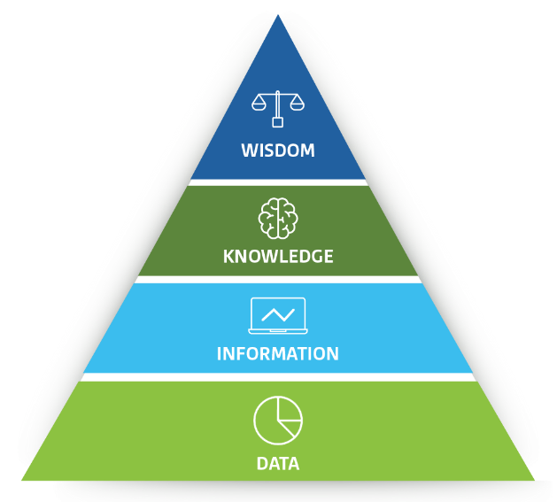

Through Ackoff's DIKW model, you'll learn how raw data can be turned into actionable knowledge, emphasizing how to contextualize and process information within an organization.

Explain the relationship between individual knowledge and organization knowledge.

Knowledge management boosts organisational capabilities by leveraging individual and organisational knowledge. We must understand how knowledge goes from personal to collective and how organisations manage it to grasp this relationship.
Personal experiences, actions, and values shape tacit knowledge. Skills, ideas, and insights are included, as are hard-to-state notions. People exchange tacit knowledge through human contact and shared experiences (Nonaka & Takeuchi, 1995).
Explicit knowledge is formal, objective, and documentable. Books and documents include this information.
Individual and organizational knowledge is always changing, where individual knowledge feeds into and shapes organizational knowledge. Nonaka and Takeuchi's SECI model describes four modes of knowledge conversion:

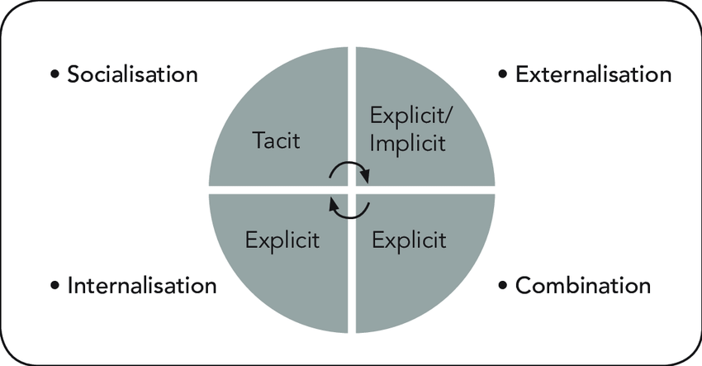

Nurturing this relationship allows organizations to take advantage of their workforce's knowledge. Individual insight and skills can be turned into valuable organizational assets that drive innovation.

Apply analysis and modelling techniques to identify knowledge assets.

A children's events business must capture, assess, and model critical knowledge to succeed and innovate. A company's knowledge assets may include customer data, event management expertise, partner and supplier data, regulatory knowledge, and tacit customer preferences and behaviours. How to identify these assets with analysis and modelling:
Asset identification: Catalogue the organisation's expertise. Among them:
• Databases with customer preferences, comments, and demographics.
• Relationships with suppliers and vendors.
• Resources for event planning, including checklists and best practices.
• Analysing marketing strategy and results.
• Legal compliance requirements for child-related events.
• Employee skills and experiences, particularly tacit knowledge in event management and customer service.
Data gathering
Use in-depth and quantitative data collection methods like:
• Researching employee tacit knowledge through surveys and interviews.
• Analysing customer feedback and event performance.
• Auditing existing documents and databases.
Analyse knowledge assets
• Use knowledge mapping to visualise and link different sorts of assets. Understanding organisational knowledge flows helps identify bottlenecks and gaps.
•Key knowledge holders and how they affect information exchange in an organisation can be identified using Social Network Analysis (SNA) (Cross & Parker, 2004).
• Conduct a SWOT analysis to evaluate the effectiveness and relevance of present knowledge assets. Knowledge assets will also be identified for improvement.

Knowledge Asset Model
Business Process Modelling: Identify knowledge-dependent processes. BPMN (Business Process Model and Notation) visualises event planning and execution, highlighting knowledge inputs.
Model event planning and management decisions with decision trees. Identifying these knowledge points can improve results.

Assess and Prioritise Knowledge Assets
Assess knowledge assets' worth based on their impact on customer happiness, cost savings, revenue, and risk reduction.
• AHP (Analytic Hierarchy Process) prioritises knowledge assets based on company goals and strategic value (Saaty, 1980).

Strategic Knowledge Management
Based on analysis, develop ways to acquire, share, and apply essential knowledge assets. This includes:
• Managing knowledge with Momentus or Zendesk systems.
• Enhancing staff skills and knowledge sharing through training and development programmes.
• Creating policies for knowledge retention and updating.

A children's event business can discover, model, and manage its knowledge assets to improve operational efficiency and innovation, improving client experiences and business growth.

Evaluate actual and potential knowledge assets. Provide a rationale for capturing and managing knowledge.

As a knowledge management tool, Google Docs is currently used by the events business in question. Its strengths and weaknesses, opportunities, and threats will now be evaluated by the author. Additionally, explore other tools that may be able to complement the use of Google Docs.
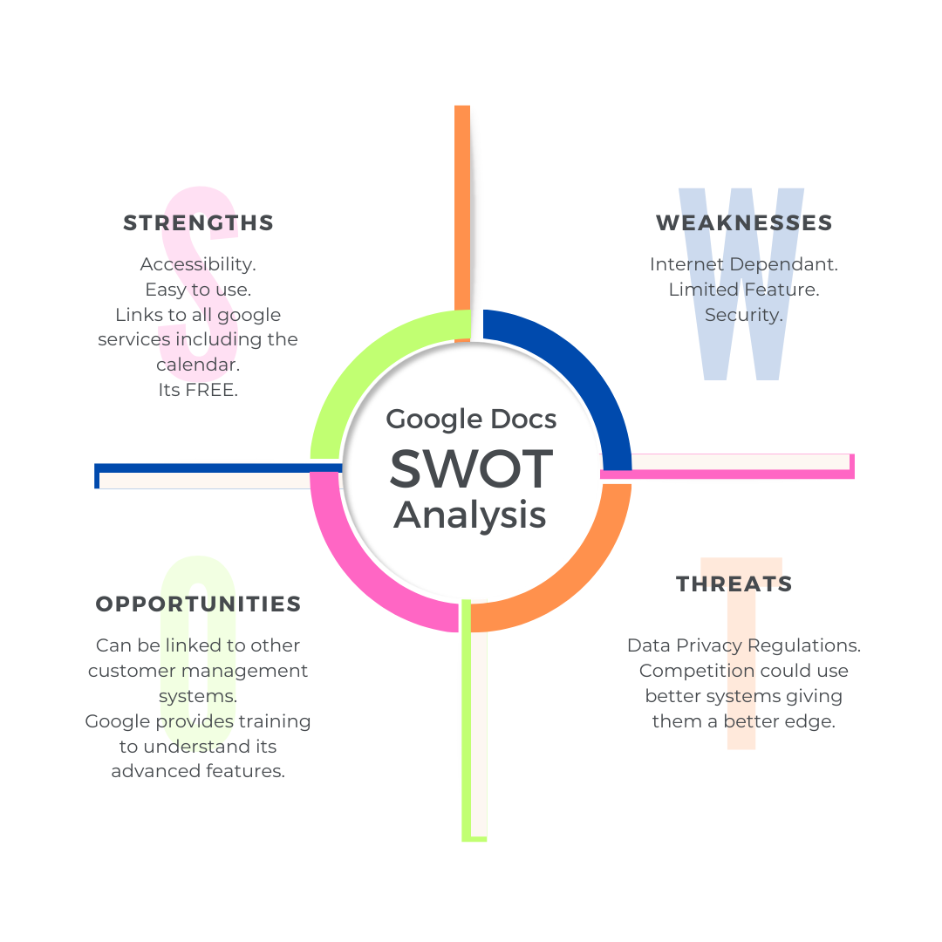

Google Docs in Children's Entertainment: SWOT Analysis
Strengths:
• Google Docs allows real-time collaboration across different locations with easy access from any internet-connected device.
• Ease of Use: Team members can immediately utilise the platform's functionalities without training.
• Seamless integration of Google Drive and Google Calendar enables efficient document management and scheduling.
• Google Docs is cost-effective for small to medium-sized organisations due to its free basic use.
Weaknesses:
• Internet dependence limits its use in places with unpredictable internet connectivity.
• Limited Features: Google Docs lacks the functionality of more advanced document and project management applications.
• Security Concerns: Google's extensive access and sharing capabilities raise the potential of accidental data leaks, despite its rigorous security procedures.

Opportunities:
• Google Docs may be connected with advanced project management and CRM solutions via APIs to enhance functionality.
• Training on advanced Google Workspace capabilities can boost productivity and efficiency.
• Enhanced Collaboration: Google Docs enhances collaboration, customer feedback, and event requests, fostering increased involvement.

Threats:
• New data privacy regulations may complicate compliance by impacting data storage and management.
• Industry-specific project management and content development technologies offer a competitive threat.

The SWOT analysis of Google Docs for a children's entertainment company emphasises its real-time collaboration and document management capabilities and cost-effectiveness for small to medium-sized businesses. However, its internet dependence, limited advanced functionality compared to specialised software, and security vulnerabilities present considerable issues. Integration with other project management and CRM applications and training on Google Workspace's advanced capabilities can boost productivity. However, new data privacy laws and industry-specific technology pose concerns. The Resource-Based View (RBV) theory supports this analysis, arguing that leveraging organisational capabilities like Google Docs can give a competitive edge if managed wisely to mitigate weaknesses and external threats and align with strategic resources and capabilities (Barney, 1991).

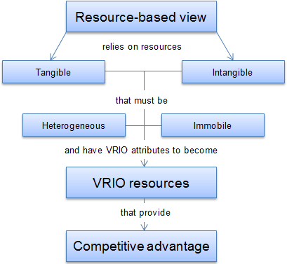

Demonstrate an understanding of important knowledge management processes in the context of organisational development

Organisational development requires knowledge management (KM), especially in a children's events company that prioritises customer satisfaction, creativity, and safety. Such a setting can leverage key KM procedures:
1. Knowledge-making.
Knowledge creation helps children's event companies produce fresh concepts, activities, and entertainment. This accommodates kids' changing interests and parents' expectations. Brainstorming and creative workshops assist this process.
2. Knowledge Capture
Children's event companies must record customer feedback and safety standards. A digital knowledge management platform or policy handbook should give team members this information. Participant and organiser feedback can improve future events. 2013 (Dalkir).
3. Sharing Knowledge
Staff share ideas and best practices to improve event quality and safety. Team meetings, training, and collaboration tools help. Show team members a successful birthday party case study to inspire and guide future events. This promotes learning and progress (Hislop, 2013).
4. Applying knowledge.
The success of an events business depends on knowledge application. Reusing and adapting successful ideas for new clients is the process. The party can include easy-to-follow dances based on the birthday child's age. Feedback systems should evaluate applied knowledge and improve iteratively based on findings (Jennex, 2015).
5. Keeping Knowledge
Critical knowledge must not be lost when employees leave. This is attainable with adequate documentation, clear process manuals, and an updated event history and client database. Mentoring and succession planning preserve firm tacit knowledge (Liebowitz, 2001).
A children's events firm can expand, improve, stay competitive, and deliver exceptional customer service using these KM methods. Reassessing and modifying the knowledge management strategy maintains the company flexible and adaptable.

Explain what is required to create, store, apply and integrate knowledge.

Children's party planners must prioritise safety and fun. The steps for each are:
Understanding
Children's party businesses create safe, enjoyable, and age-appropriate party themes and games. This requires collaborative thinking. Team members should continually generate fresh ideas, topics, and engaging activities. Client input, especially from parents, is also useful.
Keeping up with children's entertainment trends like new films, games, and instructional toys is crucial.
Information security
Effective knowledge storage keeps important thoughts and operational data safe and accessible.
• Use event management software to track party plans, client comments, vendor lists, and event results. The application can also track party preferences (Jennex, 2015).
• Security: Protect client payment and contact data with data security and GDPR requirements.
Applying your knowledge
Use your knowledge to organise memorable parties:
• Event execution: Event management best practices may help every party go smoothly, from setup to cleanup, and on time (Allen, 2010).
• Customisation: Use past successful events and client feedback to tailor parties to each client's needs and improve customer satisfaction.
• Safety Rules: Follow and update child safety rules depending on new information and industry standards to keep partygoers safe.
Using Knowledge: Childrens party hosts must use knowledge everywhere:
Standard operating procedures: Use what you've learned to create consistent, high-quality party planning and execution SOPs (Montana & Petit, 2008).
Continuous Improvement: Review comments and performance data often to improve party packages and operations (Allen, 2010).
Use technology: Use CRM systems and analytics tools to apply knowledge to daily work (Dalkir, 2013).
A children's party company may ensure its events are unique, safe, and highly tailored to match client expectations by following the above.

The Knowledge Management Value Chain (KMVC) illustrates how an organisation generates, outlines, and transfers knowledge to produce value. This approach emphasises knowledge processing and use to improve organisational performance and competitiveness.

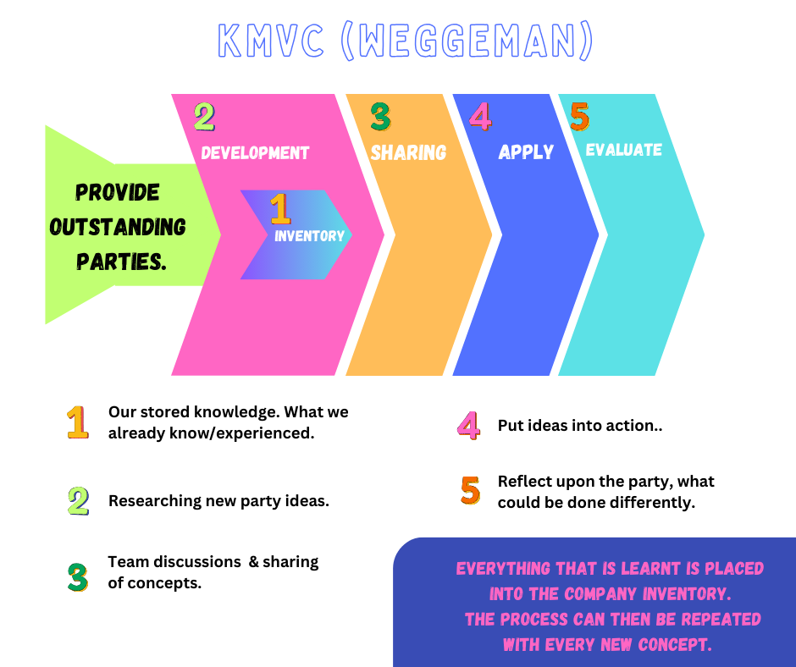

Consider the importance of Intellectual Property rights
IP rights are important since children's events feature many characters, themes, music, and activities that may be protected by IP regulations. Why IP rights matter and how to handle them:
1. Protecting Original Content: Businesses typically develop unique activities and themes for children's events, including character designs, games, stories, and educational content. Protecting IP rights can prevent competitors from using this content and make it associated with the company (Corbett, 2002).
2. Licencing Requirements: Popular media themes like superheroes, cartoon movies, and fairy tales are common for children's parties. Use of these themes without licencing agreements can result in copyright infringement lawsuits. Event licencing agreements ensure copyrighted content is utilised and shared legally (Landes & Posner, 2003).
3. Avoiding Infringement: Understanding IP rights can assist event planners avoid accidental infringement. Unauthorised usage of copyrighted music or characters can damage a company's brand (Bently & Sherman, 2009).
4. Use licenced or copyright-free resources: Ensure music, characters, and other elements are licenced. You may pay royalties or employ royalty-free alternatives that can be lawfully incorporated into planning.
5. Creating unique content: This can prevent infringement and establish a brand identity and IP assets for future protection and licencing (Corbett, 2002).

Children's event planners must manage IP rights to avoid legal issues, protect their creative assets, and compete.

Provide a framework for establishing a knowledge management culture

A children's event company must openly exchange information, stimulate innovation, and regard knowledge as a strategic advantage to foster a knowledge management (KM) culture. With this structure, the corporation can plan, execute, and innovate in children's entertainment, providing it a strategic advantage. Establish this culture using these steps:
1. Leadership Commitment
• Prioritising KM: Senior management must commit to KM by integrating it into the company's strategy. Leaders should regularly discuss knowledge sharing, which is crucial to organisational success. 1998 (Davenport & Prusak).
• Resource allocation: Invest in KM efforts, such as systems and training.
2. Determine Knowledge Needs
• Determine the company's most valuable expertise. Children's event businesses may consider client preferences, event management best practices, safety, and unique entertainment.
Set KM Objectives: Ensure the KM programme matches corporate strategy. (1995, Nonaka & Takeuchi).
3. Encourage Knowledge Sharing
• Encourage communication: Create an environment of knowledge exchange. Share knowledge internally and in frequent meetings.
• Reward and Recognise: Establish programmes that reward knowledge sharing. 1998 (O'Dell & Grayson).
4. Use Knowledge Management
• Establish Knowledge Sources: Organise documents, templates, and best practices in databases.
• Form Communities of Practice: Create teams around certain issues, such as party themes, customer interaction tactics, or safety standards, for staff to share ideas. 2000 (Wenger & Snyder).
• Utilise technology: Utilise CMS, CRM, and collaborative platforms for knowledge management.
5. Development and Training
• Ongoing Training: Teach staff effective KM tool use and promote information exchange for professional development.
• Provide learning opportunities for staff to experience industry trends and bring new ideas to the organisation.
6. Assess and Improve KM Practices
• Set Metrics: KM KPIs should include event success rates, customer happiness, and employee participation with KM systems.
• Continuous Improvement: Review and adjust KM procedures based on input and KPIs to match with organisational goals. (Kaplan, Norton, 1996).
7. Maintain Legality and Ethics
• Ensure staff understand intellectual property rights and confidentiality, especially when managing sensitive customer information.
8. Foster Innovation
• Encourage employees to generate innovative ideas for events, topics, and business systems to improve processes. Create a method for submitting and assessing ideas.
A children's events firm can create a KM culture that improves internal efficiency, staff capabilities, client experiences, and competitive advantage using this framework. Due to this strategic KM approach, the organisation remains an industry leader.

Explain the contribution knowledge assets have on an organisation.

Knowledge is key to a children's events company's success. An organisation's assets include explicit (recorded) and implicit (skills, experiences) knowledge. Knowledge assets benefit a children's event company:
1. Better Event Planning and Execution
Knowing prior event plans and client feedback makes event planning and execution more efficient. Event planners should use past experiences to foresee obstacles and opportunities, improving operations and client satisfaction. Knowledge enhances decision-making and problem-solving, according to Davenport and Prusak (1998).
2. Innovation, Creativity
With a wide range of party types and entertainment options, planners may design unique and creative events. Knowledge development and implementation can create organisational knowledge, according to Nonaka and Takeuchi (1995). This invention can let children's parties include contemporary trends like tik tok dances.
3. Better Client Relations
Knowing consumer preferences and needs helps customise events that exceed expectations. Businesses can boost customer loyalty and repeat business by recording consumer interactions, preferences, and feedback (O'Dell and Grayson, 1998).
4. Competitive edge
Children's events companies can acquire a competitive edge by strategically applying knowledge assets. Better risk management, unique event solutions, and market agility are included. Knowledge assets set firms apart (Jennex, 2015).
5. Development and Training
Training and upgrading staff require knowledge assets. Companies can construct thorough training manuals based on prior events, successes, and customer feedback to maintain high service standards (Hislop, 2013).
6. Cost-efficiency
Knowledge assets can save money by avoiding mistakes and leveraging successes. Choose the proper products, use smart promotion, and optimise event logistics. Knowing what works improves budgeting (Dalkir, 2013).

Evaluate the knowledge requirements for the organisation.

A children's event organisation must identify expertise needed for event planning, client interactions, marketing, compliance, and innovation.
A full analysis of these knowledge requirements:
1. Event Planning and Management
• Have strong operational knowledge in logistics, venue selection, entertainment, and scheduling. Successful events must cater to different age groups and tastes (Allen, 2010).
• Project Management Skills: Experienced in managing budgets, timetables, and resources to ensure successful event execution within budget (Kerzner, 2013).
2. Customer Relations Management
• Customers' Preferences and Insights: client feedback and historical event evaluations reveal client preferences, particularly popular parties (Peppers & Rogers, 2011).
• Communication Skills: Addressing parents' and children's wants and concerns requires effective communication (Lencioni, 2002).
3. Market and Marketing Trends
• Expert in digital marketing tactics, including social media and email marketing, to promote events efficiently (Chaffey & Ellis-Chadwick, 2019).
• Market Research: Understanding current trends in children's entertainment, an important factor in service demand and success (Kotler & Keller, 2016).
4. Safety, compliance
• Comprehensive knowledge of health and safety laws for children's events, including first aid and emergency procedures (HSE, 1999).
• Legal Compliance: Understanding copyright, data protection, and contract management is essential (Bently & Sherman, 2009).

5. Technology Use
• Event Management Software: Facilitates planning, execution, and monitoring of events (Freedman, 2015).
• Knowledge of CRM systems for customer interaction management and service improvement (Greenberg, 2010).
6. HR
• Training and Development: Effective approaches for staff skill acquisition and industry standards compliance (Goldstein & Ford, 2002).
• Staff Management: Knowledge in managing various teams, dispute resolution, and motivating people towards organisational goals (Northouse, 2018).
7. Creativity and innovation
• Creative Design: Florida (2012) highlights the importance of creative design and delivery skills for creating memorable event concepts.
• Adaptability and Problem-Solving: Capable of responding to trends, resolving unexpected challenges, and utilising resources creatively (Dyer, Gregersen, & Christensen,

Evaluation
The company can review and improve these knowledge requirements by taking these steps:
1. Conduct abilities Audits: Evaluate workforce abilities to discover knowledge gaps for training or hiring (Lawler III, 2008).
2. Customer Feedback Analysis: Assess client wants and change services accordingly (Ulrich, 1998).
3. Market Research: Monitoring market developments and competition (Porter, 1985).
4. Regular Training Programmes: Educate workers on event management and safety measures (Noe, 2013).
5. Technology updates: Staying updated with new tools and platforms (O'Reilly III & Tushman, 2008).
Assessing and meeting these knowledge needs helps children's event organisations stay competitive, compliant, and ready to deliver great events.

Evaluate the organisations framework for enabling knowledge sharing.

Google Docs for knowledge sharing in a children's events company has pros and cons.
Benefits of Google Docs
• Real-Time Collaboration: Enhances teamwork by allowing simultaneous editing of documents.
- Accessible from any internet-connected device, ideal for event planners on the go (Klein, 2018).
• Cost-effective: Provides affordable document management in Google's free and premium suites (Google Workspace, 2020).
• Version Control supports document tracking by automatically saving changes and providing a revision history (G Suite, 2020).
Google Docs issues
• Data Security hazards: Unauthorised access and breaches represent considerable hazards (Sookhak et al., 2017).
• Internet Dependency: Requires ongoing connectivity, which may be limited in places with inadequate service (Klein, 2018).
• Restricted offline functionality impacts productivity and data synchronisation (Google Workspace, 2020).
• Over-reliance on Google's ecosystem may cause difficulties if moving platforms is necessary (Holtshouse, 2013).
• Intellectual Property Risks: Poor management of confidential data can lead to theft (Sookhak et al., 2017).
Conclusion
Google Docs allows collaboration and accessibility, but security and functionality constraints must be managed to reduce hazards.

.

Recommend improvements to the current framework.
Improve the use of Google Docs in a children's events company by making these changes:
- Data Security: Use two-factor authentication and access controls to safeguard sensitive info (Chaffey & Ellis-Chadwick, 2019).
- To ensure constant access, invest in reliable internet services and offline capabilities (Google Workspace, 2020).
- Diversify Technology Tools: Integrate Google Docs with other platforms like Microsoft OneDrive to reduce Google dependency (Holtshouse, 2013).
- Manage Intellectual Property: Enforce strict documentation policies and conduct regular audits to protect proprietary information (Sookhak et al., 2017).
- Improve Training and Feedback: Offer advanced feature training and establish a feedback mechanism to improve user competency and address issues (Klein, 2018).
You can use these strategies to make Google Docs more effective and secure.
.

What factors specific to this workplace context should be considered?
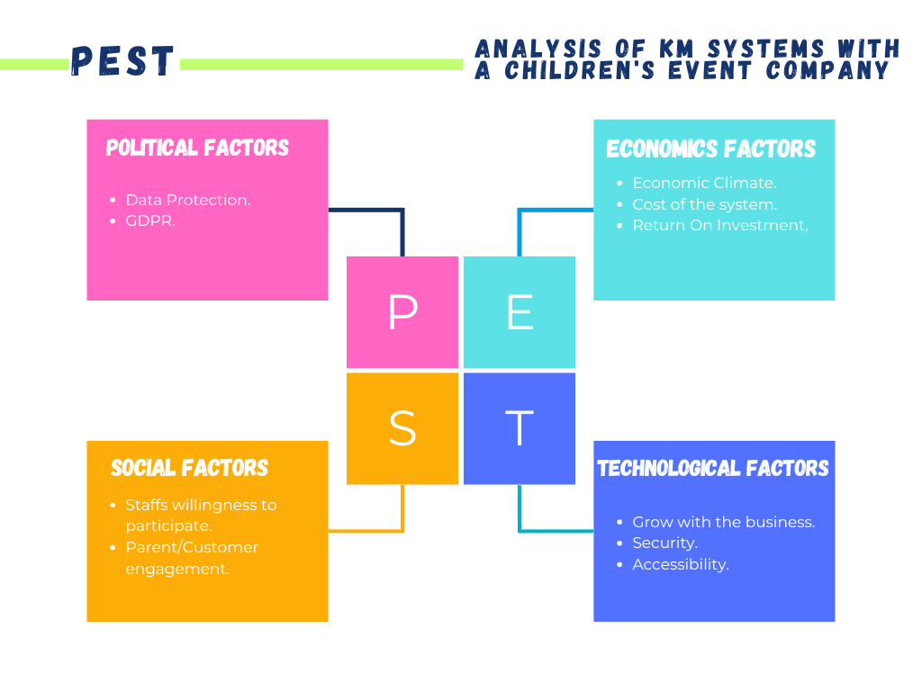

PEST Analysis
Following are the steps you need to take to apply this PEST analysis in a children's event company:
• Regular Environmental Scanning: Continuously monitor political, economic, social, and technological changes that could impact the KM system.
• Adapt to external changes with flexible KM strategies. In response to new cybersecurity threats or changing data protection laws, for example.
• Customer Engagement: Engage with employees, customers, and tech providers to understand their needs and expectations from the KM system.
• Technology Updates and Training: Regularly update the KM system with the latest technology and provide ongoing training to employees to ensure effective usage.
By considering these PEST factors, a children's event company can better plan, implement, and maintain a KM system that not only supports current business operations but is also robust enough to adapt to future changes and challenges.

Are there any key knowledge management processes currently not in operation that could be applied?
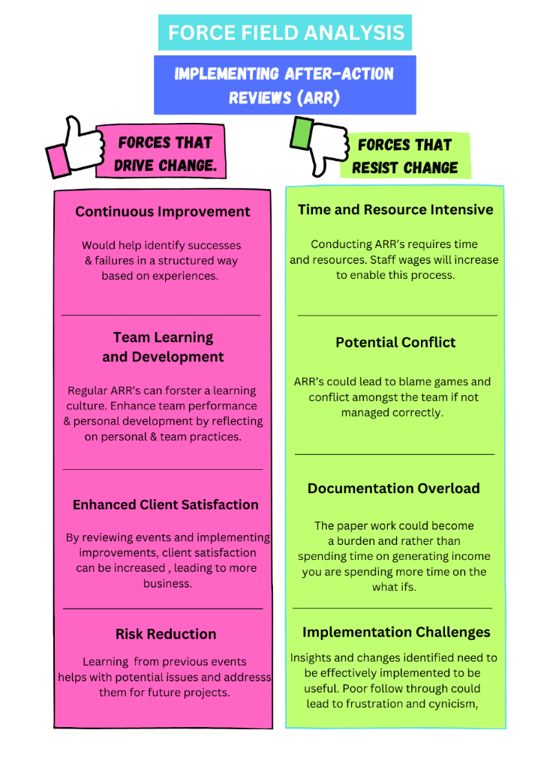
An AAR can enhance organizational learning, improve operational efficiency, and increase client satisfaction in a children's event company (Ellis & Davidi, 2005). A company's success depends on integrating these insights into its operations and cultivating an open, constructive culture that encourages learning. When managed properly, AARs can become a crucial part of a dynamic event planning environment, outweighing the challenges (Edmondson, 2011; Tannenbaum & Cerasoli, 2013).

What steps would you take to further develop a framework for establishing a knowledge management culture?

Reward employees who collaborate, share knowledge, and promote KM. Incentives boost knowledge sharing and KM practises, confirming its worth to the company (O'Dell & Grayson, 1998).
O'Dell and Grayson's influential book If Only We Knew What We Know: The Transfer of Internal Knowledge and Best Practice discusses the challenges and implications of reward schemes in businesses, especially when trying to promote knowledge-sharing and management. They discuss their pros and cons.
These reward programmes encourage knowledge sharing. Employees will contribute to knowledge management if they know they'll profit. Rewards can encourage sharing and collaboration, showing employees the organisation values their knowledge.
Employees may make low-quality, meaningless contributions for rewards. Focusing too much on rewards, Deci & Ryan believe, can lower motivation. If rewards end, employees may stop sharing expertise. Monitoring reward schemes is time-consuming. Rewards can seem manipulative or patronising, causing resistance.
O'Dell and Grayson argue reward schemes can be beneficial if well designed to avoid these issues. Rewards should encourage great work and knowledge sharing without being the main motivator. Recognition, career prospects, decision-making, and reward plans should also be part of a KM strategy.
O'Dell and Grayson believe reward programmes can promote KM, but they warn that they should be managed cautiously to avoid unexpected consequences.

Conclusion.

Effective knowledge asset management improves organisational learning, innovation, and competitiveness. A supportive organisational culture, strong leadership support, and strategic alignment of KM objectives with business goals are essential for KM success (Nonaka & Takeuchi, 1995; Hislop, 2013). Advanced technology platforms for knowledge collection, storage, and communication are essential (Davenport & Prusak, 1998; Jennex, 2015). To tackle the storage of information and ensure relevance, KM must be dynamic and assessed and adapted (McElroy, 2003). KM approaches like communities of practice and after-action evaluations can capture tacit knowledge and promote continuous learning and improvement (Wenger et al., 2002; Ellis & Davidi, 2005). Organisations can utilise knowledge management to achieve long-term competitive advantage and improve organisational outcomes by using a balanced strategy that encourages participation and focuses on quality contributions.

References
- Ackoff, R. L. (1989). "From Data to Wisdom." Journal of Applied Systems Analysis, 16, 3-9.
- Allen, J. (2010). Event Planning: The Ultimate Guide to Successful Meetings, Corporate Events, Fundraising Galas, Conferences, Conventions, Incentives and Other Special Events. Wiley.
- Barney, J. (1991). "Firm Resources and Sustained Competitive Advantage." Journal of Management, 17(1), 99-120.
- Bently, L., & Sherman, B. (2009). Intellectual Property Law. Oxford University Press.
- Chaffey, D., & Ellis-Chadwick, F. (2019). Digital Marketing. Pearson.
- Corbett, S. (2002). "Protecting and Profiting from Intellectual Property: A Guide for Small and Medium-sized Enterprises". Journal of Small Business Management.
- Cross, R., & Parker, A. (2004). The Hidden Power of Social Networks: Understanding How Work Really Gets Done in Organizations. Harvard Business School Press.
- Dalkir, K. (2013). Knowledge Management in Theory and Practice. MIT Press.
- Davenport, T. H., & Prusak, L. (1998). Working Knowledge: How Organizations Manage What They Know. Harvard Business School Press..
- Deci, E. L., & Ryan, R. M. (1985). Intrinsic Motivation and Self-Determination in Human Behavior. Plenum.
- Ellis, S., & Davidi, I. (2005). "After-Event Reviews: Drawing Lessons from Successful and Failed Experience", Journal of Applied Psychology.
- G Suite. (2020). Understanding Collaboration in Google Workspace. Google.
- Google Workspace. (2020). Google Workspace Administrator Guide. Google.
- Gray, D. E. (2007). Facilitating Management Learning: Developing Critical Reflection Through Reflective Tools. Management Learning.
- Hislop, D. (2013). Knowledge Management in Organizations: A Critical Introduction. Oxford University Press.
- Holtshouse, D. (2013). Information technology for knowledge management. Springer.
- Jennex, M. E. (2015). Case Studies in Knowledge Management Research for Researchers, Teachers and Students. Academic Conferences and Publishing International Limited.
- Kaplan, R. S., & Norton, D. P. (1996). The Balanced Scorecard: Translating Strategy into Action. Harvard Business School Press.
- Klein, D. (2018). The Google Docs Survival Guide. Packt Publishing.
- Landes, W. M., & Posner, R. A. (2003). The Economic Structure of Intellectual Property Law. Harvard University Press.
- Liebowitz, J. (2001). Knowledge Management and Its Integrative Elements. CRC Press.
- Montana, P. J., & Petit, F. (2008). Management. Barron's Educational Series.
- Nonaka, I., & Takeuchi, H. (1995). The Knowledge-Creating Company: How Japanese Companies Create the Dynamics of Innovation. Oxford University Press.
- O'Dell, C., & Grayson, C. J. (1998). If Only We Knew What We Know: The Transfer of Internal Knowledge and Best Practice. Free Press.
- Saaty, T. L. (1980). The Analytic Hierarchy Process: Planning, Priority Setting, Resource Allocation. McGraw-Hill.
- Silberman, M. L., et al. (2003). The 2003 Pfeiffer Annual: Training. John Wiley & Sons.
- Sookhak, M., et al. (2017). Security and Privacy for Storage and Computation in Cloud Computing. Information Sciences.
- Wenger, E., & Snyder, W. M. (2000). "Communities of Practice: The Organizational Frontier". Harvard Business Review.

Appendices



