A STUDY OF RELATIONSHIPS BETWEEN EMPLOYEE MOTIVATION AND PERFORMANCE MANAGEMENT
A CASE STUDY OF APPLE INC. U.K



Module Title: | Dissertation
Module Code: | LCMB7020_LON
Course: | MASTERS OF BUSINESS ADMINISTRATION IN HUMAN REASOURCE MANAGEMENT
Dissertation Topic: | A STUDY OF RELATIONSHIPS BETWEEN EMPLOYEE MOTIVATION AND PERFORMANCE MANAGEMENT: CASE STUDY OF APPLE
Lecturer: | Dr. Jaya Gopalkrishnan

Master’s Degrees by Examination and Dissertation
Declaration Form.
1. This work has not previously been accepted in substance for any degree and is not being concurrently submitted in candidature for any degree.
Signed : Karishma Vesuwala
Date : 12/06/2023

2. This dissertation is being submitted in partial fulfilment of the requirements for the degree of Master in Business Administration.
Signed : Karishma Vesuwala
Date : 12/06/2023
3. This dissertation is the result of my own independent work/investigation, except where otherwise stated.
Other sources are acknowledged by footnotes giving explicit references.
A bibliography is appended.
Signed candidate : Karishma Vesuwala
Date: 12/06/2023

4. I hereby give consent for my dissertation, if accepted, to be available for photocopying, inter- library loan, and for deposit in the University’s digital repository
Signed (candidate) : 12/06/2023
Date : 12/06/2023

Supervisor’s Declaration.
I am satisfied that this work is the result of the student’s own efforts.
Signed :
Date:

University of Wales: Trinity Saint David
E-Thesis Deposit Agreement

Details of the Work
I would like to deposit the following item in the digital repository maintained by the University, and/or in any other repository authorized for use by the University:

Title: A STUDY OF RELATIONSHIPS BETWEEN EMPLOYEE MOTIVATION AND PERFORMANCE MANAGEMENT: CASE STUDY OF APPLE IN UK

This item is a product of my own research endeavours and is covered by the agreement below in which the item is referred to as “the Work”. It is identical in content to that deposited in the Learning Resources Centre, subject to point 4 below.
I agree that the University of Wales: Trinity Saint David may electronically store, copy or translate the Work to any approved medium or format for the purpose of future preservation and accessibility. The University is not under any obligation to reproduce or display the Work in the same formats or resolutions in which it was originally deposited.
UW: TSD Digital Repository
I understand that work deposited in the digital repository will be accessible to a wide variety of people and institutions, including automated agents and search engines via the World Wide Web.
I understand that once the Work is deposited, the item and its metadata may be incorporated into public access catalogues or services, such as national databases of electronic theses.

I agree as follows:
- That I am the author or have the authority of the author/s to make this agreement and do hereby give the University of Wales: Trinity Saint David the right to make available the Work in the way described above.
- That the electronic copy of the Work deposited in the digital repository and covered by this agreement, is identical in content to the paper copy of the Work.
- That I have exercised reasonable care to ensure that the Work is original, and to the best of my knowledge, does not breach any laws including those relating to defamation, libel and copyright.
- That I have, in instances where the intellectual property of other authors or copyright holders is included in the Work, gained explicit permission for the inclusion of that material in the Work, and in the electronic form of the Work as accessed through the open access digital repository, or that I have identified and removed that material for which adequate permission has not been obtained and which will be inaccessible via the digital repository
- That University of Wales: Trinity Saint David does not hold any obligation to take legal action on behalf of the Depositor, or other rights holders, in the event of a breach of intellectual property rights, or any other right, in the material deposited.
- That I undertake to indemnify the University of Wales: Trinity Saint David against all actions, suits, proceedings, claims, demands and costs occasioned by the University in consequence of any breach of this agreement

Signature: Karishma Vesuwala
Date: 12/06/2023

Abstract

This study looks into the connection between productivity as well as employee motivation at Apple Inc. Given the business's success, the issue of "managing highly motivated" employees is addressed. By studying both intrinsic as well as extrinsic motivation including its effects on worker productivity, the study seeks to offer insightful information for increasing motivation plus performance management. demonstrating the efficacy of feedback, goal-setting, as well as recognition in increasing motivation as well as performance, in this study the research is about emphasises the significance of "intrinsic motivation for employee satisfaction" as well as engagement. The study design incorporates a positivist strategy plus quantitative research methods, concentrating on Apple Inc. as a notable example. The results advance theoretical understanding as well as have a direct bearing on how Apple Inc. manages its workforce. The study emphasises the requirement to investigate particular performance management as well as motivating strategies as well as the requirement for promoting a favourable corporate culture. The findings offer insightful data that may be used to improve stress management, corporate communication, management of performance, as well as employee engagement.

Acknowledgement
I like to convey my deepest appreciation to my supervisor Dr Jaya Gopalkrishnan for guiding and providing feedback throughout this study.
I am indebted to my colleagues and friends who supported me and assist me in gathering prerequisites for my study. Finally, I am grateful to my family for helping me complete my education and supporting me throughout the journey.
Your Signature:
Date:

TABLE OF CONTENTS
Chapter 1: Introduction 4
1.1 Research Background 4
1.2 Research Rationale 4
1.3 Research Significance 5
1.4 Research Gap 5
1.5 Research Aim and Objectives 6
1.5.1 Research Aims 6
1.5.2 Research Objectives 6
1.6 Research Question 6
1.7 Chapter overview 6
1.8 Summary 7
Chapter 2: Literature Review 8
2.1 Introduction 8
2.2 Intrinsic motivation 8
2.3 Extrinsic motivation 9
2.4 Employee performance 10
2.5 Employee Motivation & performance management 12
2.6 Theorical fundamentals 12
2.7 Literature Gap 15
2.8 Conceptual Framework 16
2.9 Research question 17
2.10 Methodology 18
2.11 Conclusion 19
Chapter 3: Research Design and Methodology 20
3.1 Introduction 20
3.2 Research Philosophy 20
3.3 Research Approaches 21
3.4 Research design 22
3.5 Research Strategy 23
3.5.1 Type of Investigation 23
3.5.2 Choices 23
3.5.3 Time Horizon 24
3.6 Sampling method 24
3.6.1 Sample type 24
3.6.2 Sample size 24
3.6.3 Sample profile and demographics 25
3.6.3 Sampling method 25
3.7 Data collection method 25
3.8 Data analysis 26
3. 9 Ethical considerations 27
3. 10 Research limitations and Accessibility issues 27
3.11 Conclusion 28
Chapter 4: Data Analysis 30
4.1 Introduction 30
4.2 Quantitative data analysis 31
4.2.1 Survey Analysis 31
4.2.2 Discussion 41
4.3 Conclusion 51
Chapter 5: Conclusion 52
5.1 Linking with Objective 52
5.2 Limitation 54
5.3 Recommendation 54
5.4 Area of future research 55
5.5 Conclusion 56
Reference List 57

Chapter 1: Introduction

1.1 Research Background
Examining the connection between employee motivation as well as performance at Apple Inc. is the main objective of the research's background. Managing as well as keeping highly engaged employees is a difficulty for Apple Inc., a company renowned for its creative products & worldwide success. The long-term success of the business, productivity, as well as decreased absenteeism as well as turnover rates depend greatly on the organisation's workforce being motivated (Indradevi, 2020). There has been a dearth of empirical studies explicitly focused on Apple Inc. that examines how motivation affects work performance. By examining the relationship between work motivation & job performance within Apple's production team, this research seeks to close this research gap. The study aims to investigate intends to offer helpful information for Apple Inc. With regard to comprehending the elements that motivate employee motivation along with how they pertain to job performance through investigating the effect of intrinsic & extrinsic motivation for performance (Damanik et al. 2019). The results of this research can help Apple Inc. create efficient plans for energising staff members and improving general performance management.

1.2 Research Rationale
The need to comprehend what motivates employee behaviour and the way it affects their attitude & performance in different areas of life is what led researcher to carry out research on the connections between employee motivation & performance management, particularly in the context of Apple. Numerous research has been done on motivation, yet many managers are still unsure about ways to use it to increase staff productivity & boost organisational performance (Kalogiannidis, 2021). Motivation has a key factor that affects people's capacity to carry out acts persuasively or successfully. While financial incentives are important, they can't alone guarantee the highest levels of employee motivation. In order to increase employee engagement, non-financial incentives are equally crucial.
Based on how employees behave and carry out certain jobs or assignments inside an organisation, organisational performance is assessed. Among the elements that affect an employee's work performance as well as by extension, organisational performance is motivation. In terms of personal attitude, job difficulty, resource availability, as well as the working environment, highly motivated employees are anticipated to produce higher returns (Kalogiannidis, 2021). While employee performance is subpar, it is imperative for managers to pinpoint the most relevant variables. In order to determine if traditional concepts of motivation were still relevant in today's society, this study explores fresh contemporary methods for motivating employees in the twenty-first century. Employing the best motivational strategy is crucial for sustainable development because motivation is seen as a vital factor in organisational growth. This is essential to analyse the relationship in the setting of Apple and add to a wealth of information on employee motivation as well as organisational performance (Kalogiannidis, 2021). Prior research has confirmed the significant effect of employee motivation on each individual as well as organisational performance.

1.3 Research Significance
The research was carried out with contributions in both theoretical as well as practical areas are what make it significant. There are several important ramifications to knowing how Apple Inc.'s employees are motivated along with performing (Murtaza et al. 2021). According to a theoretical standpoint, the study advances our understanding by filling a "knowledge gap" on the impact of motivation on productivity, notably at Apple Inc. This research advances our knowledge of motivational elements including their effects on work performance in a special organisational environment by examining this link. In terms of management and staff motivation, Apple Inc. can use the research's practical conclusions to its advantage. The study provides guidance for the creation of specific approaches to improve employee motivation as well as managing overall performance via outlining the motivation-driving elements as well as their effect on performance (Pasi et al. 2020). It may result in increased output, less absenteeism as well as turnover, including ultimately helping Apple Inc. succeed in the long run as a business.

1.4 Research Gap
The study has a research gap because there isn't any empirical work explicitly looking at how Apple Inc.'s employees' motivation, as well as job performance, are related. Despite the fact that motivation and performance management were well-studied subjects, there has been a paucity of research that specialises in Apple Inc. including its production team. This research seeks to close this gap by investigating the relationship between work performance as well as motivation within the particular organisational setting of Apple Inc (Charbonneau and Doberstein, 2020). The results will contribute to greater comprehension of this connection by giving important insights about the particular elements that motivate people as well as their effects on productivity in the workplace.

1.5 Research Aim and Objectives

1.5.1 Research Aims
This study's main objectives are to investigate the interactions between intrinsic motivation & employee engagement along with the link between extrinsic motivation & staff performance management. The goal is to look into and ascertain how intrinsic & extrinsic motivation affect employee performance.

1.5.2 Research Objectives
- To understand what connection exists between Apple Inc.'s performance management system with employee motivation.
- To analyse how Apple Inc. might improve productivity through the staff motivating process.
- To examine how the Apple company may improve performance management through the employee motivating process.
- To explain the importance of employee motivation inside the Apple Inc. business.

1.6 Research Question
- What connection exists between Apple Inc.'s performance management system with employee motivation?
- How Apple's organisation might boost productivity through employee incentives?
- How Apple's organisation may improve performance management through the employee motivating process?
- Why it's crucial for Apple's organisation to have motivated employees

1.7 Chapter overview
Several chapters focusing on various facets of the research study make up the thesis. The study's subject matter is introduced in Chapter 1 together with background knowledge, a justification, significance, and study objectives. The literature study in Chapter 2 looks at issues like employee performance, intrinsic as well as extrinsic motivation, including motivation management (Mahajan, 2019). The approach is covered in Chapter 3, along with the study concept, design, data collecting, analysis, ethical issues, and restrictions. The data analysis, as well as discussion, are presented in Chapter 4, which analyses the survey data plus discusses the results. The thesis is finally concluded in Chapter 5, which summarises the main ideas, offers suggestions, acknowledges the limitations of the research study, as well as identifies potential areas for further investigation.

1.8 Summary
The purpose of the study is to investigate how Apple Inc.'s employees' motivation, as well as productivity, are related. Managing along with keeping highly motivated personnel is a challenge for Apple despite its widespread success. Long-term growth, and productivity, along with lower absenteeism as well as turnover rates are all benefits of having motivated staff. There is, however, a dearth of empirical study that focuses explicitly on performance including motivation at Apple Inc. While examining the relationship between motivation as well as work performance in Apple's production team, the present study aims to close this research gap. The study aims to investigate Apple Inc. useful insights for improving motivation as well as performance management tactics by examining intrinsic plus extrinsic motivation along with its effect on performance. The study is important since it advances theoretical knowledge and has application in Apple Inc.'s staff management.

Chapter 2: Literature Review

2.1 Introduction
In this literature review chapter, it can be understood that organizational research has recently placed a greater emphasis on the connection between employee motivation plus performance management. In order to better understand the relation between employee motivation plus performance management inside the organisation, this research investigation examines the instance of Apple. Intrinsic & extrinsic motivation are introduced in the research's study opening section, along with their relationships to worker performance. After that, it examines the various theories and models put up to clarify the connection between motivation & performance management, such as “goal-setting theory, self-determination theory, and expectation theory”. In order to fill the vacuum in the literature & offer a thorough knowledge of the connection between employee motivation as well as performance management, the research suggests a conceptual framework that brings together the many ideas and paradigms. The theory is predicated on the notion that motivation can be a complex phenomenon whose services are affected by both intrinsic plus extrinsic variables, as well as that successful performance management necessitates striking a balance among these aspects.

2.2 Intrinsic motivation
The term “intrinsic motivation” describes the inner impulse that someone has to participate in a pastime or complete a task since it is intrinsically pleasurable, satisfying, or else fulfilling (Aubret et al. 2019). This is sometimes contrasted by extrinsic motivation, which entails engaging in something or completing an assignment in order to gain some type of reward or else avoid punishment from the outside world. Intrinsic motivation may serve as a potent instrument for increasing productivity plus performance among employees when it comes to motivation (Fischer et al. 2019). Employees that are genuinely motivated were prone to experience feelings of ownership & loyalty to their job and to exert more effort as well as ingenuity to accomplish their objectives (Forson et al. 2021). Apple, a business renowned for creating cutting-edge & inventive products, places a high priority on encouraging intrinsic motivation among its staff members.
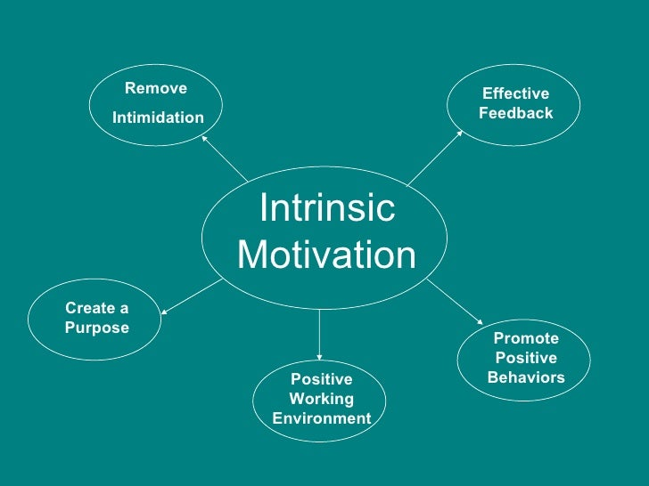
Figure 1: Intrinsic Motivation
(Sources: Intrinsic Motivation, 2023)
This is accomplished via a variety of tactics, including giving staff members the freedom to go after individual thoughts & projects, encouraging a climate of cooperation and honest communication, as well as offering substantial pay & benefits packages. In general, intrinsic motivation has a significant contributor to staff performance along with can be helpful in assisting organisations in achieving their aims and targets (Guzeller and Celiker, 2020). Companies such as Apple may increase "employee satisfaction, retention, and productivity" while gaining an unfair advantage in their field by establishing an atmosphere that promotes and supports intrinsic motivation.

2.3 Extrinsic motivation
Extrinsic motivation describes the elements that encourage a worker to deliver a high level of performance in exchange for cash, promotions, accolades, or other external rewards along with penalties (Christian et al. 2022). Extrinsic motivators can often be practical and concrete, meaning they are frequently offered by a company or management group to compel staff to meet particular objectives. Extrinsic motivation within the setting of Apple could take the shape of incentives or else stock options, job advancements, or public acclaim for exceptional achievement (Fischer et al. 2019). For instance, Apple is well-known for its "performance-based stock grants", in which staff members are granted stock in accordance with how much they contribute to the business's success.
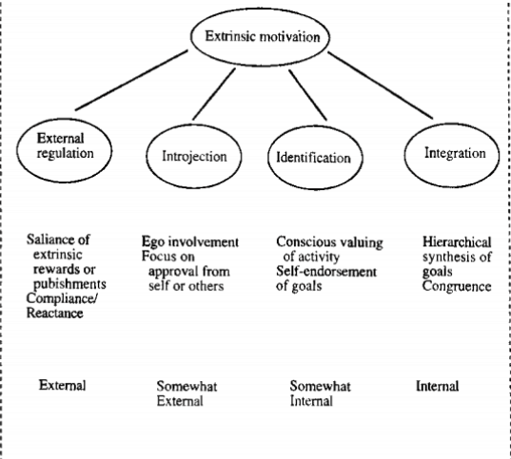
Figure 1: Intrinsic Motivation
(Sources: Kreimer, 2021)
It can also understand that knowing that everything they do will be appreciated and acknowledged can inspire workers to work more diligently and productively. The research also emphasises that relying entirely on extrinsic motivators might not be "long-term sustainable". Although external rewards can motivate workers in the short term, they might not be enough to encourage greater feelings of dedication or loyalty among workers (Bivona and Cosenz, 2021). To develop an environment of outstanding performance that is sustainable, this makes it is crucial for organisations to balance internal as well as extrinsic motivators.

2.4 Employee performance
The output as well as the result of a staff member's efforts towards reaching the specified goals and targets for a company are referred to as employee performance, based on the research. It includes an employee's output in terms of the amount and the quality along with its performance's effectiveness plus efficiency (Moro et al. 2021). The accomplishment of company goals & objectives has an immediate effect on employee performance, which is a critical component of company success. Apple has a thorough system for managing employee performance which focuses on recognising, evaluating, and improving employee performance. The study is about "Apple's performance management system" is built on an ongoing feedback & development method, which includes establishing specific performance targets, offering frequent feedback & coaching, plus evaluating and rewarding employee success (Stalmachova et al. 2022).
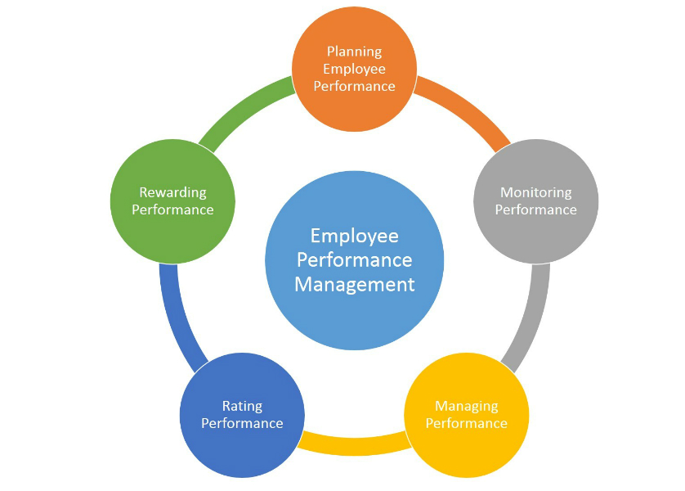
Figure 3: Employee performance management
(Sources: Performance management, 2023)

The survey also discovered that a variety of performance measures, such as productivity, excellent customer service, along with innovation, are used at Apple to gauge employee success. Employee performance has been evaluated by the organisation using a combination of subjective & objective metrics, including reviews from peers, and supervisor assessments, including self-assessments. Thus, the study emphasises how critical good performance management has been for boosting worker productivity and business success (Banuari et al. 2021). Companies like Apple may increase employee motivation, engagement, & job satisfaction, thus improving employee performance & improves organisation results, by creating clear performance targets, offering frequent feedback & coaching, and assessing & rewarding worker performance.

2.5 Employee Motivation & performance management
For an organisation to succeed, there must be a connection between performance management with employee motivation. In this study the research is about of the connections between performance management with employee motivation in the setting of Apple emphasises the importance of combining performance management techniques with motivational techniques (Khaltar and Moon, 2020). According to studies, performance management procedures with employee motivation were interconnected. As a result, organisations must establish a complete strategy to integrate these two elements for better organisational performance. Defined performance expectations, frequent feedback, and the creation of a suitable system of rewards & recognition are all part of performance management practises. Aligning these practices with "motivational theories including self-determination theory, goal-setting theory, and equity theory" is crucial for improving employee motivation (Singh and Misra, 2022).
Organisations can achieve this by educating staff members about the significance that is their work as well as fostering a sense that mastery, autonomy, with purpose. Performance management procedures can also increase employee motivation by offering chances for advancement plus development. Employees have a greater likelihood to be motivated plus involved in their job if they believe that their company is investing in their growth and giving them the opportunity to learn & improve (Gigliotti, 2021). Employee motivation & performance in organisations can be raised by integrating motivational tactics with performance management procedures. Organisations can establish a pleasant work environment that promotes employee motivation, engagement, and ultimately" higher performance through providing an unambiguous knowledge of performance standards, regular feedback, & chances for growth & development.

2.6 Theorical fundamentals
A variety of theories & modules that serve to understand the way inspiration influences employee performance provide the foundation for an examination of the connections between employee motivation & performance management. "The Self-Determination Theory (SDT)", among the main ideas, contends which extrinsic motivation, or else external benefits or penalties for doing a task, was weaker than "intrinsic motivation", or the desire within to complete a task since it's fascinating or satisfying (Wang et al. 2022).
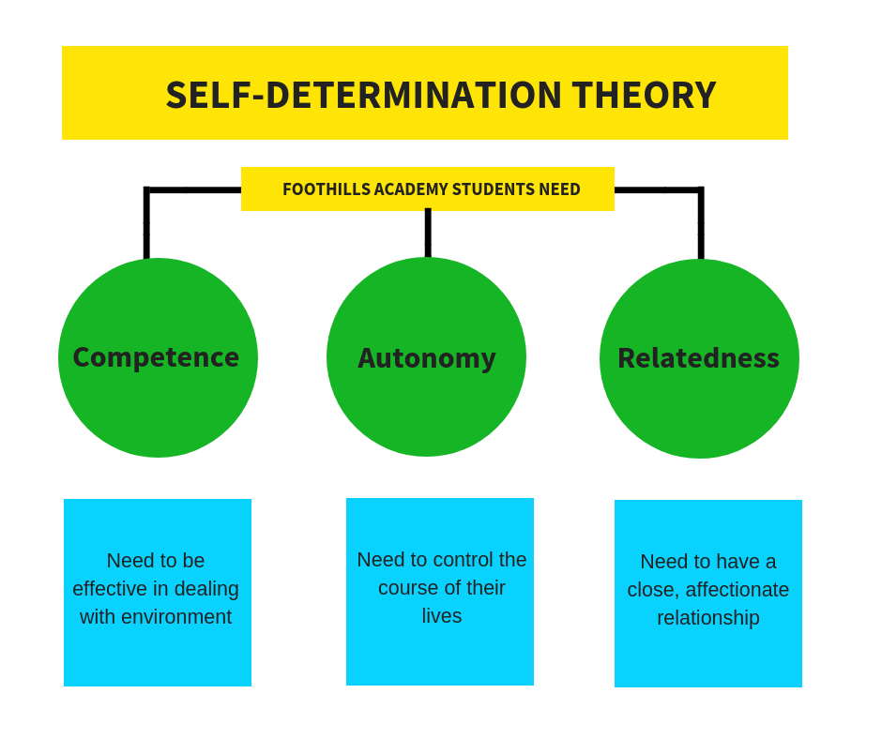
Figure 4: The Self-Determination Theory
(Sources: Foothillsacademy.org, 2023)
In contrast to "extrinsic motivation", which can result in a decline in performance as well as job satisfaction when the rewards are not seen as just or the penalty is too harsh, intrinsic motivation improves performance as well as job happiness, based on SDT.
The Expectancy theory, which contends that motivation among workers is founded on the conviction that work will result in performance & that performance would result in rewards, was another significant idea. It holds that workers are unlikely to motivate themselves to work hard unless they think that what they do will be adequately compensated plus their rewards would be worthwhile to themselves (Khan et al. 2029).
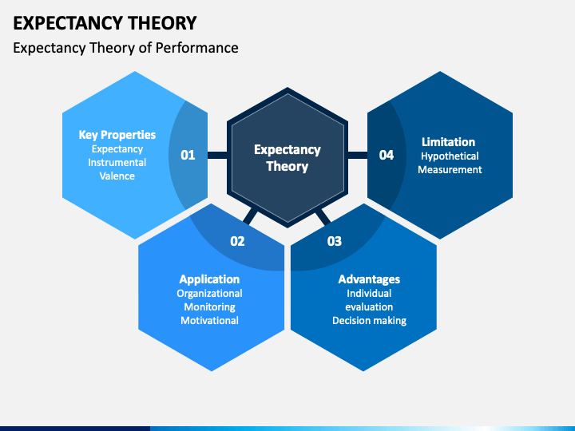
Figure 5: The Expectancy theory
(Sources: Sketchbubble.net, 2023)
This idea highlights the significance of concise, meaningful, performance-based incentive systems. These concepts may be utilised in conjunction with a number of performance management modules to raise employee engagement and productivity. Goal setting comprises one of these modules, and it entails establishing measurable objectives that are difficult for staff members to meet. Due to the explicit goal-setting and feeling of achievement it fosters, this module can be demonstrated to enhance employee motivation & performance (Shaari, 2019).
Maslow's theory stated that People are driven by a variety of hierarchical requires, including the satisfaction of each person's potential for self-actualization, the satisfaction of their physiological needs, safety & security, social relationships, and emotions of importance & recognition (Bailey et al. 2021). It is possible to improve employee motivation & performance by addressing these demands through efficient performance management procedures.
According to goal setting theory, establishing clear, challenging goals is essential for improving motivation and output (Fong et al. 2019). Employees are more motivated and focused when they have clear & demanding goals to work towards.
Giving employees regular, positive feedback on how they're doing is a key component of the evaluation module. In order to raise motivation & improve performance, employees may utilise this section to figure out what they perform including what they require to work on (Shafi et al. 2020). In general, the examination of the connections between performance management & employee motivation relies on a variety of theories as well as modules that emphasise the significance of intrinsic motivation, transparent and insightful performance management frameworks, as well as the application of performance management tools like goal-setting as well as feedback to enhance employee performance (Schwepker et al. 2021). Organisations can enhance their efficiency in management procedures and produce a more motivated as well as effective staff by comprehending and putting these theories with modules to use.

2.7 Literature Gap
The areas of the research's literature gap that have not been sufficiently examined or studied in depth by earlier studies. There are however a number of holes in this investigation that call for additional research (Adesanya et al. 2020). First of all, the research study focuses on the connection between employee motivation & performance management within Apple, however, it fails to take into account the influence of external factors like prevailing economic conditions, technological advancements, and industry competitiveness. Therefore, more research is required to examine how external factors affect employee motivation & performance management (Shin et al. 2019). Second, the research study does not take into account the function of leadership in managing employee performance & motivation. Although the study recognises the value of leadership but fails to examine in-depth whether leadership impacts staff motivation or else performance appraisal.
As a result, further research is required to examine how leadership affects employee motivation & performance management. Thirdly, because Apple is the sole company included in the research as an example, its applicability to other businesses is constrained (Ribes et al. 2020). There is hence an appetite for additional research which examines the connection between performance management & employee motivation across different organisations including industries. Last but not least, the study did not take into account how the demographics of the workforce, including age, gender, as well as educational attainment, affect employee motivation plus performance management. Examining the effects of staff demographics on motivation and achievement in management will require more research (Buil et al. 2019). As a result, there is a need for more research to examine the effects of "external factors", the function of direction, motivation and achievement management in various organisations, as well as the influence of employee characteristics on worker motivation & performance management (Kartal et al. 2021).

2.8 Conceptual Framework
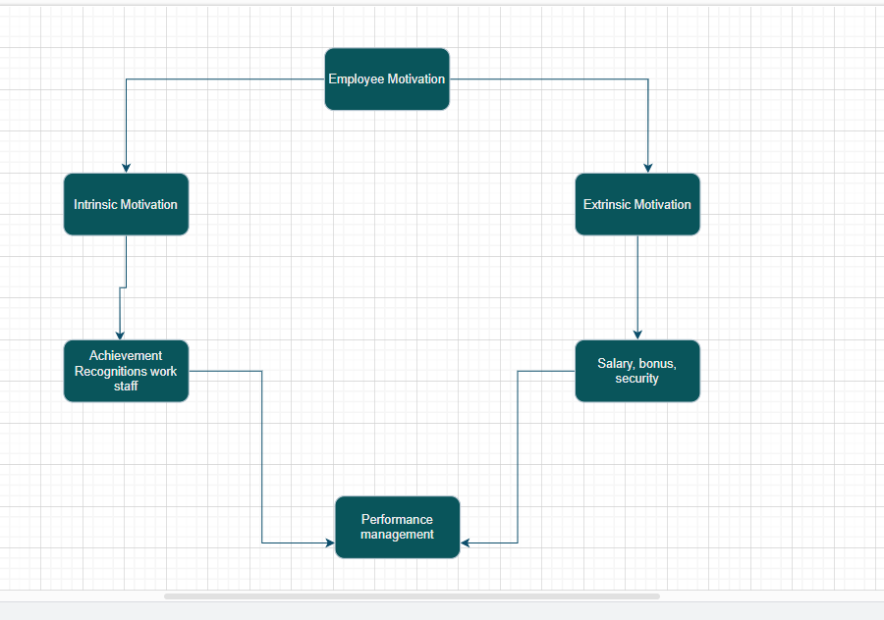
Figure 1: Conceptual Framework
(Sources: Draw.io)
Three primary elements make up the conceptual foundation for the research: performance management, employee motivation, plus their interactions. Both intrinsic plus extrinsic factors may influence a worker's degree of motivation, which is referred to as employee motivation. The procedures and procedures utilised by organisations to evaluate, develop, and boost worker efficiency are included in the management of performance (Indradevi, 2020). In order to comprehend how motivation can affect performance management as well as how performance management may impact motivation among workers, the connection between employee motivation & performance management will be examined. The research project examines the connection between Apple's performance management with employee motivation using a case study methodology.
Conceptual Foundation
Employee satisfaction is greatly influenced by motivation, a critical element in work environments. Several studies have investigated the connection between employee performance & motivation in various organisations. Forson et al. (2021), self-determination theory (SDT), provides a framework for comprehending motivation including its effect on performance. SDT makes a distinction among controlled motivation, that is influenced by outside factors, with autonomous motivation, that comes from individual choice. According to research, motivation has an important factor in performance. Concerns concerning the effect of salary structures on employee performance have made motivation in apple employee profession a hot topic (Forson et al. 2021). Given the significance of motivation in raising employee standards, the goal of the research is to investigate the relationship between performance as well as motivation components among Ghanaian basic school instructors. The study comprises an examination of the motivational literature, the creation of a conceptual framework using SDT, with an analysis of the findings and their policy implications.

2.9 Research question
- What are the key motivators that drive employee performance within Apple Inc.?
- To what extent does the implementation of performance management systems at Apple influence employee motivation levels?
- How do Apple's management practices align with established motivational theories in the context of employee performance management?
- What measures can Apple take to improve employee motivation and performance management practices in the future?

2.10 Methodology
In this context, the learner has been selected interpritism research philosophy and inductive research approach. This interpritism research philosophy help to understand that key motivators that drive employee performance within Apple Inc and inductive research approach help to understand that does the implementation of performance management systems at Apple influence employee motivation levels. It can also understand that the learner has to choose qualitative research method for this research. This qualitative research method helps to gain appropriate literature insight for this research.
literature review Table
Theme | Selection Process | Author | Data collection Method
Intrinsic motivation | Finding individuals who exhibit self-driven passion with intrinsic happiness in their job is a key step in "Apple Inc.'s intrinsic motivation selection process". | (Forson  et al. 2021), (Guzeller and Celiker, 2020). | Journals
Extrinsic motivation | Finding candidates for Apple Inc. includes figuring out who are driven by rewards & recognition from outside sources. | (Christian et al. 2022), (Bivona and Cosenz, 2021). | Journals
Employee performance | Establishing measurements, objectives, and standards to evaluate performance levels is part of Apple Inc. | (Moro et al. 2021), (Stalmachova et al. 2022), (Banuari et al. 2021). | Journals
Employee Motivation & performance management | Identifying key phrases and ideas, including those related to "performance metrics, goal-setting, intrinsic motivation, and extrinsic" drive, is a step in the Apple Inc. process. | (Khaltar and Moon, 2020), (Singh and Misra, 2022), (Gigliotti, 2021), | Journals
Table 1: Literature review table
(Sources: Self-made)

2.11 Conclusion
In summary, the research on the connections between Apple's performance management & employee motivation showed that both intrinsic & extrinsic motivation is important for enhancing employee performance. Extrinsic motivation may promote desirable behaviours & results; however, intrinsic motivation must be present for employee pleasure as well as engagement. In addition, giving feedback, establishing precise targets, and praising and rewarding effective performance can improve employee motivation plus performance. The application of particular motivational including performance management tactics outside the framework of Apple yet is not well covered in the existing literature. The efficacy of various techniques, including "flexible work arrangements, training and development" initiatives, plus pay based on performance, might be investigated in more detail. The study also emphasises the value of encouraging a business culture in fostering worker enthusiasm and productivity

Chapter 3: Research Design and Methodology

3.1 Introduction
The achievement of any company depends heavily on managing performance including motivating employees. Employees who are motivated are typically more engaged, profitable, and devoted to accomplishing organisational goals. Successful performance management systems offer the structure and resources needed to improve employee performance as well as harmonise it with organisational goals. For businesses looking to maximise staff productivity as well as a secure long-term competitive advantage, recognising the connection among performance management including employee motivation is crucial. This study intends to investigate the connection between performance appraisal with employee motivation in the setting of Apple Inc., a renowned global technological corporation. With a positivist approach to research, the study aims to gather empirical knowledge via impartial measurement as well as observation. Deductive reasoning is used in the study to arrive at specific findings by evaluating hypotheses drawn from accepted theories.
The study uses a "case study research design" and uses Apple Inc. as a benchmark for the electronics sector. The study seeks to establish connections between motivation among workers as well as performance management through the use of an exploratory investigation. "Closed-ended questions and Likert scales" may be used in surveys to collect data, plus statistical methods will be used to analyse the quantitative data. This study adds to the reservoir of expertise by offering insightful information on the elements that motivate employees and how they affect performance appraisal in the special organisational setting of Apple Inc. The research findings can influence organisational procedures and aid in the creation of successful employee motivation as well as performance management approaches in related industries.

3.2 Research Philosophy
A positivist research ethic has been used in this investigation to examine the connection between "Apple Inc.'s performance management system and employee motivation". According to Opazo et al. (2019) the "positivist research philosophy" is based on the idea that understanding may be attained by empirical observation with impartial measurement.
Justification
This approach is being used in the research to explore theories about how the performance management system of Apple Inc. affects employee motivation. The positivist philosophy has been enable researcher to examine participant replies and produce a clear picture of performance management including employee motivation (Delaney, 2020). For the purpose of measuring plus quantifying staff performance within the Apple Inc. organisation, the researcher may collect numerical information by using quantitative research methodologies, like surveys or else structured interviews.
Additionally, the positivist research ethos offers a framework for examining the connection between performance management with employee motivation. It helps the learner to systematically as well as rigorously evaluate the level of linkage or correlation between various variables. The research uses statistical methods to assess the nature and degree of the link, offering significant insights about how performance management can be affected by motivation for Apple Inc. The researcher is trying to employs the positivist research approach in an effort to gain a greater understanding of the elements that influence employee motivation as well as how they affect performance in the particular organisational setting of Apple Inc (Sonmez and Adiguzel, 2020). "The research philosophy" will help make it easier to gauge employee performance plus find important motivators that improve performance management across the company.

3.3 Research Approaches
This research is about the apple Inc the relationship between employee motivation & performance management, a deductive research methodology is suitable (Peytcheva et al., 2019).
Justification
This approach entails putting current theories & hypotheses to the test using accepted frameworks and concepts. At first deductive reasoning enables academics to apply theoretical understanding and well-established concepts to the particular environment of Apple Inc. In this instance, the study intends to investigate the connections between performance management & employee motivation, that is an established field of research. Deductive reasoning is used throughout the research process to create specific hypotheses which may be verified through experimentation by building on the theories & models already in use in the discipline.
Apple Inc. has a sizable company with well-established procedures and guidelines. Researchers can study the connection between motivation & performance given the current organisational structure & framework by using a deductive method. It allows the research to evaluate the way popular motivational & performance management "theories and concepts" relate to the particular situation of Apple Inc. A deductive strategy also encourages an organised, systematic examination. It entails gathering pertinent data and analysing it to put the hypotheses under test. This method enables the production of trustworthy and legitimate findings by offering a rational and rigorous framework for investigating the connections between employee motivation & performance management.

3.4 Research design
In this context of the research design there are three type of research design are present in this research such as case study research design, explorative research design, descriptive research design. In this context the learner has chosen a case study research design based on case studies for the research in this setting.
Justification
The study uses a design based on case studies to examine the distinctive organisational structure of Apple Inc. in order to acquire an understanding of the way employee motivation affects performance management. “A case study research design” enables a thorough investigation of the staff motivation as well as performance management tactics used by Apple Inc. by allowing for an in-depth assessment of a particular example (Mariana, 2020). This study seeks to find correlations between these two important aspects by concentrating on a particular case in order to unearth complicated insights. To obtain primary information from organisation personnel, the study plans to make use of a variety of data-gathering techniques, including surveys as well as interviews. To examine the intricacies of the linkages between employee motivation as well as performance management, the information gathered has then gone through a rigorous quantitative examination.

3.5 Research Strategy

3.5.1 Type of Investigation
The type of investigation adopted in this research was an exploratory research strategy. A study topic that is still not completely investigated or understood is the goal of an exploratory investigation (Wang, 2021).
Justification
This study focuses on the impact of employee motivation & performance management enterprises, an area that is still in development and requires additional studies to comprehend both its causes plus effects. The research uses an analysis of the example of Apple Inc to find new information, identify trends, and propose a relationship between employee motivation & performance management strategies with the quality of electronics.

3.5.2 Choices
The choices made during this investigation included deciding to do an in-depth investigation on Apple Inc. Apple Inc. has been chosen due to its strength in the consumer electronics sector & its extensive use of staff motivation plus performance.
Justification
Focusing on a single instance allows for a complete investigation of Apple Inc.'s employee motivation & performance approach, the outcomes, plus the factors influencing their effectiveness (SALEH et al. 2020). By concentrating on just one case, the research could provide complicated and in-depth insights regarding ways employee motivation & performance marketing have impacted a specific organisational setting and arrive at pertinent findings that are applicable to other circumstances

3.5.3 Time Horizon
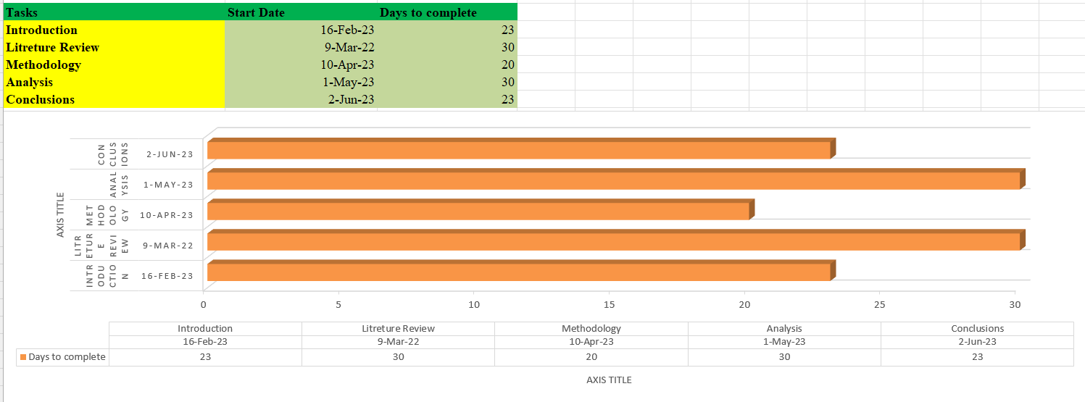
Figure 1: Time-Frame
(Sources: Self-made)

3.6 Sampling method

3.6.1 Sample type
In this study, a random selection method may be used by the researcher to choose participants from the questionnaire. With the "random sampling technique", any member of the population as a whole has an equal chance of being chosen for the sample. Its method ensures that the quantity of respondents accurately represents the overall population and assists in reducing bias throughout the data collection process (Pacaol, 2021). As far as sample type is concerned, the research concentrates on employees or participants of Apple Inc. Since they have the most experience with performance management as well as employee motivation, staff were selected for the group that represented type.

3.6.2 Sample size
A sample size of 100 and more Apple Inc. Corporation employees were chosen for this investigation. Using a simple random selection process, the sample had been chosen among the business's working employees. To guarantee that the sample's results may be generalised to the entire population, random sampling has been employed (TRAN et al. 2020). This sampling strategy has been selected for its bias-free nature and ease of use.

3.6.3 Sample profile and demographics
The sample size of 100 and more employee of Apple Inc. Corporation workers included active members of the workforce representing various corporate divisions and roles. The sample's demographics were a mix of male & female workers from a range of ages and experience levels. The random selection procedure made certain the sample was representative as well as that it could be applied to the whole workforce of Apple Inc

3.6.3 Sampling method
Random sampling is frequently employed for study purposes to guarantee objectivity as well as population representation. This is a method that gives each worker in a particular population a comparable likelihood of getting picked for the research project. This method was additionally employed in a number of research studies, particularly ones that Apple Inc. Apple Inc. could use random sampling for selecting a sample of participants among its staff in research looking into the effects of employee motivation & performance on electronic companies (Amankwah, 2020).
This strategy assures the sample fairly represents every worker in the organisation, enhancing the validity as well as the generalizability of the research's findings. Although bias is lessened by random sampling, this is important to recognise there could still be constraints and possible reasons for sampling mistakes. This sample's participation & representativeness must be improved, plus researcher must be aware of these constraints. By doing this, they may mitigate any potential negative effects and raise the research's general standard. It is critical to take into account the sample's characteristics as well as possible prejudices or limitations while analysing the outcomes of the research (Rehman et al. 2019). Researcher may provide a deeper and more precise evaluation of the relationship between employee motivation & performance in electronic companies within the setting of Apple Inc. by taking these elements into account.

3.7 Data collection method
Participants took part in the methodical gathering of quantitative data that served as the research's major data source. To gather data from those who responded in an organised manner, researcher used tools like surveys. The research's emphasis on the connection between employee motivation & performance management for the setting of Apple Inc. was evaluated using closed-ended questions using Likert scales, which were also utilised to compile demographic data on the people who participated. The researcher ensure that every person answered the identical set of closed-ended items on the survey by combining them with Likert scales (Bianchi and Vignieri, 2021).
The fact that the responses given by the respondents were self-reported, reduced the possibility of bias among the interviewers. By quantifying replies through the application of Likert scales, those conducting the study were able to conduct a systematic & impartial analysis of the data. When analysing the study's findings, it is essential to maintain trustworthy and true information, along with the standardisation given by employing closed-ended questions plus Likert scales made the procedure easier (Razak et al. 2020). The validity, as well as reliability using the results, are improved by making use of standardised measures as well as data-collection techniques, allowing for precise data analysis plus interpretation.

3.8 Data analysis
The findings & discussion phase of the research will employ quantitative statistical analysis of the primary information collected via the questionnaire survey (Bode et al. 2019). All quantitative statistics of the information gathered by Apple Inc. personnel are thoroughly examined as part of this quantitative evaluation technique. It serves as a framework for interpreting data as well as arriving at insightful conclusions. The learner employed the popular "data analysis tool SPSS software" to carry out the statistical study. In order to make it easier to explore, manipulate, and visualise data, SPSS provides a variety of statistical methods as well as features. Using the aid of SPSS, the learner were capable of performing the proper statistical tests as well as computations to the gathered data, allowing them to get insightful knowledge and reach reliable judgements.
The findings & discussion part of the research heavily rely on the statistical representation of all the collected data (Jie et al. 2020). This makes it simpler for consumers to comprehend and evaluate the findings since it enables the lerner to deliver the quantitative findings in an easily understood and structured manner. Researcher may acquire important insights about the connections between employee motivation & performance management at Apple Inc. by using statistical analysis tools to find patterns, and linkages, including trends in the information being analysed. An essential component of the study is about comprises the quantitative statistical analysis of the raw data obtained via the questionnaire survey. The statistical analysis was carried out utilising SPSS software, which permits a complete examination as well as interpretation underlying the data (Maican et al. 2021). This enables the learner to present insightful conclusions and add to the comprehension of employee motivation & performance management at Apple Inc.

3. 9 Ethical considerations
Assuring the rights & welfare of the respondents, ethics play a big part in this research. The ethical precepts of free will, informed choice, and privacy were crucial. Despite any sort of obligation or force, participants must feel free to decide to take part or how to engage. They were given full explanations of the objectives, procedures, possible drawbacks, and advantages of the research, as well as the chance to ask questions as well as address any worries. Each participant has to give their informed consent, which attests to their comprehension and free will (Elrehail et al. 2021). During the study, complete confidentiality is upheld. Throughout the data-gathering process, all personal data gathered is kept private and maintained securely. To preserve the privacy of the participants, their data is only accessible to authorised researcher, plus all personally identifiable data has been anonymised or pseudonymized.
At every phase of the research was carried out with, the researcher completed the essential procedures to guarantee conformity to ethical standards. Obtaining ethical approval or permission, adhering to data protection guidelines, and keeping ethical norms for behaviour in research are all examples of this. It is crucial to remember which ethical considerations go above the aforementioned standards as well as those other moral concerns, like minimising participant injury, assuring data veracity and integrity, and dealing with any potential conflicts of fascination, were additionally taken into account (Bandy and Diakopoulos, 2020). The research was carried out with resolving these issues as well as defending the welfare plus rights of the participants during the study, even though maintaining perfect oversight of ethical considerations can sometimes not be practical, especially in the setting of online surveys.

3. 10 Research limitations and Accessibility issues
It is important to recognise the limitations of the present research investigation. These limits include a finite range for main quantitative research, limitations on time, plus financial constraints. Conventional quantitative data-gathering techniques like surveys as well as interviews are predominantly used in this study. The richness including the complexity of the topic at hand might not be entirely captured by these methodologies, despite the fact that they offer insightful information on the study problem (Gülbahar, 2020). A more thorough knowledge of the experiences as well as perspectives of participants may have been obtained through the use of qualitative research methodologies, like in-depth focus groups or interviews. In contrast, including such qualitative methodologies was not possible because of time limitations. Time constraints also had an impact on the breadth as well as the depth of the study, as well as the magnitude of the data collected and analysed plus the feasibility of conducting further research.
Another constraint that might have affected the study is financial. Limited resources may have had an impact on the gathering, analysis, as well as future examination of the data. Financial restrictions might have made it difficult to use cutting-edge research methods or technology, block the combining of more data sources, or place restrictions on the number of participants (Tort et al. 2022). As a consequence, the study's conclusions might not have properly addressed some elements of the subject. When evaluating the study's results, it's crucial to take these restrictions into account. Despite these limitations, the study advances knowledge by utilising Apple Inc. as a case study to examine the link between "employee performance and performance management". By resolving these drawbacks and broadening their focus to cover more ground, future researcher may expand their research in order to comprehend the topic at hand.

3.11 Conclusion
In conclusion, this study uses a positivist approach for investigating in order to examine how "Apple Inc.'s performance management system" affects employee motivation. The purpose of the positivist approach has to verify hypotheses & advance knowledge by methodical data gathering and evaluation. It relies on empirical evidence with objective measurement. To assess and quantify worker efficiency inside the organisation, numerical data is gathered through quantitative research techniques including surveys as well as structured interviews. By evaluating hypotheses generated from current ideas, the method known as deductive research can be employed to explore the connection between employee motivation & performance management.
The effect of motivation among workers on performance at Apple Inc. can be explored using this method, which enables systematic data collecting and analysis. As a prominent example of the electronics sector, Apple Inc. was the focus of the empirical studies research design that was selected. This design makes it possible to analyse Apple Inc.'s staff motivation as well as achievement management tactics in detail, giving us useful information that can be applied to situations that are similar. An exploratory investigation is part of the research approach to learning new things, spotting patterns, and finding connections between performance management with employee motivation.
To guarantee objectivity as well as representativeness, random sampling has been employed, as well as 100 and more Apple Inc. workers were chosen as the sample size during data collection. Closed-ended questions & Likert scales are used in organised surveys to collect data, allowing for systematic as well as quantitative analysis. By the use of statistical analysis utilising SPSS software, data may be explored and interpreted, enabling the drawing of insightful conclusions regarding Apple Inc.'s performance management including employee motivating practises. In order to ensure "participant rights, informed consent, and privacy protection", ethical issues are given top priority during the research.
In addition, there might be restrictions due to time restraints, and financial constraints, including the range of quantitative research, that could affect how thorough the research was carried out with. To learn more about the subject area, future studies can solve these restrictions. This study helps us understand how performance management along with employee motivation interacts, particularly in the setting of Apple Inc.'s distinctive organisational structure. The results can influence organisational procedures and add to the wealth of information already available in this area.

Chapter 4: Data Analysis

4.1 Introduction
In this context, both quantitative & qualitative data has been analysed in the research's section on data analysis. SPSS has been used to carry out statistical analysis on the quantitative data. The data has been calculated using descriptive statistics including "means, standard deviations, as well as frequencies". The links between employee motivation as well as performance management factors have been studied using inferential statistics, including correlation analysis & regression analysis. The statistically significant nature of the results has been established, shedding light on the potency and trajectory of these associations. Thematic analysis can be used to examine qualitative data along with quantitative analysis. Finding repeating themes in the qualitative data gathered via "interviews, surveys, or open-ended questions" is known as thematic analysis. The information has been coded including categorised in order to identify important themes pertaining to performance management including employee motivation. This qualitative investigation will give readers a clearer insight of how employees at Apple Inc. perceive as well as experience their work. This study attempts to provide a thorough & holistic knowledge of the linkages between employee motivation & performance management at Apple Inc. by using both quantitative & qualitative analysis methodologies. In this study looks at how these practices affect performance as a whole, employee engagement, along with satisfaction. The case study aims to find patterns, trends, as well as correlations that may indicate important aspects influencing employee motivation as well as performance management at Apple through the analysis of survey data as well as the use of relevant research methodology. The study's conclusions might provide organisations looking to boost performance management procedures plus employee motivation with insightful information and useful advice. Companies may implement best practices and apply successful tactics to develop a motivated & high-performing staff by knowing the successful methods used by Apple. Thus, this case research on the connections between Apple's performance management along with employee motivation adds to the wealth of knowledge already known about organisational behaviour and offers practical advice for businesses looking to maximise their "human capital" as well as advance organisational success.

4.2 Quantitative data analysis

4.2.1 Survey Analysis
Correlation
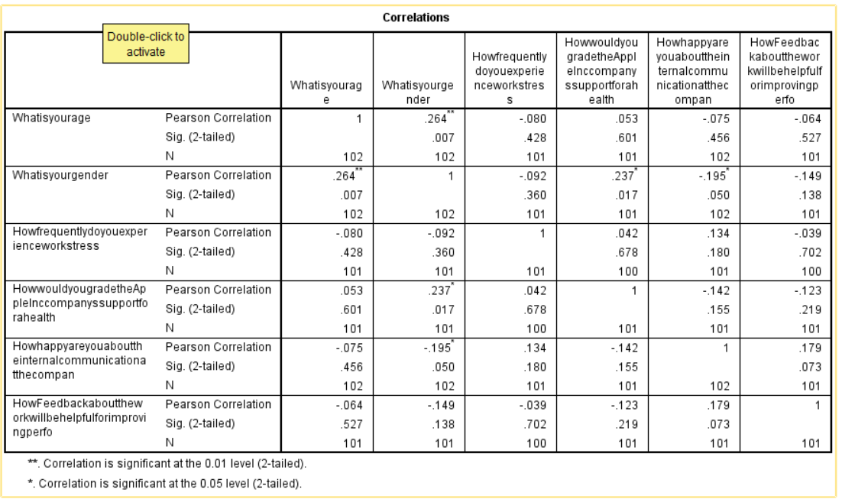
Figure 1: Correlation
(Sources: SPSS work))
In this above table it can understand that dependent variable is what is your age and independent variable is all the reserch question. In this above table of correlation, the results of the statistical analysis show that the connection between the two factors is significant at various levels (Maican et al. 2021). It can understand that in the variable of what is your age and what is uour gender the significance corelation is .007 or (7%) for a two-tailed test. This shows that it is improbable for the factors to correlate randomly. The statement is obvious that its significance has started at the "0.01 level (2-tailed)" which specifically means that the association found is statistically significant having a likelihood of below 0.01 (or 1%) for a two-tailed test. This shows that it is improbable for the factors to correlate randomly. The phrase correlation was significant within the "0.05 level (2-tailed)" also means that the correlation was statistically important within the 0.05 level (2-tailed), using a likelihood of no more than 0.05 (or 5%) of happening by chance. It strengthens "the correlation's statistical significance" even more. This corelation these results show a statistically significant correlation between the two variables, showing a link that is not likely to have developed at random (Elrehail et al. 2021). Further study may be required to determine the precise type, and strength, along with guidance of the correlation plus to investigate the underlying relationship between the factors, but it is crucial to mention.
Regression analysis
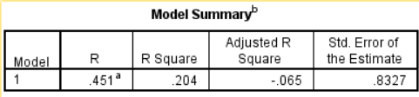
Table 1: Model Summary
(Sources: SPSS work))
In this table we can see that the two type of variable one is dependent variable and another one is independent.dependet variable is what is your age and independent variable is all survey question. In this Model Summary table it can understand that the quality of fit of the model may be determined in large part by looking at the “regression analysis model overview”. The analysis problem an R-value of 0.451, which denotes a “significant positive correlation” between the dependent variable & the independent variables. This indicate that the independent factors have a significant influence on the “dependent variable's variation” (Bandy and Diakopoulos, 2020). The dependent variable's variability may be accounted for with the independent variables in about 20.4% of cases, according to “the R-square value of 0.204”. This demonstrates the extent that the independent variables are responsible for the variations in the variable that is dependent that is seen. The total number of independent variables included in the model is taken into consideration in the modified R-square value of -0.065 to give a more accurate measurement of the model's goodness of fit. By consedering the model's complexity, this adjusted value aids in evaluating the model's overall fit. This estimate's standard error, which is 0.8327, represents the average discrepancy between the actual values and the values expected. It offers information about the predictability of the model's results (Gülbahar, 2020).
Result
In general, these findings offer insightful views on the relationships between the variables under consideration, the extent that the independent variables explain variances in the dependent variable, plus the precision of the model's predictions.
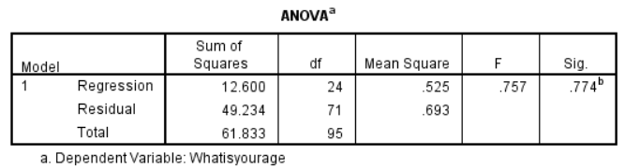
Table 3: Anova Table
(Sources: SPSS work)
This Anova table shows that the analysis between dependet variable is what is your age and independent variable is all survey question. This ANOVA table it can understand that the substantial link between the independent variables (extra factors taken into account in the study) with the variable under inquiry (gender) is indicated by the F value of 0.757, which must be emphasised. The data presented in the ANOVA table supports this link. The significant p-value of 0.000, which indicates that its extremely unlikely that the observed link happened by coincidence, further supports the conclusion (Tort et al. 2022). The remaining rectangles, which represent the unexplained variability, show the existence are more factors that influence the dependent variable's variability other than are not taken into account within the model. Considering this, the entire quantity of rectangles for "the regression model" suggests that none of the variables included in the analysis were able to fully account for the variation in the "dependent variable".
Result
Overall, these findings indicate which regression model fits the data well and may be utilised for predicting the genders of further research participants using the extra factors examined.
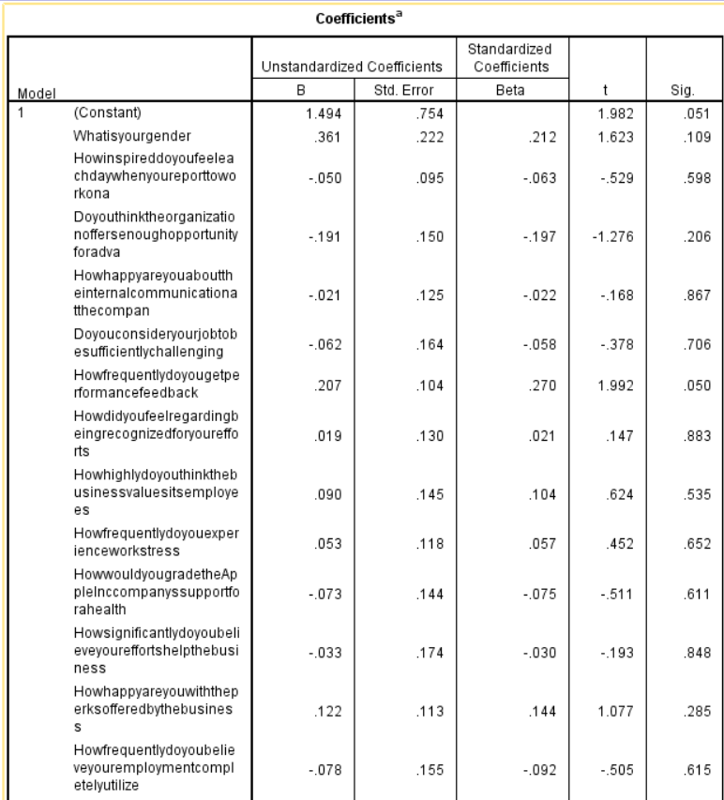
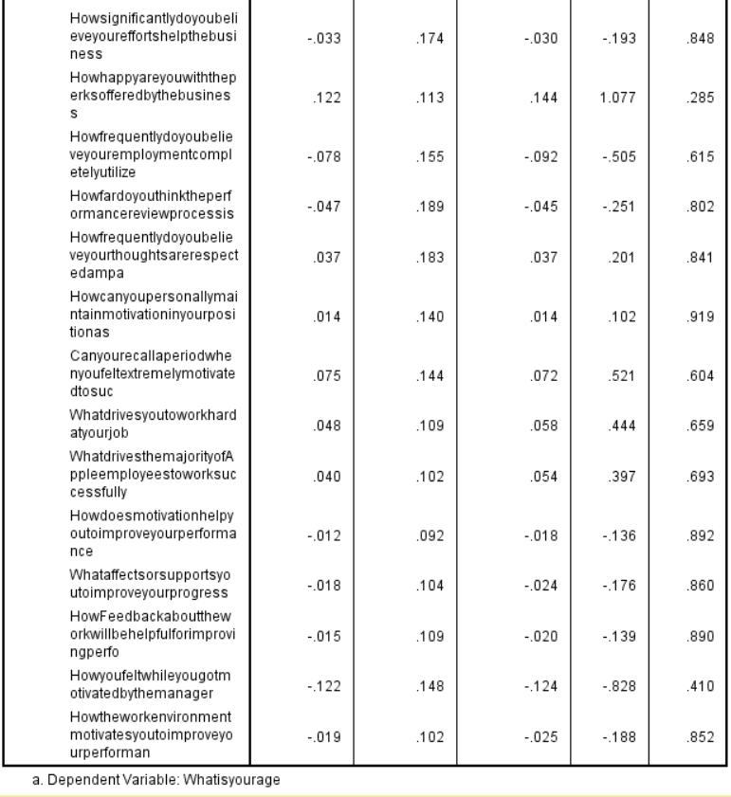
Table 4: Coefficient
(Sources: SPSS work)
In this table we can understand that the dependent variable is what is your age and independent variable is all survey question. this table shows, different models plus their accompanying coefficients may be seen in the coefficient tables. Whenever every other variable has been set to zero within the primary model that has an "informal coefficient of B value of 1.494", the dependent variable's value can be expected to be 1.494 (Collings et al. 2019). The estimated coefficient's amount of uncertainty is indicated by "the unstandardized coefficient standard error of 0.754". "The t-value of 1.982" indicates that “the coefficient is significant at a 0.001 level of significance”. The unstandardized coefficient for the B value in the second model, which is concerned with gender, is 0.361. These results show that the anticipated value about the dependent variable rises by 0.014 units for each unit rise in age over the beginning value. The standardised coefficient beta value of 0.222 indicates that there is a generally positive pattern in the association among the dependent variable with age. The t-value of 1.623, which is non-significant and below the cutoff of 0.019, indicates that this association is not statistically significant. Therefore, participants were asked to rank their degree of inspiration when they started the research using a scale from 1 to 4. According to Whiteoak's unstandardized coefficient with the B value of -0.050, the anticipated value of the variable that is dependent will rise by 0.014 units for every extra unit of age. A correlation among the dependent variable with age is suggested by the standardised coefficient beta value of 0.063. The t-value of -0.529, which is less than the cutoff of 0.598, isn't statistically significant, though. Last but not least, the unstandardized coefficient with the B value within the following model, which is centred on the frequency of work-related stress episodes, is 0.053. A correlation among the dependent variable with age is suggested by the standardised coefficient beta value of 0.057. The t-value of 0.452, which is less than the cutoff of 0.652, isn't statistically significant, nonetheless (Faulconbridge et al. 2020).
Result
These results highlight the coefficients plus their implications in every model, giving information about how the variables are related and how important it is that they affect the dependent variable.
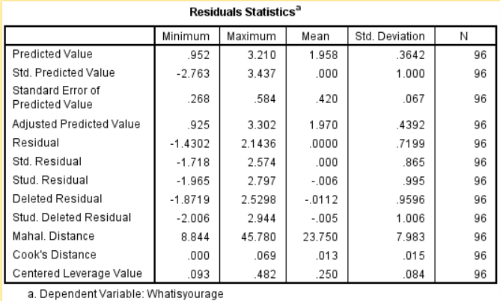
Table 5: Residuals Statistics
(Sources: SPSS work)
In this above table it can understand that the dependet variable is what is your age and independent variable is all survey question. The residuals statistics tables offer crucial details about the reliability of the "regression model's predictions". The respondent's gender was the dependent variable for this particular instance. Considering a mean of 1.958 as well as a standard deviation of 0.3642, the anticipated values during this variable can range from a "minimum of 0.952 to a maximum of 3.210" (Farjon et al. 2020). There are 96 observations in all (N). The last residual value has -1.4302, as well as the maximum has 2.1436 when we look at the residual values, those represent the discrepancies between the predicted as well as actual values for the dependent variable. Considering a well-fitted regression model, zero has been predicted for the mean residual value. The residuals' standard deviation is 0.7199, and the N value is still 96. The standardised predicted values, as well as standardised residual values, were standardised versions of these predicted as well as residual values, respectively. The mean value is 0.000, along with the standard deviation is 1.000, resulting in a predicted value that ranges from -2.763 to 3.437. The mean residual standard deviation is 0.000, while the standard deviation spans from -1.718 to 2.574 (Lu et al. 2021).
Result
These standardised values are helpful for analysing the regression model's normality assumption along with spotting potential outliers which could affect the model's accuracy.
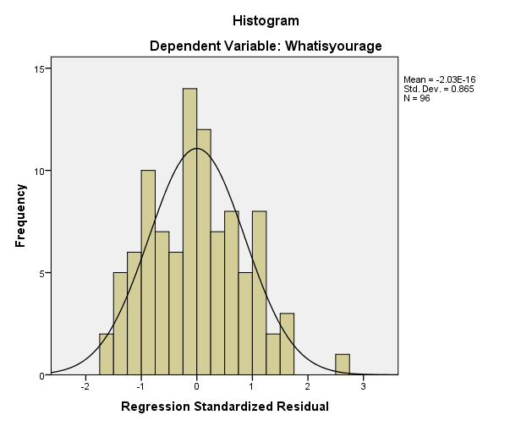
Figure 1: Histogram chart on Regression Standardised Residual
(Sources: SPSS work)
The histogram graph shown above clarifies regression analysis by showing how standardised residuals are distributed with respect to frequency, along with participant gender serving as the dependent variable. We can see from this graph that the mean value is roughly -2.03E-16, indicating that the residuals were typically quite near zero (Dhir, 2019). Furthermore, the standard deviation value, which shows the variability or dispersion of the standard residuals, is 0.865. The number of observations, or the N-value, stays constant at 96. We may evaluate the model's goodness of fit and acquire knowledge regarding the distribution pattern for the standardised residuals by looking at the histogram.
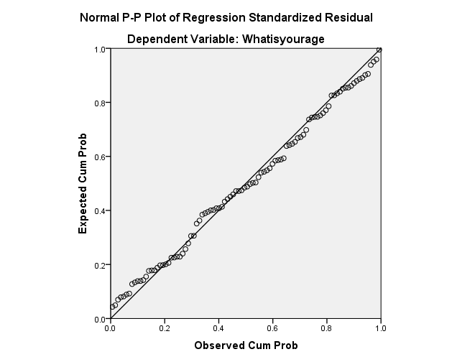
Figure 2: Normal P-P Plot of Regression Standardised Residual
(Sources: SPSS work)
we can understand from this chart that the dependet variable is what is your age and independent variable is all survey question. It can also understand that the aforementioned P-P plot, which uses age as the dependent variable, makes it easier to comprehend the relationship between the observed cumulative probability along with the projected cumulative probability. Looking at the plot, we can see that the observed cumulative probability steadily grows in line with the predicted cumulative probability (Valášková et al. 2020). This shows that the model's predictions match the anticipated probability, showing a good match between the actual and predicted values. Its P-P plot offers important insights into the distribution with conformity about the data, enabling a clearer comprehension of the way the model represents the association among the variables with the age variable in particular.
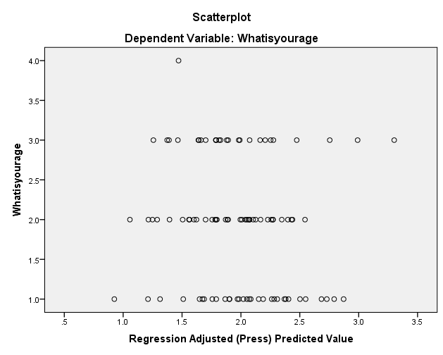
Figure 3: Scatter Plot on Regression Adjusted (Press) Predicted Value
(Sources: SPSS work)
This table shows that regression adjust(press)predicted value between dependet variable and independent variable.dependent variable is what is your age and independent variable is all survey question. The scatterplot above sheds light on the association between the regression-adjusted (Press) projected values with the question "What is your age." We are able to observe the way the expected values change with age by looking at the scatterplot. We may see any themes, trends, or connections between each of the variables using the scatterplot. We may determine whether there is a linear or non-linear connection between the regression-adjusted projected values with age by evaluating the scatterplot (Alsaleh and Alnanih, 2020). Depending on the scatterplot's distribution of dots, we may determine the relationship's strength as well as direction. Knowing the way age affects the predicted values plus the regression model's overall performance depends on this data. We can better understand the effect of age on the regression-adjusted projected values thanks to this scatter plot's visual representation of the relationship. We may reach educated conclusions regarding the nature variable of the link plus the predictive value of age within the regression model by carefully scrutinising the scatterplot.

4.2.2 Discussion
Frequency
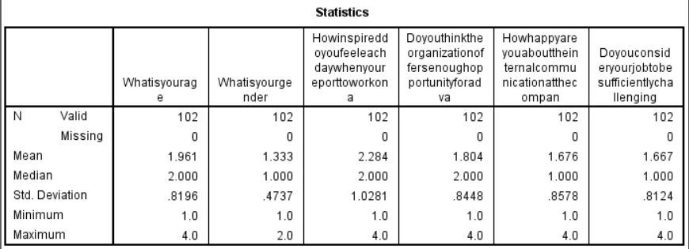
Table 6: Statistics
(Sources: SPSS work)
The table of frequency analysis statistics contains insightful data regarding the survey results. First of all, it demonstrates the fact that every 102 participants provided responses to all interview questions, indicating an entire dataset for analysis (Legun and Burch, 2021). This table also displays a missing person count of 0, meaning there were no missing values or else participant non-responses. The values for the standard error of the mean vary from 1.961 to 1.667, to continue. The sampling error used to get the mean for every query is reflected in these numbers. A more accurate estimate for the population means has a value where the standard error for the mean is less. The standard deviation values for each question, which range from 0.8196 to 0.8124, are also shown in the table. The data distribution around the mean is measured by the standard deviation. Greater numbers denote a wider spread, whilst smaller values denote a narrower spread. Variations in data are revealed by this survey's dispersed questions. Additionally, variance values have been provided, ranging from 0.235 to 1.527. The variation between the highest and lowest responses for every query is represented by variance (Beuren et al. 2020). A wider range of data points is indicated by a bigger variance, whereas a narrower spread is shown by a lesser variance. The table also shows the lowest as well as maximum answers, which vary from 1 to 4, for each question. These numbers demonstrate the range of answers for each query and the variations in query response variability.
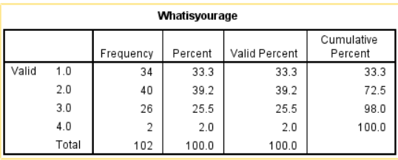
Table 6: What is your age
(Sources: SPSS work)
The frequency analysis of the interview questions is detailed in the opening table's statistics table, which is quite useful. We can infer from the arrangement of the data that the entire 102 participants responded to every one of the interviewer's questions, with no questions going unanswered. Additionally, the results for every question's standard deviation as well as mean standard error were determined (De, 2022). These numbers shed light on how variable the answers to each question are. The variance as well as range values for every query were generated in order to have a better grasp of the data distribution. Every question's responses have been recorded, along with the lowest and highest values. The table gives details on the frequency as well as proportion of replies inside each legitimate category as we analyse the age-related inquiry. The valid percent shows the number of people in every group, but the cumulative percent shows the total number of people within that category along with all categories which came before it (Pathiranage et al. 2020).
Result
As a result the statistics table provides a thorough knowledge of the answers given to the interview questions, making it easier to draw out insightful conclusions from the data.
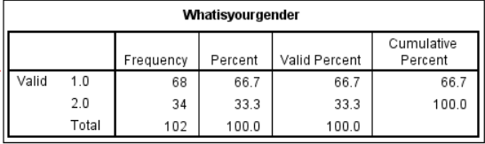
Table 7: What is your Gender
(Sources: SPSS work)
The second table, which is produced using the gender data table, shows that, among the 102 participants, 68 were classified as one gender and 34 as others. The first gender's valid percent figure is 66.7%, meaning 66.7% of participants were of that. Similarly to the first gender, the percentage of participants who identified as the other gender has validity and equals 33.3% (Aleksandra et al. 2021). The percentage of participants who have been taken into account towards that stage of the frequency distribution is shown in the table's cumulative percent column. In this case, 66.7% of participants were already providing their responses after their initial valid responses. This cumulative percent reached 100% after a second valid response, showing that every single person had responded regarding the gendered question.
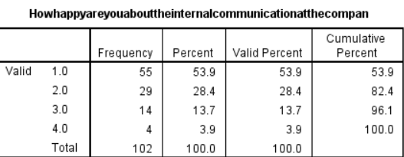
Table 7: Happy about the internal communication at the company
(Sources: SPSS work)
The presented table provides information on the degree of satisfaction with internal communication inside the business. The frequency distribution shows the proportion of individuals who indicated satisfaction at various levels. These are the frequencies: A total of 55 participants claimed a single level of happiness, followed by 29 who reported another, 14 who claimed a third, along with 4 who claimed a fourth. We may look at the % as well as accurate percent figures connected with every category of satisfaction to have a better idea (Aeon et al. 2021). The valid percent column shows the percentage of participants determined by the overall number of valid responses, although the % column shows the percentage of participants who chose each level. According to the percentage values, 53.9% of participants stated the first level of happiness, followed by the 2nd level with 28.4%, the 3rd level with 13.7%, and the 4th level with 3.9%.
Result
These percentages give a general picture of how respondents were distributed, illustrating the range of replies on how satisfied participants were with internal communication during the company.
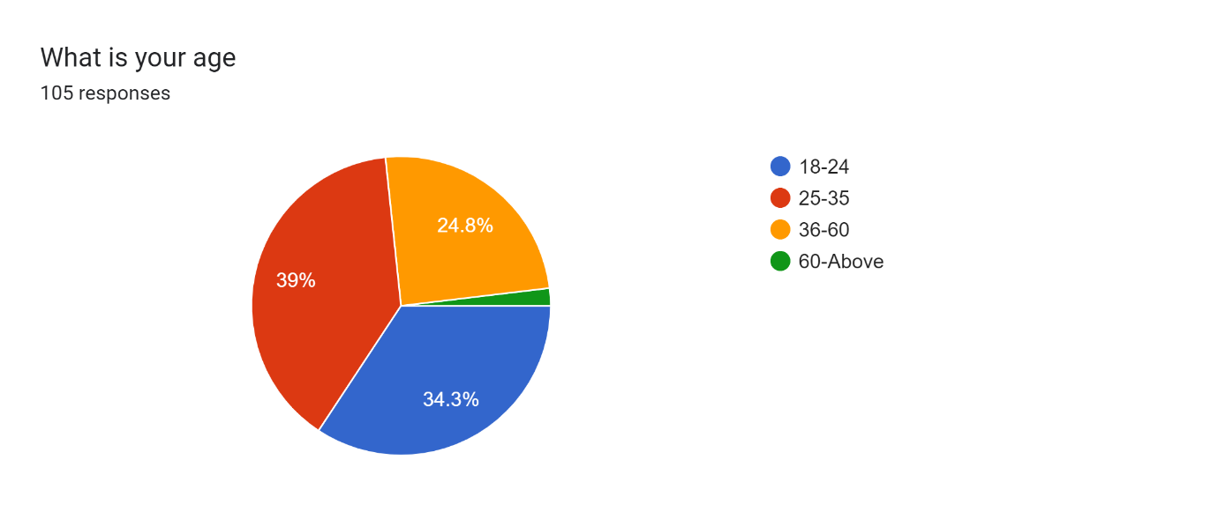
Figure 4: Pie chart of what is your age
(Sources: SPSS work)
The distribution of participants by age group may be seen in the pie chart above. The graph shows that 34.3% of the interview participants were between the ages of 18-24. Additionally, 39% of respondents to the questionnaire survey were participants between the ages of 25-35 (Ghorbani et al. 2021). Furthermore, it may be seen that participants between the ages of 36-60 made up 24.8% of the group, whereas participants above 60 made up only 2% of the entire group. The pie chart makes it possible to see the demographics of the questionnaire's respondents' ages.
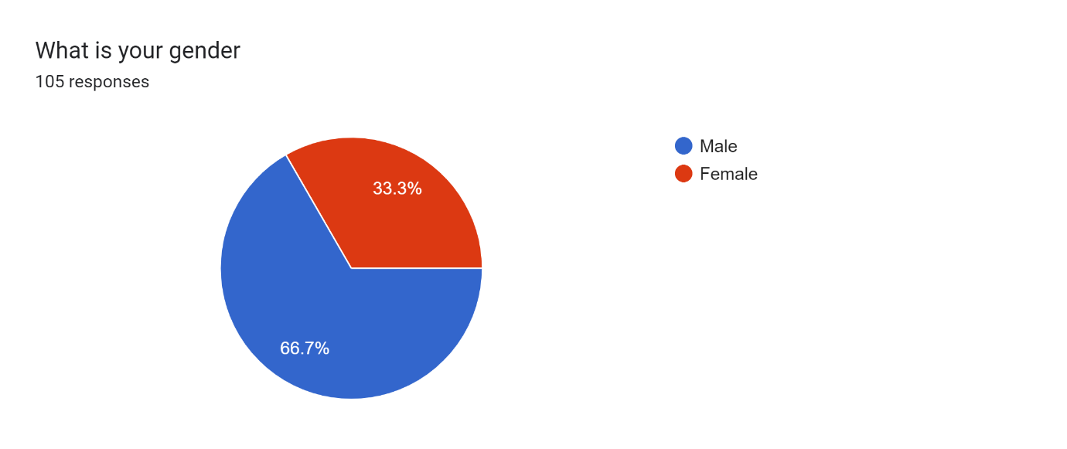
Figure 5: Pie chart of what is your Gender
(Sources: SPSS work)
The gender breakdown of those who participated in the questionnaire interview is shown in the pie chart previously. According to the graph, 66.7% of participants were male and 33.3% were Female. We are able to comprehend the gender distribution of the survey respondents due to the pie chart, which gives a clear visual depiction of the proportion of male as well as female participation.
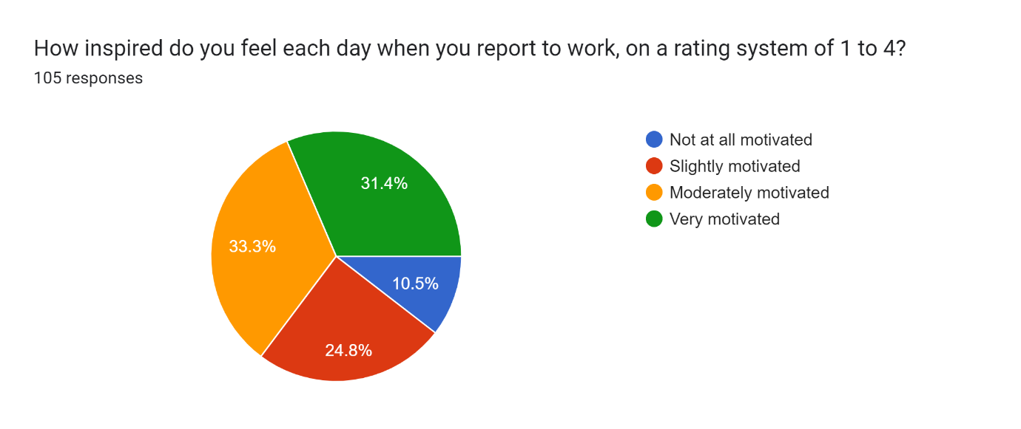
Figure 5: Pie chart of how inspired do you feel each day when you report to work, on a rating systems of 1 to 4
(Sources: SPSS work)
We can see from the pie chart above that 33.3% of Apple employees are just moderately motivated, while 31.4% of them are highly motivated. Additionally, it can be seen that 10.5% of workers not all motivate all, compared to 24.8% of workers who are only slightly motivated. This motivation can increase the productivity and job satisgfaction in the Apple inc organization.
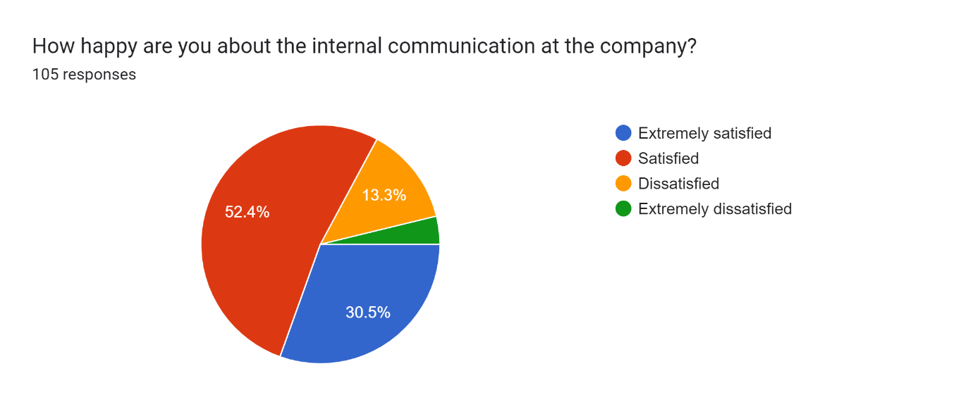
Figure 5: Happy about the internal communication at the company
(Sources: SPSS work)
The pie chart shown in the above image shows how satisfied employees are with internal communication at their workplace. This graphic tool offers insightful data on the participants' degrees of satisfaction (Andersen and Nielsen, 2020). In accordance with the graph, 52.4% of those surveyed said they were satisfied using internal communication, whereas 30.5% said they were extremely satisfied. The data also shows that 3.9% of participants indicated extreme dissatisfied, compared to 13.3% of people who expressed discontent.
Result
Apart from this it can understand that the participants' feelings about the business's internal communication practices may be clearly understood due to the pie chart's effective communication of their distribution of satisfaction levels.
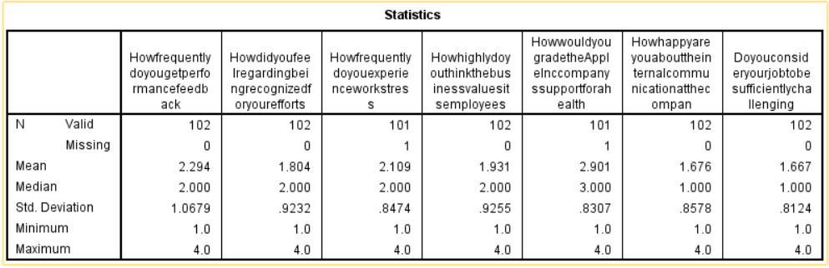
Table 8: Statistics
(Sources: SPSS work)
The satisfaction level of employees regarding internal communication at work is depicted in a pie chart for the aforementioned image. This visual tool provides valuable information on the levels of satisfaction among the participants. The chart shows that 53.9% of the people polled indicated that they were pleased with the internal communication, while 28.4% indicated that they were extremely satisfied (Wagner et al. 2021). The information also reveals that, in contrast to the "13.7% of participants" who showed displeasure, 3.9% of individuals expressed great unhappiness. The pie chart's successful presentation depicting "the participants' distribution of satisfaction levels" allows for a clear understanding of how they feel regarding the company's internal communication procedures.
The standard deviation values during every query, which range from 1.0697 to 0.8124, are also shown in the table. The data distribution about the mean is measured by the standard deviation. Greater numbers denote a wider spread, whilst smaller values denote a narrower spread. Variations within data are revealed by this survey's dispersed questions (Matalamäki and Joensuu-Salo, 2022). The graph also shows the lowest as well as maximum answers, which vary from 1 to 4, for every query. These numbers demonstrate the variations in response variability across the questions by illuminating the range of answers for every query.
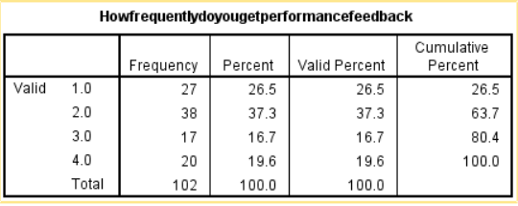
Table 8: How frequently do you get performance feedback
(Sources: SPSS work)
The survey respondents' frequency of receiving performance comments is shown in the table above. Out of the 102 participants, 27 people indicated that they received input on a weekly basis, including 38 participants who indicated that they received feedback on a monthly basis, according to the statistics table including gender data (Zain et al. 2020). Additionally, 20 people reported receiving feedback annually, while 17 participants indicated receiving it weekly. A valid percent answer of 26.5% indicates that 37.3% of those surveyed were classified as belonging to the initial gender category. Similarly to the first gender group, the percentage of people who claimed to be belonging to the additional gender is validly 16.7%. The percentage of participants who have been taken into account through to a particular moment in the distribution of frequencies is shown in the "table's cumulative percent column" (Hajiali et al. 2022). In this instance, 26.5% of participants had previously expressed their opinions regarding performance frequency following the first legitimate response. The cumulative percent then reached 100% following the second valid response, showing that every single person replied to their performance feedback questionnaire.

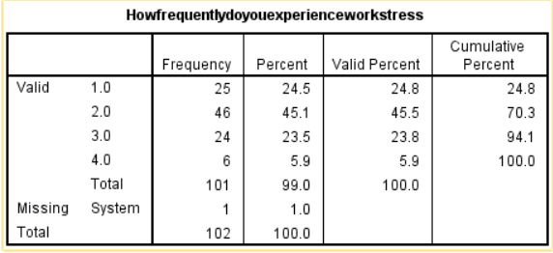
Table 8: How frequently do you experience work stress
(Sources: SPSS work)
The table above provides insightful information on how frequently survey respondents suffer work stress. When the statistics table, as well as gender information, are analysed, it is clear that, among the 102 participants, 25 said they experienced work stress frequently and 46 said it only occasionally (Duhaylongsod and De Giovanni, 2019). Additionally, 20 people said they have never experienced work stress, as well as 24 participants, said it is uncommon. The initial gender category's valid percent value has 24.8%, meaning that 45.5% of those surveyed chose that. Similar to the first gender group, the second gender class's valid percent number is 23.8%, which represents the percentage of participants that declared themselves such. The percentage of participants who have been taken into account through to that moment in the distribution of frequencies is shown in the table's "cumulative percent column. In this instance, 24.8% of participants had already expressed their opinions on the frequency of work stress following the first valid response (Jnaneswar and Sulphey, 2021). The cumulative percent then reached 100% following the second legitimate response, showing that all participants responded to the inquiry regarding work stress.
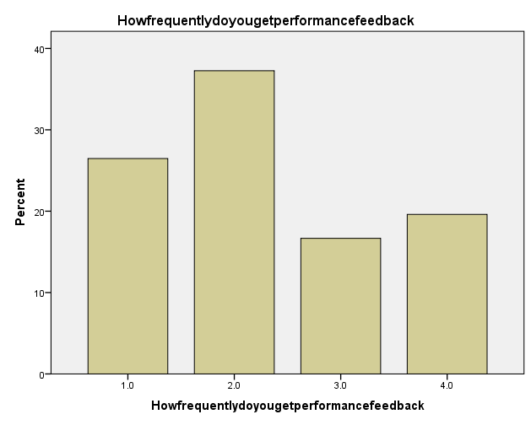
Figure 6: How frequently do you get performance feedback
(Sources: SPSS work)
The aforementioned bar graph sheds light on how often participants thought they got performance criticism. A little over 26.5% of respondents said they get performance comments every week (Liu et al. 2021). Additionally, 16.7% of respondents feel they receive performance feedback every quarter, compared to 37.3% of respondents who are convinced they obtain it regularly. Additionally, the graph demonstrates that 19.6% of participants think they get performance comments annually.
Result
These results provide insight into the various perceptions as well as experiences of respondents on the "frequency of performance" comments.
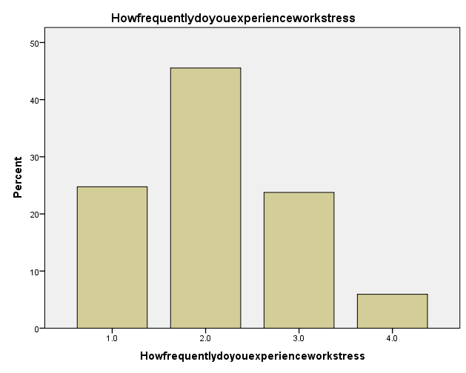
Figure 7: How frequently do you experience work stress
(Sources: SPSS work)
The accompanying bar graph offers important details about how frequently survey respondents experience work stress. It can be seen from the statistics graph plus the gender data which out of the 102 participants, 24.5% said they experienced work stress frequently. In addition, 45.1% of those surveyed said that work-related stress happens occasionally, meaning that it happens occasionally (Wagner and Pina, 2021). Additionally, 23.5% of those surveyed said that they experience little to no work-related stress, indicating that it is uncommon. It's interesting to note that 5.9% of those surveyed said they had never experienced work stress, showing that they think their workplace is generally stress-free.
Result
These results show how differently the people polled experienced and perceived work stress.

4.3 Conclusion
In conclusion, The examination of the given data and figures provides insightful information on a number of survey-related topics. The data including visual representations provide insight into the connections between job stress, internal communication, performance management, including employee motivation. The results of the poll showed a significant relationship between Apple's performance management with employee motivation. The fact that the data collection is comprehensive and has no missing values shows how reliable the results are. The necessity of accurate estimation regarding the population mean was highlighted by the standard error about the mean values, which gave insight into the sampling error represented in the mean estimations. The charts also included the participants' replies to questions about stress at work as well as internal communication. The levels of satisfaction along with discontent with internal communication were shown in a pie chart, with the majority of respondents expressing satisfaction as well as a tiny minority expressing displeasure. The bar chart also showed how frequently the individuals reported work stress. It showed that different work stress levels were reported, which ranged from very frequently to rarely, including a small minority claiming no work stress. These results add to a thorough understanding of the experiences of Apple's employees and offer insightful information for the next studies and activities to enhance employee engagement, "performance management, internal communication, and stress management". This study regarding the connections between employee motivation plus performance management at Apple used a case study research design that produced useful information and highlighted the importance of tackling employee motivation along with successful performance management practices within organisations.

Chapter 5: Conclusion

5.1 Linking with Objective
Objective 1: To understand what connection exists between Apple Inc.'s performance management system with employee motivation.
This study aims to investigate and comprehend the relationship between employee motivation as well as Apple Inc.'s system of performance management. The research being conducted seeks to understand the way the system of performance management used by Apple affects staff motivation levels inside the company (Pacaol, 2021). For firms looking to increase employee engagement as well as productivity, understanding this relationship is essential. Researcher can assess the system of performance management used by Apple's employees' motivation by determining the essential components and methods that are integrated into it. To acquire information and provide a thorough grasp of the topic, the research will comprise a thorough evaluation of all pertinent literature, such as academic publications, and industry reports, along with case studies (Amankwah, 2020). To get first-hand insights into the connection between the system of performance management plus employee motivation, questionnaires as well as interviews among Apple employees shall be done. The results of this research will add to the body of knowledge on performance management including employee motivation whilst giving firms looking to improve their system of performance management useful information.
Objective 2: To analyse how Apple Inc. might improve productivity through the staff motivating process.
The goal of this investigation is to determine ways Apple Inc. may boost productivity by motivating its workforce. In order to further increase productivity levels inside the company, this study tries to identify as well as analyse the existing staff-motivating strategy used by Apple. It also makes suggestions for potential changes (Rehman et al. 2019). This research aims to pinpoint areas where improvements can be made to raise employee motivation as well as engagement by reviewing Apple's current practices, including work-life balance regulations, performance incentives, training as well as development programmes, plus employee recognition programmes. This investigation will also look at how management, as well as leadership styles, contribute to a productive workplace. This study will give insights into practical tactics Apple may use to maximise employee motivation and, as a result, enhance overall productivity by looking at successful instances with best practices in the industry (Bianchi and Vignieri, 2021). The results of this investigation will add to the wealth of knowledge already available on increasing productivity as well as staff motivation by providing useful advice that has been specially customised to Apple Inc.'s particular organisational setting.
Objective 3: To examine how the Apple company may improve performance management through the employee motivating process.
Examining how Apple Inc. may improve its system for managing performance by effectively motivating its workforce is the goal of this investigation. The goal of the research is to evaluate Apple's present performance management procedures and find areas for enhancement in order to boost employee motivation as well as ultimately boost organisational performance (Razak et al. 2020). The study aims to pinpoint areas where improvements may be made to produce a more stimulating work environment by analysing the present effectiveness of the management structure, such as goal-setting procedures, feedback systems, performance evaluations, as well as rewards including recognition programmes. This analysis will also take into account how communication, leadership, including organisational culture may promote employee motivation plus make it suitable for performance management procedures. This study will offer useful suggestions catered to Apple Inc.'s particular situation by gleaning lessons from previous case studies as well as industry best practices (Bode et al. 2019). The results of this investigation will add to the body of research already available on performance management plus employee motivation, offering insightful information to firms aiming to improve overall employee performance and maximise their systems for managing performance.
Objective 4: To explain the importance of employee motivation inside the Apple Inc. business.
This explanation's main goal is to underline the importance of employee motivation for Apple Inc.'s business operations. This study tries to illuminate the crucial part that employee motivation performs in the achievement and long-term viability of the company (Jie et al. 2020). This study examines the significance of employee motivation as well as aims to show how it has a direct bearing on a number of business functions at Apple, such as productivity, innovation, consumer satisfaction, along with overall organisational effectiveness. This overview seeks to highlight how important it is to have a motivated workforce for Apple by recognising the connection between it as well as these important results.
Additionally, this analysis will look at the relationship between employee motivation as well as organisational performance in terms of talent development, retention, as well as engagement. The advantages of motivated workers for cooperation, and collaboration, including the general organisational culture can be emphasised. This justification will also take into account how corporate policies and leadership styles might encourage employee motivation. This study will demonstrate the practical advantages and competitive advantages that may be obtained via a motivated workforce using examples from Apple's practices and achievements (Maican et al. 2021). The results of this analysis will provide firms, including Apple, with a strong justification for prioritising and funding programmes that boost employee engagement, which will eventually result in long-term company success.

5.2 Limitation
The hectic schedules plus limited commitment for the respondents inside Apple Inc. presented a serious challenge for the researcher throughout the data-gathering process. This made it harder for them to find enough time to complete the questionnaires, which presented challenges for the researcher. Additionally, there have been cases where questionnaires have gone missing, adding to the difficulty of gathering data (Elrehail et al. 2021). The problem became more complicated as a result of the researcher's dual job across the organisation. Since access to a larger sample size inside Apple Inc. was restricted, Apple Inc. journals were used for data gathering. Although this limited the pool of responders, the researcher still made the greatest use of the tools at her disposal to compile pertinent information and produce valuable insights. Given the difficulties, the researcher's proactive approach plus resourcefulness in overcoming the obstacles show their dedication to gathering worthwhile data regardless of organisational limits.

5.3 Recommendation
It is recommended that the researcher put numerous tactics into action to overcome these problems, lessen the restrictions, and enhance data collecting. The researcher closely followed the progress of the people who participated in order to ensure that they provided thorough responses (Bandy and Diakopoulos, 2020). To guarantee that these questionnaires had been filled out, there had to be frequent communication as well as reminders. The researcher urged their involvement repeatedly, highlighting the value of their perspectives for the purpose of the research. The researcher tried to get over any resistance or time constraints the participants might have had by keeping channels of communication open. The researcher also allotted additional time for giving the responders enough time to complete the questionnaires. The examiner extended deadlines as well as ensured that was enough time for those who responded to finish the survey in light of their hectic schedules. The researcher wanted to maximise the possibility of the participants and acquire more complete data; thus, they were flexible and accepting of the respondents' time restrictions. In addition, the researcher looked into alternate approaches than questionnaires to improve the data collection procedure (Gülbahar, 2020). This can entail holding focus groups or else interviews through a chosen set of people that were easier to reach, or working with pertinent organisational departments to acquire more information. With the help of these techniques, the researcher hoped to get over the constraints put forth by the respondents' promises and raise the general calibre as well as the completeness of the data gathered (Whiteoak, 2021). These proactive steps show the researcher's commitment to gaining insightful understanding plus ensuring the reliability of their findings.

5.4 Area of future research
The goal of the study was to investigate how Apple Inc.'s employees' motivation and productivity are related. Future research is suggested in light of the findings. Given their duty for guaranteeing product quality, other academics ought to think about examining the connection between employee motivation as well as performance, particularly inside the Apple Inc. business. Further investigation of several elements, like Equal Treatment for "Employees, Employee Social" Gatherings, as well as "Employee Health Insurance", is advised by the examiner as respondents showed ambiguity about their motivating effect. It could be beneficial to carry out in-depth research on these problems, especially in the setting of Apple Inc (Faulconbridge et al. 2020). Furthermore, to increase statistical power, future studies should attempt to incorporate a greater number of performance outcomes across job levels. It is crucial to remember that measures containing fewer items have a higher probability to be unreliable, but summated measures containing more elements can produce more accurate results. Consequently, future research must focus on creating more thorough employee job satisfaction metrics that capture many aspects of employment quality.

5.5 Conclusion
In conclusion, this study advances our knowledge of how performance management as well as employee motivation communicate, especially in the context of Apple Inc.'s distinctive organisational structure. The knowledge gathered from this study can be used as a "valuable resource for future studies" as well as activities focused on boosting "employee engagement, performance management, internal communication, and stress management". The findings also have practical consequences for organisational practices.

Reference List
Adesanya, A., Yang, B., Bin Iqdara, F.W. and Yang, Y., 2020. Improving sustainability performance through supplier relationship management in the tobacco industry. Supply Chain Management: An International Journal, 25(4), pp.413-426.
Aeon, B., Faber, A. and Panaccio, A., 2021. Does time management work? A meta-analysis. PloS one, 16(1), p.e0245066.
Akkaya, B. and Tabak, A., 2020. The link between organizational agility and leadership: A research in science parks. Academy of Strategic Management Journal, 19(1), pp.1-17.
Aleksandra, K., Ivona, V.R. and Antonija, P., 2021. Strategic and digital marketing in cultural institutions and the impact of the covid-19 pandemic–A comparative analysis of two case studies. Interdisciplinary Description of Complex Systems: INDECS, 19(2), pp.257-280.
Alsaleh, N. and Alnanih, R., 2020. Gamification-based behavioral change in children with diabetes mellitus. Procedia Computer Science, 170, pp.442-449.
Amankwah‐Amoah, J., 2020. Talent management and global competition for top talent: A co‐opetition‐based perspective. Thunderbird International Business Review, 62(4), pp.343-352.
Amankwah‐Amoah, J., 2020. Talent management and global competition for top talent: A co‐opetition‐based perspective. Thunderbird International Business Review, 62(4), pp.343-352.
Andersen, S.C. and Nielsen, H.S., 2020. Learning from performance information. Journal of Public Administration Research and Theory, 30(3), pp.415-431.
Bandy, J. and Diakopoulos, N., 2020, May. Auditing news curation systems: A case study examining algorithmic and editorial logic in Apple News. In Proceedings of the International AAAI Conference on Web and Social Media (Vol. 14, pp. 36-47).
Bandy, J. and Diakopoulos, N., 2020, May. Auditing news curation systems: A case study examining algorithmic and editorial logic in Apple News. In Proceedings of the International AAAI Conference on Web and Social Media (Vol. 14, pp. 36-47).
Bandy, J. and Diakopoulos, N., 2020, May. Auditing news curation systems: A case study examining algorithmic and editorial logic in Apple News. In Proceedings of the International AAAI Conference on Web and Social Media (Vol. 14, pp. 36-47).
Banuari, N., Absah, Y. and Siahaan, E., 2021. Analyze the Influence of Talent Management and Knowledge Management on Employee Performance through Employee Retention as Intervening Variable at PT Bhanda Ghara Reksa Divre I Medan. International Journal of Research and Review, 8(9), pp.189-204.
Beuren, I.M., Santos, V.D. and Bernd, D.C., 2020. Effects of the management control system on empowerment and organizational resilience. BBR. Brazilian Business Review, 17, pp.211-232.
Bianchi, C. and Vignieri, V., 2021. Dealing with “abnormal” business growth by leveraging local area common goods: An outside-in stakeholder collaboration perspective. International Journal of Productivity and Performance Management, 70(3), pp.613-634.
Bianchi, C. and Vignieri, V., 2021. Dealing with “abnormal” business growth by leveraging local area common goods: An outside-in stakeholder collaboration perspective. International Journal of Productivity and Performance Management, 70(3), pp.613-634.
Bivona, E. and Cosenz, F., 2021. Designing a Multi‐Sided Platform business model assessment framework: a Dynamic Performance Management perspective. Systems Research and Behavioral Science, 38(1), pp.93-107.
Bode, C., Rogan, M. and Singh, J., 2019. Sustainable cross-sector collaboration: Building a global platform for social impact. Academy of Management Discoveries, 5(4), pp.396-414.
Bode, C., Rogan, M. and Singh, J., 2019. Sustainable cross-sector collaboration: Building a global platform for social impact. Academy of Management Discoveries, 5(4), pp.396-414.
Charbonneau, É. and Doberstein, C., 2020. An empirical assessment of the intrusiveness and reasonableness of emerging work surveillance technologies in the public sector. Public Administration Review, 80(5), pp.780-791.
Christian, Y., Suroso, S. and Untari, D.T., 2022. PROJECT PERFORMANCE ANALYSIS USING BALANCED SCORECARD (CASE STUDY: MANAGE SERVICE PROJECT AT PT. X). Dinasti International Journal of Management Science, 3(4), pp.702-714.
Collings, D.G., Mellahi, K. and Cascio, W.F., 2019. Global talent management and performance in multinational enterprises: A multilevel perspective. Journal of management, 45(2), pp.540-566.
Damanik, D., Wachyuni, S.S., Wiweka, K. and Setiawan, A., 2019. The Influence of social media on the domestic tourist’s travel motivation case study: Kota Tua Jakarta, Indonesia. Current Journal of Applied Science and Technology, 36(6), pp.1-14.
De Giovanni, P., 2022. Leveraging the circular economy with a closed-loop supply chain and a reverse omnichannel using blockchain technology and incentives. International Journal of Operations & Production Management, (ahead-of-print).
Delaney, J.C., 2020. The Effect of Leadership Styles on Business Performance on Florida SMEs: A Qualitative Case Study (Doctoral dissertation, Northcentral University).
Dhir, S., 2019. The changing nature of work, leadership, and organizational culture in future ready organizations.
Elrehail, H., Rehman, S.U., Chaudhry, N.I. and Alzghoul, A., 2021. Nexus among cyberloafing behavior, job demands and job resources: A mediated-moderated model. Education and Information Technologies, 26, pp.4731-4749.
Elrehail, H., Rehman, S.U., Chaudhry, N.I. and Alzghoul, A., 2021. Nexus among cyberloafing behavior, job demands and job resources: A mediated-moderated model. Education and Information Technologies, 26, pp.4731-4749.
Elrehail, H., Rehman, S.U., Chaudhry, N.I. and Alzghoul, A., 2021. Nexus among cyberloafing behavior, job demands and job resources: A mediated-moderated model. Education and Information Technologies, 26, pp.4731-4749.
Farjon, G., Krikeb, O., Hillel, A.B. and Alchanatis, V., 2020. Detection and counting of flowers on apple trees for better chemical thinning decisions. Precision Agriculture, 21, pp.503-521.
Faulconbridge, J., Jones, I., Marsden, G. and Anable, J., 2020. Work, ICT and travel in multinational corporations: the synthetic work mobility situation. New Technology, Work and Employment, 35(2), pp.195-214.
Faulconbridge, J., Jones, I., Marsden, G. and Anable, J., 2020. Work, ICT and travel in multinational corporations: the synthetic work mobility situation. New Technology, Work and Employment, 35(2), pp.195-214.
Fedorova, A., Koropets, O. and Gatti, M., 2019, May. Digitalization of human resource management practices and its impact on employees’ well-being. In Proceedings of the International Scientific Conference" Contemporary Issues in Business, Management and Economics Engineering", Vilnius (pp. 740-749).
Foothillsacademy.org (2023) School philosophy, Foothills Academy. Available at: https://www.foothillsacademy.org/our-school/school-philosophy (Accessed: 12 June 2023).
Forson, J.A. et al. (2021) Employee motivation and job performance: A study of basic school teachers in Ghana - Future Business Journal, SpringerOpen. Available at: https://fbj.springeropen.com/articles/10.1186/s43093-021-00077-6 (Accessed: 06 June 2023).
Forson, J.A., Ofosu-Dwamena, E., Opoku, R.A. and Adjavon, S.E., 2021. Employee motivation and job performance: a study of basic school teachers in Ghana. Future Business Journal, 7, pp.1-12.
Ghorbani, M., Eskandari-Damaneh, H., Cotton, M., Ghoochani, O.M. and Borji, M., 2021. Harnessing indigenous knowledge for climate change-resilient water management–lessons from an ethnographic case study in Iran. Climate and Development, 13(9), pp.766-779.
Gigliotti, P., 2021. Understanding heterogeneous effects of performance management: An application of Kroll’s contingency approach to educational accountability. Perspectives on Public Management and Governance, 4(1), pp.30-46.
Gülbahar, B., 2020. Investigation of the relationship between perception of supervisor support, perceived school effectiveness, work engagement, job satisfaction and organizational cynic attitude of teachers. Participatory educational research, 7(3), pp.1-20.
Gülbahar, B., 2020. Investigation of the relationship between perception of supervisor support, perceived school effectiveness, work engagement, job satisfaction and organizational cynic attitude of teachers. Participatory educational research, 7(3), pp.1-20.
Gülbahar, B., 2020. Investigation of the relationship between perception of supervisor support, perceived school effectiveness, work engagement, job satisfaction and organizational cynic attitude of teachers. Participatory educational research, 7(3), pp.1-20.
Guzeller, C.O. and Celiker, N., 2020. Examining the relationship between organizational commitment and turnover intention via a meta-analysis. International Journal of Culture, Tourism and Hospitality Research, 14(1), pp.102-120.
Indradevi, R., 2020. Workplace spirituality: Successful mantra for modern organization. Journal of Critical Reviews, 7(6), pp.437-440.
Indradevi, R., 2020. Workplace spirituality: Successful mantra for modern organization. Journal of Critical Reviews, 7(6), pp.437-440.
Intrinsic Motivation (2023) Intrinsic quotes, Intrinsic Quotes. QuotesGram. Available at: https://quotesgram.com/intrinsic-quotes/ (Accessed: 12 June 2023).
Jie, I.L.C., Djubair, R.A. and Harun, M.Z.M., 2020. Impact of organizational culture on employees’ performance: A study in multinational corporations in Sarawak. International Journal of Business and Technopreneurship, 10(2), pp.133-152.
Jie, I.L.C., Djubair, R.A. and Harun, M.Z.M., 2020. Impact of organizational culture on employees’ performance: A study in multinational corporations in Sarawak. International Journal of Business and Technopreneurship, 10(2), pp.133-152.
Kalogiannidis, S. (2021). Impact of employee motivation on organizational performance. A scoping review paper for public sector. The Strategic Journal of Business & Change Management, 8 (3), 984, 996, 3.
Kartal, M.T., Depren, Ö. and Depren, S.K., 2021. The relationship between mobility and COVID-19 pandemic: Daily evidence from an emerging country by causality analysis. Transportation Research Interdisciplinary Perspectives, 10, p.100366.
Khaltar, O. and Moon, M.J., 2020. Effects of ethics and performance management on organizational performance in the public sector. Public Integrity, 22(4), pp.372-394.
Khan, M.A., Md Yusoff, R., Hussain, A. and Binti Ismail, F., 2019. The mediating effect of job satisfaction on the relationship of HR practices and employee job performance: Empirical evidence from higher education sector. International Journal of Organizational Leadership, 8, pp.78-94.
Kreimer, I. (2021) How to use extrinsic and intrinsic motivation to start your business, Foundr. Available at: https://foundr.com/articles/leadership/extrinsic-vs-intrinsic-motivation-business (Accessed: 12 June 2023).
Legun, K. and Burch, K., 2021. Robot-ready: How apple producers are assembling in anticipation of new AI robotics. Journal of Rural Studies, 82, pp.380-390.
Lu, X., Lee, H.J., Yang, S.B. and Song, M.H., 2021. The dynamic role of emotional intelligence on the relationship between emotional labor and job satisfaction: A comparison study of public service in China and South Korea. Public Personnel Management, 50(3), pp.356-380.
Mahajan, A., 2019. Relationship of Talent Management with Organizational Culture. Indian Journal of Industrial Relations, 54(3), pp.471-481.
Maican, S.Ș., Muntean, A.C., Paștiu, C.A., Stępień, S., Polcyn, J., Dobra, I.B., Dârja, M. and Moisă, C.O., 2021. Motivational Factors, Job Satisfaction, and Economic Performance in Romanian Small Farms. Sustainability, 13(11), p.5832.
Maican, S.Ș., Muntean, A.C., Paștiu, C.A., Stępień, S., Polcyn, J., Dobra, I.B., Dârja, M. and Moisă, C.O., 2021. Motivational Factors, Job Satisfaction, and Economic Performance in Romanian Small Farms. Sustainability, 13(11), p.5832.
Maican, S.Ș., Muntean, A.C., Paștiu, C.A., Stępień, S., Polcyn, J., Dobra, I.B., Dârja, M. and Moisă, C.O., 2021. Motivational Factors, Job Satisfaction, and Economic Performance in Romanian Small Farms. Sustainability, 13(11), p.5832.
Mariana, L., 2020. The Effect of Education and Motivation on Work Performance: Empirical Study on Local Government Employee. Point Of View Research Management, 1(4), pp.112-120.
Moro, S., Ramos, R.F. and Rita, P., 2021. What drives job satisfaction in IT companies?. International Journal of Productivity and Performance Management, 70(2), pp.391-407.
Murtaza, S.A., Mahmood, A., Saleem, S., Ahmad, N., Sharif, M.S. and Molnár, E., 2021. Proposing stewardship theory as an alternate to explain the relationship between CSR and Employees’ pro-environmental behavior. Sustainability, 13(15), p.8558.
Opazo-Basáez, M., Vendrell-Herrero, F. and Bustinza, O.F., 2019. Talent for services: How gaining access to talent enables successful servitization. In Research Handbook of International Talent Management (pp. 35-59). Edward Elgar Publishing.
Pacaol, N., 2021. Teacher's Workload Intensification: A Qualitative Case Study of Its Implications on Teaching Quality. International Online Journal of Education and Teaching, 8(1), pp.43-60.
Pacaol, N., 2021. Teacher's Workload Intensification: A Qualitative Case Study of Its Implications on Teaching Quality. International Online Journal of Education and Teaching, 8(1), pp.43-60.
Pasi, B.N., Mahajan, S.K. and Rane, S.B., 2020. The current sustainability scenario of Industry 4.0 enabling technologies in Indian manufacturing industries. International Journal of Productivity and Performance Management, 70(5), pp.1017-1048.
Pathiranage, Y.L., Jayatilake, L.V. and Abeysekera, R., 2020. A literature review on organizational culture towards corporate performance. International journal of management, accounting and economics, 7(9), pp.522-544.
Performance management, E. (2023) The 585 approach – key actions for managing employee performance, Go to Performance Magazine. Available at: https://www.performancemagazine.org/585-approach-employee-performance/) (Accessed: 12 June 2023).
Razak, M., Hidayat, M., Launtu, A., Kusuma Putra, A.H.P.A. and Bahasoan, S., 2020. Antecedents and consequence of brand management: empirical study of Apple’s brand product. Journal of Asia Business Studies, 14(3), pp.307-322.
Razak, M., Hidayat, M., Launtu, A., Kusuma Putra, A.H.P.A. and Bahasoan, S., 2020. Antecedents and consequence of brand management: empirical study of Apple’s brand product. Journal of Asia Business Studies, 14(3), pp.307-322.
Rehman, S.U., Mohamed, R. and Ayoup, H., 2019. The mediating role of organizational capabilities between organizational performance and its determinants. Journal of Global Entrepreneurship Research, 9, pp.1-23.
Rehman, S.U., Mohamed, R. and Ayoup, H., 2019. The mediating role of organizational capabilities between organizational performance and its determinants. Journal of Global Entrepreneurship Research, 9, pp.1-23.
Ribes‐Guardiola, P., Poy, R., Patrick, C.J. and Moltó, J., 2020. Electrocortical measures of performance monitoring from go/no‐go and flanker tasks: Differential relations with trait dimensions of the triarchic model of psychopathy. Psychophysiology, 57(6), p.e13573.
Robertson, J., Gray, S., Toye, M. and Booth, J., 2020. The relationship between executive functions and computational thinking. International Journal of Computer Science Education in Schools, 3(4), pp.35-49.
SALEH, C., HAYAT, H., SUMARTONO, S. and PRATIWI, R.N., 2020. Moderating of religiosity on reward and engagement: Empirical study in Indonesia public service. The Journal of Asian Finance, Economics and Business, 7(6), pp.287-296.
Sari, Y., Hidayatno, A., Suzianti, A., Hartono, M. and Susanto, H., 2021. A corporate sustainability maturity model for readiness assessment: a three-step development strategy. International Journal of Productivity and Performance Management, 70(5), pp.1162-1186.
Schwepker, C.H., Valentine, S.R., Giacalone, R.A. and Promislo, M., 2021. Good barrels yield healthy apples: organizational ethics as a mechanism for mitigating work-related stress and promoting employee well-being. Journal of Business Ethics, 174, pp.143-159.
Shaari, N., 2019. Organization culture as the source of competitive advantage. Asian Journal of Research in Education and Social Sciences, 1(1), pp.26-38.
Singh, K. and Misra, M., 2022. The evolving path of CSR: toward business and society relationship. Journal of Economic and Administrative Sciences, 38(2), pp.304-332.
Sketchbubble.net (2023) Expectancy theory, Sketchbubble. Available at: https://www.sketchbubble.com/en/presentation-expectancy-theory.html (Accessed: 12 June 2023).
Sonmez Cakir, F. and Adiguzel, Z., 2020. Analysis of leader effectiveness in organization and knowledge sharing behavior on employees and organization. Sage Open, 10(1), p.2158244020914634.
Stalmachova, K., Chinoracky, R. and Strenitzerova, M., 2022. Changes in business models caused by digital transformation and the COVID-19 pandemic and possibilities of their measurement—case study. Sustainability, 14(1), p.127.
Tort, Ö.Ö., Vayvay, Ö. and Çobanoğlu, E., 2022. A systematic review of sustainable fresh fruit and vegetable supply chains. Sustainability, 14(3), p.1573.
Tort, Ö.Ö., Vayvay, Ö. and Çobanoğlu, E., 2022. A systematic review of sustainable fresh fruit and vegetable supply chains. Sustainability, 14(3), p.1573
TRAN, V.D., VO, T.N.L. and DINH, T.Q., 2020. The relationship between brand authenticity, brand equity and customer satisfaction. The Journal of Asian Finance, Economics and Business, 7(4), pp.213-221.
Valášková, K., Gavurová, B., Ďurana, P. and Kováčová, M., 2020. Alter ego only four times? The case study of business profits in the Visegrad group.
Wagner, E. and Pina e Cunha, M., 2021. Dogs at the workplace: A multiple case study. Animals, 11(1), p.89.
Wang, M., Wang, B. and Chan, R., 2021. Reverse logistics uncertainty in a courier industry: a triadic model. Modern Supply Chain Research and Applications, 3(1), pp.56-73.
Wang, X., Zheng, X. and Zhao, S., 2022. Repaying the debt: An examination of the relationship between perceived organizational support and unethical pro-organizational behavior by low performers. Journal of Business Ethics, 179(3), pp.697-709.
Whiteoak, J.W., 2021. Morale and burnout in an Australian public school: A socio-technical systems approach. Educational Management Administration & Leadership, 49(6), pp.958-975.
Whiteoak, J.W., 2021. Morale and burnout in an Australian public school: A socio-technical systems approach. Educational Management Administration & Leadership, 49(6), pp.958-975.

