Module Name: Effective Teamworking and Communication

. Module Code: BMSW4009
. Assignment: Report

. Student Name: Florentina Barbulescu
. Student ID: 2324276
. Word count -1747
.Terms reference-this report was requested by UWTSD Lecturer, Melanie Squire as part of Effective Teamworking & Communication module with a submission date of June 14,2024.

Table of Contents
Introduction 3
Theoretical Framework 4
Belbin’s Team Roles Model 4
Tuckman’s Stages of Group Development 4
Kilmann’s Conflict Management Model 5
Team Roles 6
Understanding Team Development 7
Stage 1: Forming 7
Stage 2: Storming 7
Stage 3: Norming 8
Stage 4: Performing 8
Stage 5: Adjourning 8
Managing Conflict in the Workplace 9
Mode 1: Avoiding 9
Mode 2: Accommodating 9
Mode 3: Competing 9
Mode 4: Collaborating 10
Mode 5: Compromising 10
Conclusion 11
References 12

Introduction
A team is a group of members working together to strive for excellence through communication, trusting mutually amongst each other, and chasing common goals. Furthermore, the typical maintenance of sharing the leadership, clearance of the job roles and conflicts of construction (Mullins, & Christy, 2016). Hence, the group should consist of individuals capable of thinking innovatively and sharing their ideas and suggestions on the table. Moreover, this report proposes to delve into a deeper understanding and learning to build a strong team of employees that can help boost the business. The report aims to understand the importance of building effective teamwork in the organisations' success and growth of the businesses. This report will include different theoretical explanations and relate the dynamics of the group, communication and teamwork that can be applied in a workplace. Also, this report will show different relevant theories and models to support the research and elaborate on the essentiality of roles played by the team working in an organisation.

Theoretical Framework
Accepting being individually accountable for the equal workload and actions taken as a team (Bonert, et al., 2022). The advantages that are to having a highly performing and strong team involve aspects like having employees holding a broader range of talents and skills. The theoretical models and their ideas for building an effective team for uplifting the businesses’ market and compete with the companies of the similar sector.

Belbin’s Team Roles Model
This model helps show effective ways to attain the strengths and weaknesses of the team relatively, also helping them to understand the aspects to improve their working performances. This model was developed by the theorist and researcher Meredith Belbin in the year of 1981, and this model was later renowned for the accessibility this tool provides in building teams (Belbin, 2010). These team roles are specifically designed for defining and predicting the potentiality of successfully managing a team. The strongest teams are typically recognised as the availability of several diversifying characters and personality types of people working in a team. This theory-based model is used specifically to judge the team members' capacity of strengths and weaknesses which is insightful as working in a team. Belbin had described the team role as the tendency to behave, contribute and interrelate with others in a way of 3 action-oriented roles the shaper, completer Finisher and implementer. Also, the model is inclusive of 3 other people-oriented roles the team worker, coordinator resource investigator. Finally, the other 3 cerebral roles the monitor evaluator, plant and specialist, and Belbin’s team roles are inclusive of a total of 9 team roles that are explained in these 3 main categories.

Tuckman’s Stages of Group Development
The theory of group development is comprised of stages like Forming, Norming, Performing and Adjourning and the part of Tuckman’s model. The theorist’s model explains that as the team is developed with ability and maturity, the establishment of relationships and styles of leadership is transforming into more collaborative and shared leadership (Tuckman and Harper, 2012). Tuckman’s model explains working simply in a way that he has observed which is consciously taken or unconsciously. In contrast, the model of group development recognises whether a team is in its developmental stage processing and assisting the team to enter a consistency to work collaboratively. Furthermore, in a real-life situation, the changing teams built in a business are forming and every time the teams are shifting to the different stages of Tuckman’s group development. The group or a team can happily make their Norming and performing until a new member can directly divert the wave towards the Storming stage. On the other hand, similar consequences arise when a member misses the meetings which also leads the team to fall under the stage of storming. Hence, in these contradictory situations are helped by the guides of the projects to draw the team back to the performing stage as quickly as possible.

Kilmann’s Conflict Management Model
This theory was conducted in a pair by Thomas and Kilmann who were studying and working on their routine of conflict in the workplace. The model consists of two approaches named by the dimensions such as assertiveness and cooperation (Stadler, 2019). The commonly known two dimensions are elaborated and are also associated with personality traits but not the ways the members of the team interact. The model shines among these two dimensions which are comprised of 5 forms of revolutionary conflicts for different degrees. The backbone of the model is the design with four forms such as competition, collaboration, avoidance and accommodation. Furthermore, these forms are highlighted by one common form which is, compromise, as a center of the mode of conflict resolution.

Team Roles
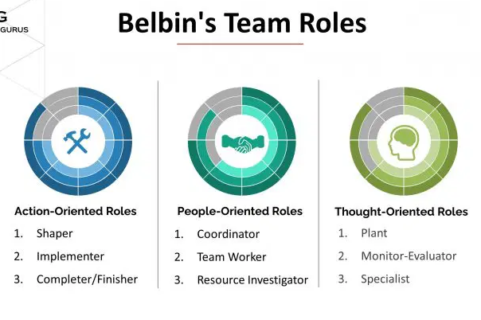
Source: (Belbin, & Belbin, 2010).
The development of the model of Belbin’s team roles, in the year 1981, which are followed by the 9 different diversities that are seen and maintained in this approaching tool. The model basically, classifies the categories in a grid format providing further subcategories under them. The team roles mentioned in the image show the pattern of behaviour that is characterised by an individual behaviour towards another through facilitating the team’s progression (Belbin, & Belbin, 2010). The approach of this model allows the team members to benefit from the acknowledgement done by themselves and adjust their behaviour to the demands of the external situation. The person’s team role is established through the use of the “self-perception inventory” that helps accommodate the pattern of work that is preferred for working in the environment of the team.
Example of using this model
The model is only providing with the team members' preferences in team roles and not designed to operate the environment of the team. The strength in one of the team roles can often cost the weakness in another context for a similar role (Quintanilla, & Wahl, 2020). The strong ideal team should be comprised of all the 9 team roles being balanced more healthily and the strong teams should have a strong coordination, a plant, a monitor evaluator, more than one implementer, team workers, and resource investigators. The team role of the shaper can be alternated by the role of coordinator rather than having both roles in one team. The organisations that are operating while applying this model as a tool to build a good and strong team working to harness the competitive market.

Understanding Team Development
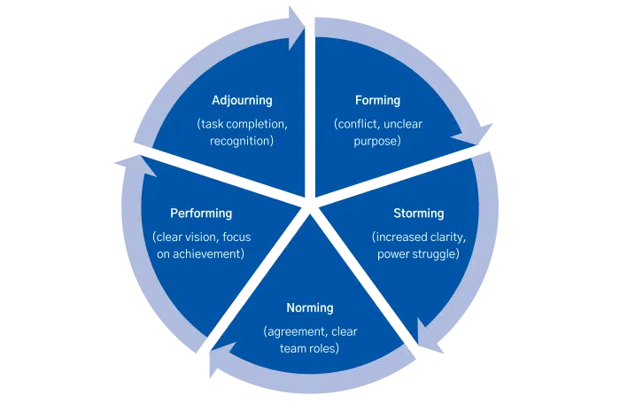
Image: Tuckmann’s model of Group development
Source: (Tannenbaum, & Salas, 2021).
The stages of Tuckmann’s model of understanding and making teams according to the process and progress made by every member of the team taking equal responsibility for the workload (Tannenbaum, & Salas, 2021). Further, the stages are elaborated from the initiating stage to the final stage with specific observable behaviours, the leadership required, team needs and feelings and thoughts of the team members.

Stage 1: Forming
The forming is the initial stage that is responsible for creating the structure of the team that is put together. The feelings and thoughts of the team members are avoided are being ambiguous and conflicting at all costs due to the need to practice acceptance in the group (Selart, et al., 2020). Hence, these specific coordinating responsibilities are taken by the team leader who directs and guides the members. This stage is advanced by showing relinquishment in the comfortable zones of the topics which are not threatening and fewer risks in the probability of creating conflicts.

Stage 2: Storming
This is considered the second stage which begins with the occurrence of the process of task organising and the processing of interpersonal conflicts. The stage is particularly dominated by leadership, structural issues and power.

Stage 3: Norming
The adaptation of the new ways of doing and being together by the team members, while the development of cohesion, in the group (Adair, 2015). The participation of the leadership is changed by taking charge of the shared leadership. Trust is built amongst the team members for having the effectiveness of shared leadership.

Stage 4: Performing
This stage focuses on inter-dependency, as the team members take responsibility for each other's needs meeting with flexibility. This stage is well-known for being highly productive in both personal and professional ways.

Stage 5: Adjourning
This stage is considered the terminating stage for the team members are ready to leave causing changes in significant aspects like membership, structure, and purpose of the team (Duck and McMahan, 2021). The team members are going through the changes and transitions to continue the productive performance.

Managing Conflict in the Workplace
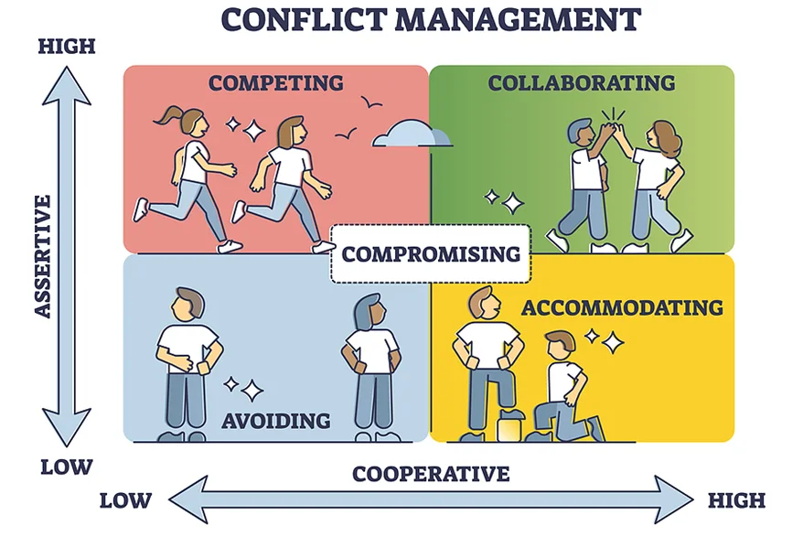
Source: (Guerrero, 2020).
The model of conflict management developed by the theorist named, Thomas and Kilmann’s Conflict mode instruments comprising of 5 different modes:

Mode 1: Avoiding
The mode of avoiding is low in assertiveness and low in cooperativeness and compromising is involved by the avoiding conflict mode completely (Guerrero, 2020). For example, the person who is watching the situation being played organically is also trying to avoid direct involvement. This mode of commonly used in the daily situations of the team.

Mode 2: Accommodating
The involvement of acknowledging of the conflicts also ends the stress and tension that is put on the team (Bolliger, et al., 2022). The team that has chosen this strategy should be losing a lot of favours for being an aggressor. For example, if a person is back from a project due to unavoidable circumstances, then the team would agree to cover the work of the absentee without being friends.

Mode 3: Competing
This type of mode shows the competing nature of the people working in a company in different parties (Clapp, 2021). However, using this mode in extreme ways can lead to massive blowback due to the direct need to be right in a debate or argument stance of proving their versions to be right.

Mode 4: Collaborating
This mode influences the option of sharing assertive creativity, the power of people bouncing their ideas off each member. This mode must consist of a degree of assertiveness and less dominance as the collaboration can be affected due to the pointlessness.

Mode 5: Compromising
This mode is considered the midpoint of the entire design of the model and is defined to be all about being assertive and cooperative (Abele, et al., 2021). This can be elaborated by allowing the accessibility of giving out grounds and gaining a little bit. For example, when two companies cooperate on efforts of their marketing strategies for increasing more customers.

Conclusion
There are a keen difference and similarities between the model of Tuckman that recognises the groups are not started by being fully formed and functioning. Whereas, Belbin’s model provides more specification and a detailed look at the different roles in the team. Further, the third model of Kilmann shows the conflicts that are impeded by managing assertiveness and coordination with a compromising nature. The report concludes by highlighting the specific team roles and the conflictual choices made by the team members and dominated by the leadership styles used by the team leader. These three models show a better specification and the roles alongside their responsibilities as a team member and being individually important as members of the team. Hence, these theories and models are utilised as tools to elect more assertiveness and gain productivity in the workplace of any organisation.

References
Abele, A.E., Ellemers, N., Fiske, S.T., Koch, A. and Yzerbyt, V., (2021). Navigating the social world: Toward an integrated framework for evaluating self, individuals, and groups. Psychological Review, 128(2), p.290.
Adair, J.E., (2015). Effective teambuilding: how to make a winning team (revised.edition). London: Pan Books
Belbin, R. M & Belbin, R. Meredith, (2010). Management teams why they succeed or fail 3rd ed., Amsterdam; Oxford: Butterworth-Heinemann.
Belbin, R. M., (2010) Team roles at work, (2nd edition). London: Routledge
Bolliger, L., Lukan, J., Colman, E., Boersma, L., Luštrek, M., De Bacquer, D. and Clays, E., (2022). Sources of occupational stress among office workers—a focus group study. International Journal of Environmental Research and Public Health, 19(3), p.1075.
Bonert, M., Zafar, U., Maung, R., El-Shinnawy, I., Naqvi, A., Finley, C., Cutz, J.C., Major, P. and Kapoor, A., (2022). Pathologist workload, work distribution and significant absences or departures at a regional hospital laboratory. PloS one, 17(3), p.e0265905.
Clapp, J., (2021). The problem with growing corporate concentration and power in the global food system. Nature Food, 2(6), pp.404-408.
Duck, S. & McMahan, D.T., (2021). Communication in everyday life: a survey of communication (4th Edition), Los Angeles: SAGE
Guerrero, L.K., (2020). Conflict style associations with cooperativeness, directness, and relational satisfaction: A case for a six‐style typology. Negotiation and Conflict Management Research, 13(1), pp.24-43.
Mullins, L.J. & Christy, G., (2016). Management & organisational behaviour Eleventh. (11th Edition). Harlow: Pearson
Quintanilla, K.M. & Wahl, S.T., (2020). Business and professional communication: KEYS for workplace excellence (4th edition). Los Angeles: SAGE ©2020
Selart, M., Schei, V., Lines, R. and Nesse, S., (2020). Can mindfulness be helpful in team decision‐making? A framework for understanding how to mitigate false consensus. European Management Review, 17(4), pp.1015-1026.
Stadler, S., (2019). Conflict, Culture and Communication, Milton: Routledge.
Tannenbaum, S.I. & Salas, E., (2021). Teams that work: the seven drivers of team effectiveness, New York: Oxford University Press
Tuckman, B.W. and Harper, B.E. (2012) Conducting educational research. 6th edn. United States: Rowman & Littlefield Publishers.

