Principles of Design Process Workbook

What is art?
Definition: “The expression or application of human creative skill and imagination, typically in a visual form such as painting or sculpture, producing works to be appreciated primarily for their beauty or emotional power.”

Art Styles:
Abstract expressionism, Art Noveau Avant-garde, Baroque, Classicism, Minimalism, Neo-Impressionism, Neo-Classicism, Performance Art, Pointillism etc.
The list of different art styles is ENDLESS, as an artist and designer its important to know of them, including what you like/ don’t like about it.
“Art provides us with a deeper understanding of our emotions and self-awareness”
Art is a process not a product. Art is a human act. Art is Risky.

Scenography: - The design of a space in which a performance takes place, includes minor and major details to portray a time period, location or even a message.

Examples:
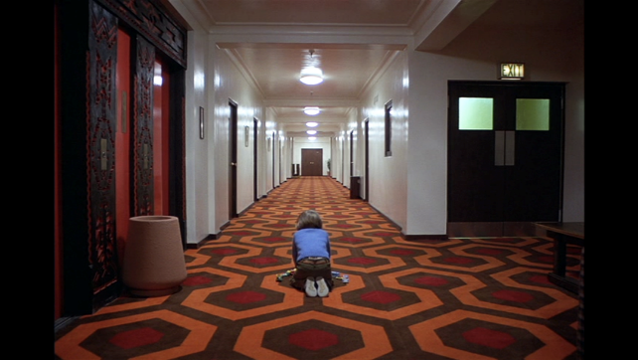
So, using this iconic scene from the shining we see a completely empty hotel hallway minus Danny Torrance innocently playing, but the way the scene is shot it has an ominous effect as the focus isn’t on the child playing but the background and its emptiness, as well as this we see the use of the colour red a lot in this image, with the elevator doors and the carpet which signifies danger and something evil.

Right side vs left side brain
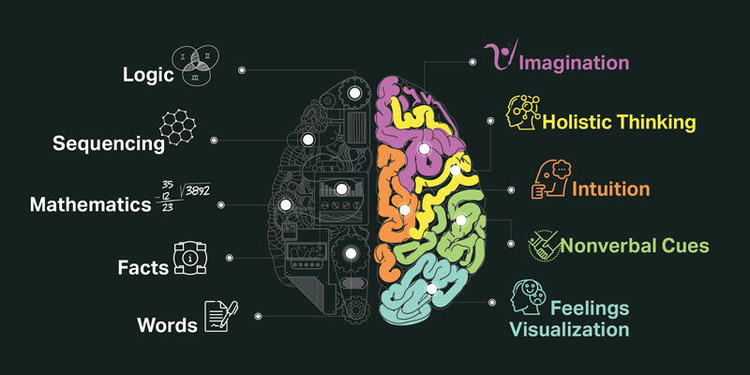

During class we started the session with a quick 5-minute task of drawing your hand without looking at the paper you’re drawing on, this little challenge is often referred to as Blind Contour Drawing, the reasoning behind us doing this task was for us to reflect on how we felt during the drawing and for us to better understand the whole concept of right brain vs left brain.
My attempts:
So during the 5 minute slot we had to do it I was filled with uncertainty and annoyance as I could see what my hand looked like in front of me but not what it looked like on paper after I had drawn it, the first attempt I did I drew from the perspective of looking at the palm of my hand and after completing what I thought was an outline of my hand I decided to try and add certain details such as creases in my fingers and palms which filled me with even more dread as I didn’t know where I was actually drawing them, after around 3 minutes or so I finished my first -
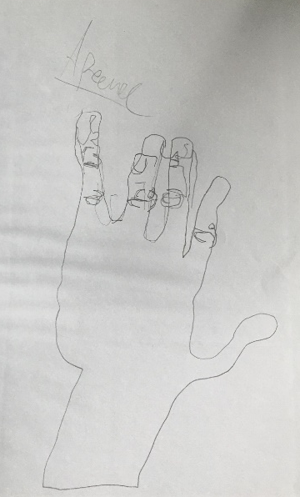
1st: 2nd:
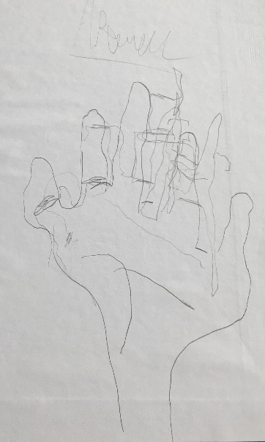
drawing and tried to do my hand from the perspective of looking at it from the back which was a mistake as all I could think of where the details and where they should go on the page but not actually knowing where the details would be on paper.

Study Task 1
- Watch a pot of water boil and write about what you think
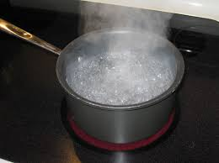
- Take a right vs left brain test

- Pot of boiling water task:
Now overall during this task I thought I looked 100% silly and stupid, especially when my mother wondered what the hell I was doing but despite this many thoughts did come to mind, although they were mainly thoughts on what I will be adding to the pot to cook, so first thoughts that came to my mind was adding some pasta or adding an egg into the pot to prepare some dinner, I feel as if this was the right side of my brain taking over and wanting to create something useful for me to eat as I was very hungry at the time, but also I feel as if the left side of my brain added to idea of cooking something to try and make sense out of this completely random action I was doing.
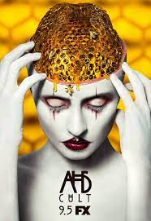
Afterwards in class we all shared each other’s thoughts on the task and what came to mind and after we all confirmed we felt weird when doing the task many people talked about how the bubbles looked when boiling the water and how it reminded them of the phobia: Trypophobia which is the fear or disgust of closely packed holes, as an example the view of a strawberry and its holes that hold its seed are a common trigger for people with this phobia, or even a bees honeycomb is a well-known Trypophobia trigger. Now originally, I didn’t know of the actual name of the phobia, but I did remember it being a theme during season 7 of American Horror Story titled “Cult” as I remembered the main character of the season was shown to suffer badly from this phobia, which caused her and many viewers of the series to feel extremely nauseous during certain scenes which as a result drew in many complaints as all of seasons of American Horror Story normally do.

- Right Brain Vs Left Brain Test
Initially when learning of the right brain vs left brain concept I initially believed myself to be 100% left brained meaning I believe myself to be more logical rather than creative especially when it comes to producing things such as sketchbooks and documents, but to properly gauge where I actually stand on this spectrum I decided to do one of the Right Brain Vs Left Brain tests to really see if the responses/ actions I take match where I think I am on the spectrum

(Anon., n.d.)
https://testyourself.psychtests.com/testid/3178
The result I received in this test was presented as a percentage between 0-100% with left brain being 0% and right brain being 100% and after finishing the test I had a percentage was 46% meaning I’m only slightly righter brained than left.

Overall, I am really surprised with what results I had been given from the test as it was nowhere near what I would get, however I still see myself as more of a left brained person mentally but maybe I’m mentally left brained and more physically right brained.

Movements within design

Modernism: - Focusses on individual designers forming a linear “evolutionary” narrative

Evolutionary Narrative:
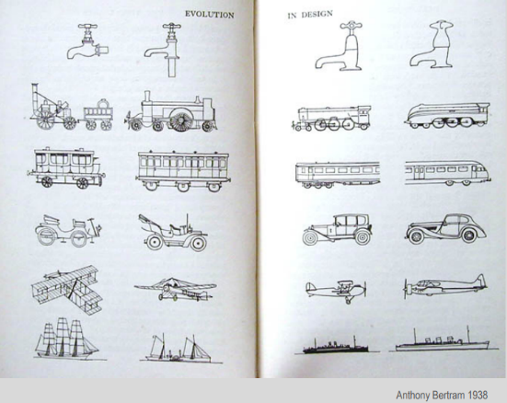
This diagram perfectly explains the “evolutionary” narrative commonly associated with modernism.
evolutionary narrative is the idea that over time everything will get better and better by being more effective in its field, until it reaches perfection or a utopia like state

*Utopia state is the idea that one day everything will reach perfection in which there are no more issues or problems in the world, kind of like the idea of paradise.

Industrial Design: - Focusses on the mass production of the object
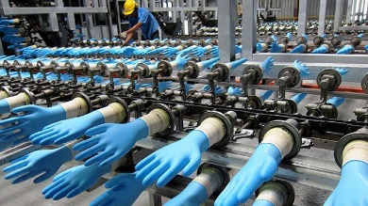
Industrial design is a process of design applied to physical products that are to be manufactured by mass production, companies that rely upon industrial design include Mini Cooper brand, Coke and even Dyson.

Industrial design firstly originated sometime within the 18th century as during the time textiles was the most dominant industry, usually the textiles were all handmade but slowly but surely the textiles companies started replacing the workers with machines that could do the job more effectively without worrying about labour costs.
As a result of the Industrial revolution many textile workers decided to rebel and riot against these machines that threatened to take their jobs by destroying the machines inside the factories and even setting the mills ablaze to destroy this new technology and hopefully get their jobs back because of the destruction, earning themselves the name of Luddite - someone who is opposed to new technology.

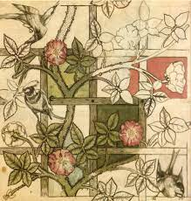
The Arts and Crafts Movement: -
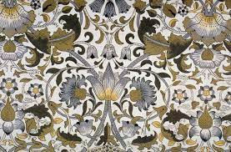
The arts and crafts movement founders were the first major critics of the industrial revolution. Disliking the mechanised direction of society had taken during the 19th century, their aim was to return to a simpler and more fulfilling way of living. The movement is highly regarded for its use of high-quality materials and focus on the utility in designs, their belief was also that a connection formed between an artist and their work added to the items beauty whether the item is to be used daily or not.

The Bauhaus Movement:
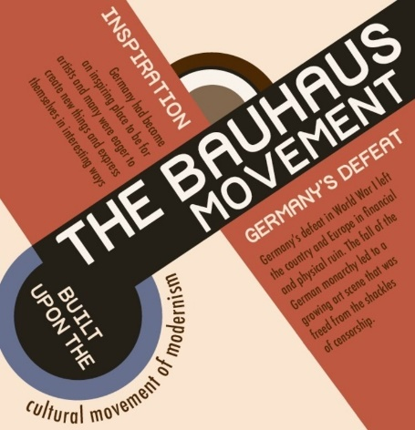
Beginning in 1919 Germany the Bauhaus supported and defended the geometric, abstract style, the style itself featured little sentiment, emotion, and no historical nods, to this day its aesthetic still manages to influence designers, architects, and artists alike.
The Bauhaus movement came to an end in 1933, during the time of the second world war those who followed the Nazi party would spend time harassing the Bauhaus school and rather than cooperate with the Nazi party the faculty of the school had a vote whether to close the school or not, leading to its closure. (History.com editors, 2017)
Why didn’t the Nazis like the Bauhaus style? The Nazi party favoured art that featured realism over any other style, so much so that the Nazi party deemed the modern stylised art as “Degenerate Art” and saw the Bauhaus style specifically as a “disease, spread about by the Jewish people to contaminate the German body politic” (ABC news, n.d.) causing many teachers who worked at the Bauhaus to flee the country in fear of what the Nazis would do to them.

“Degenerate art”
Translated from a German phrase (Entartete Kunst) degenerate art is what members of the German National Socialist / Nazi party deemed art that they didn’t approve of, attempting to bring art under their control.
Examples of famous artist and their work the Nazis disliked:
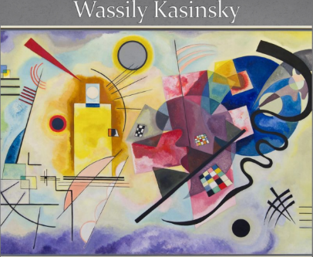
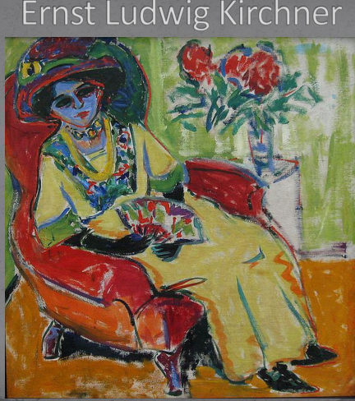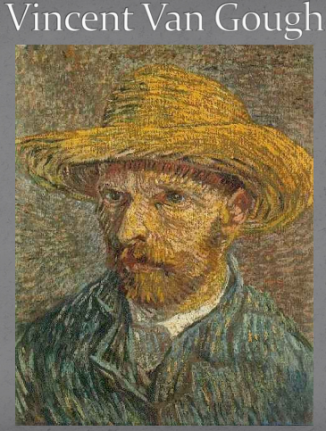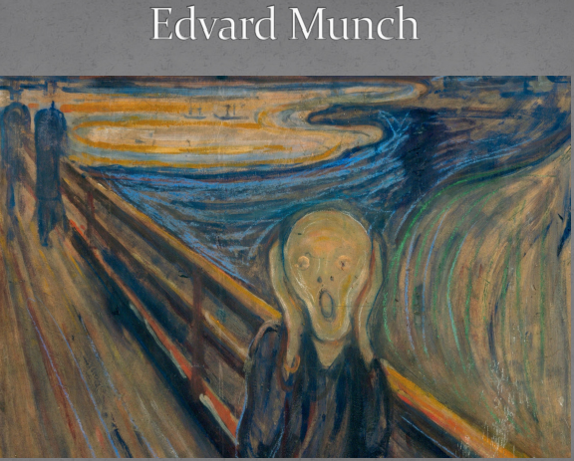

“Form Follows Function”
Form follows function is the idea of whatever that’s been designed/ created must fulfil the role for what its built for.
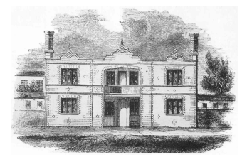
as an example, this design made by Prince Albert in 1851 was designed to house the working class.
So, the form should follow the same as any other house does, so this design works as it has walls, doors, windows, and a roof…. Right?
Unfortunately, not although the house possesses all these characteristics of a normal house the problem in this image lies with the roofing of the- house, the roof of the house is designed here to be a flat surface which means that if it were to rain heavily all the rainwater would pool at the top until it eventually sinks through into the house possibly collapsing the entire roof.
So, although in this instance form does follow function it wouldn’t function well for very long due to its form.

7 elements of storytelling:
Exposition- the storyteller sets the scene and the protagonist’s background.
Inciting moment- An event that hooks the viewer and sets everything in motion, an event in a story when the main protagonist is thrusted into the main action of the story.
Rising action- A series of relevant incidents that create suspense, interest, and tension in a narrative.
Climax- The turning point of a story, usually has the highest amount of tension and drama or even at the point where the action starts during which a solution is given.
Falling action- Action that happens because of the climax
Resolution- the character solves the problem or conflict
Denouement- French word for the ending.

Narrative structures

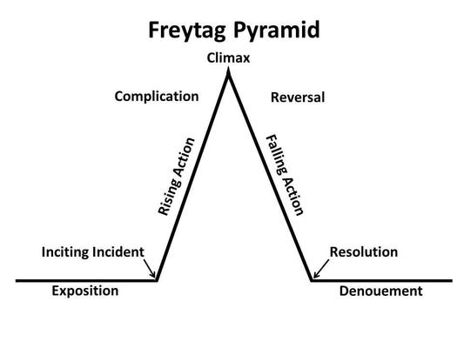
Freytag’s pyramid:

Vladimir Propp:
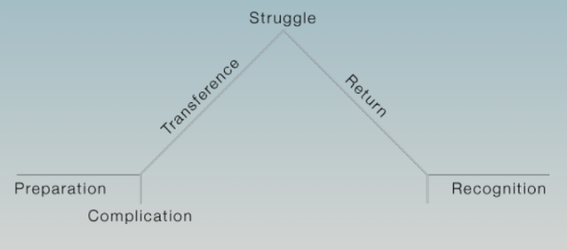
(Based on the study of Russian folklore) ->

(Freytag’s pyramid with Propp classification)

Bangs Model:

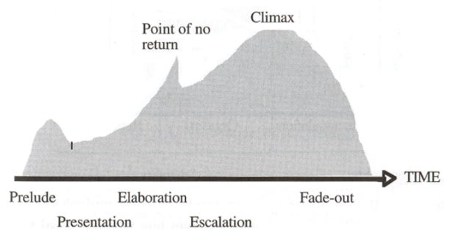

(Linear Storytelling)
Laurel’s Dramatic Arc:
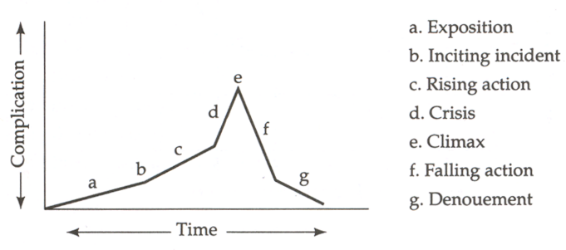
Principles of Design:
- Unity
- Rhythm
- Emphasis
- Proportion
- Balance

Elements of Design:
- Line
- Shape
- Colour
- Scale
- Texture
- Light
- Movement

Study Task (Pick a film trailer and work out the structure)

Trailer: Deadpool 2 https://www.youtube.com/watch?v=D86RtevtfrA

I believe the structure of this trailer follows the Bangs model the most fluently which is a common feature especially with recent film trailers and movies.

Although I see a lot of features being repeated and reused throughout the trailer, for example I can see the trailer having multiple moments of climax and rising action.

The opening scene in the trailer is a scene where Deadpool is running away from a mob with calm music playing until Deadpool jumps through the backseat window to get into the taxi, I see this segment overall as the prelude setting the story with certain scenes of Deadpool in action killing and comically relating to what the taxi driver Dopinder is talking about

Then I believe the scene when cable is introduced is used as the presentation and the elaboration as to why cable is here and what his goal is also by showing the short fight of Deadpool vs cable we see how much stronger he is than Deadpool which hooks the viewer even more into wanting to watch the film as they want to see how the hero will triumph.

The point of no return I believe for this trailer is the scene in which Deadpool says how he can’t let cable complete his goal of killing the child then continues with the subsequent scenes of Deadpool recruiting for this new team I see as the escalation of the trailer

Then I believe the climax is the scene which Deadpool and his team jump from the back of the plane with all the scenes from that point on being a fade – out but instead of a regular fade out this final scene is filled with action that doesn’t seem to die down until the trailer end with Domino stating how she regretted not going to college.

Then weirdly in a sort of post credit scene in the trailer Deadpool and weasel seem to be discussing movie remakes and in typical 4th wall breaking fashion seems to be joking about how if they were to make a Deadpool 3 it would be terrible as they wouldn’t be able to top the first 2 movies.

What do you think of poetry?
(Initial Reactions)
Poem 1: A dream within a dream by Edgar Allan Poe.
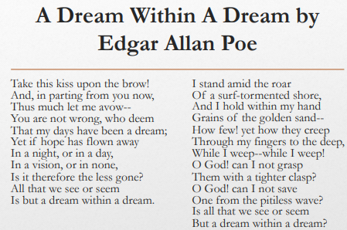
Seems to be located on a beach, the poem also feels like a love poem but also feels like a sort of parting poem with some lines seeming as if he was saying goodbye to someone, towards the end of the poem I feel it turns into a poem about loss or some sort of regret with the constant use of “O God” it as well seems like the main protagonist blames himself for the loss as he couldn’t grasp onto whatever was being taken away from him.

Poem 2: The road not taken by Robert Frost
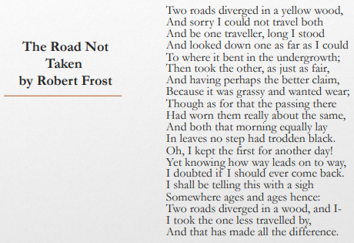
Seems to be located along a woodland path, the poem tells us about how the path diverged into two paths with one path being least travelled down compared to its “better claim” counterpart, the traveller also recounts about how he himself will one day tell this story to somebody, but the ending of the poem seems to alure to something ominous happening and leaves me questioning what did happen and what difference it did make for him.
7 Steps of Design:
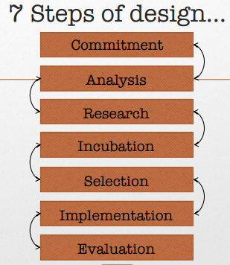
Commitment- Commit to the idea and process
Analysis- Analysing of the source material
Research- Looking into the context of the material
Incubation- Let the ideas process
Selection- make decisions or choices (use instinctive)
Implementation- Select ideas and mediums to be used
Evaluation- What worked and what didn’t, look back and develop

*Advice*
Try not to skip steps
The more done during the process stage the more understanding you’ll have
Don’t pigeonhole
Don’t go off track

Storytelling: - The conveying of events in words, sounds and/ or images, often by improvisation or a decorative detail added to something to make it more attractive (embellishment). Stories have been shared in every culture as means of entertainment, education, cultural preservation and instilling moral values.

Phatic: - Denoting or relating to language used for the purpose of social interaction rather than to convey info or ask questions, for example “hello how are you? And nice morning, isn’t it?” is phatic.

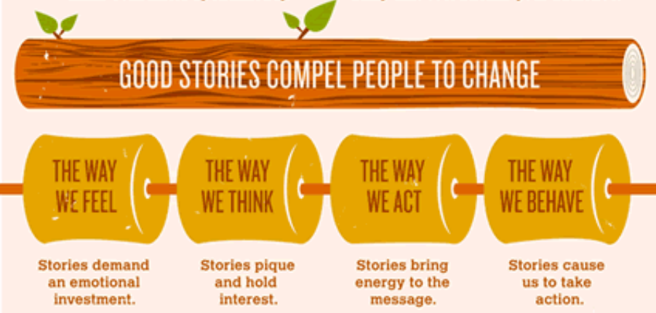

The importance of storytelling:
- Its interactive
- It involves two-way interaction between the storyteller and the audience. The responses of the audience influence the telling of the story.

Storytelling uses words/ gestures.
Language is used, whether verbal or visual
Storytelling uses actions such as vocalisations, physical movement, or gesture.
These actions are the parts of spoken or manual language other than words.

“The purpose of a storyteller is to not tell you how to think but to give you questions to think upon” – Brian Sanderson, The Way of Kings

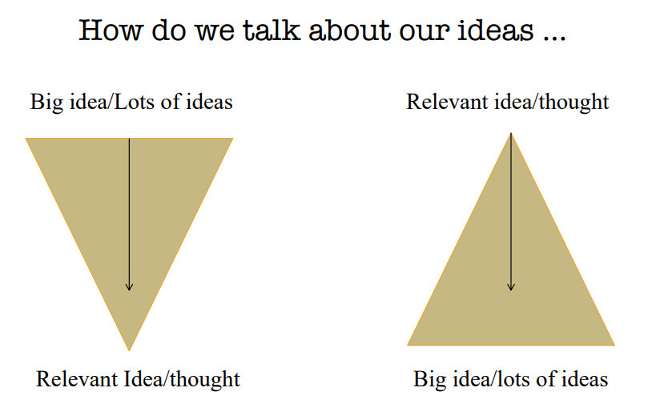

Mediums and different styles of storytelling:
Personal Storytelling:
Through living everyone is in the constant and on-going process of composing a personal story.
The stories are personal and concern individuals lives, they are composed to remember, change, and find meaning to life.
Through personal storytelling, the teller can share experiences with others to possibly motivate and inspire.

Family Storytelling:
Family storytelling is known as the history of the family, preserving a long line of various events and experiences whilst keeping traditions and expectations alight.
Allows for the family identity to show, bringing with it the finest traits of ancestral history as a reminder to live up to something.
This type of story can give the listeners motivation to live up to the family’s previous achievements, but also can give a lot of unhealthy pressure to the listener to live up to their family’s standards.

Cultural Storytelling:
Passed down from generation to generation in engageable and memorable forms
Given to children to help teach the meaning of things.
Can pass on stories of religion and culture to keep traditions going, for example native American traditions and history aren’t forgotten.

Friendship:
Brings friends together to recollect shared experiences, they can also stop individuals from drifting apart in later lives. These stories can be the centrepiece of a reunion or even to bring a laugh out among friends.

Social:
People talk and gossip all the time about everything from celebrities and co-workers, this form can bring people together and can help during awkward silences. Talking about other people’s problems can distract you from your own problems as well as help people find a new perspective on their lives.
Myth:
Stories presented as being true, but the authenticity is doubted because nobody knows the origins of the stories, typically associated with cultural issues, and provide reminders of what people should fear in life

Unexplained:
Stories about unexplained phenomena such as ghosts, haunted houses, or UFOs to excite people, stories usually told to help conquer fear or show warnings of what not to do and even provide hope that there’s something more out there in their lives, these stories are also easier to believe in as we don’t fully understand them.

Study Task: Pick a song lyric and portray their storytelling visually using 2 storytelling modes in 24 frames
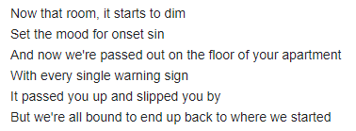
Song: - Phantom by Natewantstobattle
<- So, for this task myself and my partner for the task Edward and I had several songs, but we narrowed out choices down to this song as we both felt we could visualise more compared to the other songs.

After choosing these lyrics myself and Edward decided the first to select the unexplained storytelling mode first and after selecting the mode, we both made a joint Pintrest pin board and shovelled any images we felt related to the lyrics or even images we felt could be a good idea to add into our storyboard.
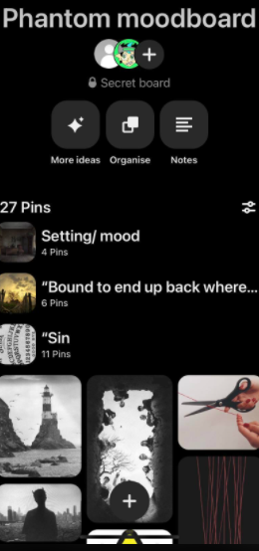
We also decided to try and put our photos into categories that relate to the individual lyrics.

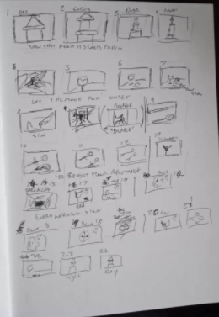
Later, myself and Edward had a discussion on certain scenes we could do and luckily thanks to Edward’s artistic skills we managed to do a basic storyboard of the lyrics we had chosen

Condensed imagery: - Being able to covey an idea or image through the simplest form

Cognitive Dissonance Theory: - The theory that people feel uncomfortable when faced with contradiction or inconsistent information or viewpoints and therefore tend to seek out messages which conflict/ confirm them in choices or verdicts which they have reached

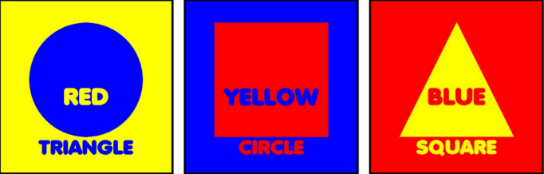
Each square has contradicting or wrong information, the colour doesn’t match the text, the shape doesn’t match the text as well.

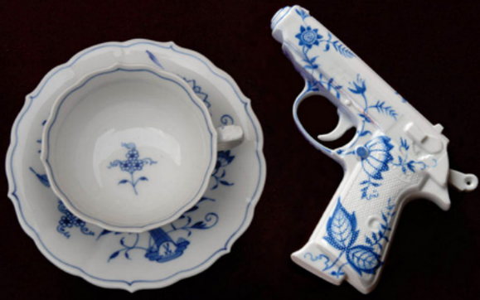
Ceramic styled weaponry, ceramics being fragile and decorative which are none of the characteristics of a weapon.

Study Task: Choose lyrics – Think about the storytelling and condensed imagery.
Backseat Serenade, All Time Low
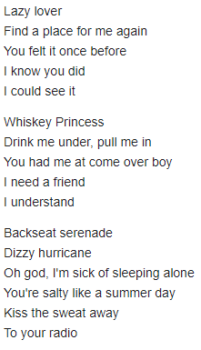
Opening verse of the song begins with “lazy lover, find a place for me again” so from that opening verse I see it as a song to an ex-girlfriend and how the protagonist wants them back, then continues with “you felt it once before” this idea becomes reinforced as she loved him once why not do it again.
Second verse the singer seems to be talking to/ about a sort of drunk hook up who beckons him to come over when she’s drunk and needs a “friend” which could mean exactly what she said but personally I just think it’s a hook up scenario as the singer himself understands.
Third and final verse is the songs main chorus and opens with “backseat serenade” which seems to be a term for a sexual encounter possibly whilst drunk with the next line “dizzy Hurricane” then after this line we have “oh god I’m sick of sleeping alone” giving a sort of insight to how lonely the singer is as he wants this encounter just to have company, all whilst the radio plays in the background.

Mood boards – Why do we use them?
Simply to collect and organise our ideas
Can take many physical and digital forms, forms include pinboards, sketchbooks, wall displays, digitally on Pintrest or Padlet the list is endless
Mood Board Definition:
An arrangement of images, materials, pieces of text etc. intended to evoke or project a particular style or concept.
Mood Boards Purpose:
We put together a mood board with key images and words that best convey the essence of the idea/ show/ branding.

Good practice:
- Organised and thought about
- Has personality
- Aesthetically interesting
- Not too cluttered
- Annotations – thoughts/ texts/ facts
- Draws people in – makes them want to see more
- Periods correct

Bad practice:
- Bland
- Too busy/ too sparse
- Inaccurate information
- Unorganised
- No visions
Who uses them?
Theatre designers, production designers, film makers, costume designers, architects, fashion designers, lighting and sound designers, puppet, and props designers, etc.
The list goes on…

What can they include?
Images, text, references to source material, facts, textures, colour palettes, fabric swatches, samples, videos, etc.

Ray Bradbury: The Last Night of the World
https://moodle.uwtsd.ac.uk/pluginfile.php/199107/mod_resource/content/1/The_last_night_of_the_world%20%281%29.pdf
Initial reactions:
After reading the story for the first time I see the main story surrounds a husband and wife and their two daughters, but the story itself is based off a very ominous question which the husband asks his wife, the question being “what would you do if you knew it was the last night of the world?” Although the story itself doesn’t give us a definite reason behind this question for example the story doesn’t give us a definite reason for the end of the world, so the wife questions the husband the reasoning behind this question, but with no apocalypse, no meteor or other world ending disaster as a sort of proof, the story does give us a quite a mysterious and ominous reasoning behind the question, the husband asking the question because he dreamt it was the end and to reinforce the idea it’s the end the husband says how everybody he works with has had the exact same dream that this is the end or the “closing of a book” as the husband says, but the family we see doesn’t react to the idea that this is the end and carry on as normal up until the end of the story which finishes with the couple going to bed.
Task: - Storyboard the story in 24 frames and create a short presentation on the story’s context and author
Firstly, as a group we all decided to create a word document where we would stick all of our research on the matter, to then transfer into a PowerPoint ready to present in front of the class
Word Document:
Ray Bradbury.docx

PowerPoint Document:
Story board presentation.pptx
As well as the PowerPoint we all as a group held up our drawings of the storyboard to present alongside the presentation

Life Casting
Life casting is the process of using skin safe moulds and producing a copy of whatever needs casting.
There are 4 materials needed to create a cast:
- Alginate - To create the mould
- Mod-roc - To support the skin mould
- Plaster - The casting material
- Water - To add to the plaster and alginate powder
The measurements for water to powder solutions is normally 1:1, although it can vary, so add to the solutions with more powder/ water and mixture is smooth
Making the mould:
For today’s session we will be making a life cast of our fingers inside plastic cups then have a demonstration at the end of the session on how to cast somebody’s face
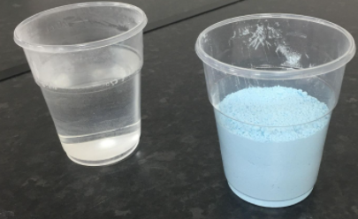
So, with our 2 cups of powder and water we added the water into the powdered alginate and started mixing it until it became smooth.

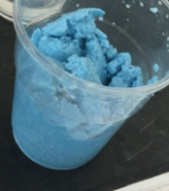
Attempt 1:
Unfortunately, the first attempt at mixing together the powder and water went wrong, and the final product looked like blue curdled milk, as a class we believe it was because the water we used was hot water, so onto attempt 2.
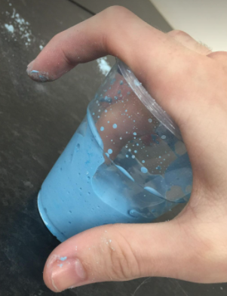
Attempt 1 (2.0):
Now on this attempt using some cold water and a pencil to help mix the solution I managed to produce a smooth alginate mixture, it wasn’t as much as id like and I could of needed more alginate podwer but after inserting the tip of my middle finger and holding the position in the photo, after a couple of minutes or so the mixture started to set and feel cold and weirdly claustrophobic on my fingertip and when the mixture had fully set I then had to wiggle my fingertip back and forth to pry it free from the mould.

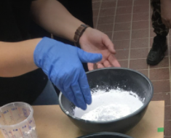
After we had our mould set Stacey then mixed us our plaster using the 1:1 formula and adding to it with either more powder/ water as she saw fit to, then proceeded to go around the class and fill all of our mould with the plaster, pouring the plaster slowly to avoid any bubbles forming in the mould.
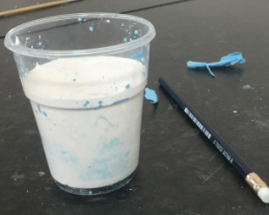
Just after the mixture had been poured, we had to bang the bottom of the cup so that the air bubbles inside the mould could rise to the surface
During the process of the plaster drying and setting it produces an exothermic reaction in which it releases heat is why plaster isn’t a skin-safe material to be using, always have a protective layer like gloves when mixing and don’t apply plaster to skin ever, then whilst waiting for the plaster to set setting we took a 15/30-minute break to let our plaster set, when we returned our plaster had nearly set, but the top of the plaster was still a little bit soft, so we gave it another 5 minutes to fully set.

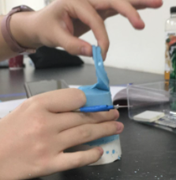
After our plaster had fully set and dried properly, we now had the job of freeing the statue from the mould so after letting the mould and the plaster fall out the cup like a cup of jelly we had to carefully pick away at the set alginate mould until we reached out, luckily for me mine was taken out the mould by Stacey as an example but usually you could just either peel it off or just use a knife or something sharp to cut the alginate to reach the mould.
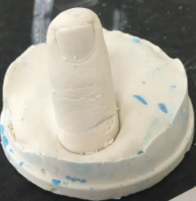

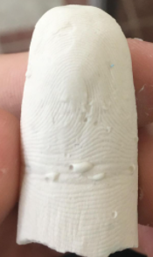
Unfortunately, during the process of freeing the statue of my middle fingertip it did snap away from the base, but I was amazed with the level of detail that were on the plaster, for example on the stature of my fingertip you were able to see my fingerprint and it clearly showed the patches of peeled skin on the statue.
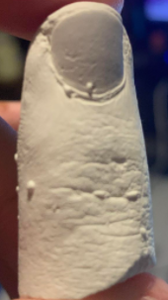
The statue itself did have some bubbles that didn’t rise to the surface, but I know for next time to both avoid hot water to mix with the powder and to bang the mould more to get the bubbles out of the mould

Moulding and casting a human face:
When moulding somebody’s face the alginate mould when it set can pull hairs out unless all hairs including eyelashes are covered with a layer of Vaseline or if the mould is of the whole head, then a swimming cap is needed to protect the hair of the person you are moulding
It is always best to communicate with whoever is being moulded as their mouth, nose- (minus the nostrils so they can breathe) and eyes will be covered they can become claustrophobic but if their mouth is covered, they won’t be able to say stop so make sure you pay attention and see if they are making any hand gestures signalling you to stop and simply talk them through everything you’re doing so they feel comfortable knowing what you are doing to their face.
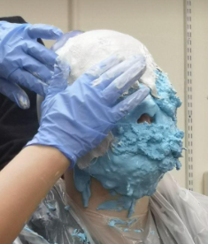
So after preparing the alginate mixture Stacey and Dave applied the Vaseline to all hairs on the volunteers face and proceeded to apply the alginate mixture onto her face talking her through which part of the face they were working on, the alginate itself can’t support itself so we used another material called Modroc which is a plaster impregnated bandage, the bandage itself needs to be we for it to set and harden, so beforehand Stacey and Dave had prepared the Modroc by cutting it into small strips and having two separate bowls of water, one to wet the bandage and the other to wash their hands in after handling the plaster.

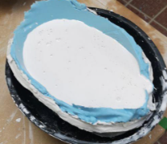
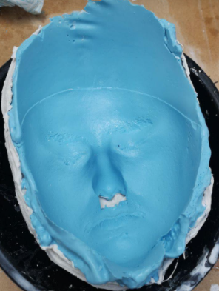
Finally, after the plaster bandage had set it was time to remove the alginate mould so after turning the lights off, so the person doesn’t get blinded after being in darkness for so long, Dave and Stacey peeled the whole alginate mould with the Modroc set bandage off the persons face and plugged the nose holes so no plaster can leak from the mould, and now we have a full set mould of that persons face ready to filled with plaster.
Unfortunately as we had run out of time we werent able to see the final statue of the face but by our next session we will be able to see the final product.

Alginate has 2 different powder solutions, one being called FX3 is a slow setting solution whereas FX9 is the fast-setting solution
With every alginate product sold it should contain a safety data sheet which contains allergy information and even the ratio of mixing powder solution to water.

Table Reading:
What does a designer need to know? Time period, location for the story and the location of the performance space, colour scheme, notes within the script.
No matter your job within the production team you must know the script and the world its set within
Re-read the script multiple times
1st time just a normal read through
2nd time note down any thoughts and questions
3rd time more questions and ideas
Then after the questions get out the highlighters and highlight anything that will be useful to the production team (costume, LX and sound, practical questions – venue, money, set up, crew)
Analysis Questions:
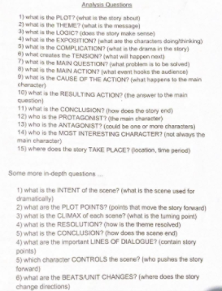

Analysis of The Mountaintop (by Katori Hall)
- Plot?
The story of The Mountaintop is a fictional depiction of Martin Luther King Jr’s last night alive, on the eve of his assassination
- Theme?
From what I can see the story doesn’t really portray any kind of message.
- Logic?
The story itself is a somewhat religious piece so to someone of the same faith it can make perfect sense, but the story’s logic is easy to follow for every viewer.
- Exposition? (What are the characters thinking/doing)
Camae - Camae starts off as an undercover angel but after revealing who she really is her main goal is to help MLK come to terms with the fact he is going to die.
MLK Jr – Before he finds out about his fate all MLK Jr wants is his pall malls but after discovering is fate he wants to find any way to escape it as he doesn’t want to become a martyr, thinking of any way to convince Camae and God herself until its revealed to him his impact on the world.
- Complication?
MLK Jr doesn’t want to die and become a martyr
- Tension?
MLK Jr refuses to die as his mission and his dream haven’t come to fruition
- Main Question?
Will MLK Jr come to terms with his fate and accept what’s to come?
- Main action? (What hooks the audience)
The realisation that Camae is an angel come to prepare MLK Jr
- Cause of action?
MLK Jr’s realisation that he’s trapped in this motel room with Camae
- Resulting Action? (Answer to main question)
Camae reveals to MLK Jr what impact he has on the world after his passing
- Conclusion?
MLK Jr comes to terms with the fact he’s going to die
- Protagonist?
Martin Luther King Jr
- Antagonist?
Camae (The angel)
- Most interesting character?
To me Camae is the most interesting as she is a completely fictional character in the story, with her backstory being the most intriguing and the most upsetting.
- Where does the story take place?
The story takes place in the Lorraine Motel in Memphis, USA, in the year 1968.

Clay Sculpting
When using clay to sculpt there are many types of clay you can work with W.E.D. clay and oil-based clay:
WED clay – originally created by Walt E Disney for use on Disney’s animatronic models, WED clay is a versatile water based that’s designed to be very smooth and slow drying
OIL-Based clay – Made from a combination of oils, waxes and clay minerals, unlike the WED clay the oil based clay don’t evaporate like water and remains malleable even when being left in dry environments.
My first attempt at sculpting:
For this class we had to find a reference image and try to recreate and sculpt whatever the image was during the class
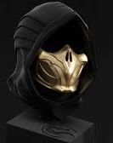
My reference photo:
I chose this as I actually own this item in my home

We started the session with a wooden stick with a base and some foil to wrap around the top of the wood to have a foundation to sculpt upon
After doing my foundation I proceeded to add a layer of clay on the foil then proceeded to place a layer of clay to act as the hood of my reference image:
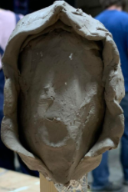
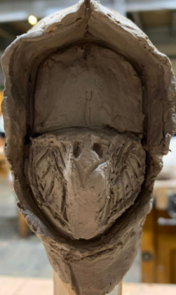
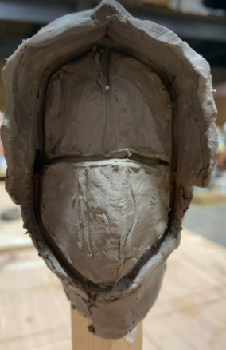
Then after doing the hooded layer I decided to try and shape the facial area of the sculpture using a pencil as my sculpting tool:

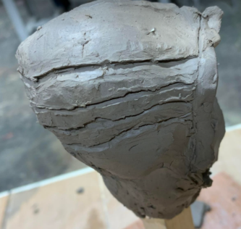

Then finally for my sculpture I had the job of putting the groves on top of the sculpture

To make sure the clay stayed wet and malleable we had to wet a sponge and warp it in cling film over the sculpture to stop it from drying.
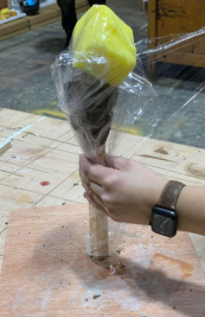

Theatre history timeline
https://padlet.com/21032352/5we082fkduqnkzn3

Principles of Design Robot Boy Project
For our final Principles of Design project we were all introduced to a stimulus, the stimulus being Tim Burton’s poem “Robot Boy” and set with the task of pitching as if we were to produce this poem as a physical piece, whether it be for theatre, tv or even animation, with the challenge being we only have 3 weeks to do it.
After first being introduced to the poem we were then assigned into groups of 4, I was placed in a group with Molly Pearce, Gareth Otely and Hannah Payne, and immediately as a group we followed the 7 stages of design and committed to doing the project, although at this point in time we were unsure of what the final project would look like.
We then started to share one another’s ideas and thoughts on the poem to one another and as a group to share and analyse each other’s ideas, we all came up with relatively unique ideas towards the piece, for example I shared an idea with the group how I believed that Mr and Mrs Smith unfairly blame robot boy for their unhappy marriage, then Gareth added to that idea with the thought that Robot Boy’s parents try to hide Robot Boy as if he is just a normal child an element of forcing him to be someone he’s not, after sharing and discussing our ideas we did reach the problem of not fully knowing what we as a group would like to produce to then be presented, so following the 7 stages of design we let ourselves incubate over the space of a weekend.
After our incubation period we as a team reconvened to discuss what wed like to physically produce for our presentation, luckily we all had the same idea to produce some sort of model box of robot boy in a specific segment of the play, we originally had the idea of doing more than one location but due to having a short period of time to make them in we decided to stick with doing one location from the poem with a model of Robot Boy model to go alongside it.
Alongside our final selection for our model we then as a group decided to split the group in half with one groups focus being on robot boys design and the other half to focus on a location, its around about this time in which we decided to make a mood board focussing on what we believed to be the main focus of the poem, i.e. robot boy himself, the house he lives in and also his parents

Our teams moodboard:
Tim Burton Robot boy mood board.pptx
As well as this we as a team decided to create a WhatsApp group chat with one another so that we can all effectively communicate and share with each other even outside of university hours.
After compiling all our images into the mood board we had a group discussion to select the location for the model box we are going to build, luckily we all agreed that it would be best and more effective for us to make a model of robot boy’s bedroom to go alongside a robot boy model, this then gave us the opportunity to share ideas with one another again but this time on specific details we want to try and produce, for example myself and Gareth really liked the idea of robot boy having a working LED light in his head to really showcase how robot boy only seems alive when he’s plugged into the wall and the girl came up with the idea that robot boys bedroom was once a typical boys bedroom but now its just a seemingly rubbish tip filled with the things robot boy loves and not what his parents are trying to make him love, so the girls came up with the idea of building the room so that it has litter and rubbish scattered all over adding key details like the bed being made, to show robot boy doesn’t sleep in this bed instead opting to sleep in his happy place, that being a big pile of trash in the corner of the room.
During one of our scheduled lessons we decided to use this time to draw basic concept of robot boys appearance and a somewhat floor plan of what robot boys room looks like, with the only condition being we cant write any of our ideas we had to draw them.
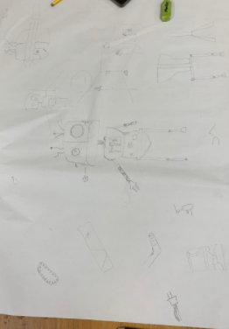
Robot boy concept ideas:
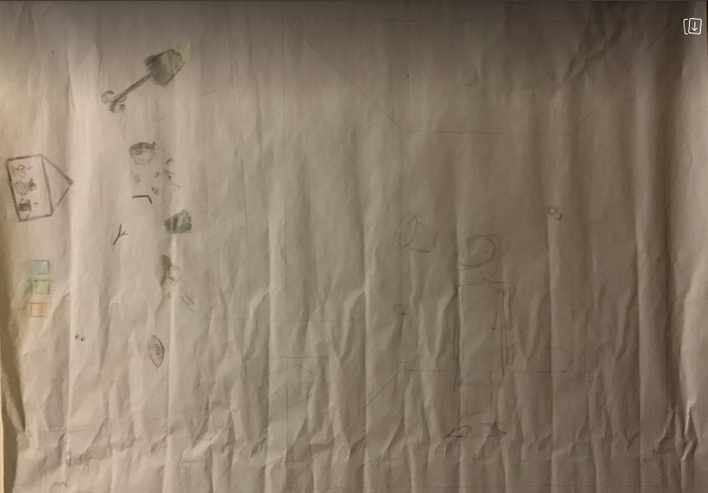
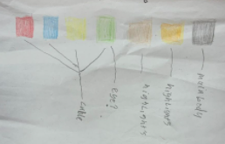

After doing the concepts we needed to have a rough estimate of the measurements for our scale model so we decided to focus on the measurements of the room then build robot boy to fit into this environment.

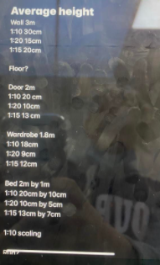

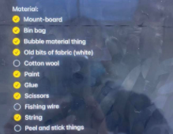
Alongside this producing a materials list for what we would need for the set:

We also made a material list for the robot boy which consisted of using straw, recycled materials and some thin metal wire.

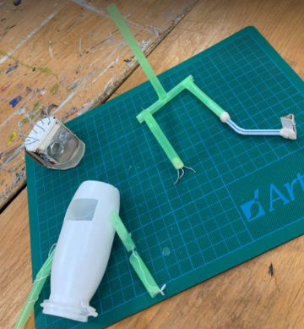
Eventually we managed to create 3 separate pieces to robot boy, the head, the torso and the legs:
To be pieced glued and then painted

Eventually leading to this masterpiece:
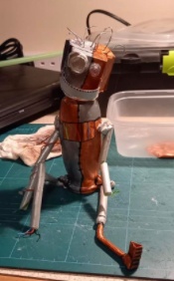

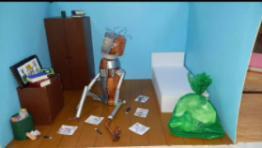
To be accompanied with our wonderful set like so:

Evaluation of robot boy project
Overall I am very pleased with the progress that both myself and my team made throughout this project, I feel as if we throughout the design process we managed to apply all the stages of design, although we didn’t apply it in the specific order we always managed to evidence the steps within our work. I feel if we were able to do this project again but with more time to complete the project that myself and my group would fully be able to pitch this project to a very high level with better models of more locations from the poem and even possibly a chance to create models of the other characters within the poem, maybe even going as far as doing the entire poem with scenes such as when the robot boy falls in love with the slot machine that is also alive.

