Matlab Certificate
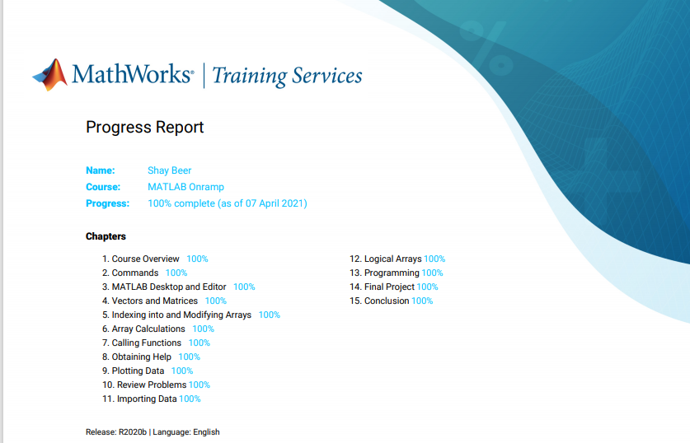
Below is the certificate to show that I have completed the matlab onramp course at 100% for the workshop assignment.

