Fundamentals of Construction Technology. New Build Dwelling: Technical report with drawings
ACBA4001
Victoria weeks
Table of Contents
1. Typical sketched construction details for a timber frame building constructed off a raft foundation 1
2. Benefits of using a trussed roof over clad with OSB sheathing and metal profile 4
3. Example of an alternative method of roof structure 6
4. Offsite Construction 8
5. Reference List 10

1. Typical sketched construction details for a timber frame building constructed off a raft foundation

The ground floor construction, detailing and junctions with external walls
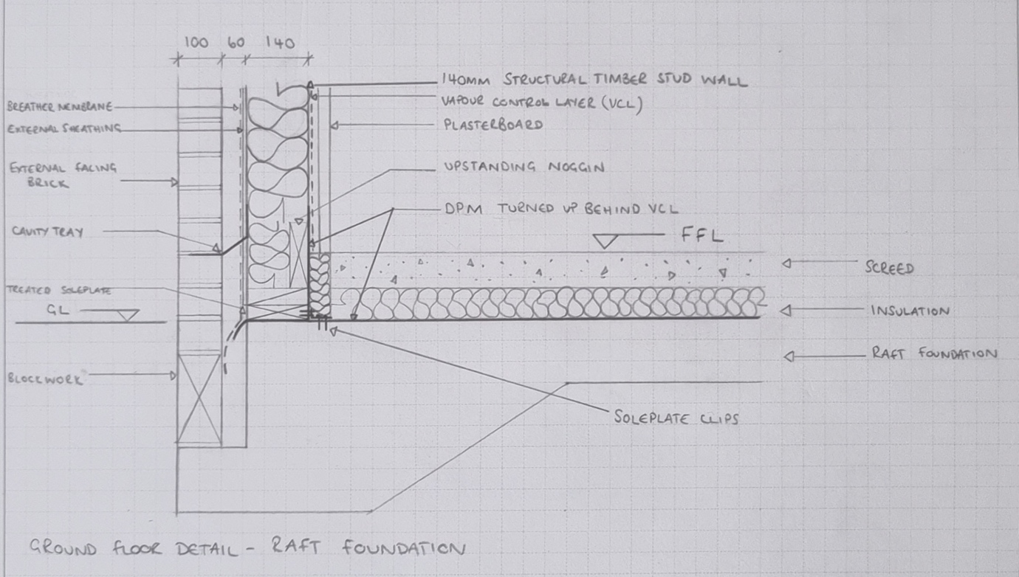
Image 1- Ground floor detail with raft foundation

The first-floor construction, detailing, junctions with external walls and restraints. Included are two details; parallel and perpendicular, for completeness.
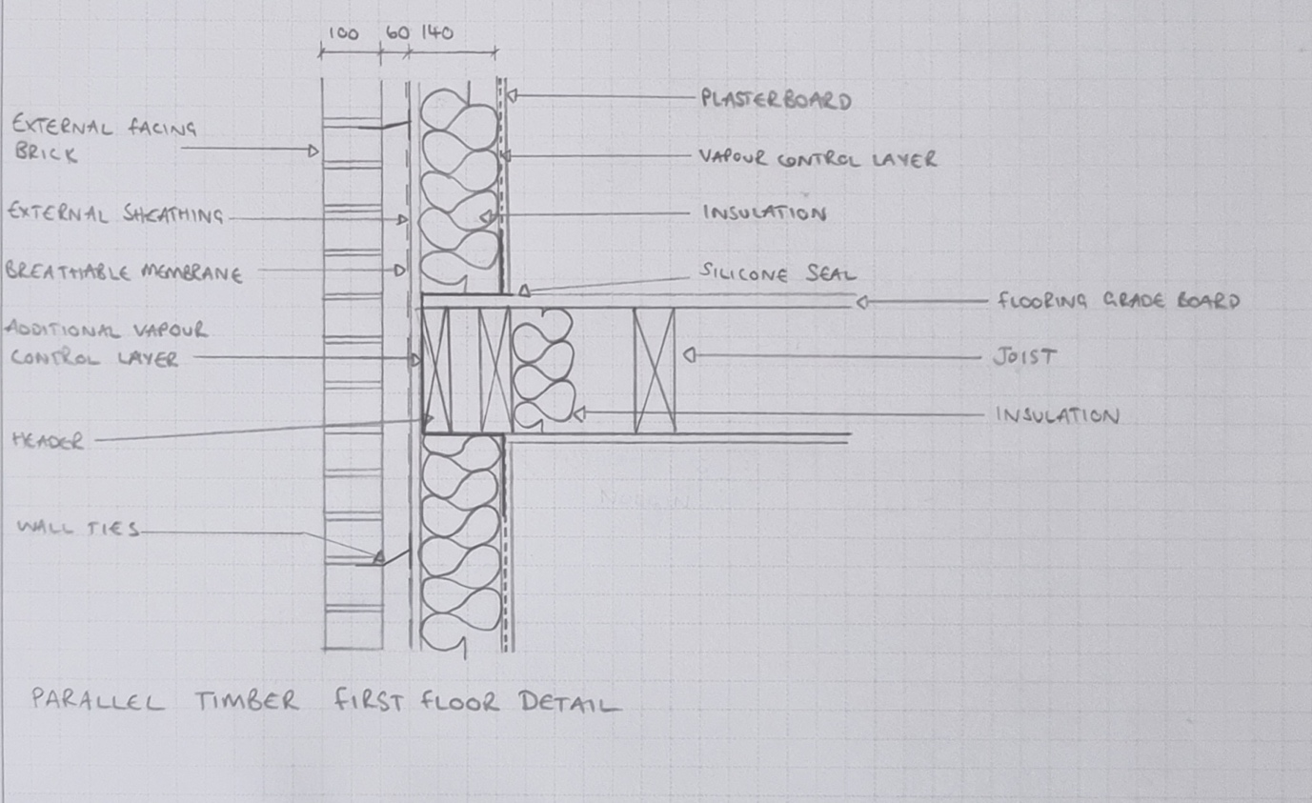
Image 2- Parallel timber first floor detail
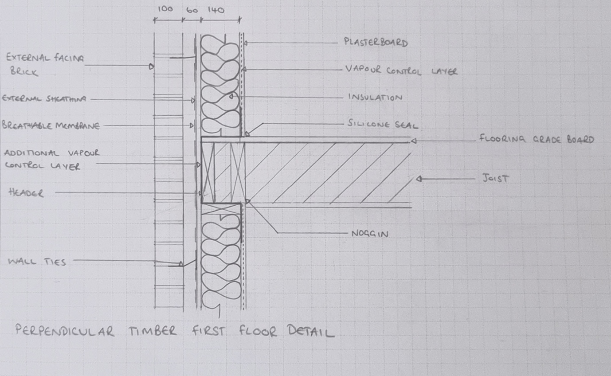
Image 3- Perpendicular timber first floor detail

Eaves detailing and roof covering- indicating appropriate weathering, fixings and laps
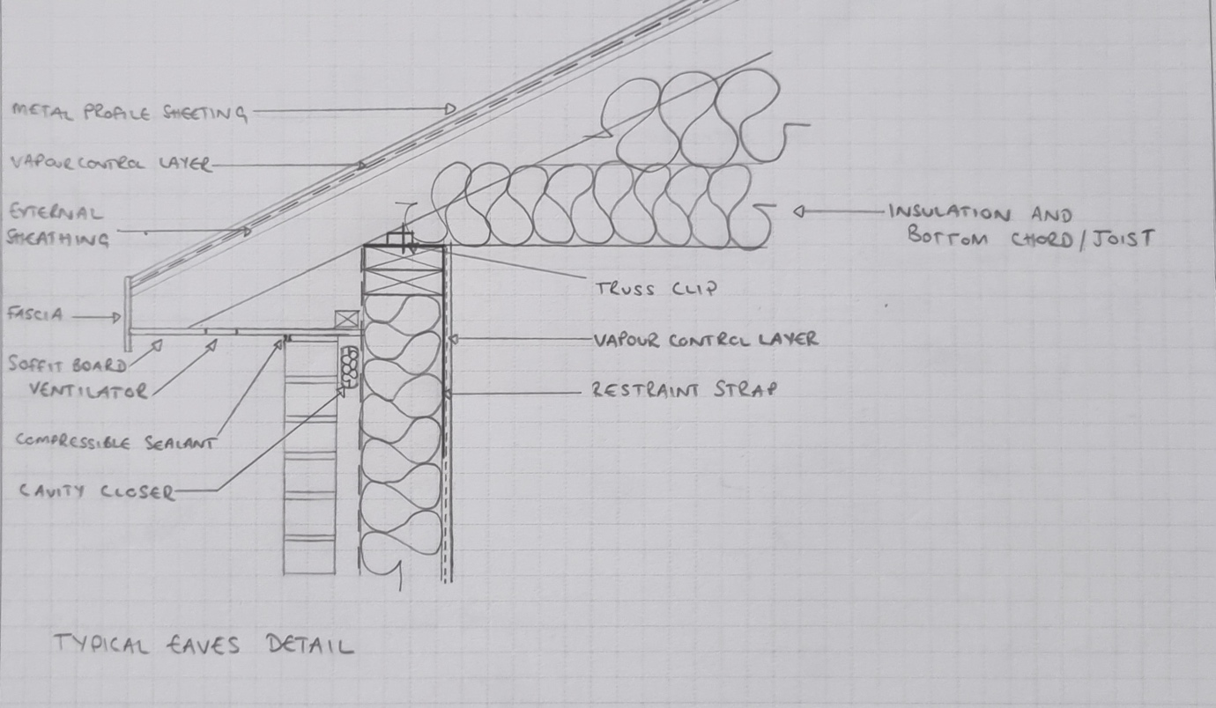
Image 4- Eaves detail

The main roof structure. Construction, detailing and fixing
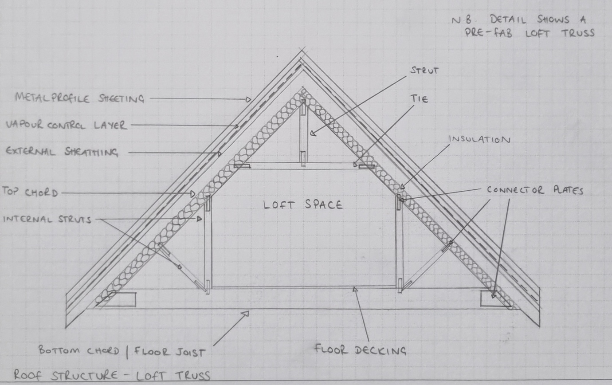
Image 5- Roof structure

The construction details shown above, will all meet the minimum standards set out in Table 1 below, from Approved Document L1A, Building Regulations for new dwellings. (The Building Regulations, Approved Document L1A, p.18)

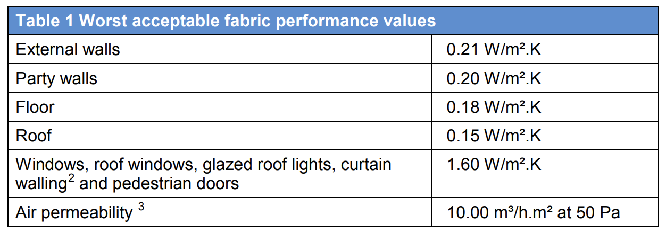
Table 1- Fabric minimum performance values

2. Benefits of using a trussed roof over clad with OSB sheathing and metal profile

Given the specified roof structure and finish, there are many advantages and disadvantages of such a construction method. Some of the advantages of using a trussed roof include that they will be prefabricated offsite, meaning that they are manufactured in a quality-controlled construction environment, which will help to minimise waste and any additional wood requirements, while providing improved durability. They provide the luxury of quick installation and can be delivered on the same day that installation is required.

Trusses will be pre-designed for typical loadings, e.g., solar panels, reducing the design time for third party engineers, ahead of time. A trussed roof is more efficient in terms of design, i.e., less timber is used, and fewer natural resources are consumed in the process. A trussed roof can also span further than a cut timber roof, without the need for internal supports. This is demonstrated in Image 6 (Chudley & Greeno, 2020, p.586), which shows a comparison between a trussed roof and a cut timber roof. The trussed roof image (the image at the top of the page) shows that it requires less internal supports, such as purlins, and this comparison image also shows that the trussed roof is less likely to require an internal load bearing wall for support.

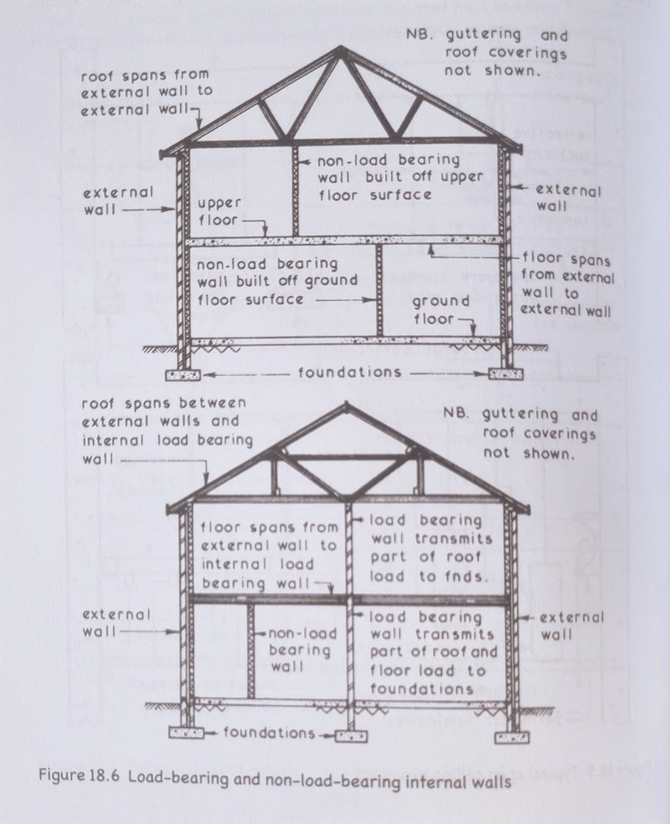
Image 6- Truss roof construction vs cut timber roof construction

The disadvantages of using a trussed roof could include potential longer lead times due to having to follow offsite construction processes e.g., relying on the manufacturer to fabricate and deliver the item on time, while disruptions in supply chain could also have a negative impact on delivery of the finished item. Depending on the truss configuration, there may be no usable roof space for installing a loft or other alterations, in future. The timber used may not be locally sourced and may come with a high carbon footprint, due to its transportation. A trussed roof will also require delivery to site, so space to unload delivery trucks will be needed along with the potential of needing a crane for installation.

There are also advantages and disadvantages of the metal sheeting that has been chosen for this build. Metal sheeting is quick to install if a specialist is used. It comes in a variety of colours and is lightweight, meaning it’s easier to handle and install when working from height. The build-up of the roof (OSB sheathing) provides a very robust and strong diaphragm for stability, so no additional bracing would be required.

Some of the disadvantages of using metal sheeting include that some may argue that it’s not as aesthetically pleasing as other roof coverings, e.g. tiles. Metal sheeting has poor heat and sound insulation qualities, so additional insulating materials would be required to help it meet Building Regulations, which would increase the overall cost. Specialist installation is required, which can also be more costly. This material is not usually readily available at builder merchants, and would need to be ordered in, especially for the project, making this subject to lead times, which may impact other parts or timeframes of the project. Lightning protection would be required for metallic roof coverings, which would result in another additional cost and specialist design.

3. Example of an alternative method of roof structure

The typical cut roof detail shown below (Chudley & Greeno, 2020, p. 377), gives an alternative method of roof structure that could be used for Miss A. Client’s house.

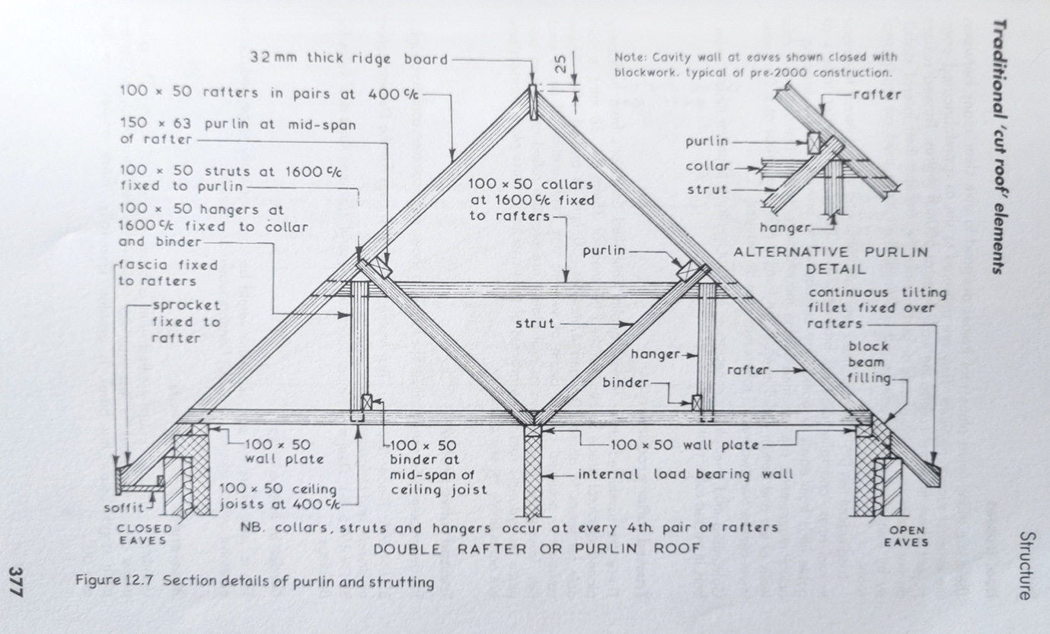
Image 7- Conventional cut roof

This type of roof structure would be formed using cut rafters, purlins, ridge, and valley boards, all clad with batons and felt, ready for roof tiles. There would be several advantages to choosing this type of construction. No specialist installation would be required for this type of roof build- any roofer could use this construction technique, unlike the metal sheeting option, which would require a specialist to install it. All components for this alternative solution are readily available at local builder’s merchants, so wouldn’t require any advanced ordering or long lead times. Timber can also be sustainably and locally sourced, which would support local businesses and reduce the project’s carbon footprint, by not using imported timber.

A cut-timber roof can be altered and changed, relatively easily, compared to a trussed roof and roof space can be used for loft conversions in the future (subject to analysis). This type of roof may also be more appealing to local authorities when applying for planning permission because it’s a more ‘conventional’ looking roof and wouldn’t be as likely to raise any questions about its appearance of how it may fit in to the local area.

This alternative option also has potential disadvantages that would need to be considered, such as longer installation times, it would require more components to be handled, e.g., roof tiles and timber members, which makes it more time consuming and could lead to more wastage, errors, or damage during construction. This option is not as rigid as the proposed option described in the brief, so would require extra bracing, also, the purlins would require support on the gable walls and potentially, the rafters would require a tie member at ceiling level to restrain any lateral forces. Finally, more attention would be needed on the health and safety aspect of constructing this roof, e.g., roof tiles falling on people passing below.

4. Offsite Construction

Offsite construction is the term used to describe the manufacture and pre-assembly of materials, before they are transported to site for installation. Said materials can consist of components, elements or modules that are required for the intended project. There are many benefits to having parts manufactured off site; specialist equipment in controlled environments can be used to manufacture each component, which ensures that each piece is made to the highest standard. Not only is each piece checked thoroughly through better quality control, but the materials are not exposed to any such conditions that could be harmful to or alter its quality, before it’s needed for installation.

Having components built in such controlled environments, will also result in less waste, both in terms of the material, as well as costs. Projects can be better managed, and timescales can be reduced, by having offsite components created and delivered on the day that they are required for installation (or any other specified/chosen day). Not only will this mean that work men don’t have to build pieces on site, with the potential for delays through human error or bad weather, for example, but there won’t be any need to organise additional storage for materials that would otherwise need to be stored and built on site, with any additional waste also needing to be stored and disposed of.

Although there are some great advantages to offsite construction, there are also some factors that may be considered as disadvantages, or could cause problems on site, if not considered, early in the project planning stages. Things such as last-minute changes or alterations are common in most designs, however, when using offsite construction methods, this could prove to be problematic, as pieces are often constructed well in advance and in preparation for the chosen delivery date. If a change is requested after the manufacture of the prefabricated component has already started, then this could either result in additional costs for the alteration to the piece that has been started, or the complete replacement of it. This change could also affect other third-party services, in other or later stages of the project, who’d need to review and check that their design doesn’t also need to be altered, to work alongside it. In turn, both scenarios could also cause major delays to the project, through then having to wait for the new piece(s) to be manufactured. The time needed to manufacture a revised piece is one consideration to be mindful of, but being allocated a time slot for manufacture of an additional piece to even start, is another factor that may cause issues, as many manufacturers won’t have the ability to change their own workloads with other clients, to accommodate last minute changes that may arise. If one phase of the project is delayed through any issues with items being fabricated offsite, then all future phases will also be negatively impacted and likely delayed, potentially resulting in additional costs for the project, both in terms of time and deadlines being missed, as well as knock-on financial implications and costs.

The site in question will need to have suitable access and storage facilities to accept potentially large deliveries of pre-assembled components, which can also be large in size. This will also require specialist equipment to unload the delivery trucks, while large machinery such as cranes, will sometimes be needed for installation of the pre-assembled units. To facilitate this, additional site works would generally be required, e.g., crane hard stands and paved roads for forklift trucks. Extras, such as the machinery described, can be included or built into the cost issued by the manufacturer/contractor, but it would be good practice to compare such costs and requirements with those of building some elements, onsite, before making a final decision.

There are four main categories of offsite construction-

- Panelised units.
These panels are manufactured offsite and then put together onsite, creating a three-dimensional unit. The Trada Introduction to off-site Construction document explains that these panels vary in complexity and structure, with some comprising of a simple skeletal structure, to be made up as is required for the project, while others can be delivered already including lining materials, insulation, services, windows, doors, internal wall finished, as well as cladding.

- Volumetric Construction.
These are also three-dimensional units, but on a much larger, complex, and complete scale. One module alone can consist of full rooms or single storey buildings, already fitted out with full furnishings, such as windows and doors, insulation, internal linings, finishes, services, kitchens and bathrooms, which are all ready to be connected to their required power supply and be used immediately after.

- Sub-assemblies and Components.
These are additional items that don’t fall into the other categories mentioned, such as stairs, doors, windows, steel elements etc, which again can be prefabricated offsite and assembled on-site, upon delivery.

- Hybrid Systems
These are a mix of panelised and volumetric techniques, also known as ‘pods’. Such systems are typically best suited for “highly serviced and repeatable areas such as kitchen and bathrooms with the remainder of the dwelling or building constructed using panels”. Buildings where the same design for large brands is required, have started adopting this approach- hotels, student accommodation etc. (Introduction to offsite construction and construction sequence, 2016, p. 2)

5. Reference List

Chudley, R. and Greeno, R. (2020) Building Construction Handbook, 12th Edn. Oxon: Routledge, p. 377, illus.

Chudley, R. and Greeno, R. (2020) Building Construction Handbook, 12th Edn. Oxon: Routledge, p. 586, illus.

Construction principles, specification and design. (2016) Introduction to offsite construction and construction sequence. Buckinghamshire: Exova BM TRADA

The Building Regulations Approved Document L1A (2014 showing 2016 Amendments) Conservation of Fuel and Power in new dwellings [Table]. Available at: https://gov.wales/sites/default/files/publications/2019-05/building-regulations-guidance-part-l-conservation-of-fuel-and-power-2014-l1a-new-dwellings.pdf (Accessed on 17 April 2022).

