Students are required to write a 1000 word Individual Reflective Account of engaging in the group work task.
Introduction
In this reflective account I will reflect on the group work task I undertook using Gibbs theory on reflection (1988), I will give a quick overview of the group objective and how the group I was in achieved the objective. I will provide a definition for group work. In addition to this I will link the group task to some group work theory, including Tuckman’s theory’s on group dynamics and forming (1965), also Belbin’s (1981) theory on group Dynamics.
Toseland and Rivas (2008) define group work as:
A goal directed activity aimed at accomplishing tasks. Members of the group have the opportunity to share ideas, feeling, thoughts, beliefs, engage in interactions and also share experiences.
I define Group work as a collection of individuals that are working together to achieve a common goal or task.
Description
In this group task we were asked to plan and deliver an activity session for the youth and community level four students to help improve group dynamics and cohesiveness.
I was in a group with two other level five youth work students, using Tuckmans theory I can identify this was the forming stage to our group task as we had been given our task and now had to plan and prepare to deliver the session. When we were given the task the group members all lived considerable distances away from each other and one member could and relied on public transport. However group member A took it upon themselves to open up a group chat and this is how we communicated with each other.
Within the group chat all members pitched ideas for the group task but the group could not decide on an activity, also during this time I was experiencing personal problems and wasn’t sure if I could continue with my studies and therefore the group task and team member A was experiencing trouble with public transport so was not able to get to university. I identify this as the storming part of Tuckmans theory as the group was not communicating effectively and had not met up at this point to decide on the activity. This is where most teams fail due to not having the full support of their colleagues, or they may lose sight of the task at hand.
My troubles cleared up and I was able to continue with the group work task and at this point all member of the group managed to get in to university to talk about the group task, we decided that for the group would do three separate activities that blended together to improve group dynamics and cohesiveness. I identify as this is the norming part of Tuckman’s theory as the group has overcome the barriers to working with in the group and has started to focus on the task.
At this point group member A was taking a leadership role and sharing responsibilities between the group members. Using Belbin’s theory I can identify that everyone has a part to play within a group and group member A kept the group focus and delegated task and therefore naturally became the leader, It was decided that we would come up with a session plan for our session with the level four students, group member B collected the items needed for the activities, group member A created the PowerPoint and I rescreened the history of group work theory, it was also agreed that we would all lead an activity in thirty minute our session. This is the performing stage of Tuckman’s theory where the team works without conflict to achieve the task, at this stage the leader will delegate work to the team members using their strengths to the advantage of the task.
Feelings
At this point I was feeling that I had let the group down with my lack of attendance I was also feeling that I had not contributed to the group work, but I was still communing within the group chat and when I was able to continue in university I messaged the group chat apologising and the members we accepting and understanding. This then made me feel as if I could continue with in the group. Also when we met up and delegated tasks I then felt as if I contributed to the task.
Evaluation
I believe this was a good experience as the group task went well but obviously there were barriers due to the lack of my attendance and person A not being able to get to university, but once the group was on track we worked efficiently and effectively to get the task done. Over all it was a good experience.
Analysis
I believe that my group worked together well and delivered the session to a high standard, we all knew what we needed to do for the task and we planned and give each activity the allotted times and we practiced the activates the morning to ensure things would run smoothly. I believe we completed the task to a high standard .although I think we may have run other the time allocated to us.
Conclusion
In hindsight I believe my group and I went over the allotted time, in result next time I would have allowed less time on the first activity as it took the longest or suggested that we would have skipped the presentation at the start to allow us to fit in the time frame. In addition to this the only negative feedback was that the group presentation went on too long.
Action plan
If I were to do this activity again I would consider cutting out the presentation on the group work history as that is the only negative feedback we had at the end of our session and this would also to allow the activity to be in the time frame allocated to us.
In conclusion, the task went well and the participants in our session enjoyed the activities, the group I was involved with worked well together even though we had our challenges, yet we were able to overcome them to achieve the task. With the end of our activity we entered the Adjourning stage of Tuckman’s theory, this is the stage where the task has been achieved and the group is disbanding, this is because of a project coming to an end and we have achieved the task.
Feedback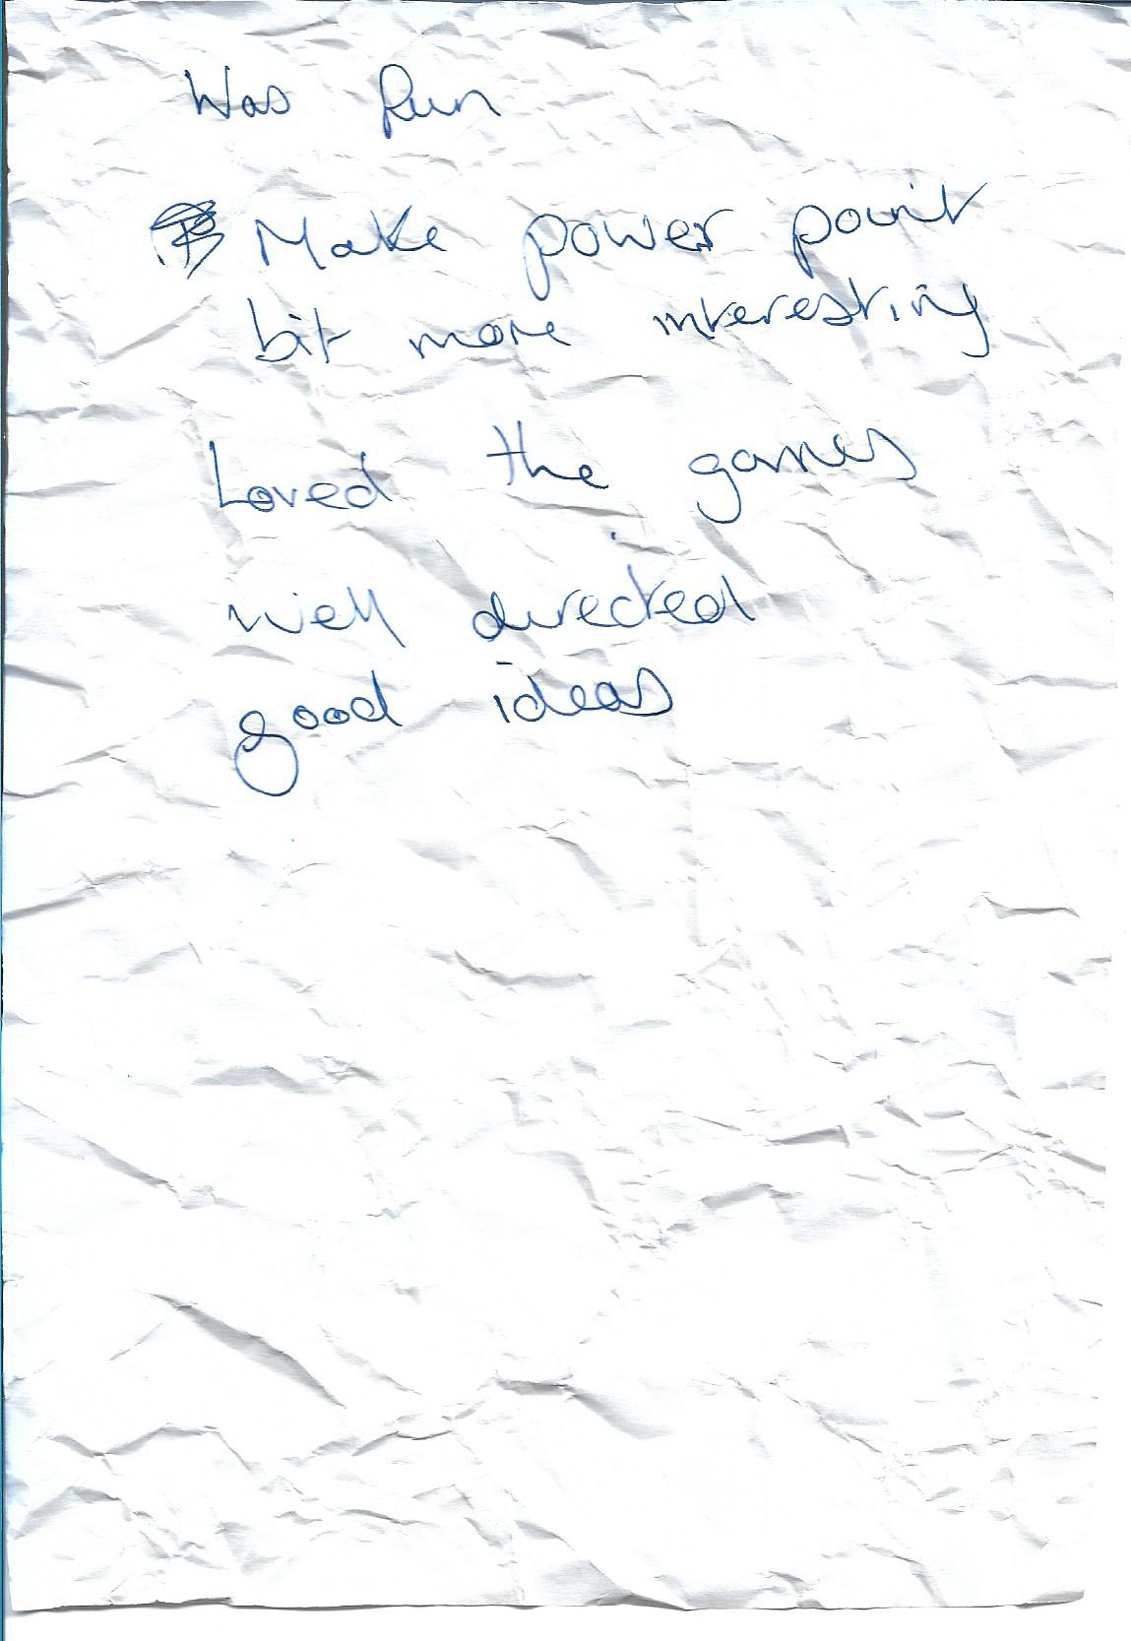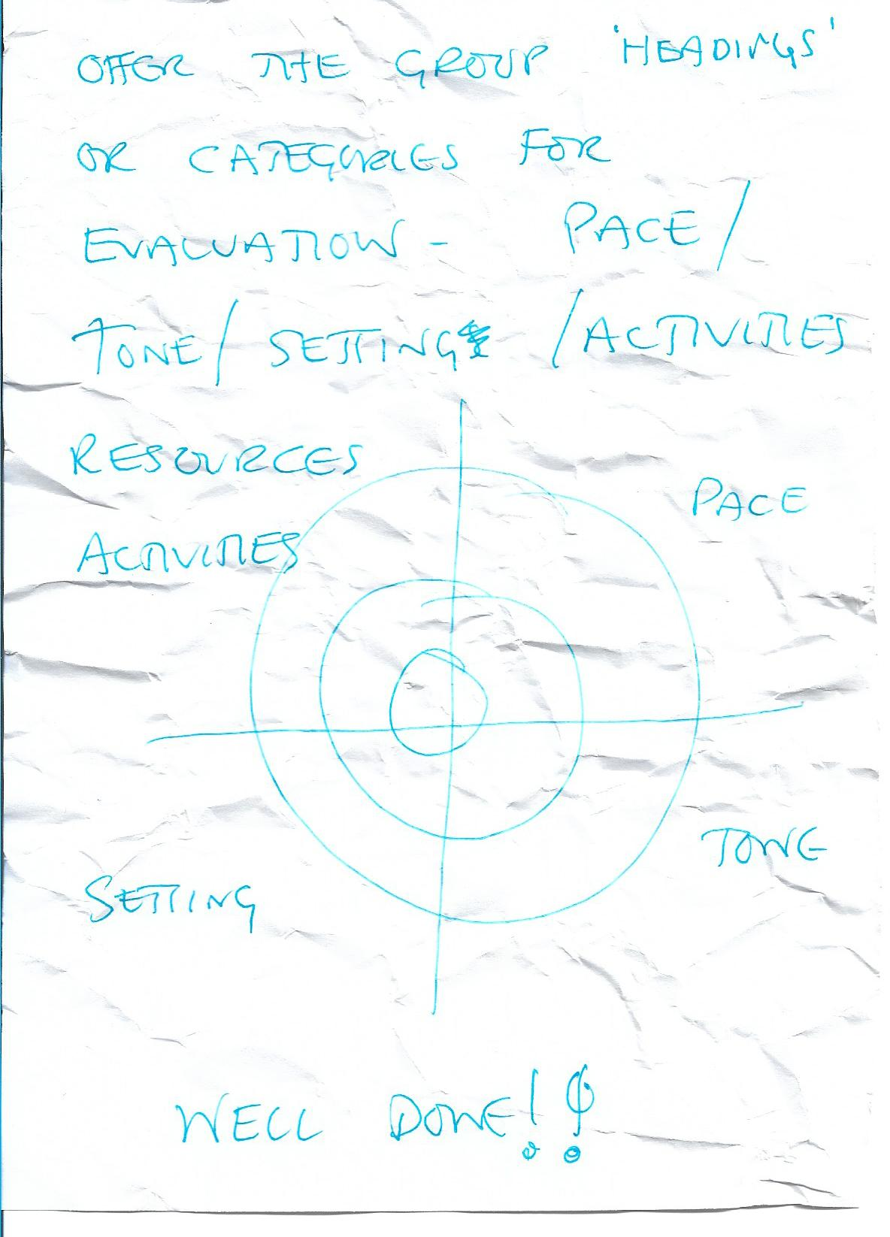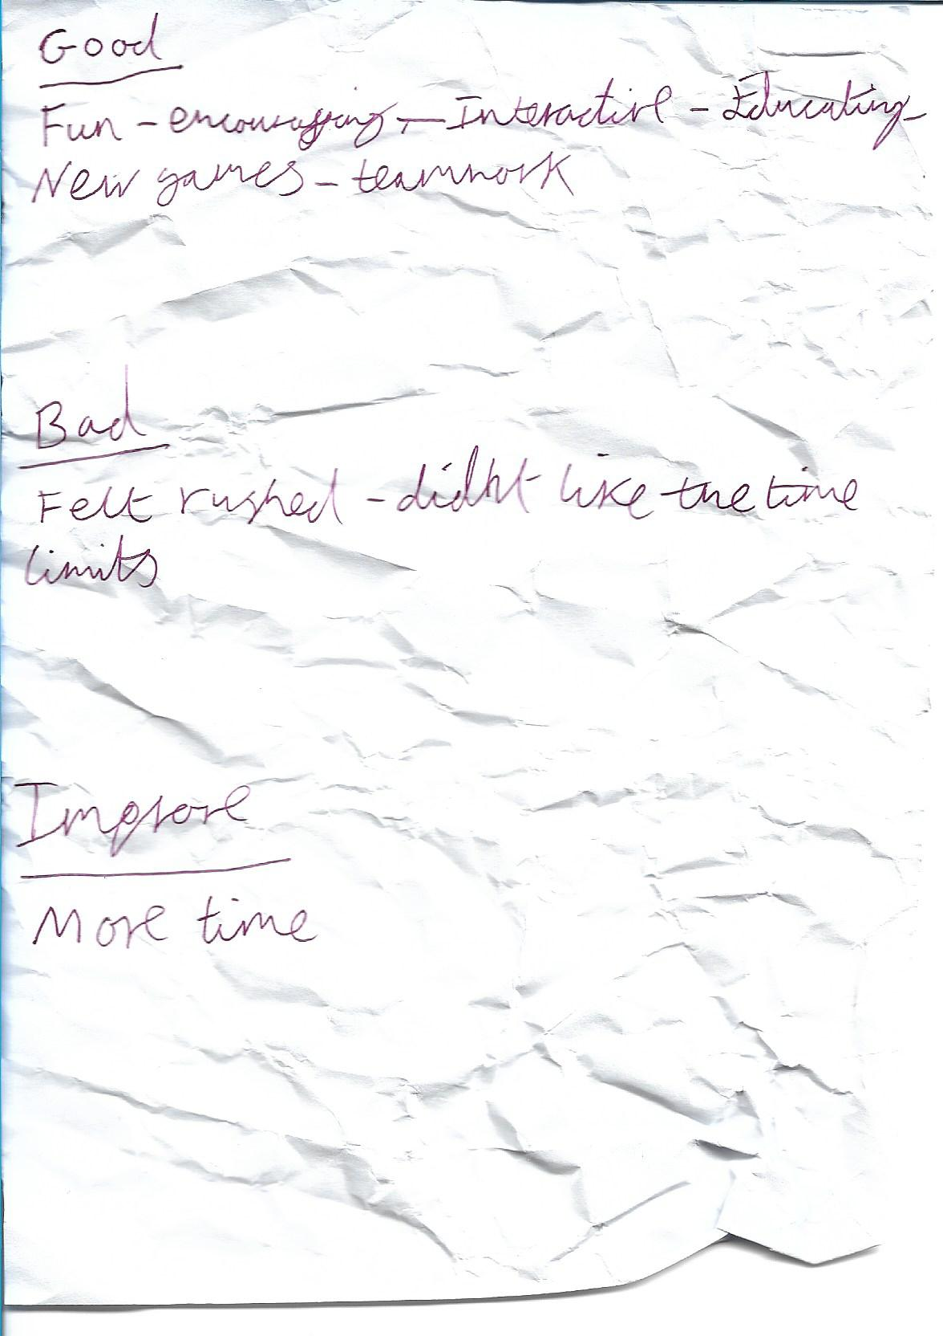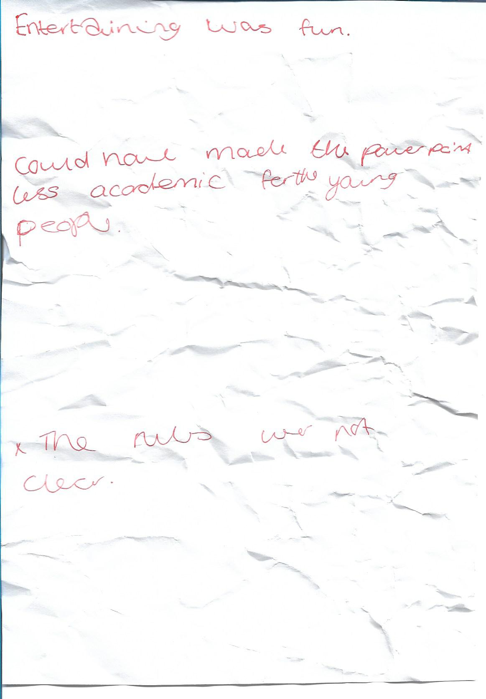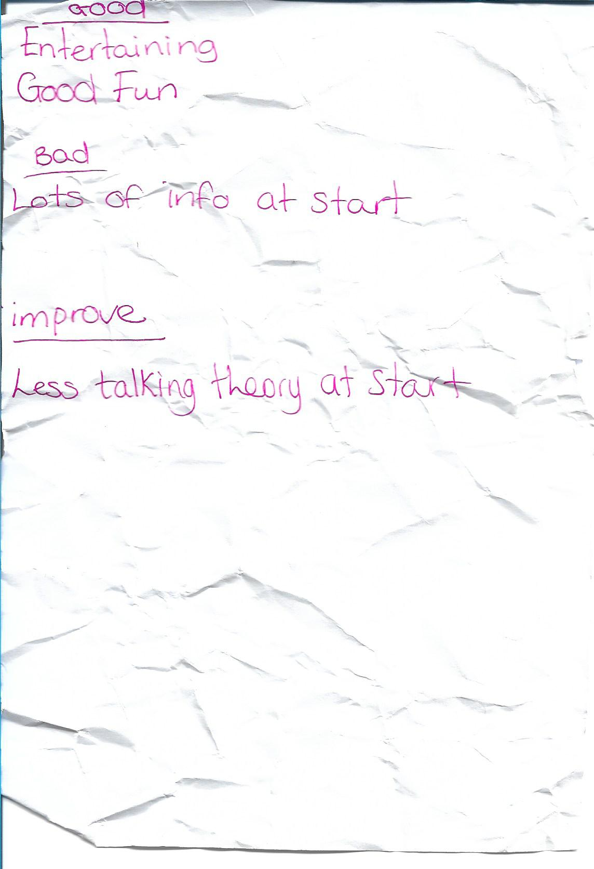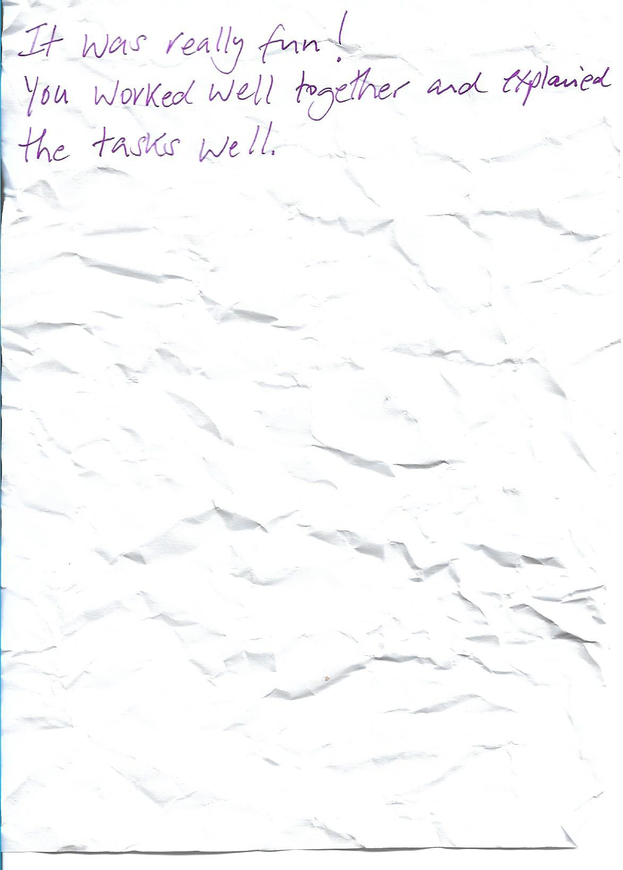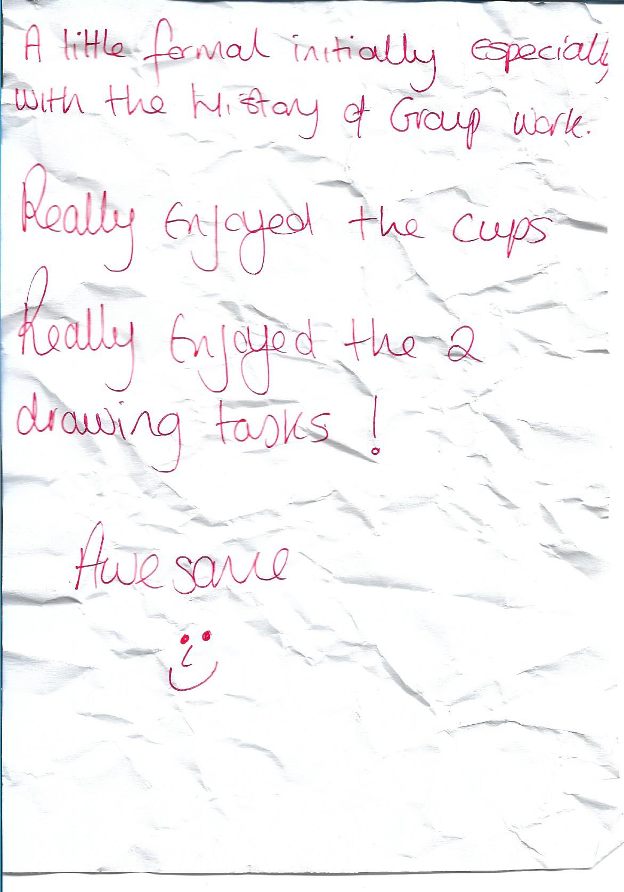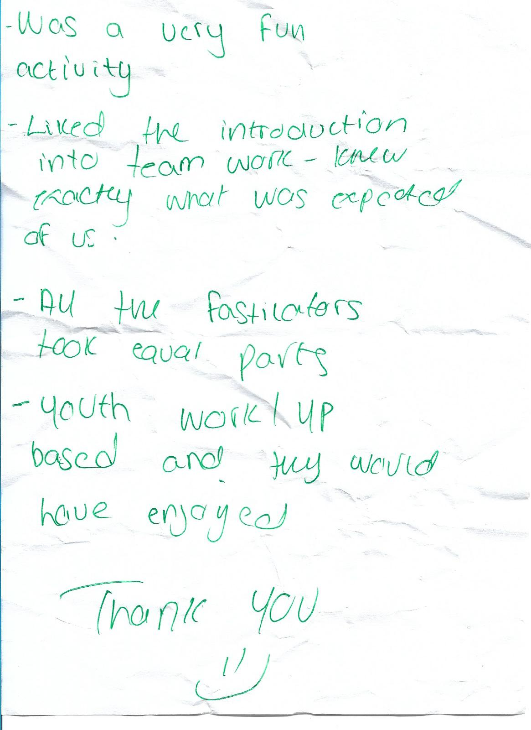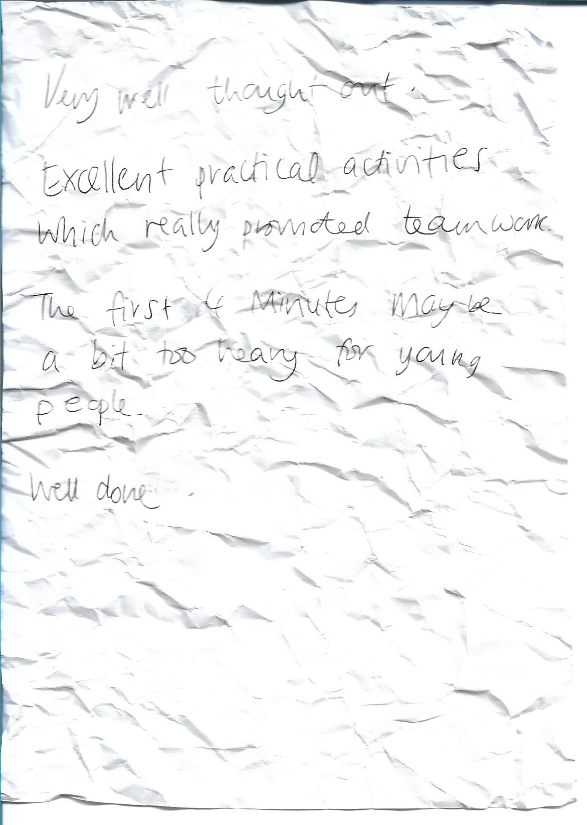

Reference list;
Belbin, M. (2018). The Nine Belbin Team Roles. Belbin.com. [online] Available at: https://www.belbin.com/about/belbin-team-roles/ [Accessed 15 Dec. 2018].
Gibbs. G., (1988), Reflective writing: About Gibbs reflective cycle, [Online] Available at: https://www.brookes.ac.uk/students/upgrade/study-skills/reflective-writing-gibbs/, (Accessed 11/12/18)
Toseland, R. and Rivas, R. (2008). Toseland & Rivas, Introduction to Group Work Practice, An, 7th Edition | Pearson. [online] Pearson.com. Available at: https://www.pearson.com/us/higher-education/program/Toseland-Introduction-to-Group-Work-Practice-An-7th-Edition/PGM334202.html [Accessed 15 Dec. 2018].
Tuckman. B., (1965), FORMING - STORMING - NORMING – PERFORMING, [Online] Available at: https://www.teambuilding.co.uk/Forming-Storming-Norming-Performing.html, (Accessed 11/12/18)

