

J Matthews (Pembrokeshire Learning Centre)
Student Number: 2213319


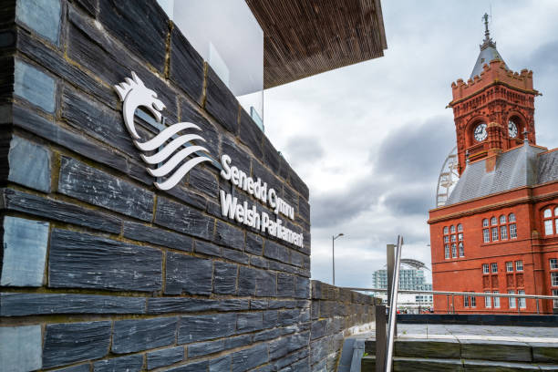



Celebrating Language and Culture - Belonging to Wales (ECIE5004)

Content:

Rationale Page 2-3
Activity Overview Page 4
Evaluation Page 5
References Page 6
Appendix Page 7-9



Rationale
The Welsh language has seen great decline over the last century. Fewer and fewer young people take any interest in keeping the historic language alive. Fewer children aged 3 to 15 are Welsh speakers which is considered to be a contributing factor to this decline (BBC, 2022). These figures will lead to a fall in Welsh speaking adults in the future, and their children are less likely to learn the language. Although some may believe that ‘learning begins at home’ which is true in many cases, if less welsh is being spoken in homes, it falls to the education system to provide the means to learn this important language. The Welsh Government highlighted this in the Future Generations Bill (2015) and stated:
“And while the target of a million Welsh speakers by 2050 is an ambitious policy, there are concerns that it is falling short in terms of implementation, and more needs doing to join the dots with the other well-being goals.
Not enough public bodies have set objectives and steps in relations to this goal, and those who do are failing to integrate culture and language with their other objectives” (www.futuregenerations.wales, 2015).
This will undoubtedly cause pressure in schools, as it is one of many subjects they are required to teach. They are tasked with teaching many pupils an entirely new language which they can utilise in future endeavours. Competing with other linguistic studies such as French and German, it is challenging to create a space for Welsh despite it being the national language. To compete with these, they need to make these lessons as memorable, fun and engaging as they can. One method of achieving this is through kinaesthetic learning. This involves much more physical movement than in a conventional classroom with hands-on activities. Numerous studies support this method of learning. It can stimulate senses, promote understanding and deepen a learner’s focus. Furthermore, studies have found pupils have improved motivation and problem solving-skills as a result on kinaesthetic learning (Nancekivell, Shah and Gelman, 2020).
The Urdd Gobaith Cymru are a great example of integrating Welsh into fun and engaging activities. The Eisteddfod provides a platform for many young people, and offers rewarding outcomes. Outdoor residential trips are another great form of kinaesthetic learning, and the range of activities is enough to get young people thoroughly engaged. The benefits of being outdoors also supports the nature of the Urdd, and living in a country with beautiful examples of the outdoors enhances these benefits. It encourages inclusivity and it can boost both physical and emotional wellbeing as well as encourage learners to engage in natural and local heritage (Harvey, 2022).
This activity is also great for learners with Additional Learning Needs (ALN) due to its simplicity and encourages cognitive thinking and promotes physical activity, as well as developing an improved relationship with nature. This is something of great importance in these times due the rise of social media and gaming which sees are children indoors more often. Those working with learners with behavioural needs may also benefit from these types of activities. Many pupils who find themselves with Pupil Referral Units (PRUs) often have a negative mind-set when it comes to working in a classroom. This format allows them to learn in a more informal and open surrounding which in turn can encourage them to attempt these tasks. Many of these learners being diagnosed with Attention Deficit Hyperactivity Disorder (ADHD) and studies have shown that working in greener and outdoor spaces can improve the symptoms of ADHD. It has also suggested that it can improve attention and children are less likely to act impulsively or suffer with mental fatigue (Smith, 2023).
These activities also take inspiration from Lev Vygotsky’s work regarding the Sociocultural theory of development (1930). These activities can encourage and enhance the social skills of the learners as they are in a more open and free environment and, if his theory is to be believed, enhance their cognition and understanding.
Taking inspiration from the Urdd, having activates that can be used via outdoor leaning and encourage kinaesthetic learning is a promising start to encouraging incidental Welsh within the school environment.

Activity Overview:

This activity is a scavenger hunt designed to help students learn and remember significant words depending on the topic/trip they are embarking on. With minimal writing and much more emphasis on oral discussion, it is designed to help them identify words to objects and retain this knowledge due to the memorable and unique aspect of their learning. It promotes kinaesthetic learning and being outdoors can overall improve mood, focus and mental wellbeing. It can be used for children of any age, and is versatile in their design, and can be made more/less challenging depending on the level on the group. (See Appendix A, B and C).
These are some basic examples of this activity. Utilising the great outdoor spaces in Wales, learners can be encouraged to seek some of these items, either working independently or with peers, both having benefits to the cognition of the pupils. There is also a sensory aspect of this activity, as pupils can be implored to make use of their senses. The use of these sense can make for a much more rewarding and memorable experience (Francis, 2023).
Pupils are given these sheets (or can be displayed on iPad) with a clipboard and pen. They are then told as they explore to find these items whilst practising their Welsh orally. Using the welsh translations needs to be encouraged in order for pupils to gain and retain this information. Teachers may wish to make it a competition, so their learners enticed to complete the task to the best of their ability.
Lesson Plan:
Task | Resources
Pupils are taken to Scolton Manor for Outdoor Education. Continuation of the topic British Wildlife  - Pupils are briefed on the ask of the scavenger hunt.  - Encourage to find something not included on the list.  - Encourage use of Welsh language and oracy. | - Clipboard  - ‘Y Goedwig’ worksheet  - Pencils  - Welsh dictionary  - 1:1 support if required

Evaluation

This activity was conducted with eight Key Stage 3 Pupils aged 11-14. Although it may seem simplistic for learners of that age, these pupils are part of a PRU and as a result, have missed out on much of their learning, in turn needing extra support.
Pupils were taken to a local woodland, and were given this as their first task before lunch. More than 50% of the pupils have an ADHD diagnosis, with some of the other showing traits of ALN.
Pupils were put into pairs and were encouraged to spread out and find the items. They were briefed in both English and Welsh although all have shown no proficiency in the Welsh language. They were given the sheet (refer to appendix C). Pupils were eager to begin and explore. Each pair had a staff member to support. They were quick to find some of the items e.g. coeden yet pupils did need to be encouraged to use the Welsh translations to begin with. With Welsh being new to many of the learners, pronunciation was also something that needed to be supported. This was however a great way to gauge where their Welsh language capabilities were, with some being quite confident in reading as opposed to speaking and vice versa. This activity is also beneficial when it comes to the development of Curriculum Cymreig which encourages them to gain understanding in the historical and geographical knowledge of the area (Developing the Curriculum Cymreig, 2003).
One thing that was noticed was the profound difference in attitude in some of the pupils. Many who proved to be quite difficult within a classroom were on task and didn’t show any of their usual signs of defiance e.g. absconding, profanity and violence. Although the task is a simple one, it proved to be very beneficial in this instance and allowed the learners to gain some Welsh vocabulary relating to their termly topic. This is something that can be repeated through different topics, and repetition will help their development of the Welsh Language. If this activity were to be conducted again, it may be beneficial to create a second sheet with more challenging vocabulary for those who are working at a higher level. It would also work well if the task was then brought back to the classroom for further work e.g. writing simple sentences in Welsh. This will solidify the vocabulary they have used in their outdoor education.

Reference List:
BBC (2022). Welsh language: Fewer speakers in Wales in past decade. BBC News. [online] 6 Dec. Available at: https://www.bbc.co.uk/news/uk-wales-63860772.
Accessed – 20/12/24
Developing the Curriculum Cymreig. (2003). Available at: https://hwb.gov.wales/storage/8e68e2f5-851f-43b8-af24-9eb38cf62482/developing-the-curriculum-cymreig.pdf.
Accessed – 20/12/24
Francis, C. (2023). 3 reasons and why you should be doing outdoor scavenger hunts with kids by Sensory Trust. [online] www.sensorytrust.org.uk. Available at: https://www.sensorytrust.org.uk/blog/3-reasons-why-you-should-be-doing-outdoor-scavenger-hunts-with-kids.
Accessed – 26/12/24
Harvey, D. (2022). 5 key benefits of outdoor learning. [online] Learning through Landscapes. Available at: https://ltl.org.uk/news/5-key-benefits-of-outdoor-learning/.
Accessed – 20/12/24
Nancekivell, S.E., Shah, P. and Gelman, S.A. (2020). Maybe they’re born with it, or maybe it’s experience: Toward a deeper understanding of the learning style myth. Journal of Educational Psychology, [online] 112(2), pp.221–235. doi:https://doi.org/10.1037/edu0000366.
Accessed – 04/01/25
Smith, L. (2023). Benefits of Outdoor Learning for Children | Wild & Immersive. [online] Wildandimmersive.ubc.ca. Available at: https://wildandimmersive.ubc.ca/benefits-of-outdoor-learning-for-children/.
Accessed – 27/12/24
www.futuregenerations.wales. (2015). A Wales of Vibrant Culture and Thriving Welsh Language – The Future Generations Commissioner for Wales. [online] Available at: https://www.futuregenerations.wales/a-wales-of-vibrant-culture-and-thriving-welsh-language/.
Accessed – 27/12/24

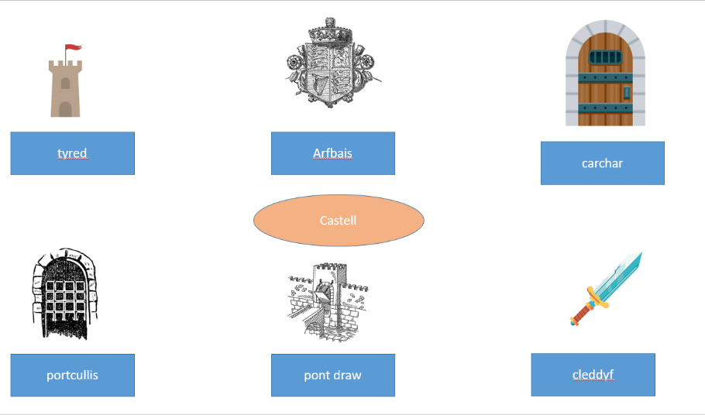
Appendix A
Appendix B
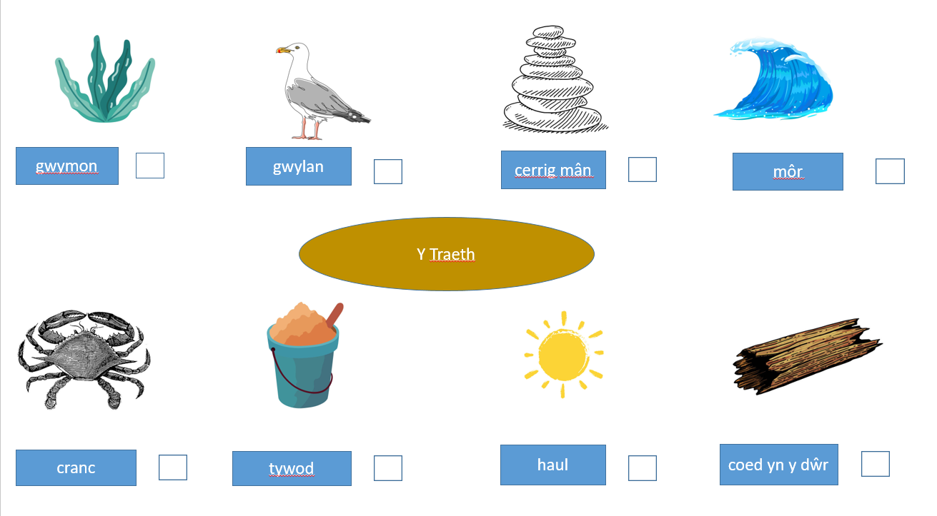

Appendix C



