

DOES THOMAS HEATHERWICK’S ORGANIC, ARCHITECTURAL STYLE DELIVER BUILDINGS THAT WORK WELL WITHIN THE NATURAL ENVIRONMENT WITH A POSITIVE PUBLIC IMPACT?

School of Architecture, Built and Natural Environment
Course: BSc Architecture

Name: Rhianwen Jones
Student number: 2405060
Module code: ACAA5003
Word count: IDK
Date: 12.12.2025

Contents
DOES THOMAS HEATHERWICK’S ORGANIC, ARCHITECTURAL STYLE DELIVER BUILDINGS THAT WORK WELL WITHIN THE NATURAL ENVIRONMENT WITH A POSITIVE PUBLIC IMPACT?
School of Architecture, Built and Natural Environment
Course: BSc Architecture
Introduction
Methodology
Aims and objectives
Detailed critical analysis of Heatherwick’s architectural philosophy and practice
Case studies:
The Seed Cathedral, Sanghai Expo (2012)
1000 trees, Shanghai (2022)
Aberystwyth Crinkly Huts project
Conclusion
Bibliography

List of Figures
Figure 1: Mental Health (from Dalton, R. C. et al, 2025, p.1)
Figure 2: Plan showing extensive greenery and gangplanks allowing views of water. (from Brandon, E. M, 2021, n. p)
Figure 3: The tree of Life. Centrepiece of Xi’an Centre Cultural Business District (from Kucharek, 2025, n. p)
Figure 4: My drawing of the crinkly hut unit exterior, inspired by original plans. (Rhianwen Jones, 2025)
Figure 5: My drawing of the ventilation and environmental factors affecting the crinkly huts inspired by original designs (Rhianwen Jones, 2025)
Figure 6: My drawing of the insulated foil cladding inspired by original drawings (Rhianwen Jones, 2025)
Figure 7: Photographs of leaking windows in the crinkly huts (Rhianwen Jones, 2025)

Introduction
Thomas Heatherwick is a well-known British architect who has developed a globally recognised architectural philosophy and reputation. He believes that design begins with how people feel and interact with a space or building and that architecture should fit in with its broader physical, social and geographical context. He thinks that architecture can improve lives and that design work should have a soul or inner energy that counteracts boring, modern city architecture. He sets out to innovate, to find creative solutions to problems and is committed to an organic style of architecture that reduces carbon footprint, is ecologically friendly and works with and within the natural environment. His philosophy is ambitious and reflects many current themes such as sustainability, biodiversity, and community building in general. But do his buildings deliver on their promise?

Methodology
In this essay, Heatherwick’s architectural philosophy will be set out in greater detail and its aims will be assessed by looking at case studies. Within this broader comparative framework, critical evaluation will be provided of a project completed by Heatherwick in the author’s hometown of Aberystwyth. Direct observations will be drawn upon, supplemented by scholarly literature in the form of journal articles, together with original plans and client briefs. In this way, the project’s success in embodying Heatherwick’s central values—sustainability, creativity, boldness and innovation, organic essence, and the integration of architecture with both natural and constructed environments—will be evaluated.

Aims and Objectives
The aim of the essay will be to bring Heatherwick’s architectural philosophy to life and to evaluate how it is manifested in several key global projects. The overall objective will be to determine how successfully Heatherwick brings his philosophy into practice and to measure any risks or sacrifices made against the overall outcomes. Many architects anchor their reputations on distinct philosophies so an assessment of the extent to which Heatherwick’s designs achieve his stated aims will influence how seriously architectural philosophies can be taken in general. Are such philosophies function merely marketing devices or do they genuinely reflect a lifetime’s ambitions.

A detailed critical analysis of Heatherwick’s architectural philosophy and practice.
Thomas Heatherwick is an experimental architect with interest in organic architecture and including nature within buildings as well as harmonising his buildings with nature. We see this literally in some of his cityscape designs such as Shanghai’s 1000 trees where he used live trees as columns and incorporated hundreds of plants into the building’s interior design. Heatherwick insists that design should start with how people feel and interact with the spaces they are in, not with abstract theories or rigid architectural dogma. He views architecture as a way of improving lives not just as art or engineering.
One of Heatherwick’s most important philosophies is to design a structure that reconnects people with nature even in dense urban contexts. He believes buildings should evoke emotion and curiosity not just serve practical needs. Both Little Island, 1000 Trees and The Seed Cathedral are the opposite of sterile and box-like modernism and in fact are sculptural and organic forms. In an article co-written by Heatherwick, the authors explain that, “in recent years, there has been a notable shift towards prioritising mental wellbeing, particularly in relation to how our surrounding influence our emotional states”. (Dalton, R.C. et al, 2025, p. 1) (See visual pie chart representation below)
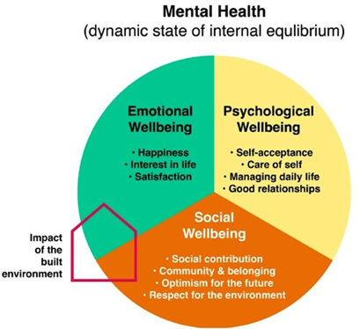

Figure 1: Mental Health (from Dalton, R. C. et al, 2025, p.1)

The paper goes on to explore another aspect of Heatherwick’s work and thought about how, ‘our built environment contributes to, or mitigates against, environmental destruction’. (Dalton, R. C. et al, 2025, p. 3).
Heatherwick uses a lot of greenery in his designs not only as a decoration but as an integral feature of the architecture. This can be seen as a direct attempt to impact public wellbeing positively and to address ecological and climate issues. It is important to note that public opinion is not unanimous about the success of his designs from this point of view. Objections are raised to his biophilic approach in an article on the Little Island project. Described as a “green oasis” ; (Monages, 2024), Little Island is an elevated park over Hudson River with tulip-shaped supports, designed as an escape from Manhattan’s chaos. However, Heatherwick is accused by some of ignoring the project’s surroundings;
Heatherwick talks about the pier’s “relationship to water” but you can’t really see the water whilst on the pier from anywhere but the gangplanks … for a project that purports to bring nature to the city, Little Island ignores much of its surroundings’. (Brandon, E.M, 2021, n. p)
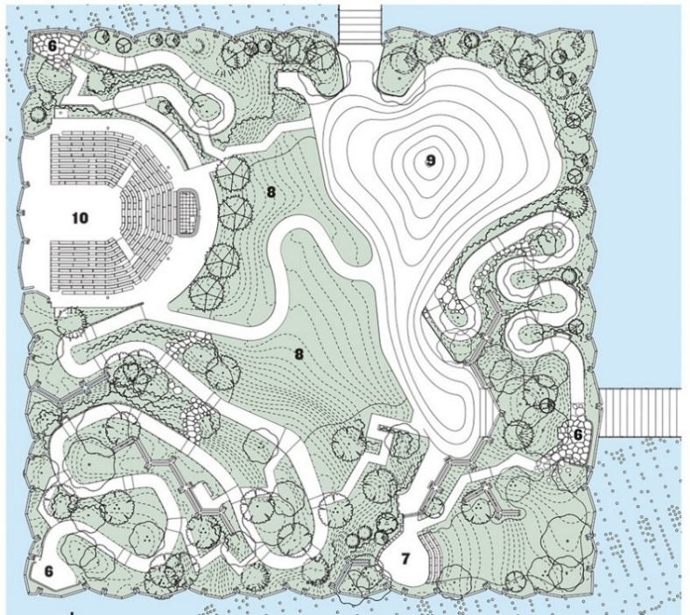
The same author complains that Heatherwick could have brought, “some much-needed greenery into Jackson heights in Queens, which has as little as 0.18m² of park space per resident.” (Brandon, E. M, 2021, n. p). The aggressive tone of the report may undermine the criticism, but it does seem that not everyone believes in Heatherwick’s vision or his ability to deliver on it.

Figure 2: Plan showing extensive greenery and gangplanks allowing views of water. (from Brandon, E. M, 2021, n. p)
Soulfulness within architecture is another of Heatherwick’s key principles. Hobson (2022) argues that Heatherwick fights against buildings with no character and wants urban architecture to express and create more emotion. There is no doubt that he wants to create buildings with personality, warmth and emotional resonance. (Elkann 2025). His mission is to make environments radically more joyful and engaging. Stataki (2025) argues that his buildings are about improving lives rather than just objects of art or engineering feats. If we take the example of Xi an Centre Cultural Business District, Heatherwick’s Tree of Life at the centre of Xi an CCBD is a prime example of his brilliance in bringing nature to life through architecture.
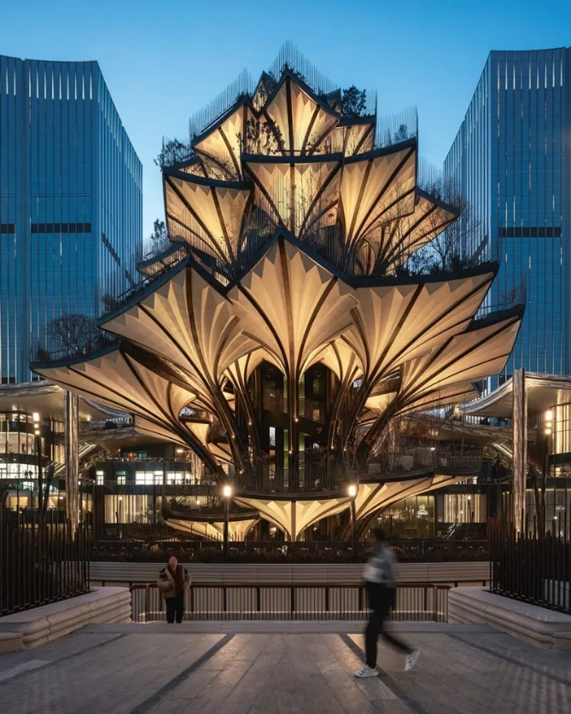

Figure 3: The tree of Life. Centrepiece of Xi’an Centre Cultural Business District (from Kucharek, 2025, n. p)
In some cases, the way he mimics nature leads to sustainability challenges. With this project, Kucharek (2025) explains that creating the dappled natural forest light effect, required powerful, high-level lights. This is not in keeping with Heatherwick’s commitment to sustainability and eco-friendliness. SMLA (the lighting technicians) found a solution using unique, low-luminosity fixtures set at a low level, but this does show that Heatherwick’s practical designs do not always fit with his theoretical design principles
Case studies:
The Seed Cathedral, Sanghai Expo (2012):
Architecture (2025) explains that The Seed Cathedral was 20 metres high and composed of 60,000 acrylic fibreoptic filaments that housed 250,000 seeds at their tips. According to Heatherwick Studio (2010), it was inspired by the Kew Gardens’ millennium seed bank and showcased seeds from 25% of the world’s plant species. The structure’s kinetic exterior swayed gently in the breeze resembling long grass and was designed to provide a calming respite from the sensory overload typical of exposition pavilions. Like all pavilions, it was dismantled after a period, however, some of the seeds were donated to educational institutions and botanical gardens. The Seed Cathedral is probably one of Heatherwick’s most successful attempts to achieve his key design principles in practice, bringing joy and emotional connection together with a proximity to nature whilst maintaining his commitment to sustainability.
1000 trees, Shanghai (2022):
The 1000 trees is another example of Heatherwick’s success in achieving his key aims. It is a shopping centre with 1000 tree-topped columns that integrates nature, art and urban life. This structure was designed to resemble a pair of forest-capped mountains across the site and create a new kind of urban topography where the landscape is raised up to form the buildings. According to NeverenoughArchitecture, (n. d.) this is a unique living structure that seamlessly blends into the city’s landscape while serving as a functional commercial and entertainments complex.
Aberystwyth Arts Centre Crinkly Huts project.
In 2005 Heatherwick was commissioned by the Royal Institute of British Architects to design a building for Aberystwyth University. By 2009, the project composed of 16 studio/creative workspaces/ meeting spaces averaging about 35 square metres. The studios are eye catching but hidden away within and by nature whilst still being completely untraditional and unique.
Heatherwick’s approach was to preserve the sense of the woodland and to create an exciting environment which would attract nearby creative businesses. He employed a simple, modular building technology that combined the practical economies of prefabricated building with the unique character of a specially designed structure.
The eight studios are split into two independent workspaces per unit with a skylight separating the two halves allowing plenty of natural light within each space. The exterior of the structures is the show stopping feature. The prominent ultra-thin crinkled steel sheets wrapping around the whole of the structure creating a shimmering and irregular surface. The structures are simple timber- framed buildings with pitched roofs that balance modest construction with its bold cladding.

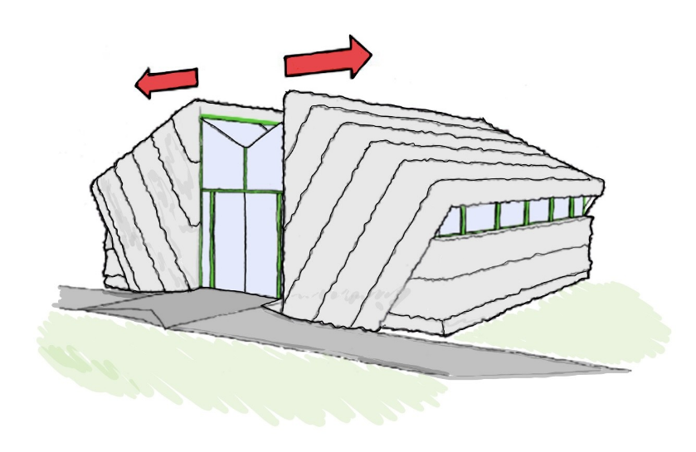

Figure 4: My drawing of the crinkly hut unit exterior, inspired by original plans. (Rhianwen Jones, 2025)
The site analysis:
The Art Centre is the busiest centre for the arts with over 500,000 visitors per year and the project was to redouble its economic impact and its role in the development of creative businesses, products and activity. The designated site was a piece of raised woodlands overlooking the Art Centre so once again the project required bringing nature into a close relationship with commercial activity, although this time the activity itself was creative.
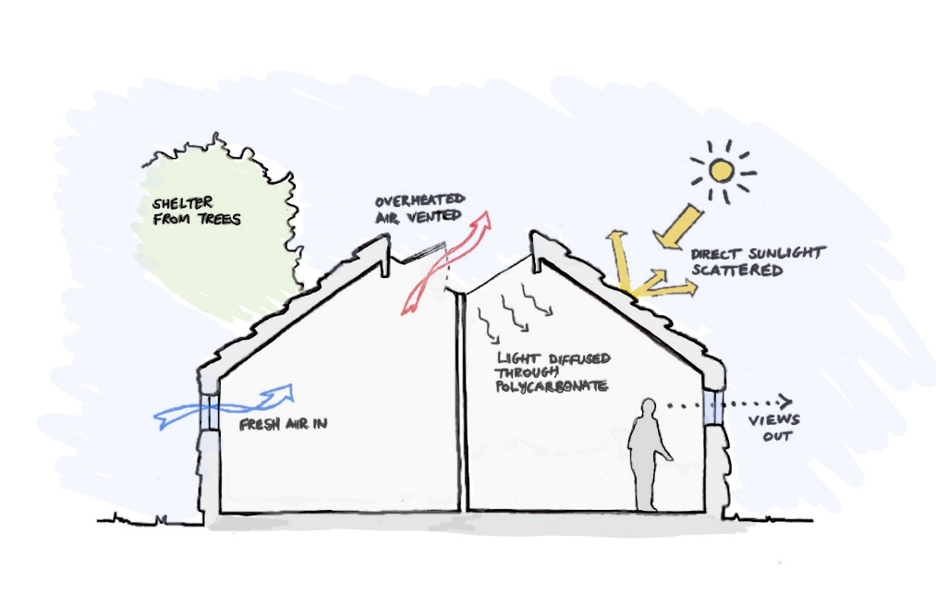
Heatherwick wanted to have the units scattered around to allow for the feeling of a “village” environment, to aid a sense of community and allow circulation through the site following the topography of the land. This also allowed the retention of many of the site’s trees. The units were positioned to benefit from the sun’s warmth, the trees’ shelter and to have air circulation constantly. The surface interacts with natural light and the environment, producing constantly shifting reflections.

Figure 5: My drawing of the ventilation and environmental factors affecting the crinkly huts inspired by original designs (Rhianwen Jones, 2025)
The foil exterior:
The foil exterior is 0.1mm thick stainless steel sheets which is the same thickness of a drinks can and is waterproof, decorative and long lasting to create a variable cladding for the units. At different times of the day and as seasons change the panel becomes a shimmering copy of its environments and blends into its surroundings and becoming almost invisible.
Heatherwick was inspired by Peter Cook’s 1972 vision of “quietly technologized folk-Suburbia”. (Franklin, 2009). This was an experimental project for Thomas Heatherwick, the brief meant that he had to stick to a low costing design and therefore the foil sheets came into mind. The steel sheets were fabricated on site using a mangle device that allowed the sheets to be crinkled and shaped to create an eye catching and reflective exterior. The foil wrapped around the structure was not sturdy enough nor was it insulative, therefore a spray-on insulation foam was added for more stability and thermal integrity. As the original plans and proposal (2005) demonstrate the design embraces imperfection and challenges conventional notions of smooth, polished architectural surfaces. Some do think these studios are out of place, but Heatherwick felt quite the opposite. He felt that the bright and colourful environment reflected on the surfaces creating and copying its lively and naturistic surroundings.
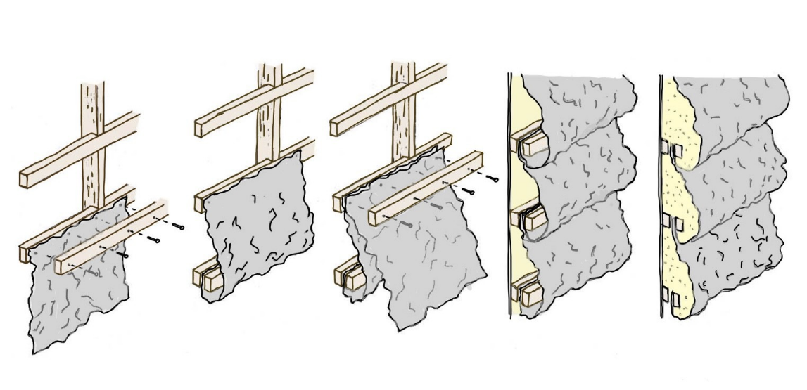

Figure 6: My drawing of the insulated foil cladding inspired by original drawings (Rhianwen Jones, 2025)

Conclusion.
There is no doubt that Heatherwick deserves his world-renowned reputation and that he does bring nature into exciting proximity with urban and commercial settings in a way that positively impacts human wellbeing and mental health. It is also true that he cannot always be true to his key deign commitments and that the biggest area of stress for him is achieving his sustainability goals. In the Aberystwyth project, the construction of the units is based of sustainable timber frame with timber floors. Each unit is insulated with BS approved, environmentally friendly rockwool. The units are prefabricated off site and as such cause little disruption to the local environment on construction. Nonetheless, twenty years post construction, the units are leaking, rotting and have become a bit of an eyesore.
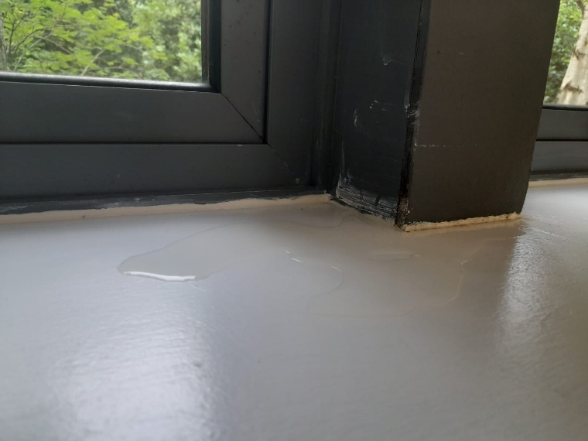
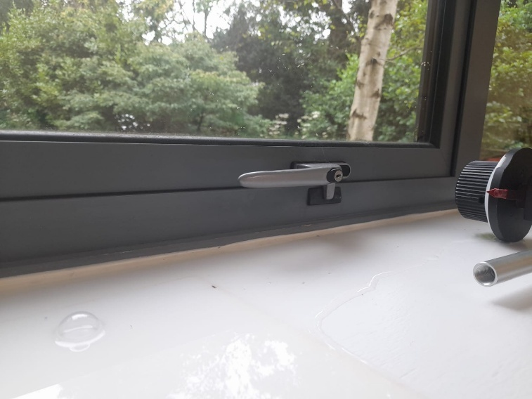

Figure 7: Photographs of leaking windows in the crinkly huts (Rhianwen Jones, 2025)
It may well be that they were not intended to last forever but their current state demonstrates a persistent tension through Heatherwick’s work around the need for sustainability versus the practical realities of constructing his buildings and spaces.

Reference list
Arquitect Uraviva (2025) Artist Studios, Aberystwyth. Available at: https://arquitecturaviva.com/estudios-de-artistas-aberystwyth-6 (Accessed 4 December 2025)
Dalton, R, et al. (2025) ‘Building appearance and wellbeing: how architectural design affects public emotion’, Architectural Science Review, pp. 1-20. doi: 10. 1080/00038628.2025.2558092.
Contributor, AJ (2009) First look: Heatherwick unwraps foil-clad Aberystwyth artist centre. Available at: https://www.architectsjournal.co.uk/archive/first-look-heatherwick-unwraps-foil-clad-aberystwyth-artist-centre (Accessed: 6 December 2025).
Design Indaba (2010) Wrapped in foil. Available at: https://www.designindaba.com/articles/creative-work/wrapped-foil (Accessed: 5 December 2025)
Elkann, A. (2025) Thomas Heatherwick. Available at: https://www.alainelkanninterviews.com/thomas-heatherwick/ (Accessed 6 December 2025)
Franklin, G. (2009) 100 Buildings, 100 Years. Available at: https://c20society.org.uk/100-buildings/2009-aberystwyth-arts-centre (Accessed: 3 December 2025)
Frearson, A. (2021) Thomas Heatherwick’s green vision of the future. Available at: https://www.elledecoration.co.uk/design/a35242036/thomas-heatherwick-green-architecture/ (Accessed 7 December 2025)
Heatherwick Studio. Buildings- Projects. Available at: https://heatherwick.com/projects/buildings/ (Accessed 8 December 2025)
Kucharek, J-C. (2025) In Urban China, lighting a vast new ‘living sculpture’ poses a thorny challenge. Available at: https://www.ribaj.com/spec/speirs-major-lighting-heatherwick-xi-an-ccbd-china/ (Accessed 4 December 2025)
Public Delivery (2025) This was Thomas Heatherwick’s Pavilion in Shanghai. Available at: https://publicdelivery.org/thomas-heatherwick-shanghai/ (Accessed 8 December 2025)
Slessor, C. (2009) Creative Business Units by Heatherwick Studios, Aberystwyth, UK. Available at: https://www.architectural-review.com/buildings/creative-business-units-by-heatherwick-studios-aberystwyth-uk (Accessed: 8 December 2025)

