Tyler King 2008275
Tyler King
uwtsd
Curriculum Development Proposal
By Tyler King 2008275

Contents page

 | Page Number
Section One: Context of the curriculum | 2-3
Section Two: Rationale for the curriculum | 4-10
Section Three: Curriculum aims and learning outcomes | 10-11
Section Four: Timetable and scheme of work | 11-16
Section Five: Assessment Strategy | 16-18
Section Six: Reading list | 18
Section Seven: Skills and Knowledge Development Opportunities | 19-20
Section Eight: Further development for the training program | 20-21
Reference List | 22-24
Appendix A | 25-32
Appendix B | 33-38
Appendix C | 39
Appendix D | 40-45
Appendix E | 46-50

Section One – Context of the curriculum

For this curriculum proposal, I propose a Four-week training course for lecturers at the University of Wales Trinity St David (UWTSD) to become trauma-informed practitioners. Lecturers within Higher Education Institutions (HEIs) are seen as ‘on the front line’ according to Scholkmann (2023). Therefore, I think they must have the training to ensure they are adequately equipped to deal with students who may have experienced trauma, so they can promote resilience and avoid re-traumaisation. Public Health Wales (2016) conducted a study whereby they found that 47% of adults had experienced at least one traumatic event. Ensuring that educators have an understanding of trauma awareness will also ensure best practice and enhance students' experience, which will result in student satisfaction and retention. Section Two of this proposal l will detail a rationale and justification for the curriculum.

The curriculum will include information on trauma awareness and the importance of being trauma-informed practitioners, as the Welsh Government makes the move to becoming a more trauma-informed Nation it will benefit organisations such as UWTSD to train their staff on becoming trauma-informed (Welsh Government, 2015).

I propose this training to begin with Lecturers at UWTSD initially, I have included further development plans in Section Eight of this proposal. These further development strategies include plans for the training course to be delivered to all faculty staff to ensure the University becomes a trauma-informed institution, which will align with the Wellbeing of Future Generations (Wales) Act 2015 (Welsh Government, 2015) wellbeing goals of becoming a more resilient Wales and a healthier Wales.

The curriculum will take place in the UWTSD IQ building in Swansea, and I have devised a timetable and scheme of work available in Section Four of the proposal. I have suggested that the training take place in the evening to align with the lecturer's teaching commitments, to ensure full attendance, and to avoid any conflicts. When devising the scheme of work and timetable it was evident that a four-week course would suffice in ensuring learning outcomes could be met and all relevant content covered. I have included Week Four as a catch-up session, a month after course completion, to allow the students to put their training into practice, and collaborate with their peers with any potential scenarios they have been faced with upon course completion. This recap session will also be beneficial if students have any questions following course completion. This will allow students to provide feedback on the curriculum, and allow the trainer to provide the students with feedforward to implement into their daily practice. Upon completion of this course, I recommend a certificate of participation for all students who attend.

ACE Hub Wales (2022) describes trauma-informed organisations create an environment where creativity and fluidity flourish. Creativity and fluidity are imperative in HEIs such as UWTSD, so I feel that this training program will enhance both student and lecturer experiences. Included in UWTSD’s strategic plan 2022-2024 (UWTSD, No Date) is the University’s pledge to ensure that the organisations policies and structures prioritise learner health, well-being, and inclusion. Considering this, I feel that the implementation of this training course will be beneficial in ensuring that learners health and well-being are prioritised.

Section Two – Rationale for the curriculum

This section will include a clear rationale for the curriculum, including all legislation and policy that align with trauma-informed practice and detailing where the course links with professional standards.

Trauma-informed approach
“‘A trauma-informed approach recognises that everyone has a role in sensitively facilitating opportunities and life chances for people affected by trauma and adversity. It is an approach where a person, family, community, organisation, service or system takes account of the widespread impact of adversity and trauma and understands the potential ways of preventing, healing and overcoming this as an individual or with the support of others, including communities and services. It is where people recognise the multiple presentations of being affected by trauma in individuals, families, communities, staff, and others in organisations and systems across all Welsh society. In this approach knowledge about trauma and its effects are integrated into policies, procedures, and practices. It seeks to actively resist traumatising people again and prevent and mitigate adverse consequences, prioritising physical and emotional safety and commits to ‘do no harm’ in practice and to proactively support and help affected people make their own informed decisions’ (ACE Hub Wales and Traumatic Stress Wales, 2022, p. 10).

Trauma-informed approaches are garnering greater attention in policy and are being implemented in practice to mitigate the adverse effects of traumatic experiences and promote mental and physical well-being (UK Gov, 2022). This is something that the Welsh Government recognises and has implemented The Trauma Informed Framework to establish Wales as a ‘Trauma-informed Nation’ (ACE Hub Wales, 2022). The policy aims to set out an all-society framework to support a coherent, consistent approach to developing and implementing trauma-informed practice across Wales (Welsh Government, 2015).

According to ACE Hub Wales (2023), organisations embracing trauma-informed practices recognise that adversity, trauma, and distress are universal experiences that can arise at any stage of life. Dye (2018) expands on this notion further highlighting that exposure to trauma can influence an individual's neurological, biological, psychological, and social development. Beattie et al (2019) highlight the goal of trauma-informed organisations is to cultivate psychosocially healthy environments for both their workforce and the individuals they serve, aiming to reduce exposure to such challenges.

Poon (2018) shines a light on by organisations employing a trauma-informed approach could have a far-reaching impact. By adopting trauma-informed practices, practitioners contribute to the broader public health agenda, by addressing the root causes of trauma and promoting resilience and well-being within communities. This proactive approach can lead to positive outcomes on a societal level, including reduced healthcare costs, crime rates, and social inequalities (Elisseou et al, 2024). Wall (2021) believes that having trauma awareness is crucial because it helps individuals understand the impact of trauma on mental health, behavior, and relationships. Adopting a trauma-informed approach enables organisations and practitioners to provide sensitive and supportive responses, fostering healing and resilience among those who have experienced trauma (Osher et al, 2021).

Trauma-informed practitioners in Higher Education

Carello and Butler (2015) draw attention to a trauma-informed practitioner in Higher Education (HE) as someone who applies principles of trauma-informed care to support students who have experienced trauma. Cavener and Lonbay (2024) expand on this further explaining that trauma-informed practitioners would prioritise creating safe, supportive, and inclusive environments that recognise the impact of trauma on learning and well-being. These practitioners understand the prevalence of trauma among students and seek to build trusting relationships, provide individualised support, and implement trauma-sensitive practices (Brunzell, Stokes, and Walters, 2019). McChesney (2022) explains that trauma-informed practitioners fostering resilience, promoting healing, and preventing re-traumatisation, aim to empower students to succeed academically and thrive emotionally. Through ongoing training, collaboration with colleagues, and a commitment to trauma-informed approaches, trauma-informed practitioners contribute to a culture of compassion and understanding, which McChesney (2022) believes is critical to ensuring best practice.

Barton, Newbury, and Roberts (2018) stipulate in Wales, as in other parts of the world, prioritising a trauma-informed approach in education can lead to more supportive and inclusive learning environments where all students can succeed academically and thrive emotionally. The benefits of adopting a trauma-informed approach in HE are as follows:

- Understanding student behaviour: Many students in Wales, and globally, may have experienced trauma in various forms, such as abuse, neglect, or family instability. Trauma can manifest in behaviour that may be challenging for educators to understand without proper knowledge. A trauma-informed approach helps educators recognise that certain behaviours may be coping mechanisms or responses to past traumatic experiences rather than deliberate disobedience or defiance. If educators were given essential trauma training it would aid in managing potentially challenging behaviour in the classroom (Doyle, 2023)
- Creating a safe environment: Trauma-informed educators prioritise creating a safe and supportive environment for all students. This includes implementing strategies to minimise triggers that may re-traumatise students and fostering a sense of safety, trust, and belonging in the classroom. When students feel safe and supported, they are more likely to engage in learning and academic success which would ensure student satisfaction and better learning outcomes. This would also align with professional standards to promote engagement in learning and equity of opportunity for all to reach their potential (Advance HE, 2023)
- Promote resilience and healing: Trauma-informed educators aim to promote resilience and healing among students who have experienced trauma. They recognise the importance of resilience-building skills and coping strategies in overcoming adversity. By fostering a strengths-based approach, educators help empower students to navigate challenges and thrive despite past traumatic experiences. This would align with the Wellbeing of Future Generations (Wales) Act 2015 goal to become a more resilient Wales (Welsh Government, 2015).
- Preventing re-traumatisation: Educators who are trauma-informed are mindful of avoiding practices that may inadvertently re-traumatise students. This includes avoiding punitive discipline measures that may trigger trauma responses and instead implementing restorative practices that focus on accountability, reconciliation, and healing. This would also align with the Wellbeing of Future Generations (Wales) Act 2015 goal to become a more resilient Wales and a healthier Wales (Welsh Government, 2015).

Harriston, Burke, and Clarke (2023) believe as Wales attempts to become a more trauma-informed nation, it is vital for organisations to consider what they can implement to adhere to this goal. The UK Trauma Council (No Date) delivers trauma-awareness training courses, to support teachers working with children and young people, but there are currently no trauma training courses for HE educators. Considering that it is high on the Welsh Government agenda for Wales to become a trauma-informed Nation there is a definite need for trauma training so that educators can become trauma-informed practitioners, which would ensure organisations are aligning with current policy and legislation.

Policy, legislation, and professional standards

Lovell et al (2022) believe trauma-informed organisations excel when they allocate time and resources where they are most needed. Trauma-informed practitioners prioritise integration and person-centered approaches, aligning with the five principles of the Well-being of Future Generations Act (Wales) (Welsh Government, 2015). It is also noted in Public Health Wales's (2018) Long-term strategy that by 2030 Wales will aim to; reduce the impact of emotional trauma and toxic stress (mitigating ACEs), and facilitate a trauma and resilience-informed Wales, aiming to break generational cycles of poor mental and physical health outcomes. Organisations training their employees to be trauma-informed practitioners will ensure their organisations align with Wales’ goal of becoming a trauma-informed Nation and policy frameworks such as the Wellbeing of Future Generations Act (Wales) 2015 and Social Services and Wellbeing Act (Wales) 2014 (Welsh Government 2015; Welsh Government 2014).

If Higher Education Institutions (HEIs) offer trauma awareness training to their faculty staff this would ensure that they are aligning with professional standards to;
- Respect individual learners and diverse groups of learners, by creating a safe and inclusive environment and applying their trauma awareness training.
- Promote engagement in learning, and equity of opportunity for all to reach their potential by practicing as trauma-informed practitioners.
- Use the scholarship, or research, or professional learning, or other evidence-informed approaches as a basis for effective practice, respond to the wider context in which higher education operates, recognising implications for practice. By understanding trauma-informed pedagogy and practicing as trauma-informed practitioners (Advance HE, 2023)

Participating in the trauma-awareness course would also aid in educators ensuring they are continuing their professional development which MacPhail et al (2019) pose as critical to ensure best practice.

Section Three – Curriculum aims and learning outcomes

The program aims to deliver trauma-awareness training to lecturers within UWTSD to ensure they are trauma-informed practitioners. As detailed in Sections One and Two of this proposal this will align with the Welsh Government’s pledge to be a more trauma-informed nation (Welsh Government, 2015).

The program will seek to achieve this over four weeks by covering topics such as; Adverse Childhood Experiences (ACES), the importance of being trauma-informed in practice, how to be trauma-informed, and harmful language surrounding trauma. There will also be the opportunity for cross-cutting themes such as anti-racism and anti-hate within the session on destigmitisation of trauma and addressing unconscious bias. A more detailed overview of the topics that will be covered throughout the course is available in Section Four of this proposal.
The aim of the course is for learners to;
- Develop an understanding of the importance of trauma-informed practitioners and how this can affect practice
- Develop an understanding of how to prevent, heal, and overcome trauma and identify strategies in which educators can support learners in a trauma-informed way.
Please refer to the scheme of work in Section Four of this proposal, which contains the topic/session-specific aims and objectives.
The learning outcomes of the course are for learners to;

- Understand the prevalence and impact of trauma on individuals, families, and communities
- Develop empathy and sensitivity towards individuals who have experienced trauma
- Acquire skills for creating safe and supportive environments for individuals affected by trauma
- Reflect on personal biases and assumptions related to trauma and develop a commitment to ongoing learning and growth.

Section Four – Timetable and scheme of work for the curriculum

Timetable

 | Location | Length of session
Week 1 | UWTSD IQ Building | 4pm-7pm
Week 2 | UWTSD IQ Building | 4pm-7pm
Week 3 | UWTSD IQ Building | 4pm-7pm
Week 4 | Microsoft Teams | 4pm-6pm

Scheme of work

 | Subject/Content. | Aims and Objectives | Resources needed | Assessment Methods
Week 1 | The importance of trauma-informed practitioners  Different sources of trauma and the effect this can have on learners  Destigmatising trauma and addressing unconscious bias | - Develop an understanding of the importance of trauma-informed practitioners and how this can affect practice  - Identify different sources of trauma and how this could affect learners  - Identify strategies in which educators can support learners in a trauma-informed way  - Address the stigma surrounding trauma and confront unconscious biases attached. | Powerpoint presentation  Online Video  Pens and flip chart paper for group activity | Q+A throughout session  Misconception check  Activity – true or false?  Summative – entries into the journal
Week 2 | How to be ‘trauma-informed’  ACEs. the prevalence in Wales, and the detrimental effects they have  Harmful language surrounding trauma  The importance of building resilience in learners  The importance of protecting your mental health and wellbeing | - Develop an understanding of how to be a trauma-informed practitioner and what this would look like in everyday practice  - Identify ACEs and develop an understanding of their detrimental long and short-term effects  - Have an awareness of the harmful language surrounding trauma and the working definition and key principles of being a trauma-informed practitioner  - Identify the importance of building resilience and how this links to policy and legislation in Wales  - Understand the importance of protecting your mental health and well-being when supporting someone who has been through trauma. | Powerpoint  Online Video  ACE test | Q+A throughout session  Misconception test  Summative – entries into the training journal
Week 3 | Preventing, healing and overcoming trauma  Policy and legislation surrounding trauma  Wales- A trauma-informed nation?  Recap everything that has been covered | - Develop an understanding of how to prevent, heal, and overcome trauma  - Identify the policy and legislation surrounding trauma awareness and how being a trauma-informed practitioner would link with these and professional standards  - Identify the initiatives and efforts that the Welsh Government is implementing to become a trauma-informed nation and link this to practice – how can this be achieved as educators? | Powerpoint  Handouts of Welsh Government policy printed for students to read | Q+A throughout the session  Summative - entries into the journal  Formative - Test to check students knowledge
Week 4 (One month after completion of course) | - Informal catch-up on how students are getting on in their practice since the course completion  - Opportunity for students to share any examples (anonymised) on where they may have had to display their knowledge on being a trauma-informed practitioner  - “What would you do” scenarios now that students have a foundation understanding of trauma awareness and are trauma-informed practitioners  - Opportunity for students to ask any questions following on from course completion. | - Collaborate with peers on scenario-based case studies and identify the best course of action now that students have an understanding of trauma awareness and are trauma-informed practitioners | Powerpoint | Scenario-based game  Group discussion on potential instances since training completion  Feedback on course material and understanding

Please refer to Appendix B and E for the lesson plans for two of the sessions outlined above. Included in Appendix A and D are the teaching resources required for the two sessions.

Section Five - Assessment Strategy
Initial assessment
I propose in session one an initial assessment to ascertain learners entry-level and understanding. There will also be an opportunity for Question and Answering (Q+A) throughout each of the sessions so that I can assess learners understanding as we go along and will ensure I can address any concerns or questions as they arise.
I suggest the inclusion of a misconception test to ascertain learners' entry-level beliefs and understanding in relation to trauma.
Formative assessment
Throughout the four-week training course, I propose having a journal as a form of formative assessment to enhance student experience and learning. McDonald (2012) highlights journals offer a more authentic form of assessment by allowing students to express themselves in their own words and demonstrate their understanding in a personalised manner. Miller and Konstantinou (2022) champion this notion agreeing that journals can lead to more meaningful assessments that align with real-world skills and experiences.
Moreover, journals serve as a versatile tool for assessment in teaching, offering educators valuable insights into students' learning journeys while promoting reflection, critical thinking, and authentic engagement with course content (Deeley, 2022). Considering this, I propose a journal that the students will be able to have open access to will be beneficial for this training program. Not only will it give me, the trainer, an insight into the student's understanding of the topic, but it will also allow the students to collaborate, which for a potentially heavy topic like trauma, will be beneficial. I propose that this journal be accessible to students via Moodle and visible to all, with a function whereby students can comment on each other's submissions and collaborate virtually. I propose that after each session a specific question is uploaded for the students to answer, so I can evaluate students understanding.
I will also include formative assessments in the form of recaps after every session to gauge learners understanding and solidify learning.
I suggest the incorporation of the Know, Want to Know, and Learn (KWL) chart as attached in Appendices C, in each of the sessions as a form of formative assessment. Greenwood (2019) champions the use of the KWL model as a form of assessment and Sinambela, Manik, and Pangaribuan (2015) agree, highlighting the KWL chart puts the learner at the forefront of learning. The KWL chart will also encourage collaboration with the learners and allow them to take ownership of their learning, which will align with professional standards to collaborate with others to enhance practice (Advance HE, 2023). I also propose the incorporation of a misconception test in each of the sessions as a form of assessment. As trauma can be relatively misunderstood I believe a misconception test will be a useful tool in ascertaining the student's current understanding and will allow me to debunk any common misconceptions to ensure the students are trauma-informed.
Summative assessment
In regards to summative assessment, I suggest the incorporation of a test at the end of session three to assess students' knowledge and understanding of the content that had been delivered over the course. I feel this test would be integral in ensuring that all students have an understanding of trauma awareness and how to be trauma-informed practitioners. As this course has a certificate of participation only, this test would not be required to be accredited as students will not gain a qualification.

Section Six - Recommended reading list

Essential

- UK Government., (2022)., Working definition of trauma-informed practice., Available at: https://www.gov.uk/government/publications/working-definition-of-trauma-informed-practice/working-definition-of-trauma-informed-practice

- ACE Hub Wales., (2022)., Trauma informed Wales., Available at: Trauma-Informed Wales (traumaframeworkcymru.com)

- Carello, J. and Butler, L.D., 2015. Practicing what we teach: Trauma-informed educational practice. Journal of Teaching in Social Work, 35(3), pp.262-278.

- Oshri, A., Duprey, E.K., Liu, S. and Gonzalez, A., 2020. ACEs and resilience: Methodological and conceptual issues. In Adverse Childhood Experiences (pp. 287-306). Academic Press.

- Henshaw, L.A., 2022. Building trauma-informed approaches in higher education. Behavioral Sciences, 12(10), p.368.

Further

- Public Health Wales., (2018)., Long Term Strategy 2018-2030., Available at: https://phw.nhs.wales/about-us/our-priorities/long-term-strategy-documents/public-health-wales-long-term-strategy-working-to-achieve-a-healthier-future-for-wales/

- ACE Hub Wales., (2023)., Guidance for Trauma-Informed Policy and Practice., Available at: file:///C:/Users/tyler/Downloads/Guidance-for-Trauma-Informed-Policy-and-Practice-Eng.pdf

- Arbour, M., Walker, K. and Houston, J., (2024)., Trauma‐Informed Pedagogy: Instructional Strategies to Support Student Success. Journal of Midwifery & Women's Health, 69(1), pp.25-32.

Section Seven - Skills and Knowledge Development Opportunities

The implementation of this course will develop students understanding surrounding trauma, and the importance of being trauma-informed practitioners. Throughout the four sessions, the content will aim to develop the learner's communication and personal skills, by covering topics such as stigma and trauma and addressing unconscious bias. Berger and Quiros (2016) highlight that trauma-awareness training equips practitioners with effective communication techniques when interacting with trauma survivors, this includes empathy, active listening, and creating a safe environment. There is an opportunity for cross-cutting themes such as anti-hate and anti-racism within these sessions and has the opportunity to be implemented universally, not just in a professional capacity.

Throughout the course material there will be a focus on how learners can protect their mental health and wellbeing when delivering trauma-informed practice. These self-care techniques will prevent compassion fatigue and burnout when supporting those with trauma. Lewis and King (2019) believe this knowledge will be beneficial for learners in both personal and professional settings.

Throughout the training program, the course will deliver effective communication techniques so learners can interact sensitively and supportively with individuals who may have experienced trauma. The course will seek to learners' knowledge surrounding trauma, resilience, and ACEs, with the Welsh Government's pledge to become a more trauma-informed nation this will be beneficial for learners. This will ensure learners develop the ability to recognise potential signs and symptoms of trauma in others.

Subject-specific skills;
- Communication skills
- Understanding of policy and legislation surrounding trauma
- Avoiding retraumatisation
- Creating safe learning environments
- Recognising signs of trauma
- Interacting and responding to trauma survivors

Wider transferable skills;
- Empathy and active listening skills
- Knowledge and understanding surrounding trauma and its effects
- Emphasise safety and empowerment
- Self-care techniques
- Resilience

Section Eight - Further development for the training program
The further development opportunities for the training program are that it can be delivered to all faculty staff members, not just educators. This would ensure a whole-team approach to being trauma-informed and ensuring UWTSD creates a trauma-informed culture. The course can be developed further to investigate the impact on specific student populations, by delving into how trauma can uniquely affect students from diverse backgrounds, including those with disabilities, experiencing homelessness, or coming from refugee families. The implementation of the course could potentially lead to trauma-informed classroom practice by equipping educators with practical tools to implement a trauma-informed approach in their classrooms. This could include creating predictable routines, offering choices, and developing positive reinforcement systems.
It would be beneficial for all sectors to adopt a trauma-informed culture within their workforce to ensure they are aligning with the Wellbeing of Future Generations (Wales) Act 2015 goals to become a more resilient Wales and a healthier Wales (Welsh Government, 2015). Therefore this training program can be adapted and delivered in the private, public, and voluntary sectors. The opportunities for the course are endless and can be adapted to ensure it is sector-specific, by gaining feedback from learners and adapting the course material where necessary.

Reference List

ACE Hub Wales., (2022)., Trauma-informed Wales., Available at: Trauma-Informed Wales (traumaframeworkcymru.com) (Accessed on 11/04/2024)

ACE Hub Wales., (2023)., Guidance for Trauma-Informed Policy and Practice., Available at: file:///C:/Users/tyler/Downloads/Guidance-for-Trauma-Informed-Policy-and-Practice-Eng.pdf (Accessed on 11/04/2024)

Advance He., (2023)., Professional Standards Framework for teaching and supporting learning in higher education 2023. Available at: https://advance-he.ac.uk/knowledge-hub/professional-standards-framework-teaching-and-supporting-learning-higher-education-0 (Accessed 11/04/2024)

Barton, E.R., Newbury, A. and Roberts, D.J., (2018)., An evaluation of the adverse childhood experience (ACE)-informed whole school approach. Cardiff: Public Health Wales.
Beattie, J., Griffiths, D., Innes, K. and Morphet, J., (2019)., Workplace violence perpetrated by clients of health care: A need for safety and trauma‐informed care. Journal of clinical nursing, 28(1-2), pp.116-124.
Berger, R. and Quiros, L., (2016)., Best practices for training trauma-informed practitioners: Supervisors’ voice. Traumatology, 22(2), p.145.
Brunzell, T., Stokes, H. and Waters, L., (2019)., Shifting teacher practice in trauma-affected classrooms: Practice pedagogy strategies within a trauma-informed positive education model. School Mental Health, 11(3), pp.600-614.
Carello, J. and Butler, L.D., (2015)., Practicing what we teach: Trauma-informed educational practice. Journal of Teaching in Social Work, 35(3), pp.262-278.
Cavener, J. and Lonbay, S., (2024)., Enhancing ‘best practice’in trauma-informed social work education: insights from a study exploring educator and student experiences. Social Work Education, 43(2), pp.317-338.
Deeley, S.J., (2022)., Assessment and Service-Learning in Higher Education: Critical Reflective Journals as Praxis. Springer Nature.
Doyle, T., (2023)., Helping students learn in a learner-centered environment: A guide to facilitating learning in higher education. Taylor & Francis.
Dye, H., (2018)., The impact and long-term effects of childhood trauma. Journal of Human Behavior in the Social Environment, 28(3), pp.381-392.

Elisseou, S., Shamaskin-Garroway, A., Kopstick, A.J., Potter, J., Weil, A., Gundacker, C. and Moreland-Capuia, A., (2024)., Leading Organizations From Burnout to Trauma-Informed Resilience: A Vital Paradigm Shift. The Permanente Journal, 28(1), p.198.
Greenwood, R., (2019)., Pupil involvement in planning topics using KWL grids: opinions of teachers, student teachers and pupils. Educational Studies, 45(4), pp.497-519.
Harrison, N., Burke, J. and Clarke, I., (2023)., Risky teaching: Developing a trauma-informed pedagogy for higher education. Teaching in Higher Education, 28(1), pp.180-194.
Lewis, M.L. and King, D.M., (2019). Teaching self-care: The utilization of self-care in social work practicum to prevent compassion fatigue, burnout, and vicarious trauma. Journal of Human Behavior in the Social Environment, 29(1), pp.96-106.
Lovell, R.C., Greenfield, D., Johnson, G., Eljiz, K. and Amanatidis, S., (2022). Optimising outcomes for complex trauma survivors: assessing the motivators, barriers and enablers for implementing trauma informed practice within a multidisciplinary health setting. BMC Health Services Research, 22(1), p.434.

MacPhail, A., Ulvik, M., Guberman, A., Czerniawski, G., Oolbekkink-Marchand, H. and Bain, Y., (2019)., The professional development of higher education-based teacher educators: needs and realities. Professional development in education, 45(5), pp.848-861.
McChesney, K., (2022)., A rationale for trauma-informed postgraduate supervision. Teaching in Higher Education, pp.1-23.
McDonald, B., (2012)., Portfolio assessment: direct from the classroom. Assessment & Evaluation in Higher Education, 37(3), pp.335-347.
Miller, E. and Konstantinou, I., (2022)., Using reflective, authentic assessments to embed employability skills in higher education. Journal of Work-Applied Management, 14(1), pp.4-17.
Osher, D., Guarino, K., Jones, W. and Schanfield, M., (2021)., Trauma-sensitive schools and social and emotional learning: An integration. Issue Brief.
Public Health Wales., (2016)., Adverse Childhood Experiences., Available at: https://phw.nhs.wales/topics/adverse-childhood-experiences/ (Accessed on 23/04/2024)
Public Health Wales., (2018)., Long Term Strategy 2018-2030., Available at: https://phw.nhs.wales/about-us/our-priorities/long-term-strategy-documents/public-health-wales-long-term-strategy-working-to-achieve-a-healthier-future-for-wales/ (Accessed on 11/04/2024)

Scholkmann, A., (2023)., Who Are the Frontline Workers of Digital Transformations in Higher Education? A Conceptual Elaboration. In Digital Transformations in Nordic Higher Education (pp. 175-195). Cham: Springer International Publishing.
Sinambela, E., Manik, S. and Pangaribuan, R.E., (2015)., Improving students’ reading comprehension achievement by using KWL strategy. English Linguistics Research, 4(3), pp.13-29.
The UK Trauma Council., (No Date)., Training., Available at: https://uktraumacouncil.org/training (Accessed on 18/04/2024)
UK Government., (2022)., Working definition of trauma-informed practice., Available at: https://www.gov.uk/government/publications/working-definition-of-trauma-informed-practice/working-definition-of-trauma-informed-practice (accessed on 11/04/2024)

University of Wales Trinity St David (UWTSD)., (No Date)., Strategic Plan 2017-22 and 2022-24., Available at: https://www.uwtsd.ac.uk/sites/default/files/2024-02/UWTSD%20Strategic%20Plan.pdf (Accessed on 19/04/2024)
Wall, C.R.G., (2021)., Relationship over reproach: Fostering resilience by embracing a trauma-informed approach to elementary education. Journal of Aggression, Maltreatment & Trauma, 30(1), pp.118-137.
Welsh Government. (2015). Well-being of Future Generations (Wales) Act 2015. Available at: https://www.gov.wales/sites/default/files/pdf-versions/2023/7/2/1688462036/well-being-future-generations-act-essentials.pdf (Accessed on 18/04/2024)
Welsh Government., (2014)., Social Services and Wellbeing (Wales) Act., Available at: https://www.legislation.gov.uk/anaw/2014/4/contents (Accessed on 11/04/2024)

Appendix A

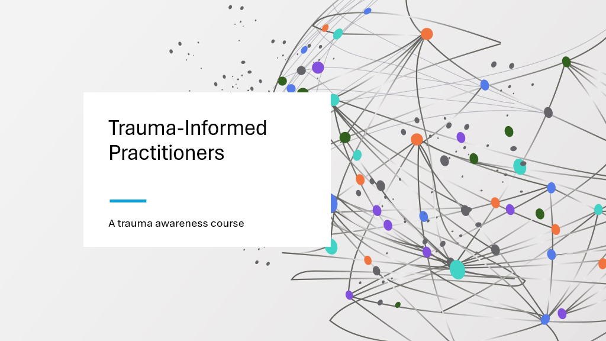

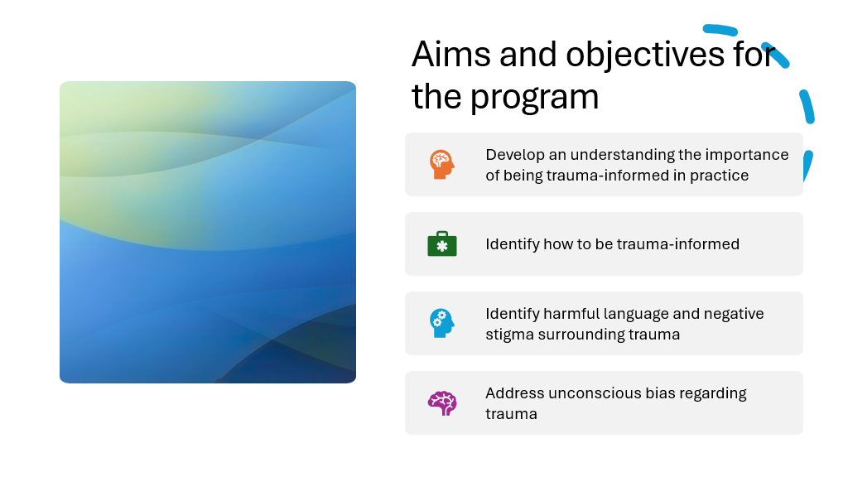
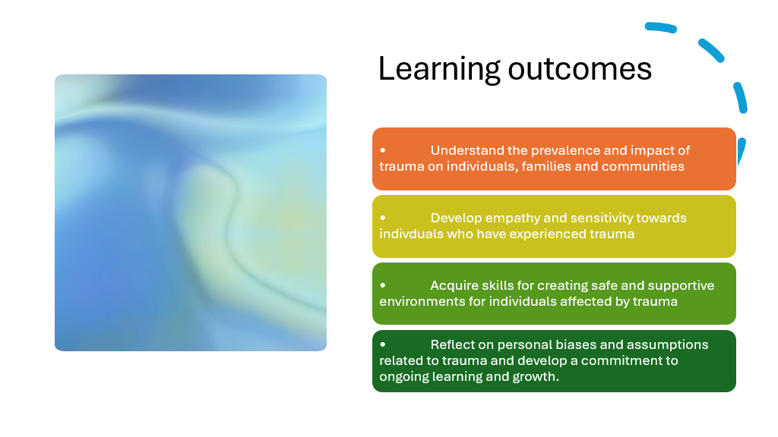
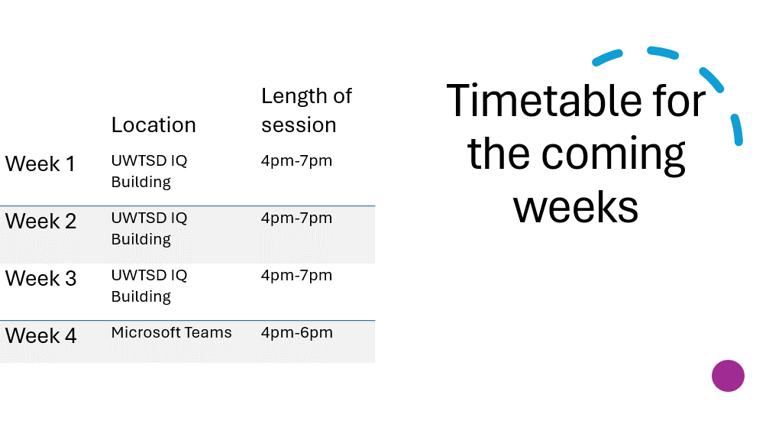
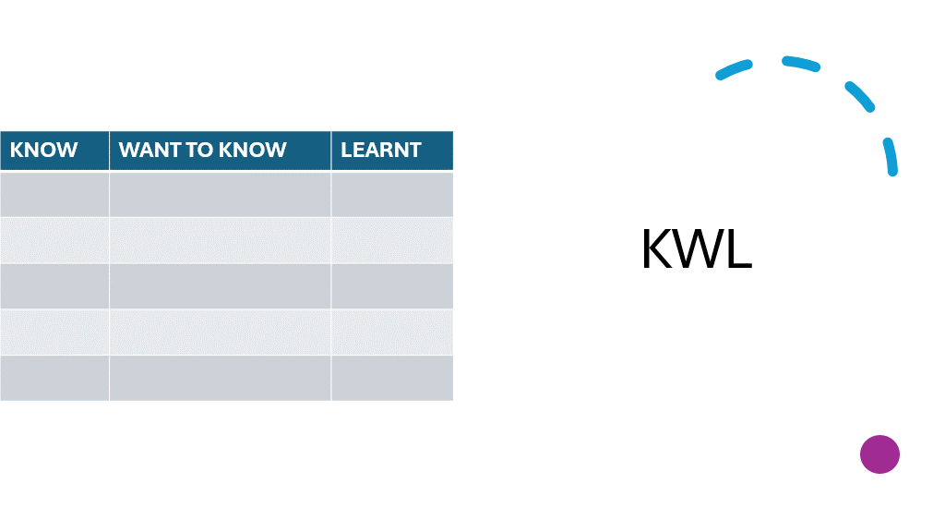
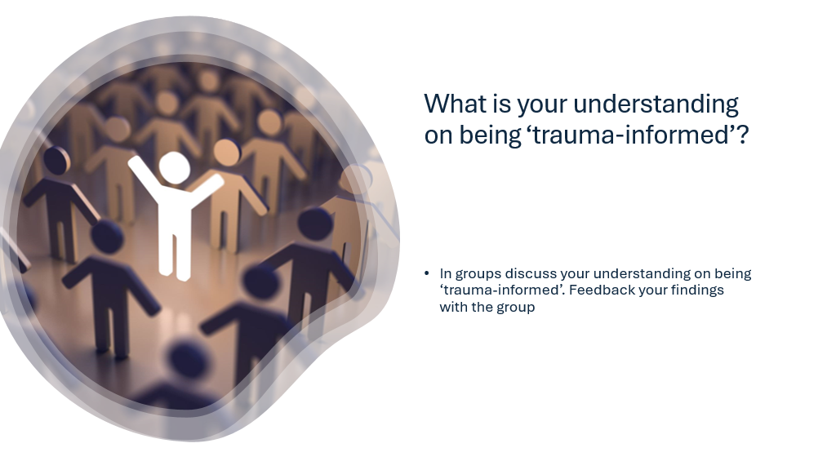
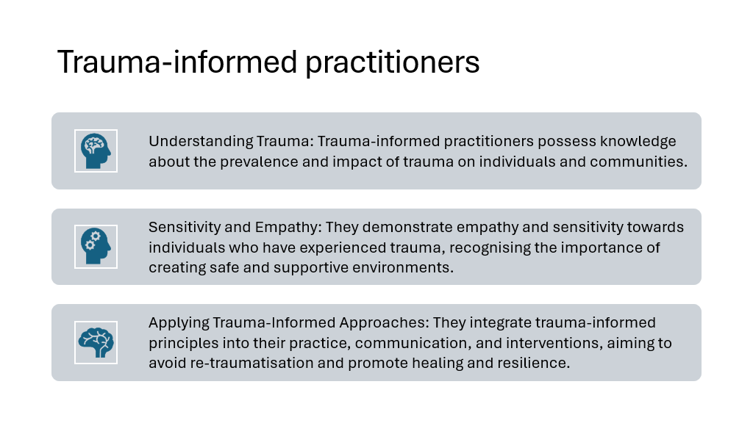
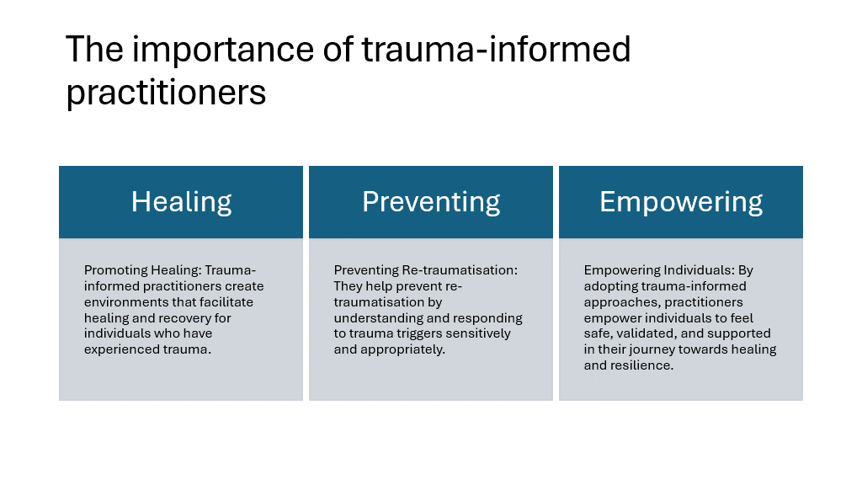
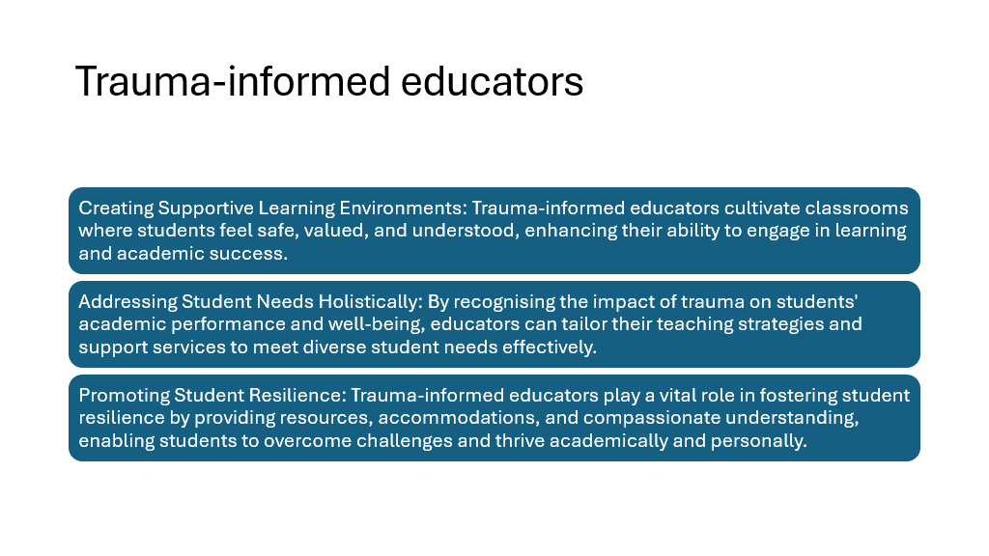
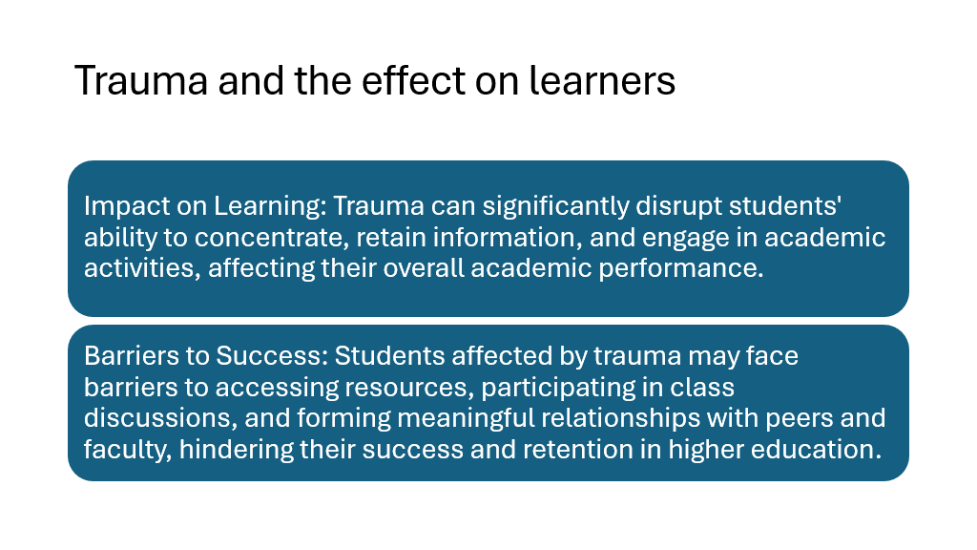
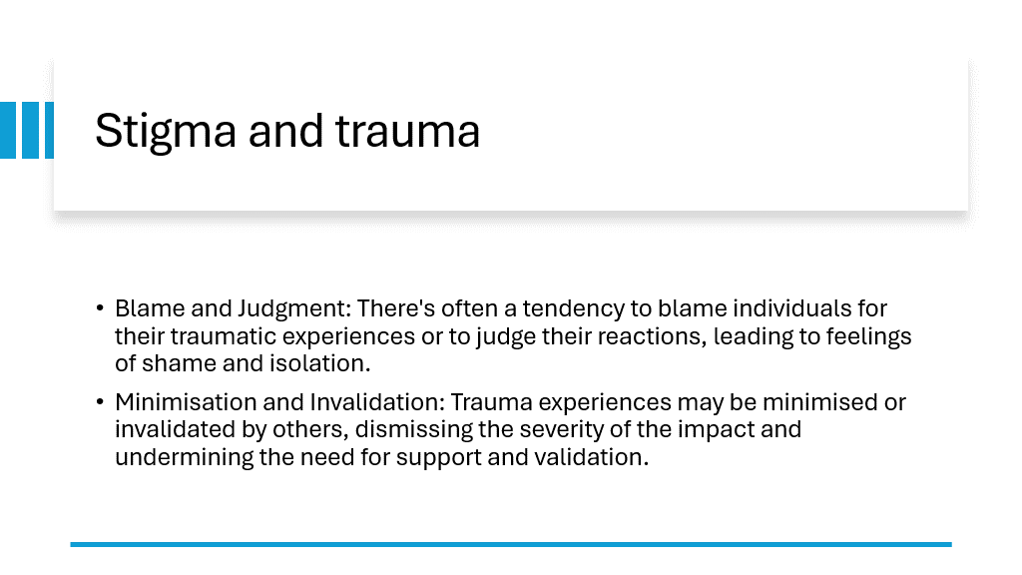
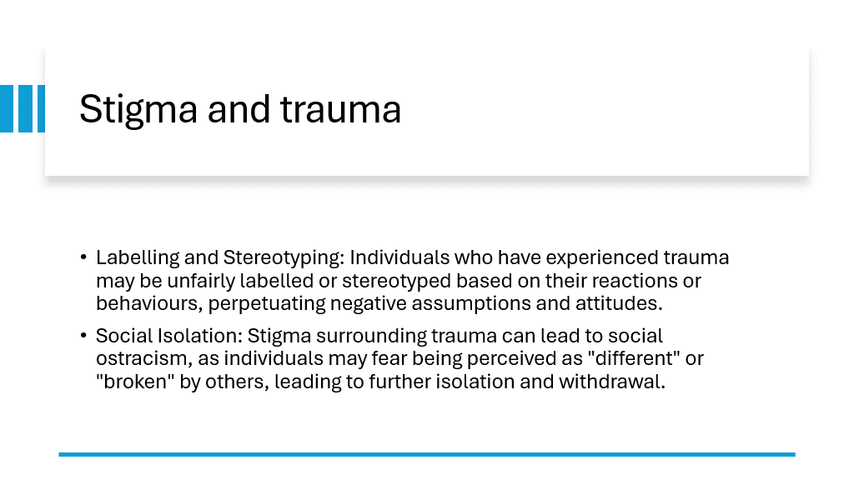

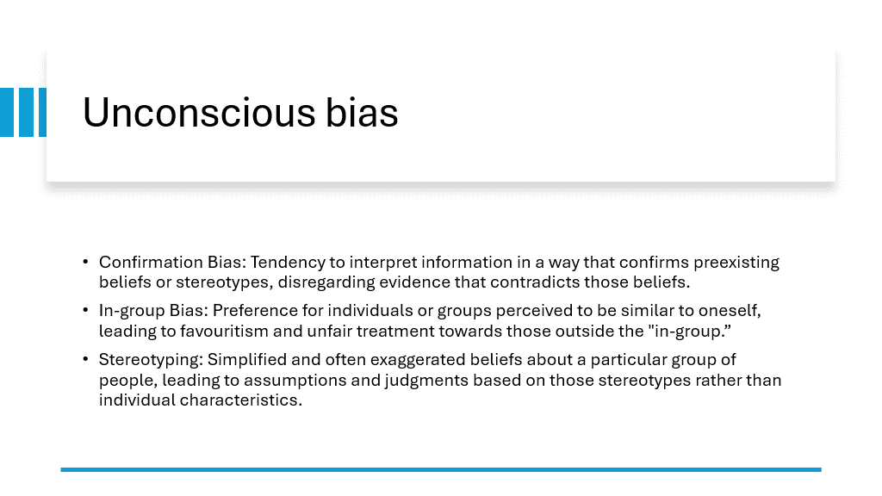
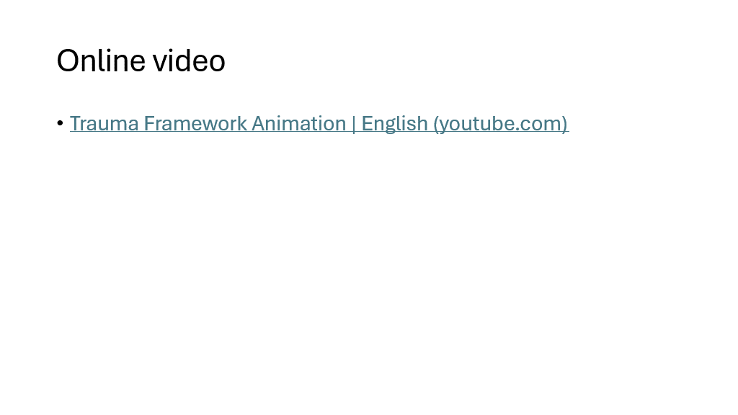
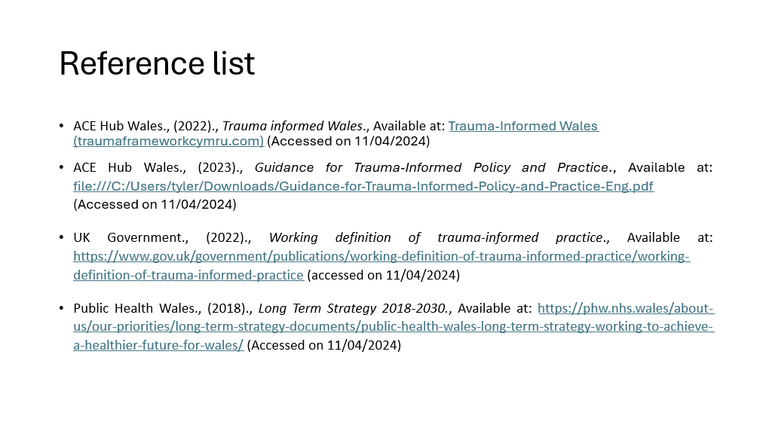

Attached is the teaching resources required for Session One of the course

Appendix B

Lesson Plan Template



Lesson Plan

Topic: Trauma informed practitioners |  | Class: tbc
Date: 25/05/2024 | Length of lesson: 3 hours |  | Number of students: 10
Powerpoint presentation

Online Video

Pens and flip chart paper for group activity
- Develop an understanding on the importance of trauma-informed practitioners and how this can effect practice
- Identify different sources of trauma and how this could affect learners
- Identify strategies in which educators can support learners in a trauma-informed way
Address the stigma surrounding trauma and confront unconscious biases attached.
Learning Outcomes – The Learners Should Be Able To:

• Understand the prevalence and impact of trauma on individuals, families and communities
• Develop empathy and sensitivity towards indivduals who have experienced trauma

Previous student knowledge required for the session:

n/a

Anticipated difficulties (if applicable):

Professional Standards (where are these being met within the session)

- promote engagement in learning and equity of opportunity for all to reach their potential – with group work
- respect individual learners and diverse groups of learners – by creating a friendly and inclusive environment

Lesson Detail:

Stage | Focus | Strategy | Time
Introduction  Development  Plenary/conclusion | Introduce myself and the topic  Aims and objectives for the program  Learning outcomes for the program  Timetable for the program  KWL chart  Group activity – what is your understanding on being trauma informed – feedback findings to the group  Trauma informed educators  Trauma and the effect on learners  Stigma and trauma  Group activity – unconscious bias – feedback findings to the group  Unconscious bias  Misconception test- true or false?  Online video  Recap and open the floor to all questions | Chalk and talk  Pp2  Chalk and talk  Pp3  Chalk and talk  Pp4  Chalk and talk  Pp5  Chalk and talk  Group discussion  Pp6  Chalk and talk  Group discussion  Pp9  Chalk and talk  Group discussion  Pp10  Chalk and talk  Group discussion  Pp11-12  Chalk and talk  Group activity  Pp13  Chalk and talk  Group discussion  Pp14  Group discussion  Group discussion  Online video  Group discussion  Pp15  Group discussion | 10 mins  10 mins  10 mins  10 mins  15 mins  15 mins  15 mins  20 mins  30 mins  15 mins  15 mins  30 mins  15 mins

Q+A throughout session

Misconception check

Activity – true or false?

Summative – entries in to the journal

Attached is a copy of the lesson plan for session one of the course

Appendix C
Know | Want to know | Learnt

Attached is a copy of the KWL chart that will be utilised in each of the sessions. This chart will be used as a form of assessment and will be beneficial for students to see their own progression.

Appendix D
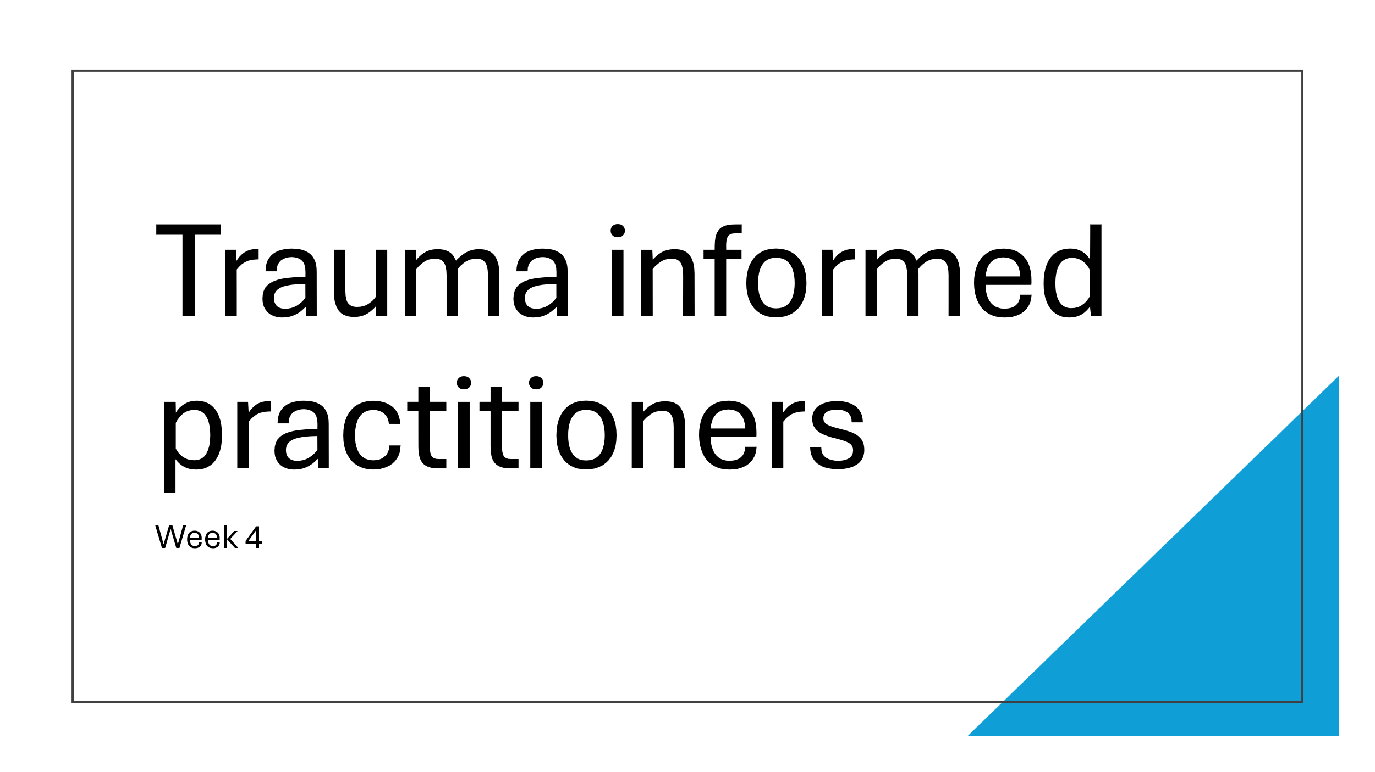
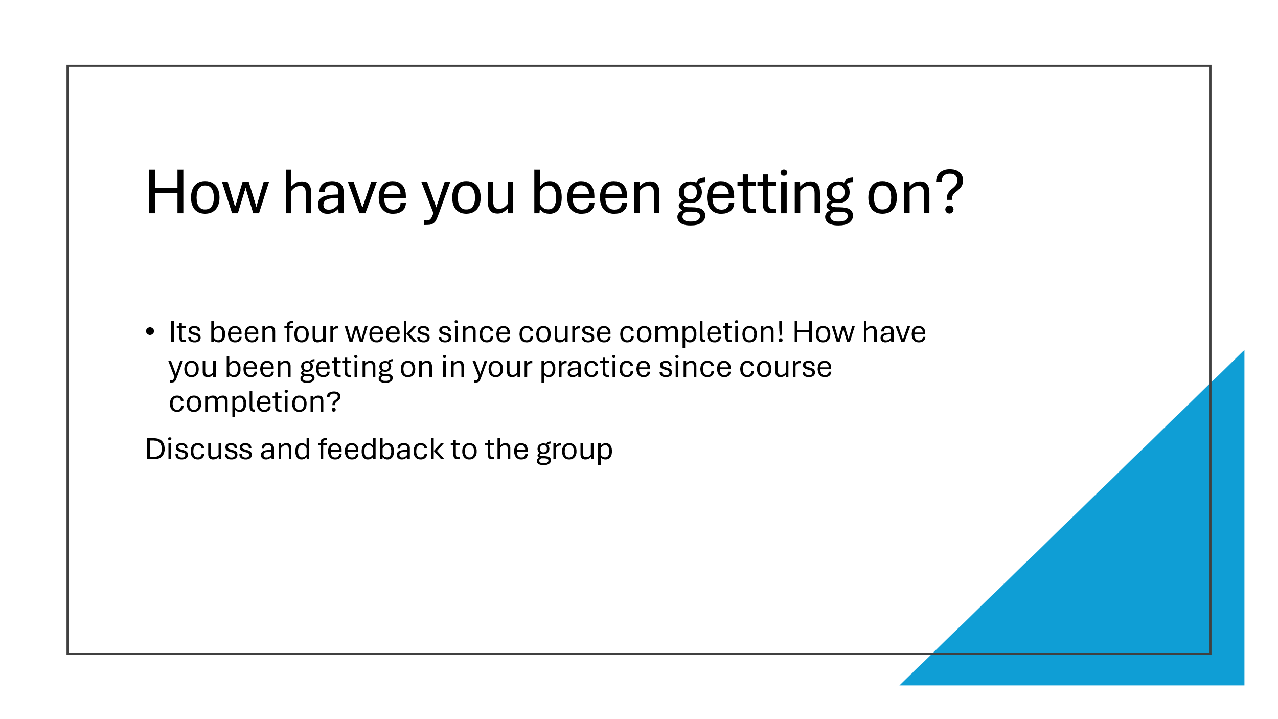
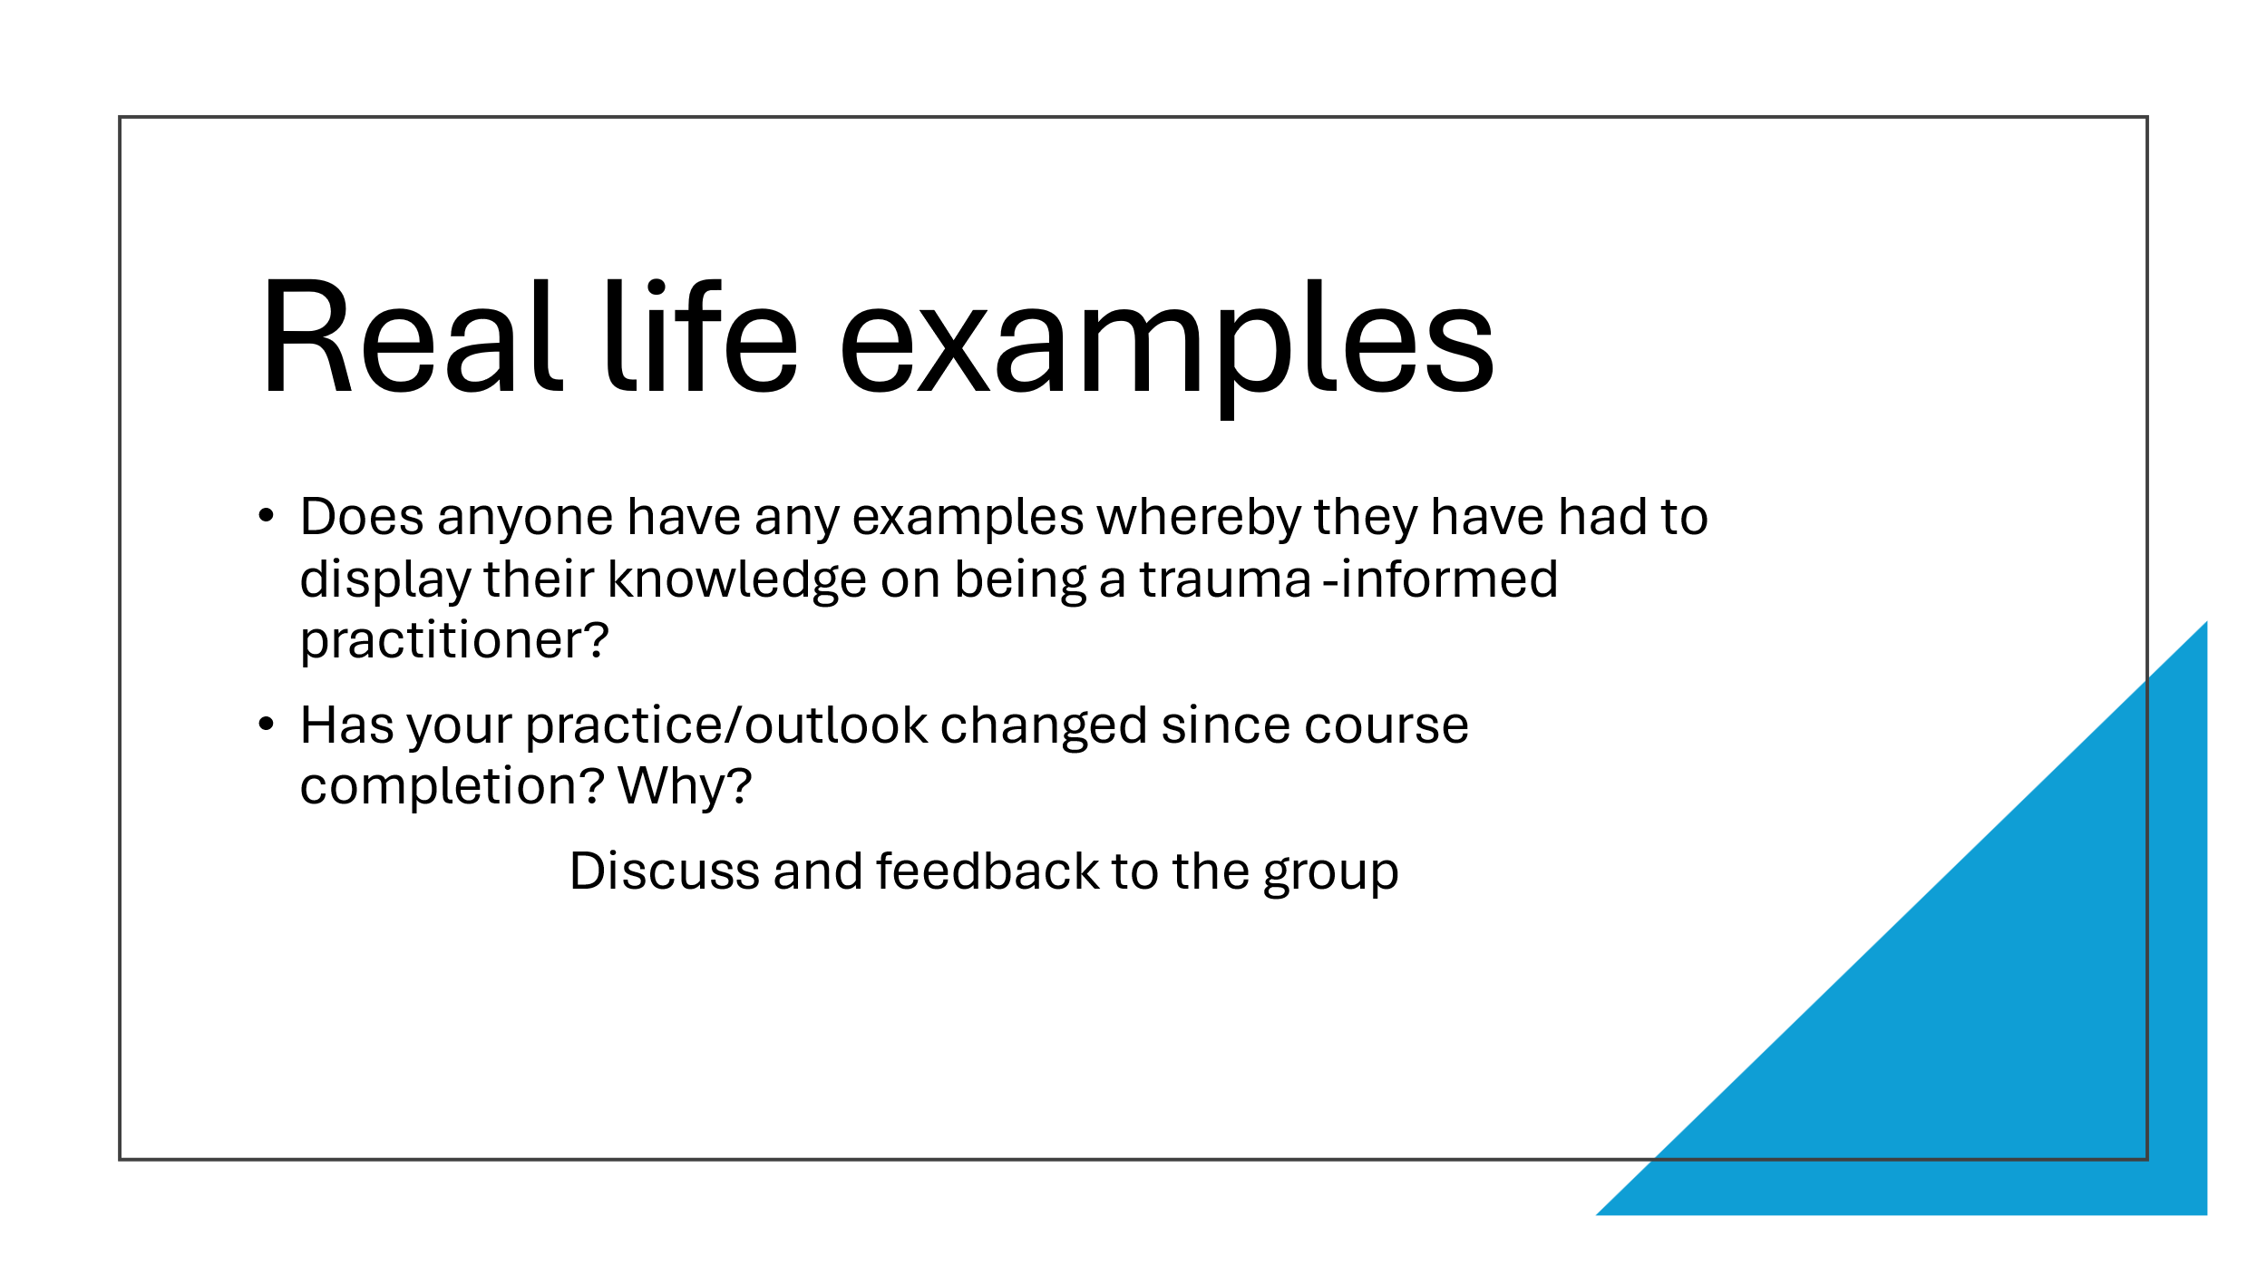
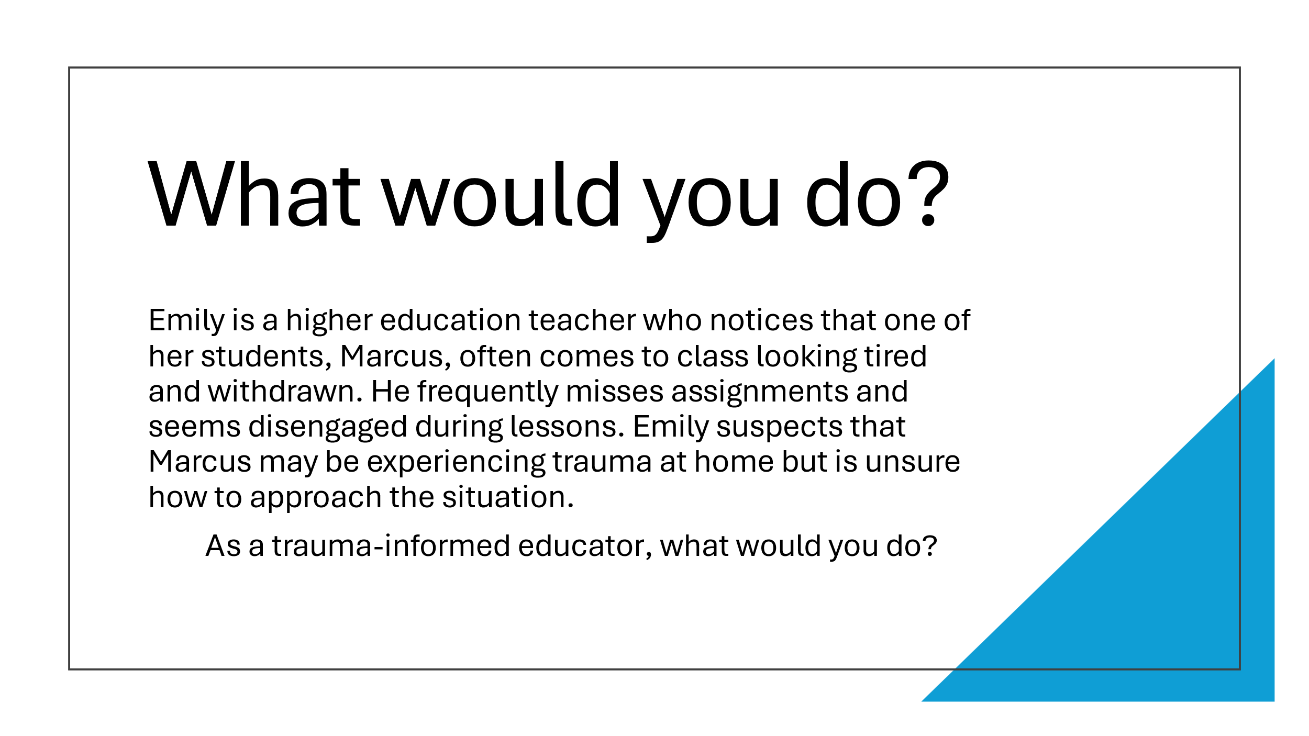
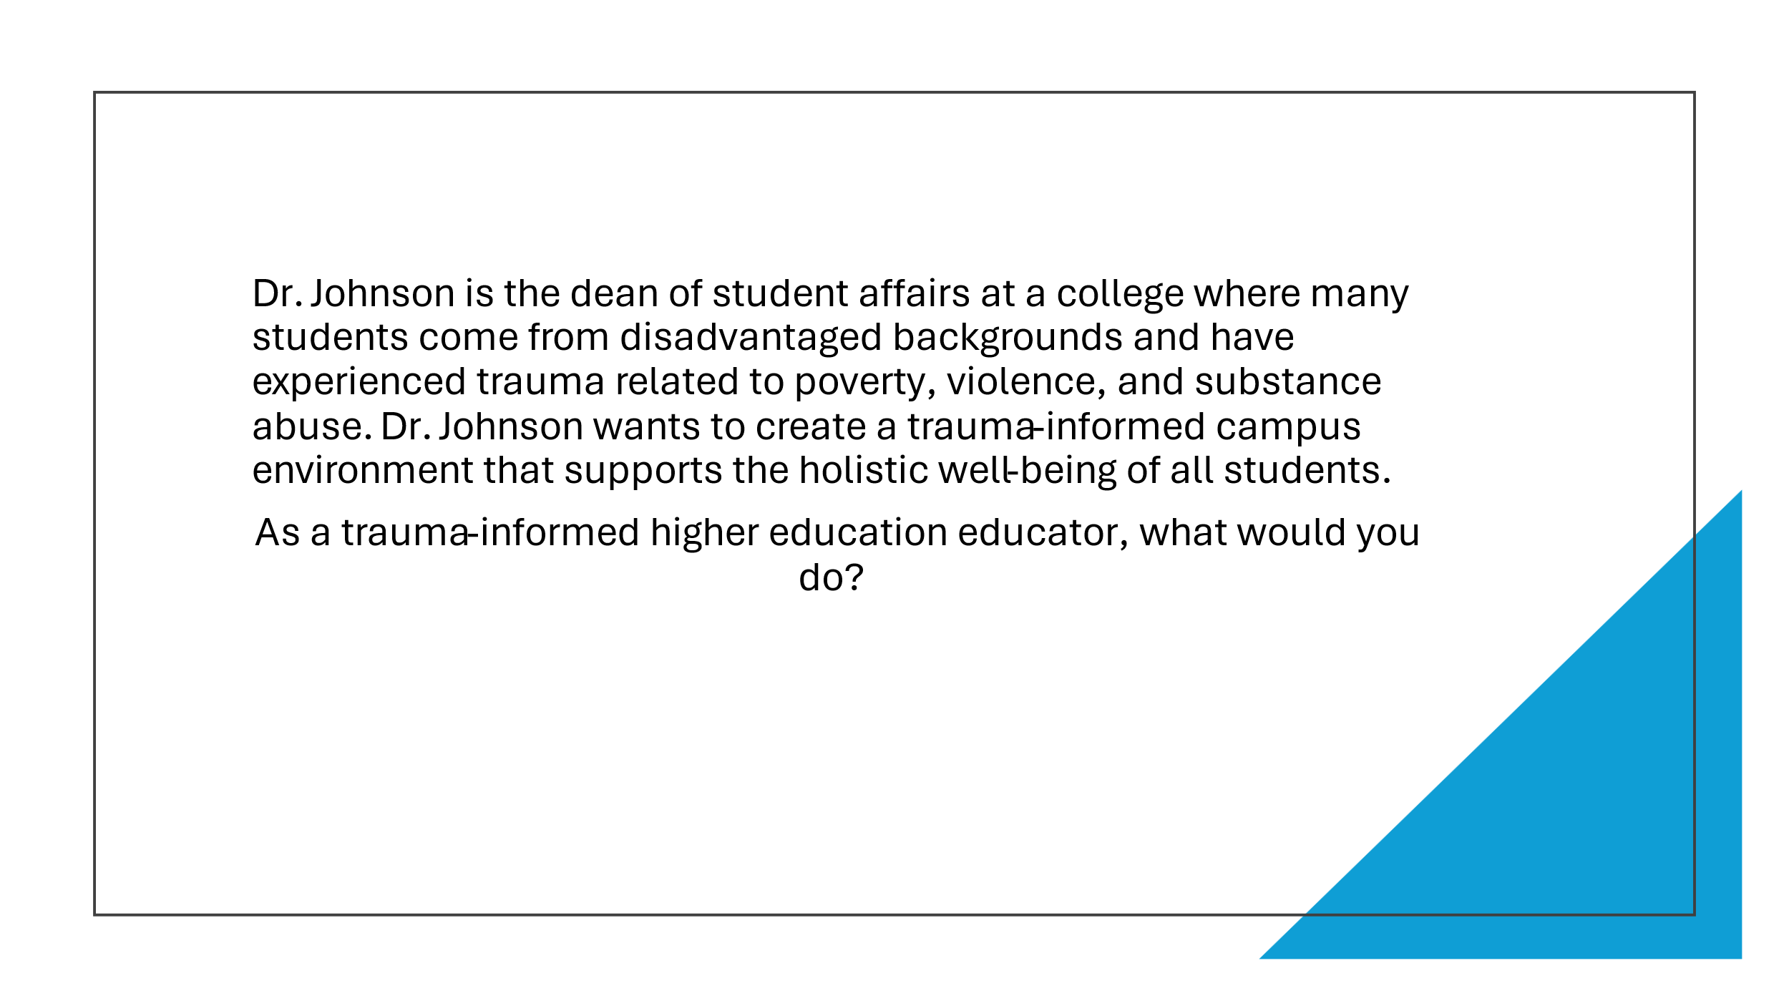
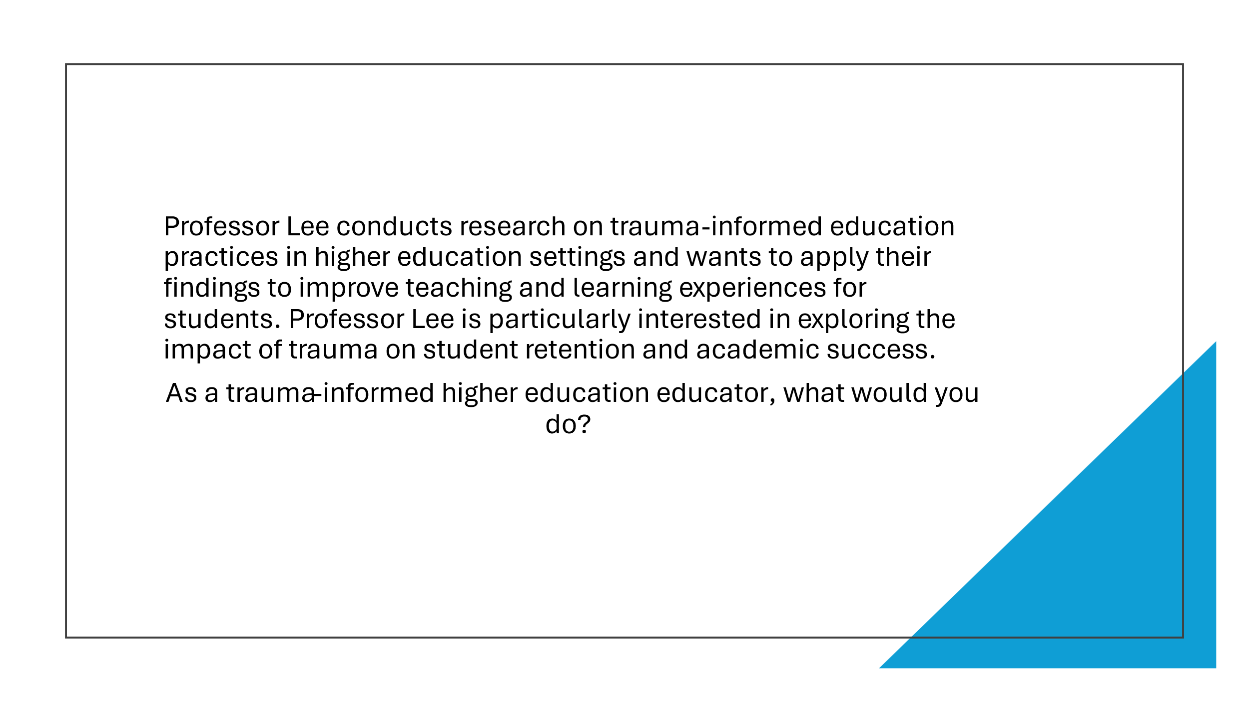
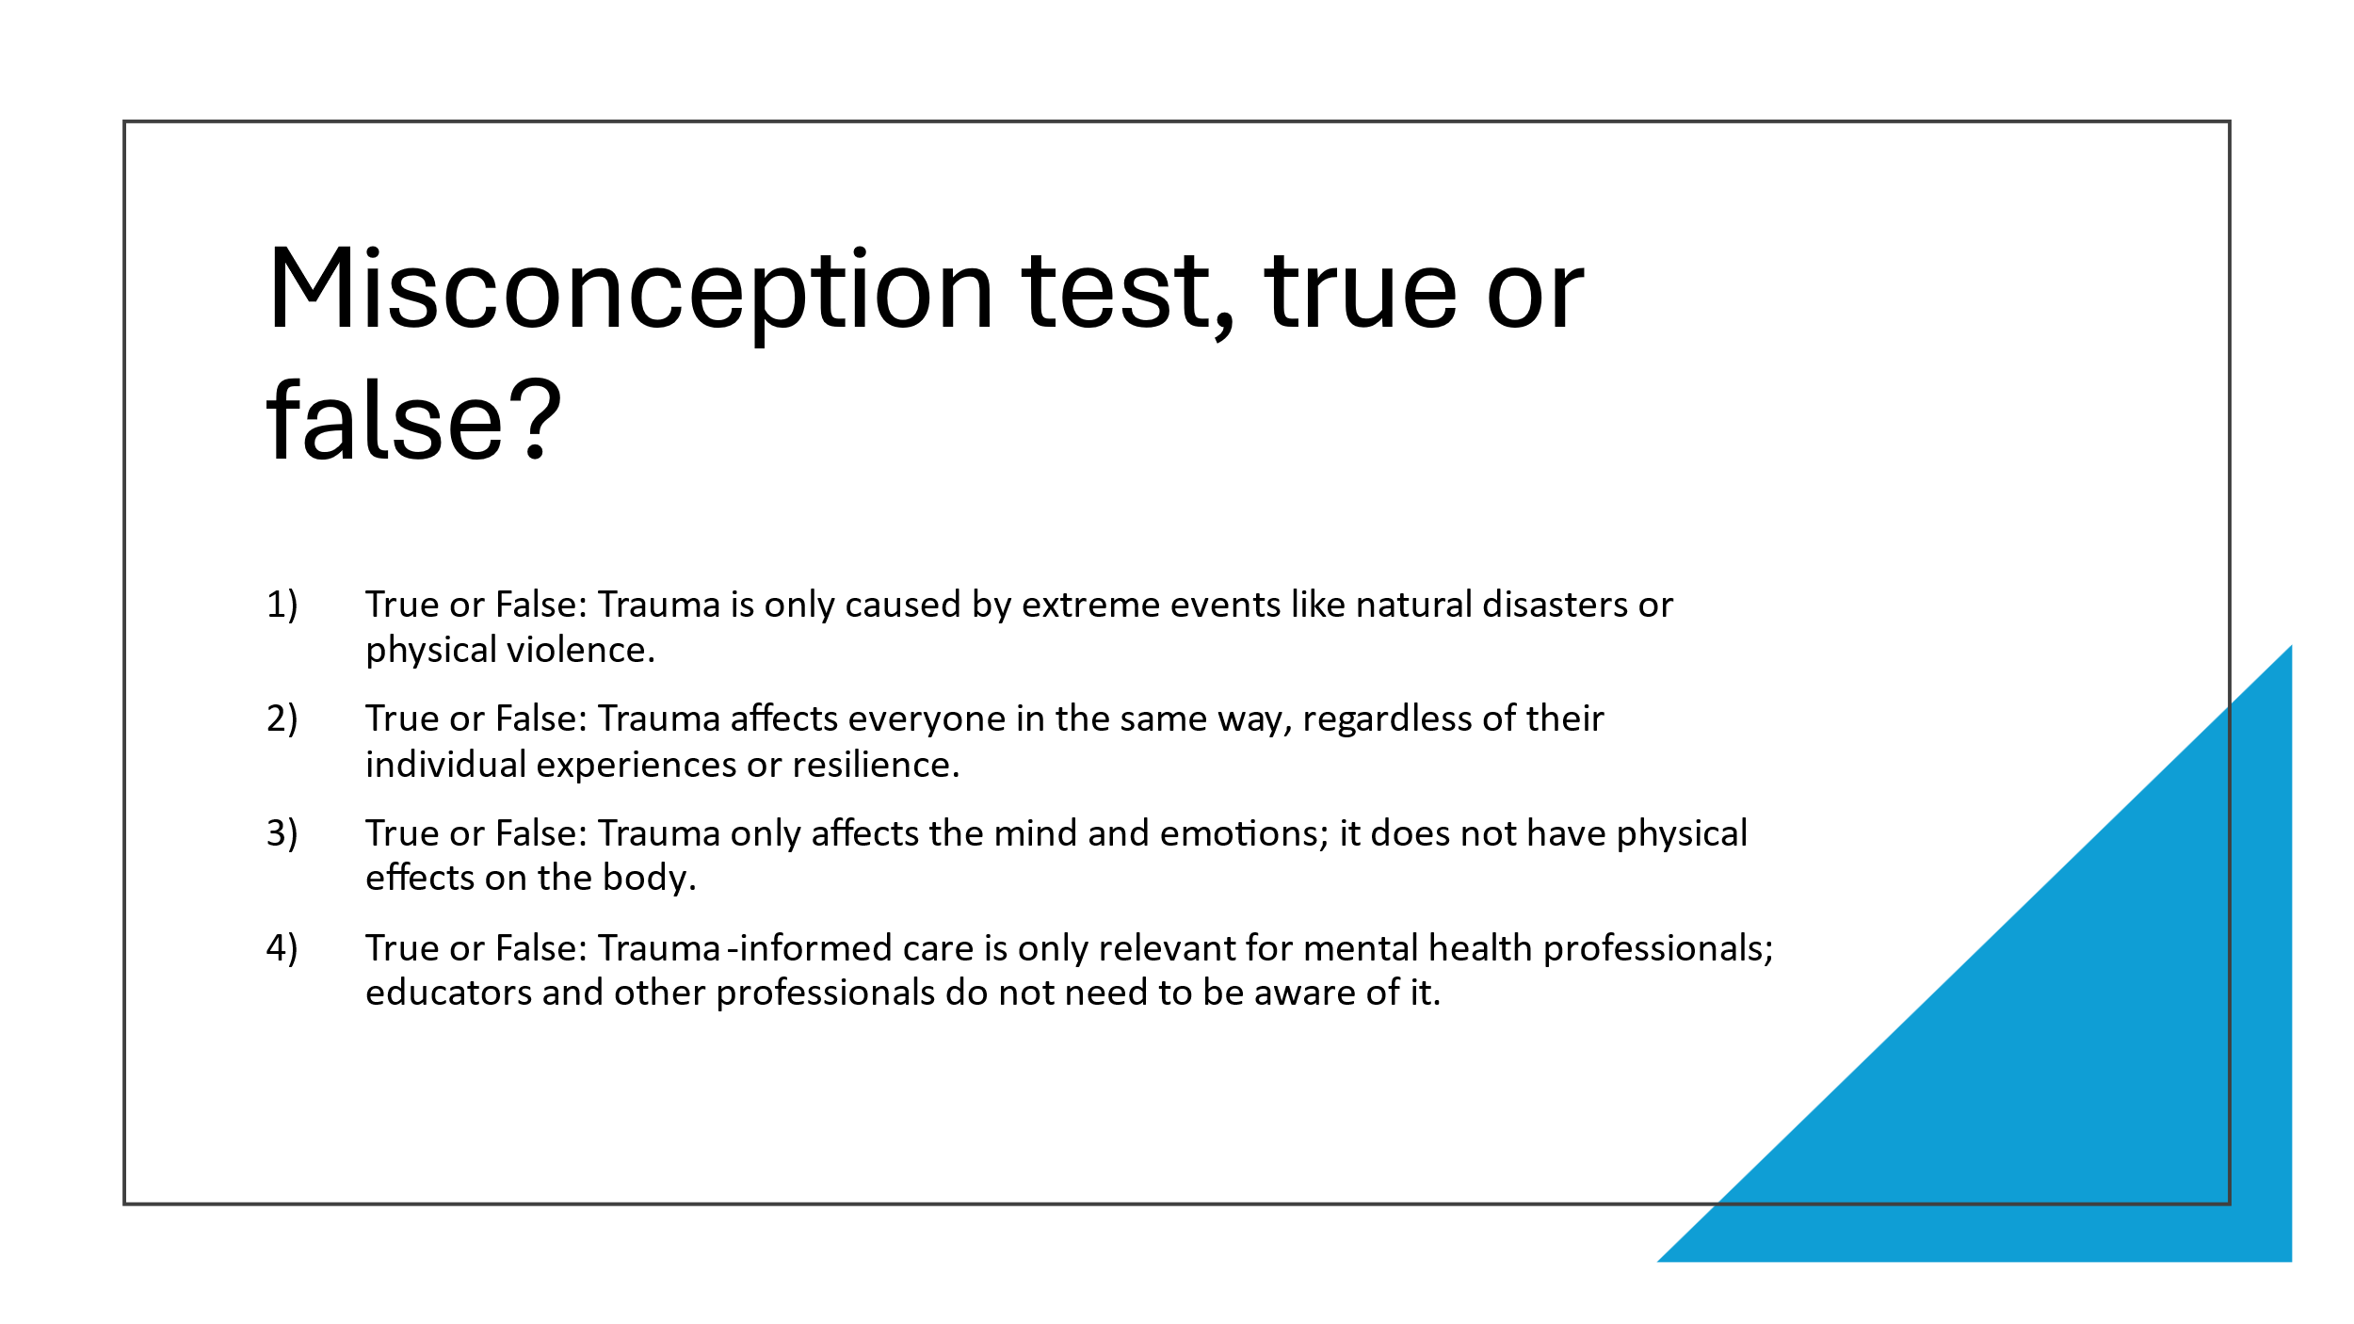
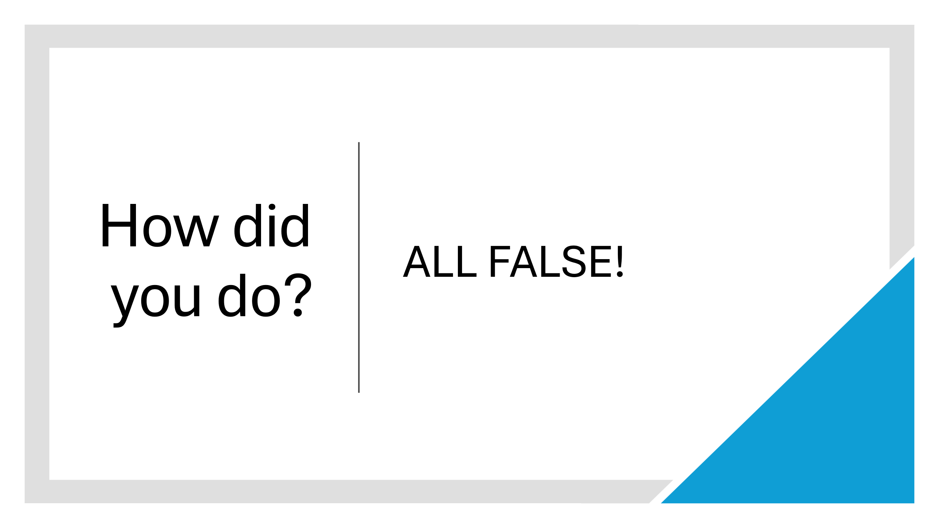
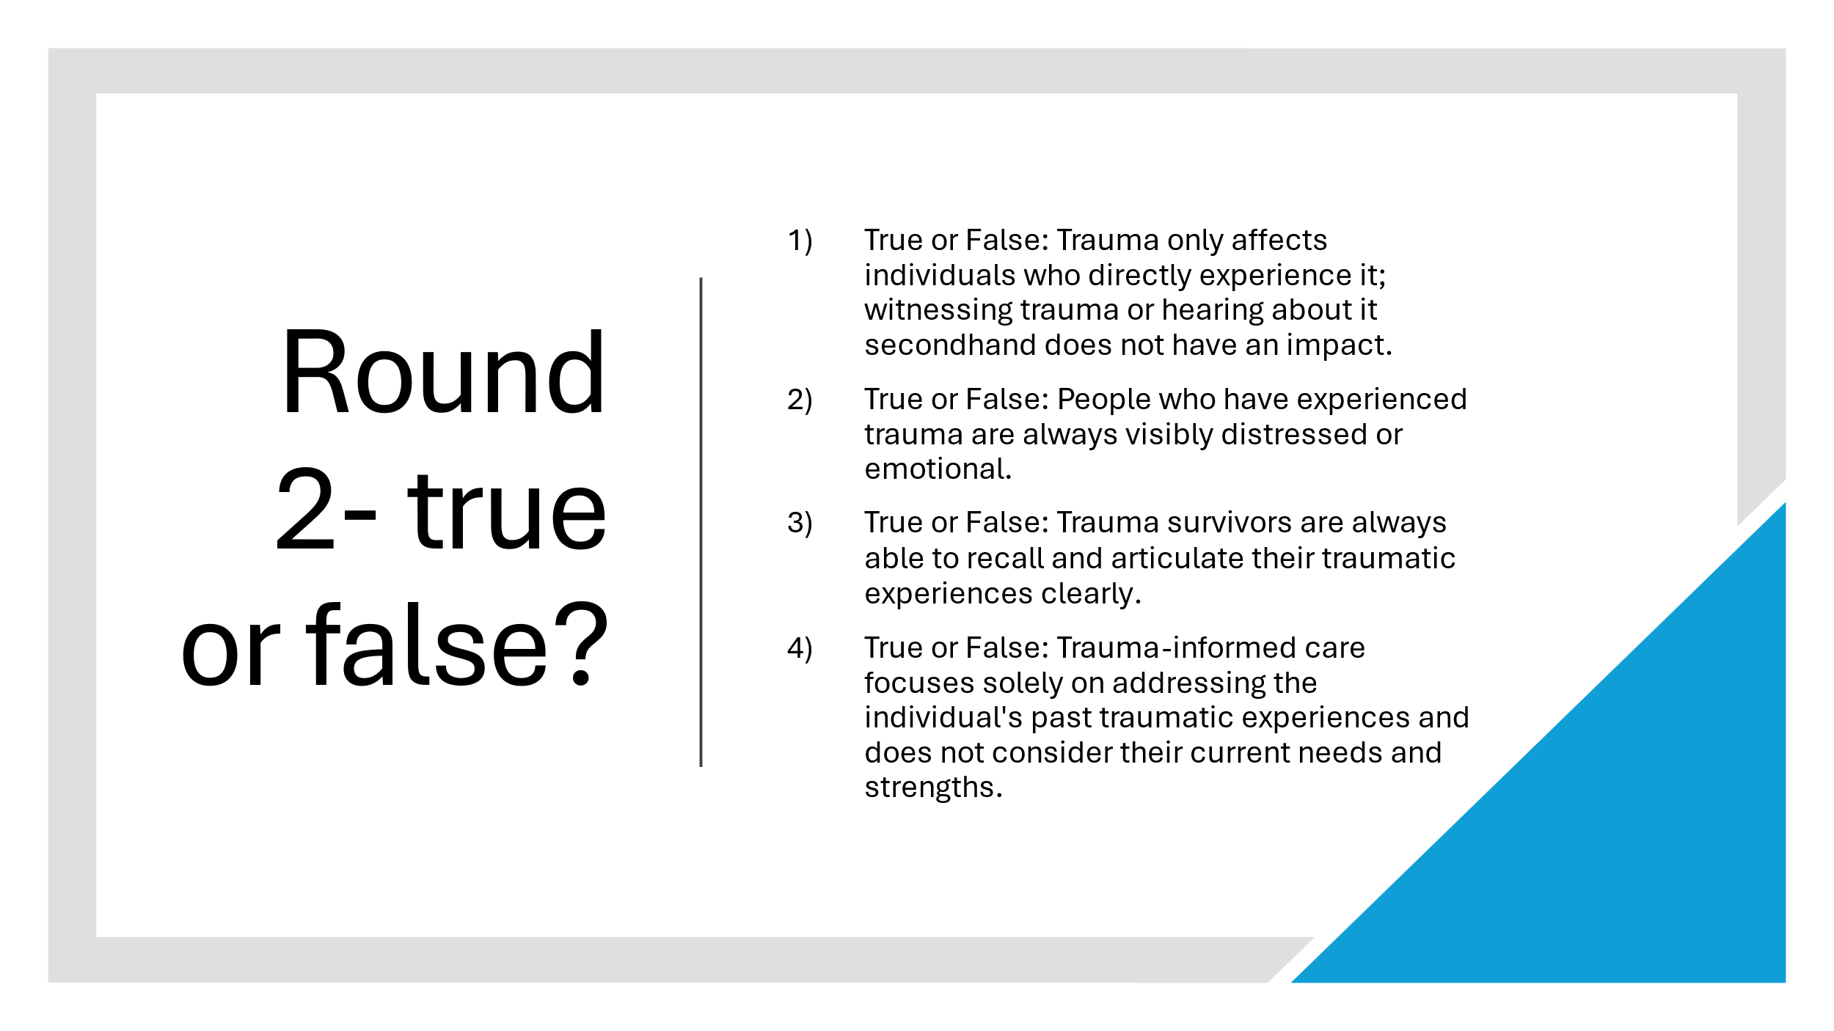
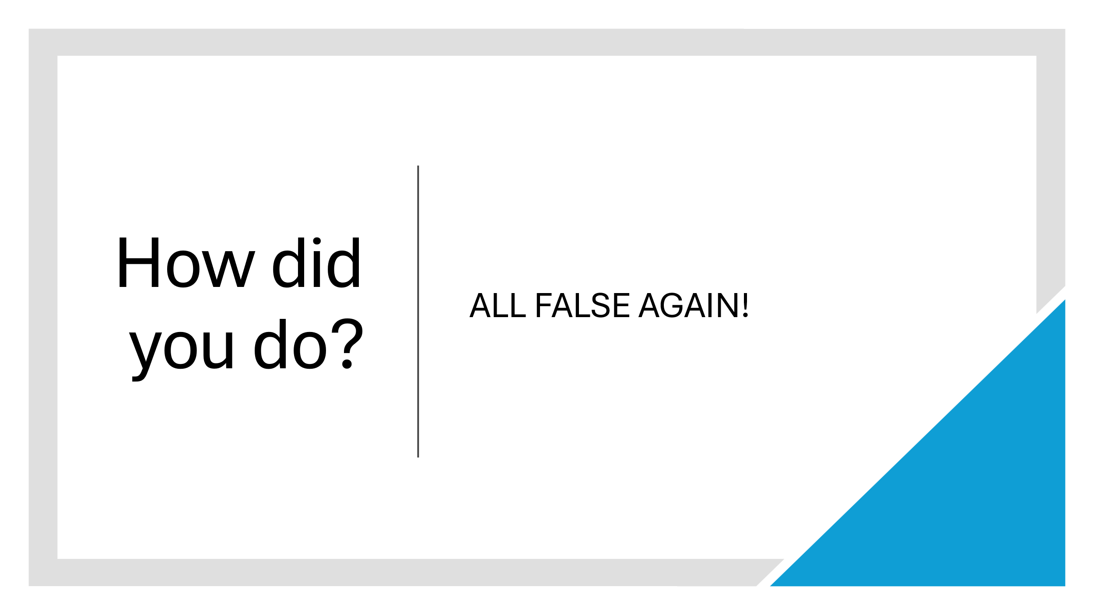
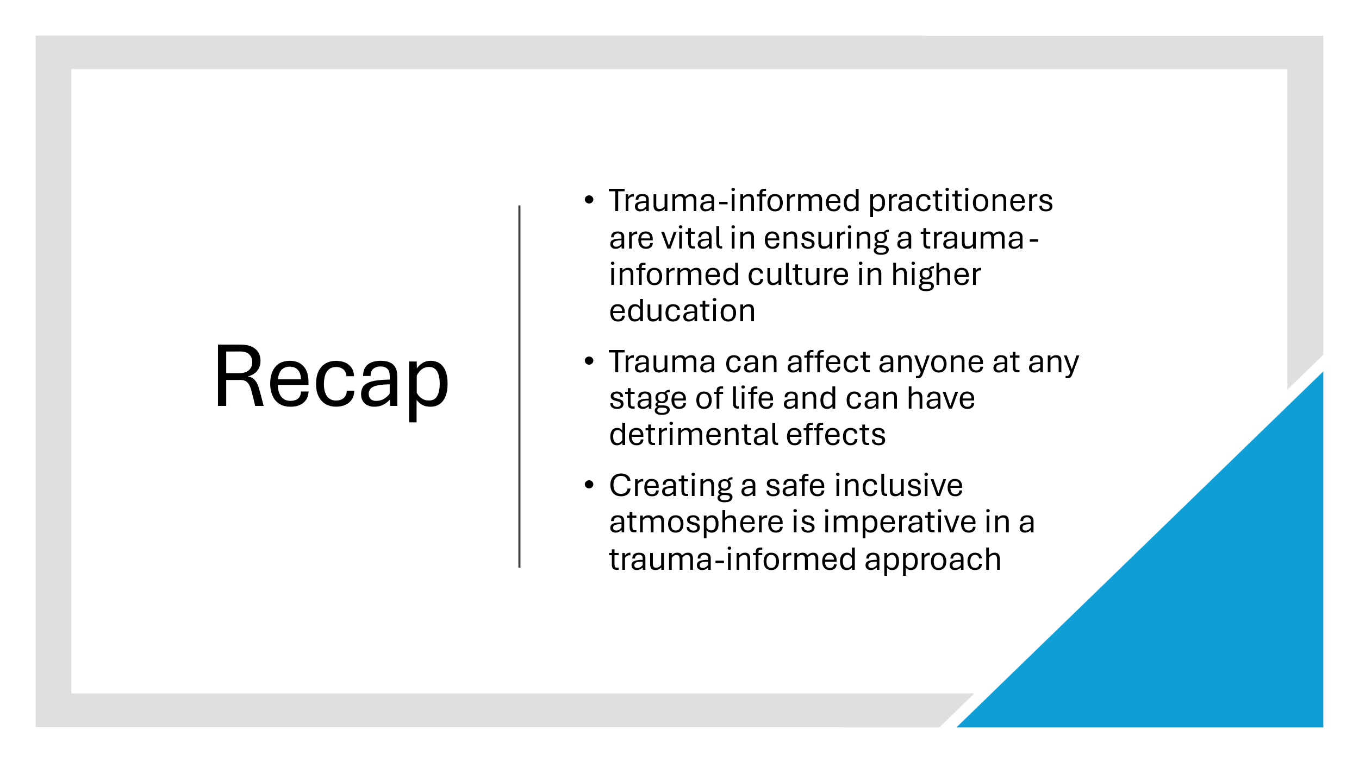


Attached is a copy of the resources required for session fours catch up session, which will be held one month after course completion.

Appendix E

Lesson Plan Template

Lesson Plan

Topic: Trauma informed practitioners training course – week 4 |  | Class: tbc
Date: tbc | Length of lesson: 3 hours |  | Number of students: tbc
Resources required: powerpoint presentation
Access to Microsoft teams

Aim of Lesson
- Opportunity for students to catch up and discuss how they are getting on in practice since course completion
- Display knowledge on the importance of being a trauma-informed practitioner

Learning Outcomes – The Learners Should Be Able To:

• Collaborate with peers on scenario based case studies and identify the best course of action now that students have an understanding on trauma awareness and are trauma-informed practitioners
- Identify the importance of being trauma-informed and how this links with policy and legislation

Previous student knowledge required for the session:

n/a

Anticipated difficulties (if applicable):

N/A

Professional Standards (where are these being met within the session)

- respect individual learners and diverse groups of learners – by creating a safe and inclusive environment
- promote engagement in learning and equity of opportunity for all to reach their potential – with group work and discussion
- collaborate with others to enhance practice – with group discussion

Lesson Detail:

Stage | Focus | Strategy | Time
Introduction  Development  Plenary/conclusion | Welcome students back and check in with how they have been since course completion  Display knowledge on the importance of being a trauma-informed practitioner – feedback to the group  Real life examples- learners display their knowledge on being a trauma-informed practitioner – has the students practice/outlook changed since course completion? – discuss and feedback to the group  What would you do? – case studies  Misconception test  Recap and open the floor to student questions  Student feedback form | Group discussion  Chalk and talk and group discussion  Pp2  Group activity  Group discussion  Pp3  Activity  Group discussion  Pp4-pp6  Activity and group discussion  Pp7-10  Chalk and talk  Group discussion  Pp11-12  Form | 15 mins  30 mins  45 mins  45 mins  45 mins  15 mins  10 mins

Assessment Strategies: when and how are they included within the lesson?

Student feedback form
Q+A throughout the session
Group activity and opportunity to collaborate with peers

Attached is a copy of the lesson plan for session four’s catch up session of the program.

