  University of wales  TRINITY SAINT DAVID | A report detailing an innovate solution to an operational problem  Anna Misiak-Ali (2311228)  21.03.2025

Executive summary

The ProCare Nursing Ltd. is a company with over 20 years of experience. It was founded by James Alan Drew on 10th March 1997. ProCare is run with his friend Nolan Dean Hulbert which has been appointed as a director on 28th of November 2024. Since the establishment of the company in 1997 the focus was to serve a local council, charities, private family homes and residential care homes providing quality carers and fully qualified nurses.
In this report I have described processes that allows us to provide innovations in our daily life and life of our patients. Its incremental process allows us to adjust existing applications and based on them produce app matching our needs. This falls on product and process of 4P’s of innovation. The creative thinking of brainstorming allowed us to come up with the idea of the app. After the meeting with management team, all carers could take time to think how to solve the problem. We went through process of preparation, incubation, illumination and verification. The force field analysis showed all forces for change with 22 points while the forces against the change had only 6 points. Due to cost of the application the changes in carers work could be stopped. As the company is doing everything to promote growth management team looked up for possibilities to make the change happen. The climate of the company is allowing us to express our needs and ideas, and it will be considered.
In conclusion ProCare Nursing is a company with the abilities to provide new technologies while respecting service users and carers. They will do it all while following government policies.

Contents
Executive summary 1
Introduction 3
ProCare Nursing Ltd. introduction and my occupation 4
Importance of creativity and innovation in care sector 6
The 4 P’s of innovation 7
Brainstorming at the ProCare Nursing Company Ltd. 10
Lewin’s Force Field analysis 12
Ekvall’s ten dimension- organisational climate in ProCare Nursing td. 15
Conclusion 18
References 19

Introduction

Health care system is overloaded with different type of disabilities and disorders. Many companies try to find solutions to ease pain and discomfort for patients. Creativity and innovation are one of the reasons why we have so many useful products on the market. Domiciliary care also uses equipment like hoists or applications on the phone for diabetics or communication devices for people with autism.
ProCare Nursing is a company started in 1997 by James Alan Drew. Since the beginning of the company main focus was to make other people life easier. ProCare is one of many companies in Cardiff and Vale of Glamorgan. Its renown was built over the last 20 years. As company grew many problems appeared. For many years care workers used paper schedule for clients. With previous problems regarding safety of a clients ProCare Nursing decided to upgrade their care system and move from paper to digital application. Throughout brainstorming many ideas appeared but one was the most challenging. The idea is good, but the problem appeared with affordability of the project. Lewin’s Force Field analysis was conducted and all the forces for change and against change were presented. From the studies shown this new application will be useful for care workers but the cost of the app is higher and might stop the progress. In further part of the report climate in the organisation is discussed and Ekvall’s ten dimension helps to define if the project will be completed.

ProCare Nursing Ltd. introduction and my occupation

ProCare Nursing Ltd. (2022) is a company located in Cardiff, on no. 1 Radnor Court 256 Cowbridge Road East CF5 1GZ. The company was incorporated by Mr. James Alan Drew on 10th March 1997. ProCare is run with his friend Nolan Dean Hulbert which has been appointed as a director on 28th of November 2024 (GOV.UK, no date). ProCare has over 20 years’ experience in health and social care. Since the establishment of the company in 1997 the focus was to serve a local council, charities, private family homes and residential care homes providing quality carers and fully qualified nurses. The experience has been documented, and we are a more frequent provider of choice not only for Cardiff, Caerphilly and Vale of Glamorgan Social Services, but also for several healthcare organizations listed below:
- Elysium Healthcare,
- Linc,
- Orbis Education and care,
- Ocean Community Services, building a life worth living,
- Priory,
- React Support Services Improving Lives,
- Summerhill Care Homes Group,
- Ludlow Street Healthcare (ProCare, 2022).

These are the three main sectors ProCare Nursing Ltd (2022) provides staff to the care industry:
- As a nurses agency we supply qualified staff to Nursing Homes, EMI Units and to Secure and Semi-Secure Units. Grades include Registered General Nurses (RGN), Registered Mental Nurses (RMN) & Registered Nurses Learning Disabilities (RNLD). All our nursing staff are registered with the Nursing and Midwifery Council (NMC).
- We also supply experienced and well-trained healthcare assistants and senior (NVQ 3) care officers to nursing and residential homes (including EMI Units) throughout southeast Wales.
- Our domiciliary care provides care and support to people with a wide variety of care requirements within their own home. The care support staff work with adults with varying degrees of learning and physical disabilities, enabling them to participate in a range of activities within the community. This includes supporting service users at education establishments, day centres, leisure and sporting activities, as well as promoting general independence and integration in the wider community.
ProCare Nursing (2022) has also established itself as a specialist provider of experienced and well-trained support staff in a variety of residential care settings, including Secure and semi-secure residential units for adults and children with severe learning disabilities and challenging behaviour.
Drug and Alcohol Rehabilitation Centres

We supply carers to small and medium-sized community houses offering supported accommodation to service users with physical disabilities, learning disabilities and mental health issues.

For over 20 years we have trained hundreds of carers. We have our own in-house facilities and trainers who have years of experience teaching health and social care.
Care workers are required to promote several factors in the care work. As a care worker I am responsible for promoting independence by encouraging clients to do things for themselves instead of doing everything for them. I am responsible for treating service users as individuals with ability to decide and provide support whilst ensuring that their choices are appropriate for them and other people. I make sure that I promote dignity and respect in the way I interact with service users, their families and the wider community. As a carer I can take care of activities lined up for my client and I must make sure that they are appropriate and within the ability of my client. If they wish to participate in any religious celebrations or activity, I am here to support lifestyle of their choice. As a part of my job description, I am also responsible for more personal care for my clients which includes supporting clients with their daily hygiene routines like washing and dressing, taking care of their environment, making laundry, cleaning and tiding, helping with daily tasks to keep client surroundings according to their standards. If they have mobility issue I provide assistance getting around safely. Many of my clients are on medication which I have training to be able to administer them safely. Some of service users are raking their meds independently, my role is to remind them to take them. There are clients who suffer from mental health and addictions. Due to safety reasons many medications are locked in safes and only carer has code. My responsibility is to administered medications and lock away the rest as it might be abused by service user and cost then lives. I am also responsible for meals preparation, making meals for clients according to their preferences and dietary requirements.

Importance of creativity and innovation in care sector

There are words that describe the highest levels of human performance: genius, invention, talent and creativity. By being creative I mean being engaged in the act of creation, being able to perform with the culmination of our abilities (Sawyer and Henriksen, 2024). Creativity is a mental process that involves the creation of new ideas, concepts or new associations, connections with existing ideas and concepts. Creative thinking is thinking that leads to obtaining original and appropriate solutions. An alternative, more everyday definition of creativity is simply the ability to create something new. Creativity is the reason why many inventions and discoveries has made possible to all major contributions in art, music, architecture, literature, science, and many other fields (Sternberg and Kaufman, 2018). There is a difference between Innovation and invention. The invention is simply the first emergence of a new idea or product, while innovation is a commercialisation and implementation of a new idea (Flessa and Huebner, 2021). Innovation contributes in several ways. Being able to make something no one else can, or to do so in ways that are better than anyone else is a powerful source of advantage (Tidd and Bessant, 2018)
The health care system in the UK is also using many different inventions and innovations. Lately NHS was funded by government with new AI technologies that can help find and treat cancer (DHSC Media Team, 2023). This new way of treatment can help diagnose and enrol patients faster and make quick recovery. Of course, those inventions are not for use for simple care worker but can help patients in hospital on larger scale. Domiciliary care workers also use innovations in their daily care routines with service users. If we look how difficult it was for carers to move patients from one place to another and yet inventors came up with hoist that can safely move people around without harming them or carers. The brand which first patented hoist was Joerns Oxford, and after the first mobile patient lift was launched in 1955, the Oxford brand began to create and bring more products to market (Joerns Oxford, 2025). There are other innovations that help while caring for our loved ones. With the phones becoming more like little computers in our pockets, we can use apps for measuring sugar levels in our blood. It gives alarm to the person using it if the levels are too high or too low (NHS Oxford Health, 2020).
ProCare Nursing had no choice but to follow world with progress. The reason why they had to move forward was an incident that happened. One of the carers lost paper schedule list with all the addresses and key passwords. Due to safety reasons immediate actions were performed and all the key passwords were changed. This led to realisation by management team that something must be done to keep carers and clients safe.

The 4 P’s of innovation

Innovation is a sequence of activities leading to the creation of new or improved products, technological processes or organisational systems. It also describes marketing or organisational method in business practice, workplace organisation or relations with the environment. The basic condition is that what is to be implemented must be completely new or significantly improved. Innovation is the systematic practice of developing and marketing development products and services for adoption by customers (McKinsey&Company, 2022).
Innovations in healthcare should serve to improve the functioning of the healthcare system, provide patients with the best possible care, provide appropriate support to medical personnel, and aim to increase the efficiency, quality and availability of the services provided. ProCare Nursing also following this trend with recent incidents. As mentioned before one of the carers lost her paper client list with all the addresses and door key passwords. This incident could put many vulnerable and sick people at risk. Immediate actions were taken to solve this problem temporarily. Throughout brainstorming we concluded that application on the phone will be the safest option to keep the service users safe. According to Tidd and Bessant (2020) there are four dimensions of innovation, and those are:
- product- changes in the things that organisation can offer for example product or service,
- process- it is a change of a way that the product or service is delivered,
- position- tells us about the change in the context of a way the product or service is introduced,
- paradigm- tells us about the changes we perceive things and give it a new meaning or use.
My idea of the app on the phone falls between product and process of 4 P’s of innovation. We all use phones; they are with us all the time and we have bound our lives with this technology. This application is to help us provide better service and make our lives easier. This product is incremental because many organisations use applications for work and communication, but in our case we need to upgrade it to help with our daily tasks and routines to be completed. What is incremental? ‘The term “incremental innovation” refers to a series of small improvements made to a company’s existing products or services’ said Costanzo Carleton (2019).

4P's Model

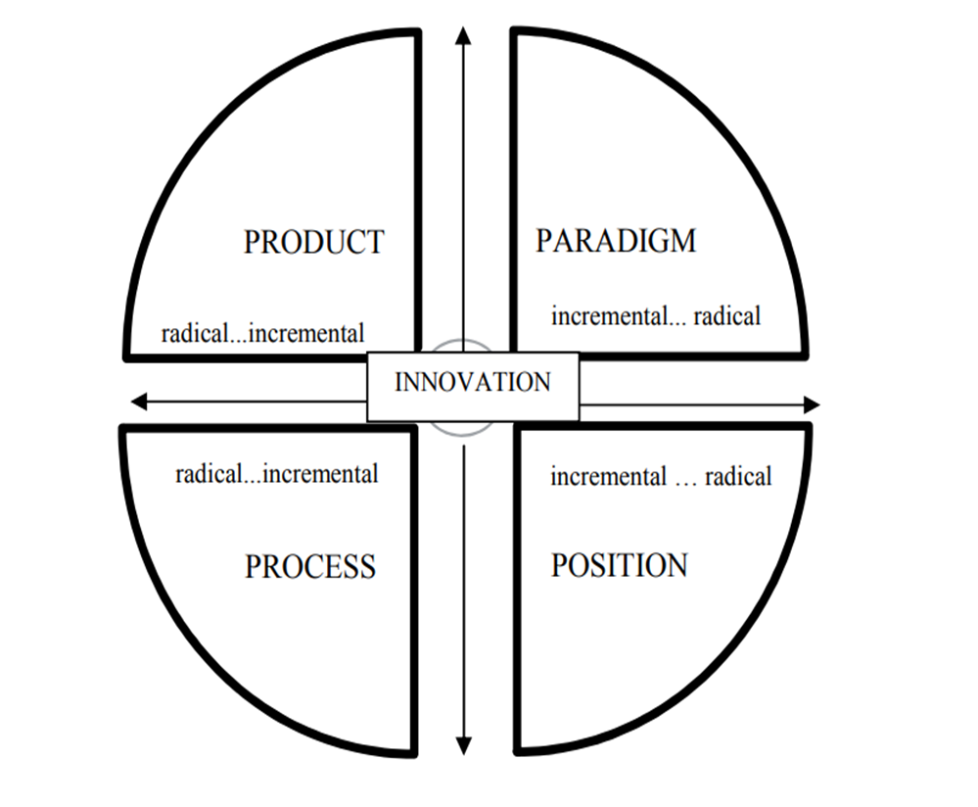
Source: Tidd and Bessant (2018)

A product or social innovation can compete with an existing standard solution. Every change comes at a cost. They can be of a financial nature (e.g., adopt the existing infrastructure to the new product) and of a non-financial nature (e.g., mental stress in the transition period from old to new). Consequently, a potential customer will only accept the competing innovation if it satisfies the needs to a higher extent than the old solution and if this benefit is worth the financial and non-financial costs (Flessa and Huebner, 2021).

Brainstorming at the ProCare Nursing Company Ltd.

Brainstorming is a creative thinking technique for generating new ideas and solving problems. Teams use this method to encourage new ways of thinking and collaboratively generate solutions. It can help with:
- Discovering what are the causes and / or solutions to problems.
- Preparation for new steps of a project.
- Decide on which problem (or opportunity) to work on (University of Cambridge, 2016).
By expressing ideas and listening to what others say, we adjust our previous knowledge or understanding, accommodate new information and increase their levels of awareness (UNSW Sydney, 2025). There are four stages of brainstorming, and they are:
Preparation for the brainstorming is important as it can give more time to attendants to think about potential solutions. When the problem with paper schedule occurs, there was a meeting with all the carers and management team regarding the issue with safety of our clients. Throughout the meeting many voices were heard, and everyone could explain what the issue was, what problem they faced. Many carers were complaining about schedule changed last moment, them not be able to remember all the addresses and codes for the keys. Some of the carers said that the paper schedule is not efficient as they can get ripped easily or misplaced and there is an issue to complete the work they are assign to. Cares age of this company differs from early 20 to late 60 years old. There were many ideas suggested like sending automatic private message to carer or sending emails with schedule. Those ideas were rejected due to difficulties for some carers, as they do not want to use their private email address for work purpose.
Incubation is a process when after brainstorming everyone introduce their ideas and now everyone has time to think about potential solutions or find another option to the problem we are trying to solve. After the brainstorming a long list of ideas and potential solutions may appear, walk away from them for a few hours or (ideally) a few days (Frey, 2022). The meeting was finished, and everyone was sent home with buzzing minds as to how solve the problem with working schedule. We were given time to think how to overcome the issue. I, myself decided to give myself time to process, go for a walk with friends and speak with them not about my work but about IT and using different tools for communication. As many of my friends are foreigners, they spoke of different apps they use. The conversation went on going with the world forward and use of computers, and how phones have changed over the years. With all the information, I have decided to give myself more time to think. Over couple of days many ideas popped up in my mind.
Illumination, walk, sleep, exercise, everything that help with brainstorming came to life and now we can focus on the exact idea and put together everything. The idea I came up with was to make an app that will have all the scheduled clients on our list. We could easier access lists of client and much more information regarding service users can be listed there. The app will be designed to help carers with the process of carrying for the clients and make sure we are informed about any changes to the care process immiedietly when occur. That app can also be connected to google map, or car parking listed near the client house. Big issue with the car parking as we as a carer have not been allowed to park on residential parking area and this is a big issue regarding wasting time to find free parking space near the client house. This resolution can give us more time to spend with service user and do our job better in assigned timeframe.
Verification can help to proceed with the idea, check how much it will be helpful. The idea is not new as many companies use apps to communicates with each other’s. For ProCare Nursing this idea is new and when described to other carers they happily express their approval. The information on the app will be more accessible to carers but also confidential as no one else can access it. The management team was informed about the outcome of brainstorming and decided to look for trusted mobile developers who could write a script that include all our needs.

Lewin’s Force Field analysis

Force Field Analysis is a tool that allows us to recognise a problem, identify main factors in a system, and make any improvements during the work. Force field analysis is helpful to gather positives and negatives aspects of the situation and make the points easy to compare. It allows to consider underlying roots of the problem and make changes to work planning to prioritise some factors (CNWL Improvement Academy, 2024).
ProCare Nursing conducted Force Field Analysis, and the results are surprising. Table below shows how the forces spread. There are much more forces for change that against it, but one point can stop all the process.

Force Field Analysis
FORCES FOR CHANGES  STAFF HAS EASIER ACCESS TO CLIENT LIST (5)  IMPACT ON ENVIRONMENT (4)  EASIER WAY TO INFORM ABOUT CHANGES (4)  COMBINED ADDRESSES WITH GOOGLE MAP (4)  SAFETY: PASSWORD ACCESS (5)  TOTAL: 22 | APP FOR CARERS | FORCES AGAINST CHANGES  STAFF NEED TO UPGRADE PHONES (1)  COST (5)  TOTAL: 6
Source: Self implemented

First force for change is the fact that staff will have easier access to client list which is weight at 5 points. Everyone has phone with them nowadays so there is no need to keep paper schedule with all the client addresses and key locks numbers. This application allows staff to enter list every time they log in. This app is password secured so every time I want check my next client address I must log in, weight at 5 points as it is very important aspect. It is better way to keep the fragile information secured. Even if I lose my phone no one else can log in. Many times, some carers felt sick so were unable to continue work which make management staff working harder to find replacement. ProCare has great number of clients so the logistics must be high quality. With so many people involved in care mistakes, sicknesses or accidents happen. Logistics is like a plan where organisation needs to successfully arrange a lot of people and equipment that is involved in a process (University of Johannesburg, 2025). All those problems are solved with the app that helps management team to informed about changes which are high on the list with 4 points. All the needed information is provided already within the system. Many carers are complaining about the parking space. Too much time is wasted to find free of charge parking space. Fines for parking on residential spaces are common. Google map has all the free car parks listed. The app can give easy access to those addresses when combine with app- 4 points. At last, but not least is the impact on environment with 4 points. Every week new schedule needs to be printed out. ProCare employs around 100 carers, printing out for all of them schedule require a lot of paper and ink which can be saved just by using phone which everybody has nowadays. Horry (2022) states that ‘by reducing the amount of paper, we can help the planet. (…) Chlorine is sometimes used to bleach paper to make it white, however this process is harmful to the environment and to human health.’ All those points are important for the process, and all together have scored 22 points.
Unfortunately, we must consider forces against the changes. With the fast-changing world, and new technology discover, many old appliances are not working well. This requires for the ordinary people to spend more money to update their phones. This is a problem for elder people who find new technologies confusing and they prefer to keep old devices. Many companies offer new phones, so it is not a problem to apply for new device that is the reason why this force got only one point. The biggest force against the change is cost of the application- 5 points on scale. All together forces against change have only 6 points, however the cost of the application is great and if not supported by huge amount of money impossible to do. The cost of app development in the UK for simple apps starts at £8,000 and exceeds £45,000 or more for complex ones states Bhatt (2024). UK government have been supportive toward businesses across the Great Britain, it has launched many projects that can help provide fundings for new plans for the company (GOV.UK, no date).
ProCare Nursing management team consider looking up for more possibilities to apply for grands or loans. There are many positives regarding new app for care workers that it would be bad decision to abandon this idea.

Cost of App Development
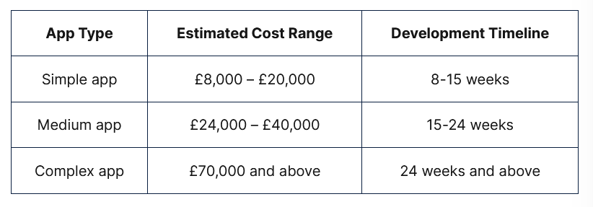Source: Bhatt, 2024

Ekvall’s ten dimension- organisational climate in ProCare Nursing td.

CIPD (2024) states that: ‘organisational culture is an important aspect of organisational life and a term that has become a mainstay among business leaders.’ According to Hussairy (2022) organisational climate affects and influence the employees’ performance, motivation, and job satisfaction. The organisation’s culture was made of the beliefs, traditions, and values of the people within the organisation. In contrast, climate refers to feelings, attitude, and recurring behaviour pattern which characterised daily life within the organisation, distinguishes between climate and culture based on methodological preferences. The ability of an organisation to adapt and develop to a changing environment is crucial for survival. This is especially true with the onset of disruptive changes when the ability and capacity to innovate becomes more important than ever (Olsson, 2019).

ProCare Nursing Ltd. Ekvall’s ten dimension

Idea support
Playfulness and humour
Dynamics and liveliness
challenge
Trust and openness
conflicts

Promoting innovation
ProCare Nursing creative climate
Inhibiting innovation

Risk taking
Idea time
debates
freedom

Source: self-implemented

Ekvall’s ten dimension describes that ProCare Nursing climate is promoting innovation to certain degree. As a company with over 20 years of experience we have learnt that everybody can solve problems with new ideas. The challenge with ProCare is that it is a private company but working with a councils must obey their regulations according to health and safety (Health and Safety Executive, no date). We are trained to deal with physical and mental disabilities. Whenever I had problem I could speak with my manager and solve the problem. My work as a carer can be challenging due to meeting with different people with different personalities and sometimes small misunderstandings can grow to a big problem. So, what style of leadership ProCare Nursing has? There are 8 leadership styles according to Parsons (2025), and those are:
- Autocratic leadership style focuses strongly on input and decision-making from the person in charge.
- Bureaucratic leadership style is primarily characterized by hierarchy.
- Coaching leadership style takes a personalized approach to leadership.
- Democratic leadership style emphasizes shared decision-making amongst team members.
- Laissez-faire leadership style Laissez-faire translates to “let it happen,” which encapsulates this leadership style.
- Pacesetter leadership style- leaders, who are pacesetters, opt to lead by example.
- Servant leadership style prioritizes well-being and harmony amongst team members.
- Visionary leadership style is all about having a long-term goal for the future and working toward that goal with others.
ProCare Nursing leadership falls in between servant leadership style and visionary leadership style. It is an organisation which motto is:

,,Providing first class health and social care
is what we are all about’’.

Working with different people especially disabled and ill can change your perspective and a way you receive the world. It can help with acceptance and stop you from overthinking over small things, it can understand other people. Management team shows us that we can show compassion and thanks to their treatment of their employees we can treat the same our service users.

Conclusion

In conclusion ProCare Nursing Ltd. is a company that will provide new technologies to improve carers and service users life. Throughout the process of brainstorming, I came up with an idea of an app for the carers to provide better service. The force field analysis also confirm that the app will be helpful. The management team of my company agreed to the idea and decided to look for possibilities to buy an app. This shows that the climate in the company is pro-innovations and will follow the world of innovation. The framework of 4’p of innovation shows that this app is incremental and falls between product and process.

References

- Bhatt, T. (2024) How Much Does App Development Cost in the UK [Full Breakdown]. [Online]. Mobile App Development. Last Updated: 15 April 2024. Available at: https://londonappdevelopment.co.uk/blog/app-development-cost [Accessed 17 March 2025].

- CIPD. (2024) Organisational climate and culture. [Online]. CIPD. Last Updated: 10 October 2024. Available at: https://www.cipd.org/uk/knowledge/factsheets/organisation-culture-change-factsheet/ [Accessed 21 March 2025].

- CNWL Improvement Academy. (2024) Force Field Analysis. [Online]. CNWL Improvement Academy. Last Updated: 2024. Available at: https://www.cnwl.nhs.uk/ia/resources/force-field-analysis [Accessed 17 March 2025].

- Costanzo Carleton, S. (2019) What is Incremental Innovation? [Online]. Northeastern University Graduate Program. Last Updated: 9 December 2019. Available at: https://graduate.northeastern.edu/knowledge-hub/what-is-incremental-innovation/ [Accessed 21 March 2025].

- DHSC Media Team. (2023) How we are delivering innovation in health and social care services. [Online]. GOV.UK. Last Updated: 23 June 2023. Available at: https://healthmedia.blog.gov.uk/2023/06/23/how-we-are-delivering-innovation-in-health-and-social-car [Accessed 20 March 2025].

- Flessa, S. and Huebner, C. (2021) Innovations in Health Care-A Conceptual Framework. Int J Environ Res Public Health. 18(19), p.1. [Online]. Available at: https://www.mdpi.com/1660-4601/18/19/10026 [Accessed 13 March 2025].

- Frey, Ch. (2022) The creator's guide to your "deep mind". [Online]. LinkedIn. Last Updated: 21 September 2022. Available at: https://www.linkedin.com/pulse/creators-guide-your-deep-mind-chuck-frey [Accessed 16 March 2025].

- GOV.UK. (no date) Find a Grant. [Online]. GOV.UK. Last Updated: no date. Available at: https://www.find-government-grants.service.gov.uk/grants?skip=70&limit=10&page=8 [Accessed 17 March 2025].

- GOV.UK. (no date) ProCare Nursing Agency Ltd. [Online]. GOV.UK. Last Updated: no date. Available at: https://find-and-update.company-information.service.gov.uk/company/03330099/officers [Accessed 13 March 2025].

- Health and Safety Executive. (no date) Care provided in people's own homes. [Online]. Health and Safety Executive. Last Updated: no date. Available at: https://www.hse.gov.uk/healthservices/domiciliary-care.htm [Accessed 21 March 2025].

- Horry, R. (2022) Seven top tips to reduce your environmental impact. [Online]. University of Derby. Last Updated: 11 November 2022. Available at: https://www.derby.ac.uk/blog/seven-top-tips-reduce-environmental-impact/ [Accessed 17 March 2025].

- Hussainy, S.S. (2022) Organizational Climate: From Literature Review to Agenda Ahead. International Journal of Engineering Technologies and Management Research. 9(1), pp.44-62. [Online]. Available at: https://d1wqtxts1xzle7.cloudfront.net/80553530/05_IJETMR22_A01_3008-libre.pdf?1644511811=&response-c [Accessed 18 March 2025].

- Joerns Oxford. (2025) Oxford Hoist: A Rich History. [Online]. Joerns Oxford. Last Updated: 2025. Available at: https://joerns.co.uk/oxford-hoist-a-rich-history/ [Accessed 20 March 2025].

- McKinsey & Company. (2022) What is innovation? [Online]. McKinsey & Company. Last Updated: 17 August 2022. Available at: https://www.mckinsey.com/featured-insights/mckinsey-explainers/what-is-innovation [Accessed 21 March 2025].

- NHS Oxford Health. (2020) Managing diabetes: check your sugar levels on an app. [Online]. NHS Oxford Health. Last Updated: 16 November 2020. Available at: https://www.oxfordhealth.nhs.uk/news/managing-diabetes-check-your-sugar-levels-on-an-app/ [Accessed 20 March 2025].

- Olsson, A. el. at. (2019) Organizational climate for innovation and creativity – a study in Swedish retail organizations. The International Review of Retail, Distribution and Consumer Research, 29(3), 243–261. Available at: https://doi.org/10.1080/09593969.2019.1598470 [Accessed 18 March 2025].

- Parsons, L. (2025) How to Determine What My Leadership Style Is. [Online]. Harvard Division of Continuing Education. Last Updated: 19 February 2025. Available at: https://professional.dce.harvard.edu/blog/how-to-determine-what-my-leadership-style-is/#Why-You-Need [Accessed 21 March 2025].

- ProCare Nursing Agency Ltd. (2022) Welcome to ProCare Nursing an award-winning health and social care agency with 25 years’ experience working in the care sector. [Online]. ProCare Nursing Agency Ltd.. Last Updated: 2022. Available at: https://www.procarenursing.co.uk/ [Accessed 13 March 2025].

- Sawyer, R.K. and Henriksen, D. (2024) Explaining creativity: The science of human innovation. Oxford university press, p.3. Accessed at: https://books.google.co.uk/books?hl=en&lr=&id=Nw3kEAAAQBAJ&oi=fnd&pg=PP1&dq=importance+of+creativity+and+innovation&ots=HFNUJeoULr&sig=WRidXdJRcLsErOcP3iUz4JRZ8mo&redir_esc=y#v=onepage&q=importance%20of%20creativity%20and%20innovation&f=false [Accessed 15 March 2025)

- Sternberg, R.J. and Kaufman, J.C. (2018) The nature of human creativity. Cambridge University Press, p.18. Accessed at: https://books.google.co.uk/books?hl=en&lr=&id=TLpQDwAAQBAJ&oi=fnd&pg=PR8&dq=related:y3fQXtkg5rsJ:scholar.google.com/&ots=hm8BiVjF-E&sig=zzF3I7E22MA0qkgurmjcX1CPwTc&redir_esc=y#v=onepage&q&f=false [Accessed 15 March 2025].

- Tidd, J. and Bessant, J.R. (2018) Managing Innovation: Integrating Technological, Market and Organizational Change. Edn. 6. John Wiley & Sons.

- Tidd, J. and Bessant, J. (2020) Managing Innovation: Integrating Technological, Market and Organizational Change. Edn. 7. Wiley.

- University of Cambridge. (2016) Brainstorming. [Online]. University of Cambridge. Last Updated: 2016. Available at: https://www.ifm.eng.cam.ac.uk/research/dstools/brainstorming/ [Accessed 21 March 2025].

- University of Johannesburg (2025) What is logistics? Definition, meaning and all the essentials. [Online]. University of Johannesburg. Last Updated: 2025. Available at: https://online.uj.ac.za/updates/what-is-logistics-definition-meaning-and-the-essentials-of-logistics [Accessed 17 March 2025].

- UNSW Sydney. (2025) Brainstorming. What is brainstorming? [Online]. UNSW Sydney. Last Updated: 10 January 2025. Available at: https://www.teaching.unsw.edu.au/brainstorming [Accessed 21 March 2025].

