The Structure and Culture of Matthews House

Module: The Introduction to the modern workplace
Name of student: Ella Williams
Student ID: 1707424
Contents Page

- What is included in this essay….…………………………………..3
- Structure……………………………………………………………………3-5
- Culture.............................................................................5
- Scheins Culture Triangle.………………………………………………5
- Cultural Web………............................................................7
- How culture and structure contribute to the organisation………………………………………………………………...8
- Conclusion……………………………………………………………………8
- Reference list…..…………………………………………………………..9

This essay will focus on the structure and culture of the organisation, Matthews House. Analysis will indicate how these factors all contribute to Matthews Houses’ performance as a whole.
Matthews House is a not for profit organisation, which offers food and hope to the local community. The organisation was established in 2015 and founded by a group of 30 friends who all wanted to give something back to their local community. Since going to an organisation like Matthews House in Cardiff they were determined to open their own organisation in Swansea. The organisation runs in The Hill Church which went on auction for £80,000 but the group managed to win the building at £75,000 (Thom, 2017).
According to Mullins (2016) structure is the division of work between members of the organisation like Matthews House and the management of all the activities each team member go towards the direction of their set goals. Within the organisation Thom is the only employee who has 62 people working for him, as well as my group and myself. As a team we are helping to raise money to fix Matthews House’s showers. People also volunteer at Matthews House. Some of the volunteers are homeless just enjoy working there because they feel like they are giving back to the community and they get hope from it. However, not every volunteer is homeless as Thom’s mother helps out with the organisation too.
Mullins (2016) state how there is no such thing as a perfect organisational structure, as building an effective organisational structure has become extremely difficult. When organisations increase their size and complexity, the co-ordination of the organisation becomes more challenging.
However, due to Matthews House only being a not for profit organisation it will not affect them as they are a small organisation it would be easier for Thom have all of the authority and responsibilities managed on a personal and personal basis (2017).
Although Thom seems extremely loyal and wants the organisation to be successful it could be dangerous because he has a lot of authority to the Matthews House. In 2017, a finance director named Robert Davies from Swansea was jailed for stealing £1.3m between 2008 and 2014 from a homeless charity to buy holidays and have a great lifestyle (2017). The charity did not pay enough attention to the finance director as they would have trusted the man.

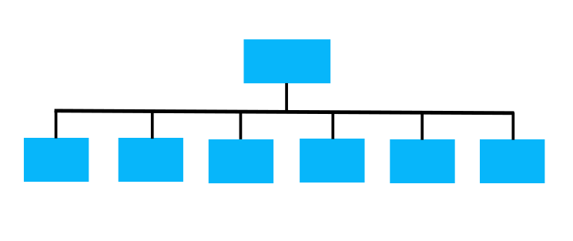
Figure 1: The flat structure has a wide span of control.

It is clear that the organisational structure of Matthews House is flat as it only has one layer in the organisational chart. As Thom is the only employee each volunteer will report to Thom about any problems or enquires on the organisation. Having one layer in management will mean fewer approvals when making a decision and Matthews House will be able to respond faster, making it more effective.
From how successful Matthews House has been so far it just shows they have a great organisational structure from the good management as it is showing great performance from the organisation. Thom believes in the organisation from the moment he set it up to now today and is extremely ambitious to become more and more successful every day.
In every organisation there is a span of control set in place as it is the amount of staff in the organisation that report to a manager. Matthews House has a higher average span of control due to their flat organisation. Decisions can be made quicker and there is much more communication between higher-level managers and trustees. This will help trustees to have more knowledge on the organisations goals. Also, due to the fewer management it would help to reduce the costs.
Span of responsibility is also important as every manager needs to know their responsibilities. However, Matthews House has a flat organisational structure so only Thom would have to learn how to do is job professionally by learning he would need to do. This would help towards his performance for the organisation (2007). Having a flat structure means everything done on a personal level and informal basis.
The people who make up the organisation are Thom, the volunteers and trustees. Trustees control the organisation and have the responsibility to make sure the organisation is on the right track, doing what it says it would (2015). By Law (Charities Act 1993, section 97), charity trustees have the general control and management of the administration of a charity. The organisation may have to pay their trustees to work for them or not pay them at all. It would all depend on the job of the trustee.
Trustees have the responsibility of planning what the charity do in order for them to reach their goal and what they would like to achieve. Managing the organisations resources responsibly such as their finances and managing their risks is very important (2015). If they have the understanding of benefiting the public then it would help a lot as the trustees would know what they would need to spend the charity’s fund on such as the café, showers, dignity packs and washing machines.
For the structure to work, Thom would have to communicate with his Trustees to know how the accounts are and how the board members are doing in order for everyone to know what is happening so everyone is on the same page. Without communication organisations would struggle. Thom would just have to communicate with his volunteers about what he would like them to do in order to help with the organisation.
“Culture is ways of thinking, behaving and believing that members of a social unit have in common” (Cooke and Rosseau, 1988).
Matthews House is a Task and Power Culture. This is because the organisation is set up just to help and give hope to the homeless, showing it is project orientated. However, there is a lot of work that needs to be done to the church itself so the organisation brings a lot of people together to help fix the roof and help out in the garden for free. Also, Tesco gives free food to the café as well as other organisations. Matthews House rely on personal communications and has worked very hard to get to where they are now (Introducing the Modern Workplace, Structure, 2017).
Power culture is usually in small organisations and they tend to rely on personal communication, empathy and trust within everything they do (Mullins, 2016).
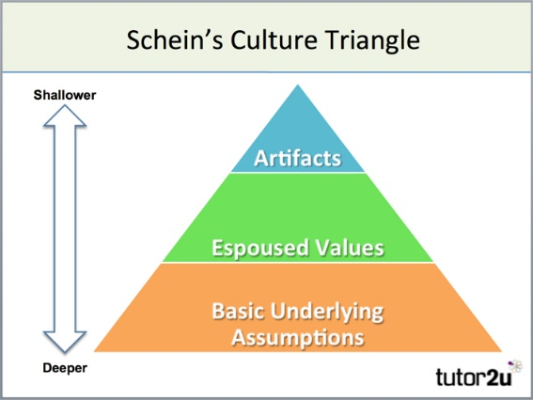

Figure 2: Schein’s Culture Triangle

In the eyes of Schein (2004), there are three different types of levels in an organisational structure, such as:
- Artefacts
- Espoused Values
- Basic Underlying Assumptions
Firstly, Artifacts are visible things which every organisations culture have (Mullins, 2016). In this case, the Artifacts of Matthews House would be homeless people. This is because they are can be seen and heard in which Matthews House are trying to help them by setting up their organisation.
Matthews House is extremely colourful and has been designed to give off a friendly image. Even the furniture looks colourful and comfy, making you feel like you would like to sit and stay in that environment. If everything is bright and colourful then it can improve your mood and behaviour.
Secondly, Espoused values are essential. Organisations need to believe in every solution that is created for them to become successful. Beliefs and values play a pain part in the organisations process which helps group members like Thom justify their actions and behaviours (Mullins, 2016).
Thom believes everyone should be happy and have a chance in life. Being homeless and feeling like you have no-where to turn and no one to talk to is out of the question for Thom. He wants to help people and give people hope that they can find their way of living again. In Matthews House there are positive statements on the walls to give homeless people positivity and hope when they read them.
Thirdly, Basic Underlying Assumptions which are very important as it is where culture is based. Solutions that become successful all of the time can be taken for granted and this could be a huge issue. However, implicit assumptions that usually guide the behaviour and determination of team members and how they feel and think about things (Mullins, 2016).
Successful organisations, like Matthews House, will understand their culture as they understand all of their assumptions. As Matthews House is based in a church it could be seen as the organisation being Christian. However, the organisation do not talk about God but it is around religious positivity and this could be another contribution to giving homeless people hope.
There is also more types of cultures such as National, International and Organisational Culture. Not everyone in an organisation is going to have the same culture so everyone has to respect cultural differences. Understanding every culture can bring people together.

The Cultural Web identifies a number of elements in which could be the stories, symbols, power and organisational structures, control systems, rituals and routines (Johnson and Scholes). This helps organisations create a bigger picture for their culture.

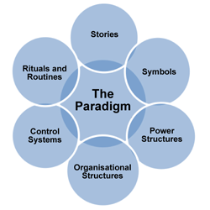
Figure 3: The cultural web
Thom has many stories such as how he ended his full time job to work at Matthews House. That job was a well-paid job and now the manager is working for less money, but is helping people who need it the most which would be more rewarding. Thom believes in what he is doing which has made it easier for him to make the decisions he has done. He has also fostered children and his mother helps out with the organisation too.
The environment has a huge impact on culture has it changes all of the time. Homeless people on the streets will be freezing as the UK weather is not great. Usually, it is either cold or raining and homeless people will struggle to keep warm. People could get extremely ill from weather changes and homeless people will become more likely to get ill. Matthews House offers vulnerable people a warm place to stay for a bit and they are able to have a warm meal too.
Organisational Culture shares beliefs, values and assumptions, directing people to behave in a certain way without realising it. Not everyone will be aware consciously of culture, it will still determine their actions and behaviour. Every organisation has their own personality employers and employees will adapt too. The personality of the organisation influences the behaviour of each individual (Mullins, 2016).
Organisations tend to develop within their culture. Instead of describing what they do, organisations set themselves mission statements. Matthews House have a mission statement which is to give hope and hospitality to people who may be homeless people, drug addicts, vulnerable people or alcoholics (2017).

The organisation itself believes that everyone should have some hope in their lives and shouldn’t have to feel like they are alone. From visiting Matthews House myself with my team members I can truly say that the organisation do exactly what they say they are going to do. Thom and volunteers all try and give hope and hospitality by opening the church every Monday, Tuesday and Sunday for people who need someone. This could just be to talk to someone and get some food.
In the church there is a Café that anyone is able to go to. Matts Café serve fresh, homemade food in which people can give as much as they feel or can to pay for it. Inside the café it is a warm, happy environment that makes you feel wanted. There is music playing in the background which is lovely and you feel safe in that environment. Being in Matthews House makes you feel like you should belong there and feel a lot of hope. However, it could be seen as Matts Café relying on people like myself to support the payments as we give what we feel and we would be able to give more than someone who is homeless.
“Many of the processes and practices we observe in an organisation could as readily be said to be part of the structure of the organisation as part of its culture” (Watson).
Structure and culture change all of the time, but both contribute to the organisations performance. Beliefs, values and attitudes will all have an impact on the organisation, including the structure. Structure and culture both impact each other and have a huge impact on the organisations performance (2013). The organisational culture would not be able to occur without the structure and if it did not match then the organisation would struggle. If the organisation knows the structure and culture well then if any changes occur it would not affect the organisation.
To conclude, the organisation itself is extremely successful. The structure of the organisation works effectively with the culture and the trustees, Thom and volunteers all work well together and all want to help their local community. The purpose of having a structure in an organisation is that it will help the organisation define each role and authority. It will help to make sure everyone in the organisation is doing what they are supposed to in order to accomplish their set goals. I also found that without culture weighing out the structure an organisation would not work so it is extremely important they both contribute to the performance of the organisation.

References
Andrew D. Szilagyi, J. a. (1990). Organisational Behaviour and Performance.
Andrew D. Szilagyi, M. J. (n.d.). Organisational Behaviour and Performance.
Commission, T. C. (2015, July 10). Charity trustee: what's involved (CC3a). Retrieved from GOV. UK : https://www.gov.uk/guidance/charity-trustee-whats-involved
Ex-finance boss jailed for stealing £1.3m from homeless charity. (2017, July 21). Retrieved from Itv: http://www.itv.com/news/wales/2017-07-21/ex-finance-boss-jailed-for-stealing-1-3m-from-homeless-charity/
Is There a Relationship Between Organizational Structure and Culture? (n.d.). Retrieved from Brighton School of Business and Management: https://www.brightonsbm.com/news/relationship-organizational-structure-culture/
Janicijevic. (2013). The mutual impact of the organizational culture and structure.
Mullins, L. J. (2016). Management & Organisational Behaviour.
Mullins, L. J. (n.d.). Management & Organisational Behaviour .
Organic Organizational Structure: Definition & Examples (n.d.). [Motion Picture].
Reach. (n.d.). Retrieved from Reach Volunteering: https://reachvolunteering.org.uk/knowledge-centre/support-boards/becoming-and-being-trustee/our-guide-being-trustee
Riley, J. (n.d.). Models of Organistaional Culture - Schein. Retrieved from Tutor2u: https://www.tutor2u.net/business/reference/models-of-organisational-culture-schein
Span of Control in Management: Definition, Disadvanages & Advantages. (n.d.).
Span of Managerial Responsibility. (2007, November 14).
The Cultural Web. (n.d.).
The Cultural Web. (n.d.). Retrieved from Mind Tools: https://www.mindtools.com/pages/article/newSTR_90.htm
The essential trustee: what you need to know, what you need to do. (2015, July 10). Retrieved from GOV.UK: https://www.gov.uk/government/publications/the-essential-trustee-what-you-need-to-know-cc3/the-essential-trustee-what-you-need-to-know-what-you-need-to-do#s4
The flat structure has a wide span of control. (2017, June 5). Dili.
Thom. (2017, October). First meeting with Thom about Matthews House. (J. N. Ella, Interviewer)
What is a Flat Structure in an Organization? - Definition, Advantages & Disadvantages. (n.d.).
What is a Trustee? (2017, November 15). Retrieved from Know how non profit : https://knowhownonprofit.org/governance/getting-started-in-governance/trustees
What is an Organizational Environment? - Definition & Theory (n.d.). [Motion Picture].
What is Organizational Culture? - Definition & Characteristics (n.d.). [Motion Picture].

