
Student Name: Poshiya Maulik Shaileshbhai

Student ID: 2511036

Module Name: Marketing Management

Module Code: LMCB7024

Lecture’s Name: Dr Laila Maazouz (London)

Poster- Marketing strategy
Term 1
Table of contents
Element 1: Segmentation, Targeting, Differentiation, and Positioning(STDP) Analysis……………………………………….…….3
Introduction of the company……………………………………………..3
Concept behind the proposed new brand……………………………...4
Why this new brand would appeal to the current market……………..5
Identification and description to the key market segments relevant to brand………………………………………………………………………..6
Explanation of the chosen target audience……………………….…….7
Why the brand will differentiate itself from competitors in the market and outline its desired positioning……...……………………………………..8
Element 2: Marketing Mix (4Ps)..…..…………………………………….8
Product…….……………………………….……………………………….8
Price……………………….………………….……………………………..8
Place………………………………………………………………………..9
Promotion………………………………………………………….……….9
Element 3: Marketing Strategy Pitch…………….…..………………….10
Element 4: Reflection….……………………………………………………………….11
References………..……………………………………………………….12
Element 1: Segmentation, Targeting, Differentiation, and Positioning (STDP) Analysis
Introduction of the company
With operations in more than 170 countries and yearly sales of over USD 8 billion, Skechers USA Inc. is one of the biggest footwear and lifestyle companies in the world (Skechers USA Inc. 2024). Since its founding in 1992, the firm has transformed from a producer of casual footwear into a well-known lifestyle brand that sell sports footwear, clothing, and accessories. By emphasizing comfort technology, ergonomic design, affordability, and inclusive positioning, Skechers has developed significant brand equity that allows it shoes appeal to a broad range of consumers, including young adults, working professionals, and senior citizens.
Skechers promotes itself around everyday movement, accessibility, and comfort-led innovation, in contrast to high-end sportswear companies like Nike or adidas, who prioritize peak athletic performance and professional sprots endorsements. Because of this difference, the brand has been able to gain a significant portion of the mass and mid-market categories, especially among customers looking for everyday products that are accessible, fashionable, and useful (Kotler, Keller, and Chernev, 2024). The brand’s deliberate emphasis on mobility, wellness, and active living as opposed to competitive sprots is in line with charging consumer preferences that place a high value on balance, convenience, and health.
Skecher’s abilities to maintain a robust worldwide distribution network while striking a balance between innovation and cost gives it a competitive edge. The brand has positioned movement as an essential part of baily wellbeing rather than a specialized athletic endeavour, progressively aligning itself with lifestyle-oriented physical exercise. This strategic focus offer a solid basis for growth into linked transportation and active lifestyle segments.
Skechers is in a good position to expand its fundamental brand promise beyond footwear give the worldwide trend toward sustainable transportation, growing urbanizing, and rising awareness of health and environmental issues. Through a well placed sub-brand, Skechers may legitimately enter the quickly expanding electric mobility market by utilizing its well-established reputation for comfort, ergonomic knowledge, and worldwide reach.
The Idea behind the suggested New Brand
S10 is an electric cycle (e-bike) brand that is intended to promote contemporary, energetic, and sustainable lives. S10 will concentrate on lightweight, ergonomic electric bicycle that put comfort, usability, and urban mobility ahead of competitive or high-performance riding criteria. The brand name “S10” represents Skechers’ next evolutionary step toward mobility-focused innovation as well as speed, simplicity, and sustainability.
S10 electricity bikes are designed for wellness-focused mobility, recreational riding and commuting. The product concept is aimed at customers who want to incorporate physical activity into their daily routines and are looking for easy, eco-friendly alternative to cars and public transportation. In order to provide accessibility for riders with all levels of cycling experience, the brand will prioritize smooth riding experiences, user-friendly, and simple aesthetics.
S10 will occupy a mind-market position that combines dependability, comfort, affordability, and lifestyle appeal rather than immediately competing with high-end bicycle companies that concentrate on advanced technical performance or professional riders. Skechers can expand its comfort-led reputation into the electric mobility market without weakening its current brand quality thanks to this strategic approach, which is consistent with the company’s key brand principles.
Why the Current Market Would Find This New Brand Appealing
Urban congestion, growth fuel prices, environmental concerns, and growth interest in sustainable and active transportation options have all contributed to the explosive expansion of the worldwide electricity bicycle market. The worldwide e-bike market is predicated to reach USD 70 billion by 2030, indicating significant long-term growth potential, according to Statista (2024). E-bikes are no longer seen as specialized recreational items but rather as useful mobility solutions.
The desire for personal mobility choices that lessens dependency on congested public transport while fostering physical and mental wellbeing has increased due to post-pandemic behavioural changes (McKinsey & Company, 2024). Nowadays, consumers are increasingly likely to embrace hybrid lifestyle that incorporate flexible commuting, remote work, and wellness-focused pursuits. Because they provide low-impact workout, ease, and environmental advantages, electric cycle blend in perfectly.
S10’s accessible entry point into electric transportation makes it appealing to the existing market. Many prospective buyers show interest in e-bikes, but are turned off by high costs, complicated technology, or performance-focused branding that seems frightening or exclusive (Mintel, 2024). S10 presents electric cycles as inclusive lifestyle items rather than specialized equipment by utilizing Skechers well-established reputation for comfort, reliability, and accessibility.
Urban workers, students and wellness-conscious consumers that value comfort, sustainability, and convenience over speed or competitive performance are especially drawn to this strategy. S10 is therefore in a good position to meet unmet demand in the expanding micro-mobility industry.
New Patterns and Shifts in Consumer Behaviour
The release of S10 is supported by a number of consumer-level and macro trends. First, the need for compact and effective mobility solutions has increased due to the growing urbanizing that has exacerbated traffic congestion, pollution, and parking issues in metropolitan regions (UN Environment Programme, 2024). Short-to medium-distance travel with little environmental impact is made possible by electric cycles, which offer a workforce solution to these problems.
Second, consumers now consider sustainability when making decisions. According to research, customers in the Millennial and Gen Z generations are expecting firms to show true environmental responsibility instead of considering sustainability as an afterthought (PwC, 2024). The relevance of S10 is further supported by the widespread perception that electric mobility is a more sustainable optional than transportation based on fossil fuels.
third, the idea of “movement as wellness” in which physical activity is incorporated into daily life rather than limited to gyms or organized supports, has influenced consumer behaviour (McKinsey & Company, 2024). By providing changing degree of physical effort, electricity bicycles encourage this way of thinking and make cycling accessible to those with different levels of fitness.
Lastly, customers are expecting more and more thing to be digitally integrated aesthetically beautiful, and easy to use. Simple interface, intelligent connection, and smooth user experiences are more appealing to mainstream users than complex technical specifications (Garter, 2024). A lifestyle-focused e-bike like S10 that place an emphasis on comfort, use and design is favoured by these trends.
Determining and Outlining Important Market Segments
The following are the main market niches that are pertinent to the S10 electric cycle brand:
Urban Millennials and Gen Z (ages 20 to 35):
Convenience, flexibility, and lifestyle mobility are valued by these environmentally conscious, digitally connected customers. Social media, peer recommendations, and experiential branding all have an impact on this market, which is quite open to sustainable solutions.
Young Working professional:
people who commute short to medium distance and are looking for stress-free, economical, and efficient transportation options. Practically, design, and depending are important to the.
Customers engaged in low-impact exercise that promotes lifespan, mobility, and health are known as wellness-oriented consumes (age 30 to 35). Comfort, security and usability are given top priority in this section.
students and urban dwellers are price-conscious customers looking for less expensive options to ride-hailing services and public transportation. Low operating cost, durability, and accessibility are important to them
Sustainable, easily accessible, and lifestyle-focused mobility solutions that blend in with everyday activities are preferred by these groups.
Explanation of the Chose Target Audience.
Urban Millennials between the age of 20 and 35 especially those who raised in metropolitan and tire-one cities, are the main target demographic for S10. This group strongly supports digital involvement, lifestyle branding, and sustainability ideals. They look for goods that are who they are, facilitate flexible living, and provide useful advantages without being overly complicated (Euromonitor International, 2024).
additionally, this demographic is more open to participating in shared or alternative transportation networks and embracing innovative mobility solutions. They are a perfect target for a lifestyle-focused electric cycle business because their purchasing decisions are heavily impacted by peer pressure, design aesthetics, and brand values.
Wellness-conscious adults between the ages of 30 and 55 who are looking are low-impact, comfortable, transportation solution make up the secondary target demographic. Skechers established reputation for comfort technology and ergonomic design makes the S10 more alluring to this demographic since it lowers the perceived danger of switching to electric vehicles.
Differentiation and Desired Positioning Using Comfort-led Mobility to Differentiate
S10 sets itself apart by marketing the electric as a lifestyle product that prioritizes comfort above performance or technological complexity. While many rivals place more emphasis on speed, battery, or cutting-edge features, the S10 priorities ergonomic design, seamless riding, user-friendly controls, and aesthetically pleasing simplicity.
By addressing unmet customer demands linked to accessibility, confidence, and everyday utility, S10 stands out in a competitive market thanks to this distinction, which is perfectly in line with Skechers brand DNA.
Statement of position
S10: Easy to Move.
For everyone urban mobility, wellness, and sustainable living, S10 will be positioned as an approachable, comfortable-led electric bike brand.
Element 2: Product Marketing Mix (4Ps)
A variety of lightweight urban electric bicycles with integrated battery systems, ergonomic handlebar, adjustable seats, and step-through frames will be available from S10. Comfort, safety, and usability will be given top priority in this product range, making it appropriate for both novice and seasoned riders.
pedal-assist modes, detachable batteries for easy charging, smart app connectivity, and integrated lighting systems are some of the key features. Customers that are concerned about their lifestyle will find the design to be contemporary and minimalist.
Alignment with Brand Strategy: The product strategy expands Skechers ergonomics knowledge into the mobility sector and strengthens S10’s comfort-led positioning.
Price
Skechers long-standing value proposition of providing high-quality items at reasonable rates will be reflected in S10’s Accessible-premium pricing strategy. While preserving a distinct quality edge over inexpensive, unbranded alternatives, the pricing will be positioned below premium performance e-bike brand. This strategy fits with lower adoption hurdles for new electric bike consumers.
The entire product line will have tiered pricing, with entry-level models intended for urban commuters and students and higher-spec models with longer battery life, more advanced smart capabilities, and better durability. Value-based pricing will be strengthened by highlighting long-term financial advantages over fuel-powered alternatives, such as lower shipping costs, low maintenance costs, and environmental savings. Seasonal promotional prices and flexible payment schedules will encourage trial and repeat purchases. Overall, S10’s reputation as a reliable, inclusive, and value-driven mobility brand is strengthened by the pricing approach.
Place
In order to maximize accessibility and convenience for urban consumers, S10’s distribution strategy will employ an integrated omnichannel approach. A major advantage will be Skechers current worldwide retail infrastructure, with certain flagship locations housing S10 experience zones. These in-store displays will lower the perceived purchase risk associated with high-involvement products, enable customers to physically interact with the product, and provide expert help.
With the help of third party markets and Skechers online channels, e-commerce will be crucial. A smooth purchase and ownership process will be guaranteed by home delivery, assembly services, and approval services, and approved service partnerships. Brand awareness in urban regions will be further increased through strategic placement in lifestyle-focused retail establishments and urban mobility stores. S10’s positioning as a daily lifestyle solution rather than a specialized cycling product is strengthened by this distribution approach.
Promotion
Comfort, sustainability, and daily mobility will be highlighted in S10’s lifestyle-driven, digital-first marketing campaign. Instead than focusing in technical details, social media campaign with urban commuters, wellness enthusiasts, and environmentally conscious influencers will highlight real-life usage scenarios. Storytelling will be the main focuse of the content, which will highlight hoe S10 fits into everyday activities including commuting, leisure rides, and wellness expeditions.
Pop-up test-ride zones and city ride events are examples of experiential marketing activities that will promote community involvement and product trails. Communication will be infused with sustainability messaging to further emphasize S10’s commitment to ecologically conscious living. The commercial campaign seek to establish trust, promote adoption, and present S10 as a cutting-edge electric mobility brand by utilizing Skechers strong brand recognition and emotional appeal.
Element 3: marketing strategy 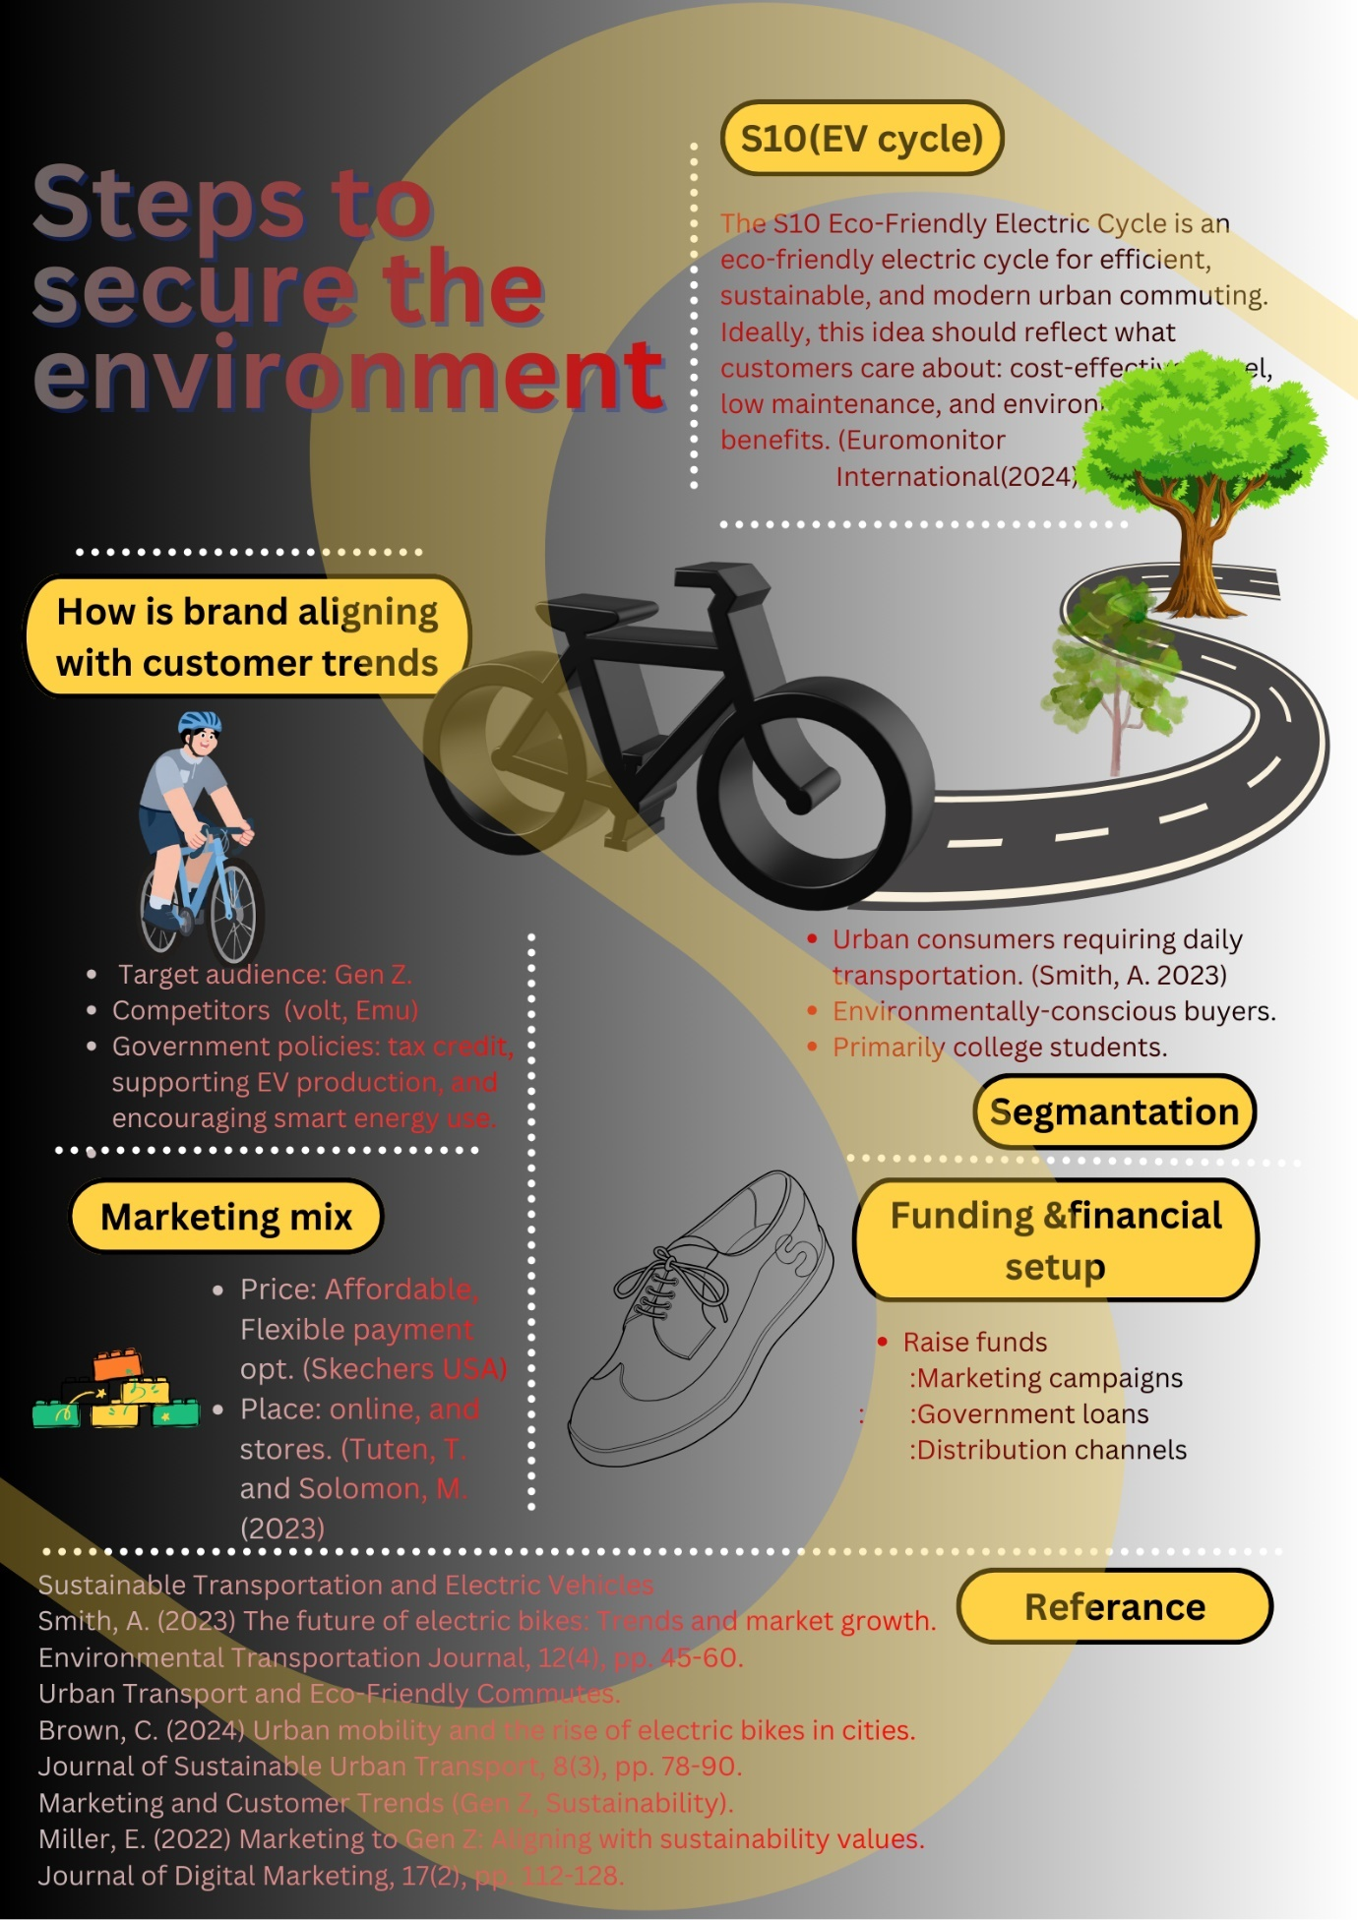
Element 4: Reflection
The creation of the S10 brand concept gave important insight into the prospects and strategic difficulties of expanding a well-known lifestyle brand into a new product category. Maintaining brand coherence while pursuing brand extension tactics was one of the most important lessons learned. The S10 idea maintains credibility and strategic alignment by firmly rooting it in Skechers current values of comfort, accessibility, and everyday movement.
using the STDP framework improved my capacity to analysed market complexity, pinpoint relevant categories, and support targeting choices with trends in modern consumer behaviour. The procedure made clear hoe crucial it is to differentiate product based on actual customers need rather than flimsy characteristics. The interdependence of product design, pricing, distribution, and promotion in promoting consistent brand positioning was reaffirmed by the marketing mix analysis.
My ability to combine intricate strategic concepts into a coherent and convincing story was enhanced by preparing the marketing strategy pitch. Incorporating financial projections, competitor benchmarking, and primary consumer research would improve strategic rigor in subsequent initiatives. Additionally marketing communications would be more effective if more sophisticated visual storytelling approaches were developed.
References
Deloitte (2024) Global automotive and mobility trends 2024. Deloitte Insights.
Euromonitor International (2024) Electric bicycles and urban mobility trends.
Gartner (2024) Urban mobility and e-mobility forecast.
Kotler, P., Keller, K.L. and Chernev, A. (2024) Marketing management. 16th end. Pearson.
McKinsey & Company (2024) The future of urban mobility.
Mintel (2024) Urban transport consumer trends.
PwC (2024) Consumer attitudes towards sustainable transport.
Skechers USA Inc. (2024) Annual report.
Statista (2024) Global electric bicycle market size and growth.
Tuten, T. and Solomon, M. (2023) Social media marketing. Sage.
UN Environment Programme (2024) Sustainable urban transport report.
WARC (2024) Lifestyle brand extensions and mobility.

