DIGITAL SURVeying and highway design
DIGITAL BUILDING SURVEY
matthew cole

2502634

30.12.25

Table of Contents
Introduction 2
Part 1: Planning the survey 3
Part 2: Practical 5
Part 3: Measurement & Analysis 6
Conclusion 7
References 8
Sketches 9

Introduction
The survey plan will outline the correct method for undertaking a professional digital building survey using the 3d laser scanner that we were provided with by the university, the survey will be carried out on a building “The Dylan Thomas Centre” which is currently in use by the university. The survey plan takes into consideration six main components of planning, these are as follows:
Survey objectives
Site logistics and layout
Safety protocols
Data requirements
Risk management
It is crucial that all of these are carried out to a professional standard, The Dylan Thomas Centre is occupied daily by university students for the use of lectures and studies.
It is important that the survey does not interrupt the day-to-day activities within the building and that we understand where is accessible to carry out the survey for both the students carrying out the survey and the students and lecturers within the building that are studying.
The objectives of the survey were to gather 3d laser data of the upstairs first floor corridors and to then correlate that data into a single format plan, with an aim to gather room layout, wall positionings and door openings and general lay out of the chosen upstairs floor.
The specific item we will be using during the laser scans is a Leica RTC360 the cost of this item is roughly around £47,000 (G2 Survey Equipment Specialists) this is excluding software’s which are used to produce the drawings and other item which is also required i.e. tripod, iPad and any other equipment which is necessary to care out the survey.

Part 1: Planning the survey
The survey main objective is to replicate an accurate digital plan of the internal geometry of the Dylan Thomas Centre using a Leica 3D laser scanner, the digital drawing will take the form of a registered point cloud, highly reliable measurements can be extracted from this to produce accurate drawings. The specific objectives within the survey will be capturing the internal layout of the building including corridors, and walking areas, recording floor plans and ceiling heights and any obstacles that are within those areas. We also aim to identify and measure structural features of the building and architectural features such as utility risers, walls, columns, staircases and openings. All of this is completed so that we can produce data suitable for measured drawings, planning the use of space, and the potential for future refurbishments projects.
Another notable objective is to demonstrate the modern digital survey techniques that are becoming ever so increasingly popular with the advancements in measuring technology.
The first floor corridors are the only parts of the building which will be incorporated within the survey, the survey will not focus on staircases, or minor architectural details as the primary focus is to obtain the spatial geometry that is relevant to the internal building measurements and layout of the chosen floor.
The level of detail that is required needs to be suitable for producing architectural drawings with a high emphasis on the internal wall layouts and thickness, the floor and ceiling planes, openings for windows and doors and include structural features such as columns. The decorative elements within the building would be captured within the 3d scans but aren’t relevant to our measurements.
Regarding our site assessment prior arrangements will be arranged in advance with the university so that it doesn’t disrupt the running of the day and that there are no interruptions, the survey work will be conducted during a period where there is lighter use of the facilities where possible to minimise disruption and reduce movement within the specific scan locations, clear access routes will be identified for the transportation of the survey equipment that will be used during the survey. All the scanning positions will have been selected prior to the survey to avoid blocking fire exits or any of the main walkways that are in regular use.
The scanning positions will be planned to ensure that there is adequate overlap between the scans so that there are no missing parts of the scan and there is full coverage of all the corridors from floor to ceiling and that there is minimal interference from any furniture, obstructions or structural elements that are linked to the building. We aim to overlap the scans typically 30/40%, this will then allow for successful post survey processing.
The lighting conditions will have little to no impact on the laser scans or the accuracy of the equipment, however, there needs to be sufficient adequate ambient lighting, this will be beneficial for any photographs that we take, there will be no additional lighting needed to conduct the survey.
During the survey there are various safety concerns that we need to be aware of these come in the form of fire exits one of which is situated to the rear of the building (North) in the form of a large internal staircase, there is to be no use of lifts in an emergency situation and the main staircase also acts as a fire exit out the front door of the building, the emergency rendezvous point is to the car park at the front of the building, whilst conducting the survey at no time will any fire exits be obstructed this falls in line with the 2005 fire safety act, “Where necessary in order to safeguard the safety of relevant persons, the responsible person must ensure that routes to emergency exits from premises and the exits themselves are kept clear at all times.” (The Regulatory Reform Fire Safety Order 2005)

As part of the risk management during the survey there are some identified risks which are as follows:
Potential trip hazards from equipment and tripods
Manual handling injuries during equipment transport
Interaction with members of the public
Potential damage to the building

Our mitigations measures come in the form of the following:
Careful placement of working equipment away from high use areas
Use of lifts and correct lifting techniques
Clear communication with staff and potential visitors
Non-contact scanning methods and cautious movement within sensitive areas

A dynamic risk assessment will be maintained consistently, thus allowing students ‘surveyors’ to adapt procedures if the site conditions change during the survey.

Part 2: Practical
We attended site on the 3rd of November 2025 at 11.30am, prior access had been agreed with UWTSD University, we all met in the auditorium where we gathered the necessary equipment and done checks of the equipment prior to the survey being conducted, Matt also give us a run-down of the equipment and how it would be used he then briefed us on the plan for the survey. We then continued to the upper first floor where the survey was to be conducted, we done the necessary safety checks i.e. familiarisation with fire exits, checked which rooms were occupied as to not cause issues with others working, we then decided on scan locations, finally we pinned doors open to allow us to conduct scans with little interference.
We then set about getting the 3D laser scanner set up at the first location in the corridor, the scanner was positioned at points of the corridors which would not cause obstruction or block any of the fire exits or their routes, we conducted various scans at each corridor to allow an overlap which would gain the relevant detail needed for a complete set of drawings, the level of detail on the scanner was reduced to the midway point as Matt didn’t feel that the highest level of detail was required. The survey was conducted without any major issues and I feel everything went ahead as planned, Matt did give us some insight into the editing software which was on the iPad and allowed us to get a hands on feel for adjusting the scan data on the iPad as an overlay & locking the scans on top of each other.
The only real time issues we were faced with as a group came in the form of people getting in the way of the scanning equipment, as we were all keen to see the equipment in operation it did prove difficult trying to keep out of the way of the scanner, nevertheless the scans were completed within the time frame window we set which was two hours and the group all worked efficiently together to complete the survey keeping the relevant task in hand at the forefront of our thoughts. Another issue we were faced with was objects such as bins and chairs that were in the corridors, it did add a small level of complexity to the scans and at times proved difficult to manoeuvre the equipment around these item, it was rather simple to avoid getting these items within the scans as we would either remove the items from the scan location or position the scanner above the items which would essentially remove them from the scanning window.
I feel the survey went to plan and followed the correct methods that we set out to complete in a well organised and timely manner, we didn’t cause any interference with the day to day running of the Dylan Thomas centre.

Part 3: Measurement & Analysis
After completion of the scanning being completed at The Dylan Thomas Centre, the processed scan data was provided to us in paper format at a scale of 1:100, the scans showed all the areas that we scanned as part of the original survey with accurate internal measurements, these drawings were cross referenced against the manual drawings that were taken in pairs. We obtained the manual drawings using laser measurers, tape measures and rulers which were provided to us by Matt.
The overall room dimensions for the corridor spaces are very close if not exact. We used corridor 1 as a comparison, corridor 1is the corridor which on the drawing is marked as having the “Fire Escape Stairs”, working to scale and against our manual measurements it reveals the scanner recorded the longest part of the corridor at an approximate length of 9.1m and a width of the widest part of the corridor at 1.8m, the average width of the corridor space was measured at 1.1m these measurements are extremely close to the manual measurements that were taken by hand the only issue I have in my findings is that the ruler I have only gives mm as its smallest measurements and my measurements by hand were measured down to the nearest mm.
The door opening dimensions show themselves in two forms on the drawings, we have single doors and double doors, the single doors measure approximately 800mm and the double doors measure at approximately 1600mm.
I find the comparison between the two methods of measuring rather differently, the traditional measuring relies on tape measures or laser metres and manual recording, this can be time consuming and prone to human error especially in complex or irregular spaces which has proved itself in The Dylan Thomas Centre with its layout, the accuracy solely depends on the surveyors skill and accuracy and consistency, revisits are generally often required if details are missed.
In contrast 3D digital scanning is superior in the sense that it captures millions of data points and correlates all this data into a single format scaled drawing, in a relatively short space of time various measurements can be taken without the needs for multiple return visits to site, whilst the initial equipment cost is higher, laser scanning is often more cost and time efficient for large scaled projects. Overall traditional methods suit small, simple spaces. However, 3D laser scanning offers superior accuracy, flexibility and speed for the more modern surveying needs.
“3D laser scanning offers a level of precision, speed, and versatility that is unmatched by traditional methods. For real estate professionals, it provides a reliable way to obtain detailed, actionable data that supports confident decision-making and minimises risks.” (Traditional surveying vs. modern laser scanning: what you need to know)

Conclusion
I conclude that this assignment has demonstrated the differences between traditional measuring methods and more modern digital methods, it shows the clear differences between the two methods and clearly demonstrates that the digital method is much more cost effective for large scale projects and produces a finer more modern more professional approach to the work that is required by many surveyors across the globe, the accuracy is far greater with a laser scanner and much more consistent than traditional methods using hand tools such as tapes and rulers.

References
The Regulatory Reform Fire Safety Order (2005) https://www.legislation.gov.uk/uksi/2005/1541/contents (Accessed on 30th December 2025)

Traditional surveying vs. modern laser scanning: what you need to know (2025) https://stak.co/insights/traditional-surveying-vs-laser-scanning (accessed on 2nd January 2025)

Sketches

Appendix A: Hand drawn sketch

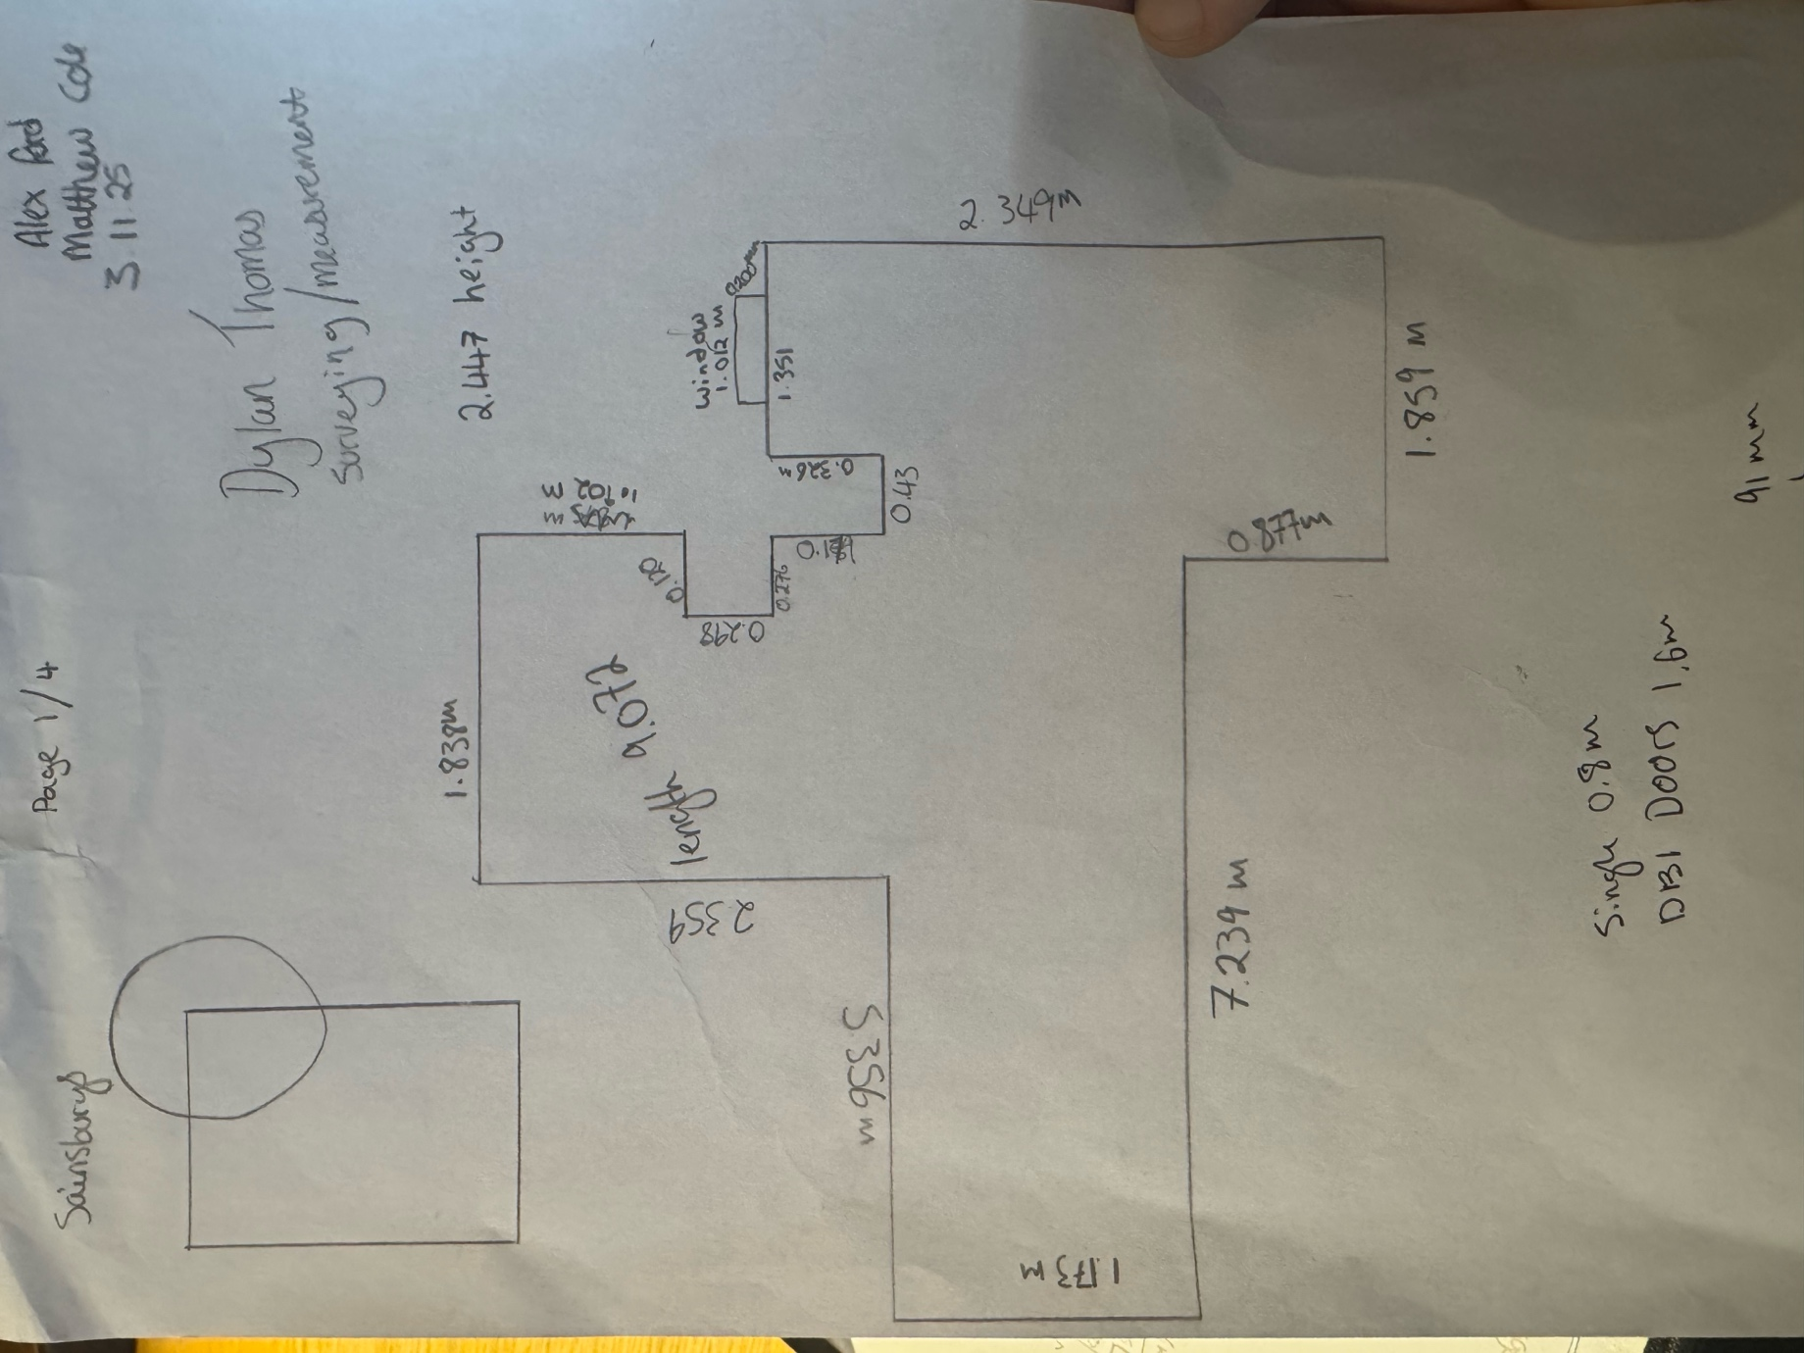

Appendix B: Laser Scan 1:100

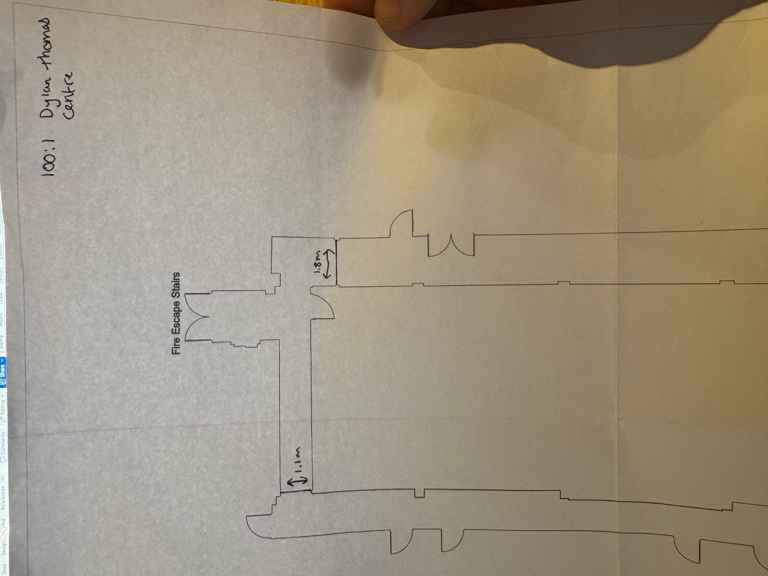

Appendix C: Measurements taken from 1:100 laser scan (The Dylan Thomas Centre)



