Student ID: 2206803
Word count: 4378

What can my Neurodivergent experience of Burnout teach me about myself and my future as a Psychotherapist?

The current Heuristic Inquiry was conducted as part of second-year requirements on a Psychotherapeutic Practice MA programme. The assignment parameters being to carry out an in-depth Heuristic Inquiry using Moustaka’s (1990) method, exploring personal insights and reflections, which may have, and may continue to, influence growth as a Psychotherapeutic Practitioner. Moustakas’s (1990) method comprises phases (initial engagement, immersion, incubation, illumination, explication, creative synthesis) and within these phases, processes (identifying with the focus of inquiry, self-dialogue, tacit knowing, intuition, indwelling, focusing, internal frame of reference); all of which were engaged with by myself during this inquiry, as sole participant and researcher.

The Heuristic Inquiry method was developed by Moustakas (1990) to reflect and encapsulate the natural process humans go through whilst exploring phenomena and is closely linked to the creative process (Sultan, 2019). Indeed, during the current investigation, I experienced natural cycles of Heuristic Inquiry before I even knew what it was (appendix 1), whilst understanding what Heuristics is and navigating how to make a start on the assignment. During these formative stages, I began to understand, through experience, the “innate artistry (of this) back and forth…rhythmic dance” (Sultan, 2019, p12) between the phases, which were all the while defined and characterised by the processes. This dance was not something I forced or tried to do, rather something that was happening anyway, and has always happened within me that I am only now discovering a common language for (appendix 9). Subsequently, Heuristic Inquiry went from being the most baffling, to the most natural and instinctive process, and from this point onwards took on what often felt like, a self-propelling life of its own.

Moustaka’s (1990) Heuristic Inquiry method has strong basis in the Humanist notion of what it is to be a person, with influences (not exclusively) from; Buber’s i-thou and betweenness, Rogers’s person-centred ideology, Gendlin’s felt senses and embodiment, Polyani’s work on tacit knowing and indwelling, and Maslow’s self-actualising tendency (Moustakas, 1990; Sultan, 2019). As an approach it is reflexive, non-linear, and concerned with deriving meaning from subjective experience, that may or may not be applied more broadly, as opposed to measuring absolute truths (Moustakas, 1990; Sultan, 2019).

The mere mention of such subjectivity is enough to strike terror into the hearts of many an ‘ethical’ researcher, whose gospel is universal truth and objectivity; certainly, measurable empiricism has long reigned as king in the world of research (Mulisa, 2022). However, a daring few pioneers had long argued that the very concept of objectivity is a fallacy, that the researcher is always present and steering the outcome, though this is often out of awareness (Bridgman, 1950; Moustakas, 1990; Rogers, 1955). One might argue then, that to not only acknowledge, but lean into the subjective experience of the researcher, merging themselves as one with participant, is the ultimate act of congruency and methodological transparency (Sela-Smith, 2002).

Initial Engagement, Internal Frame of Reference and Literature Review
Having claimed an identity as a Highly Sensitive Person with Sensory Processing Sensitivity (Aron, 2017; Roxburgh and Churchill, 2023) after the birth of my second child, it was only when re-entering the world of academics at the age of 40, that I realised the extent of my sensory and processing differences. At this point I began to suspect that I share traits in common with what some people refer to as ADHD. However, I do not feel disordered and even though I often describe myself as having ADHD to others for brevity, I relate more to the term Response Ready (Jensen et al, 1997), as this feels more accurate to my subjective experience.

In addition to this, I have recently concluded after much reading about late identification in diverse populations, that I share significant traits in common with those who identify as Autistic; something I was somewhat ‘late to the party’ in realising, as I do not (to my conscious awareness) experience significant issues with socialising or picking up on interpersonal cues (UCLA Health, 2023). In the past year I have read, and related to, myriad first person accounts of late identified Autistic individuals, and as a result have learned about subjects such as monotropism and hyperfocus (Dwyer et al, 2024) as well as fixed and repetitive behaviours (Paula-Pérez, 2013); all of which I relate to strongly and score highly in at assessment.

Late diagnosis/self-identification in individuals who experience both conditions is extremely common, as a dual diagnosis of ADHD and Autism has only been possible since 2013 under the DSM5 Criteria (Ramtekkar, 2017); and still little is known about the interaction between the two, with some academics doubting its currency as a phenomenon at all (Hours, Recasens and Baleyte, 2022). It is also common for those assigned female at birth (AFAB) to miss diagnosis/self-identification, due to a lack of awareness in how both Autism and ADHD present across genders and diverse populations (Eaton, 2024; Stibbe et al, 2020).

I clarify this, regarding my aligned experience with late diagnosed/identified ‘Autistic AFAB’s with ADHD’ and its reflection in the literature, as I believe it to be an important internal frame of reference (Moustakas, 1990) and context that my recent experience of Burnout can be both characterised by and viewed within. Many ‘AFAB’s with Autism and/or ADHD’ are not only missed but also misdiagnosed, as the title of Judy Eaton’s (2024) book suggests. Indeed, I only realised I was experiencing an Autistic Burnout because of the brave sharing of a friend who had experienced the same; I fear had I employed the help of a ‘professional’ at the time, I would have been diagnosed with some other condition and packed off with extraneous medication as my only life raft to the shores of sanity.
Whilst reading the proforma for this assignment, I had a deep tugging sensation in my ‘gut’ akin to what Moustakas (1990) describes, that my experience as a Neurodivergent person in the world of Psychotherapy training, was something I wanted to explore through Heuristic Inquiry. I use the term Neurodivergent, as there is currently no officially recognised term inclusive of both ADHD and Autism, despite their significant symptom overlap and co-morbidity (Ramtekkar, 2017; Hours, Recasens and Baleyte, 2022). Therefore, going forward, where the term Neurodivergent is used, this should be considered an umbrella term for both Autism and ADHD.

Burnout is common to both Psychotherapy trainees (Archer, 2024; Um and Seon, 2024) and the Neurodivergent community (Mantzalas, Richdale and Dissanayake 2023; Porto, Murgo and Souza 2024; Arnold et al, 2023), though research is new and scant on both topics. Neurodivergent Burnout is characterised as; a state of extreme exhaustion, sensory overwhelm and reduced functioning, often caused by excessive masking and trying to fit in to, and/or pushing oneself to meet the expectations of Neurotypical environments (Raymaker et al, 2020; Mantzalas, Richdale and Dissanayake, 2023; Porto, Murgo and Souza 2024; Arnold et al, 2023). As the nature of Neurodivergent Burnout is only just being defined within academic literature, there remains little in the way of papers exploring how to work with it, though several expert clinicians provide helpful and detailed guidance via blogs and websites. An example of this is Neff (2024), A Neurodivergent Psychotherapist who explores behaviour patterns that may lead to Neurodivergent Burnout, for example, the ‘boom or bust cycle’ and energy pacing strategies.
I believe I settled on my Neurodivergent Burnout as a topic for Heuristic Inquiry because, on some level, I instinctively knew this to be a key overlap, or intersectional (Smooth, 2013; Wickenden, 2023), of where my experience as a trainee Psychotherapist and my Neurodivergence met to create a new phenomenon. I had a powerful sense of tacit knowing that through exploring this, I might find some important new knowledge to sustain me on the rest of my journey as a trainee and my future as a qualified Psychotherapist.

Methodology
It is hard to say where the current inquiry began or ended. As discussed in the introduction, miniature cycles of Heuristic Inquiry were gone through at each fork in the road, from reading the first of Moustaka’s words to the final edit. Like overlapping tornadoes each spiralling off the other, or quantum entanglement, these non-linear cycles of inquiry are hard to extricate from one another (appendix 1; Sultan, 2019). Further to this, I have been journalling, reflecting, sensing, and creating, regarding these topics in some form, months and even years before this current process of Heuristic Inquiry was undertaken. However, a concentrated period of ‘data collection and analysis’ was undertaken over a period of 3 weeks, whereby I, as researcher and participant, forewent all other external obligations, other than the most basic family necessities.

During this time, I sat deeply with the question at hand, intentionally (but often non-linearly) following Moustakas’s (1990) phases and engaging in his processes. More specifically I; focused, created new journal entries and artwork, reflected on my embodied experience, pondered previous encounters, re-read past journal entries, listened to music, talked with friends, family and colleagues, and where my interest was piqued, read relevant literature and first-person accounts of those with similar experiences. Following this I processed the data through combined writing and embodiment, created appendices and then stepped away from the research completely for a 5-day period of incubation before starting my creative synthesis process. Creative synthesis involved viewing my appendices side my side and contemplating their essence and connection in a state of open awareness, all the while relying on focusing, intuition and self-dialogue to provide insight and collective meaning.

Throughout my life, and this process, I have been “entranced by visions, images and dreams that connect me to my quest” (Moustakas, 1990, p11), and therefore visuals and artwork form a significant part of my exploration, as does my engagement with music. In fact, I have come to realise since starting Psychotherapy training, that image, colour, sound, and other non-verbal sensing’s are my primary emotional language. Further to this, I am often haunted by song lyrics, going round and round in my mind. I sing them over and over again until at some point, my curiosity peeks through the veil of consciousness and asks the question; what is it about this song that is trying to speak to me? My instinctive process then, is to listen to the song in question and more often than not, as I immerse myself fully in sound and movement, I see images; although see does not seem quite like the right word, as the experience is not only visual but multisensory…I embody images feels more accurate. The images then connect to movement and sound to create coherent meaning and affect in the most congruent of ways, words often an afterthought or completely extraneous to proceedings.

Presentation of Data
The first sample of data, Appendix 2, is a journal entry that depicts how my Burnout felt at its peak (when the entry was created). Included are sketches, accompanied by a paragraph of song lyrics (Imagine Dragons, 2017), as well as my own reflections, which speak of the connection between the song and my embodied experience at that time. My central nervous system was in complete overwhelm, though I was trying to ignore it and push through discomfort as I always had to conquer and overcome difficulty. However, this tried and tested strategy of masking my discomfort did not work anymore, and my system simply ceased to function.

I distinctly remember this unfamiliar song stopping me in my tracks and feeling fully in my body the pull of recognition and validation; “the more I stray, the less I fear, and the more I reach, the more I fade away…the darkness right in front of me, oh it’s calling out and I won’t walk away” (Imagine Dragons, 2017). I replayed the song over and over, listening to the words and almost holding my breath as the chorus not only directly reflected my experience, but felt like a guide to recovery; “the more I stray” from the way I’ve always done things, the better I feel, and “the more I reach” for the solid ground of familiar patterns “the more I fade away” from myself (Imagine Dragons, 2017).

Like the Gestalt Paradoxical Theory of Change (Joyce and Sills, 2018), I must submit to the flow of “darkness right in front of me” (Imagine Dragons, 2017), and let it break me apart, so that I may transcend it and be formed again new. Old patterns were pulling me down to the bottom of the ocean, but to let go of them was freefall. This experience (appendix 2), guided by art and music, was a pivotal turning point and marked the beginning of my Burnout recovery journey. Following this, through focusing and experimentation, I started to understand the true needs of my Nervous System that I had ignored and overridden for so long. I started to explore the masks and adaptations I had been unconsciously employing in order to survive Neurotypical environments and expectations; processes that, whilst effective, were draining me in the background at a sensory level. My reflections at this point bear a striking resemblance to Roads’ answer to the question of self-exploration; “Let go and fall into the river. Let the river of life sweep you beyond all aid from old and worn concepts…Can you trust me enough to let go of the known and swim in an unknown current?” (Roads,1987, p26, cited in Moustakas, 1990, p13). This parallel frames my Burnout as a flare my body sent up to my soul, inviting a necessary pilgrimage back to the authentic essence I was born with.

The next data sample is a collection of images that illuminated in my mind during an intense period of incubation (appendix 3). This series of diagrams represents the sequential progression that unfolded in my mind’s eye regarding the overlap and intersect of my experience of Neurodivergence and Psychotherapy training (labelled Counselling Profession). Appendix 3, Diagram 1, shows a pyramid where these two concepts are the base that feeds into and creates the experience of Burnout (the peak). This then evolved into a Ven Diagram that felt more accurate, with Burnout being the overlap of Neurodivergence and ‘Counselling Profession’ (appendix 3, diagram 2). Whilst drawing these first 2 diagrams, something occurred to me that didn’t come to mind when they were simply mental images; that there is another Ven Diagram, where the overlap of Neurodivergence and ‘Counselling Profession’ is Creativity (appendix 3, diagram 3). This led me to reflect on what conditions might cause each differing overlap, and this resulted in appendix 3, diagrams 4 & 5, where the conditions of the intersecting circles are changed to reflect their differing nature and consequences. The diagrams are simplistic and have been reduced down to their essential nature; that highly Neuro-normative environments/expectations resulting in an excess of adaptations will land me in the energy deficit of Burnout, whereas more Neurodivergent-friendly environments/expectations result in optimum energy levels results in creativity. In appendix 3 diagram 5, I am the opposite of Burnout, I am vital, alive, energised and inspired.

As part of immersion, I had been drawn to the concept of using ‘energy pacing systems' for managing Neurodivergent Burnout caused by the ‘boom or bust cycle’ (Miserandino, 2003; Neff, 2024). Whilst reading Neff’s (2024) work it connected at a base level, and I experience a full body “YES!” of recognition. I often have periods where I overextend myself on a sensory level (boom) and this results in a following (sometimes planned) crash and lack of capacity (bust). In fact, this has been my pattern for as long as I can remember. Environments and activities designed for a different nervous system often demand more of me than my capacity, and therefore I make invisible (often unconscious) adaptations. I particularly relate to the traffic lighting system (Neff, 2024) and start to identify with this focus of inquiry. Eventually I feel as if I am the colours (appendix 4), and I sense them cluster red over the time leading up to my Burnout. Whilst looking at these images I have created, I am suddenly struck by the memory of two Internal Family Systems ‘parts’ (Earley, 2009) that were mapped during a personal development session called ‘the accelerator’ (go) and ‘the tin man’ (stop). At this point I do nothing more than acknowledge the presence of these ‘parts’, though they (along with two others) come knocking on the door of my consciousness the very next day, and I wonder at their relationship (appendix 5).

The last two samples of data to be analysed are connected in their nature and will therefore be analysed as a pair. Firstly, appendix 6, a drawing of a girl in a rainbow, reflects my experience of the immersion and incubation process. This is a version of a drawing I have created many times in various forms since starting the process of Psychotherapy training, and I believe bears great significance to my developmental journey. There is some connection between this image, my monotropic brain, Burnout and my experience of the Heuristic Inquiry process. Since embarking on this inquiry, I have felt a contented relaxation and deep joy to a level that I have not felt for quite some time. I feel energised by the deep immersion of experiencing less things more deeply, as well as the space and permission to incubate. I am beginning to examine very honestly who I really am, what energises and what drains me, all the while trying to unpick the web of the story I have told myself from reality, posing the question; is the Neurotypical norm of doing multiple things at once at conflict with how my system was built to operate? During this point of reflection, indwelling and deep focus, I am again haunted by the chorus of a song; “the dawn is coming open your eyes…the dawn is coming open your eyes” (González, 2013). An embodied image starts to form in me, I feel a sunrise and a person in a boat watching it, so I follow my process and listen to the song as I set about painting appendix 7, all the while focusing on my embodied experience.

Multisensory experiences such as these imprint on me in a permanent way, integrating themselves into my being. By simply bringing the image to mind as I write, I feel the wave again; a feeling inwards but simultaneously projecting out, arms open, eyes closed, face turned to the sky, deep contented breaths that radiate all the way to the very depths of my stomach and glow to my limbs. Space…freedom…depth…creativity…me. I feel the stirring of another image below the surface, but now is not its time, it must percolate a while longer, and I delight in the feeling of it bubbling away; for now is the time to rest, and so I follow the strong urge to step away from the research before I attempt to creatively synthesise its meaning.

Through this stepping away I gain a strong sense of birthing something significant, though at the same time, as Sultan (2019, p20) states, I suddenly feel “lost” in the research question. I feel unsure that what I have produced is right, is correct, in terms of what a Heuristic Inquiry should be. I therefore take comfort in Sultan’s (2019, p20) belief, that the essence of this lostness may “embellish(es) the research process and make(s) it richer”, and so I surrender to this organic and inevitable nature of groundlessness as a precursor to new knowledge being formed (Roads,1987, p26, cited in Moustakas, 1990, p13). If I can just stop resisting what is and take my feet off the floor, I may float through space like a star, fading into the connection of nothingness, and therefore becoming everything.

Creative Synthesis
In order to synthesise my data, I view my appendices together and sit in quiet contemplation in order to connect to their essence and overall picture. When I focus, I feel the key is in appendices 6 and 7 and the embodied feeling that came to me after the monotropic delight and hyperfocus of discovering Heuristic Inquiry. I wonder if the answer to my Burnout is, not ‘complete rest’, but rather to focus on less things more intensely with periods of rest in between. Certainly, when I reflect, the experiences I find most enriching all tend to fall into the category of intense singular focus (including Psychotherapy). This further explains why the process of Heuristic Inquiry, and my response to it, has been so entangled with the content of this exploration. The “rhythmic dance” (Sultan, 2019, p12) of immersing, incubating, illuminating, explicating and creatively synthesising is my home. I suddenly feel a strong pull towards the colour green. As often happens, this pull is preceded by circular lyrics; “I hear sounds in my mind, brand new sounds in my mind…I’m waiting for it, that green light, I want it” (Lorde, 2017); and as I listen to the song, I imagine my inner child skipping through a rainbow, arms outstretched trailing the vibrant colours, with nothing but warmth, light and space all around her…and just like that, an embodied image forms in me (appendices 8 and 9).

Summary, implications, and outcomes
My introduction to Heuristic Inquiry was a journey that was as surprising as it was organic. The research was not conducted as much as it was born, in all its messy, nonlinear rawness, and much like birth, once started, felt impossible to stop. There were times I felt lost and unsure, though in the end even the ‘lostness’ made its own kind of sense. Quite poetically, the process of Heuristic Inquiry ended up providing the answer I was looking for all along; that my monotropic brain longs for the delight of deep immersion and the swaying green charge of incubation, both making way for the piercing clarity of illumination, the solidity of explication and the integration of creative synthesis. This is something I already knew the essence of (appendix 10), but the significance and implications were not quite clear, as if under water or behind a veil, there but just out of reach.

Through this inquiry I have brought long-lost treasures down from the attic of my mind, dusting them off to reveal their contours and meaning. One such treasure is the knowledge that each time I have moved away from myself and masked my discomfort in order to access Neurotypical spaces and experiences, I have made my system work overtime; resulting in a cumulative deficit of energy so great, that eventually it could not be surmounted by sheer will. I feel that being re-connected to this ‘primal knowing’ is hugely important, though it is not the end of road. As an ‘Autistic AFAB with ADHD’ I have a lifetime of masking and adaptations behind me and this ‘boom or bust’ way of living has become second nature; a reflex I must gently and lovingly encourage to loosen its grip as I present it with new possibilities. Though in a way, I am merely trying to connect it to old possibilities, and this is perhaps the reason my inner child appears so frequently during reflections.

Another significant part of this inquiry, was in discovering how energy economy is connected to my wellness; something I have been experimenting with since, both with clients and myself. How wonderful it would be to simply live at my own pace, but the reality is that I live in a Neuro-normative world, and I must meet it somewhere in the middle if I am to do certain things; like any good relationship there must be compromise. Though I am now able, through clarity, to; make changes where possible, save up my ‘spoons’ for experiences I cannot change, and in either case, find healing simply through the enhanced knowing of my authentic self. However, with the scales not quite even, perhaps an area for growth lays in asking for more adaptations to Neurotypical environments and systems in order to redress the balance. Where simultaneity is present and assumed, is there room to make space for monotropism and hyperfocus? As the saying goes ‘if you don’t ask, you don’t get’; advocation, with its roots in both boundaries and self-care, an important lesson for therapists and clients alike.

In the Gestalt spirit of experimentation (Joyce and Sills, 2018), I have introduced the concept of energy pacing strategies (Neff, 2024) to two clients who experience sensory overwhelm; both of whom related deeply to its essence, finally feeling seen and validated for their difficulties in coping with what ‘should’ be easy in everyday life. For myself I have built on Neff’s (2024) work and devised my own pacing strategy, that I am fondly calling ‘chunking’, and is specific to the ‘tug of war’ of the ‘AuDHD’ experience. ‘Chunking’ involves balancing my ADHD need for variety with my Autistic need for stability, whilst considering my optimum ratio for each (the variety-stability ratio). Too little variety results in boredom and painful under-stimulation; too little stability (via too many transitions) results in overstimulation and Burnout. I therefore ‘chunk’ my week, several days at a time, and am currently working towards a 3-2-2 formation (3 days work, 2 days study, 2 days rest). These requirements may change over time and would certainly change between people; for some, a 4-2-1, or 2-3-2 may be ideal.

Finally, through Heuristic Inquiry, I now have a common language for my natural process of ‘creative multisensory reflection’ that has always been a part of me and is so essential to my emotional wellbeing. From this shared understanding, I feel able to speak my ‘neurological mother tongue’ and be understood by others, which is perhaps the ultimate act of self-care and the strongest antidote to my Burnout. It may seem that the creative synthesis section ended abruptly, but this was intentional. Sometimes I just want to let the images speak for themselves, and rather than finding all the words, I am asking to be met halfway; I ask you, the reader, to look at the images, listen to the songs and see how it feels for yourself. Asking to be met halfway here and now provides me with a sudden surge of energy, and so I must leave, to trail the Neurodivergent rainbow into the realms of the creative and divine. Maybe I will see you there.

References
Archer, A. (2024). ‘I’m a tough cookie’: An IPA study of the experience of burnout in trainee counselling psychologists. Counselling and Psychotherapy Research. https://doi.org/10.1002/capr.12868

Arnold, S. R., Higgins, J. M., Weise, J., Desai, A., Pellicano, E., & Trollor, J. N. (2023). Confirming the nature of autistic burnout. Autism: The International Journal of Research and Practice, 27(7), 1906–1918. https://doi.org/10.1177/13623613221147410

Aron, E. (2017). The Highly Sensitive Person: How to Survive and Thrive When the World Overwhelms You. Thorsons.

Bridgman, P. (1950). Reflections of a Physicist. New York: Philosophical Library.

Dwyer, P., Williams, Z. J., Lawson, W. B., & Rivera, S. M. (2024). A trans-diagnostic investigation of attention, hyper-focus, and monotropism in autism, attention dysregulation hyperactivity development, and the general population. Neurodiversity, 2. https://doi.org/10.1177/27546330241237883

Earley, J. (2009). Self-Therapy. Second Edition. Pattern System Books.

Eaton, J. (2024). Autism Missed and Mis-Diagnosed: Identifying, Understanding and Supporting Diverse Autistic Identities. Jessica Kingsley Publishers.

González, J. (2013). ‘Stay Alive’, Das erstaunliche Leben des Walter Mitty (Original Motion Picture Soundtrack). Available at: https://www.youtube.com/watch?v=oT4-51dgHo8 Accessed: 20/01/2025.

Hours, C., Recasens, C., & Baleyte. J. (2022). ASD and ADHD Comorbidity: What Are We Talking About? Frontiers in Psychiatry, 13. https://doi.org/10.3389/fpsyt.2022.837424

Imagine Dragons. (2017). ‘Rise Up’, Evolve. Available at: https://www.youtube.com/watch?v=LP5lRTh3K7I Accessed: 20/01/2025.

Jensen, P. S., Mrazek, D., Knapp, P. K., Steinberg, L., Pfeffer, C., Schowalter, J., & Shapiro, T. (1997). Evolution and revolution in child psychiatry: ADHD as a disorder of adaption. Journal of the American Academy of Child and Adolescent Psychiatry, 36, https://doi:1672-1679

Joyce, P., & Sills, C. (2018). Skills in Gestalt Counselling and Psychotherapy. 4th Edition. SAGE.

Lorde (2017). ‘Green Light’, Melodrama. Available at: https://www.youtube.com/watch?v=Ieqygcgzsw0 Accessed: 20/01/2025

Mantzalas, J., Richdale, A. L., & Dissanayake, C. (2023). Examining subjective understandings of autistic burnout using Q methodology: A study protocol. PloS One, 18(5), e0285578–e0285578. https://doi.org/10.1371/journal.pone.0285578

Miserandino, C. (2003). The Spoon Theory. Available at: https://lymphoma-action.org.uk/sites/default/files/media/documents/2020-05/ Accessed on: 12/01/2025.

Moustakas, C. E. (1990). Heuristic Research: design, methodology, and applications. SAGE Publishing.

Mulisa, F. (2022). When Does a Researcher Choose a Quantitative, Qualitative, or Mixed Research Approach? Interchange, 53, 113–131. https://doi.org/10.1007/s10780-021-09447-z

Neff, M. A. (2024). Neurodivergent Insights. ‘How to Use Pacing Systems to Help with Neurodivergent Burnout’. Available at: https://neurodivergentinsights.com/blog/how-to-use-pacing-systems Accessed on: 05/01/2025.
Paula-Pérez, I. (2013). Differential diagnosis between obsessive compulsive disorder and restrictive and repetitive behavioural patterns, activities and interests in autism spectrum disorders. Revista de Psiquiatria y Salud Mental (English Ed.), 6(4), 178–186. https://doi.org/10.1016/j.rpsmen.2012.07.006

Porto, T. I., Murgo, C. S., & Souza, A. P. de. (2024). Prevalence and Correlations Between ADHD and Burnout Dimensions in Brazilian University Students. Paidéia Cadernos de Psicologia e Educação, 34. https://doi.org/10.1590/1982-4327e3413

Ramtekkar, U. P. (2017). DSM-5 Changes in Attention Deficit Hyperactivity Disorder and Autism Spectrum Disorder: Implications for Comorbid Sleep Issues. Children (Basel), 4(8), 62-. https://doi.org/10.3390/children4080062

Raymaker, D. M., Teo, A. R., Steckler, N.A., Lentz, B., Scharer, M., Delos Santos, A., Kapp, S. K., Hunter, M., Joyce, A. & Nicolaidis, C. (2020). "Having All of Your Internal Resources Exhausted Beyond Measure and Being Left with No Clean-Up Crew": Defining Autistic Burnout. Autism Adulthood. 2(2):132-143. https://doi.org/10.1089/aut.2019.0079

Rogers, C. R. (1955). Persons or science? A philosophical question. American Psychologist, 10(7), 267–278. https://doi.org/10.1037/h0040999

Roxburgh, E. C., & Churchill, S. D. (2023). “It’s Like Feeling and Experiencing Everything in HD”: An Interpretative Phenomenological Analysis of Sensory Processing Sensitivity. The Humanistic Psychologist, 51(4), 377–396. https://doi.org/10.1037/hum0000297

Sela-Smith, S. (2002). Heuristic Research: A Review and Critique of Moustakas’s Method. The Journal of Humanistic Psychology, 42(3), 53–88. https://doi.org/10.1177/0022167802423004

Smooth, W. G. (2013). Intersectionality from Theoretical Framework to Policy Intervention. In: Wilson, A.R. (eds) Situating Intersectionality. The Politics of Intersectionality. Palgrave Macmillan, New York. https://doi.org/10.1057/9781137025135_2

Stibbe, T., Huang, J., Paucke, M., Ulke, C., Strauss, M., & Rodríguez, C. (2020). Gender differences in adult ADHD: Cognitive function assessed by the test of attentional performance. PloS One, 15(10), e0240810–e0240810. https://doi.org/10.1371/journal.pone.0240810

Sultan, N. (2019). Heuristic Inquiry: Researching Human Experience Holistically. SAGE Publications, Inc.

UCLA Health (2023). UCLA Health ‘Understanding undiagnosed autism in adult females’. Available at: https://www.uclahealth.org/news/article/understanding-undiagnosed-autism-adult-females Accessed: 03/01/2025.

Um, B., & Seon, Y. (2024). Counseling trainees’ academic burnout, meaningful work, and career choice satisfaction: A resilience framework. The Career Development Quarterly, 72(1), 18–31. https://doi.org/10.1002/cdq.12341

Wickenden, M. (2023). Disability and other identities? - how do they intersect? Frontiers in Rehabilitation Sciences, 4. https://doi.org/10.3389/fresc.2023.1200386

Appendix 1:
Art journal extract created by author, December 2024.
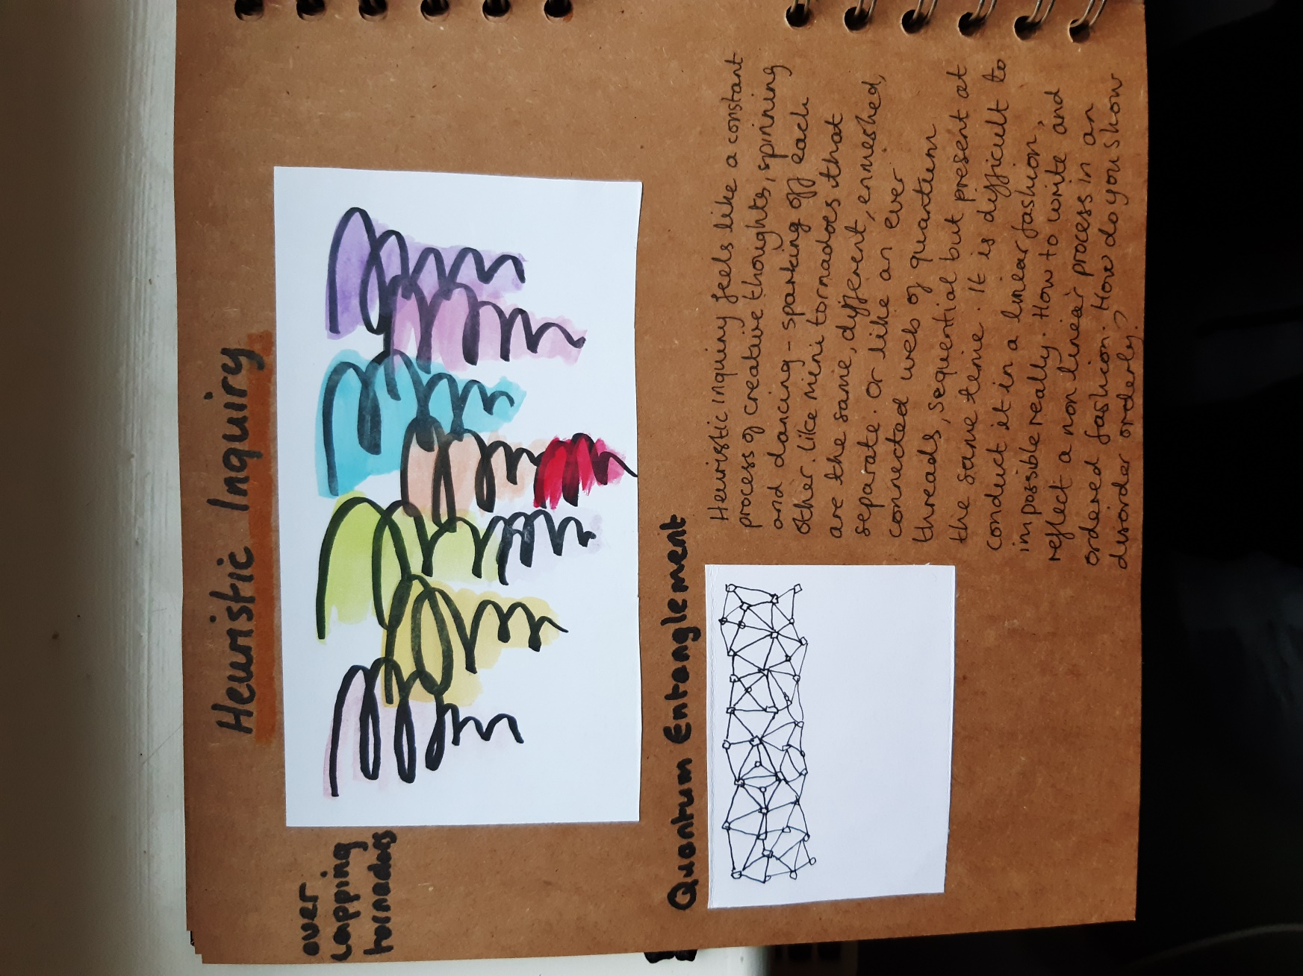

Appendix 2:
Art journal extract created by author, October 2024; quoting Imagine Dragons (2017), within quotation marks.
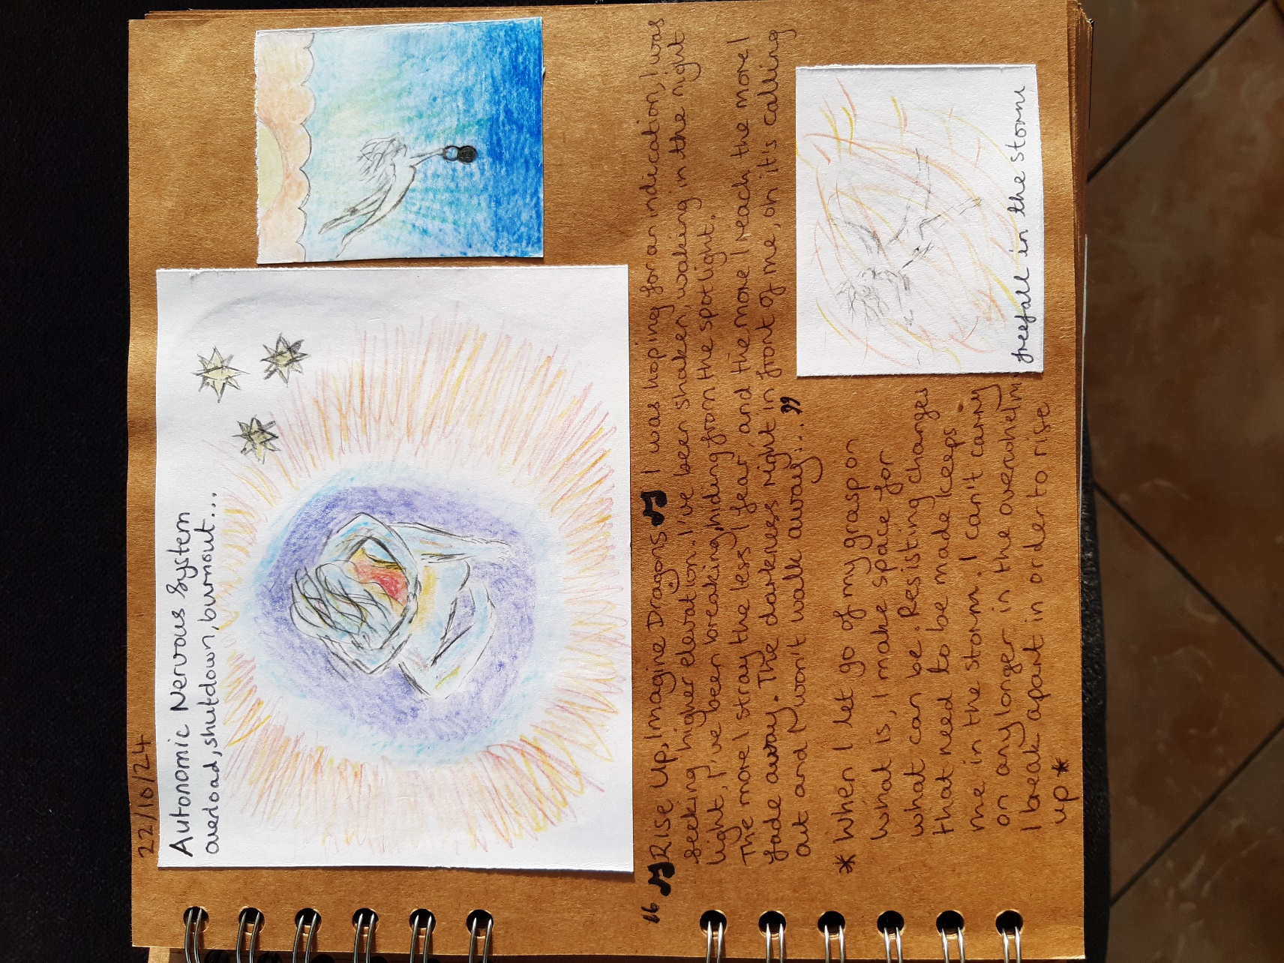
Appendix 3:
Art journal extract created by author, December 2024.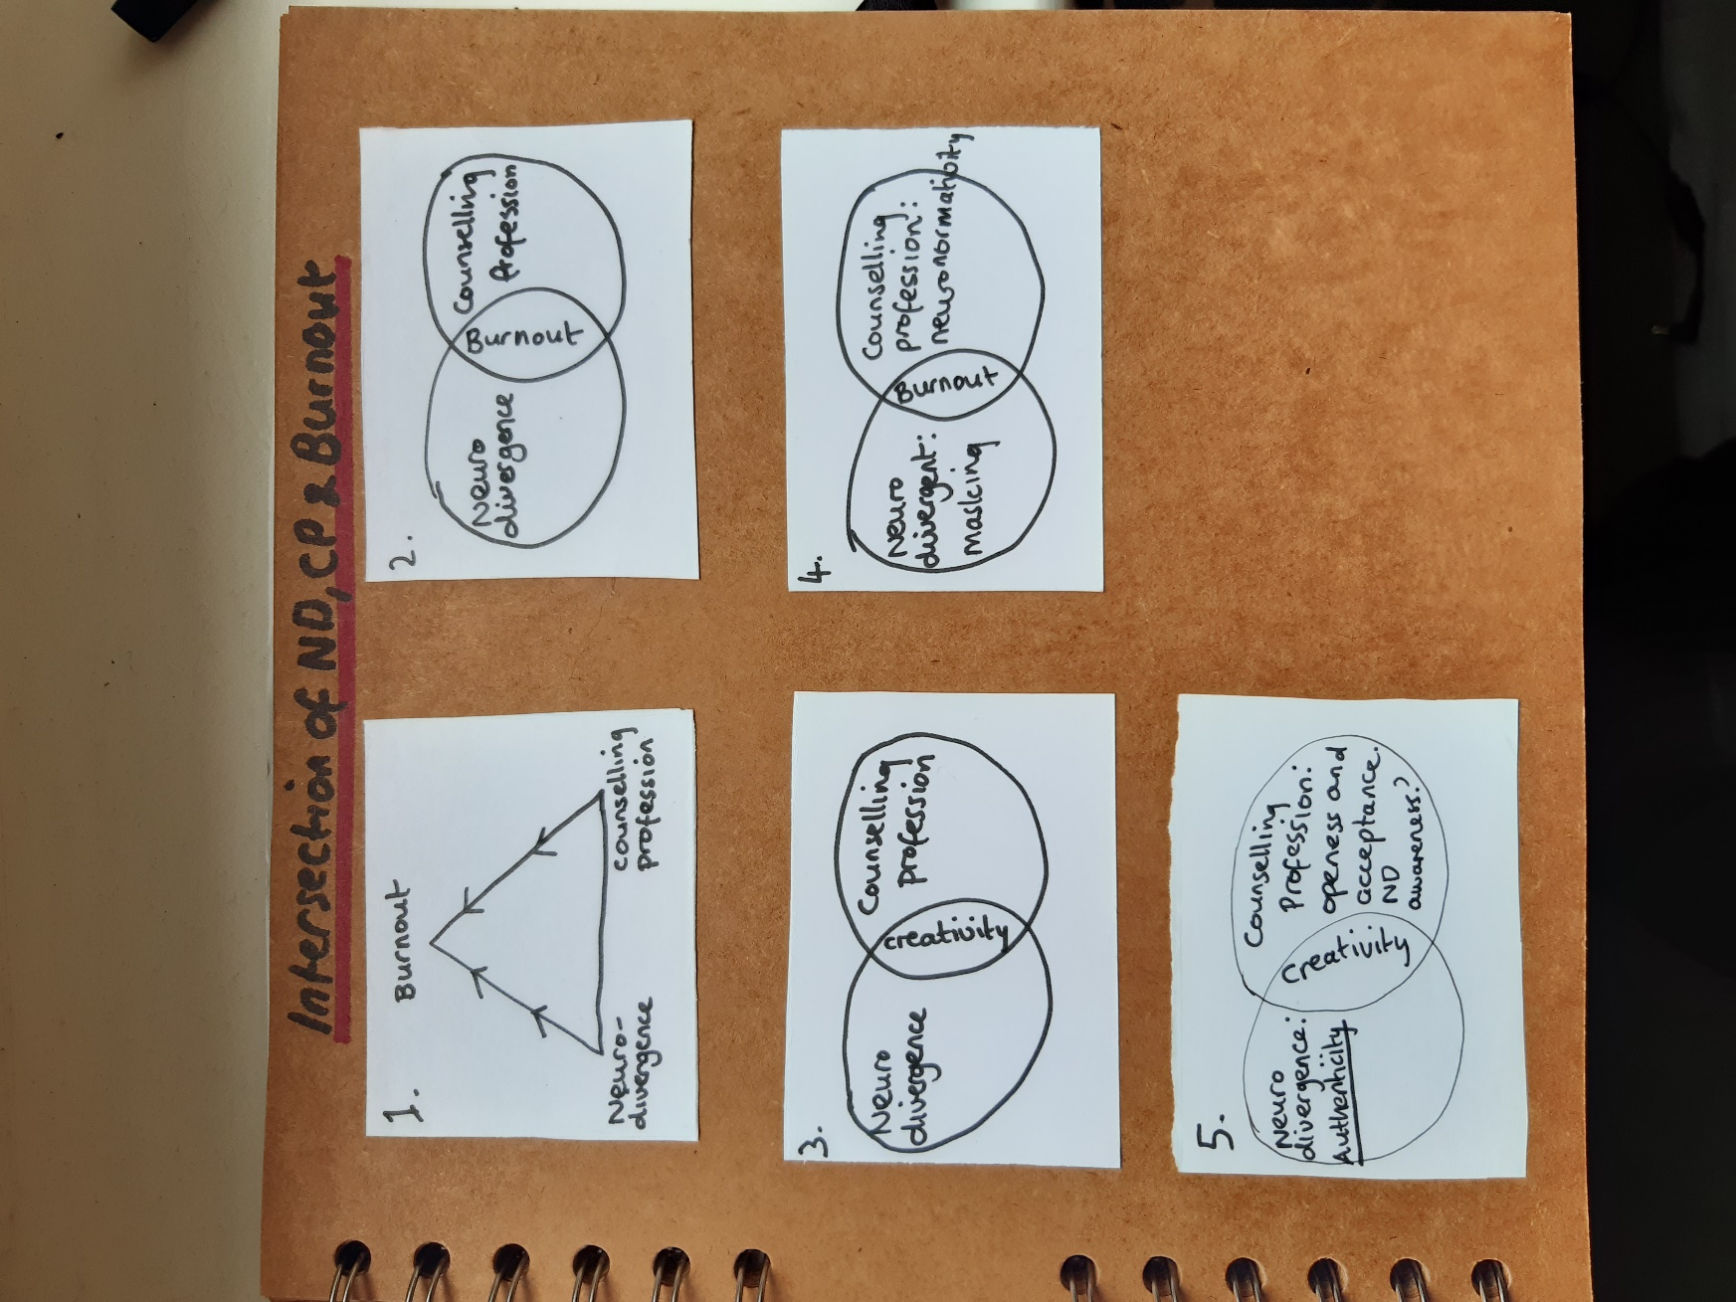

Appendix 4:
Art journal extract created by author, December 2024.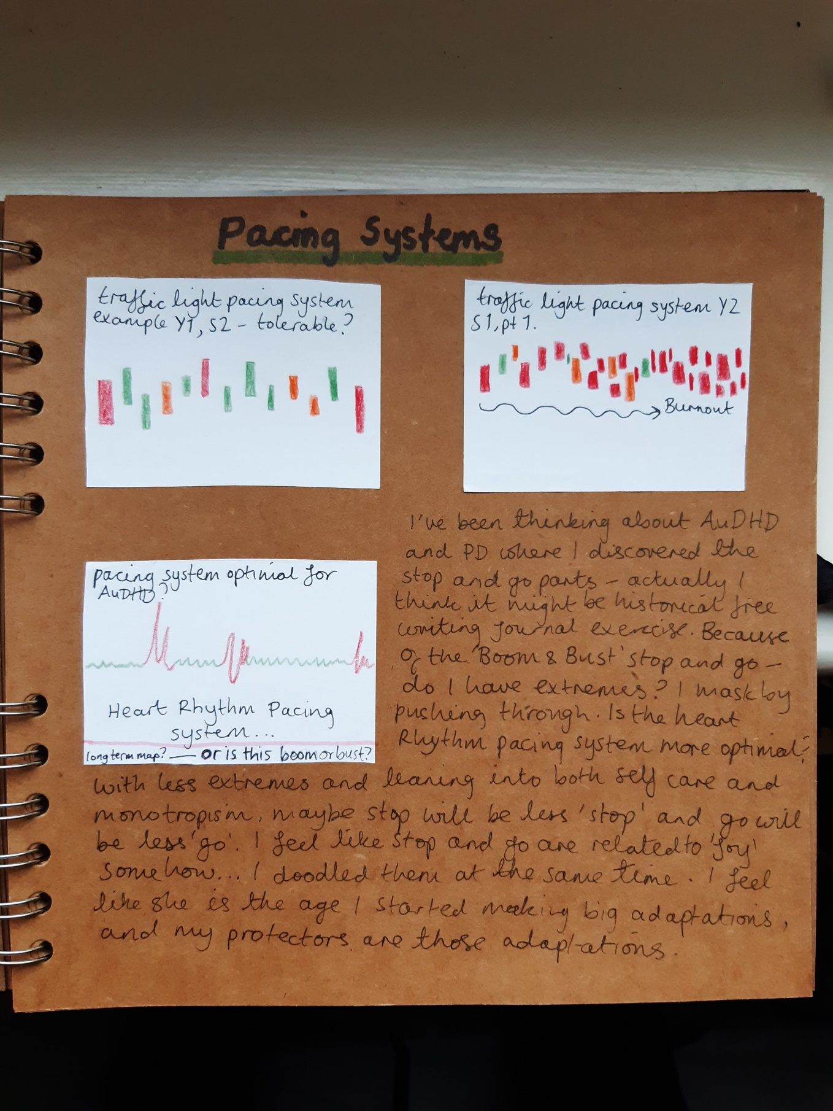

Appendix 5:
Art journal extract created by author, December 2024.
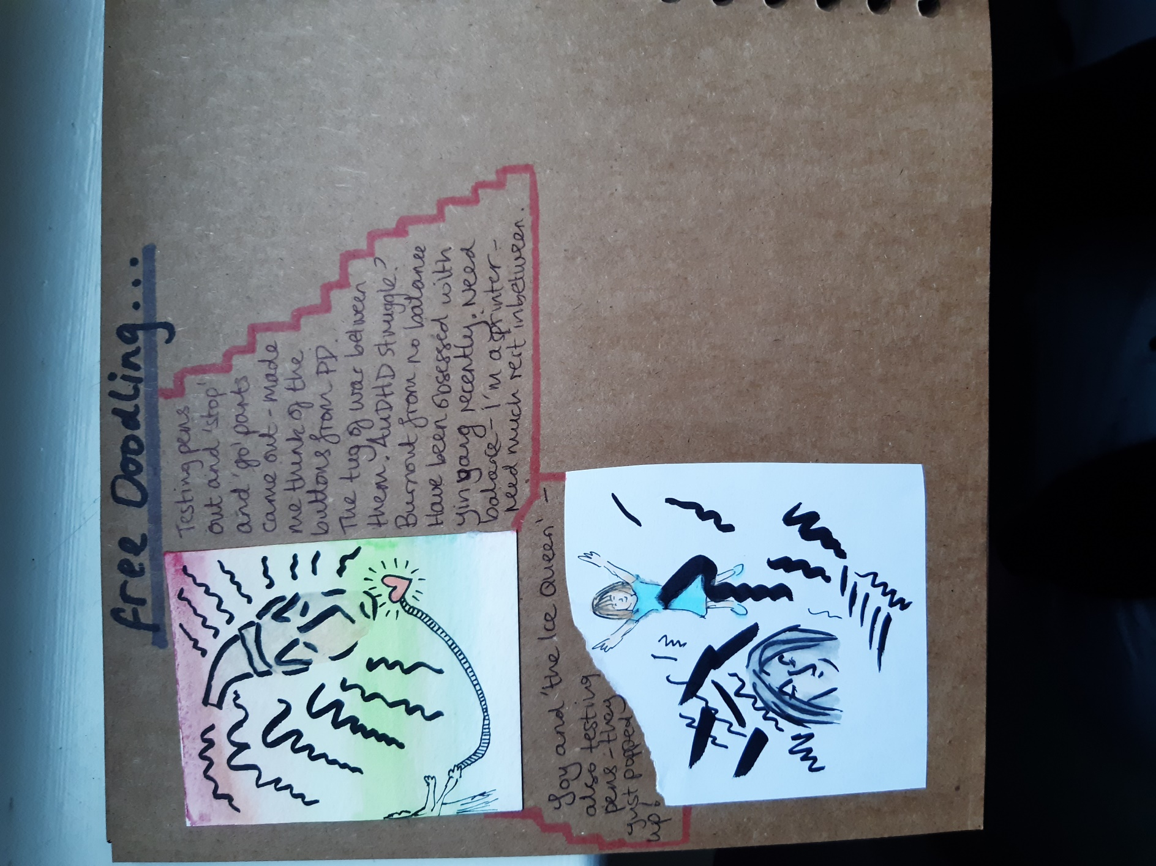
Appendix 6:
Art journal extract created by author, December 2024.
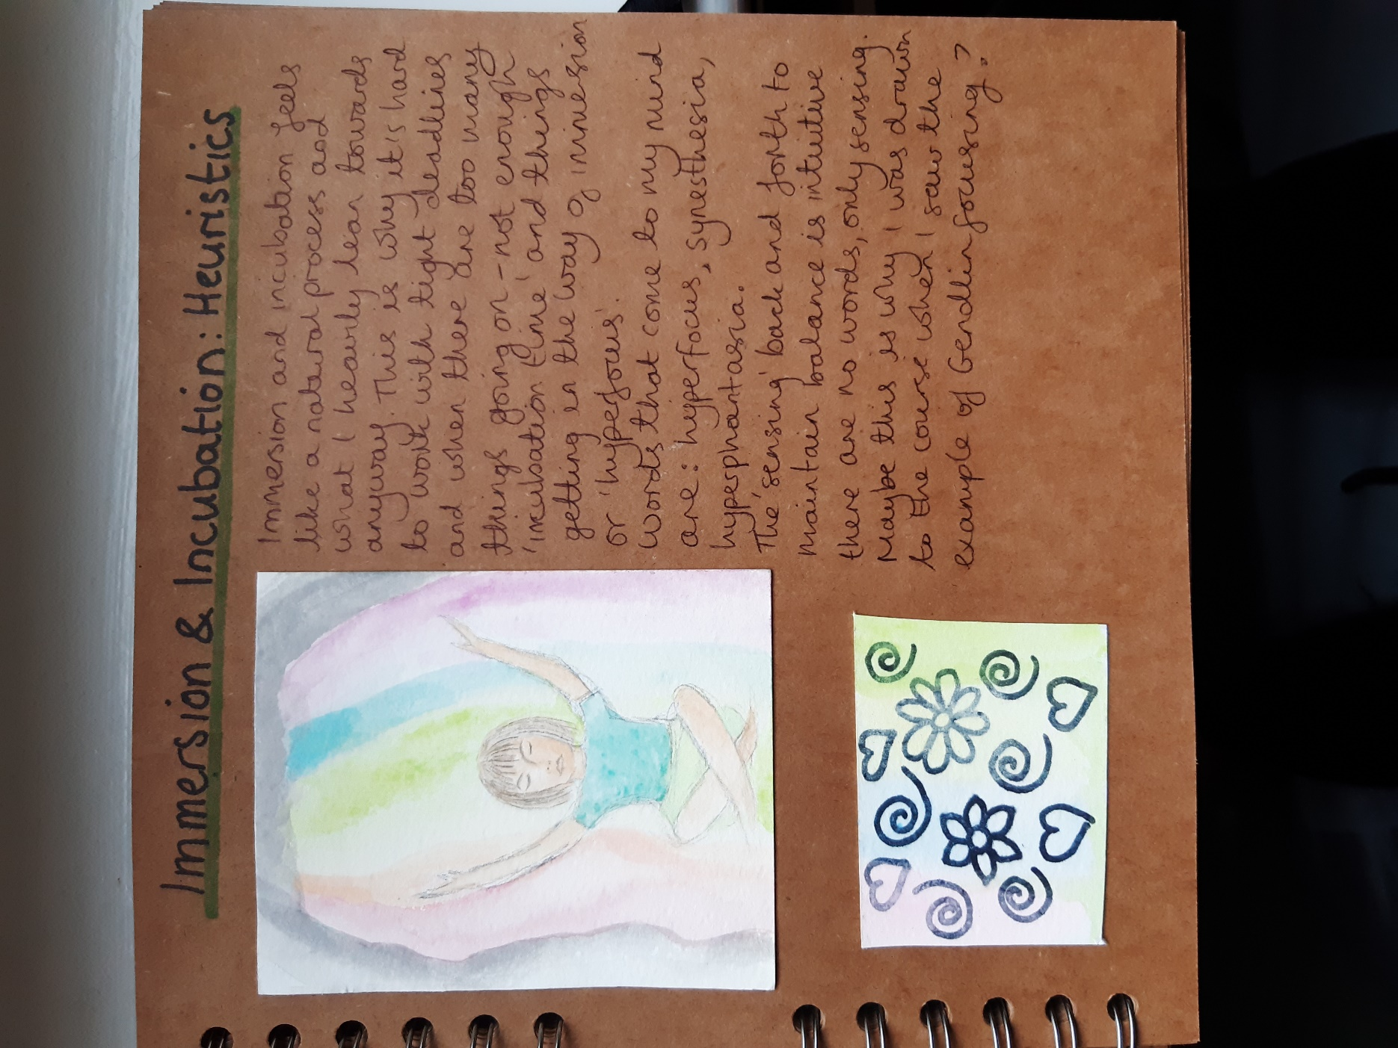
Appendix 7:
Art journal extract created by author, December 2024; quoting González (2013) within quotation marks.
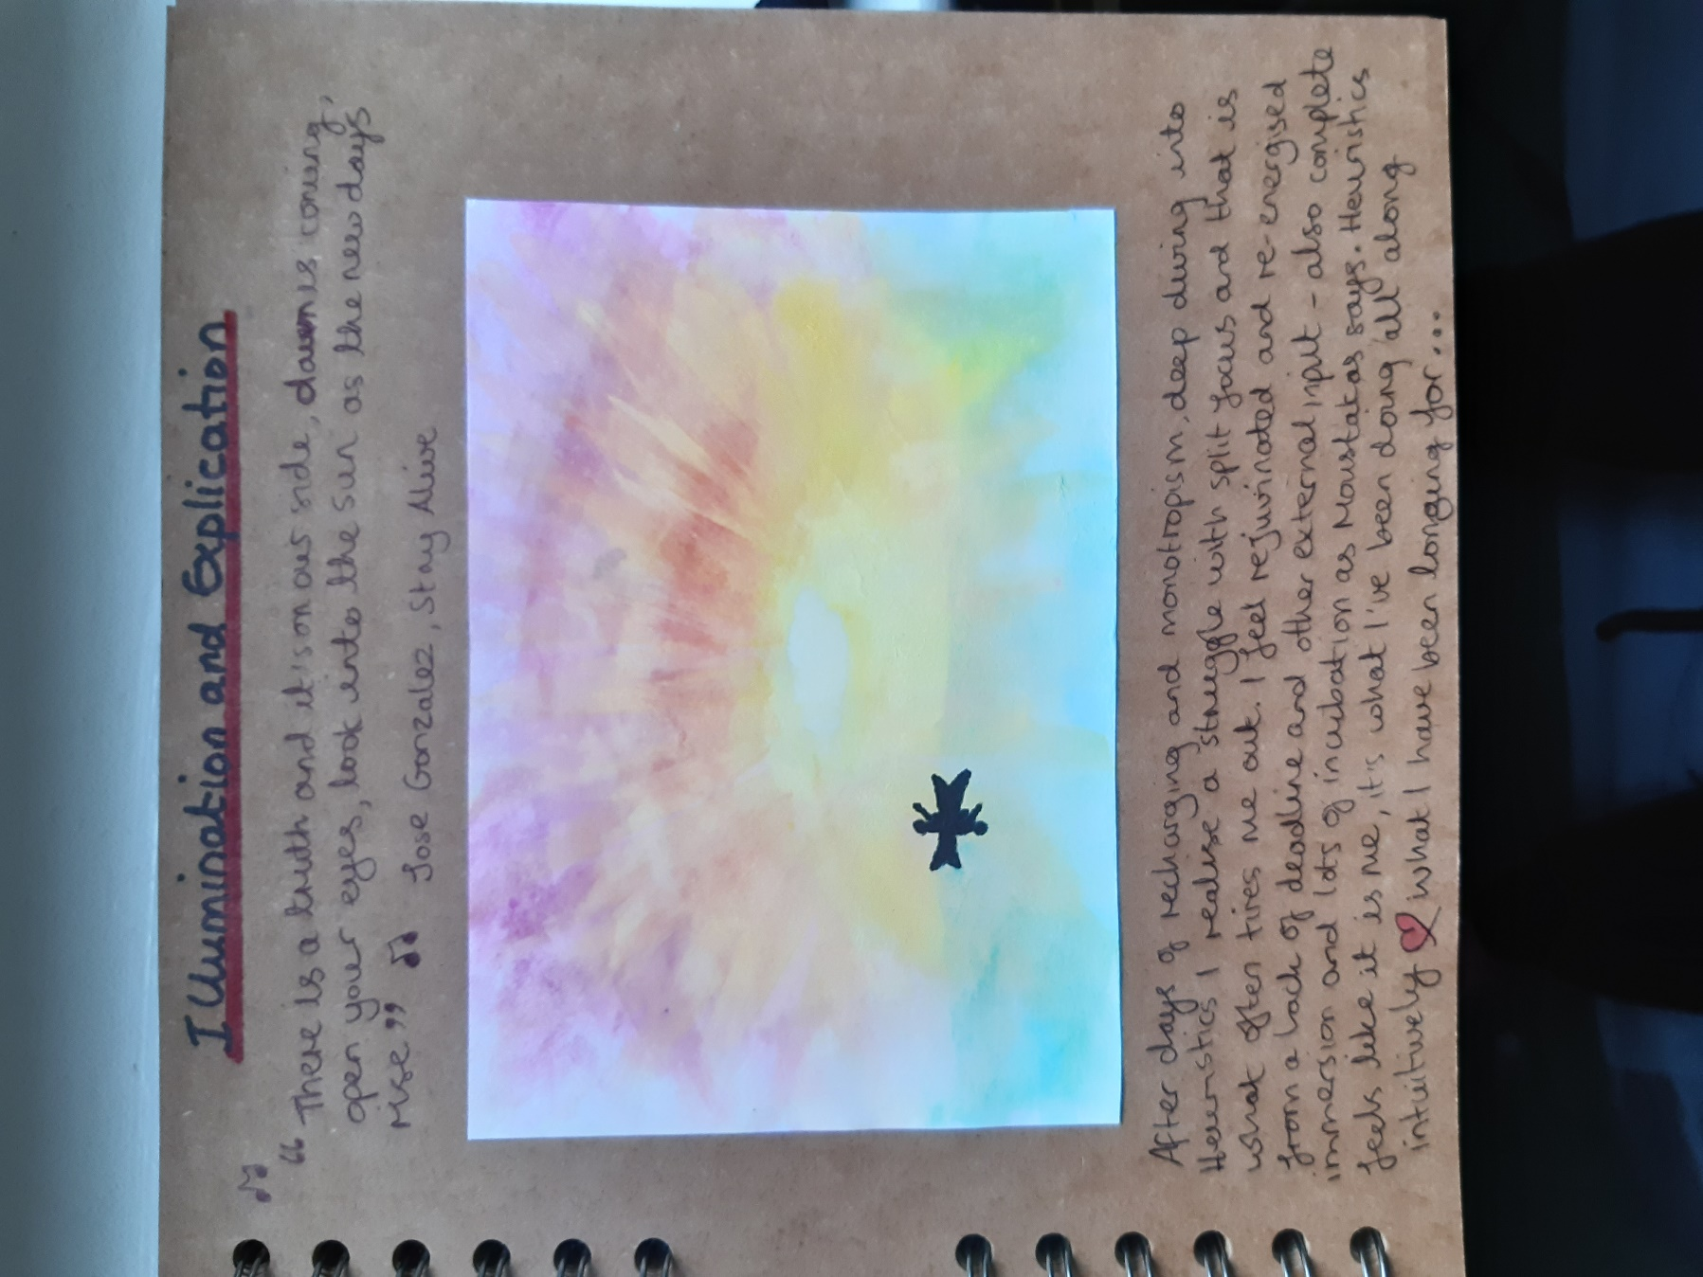
Appendix 8:
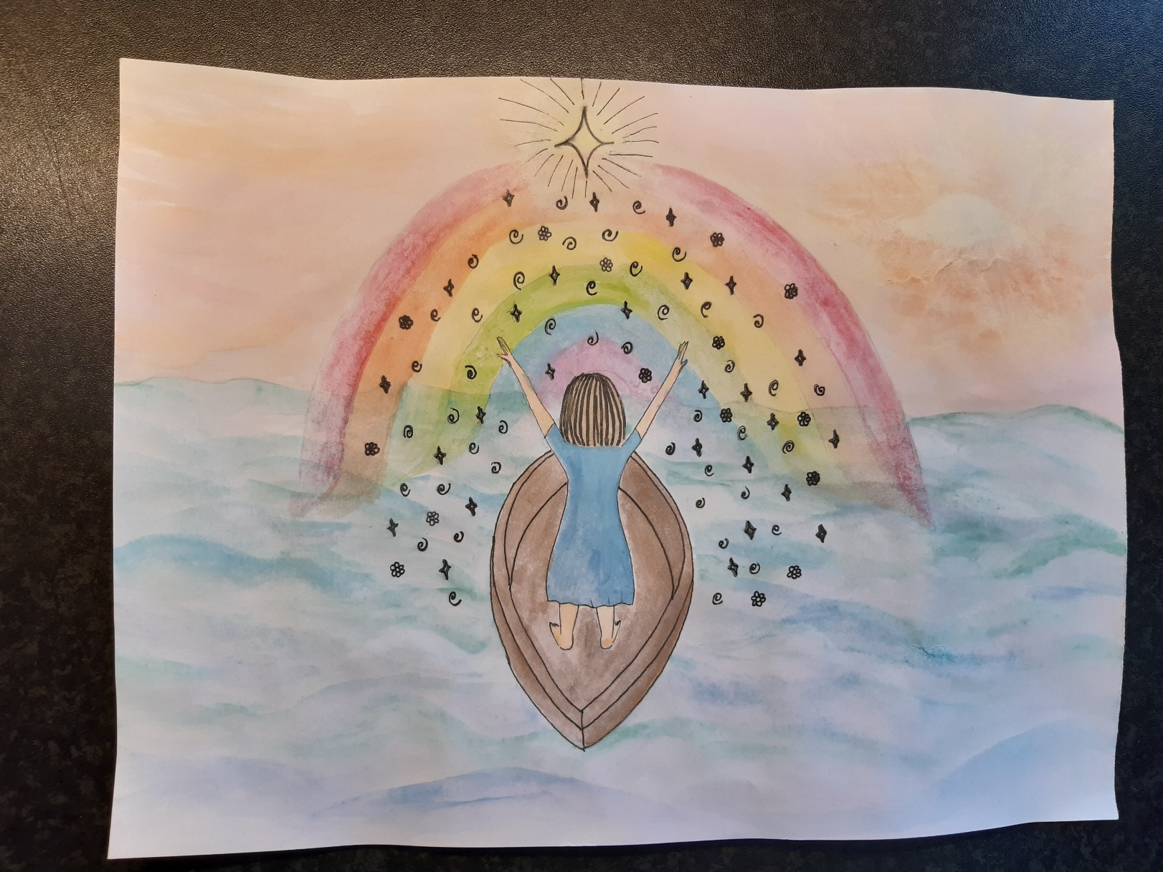
Creative Synthesis (version 1), created by author, January 2025: ‘Spiritual Rebirth’

Appendix 9:
Creative Synthesis (version 2), created by author, January 2025: ‘Shadow Lifts Me Up’
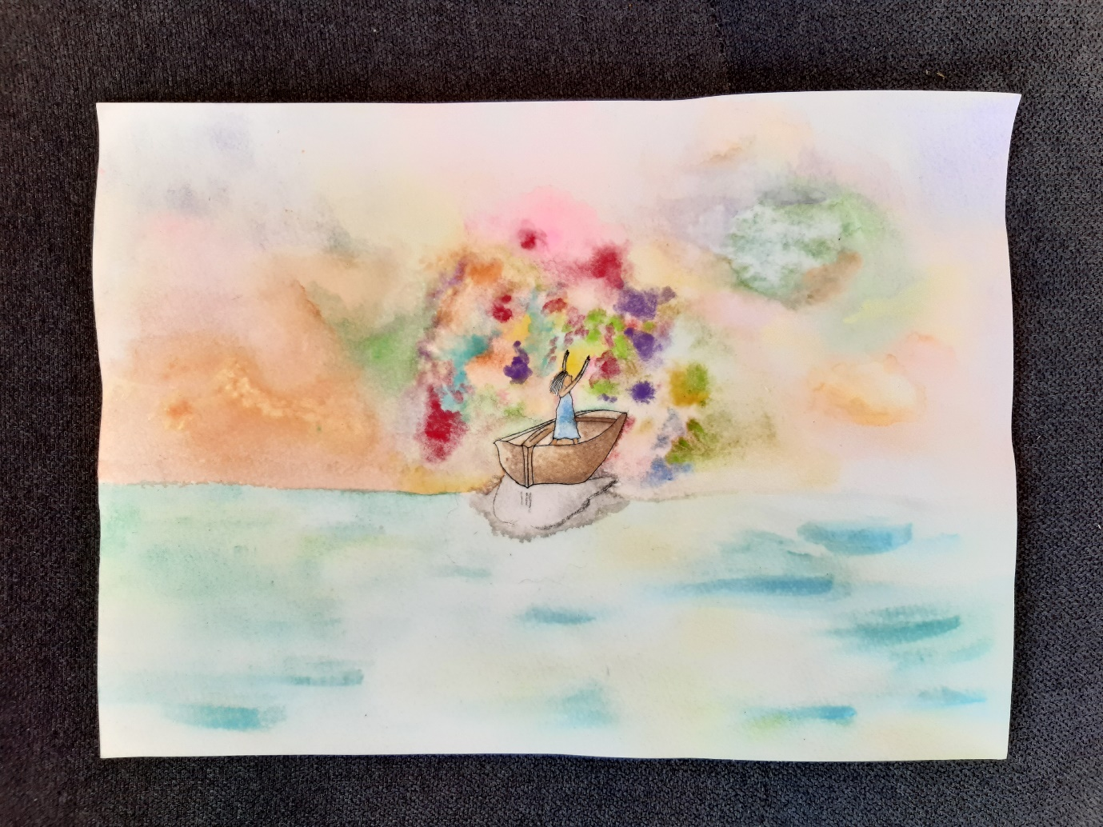

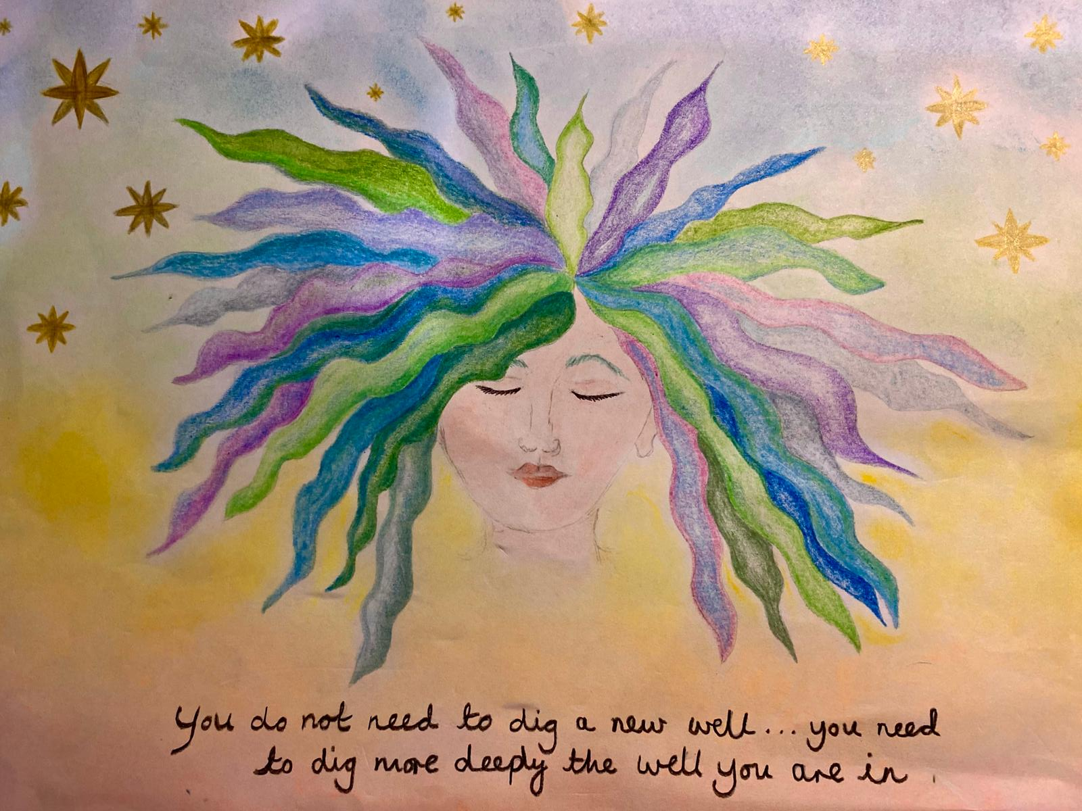
Appendix 10:
Artwork created by author in April 2023; prior to starting current MA programme.

