
University of Wales Trinity Saint David, London Campus

Assignment Title: Tesla GridHome: Strategic Development and Marketing Portfolio for a Smart Home Energy Brand

Module Name: Marketing Management
Module Code: LCMB7024

Submitted By: Syed Mujtaba Ali Bukhari
Student ID: 2434997
Submitted To: Dr Gladius David Kulothungan

Word Count:2750

Date of Submission:
17th December, 2025
Table of Contents
ELEMENT 1: STDP ANALYSIS 4
1.1 Introduction to Tesla and GridHome Concept 4
1.2 Segmentation 5
1.3 Targeting 8
1.4 Differentiation 8
1.5 Positioning 9
ELEMENT 2: MARKETING MIX - 7Ps 10
2.1 Product 10
2.2 Price 11
2.3 Place 13
2.4 Promotion 13
2.5 People 14
2.6 Process 14
2.7 Physical Evidence 15
ELEMENT 3: MARKETING STRATEGY PITCH SUMMARY 16
ELEMENT 4: REFLECTION 16
References: 18
Appendices 21
Appendix A: Tesla GridHome Poster 21

List of Figures & Tables
Figure 1: UK household energy price index (2010–2025), showing significant increases in electricity and gas prices (Source: House of Commons Library, 2025). 5
Figure 2: EU domestic output price index for energy (2021–2025), illustrating volatility in upstream energy supply markets (Source: Eurostat, 2025). 5
Figure 3: Global solar PV capacity growth by region, 2014–2023 (REN21, 2024). 6
Figure 4: Battery-electric vehicle (BEV) registrations in European markets, Q4 2018–Q2 2024 (Statista, 2025). 7
Figure 5: Forecasted number of Home Energy Management System (HEMS) installations in Europe (EU27+3) and North America, 2024–2029. Source: IoT-Now (2024) 8
Figure 6: Figure Placeholder 3: Positioning Map – Integration Level vs. Cost Efficiency, (Source: Author’s own). 10
Figure 7: European Energy Management System (EMS) (Source: P&S Market Research, 2025). 13
Figure 8: Example Tesla GridHome dashboard. (Source: Author’s Own) 16

Table 1: Strategic Evaluation of GridHome’s Segmentation Approach 7
Table 2: Advantages and Disadvantages of Tesla GridHome’s Targeting Strategy 9
Table 3: Comparative Table: GridHome vs Powerwall vs Utility Smart Tariffs 12

Tesla GridHome: Strategic Development and Marketing Portfolio for a Smart Home Energy Brand

ELEMENT 1: STDP ANALYSIS

1.1 Introduction to Tesla and GridHome Concept
Tesla has developed an international name as an innovator of sustainable energy systems with a portfolio that is focused on solar technologies, Powerwall storage systems and energy-generation solutions. These services are predominantly hardware-based and depend on a one-off sale to be installed by the homeowner for optimisation and maintenance. Unlike that, the proposed Tesla GridHome is a tactical advancement to a service-based model, with a proposed new brand of home-energy management based on subscription, with solar optimisation, battery storage, EV-charging smarts, smart metre connectivity and real-time monitoring combined into one digital experience.
The move can be explained by the increasing consumer demand towards energy resiliency, price and automated smart-home functions. The rising household energy bills and the growing frequency of grid instability, which is visible throughout the UK and EU, have reinforced the desire to adopt the highly developed home-energy management systems (Ofgem, 2023; IEA, 2024). As a result, a controlled energy platform like GridHome is similar to the current consumer interests and decarbonisation policies.
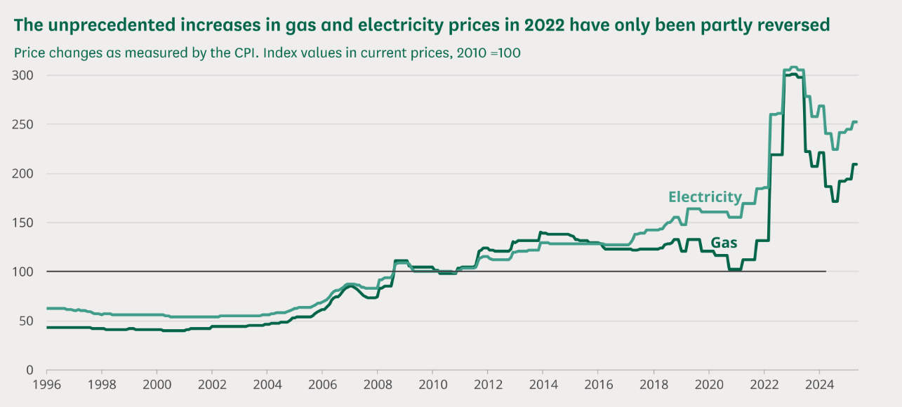
Figure 1: UK household energy price index (2010–2025), showing significant increases in electricity and gas prices (Source: House of Commons Library, 2025).
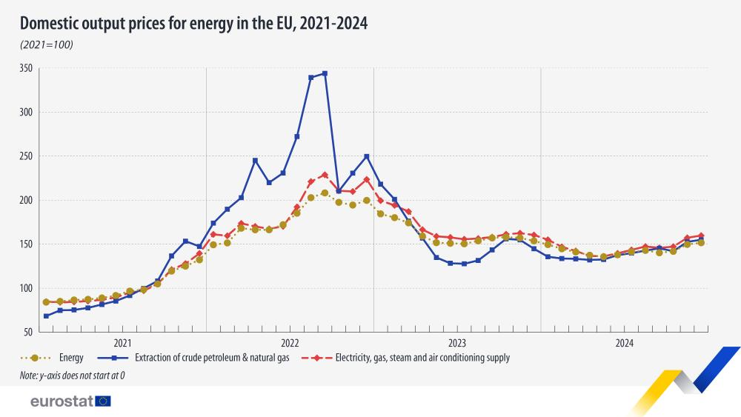
Figure 2: EU domestic output price index for energy (2021–2025), illustrating volatility in upstream energy supply markets (Source: Eurostat, 2025).

1.2 Segmentation
1.2.1 Demographic Segmentation
The target customers of GridHome are homeowners who have a median-to-high household income (usually more than £70,000) and are 35-65 years old. The studies about the adoption of household technology also show increased adoption rates among middle-aged, well-to-do homeowners who place asset security and long-term savings as their priorities (Energy Policy Journal, 2022).
1.2.2 Geographic Segmentation
The UK and EU are the strategically most favourable markets as the region has high electricity tariffs, deep penetration of smart meters, and faster realisation of net-zero strategies, which generate a high market preparedness. Solar systems across the UK alone have exceeded 1.47 million homes, which signifies 15.8 GW of the installed capacity, a point that indicates the growing readiness to spend funds in add-on storage and optimisation systems (Solar Energy UK, 2024). Similarly, Europe shows more uptake, where more than 3.8 million home-energy management systems were installed by 2024 (Berg Insight, 2025).
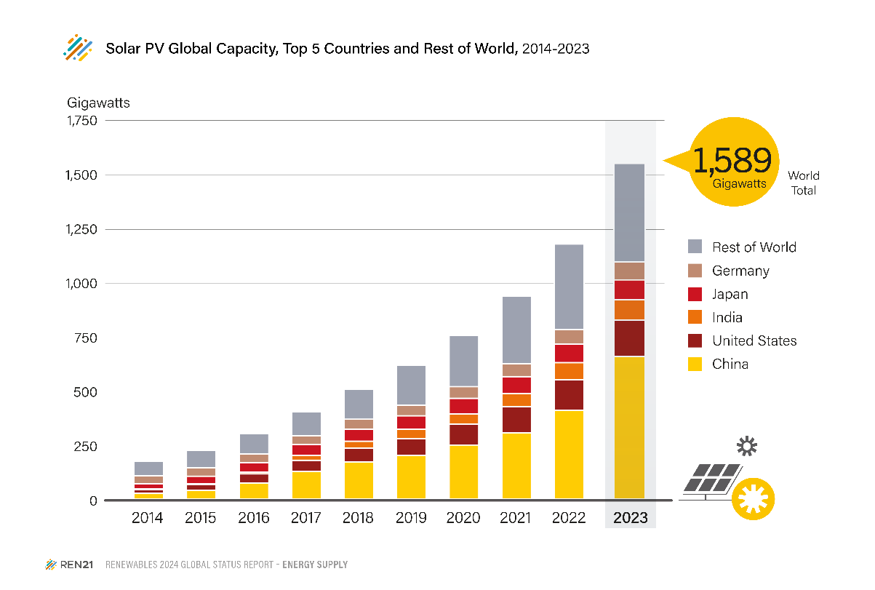
Figure 3: Global solar PV capacity growth by region, 2014–2023 (REN21, 2024).
1.2.3 Psychographic Segmentation
Three prevailing psychographic clusters arise. The former includes energy-conscious pragmatists, but they value financial security and losing bills less. The second one is tech-empowered environmental adopters, who appreciate connected ecosystems and desire smooth automation in their homes. Cost-averse innovators are the third cluster, which is in line with the VALS Innovator and Thinker typologies, as they seek sustainable living and technological efficiency (Kotler et al., 2024). The Technology Acceptance Model (TAM), in which perceived usefulness and ease of use are important predictors of the implementation of digital home-energy systems, also explains the inclination of consumers toward smart-energy technologies (Davis, 1989; Marikyan, Papagiannidis and Alamanos, 2021).
1.2.4 Behavioural Segmentation
Behaviourally, GridHome is most attractive to early adopters of smart-home systems, EV owners and those households that have already thought about investing in solar. This aligns with the Diffusion of Innovation model by Rogers, which recognises early adopters as key in the diffusion of technology when relative advantage and compatibility are realised (Rogers, 2003). Their adoption behaviour is also supported by the fact that there has been an indication that the global smart-home energy management market will grow at two-digit rates until 2029 (Grand View Research, 2023).

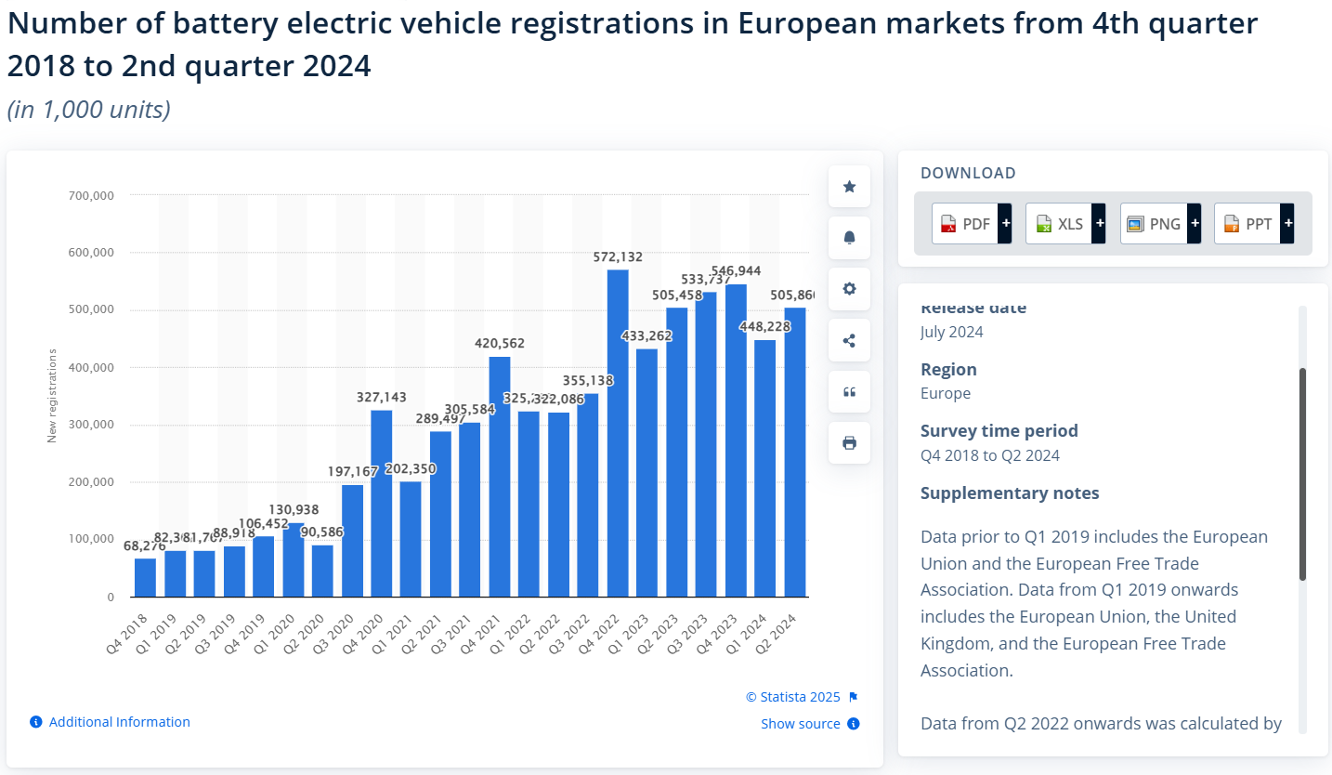
Figure 4: Battery-electric vehicle (BEV) registrations in European markets, Q4 2018–Q2 2024 (Statista, 2025).
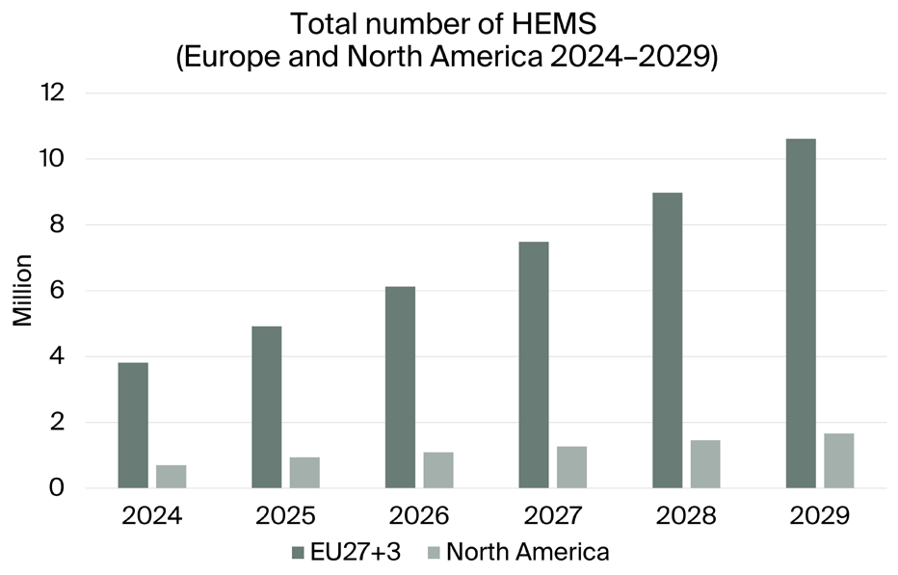
Figure 5: Forecasted number of Home Energy Management System (HEMS) installations in Europe (EU27+3) and North America, 2024–2029. Source: IoT-Now (2024)
Table 1: Strategic Evaluation of GridHome’s Segmentation Approach
Aspect | Advantages | Limitations
Demographic Segmentation | Focuses on homeowners with financial capacity and long-term orientation, improving adoption likelihood | Excludes renters and lower-income households, limiting market breadth
Geographic Segmentation | Targets regions with high tariffs, smart-meter penetration and supportive regulation (UK/EU) | Exposure to regulatory heterogeneity across EU markets
Psychographic Segmentation | Aligns proposition with sustainability values and technology readiness | Values-based segments can be difficult to quantify precisely
Behavioural Segmentation | Leverages EV ownership and prior solar adoption, increasing conversion efficiency | Early-adopter bias may slow mass-market diffusion
Source: Author’s analysis informed by Kotler et al. (2024); Energy Policy Journal (2022); Berg Insight (2025).

1.3 Targeting
1.3.1 Primary Target: The Resilient Homeowner
The primary market group consists of suburban homeowners in need of grid stability and long-term security in energy prices. These customers are very receptive to the propositions which focus on reliability, resilience and predictable household spending. This targeting has been demonstrated to have commercial validity as empirical evidence suggests that environmentally motivated homeowners are more willing to pay for integrated low-carbon services (White, Hardisty and Habib, 2019).
1.3.2 Secondary Target: The Sustainable Investor
The secondary target will be people with high incomes and sustainability interests who will value environmental performance and property value improvement. A significant number in this cohort already takes part in the EV ecosystem, so the vertically integrated platform offered by Tesla is particularly appealing. This segment can also play a powerful role in the rapid dissemination of clean-energy solutions because of its socio-economic background and early investing nature. The 2032 forecasts of smart-home market growth, estimated well beyond USD 500 billion, are also justifications of strategic targeting of environmentally conscious, technology-oriented homeowners (Market.us, 2023).
1.3.2 Targeting Strategy Clarification
Tesla GridHome uses a differentiated targeting approach by targeting two very different, but complementary groups: the Resilient Homeowner and the Sustainable Investor. This strategy enables custom value propositions, stability and predictability of the cost to the core segment, and environmental results and value to the asset segment. The differentiated targeting advantage is high relevance and willingness to pay, and the primary weakness is the complexity of marketing and service provision in contrast to undifferentiated strategies (Kotler et al., 2024).
Table 2: Advantages and Disadvantages of Tesla GridHome’s Targeting Strategy
Aspect | Advantages | Disadvantages
Differentiated Targeting | Enables tailored value propositions for resilience-focused and sustainability-driven homeowners | Requires higher marketing and service coordination effort
Focus on High-Value Homeowners | Higher willingness to pay and stronger lifetime value | Limits short-term mass-market scalability
Dual-Segment Approach | Balances stability (primary) and growth leadership (secondary) | Risk of strategic dilution if segments converge over time
Ecosystem-Based Targeting | Leverages Tesla EV ownership for cross-selling and lock-in | Dependence on EV adoption rates in target regions
Source: Author’s analysis informed by Kotler et al. (2024); Market.us (2023).

1.4 Differentiation
1.4.1 Differentiation from Tesla’s Existing Powerwall
Although Powerwall is battery-stored and has solar integration, it is essentially a hardware-based company. GridHome proposes an ongoing management service, assisted by predictive analytics, automated optimisation and full maintenance.
1.4.2 Differentiation from Competitors (Octopus, Hive, Sonnen)
The competitors provide disintegrated or semi-integrated solutions. Examples of utilities include utilities that offer tariffs and entry-level smart-metre services but do not optimise multiple devices. Smart-home brands have automation, but do not have high battery power or grid interaction. Sonnen and other rivals in storage offer hardware without full-service optimisation. The only difference that lies in the proposal of GridHome is the connection into the ecosystem, which will unite solar, storage, EV optimisation and grid intelligence- this will minimise consumer friction and maximise system efficiencies.
1.4.3 Key Differentiators
The differentiation of GridHome is based on four pillars:
- Tesla ecosystem integration to ensure an integration of EVs, solar production and storage systems.
- AI-driven energy arbitrage, a type of arbitrage, affects power usage by using AI to automatically switch power consumption or sale using real-time price research.
- Predictive outage protection, which provides the resilience improvement based on real-time data.
- Subscription-based model, where installation, optimisation, software updates and maintenance are included in one offerscape.

1.5 Positioning
GridHome is marketed as a high-end, whole-home-energy ecosystem, which gives consumers interoperability, predictable costs and automatic optimisation. It is at the crossroads of high integration and high value, which makes it different to disjointed smart-home offers and hardware-only solutions.
Positioning Statement
Tesla GridHome is the only all-encompassing ecosystem where solar storage, EV optimisation and AI-driven energy management are brought together on a single platform, designed to earn the trust of homeowners who want to gain energy independence and exercise intelligent control of their homes.
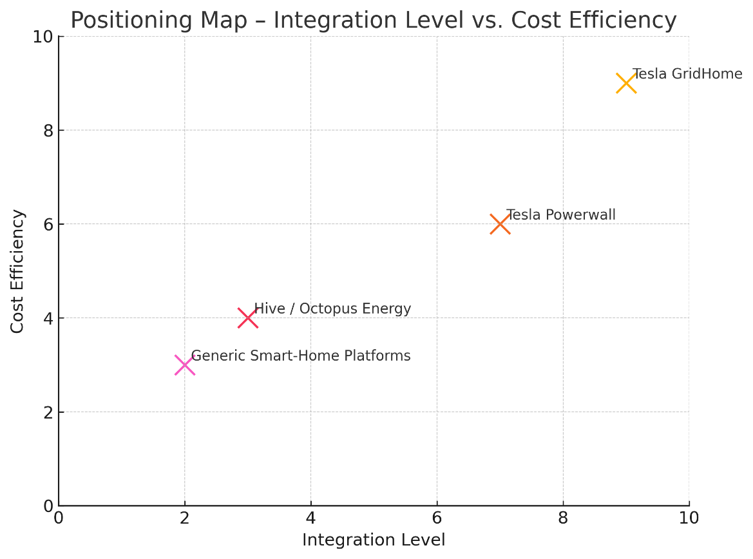
Figure 6: Figure Placeholder 3: Positioning Map – Integration Level vs. Cost Efficiency, (Source: Author’s own).

ELEMENT 2: MARKETING MIX - 7Ps

2.1 Product
Tesla GridHome is intended as a combined service offering, in which the central offering is a subscription service of intelligent home-energy management, including automated load balancing, EV charging optimisation and real-time resilience support.
The actual product will consist of the Powerwall 3 battery and compatible inverter, the smart-metre and integration and connection to the gateway to enable uninterrupted integration of solar generation, home storage and EV charging. The further development of residential storage by Tesla, as can be evidenced by the latest deployments of the multi-gigawatt-hour (Tesla, 2024), implies a high level of technological capacity to facilitate the Hurricane Home.
The augmented product further distinguishes the product with 24/7 tracking, predictive reporting, preventive upkeep and optional insurance contacts in case of unavailability. Improvement of app functionality, such as AI-generated reporting and customised optimisation insights, complements perceived value. This service orientation concurs with the Service-Dominant Logic, focusing on continual interactions and co-created value as the key sources of competitive advantage (Vargo and E. Lusch, 2004). There should always be independent testing of performance as consumers become more and more suspicious of energy technologies (Grand View Research, 2024). The integration of quantitative KPIs like self-consumption rates or peak-load shifting will align the service to the energy management models' best practices (Berg Insight, 2025). In addition, the augmented product strategy adheres to the services-marketing theory in which advanced after-sales and monitoring functions significantly raise perceived service quality (Zeithaml, Bitner and Gremler, 2018).
Table 3: Comparative Table: GridHome vs Powerwall vs Utility Smart Tariffs
Criteria | Tesla GridHome | Tesla Powerwall Only | Utility Smart Tariffs
Integration Level | Very High | Medium | Low
AI Optimisation | Advanced AI | Basic Optimisation | Minimal
Outage Protection | Yes (Predictive) | Partial (Backup Only) | No
Cost Efficiency | High | Medium | Variable
Subscription Model | Yes | No | Yes/No
EV-Charging Optimisation | Fully Integrated | Limited Scheduling | Not Included
Solar Compatibility | Full Integration | Compatible | Not Included
Created by: Learner

2.2 Price
The value-based tiered pricing strategy of GridHome is based on the economic logic of reducing the exposure to fluctuating electricity tariffs. When the average UK household energy bills are over £2,500 a year (BEIS, 2024), the subscription costs of £49.99 (Basic) and £89.99 (Premium) are enticing when they are introduced with the modelling of savings. Value-based pricing is especially good with energy services since consumers rate economic and non-economic value as a whole, not only through cost-plus models (Hinterhuber and Liozu, 2014).
Viewed over 10 years of financing of hardware, or green mortgage programs, as well as downstream barriers and match the willingness-to-pay of consumers to pay, implying energy-stability programs (Ofgem, 2024). Promotional incentives selected, six-month discounted subscriptions for Tesla EV owners are strategically correct due to high cross-product synergies and pre-existing interactions with Tesla's digital ecosystem (Tesla, 2024).
To ensure academic rigour, pricing would need cost-justification by showing that lower charges under peak periods can be achieved through optimisation to cut down payback periods, maximise solar self-consumption, and increase solar self-generation (IEA, 2024). It has also been reported that consumers trust and are more likely to adopt residential renewables in a transparent, scenario-based financial modelling (Sorin and Huang, 2020). It is an economicization approach to market positioning that uses perceived value over cost-plus logic.
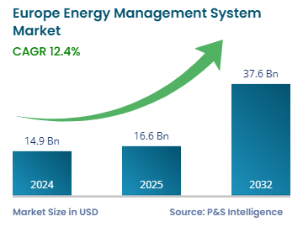
Figure 7: European Energy Management System (EMS) (Source: P&S Market Research, 2025).

2.3 Place
The distribution model of GridHome is omnichannel, which involves integration of digital platforms, specialist advisory interaction and strategic partnerships. Collaboration with energy retailers like Octopus Energy or British Gas would boost its faster adoption since it can incorporate tariffs, smart meter data and grid-interaction protocols. The OmniChannel distribution practices lower the perceived purchase risk of complex technologies through integration of digital convenience and expert advisory support along the consumer path (Verhoef, Kannan and Inman, 2017). Cooperation with the property developers and mortgage providers helps to implement GridHome in new-build housing in line with the national sustainability requirements (Grand View Research, 2024).
The place strategy should also deal operationally with grid-connexion regulations and UK or EU requirements concerning tariffs to be paid on exports. Evidence suggests that regional pilot deployments are a good way of streamlining installation operations and justifying economic results before scaling (Berg Insight, 2025).

2.4 Promotion
The promotional scheme of GridHome focuses on clear evidence-based communication in order to overcome the consumer scepticism of green claims. YouTube and LinkedIn will be used to provide technical demonstrations and specific homeowner messages, and in-app notifications will build on the current user base of Tesla.
Examples of quantifiable savings on bills and outage-resilience will be used as plausible pieces of evidence of value (IEA, 2024). With general mistrust towards environmental assertions, marketing messages should be backed up empirically and third-party confirmed to prevent the impression of greenwashing (Delmas and Burbano, 2011). Partnerships with the insurers and utilities should be anticipated as the third-party validation decreases the perceived technological and financial risk. The influencer partnerships should target energy experts and home experts who are sustainable to bring technical credibility.
An organised pilot assessment report of the early deployments will further reinforce the promotional assertions by providing standalone verifiable performance information (Berg Insight, 2025; Tesla, 2024).

2.5 People
The service experience of GridHome depends on the people dimension. Tesla Energy Advisors offer the earliest stage of professional interaction with a good analytical understanding of domestic energy modelling, household consumption and savings projection. The research on service quality evidences that the competence and empathy of employees are central influences of perceived reliability and satisfaction in high-involvement services (Parasuraman, Zeithaml and Berry, 1988).
The second important group is certified installers; the quality of installation directly influences the reliability of the systems and the satisfaction of users. Continued certification and training programmes help in keeping up with the changing AI-optimisation capacities (IEA, 2024).
The augmented value of GridHome is based on a 24/7 monitoring staff that monitors predictive maintenance, anomaly detection, and outage response. Proactive service management was proven to raise the retention in energy-service subscriptions in the long run (Berg Insight, 2025).
Service hierarchy: Advisory → Installation → Monitoring.

2.6 Process
The process model of gridHome focuses on clarity, efficiency and customer empowerment. It starts with a digital pre-assessment and system proposal customised based on AI-led modelling. Personalised suggestions contribute much to the engagement and lightning of the decision-making process (Grand View Research, 2024). Assurance and reliability dimensions mentioned in SERVQUAL are also facilitated with a smooth process design that is a transparent design, increasing the level of consumer confidence in technologically complex services (Gronroos, 2007).
Technical feasibility is achieved before the installation stage with a home audit and followed by customer onboarding and getting explained on the features of the app and the best optimisation settings. Constant remote monitoring then enhances sustained system performance. Standardised, open processes minimise apparent financial and technical risk, deemed as the main impediments in solar and battery adoption research (Solar Energy UK, 2024).
Customer journey map: Assessment → Survey → Installation → Optimisation.

2.7 Physical Evidence
Physical evidence enhances the credibility of services using both material and digital signals. The visible hardware installation, such as Powerwall, inverter and gateway, is an indicator of quality and technological sophistication, which, studies prove, have an impact on the perceived system reliability (Berg Insight, 2025).
Tesla's mobile app has real-time energy visualisation and monthly performance, which also improves the perception of control and user interaction (Energy Policy Journal, 2022). Customer perceptions are formed by the servicescape effect created by physical and digital signals like good-quality hardware, aesthetics, and convenient interface design to enhance perceived professionalism and trust (Bitner, 1992). Warranty forms, performance certificates and demonstration units in stores also define Tesla as a long-term service provider.
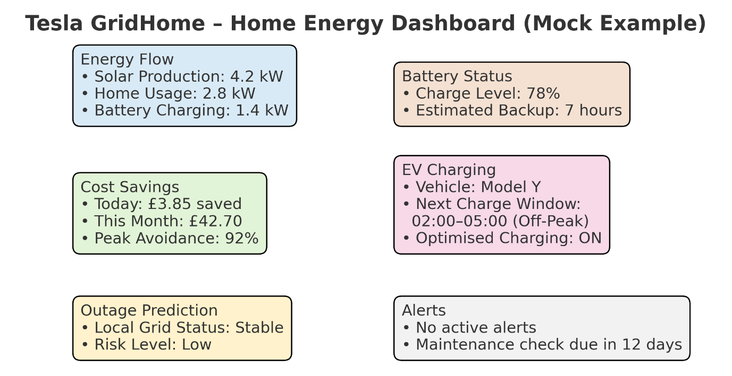
Figure 8: Example Tesla GridHome dashboard. (Source: Author’s Own)

ELEMENT 3: MARKETING STRATEGY PITCH SUMMARY
“What do you think of a home paying its bills to itself?
Families in the UK and EU continue to experience long-term tariff endurance, erratic grid stability and discontinuous smart-homes. Tesla GridHome will address these challenges by proposing an AI-based subscription that integrates Powerwall 3 storage, solar optimisation and smart-meter smartness and EV-charging automation into one intelligent user-oriented platform. Its platform provides predictable domestic energy prices, greater outage resiliency and confirmable carbon elimination by persistent analytics and preventive care. The market validation is positive: by 2030, the market of home-energy management systems is estimated to exceed USD 150 billion; by 2024, there were more than 3.8 million installed energy-management systems in Europe (Berg Insight, 2025). Systems With ESGridHome utilises Tesla's technical leadership and its base of existing EV customers to quickly adopt through specific pilots, strategic utility partnerships and flexible financing to reduce the barriers to entry. We expect the phased rollout in Q2 2026 and will start with high penetration UK areas to prove the resilience, savings and results of the bills.

ELEMENT 4: REFLECTION
As part of the Tesla GridHome development, I was able to reconcile the concepts of marketing theory and a complicated real-life issue of sustainability.
Description
This work entailed the creation of Tesla GridHome: a new subscription-based house-energy brand. I was expected to use STDP and the 7Ps to develop a coherent marketing plan, create a poster and pitch as an investor in a brief speech.
Feelings
I was excited and daunted in the very beginning. I was excited that the brief gave a chance to use a creative strategy in a real industry setting; despondent since I had to produce a rigorous and evidence-based argument that would be of Level-7 work.
Evaluation
The positive aspect was the rigorous use of frameworks: segmentation enabled me to find two high-value target markets (Resilient Homeowner; Sustainable Investor), and the 7Ps made me make practical choices regarding pricing, distribution and service delivery. The adoption of current market reports enhanced credibility and enabled me to simulate real-world situations. Difficulties were to be sure that GridHome was a truly new brand, not just a repackaging of the already available Tesla hardware, and to find peer-reviewed articles that specifically consider the household response to subscription energy services, as opposed to hardware-only.
Analysis
The practice brought out several learning points. First, the strategic framework can only be effectively used when it is accompanied by empirical modelling: segmentation without data would start to appear speculative. Second, service design should include a well-thought-out concern regarding operational feasibility - i.e. 24/7 monitoring and installer certification are not provisions; they lie at the heart of customer trust. Third, persuasive communication (the pitch) requires terse linking of customer pain, quantifiable results, as well as a feasible scaling pathway. This theory-data and communication integration is one of the major specialist skills of marketing consultants and managers.
Conclusion
I have learnt to translate the academic framework into a strategy to be implemented. I became more analytical: I am able to explain my customer targeting, my pricing, and my distribution choices, using evidence and realistic pilot plans. The project also revealed my practice gaps - in particular, the necessity of primary customer insight and finer financial modelling.
Action Plan
Next steps are concrete. To confirm assumptions on willingness-to-pay and preferred subscription features, I will develop a short primary research tool (survey + 10 interviews with customers). To reinforce the pricing justification, I will prepare a basic NPV/NPV sensitivity appendix of three household types. Lastly, I will chart competitor reaction cases and government sensibilities in the UK areas to fine-tune the rollout schedule. These measures will guarantee the coming of strategic work that is academically sound and commercially convincing.

References:
Berg Insight (2025) Home Energy Management Systems Market Report 2025. Berg Insight.
BEIS (2024) UK Household Energy Expenditure Statistics 2024. Department for Business, Energy & Industrial Strategy.
Bitner, M.J. (1992) ‘Servicescapes: The impact of physical surroundings on customers and employees’, Journal of Marketing, 56(2), pp. 57–71.
Davis, F.D. (1989) ‘Perceived usefulness, perceived ease of use, and user acceptance of information technology’, MIS Quarterly, 13(3), pp. 319–340.
Delmas, M.A. and Burbano, V. (2011) ‘The drivers of greenwashing’, California Management Review, 54(1), pp. 64–87.
Energy Policy Journal (2022) ‘Consumer adoption of smart-home and energy-management technologies’, Energy Policy, 165, pp. 1–12.
Eurostat (2025) ‘Domestic output prices for energy in the EU, 2021–2024’. Eurostat News Release, 20 February. Available at: https://ec.europa.eu/eurostat/web/products-eurostat-news/w/ddn-20250220-1 (Accessed: 9 December 2025).
Grand View Research (2023) Smart Home Energy Management Market Size, Share & Trends Analysis Report 2023–2029. Grand View Research.
Grand View Research (2024) Energy Management Systems: Market Analysis & Forecast 2024–2030. Available at: https://www.grandviewresearch.com/industry-analysis/energy-management-systems-market (Accessed: 9 December 2025).
Grönroos, C. (2007) Service Management and Marketing. 3rd edn. Wiley.
Hinterhuber, A. and Liozu, S. (2014) ‘Is it time to rethink your pricing strategy?’, Industrial Marketing Management, 43(1), pp. 86–94.
House of Commons Library (2025) Energy Prices in the UK: 2022–2025 Trends. Research Briefing CBP-9491. Available at: https://commonslibrary.parliament.uk/research-briefings/cbp-9491 (Accessed: 9 December 2025).
IEA (2024) Digital Demand, Energy Efficiency and Grid Resilience Report 2024. International Energy Agency.
IoT-Now (2024) ‘The number of Home Energy Management Systems in Europe and North America reached 4.5 million in 2024’. IoT-Now, 18 August. Available at: https://www.iot-now.com/2025/08/18/152636-the-number-of-home-energy-management-systems-in-europe-and-north-america-reached-4-5-million-in-2024 (Accessed: 9 December 2025).
Kotler, P., Keller, K. and Chernev, A. (2024) Marketing Management. 17th edn. Pearson Education.
Marikyan, D., Papagiannidis, S. and Alamanos, E. (2021) ‘Smart home technology: A critical review of evidence for consumer adoption’, Technological Forecasting and Social Change, 167, pp. 1–15.
Market.us (2023) Global Smart Home Market Forecast 2023–2032. Available at: https://market.us/report/smart-homes-market/ (Accessed: 9 December 2025).
Ofgem (2023) Energy Price Trends and Consumer Market Review 2023. Ofgem.
Ofgem (2024) Domestic Tariff Volatility and Energy Demand Response 2024. Ofgem.
Parasuraman, A., Zeithaml, V.A. and Berry, L.L. (1988) ‘SERVQUAL: A multiple-item scale for measuring consumer perceptions of service quality’, Journal of Retailing, 64(1), pp. 12–40.
P&S Market Research (2025) Europe Energy Management Systems Market Analysis 2024–2032. Available at: https://www.psmarketresearch.com/market-analysis/europe-energy-management-systems-market (Accessed: 9 December 2025).
REN21 (2024) Global Status Report 2024: Solar PV – Market and Industry Trends. Available at: https://www.ren21.net/gsr-2024/modules/energy_supply/02_market_and_industry_trends/07_solarpv/ (Accessed: 9 December 2025).
Rogers, E.M. (2003) Diffusion of Innovations. 5th edn. Free Press.
Statista (2025) Number of battery electric vehicle registrations in European markets from 4th quarter 2018 to 2nd quarter 2024. Available at: https://www.statista.com/statistics/1021892/number-of-battery-electric-vehicle-registrations-in-the-eu/ (Accessed: 9 December 2025).
Solar Energy UK (2024) UK Solar Energy Statistics- Impact Report 2024. Available at: https://solarenergyuk.org/resource/impact-report-2024/ (Accessed: 9 December 2025).
Sorin, F. and Huang, Y. (2020) ‘Consumer trust and adoption of renewable energy technologies: A financial transparency perspective’, Renewable Energy, 152, pp. 225–236.
Tesla (2024) Tesla Energy Generation and Storage Report- Impact Report 2024. Available at: https://www.tesla.com/ns_videos/2024-tesla-impact-report-highlights.pdf (Accessed: 9 December 2025).
Vargo, S.L. and Lusch, R.F. (2004) ‘Evolving to a new dominant logic for marketing’, Journal of Marketing, 68(1), pp. 1–17.
Verhoef, P., Kannan, P. and Inman, J. (2017) ‘From multi-channel retailing to omni-channel retailing: Introduction to the special issue’, Journal of Retailing, 93(2), pp. 174–181.
White, K., Hardisty, D. and Habib, R. (2019) ‘The elusive green consumer’, Harvard Business Review, 97(4), pp. 1–10.
Zeithaml, V., Bitner, M. and Gremler, D. (2018) Services Marketing: Integrating Customer Focus Across the Firm. 7th edn. McGraw-Hill.

Appendices

Appendix A: Tesla GridHome Poster


