Timeline of milestones in the development of Persia
1000-750BCE | Domestication of the horse in Steppes of Central Asia | 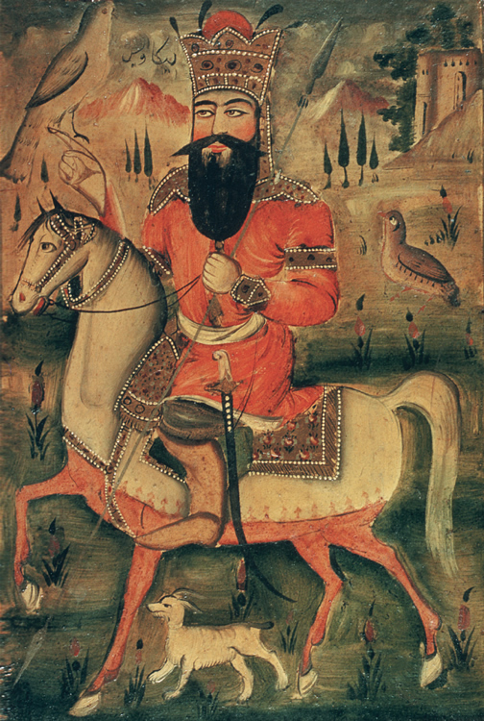
650BCE | Development of language into Old Persian using cuneiform script | 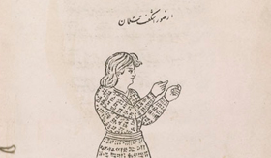
588BCE | Zoroastrianism becomes the official religion of Persia | 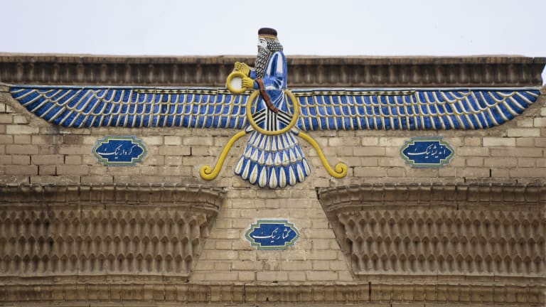
? | The study of science and technology | 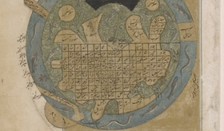
559BCE | Cyrus becomes the leader of Persia | 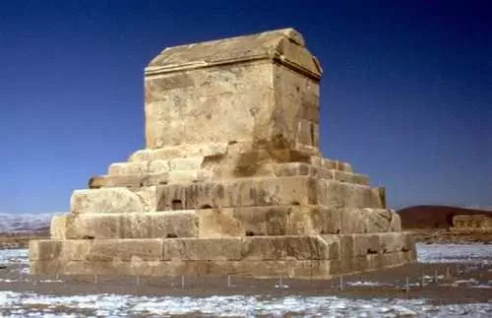
552BCE | Cyrus unified the Persian tribes
522-490(?)BCE | Darius expanded Persian empire to its full extent  Introduction of a standardised currency | 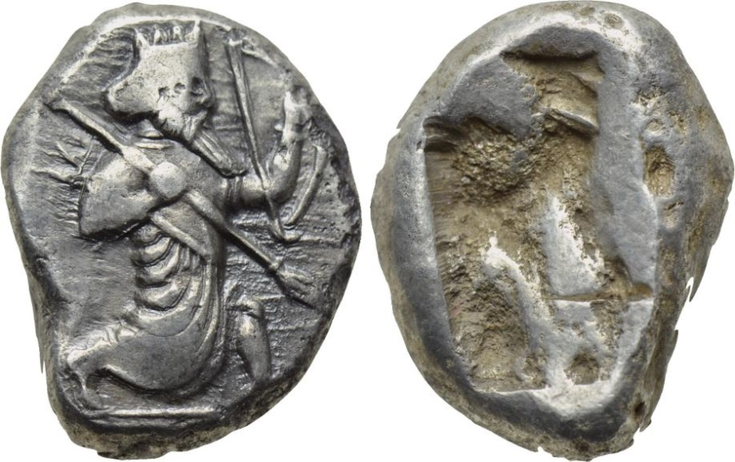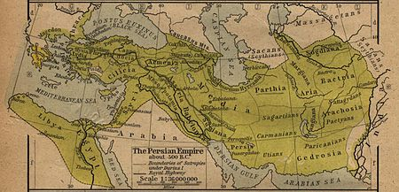
334BCE | Alexander the Great takes control of Persian empire | 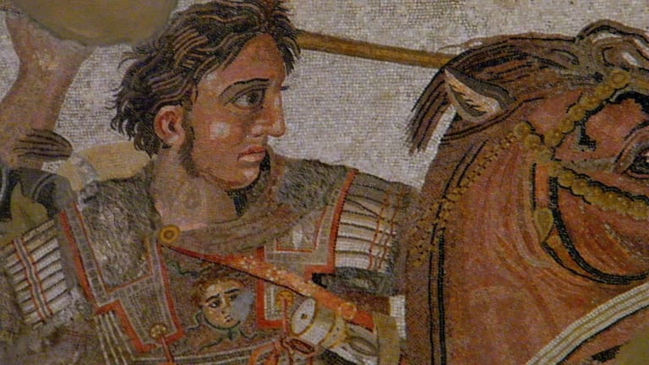
248BCE – 651CE | Writing and language influenced by Aramaic language, developed into Pahlavi | 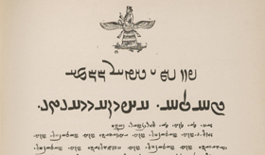

Bibliography
Frye, R. N. (1976) The Heritage of Persia, London: Sphere Books Ltd
Library of Congress (2014a) Science and Technology, Available at: https://www.loc.gov/exhibits/thousand-years-of-the-persian-book/science-and-technology.html
(Accessed: 10/01/2019)
Library of Congress (2014b) Writing Systems and Scripts, Available at: https://www.loc.gov/exhibits/thousand-years-of-the-persian-book/writing-systems-and-scripts.html
(Accessed: 10/01/2019)
Peterson, D. (2011) Achaemenid Empire, Available at: https://www.ancient.eu/Achaemenid_Empire/
(Accessed: 10/01/2019)
Schroeder, S. (2017) The Rise of Persia, Available at: https://www.khanacademy.org/humanities/world-history/ancient-medieval/ancient-persia/a/the-rise-of-persia
(Accessed: 09/01/2019)
Stark, P. (2013) A Little Big History of Horses, Available at: https://www.khanacademy.org/partner-content/big-history-project/expansion-interconnection/other-materials8/a/a-little-big-history-of-horses
(Accessed: 10/01/2019)
Images
History.com (2018a) Alexander the Great, Available at: https://www.history.com/topics/ancient-history/alexander-the-great
(Accessed: 10/01/2019)
History.com (2018b) Zoroastrianism, Available at: https://www.history.com/topics/religion/zoroastrianism
(Accessed: 10/01/2019)
Library of Congress (2014a) Science and Technology, Available at: https://www.loc.gov/exhibits/thousand-years-of-the-persian-book/science-and-technology.html
(Accessed: 10/01/2019)
Library of Congress (2014b) Writing Systems and Scripts, Available at: https://www.loc.gov/exhibits/thousand-years-of-the-persian-book/writing-systems-and-scripts.html
(Accessed: 10/01/2019)
VCoins (2019) Cyrus Coins, Available at: https://www.vcoins.com/en/stores/cyrus_coins/28/product/item_1123_ancient_persian_empire_achaemenid_kings_silver_siglos_time_of_darius_i_to_xerxes_ii_ca_485470_bc_with_spear_and_bow_type_exceptional_coin/599454/Default.aspx
(Accessed: 09/01/2019)
Wikipedia (2018) Persian Empire Available at: https://en.wikipedia.org/wiki/Persian_Empire
(Accessed: 10/01/2019)

P. Davidson, 2011
P. Stark, 2013
P. Stark, 2013
Library of Congress, 2014b
Library of Congress, 2014b
R. N. Frye, 1976
History.com, 2018b
Library of Congress, 2014a
Library of Congress, 2014a
S. Schroeder, 2017
P. Davidson, 2011
P. Davidson, 2011
S. Schroeder, 2017
S. Schroeder, 2017
VCoin, 2019
Wikipeadia,2018
S. Schroeder, 2017
History.com, 2018a
Library of Congress, 2014b
Library of Congress, 2014b

