FOOD & BEVERAGE OPERATIONS
ASSIGNMENT 2
Lecturer : Antoinette Milne
Student : Alina Iuliana Axinte 2223962
Word count : 386
Table of Contents
Part 1: Restaurant Concept 3
Part 2: Menu Design 5
References 8

Part 1: Restaurant Concept
The concept: The new restaurant will be focusing on providing vegetarian food articles to its customers (Lawo et al. 2020). Buffet service techniques and normal dine-in will be implemented. The menu will consist of various types of dishes. In addition, menu engineering will be done by considering seasonal variations. One of the exciting things about this restaurant is, that food items will be served by robots in the buffet zone (Chandrashekhara et al. 2022). People will get the opportunity to talk with robots in the serving area and whatever they need will be served to them automatically. Value-based pricing will be implemented for each food item. Moreover, the restaurant will have a proper seating arrangement indoors and out-door. Additionally, television along with Wi-Fi facilities will be provided for customers (Wan et al. 2023).
The restaurant will aim to improve and sustain a positive health status for everyone therefore the organisation will not use any type of harmful materials in its preparation (Foskett et al. 2021). Other than this, consumers will also have the opportunity to buy food items for their homes as well, however in this case little extra charge for parcels will be taken. One of the major focus areas of the business will be, it will follow value-based pricing strategy. Which can be defined as setting prices mainly depending on a customer’s perceived value of the product (Lopez, 2020).
Target audience: The main customers will be those who prefer vegetarian and vegan food items over non-vegetarian food articles (Davis et al. 2018). Furthermore, the older age group population will also be the target customer base for Hotel Trinity. Items like Cheese and Mushroom have been included as it has high levels of protein which is important for overall health (Kondyli et al. 2022). Rice has been added to fulfil the carbohydrate needs of consumers and green leafy vegetables have been considered as it contributes to vitamin and mineral requirement fulfilment (Takeda et al. 2022). Most importantly, people living in and around London will be the main target customers. The high purchasing capacity of London based on customers will help the business to blossom.
Reasoning behind menu choices: The rationale behind choosing the above menu is that, all vegetarian individuals prefer vegetarian food items. Therefore, a specific focus has been given to the vegetarian diet.

Part 2: Menu Design
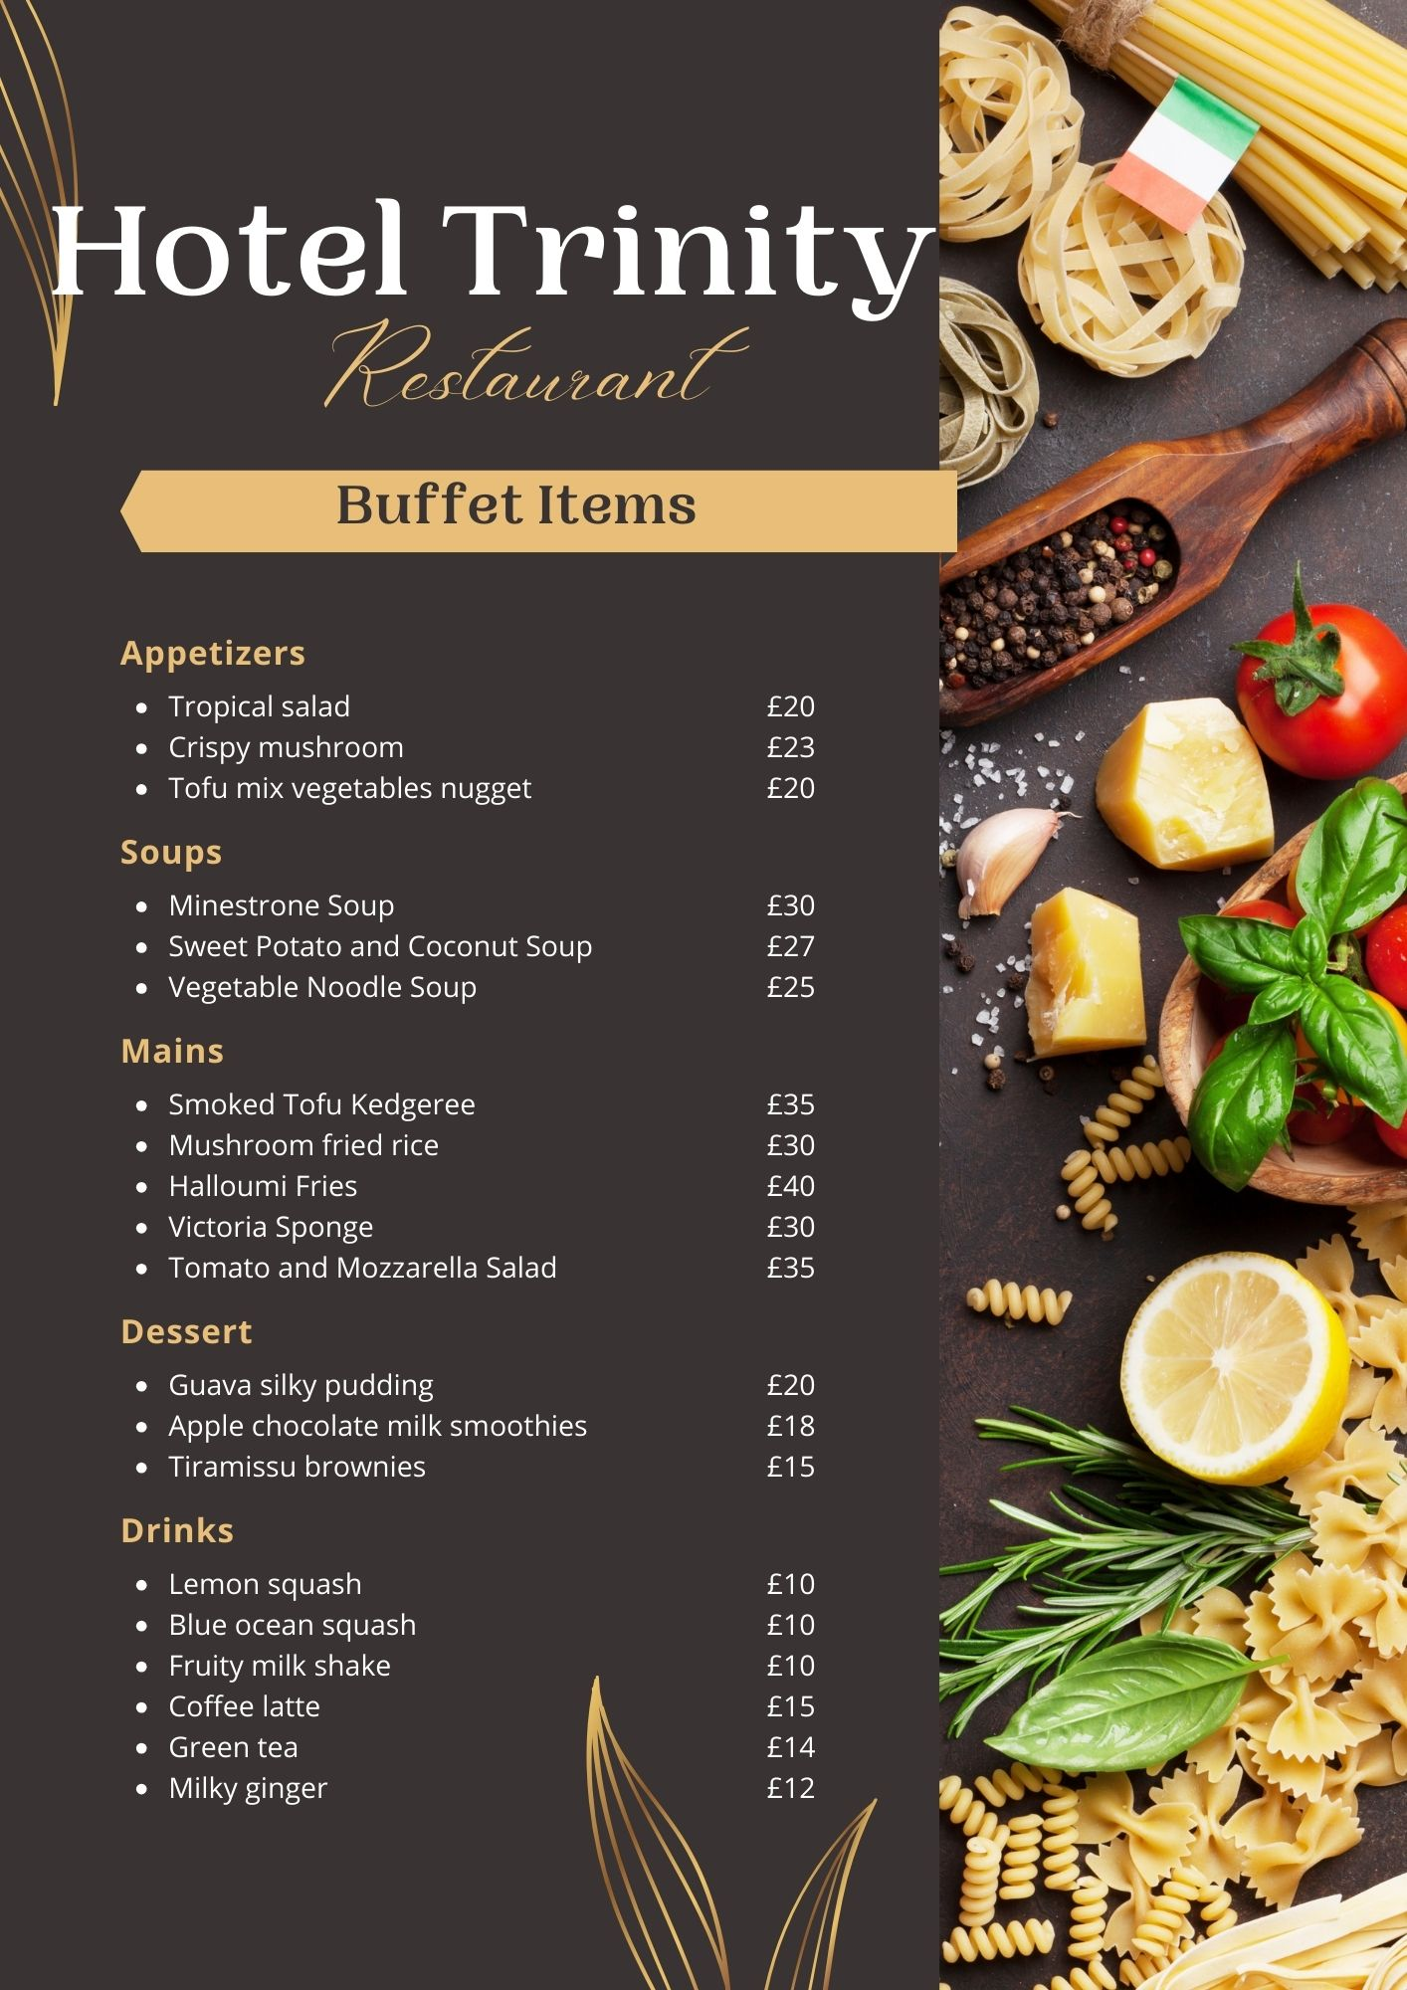
The above is the buffet menu where people will get to enjoy the above-demonstrated food articles. The list is somewhat limited however it includes some of the delicious food items. Additionally, the buffet zone is divided into five sections which are appetizers or starters followed by soups, the main menu, desserts and drinks at the end. Vegetarian customers like buffets and they might love this as well (Kohno et al. 2022).
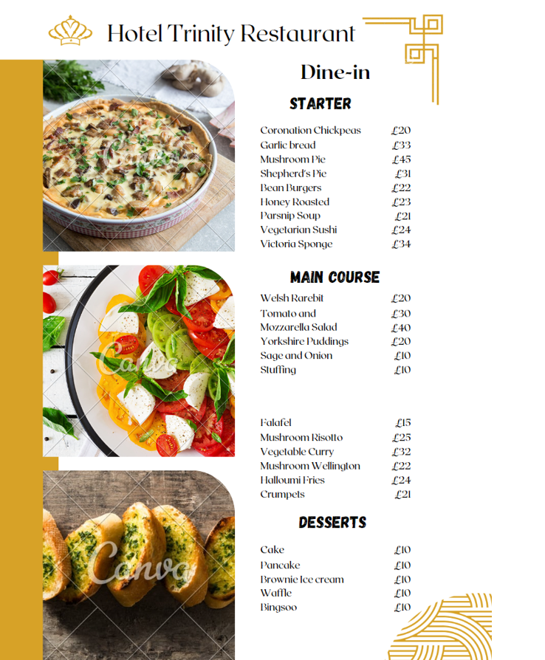
The above picture shows the dine-in menu for consumers and it consists of a wide range of food items. Items like mushrooms, cheese, tomatoes and other vegetables help in promoting health and well-being therefore, these items have been included in the menu (El-Loly et al. 2022). Different price ranges items have been included so that everyone has the opportunity to enjoy the food (Cousins, 2020).

References
1.. Chandrashekhara, J., Divya, M.S. and Shivaprasad, M.S., 2022. Food Serving Robot for Contactless Experience. International Journal of Innovative Research in Computer Science & Technology, 10(3), pp.58-61.
2.. Cousins, J. 2020 Food and beverage service. 9th ed. London: Hodder Education Group.
3.. Davis, B. et al. 2018. Food and Beverage Management. 6 edn London: Routledge.
4.. El-Loly, M.M., Mohamed, A.G. and Farahat, E.S., 2022. Innovative vegetables-processed cheese: II. high nutritional and functional attributes. Bioactive Compounds in Health and Disease, 5(1), pp.13-32.
5.. Foskett, D. et al. 2021. The Theory of Hospitality and Catering. 14th Edition. London: Hodder Education Group.
6.. Kohno, T., Cobb, C., Lerner, A., Lin, M. and Shostack, A., 2022. The Buffet Overflow Café. IEEE Security & Privacy, 20(04), pp.4-7.
7.. Kondyli, E., Pappa, E.C., Arapoglou, D., Metafa, M., Eliopoulos, C. and Israilides, C., 2022. Effect of fortification with mushroom polysaccharide β-glucan on the quality of ovine soft spreadable cheese. Foods, 11(3), p.417.
8.. Lawo, D., Esau, M., Engelbutzeder, P. and Stevens, G., 2020. Going vegan: The role (s) of ICT in vegan practice transformation. Sustainability, 12(12), p.5184.
9.. Lopez, S., 2020. Value-based marketing strategy: pricing and costs for relationship marketing. Vernon Press.
10.. Takeda, T.et al.2022, Rice apoplastic CBM1-interacting protein counters blast pathogen invasion by binding conserved carbohydrate binding module 1 motif of fungal proteins. PLoS Pathogens, 18(9), p.e1010792.

