

LEVEL 4 ASSESSMENT SPECIFICATION

Student name: | Joseph Underwood | Student ID number:
Programme: | HNC Process Operations Engineering
Module: | Plant Maintenance and Asset Care
Module code: | PCPO4005 | Contribution to Overall Module Assessment (%): | 100%
Lecturer: | P R Taylor | Internal Verifier: | Lance Rutherford
Assignment Title: | Asset Management | Word count (or equivalent): | 2000
Submission deadline: | 20 April 2020 | Return date of provisional marks & written feedback: | 06 May 2020
Submission method: | All written assessments, where practical and possible, must be submitted via Turnitin unless otherwise instructed by the Lecturer. (Please DO NOT put this assessment specification into Turnitin or it will match many similarities with other students’ submissions.)  Alternative submission method (if applicable):  Late submission of the assessment will result in a late penalty mark. Penalties for late submission: Up to one week late, maximum mark of 40%. Over one week late, 0%. Only the Extenuating Circumstances Panel may approve a change to submission dates.
Academic honesty / referencing: | Academic honesty is required. In the main body of your submission you must give credit to authors on whose research and ideas your work is based. Append to your submission a reference list that indicates the books, articles, etc. that you have used, cited or quoted in order to complete this assessment.

Module Learning Outcomes
(from module syllabus)
- Explain maintenance strategies and asset care methodologies.

- Select an appropriate maintenance strategy based on an assessment of the operational, business and legal requirements for the asset.

- Develop and implement asset care improvement techniques

TASK DESCRIPTION

Task 1. System Life Cycle (SLC)

Many companies adopt a System Life Cycle approach to the management of their assets. Explain this strategy and how it applies to the purchase, commissioning, operation, maintenance and decommissioning of equipment.

Task 2. Improvement techniques - Kaizen

Kaizen is an approach to creating continuous improvement in lean manufacturing that is adopted by a number of business. Explain this methodology and how it can be applied in an industrial setting.

Task 3. Total Productive Maintenance (TPM)

Total Productive Maintenance (TPM) is a maintenance methodology that is used to optimise asset utilisation. Explain this methodology and the key principles.

Task 4

A company has completed the installation of two electrically driven centrifugal pumps (see figure 1). The pumps will be operated in a duty/standby configuration and supply cooling water to a chemical processing vessel carrying out an endothermic reaction. The maintenance department are now assessing the new equipment to determine the most appropriate intervention strategy.

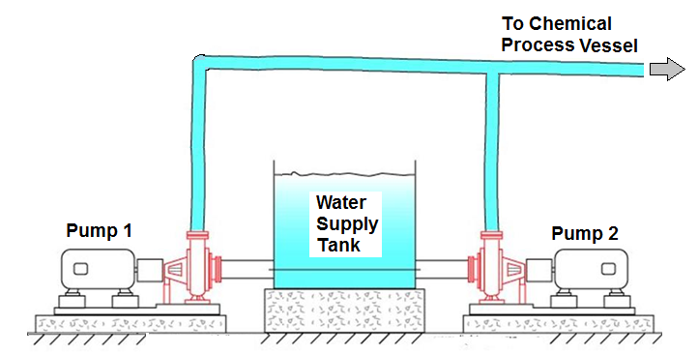

In order that a maintenance strategy can be put in place, operating information must be gathered from the new plant. Discuss a range of monitoring equipment which can be used to obtain this information. With respect to the above scenario and equipment, discuss the advantages and disadvantages of adopting either a run to failure or a planned preventative maintenance strategy. Select which strategy you would adopt, providing your justifications based on operational, business and legal requirements.

Task 5

Assets deteriorate over time which risks affecting production requirements.

For an asset that you are familiar with at your place of work, conduct an asset care assessment. Based on your assessment, develop an asset care improvement plan and describe how this might be implemented.

Report writing

To complete this assignment you are required to generate a report of 2000 words. Your report should critically present the research work undertaken. Present and discuss the results obtained with reference to any background material and draw appropriate conclusions to the results obtained.

Note: Any hand written submission will not be accepted.

Student FEEDBACK FORM

This section details the extent to which the assessment criteria are demonstrated by you, which in turn determines your mark. The marks available for each category of skill are shown. Lecturers will use the space provided to comment on the achievement of the task(s), including those areas in which you have performed well and areas that would benefit from development/improvement.

Generic Assessment Criteria | Marks available | Marks  awarded
1. Engagement with Literature Skills
.
 | 10
2. Knowledge and Understanding Skills

 | 40
3. Cognitive and Intellectual Skills

 | 20
4. Practical Application Skills

 | 20
5. Transferable Skills for Life and Professional Practice

 | 10

Assessment Mark (Assessment marks are subject to ratification at the Exam Board. These comments and marks are to give feedback on module work and are for guidance only until they are confirmed. ) | Late Submission Penalties (tick if appropriate) |  | %
 | Up to 1 week late (40% Max) |  | %
 | Over 1 week late (0%) |  | %

Learner Name: Joseph Underwood.
Course: HNC Process Operations Engineering Year 1.
Module Code: PCPO4005
Module: Plant Maintenance and Asset Care
Asset Management.

Contents
Contents 2
Task 1. System Life Cycle. 3
Task 2. Improvement techniques - Kaizen. 4
Task 3. Total Productive Maintenance (TPM). 5
Task 4. 7
Task 5. 8
References. 11

Task 1. System Life Cycle.
Many companies have opted to use the system life cycle model for planning, implementing and managing their assets. The idea of system life cycle can be broken down into 4 stages of the project’s life;
- Design- planning the system, allocating time, power and funds to relevant sections of each system.
- Commissioning- creating the designed system and running QA to begin its useful life.
- Useful Life- running the system as intended for it to serve its purpose.
- De-commissioning- stopping and removing the system once its served it purpose/ no longer fit for purpose.
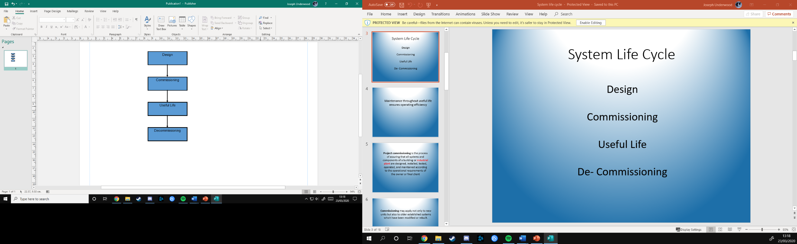
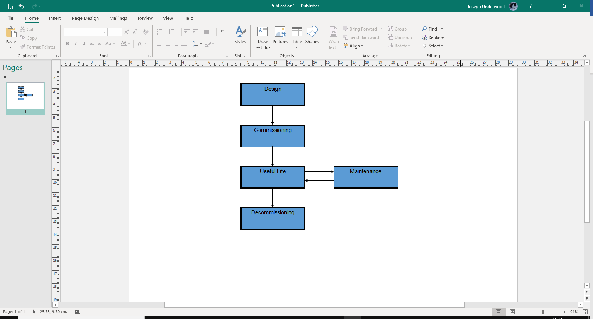
This the generic model that people will refer to when speaking of a system life cycle model and will plan their economics of the project around these four stages without consideration of another part of the model which can and should be considered, maintenance of the plant and assets.
Figure 1, Simple SLC Model.
Figure 2, SLC Model.
When using these types of models to help start in the early design stage, it helps split up the planning for the above-mentioned sections to further streamline the planning of the project. Using this system, time, money and manpower can be assigned early on from the design stage of the project to optimise those resources to help focus on a less costly operation of starting and running the system. Other models will go into further detail showing more ways to divide each section further and further to show more and more areas which can be focussed on such as splitting maintenance into UCM and PPM.
When using this approach to manage assets of a project, the designers can use the SLC layout to plan out future requirements of the system or needs for the system such as, running quality assurance for the finished stages of commissioning, building traceable maintenance schemes for the system, creating a fluent and well equipped training system for those who will work on or with the system and planning for the eventual removal of the system. All this early planning can help calculate the costs of the system from implementation to removal of the system, including the maintenance and operation of the system.

Task 2. Improvement techniques - Kaizen.
Kaizen is a workplace improvement technique invented by the Japanese with the vision in mind of continuous and incremental improvements to work areas in aid for better production and safer environments.
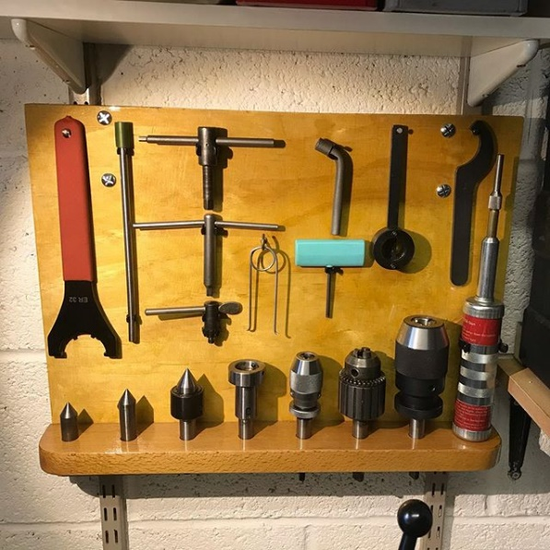
Such working environments could be something as simple as working in a metal machining workshop, that’s only just started as a workshop. Initial ideas for keeping tools and equipment in a safe place would be to keep them in stores which are commonly access by every machinist in the workshop, thus keeping them where they can be found. This process can be time consuming for workers to be continuously walking back and forth between their workstation and the tool storage when they change between different machining techniques. Using the Kaizen approach, a simple solution can be implemented such as assigning everyone a board of tools which can be left at their workstation until the end of the day which it will then be returned. The figure across shows one example of how tools can be stored and presented to easily identify if a tool is missing. Other improvements made include outlining every tool on the board so when a tool is gone, it can be spotted instatly.
Figure 3, Lathe Tool board.
The design behind the methodolgy has been summarised greatly in the book “The Kaizen Way” written by Dr Robert Maurer. Dr Maurer explains how people are reluctant to move forward with big changes due to the fear of what may occur, but by giving those people smaller incremental changes which together sum up to that large change is less challenging as it removes that initial fear. “Where once you might have been daunted by change, your new mental software will have you moving toward your ultimate goal at a pace that may well exceed your expectations.”( Robert Maurer, 2012, p.26)
The methodology of Kaizen doesn’t stop once you reach the goal which you initially set out to fix, instead it is a continuous cycle of improvement within the workplace working with the key points of;
- Getting employees involved.
- Gather list of problems or bottlenecks for work.
- Encourage the finding of the solutions.
- Test and monitor the solutions.
- Fully adopt the solutions and repeat for more problems.

Task 3. Total Productive Maintenance (TPM).
Total Preventative Maintenance (TPM) is a maintenance strategy that focusses on keeping all equipment in working order to allow for the highest production output. By minimizing the amount of time that equipment is out of service you can increase the amount of time for production to take place in. To implement TPM, you must go through a few steps to ensure that it will all work smoothly. These steps are sometimes called the pillars of TPM and are;
- Autonomous Maintenance- Setting up a maintenance strategy and generating procedures so that maintenance is effectively carried out. Includes involving low skilled and skilled workers carrying out maintenance task appropriately.
- Focussed Improvement- Identifying and rectifying problems found in the workplace to allow steady flow of work.
- Planned Maintenance- Setting up procedures and planning maintenance for ideal points when equipment can be taken out of service.
- Quality Maintenance- Ensuring that equipment receives the maintenance that is required.
- Early Equipment Management- Design teams working with operation and maintenance department to ensure the equipment is effective for use.
- Training and Education- Ensuring that all personnel working on or with the equipment is suitably trained which ensures better performance and reliability.
- Health, Safety and the Environment- Carrying out risks assessments, hazard maps, safety audits, implementing protections and following government policies to ensure zero accidents and safety to the environment.
- TPM in Administration- Streamlining processes such as work assignment to ordering materials/ parts using a suitable supply chain in order to reduce waiting time and ensuring that work can be carried out when needed to.
With these goals in mind, a company can effectively minimise the faults in their systems and ensure that plant is working correctly for as much effective time as possible. The aim is to ensure that their plant is gaining as much use as possible from working, while also protecting the employees and the environment from harm.
Carrying out all this work would seem pointless or ineffective without ways of measuring the performance changes from using TPM, thus steps must be taken to include KPIs (Key performance indices) to measure what is changing. These KPI would include metrics such as;
- Faults found in the workplace.
- Meantime between equipment failures.
- Equipment downtime.
- Cost of maintenance.
Using these as a guideline, before looking at problem areas it would most likely be found that all these metrics would be higher than expected and thus costing more money that first anticipated. Once TPM has been carried out a drastic peak would mostly be found each of the KPIs as problems are resolved to bring existing plant back to its former glory, and then a slow downwards curve as the remaining problems are addressed. The most important KPI involved with TPM is the equipment efficiency which can be calculated by;
$$Availability(\%)=\frac{(total time avaiable-downtime)}{total time available} X 100$$
Figure 4, Overall efficiency equation.
The above equation, (Steven Borris, 2006, p.26) , is generally used to find the equipment time usage efficiency of equipment and should be aiming for at least 90%, where 0% is no time in service and 100% is no time out of service.

Task 4.
As discussed within the assignment brief, two centrifugal pumps are running in parallel to supply cooling water to plant processes without a maintenance strategy in place and equipment monitoring must be used before a maintenance plan can be put in place.
There are many techniques which can be used in order to determine the expected live of a pump or other rotating equipment, an many of them can be more effective than others. Initial and commonly used monitoring techniques will include vibration analyses or thermal readings, but many other used techniques will include oil analyses, sound analyses, electrical analyses and even process surveys. I will briefly discuss the uses and benefits of each.
- Vibration analyse- Using a vibration probe to measure the movements within the equipment such as the bearings rotations, indicating if bearings are becoming worn.
- Thermal reading- Using infrared cameras or temperature gauges to monitor the temperature change at key points on the equipment such as motor or bearings, to show if any component is overheating.
- Oil analyse- Using special analysing equipment to read the chemical makeup of the equipment and find oil impurities such as coke or sediment from wearing bearings.
- Sound analyse- Using specialised microphones to detect changes in sound frequencies or imperfections in the equipment such as cracks in pump casings.
- Electrical analyse- Measuring the current consumed by the equipment to determine if there is any electrical faults.
- Process surveys- Taking measurements of the process the equipment is related to and measuring its output.
When monitoring the equipment, all measurements shouldn’t be used as definite proof of a problem occurring but just as justification that maintenance is needed to be moved forward. Each technique could be give false information and thus parameters should be set such as the measurements taken after 2 hours of running time at least to ensure consistent variables of the equipment.
Due to the urgency of the pumps requirements of being used as cooling water, I believe that a run to failure strategy would be dangerous to do if both pumps were to fail simultaneously or fail to run when needed. This is because it could endanger the process which is exothermic and could have affects such as the process becoming out of control, putting the health and safety of workers at risk. Though a run to failure could be more cost effective, the benefit doesn’t out way the risk.
I believe that the needed maintenance plan for the pumps would include a planned maintenance strategy for common services of the equipment while also implementing condition base monitoring to forecast if the pump will fail sooner than expected. Though it will be more expensive to take the pumps out of service sooner than needed, the benefit of securing health and safety of the employees and process safety out ways the additional cost.

Task 5.
35-CM-101B is an air compressor found in the utility section of the Pembroke Refinery which is vital for producing instrument and utility air for the use of operations and the control systems found on site. The compressor itself is an Ingersoll Rand JOY centrifugal air compressor, holding three stages of compression and oil cooling before producing upwards of 7Bar of pressure used across the refinery.
The compressor itself is made up of;
- One large and one small electric motor.
- Gearbox.
- Three compression stages.
- Three cooling stages.
- Two control valves.
- Various monitoring instruments.
To carry an assessment on how to care for the equipment, I will first need to carry out a FMECA assessment to determine what could fail, how it will fail and what effects it will have. I will assess each component with respect to four factors for criticality, each factor will represent;
- A- Consequences to quality.
- B- Consequences to the safety.
- C- Consequences to environment.
- D- Consequences to operation/ business.
This will be assessed from one to five where one is little or no impact and five is devastating impact (i.e. shutdown of equipment or loss of life).
Component | Factor A | Factor B | Factor C | Factor D | AxBxCxD
Electric Motor Failure. | 5 | 3 | 1 | 5 | 75
Gearbox Failure | 5 | 2 | 1 | 5 | 50
Compressor Failure | 5 | 1 | 1 | 5 | 25
Oil HE Failure. | 3 | 3 | 2 | 3 | 54
Control Valve Failure | 5 | 3 | 1 | 5 | 75
Instrument Failure | 2 | 3 | 1 | 3 | 18
Figure 5, Criticality Assessment.
I will also need to carry out a failure mode and effects assessment with the following factors;
- E- Mean repair time.
- F- Mean time between failures.
- G- Damage to other equipment.
- H- Repair costs.

Component | Factor E | Factor F | Factor G | Factor H | ExFxGxH
Electric Motor Failure. | 2 | 2 | 1 | 4 | 16
Gearbox Failure | 3 | 1 | 4 | 3 | 36
Compressor Failure | 4 | 1 | 2 | 2 | 8
Oil HE Failure. | 4 | 2 | 3 | 3 | 72
Control Valve Failure | 2 | 1 | 2 | 2 | 8
Instrument Failure | 1 | 3 | 3 | 2 | 18
Figure 6, Failure mode analyses.
To assess these figures, consideration were taken into account of the local area to where the compressor is situated and how it could fail, i.e. tube leak inside heat exchanger or instruments failing in position not responding to changes in process. Using the two tables created, we can now generate a full FMECA analyses of the systems in relation to the air compressor.
Component | A | B | C | D | AxBxCxD | E | F | G | H | ExFxGxH | Total
Electric Motor Failure. | 5 | 3 | 1 | 5 | 75 | 2 | 2 | 1 | 4 | 16 | 1200
Gearbox Failure | 5 | 2 | 1 | 5 | 50 | 3 | 1 | 4 | 3 | 36 | 1800
Compressor Failure | 5 | 1 | 1 | 5 | 25 | 4 | 1 | 2 | 2 | 8 | 200
Oil HE Failure. | 3 | 3 | 2 | 3 | 54 | 4 | 2 | 3 | 3 | 72 | 3888
Control Valve Failure | 5 | 3 | 1 | 5 | 75 | 2 | 1 | 2 | 2 | 8 | 600
Instrument Failure | 2 | 3 | 1 | 3 | 18 | 1 | 3 | 3 | 2 | 18 | 324
Figure 7, FMECA analyses.
From the table above, you can find that the equipment with the highest combined impact of all factors is the oil heater exchanger for air cooling. This would indicate that the heat exchanger would require the most attention to ensure that failure does not occur and cause damage to the equipment, personnel or the environment.
Using this information above, it would be advisable to have spares to use for the heat exchanger, electrical motors and gearbox as they have the highest scores and the remaining score much lower.
The equipment itself would require a planned maintenance schedule to ensure that no failure would occur. With such low scores, the instruments and control valves would only need yearly calibrations to stay in line with industry standards for calibration, as critical instruments run with three or six months between calibrations.
To aid in identifying problem areas, weekly inspections should be conducted on the motor, gearbox and heat exchangers using CBM and when possible, the compressor taken out of service for routine analyses of things such as oil changes, tube inspections, and proper shaft alignments. This should occur every 6 months at least to ensure safe working of the equipment.
Word Count: 2,173

References and Bibliography.
Borris, Steven. 2006. Total Productive Maintenance. 1st Edition. New York. McGraw-Hill Education.
Cousineau, Marc. How to make condition-based maintenance more effective. Fiixsoftware.com. February 2019. 5th March 2020.
Lean Manufacturing. Chapter 7, Early Equipment Management. Leanmanufacturing.online. September 2018. 4th February 2019.
Life Cycle Engineering. Life Cycle Asset Management. Lce.com. 2015. 7th February 2020.
Maurer, Robert. 2012. The Spirit of Kaizen: Creating Lasting Excellence On Small Step at a Time. 1st Edition. New York. McGraw-Hill Education.
Rolls Royce. How to Implement Asset Care. Rolls-royce.com. December 2019. 3rd March 2020.

