Questions
Section 1
AC 1.1: With reference to typical activities and behaviours, appraise what it means to be a ‘people professional’.
AC 1.2: Discuss how ethical values underpin the work of a people professional, including two examples of how ethical values might be applied in a people practice context.
AC 1.3: Consider the importance of people professionals being able to influence others and ensure that the ‘people practice voice’ is heard in an organisation, through informed, clear and confident communication.
AC 1.4: For each of the situations below (a & b), provide an example of an issue that would cause you to raise the matter to a manager (or other authority) - and describe how you would do this.
a) where you consider something to be unethical (whether or not it is illegal),
b) where you believe something contravenes legislation.
AC 2.1: Discuss two theories or models relating to the human and business benefits of people at work feeling included, valued, and fairly treated, concluding your discussion with a summary of your own view of these benefits.
AC 2.2: Discuss two ways in which a people professional can build inclusivity into a people practice initiative at the design stage, and two ways of checking inclusivity after a people practice initiative is implemented.

Section 2
AC 2.3: Reflect on your own approach to working inclusively and building positive working relationships with others.
AC 3.1: Explore how the role of a people professional (specialist or generalist) is evolving and the implications this has for your CPD.
AC 3.2: With reference to your responses for Q1 & Q2, and feedback on your behaviours or performance obtained from (at least) one other person, assess your current strengths, weaknesses, and development needs. Your response should include an explanation of the feedback received and how it has informed your self- assessment.
AC 3.3: In follow-up to your self-assessment, identify a range of formal or informal development activities you will undertake to support your ongoing professional development. Your response should include a brief description of your chosen activities and your reasons for selecting them.
AC 3.4: Reflect on the impact of three previous learning activities (i.e., not the activities planned at Q4 above) on your behaviour and performance. The selected activities may be any formal/planned or informal/unplanned activities undertaken in the last 12 months, which you consider to have impacted your behaviour and performance. (AC 3.4)
Present your reflections, attached to your assignment, as either:
- your own format CPD record, edited to include just the three selected activities, or
- a report (or reports) from the CIPD ‘My CPD Reflections’ tool.

SECTION 1
AC 1.1
Professionals are competent, skilled and qualified people with extensive, specialist knowledge and experience within the field that they work. People Professionals are often, but not always, CIPD qualified and bound to the CIPD code of conduct and standards and should work to the profession map. Their skills and knowledge should be retained through ongoing training via CPE and their behaviours should be fair, transparent and independent making decisions and provide advice which is “principles-led, evidence-based and outcomes-driven”. (CIPD, 2024)
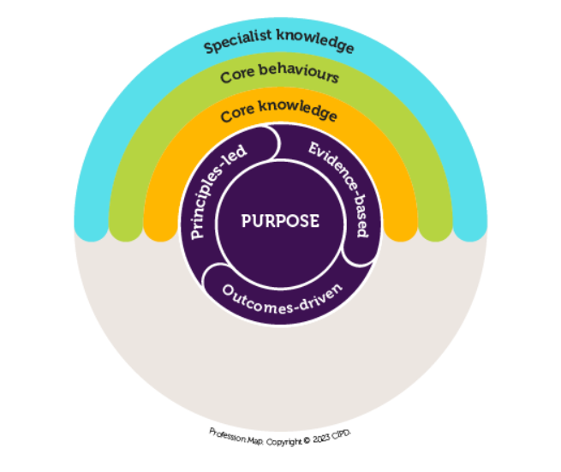
CIPD (2024)

The role and purpose of the people profession is to “champion better work and working lives. Creating roles, opportunities, organisations and working environments that help get the best out of people, delivering great organisational outcomes, in turn driving our economies, and making good, fair and inclusive work a societal outcome.”(CIPD, 2024a) This should be seen through activities and behaviours such as providing knowledge and support to the organisation, recognising and championing the importance of people, wellbeing and equity and providing the role of the “social conscious of an organisation” (CIPD, 2024b)
People professionals should provide ongoing challenge, an alternative viewpoint and promotion of current best practice advice and guidance. The CIPD states that “as people professionals, we value what people bring to organisations, and an integral part of our role is to bring the people perspective to business decisions” (CIPD, 2024c) Depending on the specialism of the role, people professionals may be involved in setting and facilitating policies, overseeing learning and development and providing help and support for activities such as recruitment, redundancy, managing conflict and overseeing continuous improvement within the People Team. In organisations in which I have worked, the People Team set the People Strategy and People Policies and then provided support and guidance to managers to implement these as opposed to day-to-day management, however, this operational approach is sometimes the case in some organisations.

AC 1.2
The CIPD (2024d) states that “Ethical values provide the moral compass by which we live our lives and make decisions… when we make decisions based on good principles, and live by good values, we can improve the lives of others and their experiences at work.”
Ethics are unpinned by the concepts of equality and fairness and whilst there are several ethical perspectives which all consider ‘doing the right thing’ from different angles, there is value to be taken from considering all options. If we utilise three different ethical perspectives to considering an appropriate outcome to an organisation considering its approach to a pay rise. Deontology would state that it is fair that the higher performer should receive a higher pay award. Utilitarianism may split any available money across all employees to ensure that all receive an increase as this is the greater good for the greater number of employees. Ethical Egoism may grant Chief Executive only a pay rise to maintain pleasure for the individual. This scenario demonstrates how different ethical perspectives can create different outcomes; none are ‘wrong’ if you believe in the ethical approach but in the interest of fairness, the CIPD (2015) introduced eight ethical lenses which show the CIPD’s expectation of how people professionals should consider ethics within their roles.
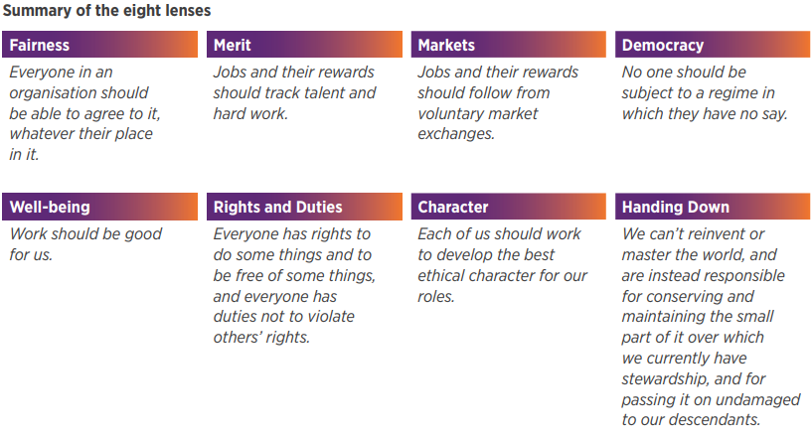
CIPD, 2015
We see examples of different ethical perspectives and approaches being used within People Practice frequency, for example, policies and procedures are an example of deontology as it is rule driven and clearly details what is to be expected, equal percentage pay awards as noted above in line with utilitarianism or performance management of underperforming employees as an example of consequentialism.

AC 1.3
The CIPD profession map includes both communication and influencing as core behaviours for people professionals.
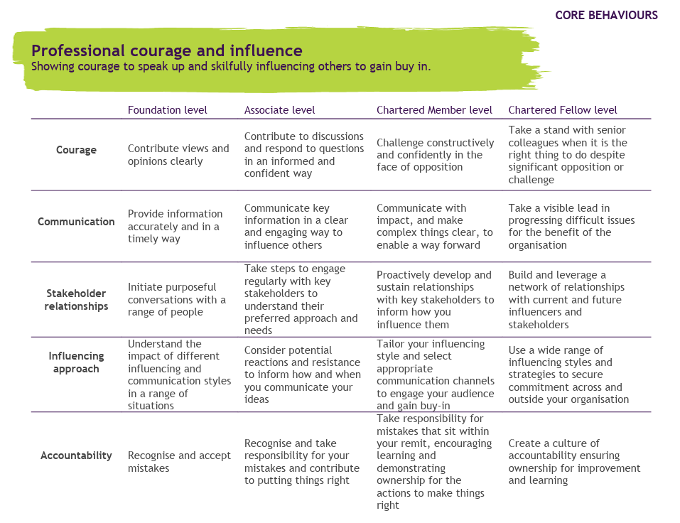
CIPD (2023)

To enable the People Professional voice to be heard, respected, considered and have leadership qualities, there is a need to be clear, informed and confident in communication. This allows the People Profession to effectively influence an organisation. The CIPD states that “influencing often happens in tandem with courage: the ability to challenge when there’s resistance or opposition, speak up when you know something isn’t right, and take a stand when it’s the right thing to do” (CIPD, 2024e). This links back to the need for morality and the ability to build strong relationships within an organisation.
It is important to be informed, using approaches such as evidence-based practice and being aware of current legislation and requirements. This allows the voice of the People Profession to provide appropriate and up to date information which will allow for more informed decision making.
Clarity in communication is important to ensure that the intended audience receives the intended message. Clarity can reduce the need for interpretation, and thus reduce difference in approaches which may defer from the intended approach. Clear messaging can take many forms, and this is often necessary to ensure that all receive the information appropriately, where diversity is considered.
Confidence in presenting the information is key to gain support, be seen as a key leadership voice and to appropriately set the tone.
It is easier in some ways to consider the impacts of where a People Professional shares information in a manner which is not informed, clear or confident. There are risks that wrong information is shared which leads to poor decision making and the desired impacts not being achieved, leading to objectives not being met, a lack of value for money and ongoing distrust in the People Profession. Lack of clarity could mean that recipients do not interpret the information as intended again, leading to the consequences detailed above. Confidence is key as in the absence of confidence in delivery, could lead to a lack of confidence in the message, a lack influence and lack of buy in to the message.

AC 1.4
Unethical workplace behaviour can be defined as “any organisational member action that violates widely accepted moral norms” (CIPD, 2019). This can span from minor misdemeanours to breaking the law. An organisation’s expectations are often outlined in policies or codes of conduct and some staff members would be bound to additional codes of ethics via professional memberships.
An example of an unethical act could be an employee receiving a gift from a potential supplier. This may breach internal policy and may be seen as inappropriate, but it is not breaking the law. Depending upon the evidence or extent of the gift there may be a need to gain further information. To approach the issue, it would be helpful to discuss the issue with a manager or another member of the people team to gain insight and guidance and to understand whether the organisational saw this action as an issue. Internal policies and guidance would need to be reviewed to ensure that the issue was handled fairly and in line with organisational expectation. However, if no guidance was in place, guidance such as the CIPD website may be consulted to understand good practice in this area to communicate the potential risk with the business to consider in the future.
However, there are some circumstances which are both unethical and unlawful. In a case where there has been a breach in legislation, there is a need for more formal and there is less ambiguity to the approach. In a case where an employee has stolen items from and organisation, there is a need to take more formalised action and to document the approach as it may end up in court. Depending on the level of evidence available, a slightly different approach may be taken. Should the incident be suspected, but no evidence, it may be appropriate to refer the issue to the Fraud or Internal Audit Team for investigation. However, if there was more solid evidence, it may be appropriate to refer directly to the Police. There is a need for confidentiality within the case as not to alert the individual as they could destroy evidence but also to protect the individual as this could tarnish their reputation and they should be able to be considered ‘innocent until proven guilty’.
There is a need for organisations to promote reporting of unethical and/ or unlawful behaviour through processes such as whistleblowing (CIPD, 2024f) and take such reports seriously and handle them appropriately (ACAS).
AC 2.1
The CIPD (2022) states that inclusion is “creating working environments and cultures where every individual can feel safe and a sense of belonging and is empowered to achieve their full potential.”
Maslow’s (1943) Theory of Human Motivation model splits human needs in to three categories: basic, psychological and self-fulfilment.
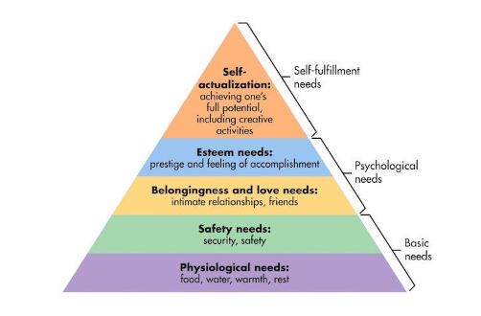
Pinterest

When we consider a person feeling valued and included, these elements would sit within the safety and belonging categories and in line with the model which states that an individual cannot progress to their full potential without the basic and physiological needs being met, organisations would not realise true value of an employee should this be the case. This could impact on the performance, commitment, retention and wellbeing of the employee which is negative for both parties. Whilst there are multiple benefits to individuals when they are included, organisations also benefit in various ways such as retention, reputation and enhanced business performance.
Rosalind G Brewer (2020) states that an organisation’s “biggest opportunity is inclusion.” Brewer explores the need for employees to feel “safe, comfortable, heard and seen” and the value that this can bring not only to the organisation via engagement and performance but also the positive impact on the wider community.
There are clear benefits to inclusion, and I agree that it brings value to all when executed appropriately. Inclusion is the right thing to do as I believe that no one should have to hide their ‘true self’ or feel unsafe. In a workplace, inclusion aligns with the CIPD code of ethics, meets legislative requirement and there are clear benefits to productivity, performance and profitability in an inclusive environment. I agree with Brewer when she states that metrics and surface level inclusion practices are not the answer and that it needs to be fully embedded within an organisation and I think that within organisations that I have worked in previously, this has been the case and it has not been successful as it felt like something that had to be done and a tick box exercise. The organisation in which I currently work is a small business and inclusivity and actively listening and learning is embedded in the culture and this is much more effective in fostering an inclusive workplace and the benefits of such are visible.
AC 2.2
As noted in 2.1, there are clear benefits of promoting fairness and inclusivity. There is therefore a need for People Professionals to ensure that initiatives set out to be inclusive and to ensure that the goal of inclusivity is achieved.
The CIPD (2019a) states that “Workplace inclusion is when people feel valued and accepted in their team and in the wider organisation, without having to conform.” Workplaces should allow all employees to be safe respected, heard and accepted.
When making any change or within an organisation, there is a need to have clear, SMART (CMI, 2020) objectives to allow for measurement of success. Commonly organisations do not utilise this approach and then find it difficult to assess impact, therefore there is a need to have a clear starting point and to clearly outline the benefits to be achieved and the metrics which will be used to assess.
Inclusivity can be built into an initiative at design stage through awareness of the employees that could be impacted by the initiative. Therefore, there is a need to understand how the initiative could impact as well as the demographic of the organisation and the current and potential barriers to inclusion. This could be through stakeholder analysis, review of Equal Opportunities Monitoring Data held by the organisation, completion of an Equalities Impact Assessment or through liaison with employee forums or groups to understand the current environment.
Focus groups are often utilised to gain feedback or project teams are built utilising representatives for stakeholder groups to allow for effective consultation and input of key users. This can be useful as it provides ongoing feedback and the opportunity to adapt and adjust plans in real time to ensure that the needs of the user are met. (Perkins and Woodhams, 2022, Pg 128-129)
Following the implementation of an initiative, organisations should ensure that inclusivity benefits have been realised and that the initiative has reached and benefited all intended staff. There are many ways that this can be done including surveys or other employee engagement practices. Surveys are commonly used as they allow many employees to provide feedback in a manner which can be compared with minimal resource from the People Team aside from setting up survey and analysing data. It is beneficial to undertake a survey before and after the initiative to assess success. However, staff forums and interviews could be helpful to collate qualitative data. (Perkins and Woodhams, 2022, Pg 128-129).
KPI metrics should be defined at design stage, again comparing previous performance or assessment point to allow objectives to be assessed. These often take the form of key performance indicators and can be useful to measure the impact of change (CIPD, 2023a).

SECTION 2
AC 2.3
I have recently undertaken the Myers Briggs assessment (MBTI, 2024) which proved to be very useful to me through the promotion of self-awareness of my own preferences but also to think about how I interact with others who will likely have different preferences. As Margaret Heffernan (2013) states, is often easier to stay with people who are like you and, as such, design working environments around your preferences that consider others and their opinions. This has prompted me to reflect on myself and others and understand that there is ongoing need to consider my approach to working inclusively and building positive working relationships. I understand that there is a need to enhance my understanding in this area and focusing on the needs of others rather than doing what I think is best.
I work hard to build positive relationships with colleagues and other stakeholders and I am open and honest. I often utilise the “know, like, trust” approach and this has allowed me to build relationships in an effective way, particularly in a more hybrid working environment.
I am aware that I have a tendency to offer too much support to staff and that there is a risk of creating a parent/ child relationship or entering in to the ‘drama triangle’ (Karpman, 1968). Therefore, I am working towards a coaching relationship with colleagues to support, empower and engage in a more positive way.

AC 3.1
The people profession is evolving and changing in the wake of AI and technology. As such, there is a need to champion difference and the advantages that it brings including challenge differing ideas and viewpoints. There is a need to embrace diversity and inclusivity as this is the value that humans bring to the workplace, which cannot currently be provided by technology. There is a drive for focus in this area and looking at how employees add value and adapt to the changes that technology brings. To promote this, HR need to ensure that they are well placed to assess the environment, providing advice using data and multiple sources (evidence-based practice). EBP is more important than ever as many sectors have less time and budget so want to make the best possible decision (CIPD 2021). There is an unpredictability in the world as demonstrated by the events over the last 10 years, as such there is a need to be agile and responsive to the challenge at hand (Ted Talk, 2019).
There is a huge focus on wellbeing and work life balance, with employees holding a lot of power and influence. Organisations are starting to understand that “people want to work for employers with good employment practices. They also want to feel valued at work” (CIPD, 2022) and that wellbeing is a “core enabler of employee engagement and organisational performance (CIPD, 2023b).
Finally, within the sector that I work in (risk assurance), recruitment and retention of staff is difficult sue to competition and skills gaps. This is cited as the second biggest risk to organisations meeting their objectives in recent research (IIA, 2023). This has meant that there has been a need to think differently, moving away from traditional approaches and introduction of the four-day working week and more investment in learning and development.

AC 3.2 and AC 3.3
Below, I have included exerts of a recent appraisal with my Line Manager. This includes a joint assessment of strengths and weaknesses as well as identifying development needs and objectives. I have anonymised the names of colleagues as appropriate. As an organisation, we undertake annual appraisals where objectives are set and monthly one to ones to discuss wellbeing and progress against objectives where appropriate. The approach is in line with the CIPD (2024g) Performance Review guidance and the fairness principles included in McKinsey’s (2018) survey.

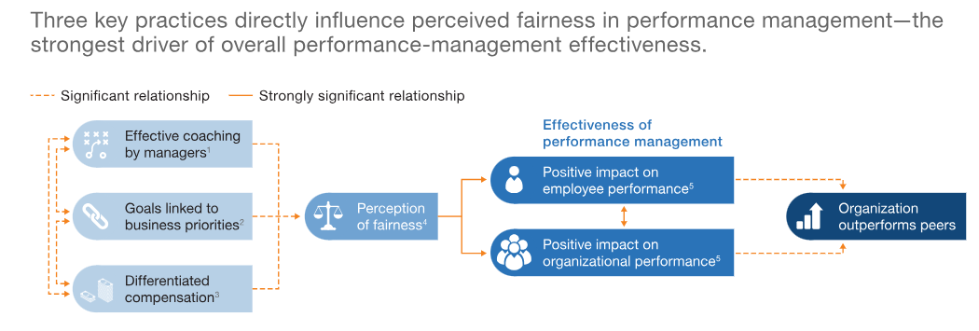
Similar opportunities for improvement were identified within this discussion as identified within my self-reflection exercise. It is key to be critical of your own processes and seek continuous development which requires self-awareness. There is also a need to look to others to gain feedback to help identify and monitor objectives. As part of my next appraisal, we are looking to implement some 360 feedback in to get feedback on progress against the Leadership objective.
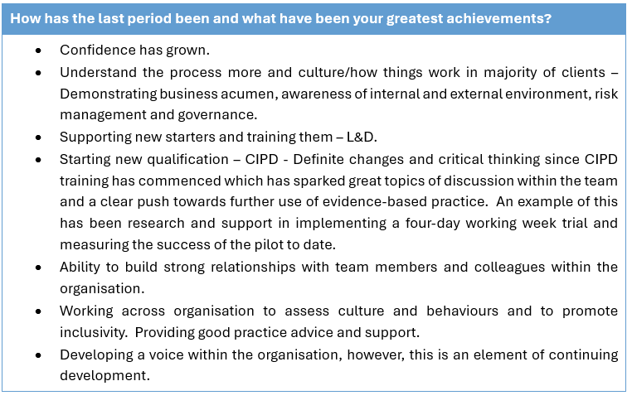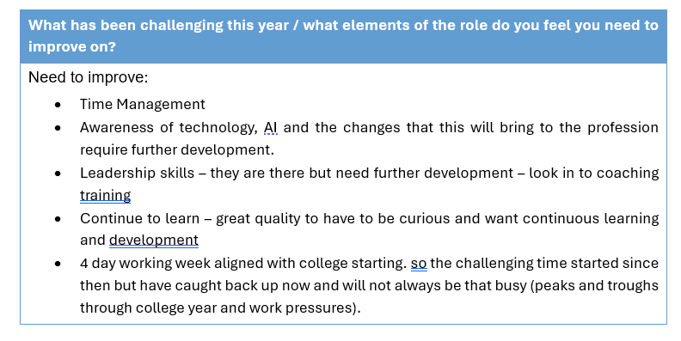
Objectives
Ref. | Objective: | Target Date: | Comments / Status:
1 | Progress / complete CIPD qualification | March 2025 | Last assignment January 2025.
2 | Develop leadership and coaching skills as senior in team – supporting with new starters, acting as a mentor for more junior staff to help them progress. | 1 Dec 2024
3 | Develop skills and understanding of the technology which may impact on the profession and potential areas of use. Work with HR Project Team to see how projects are developed, implemented and post evaluated. | 1 Dec 2024
4 | Develop understanding of inclusivity and supporting diversity within the organisation. This is a common topic asked for by clients so helpful internally and externally. | 1 June 2024
Detail any training requirements below relating to the above objectives or progression of post:
Objective Reference 1
Training identified: Ongoing attendance at CIPD course sessions. Time provided for attendance. SG currently utilising non-working day to complete assignments but will inform Manager should this not be sufficient going forward.
Objective Reference 2
Training identified: Develop coaching skills – work with XXX (Team Leader) who has undertaken Coaching Training previously. Booked on Coaching Training with XXX (July 2024) as an introduction.
Reason for selecting training: Training to provide knowledge and then put into practice through attendance at different meetings, interaction with team and ability to lead and mentorship from Team Leader.
Objective Reference 3
Training identified: Attendance at AI, revolutionising the workplace - The CIPD in Wales half-day conference Tickets, Wed 24 Apr 2024 at 09:00 | Eventbrite. Also keep an eye out for any other events which cover this topic. Involvement in the weekly HR Projects Team meetings, this will start as observatory attendance and progress to more involvement – key liaison is XXX.
Reason for selecting training: Awareness and knowledge from training session. Develop relationships and hands on skills through integration with the HR Project Team. This will also be an opportunity to provide “HR Voice” which may be helpful to develop leadership skills.
Objective Reference 4
Training identified: Places booked on the Disability and the role of HR: A Welsh perspective and Women's Health in the workplace - Half day - online Conference and Neurodiversity and the workplace. Which should help promote awareness in these specific areas.
Reason for selecting training: Specific courses relating to inclusivity to promote awareness. Number of courses selected to enable bite-size pieces of information on an ongoing basis. Networking opportunity with Welsh CIPD colleagues.

AC 3.4
Attached within CIPD Reflections Tool format.

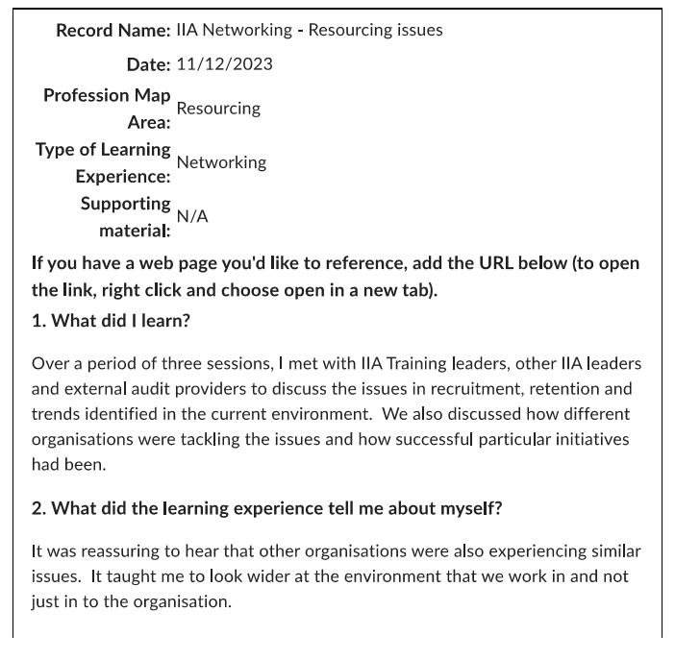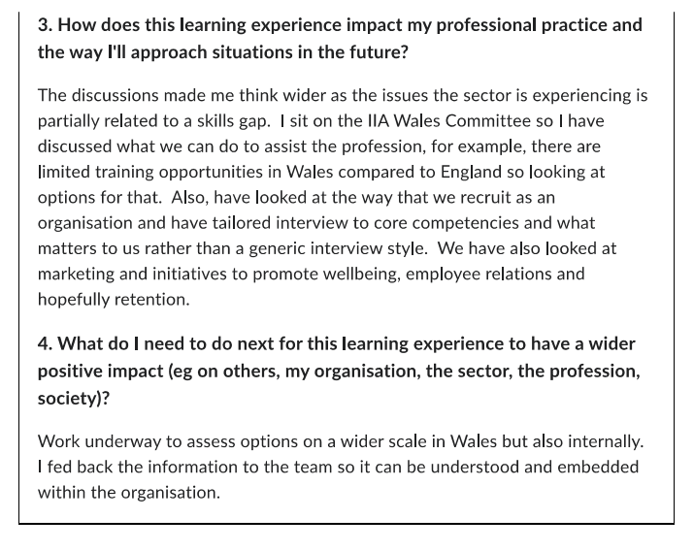
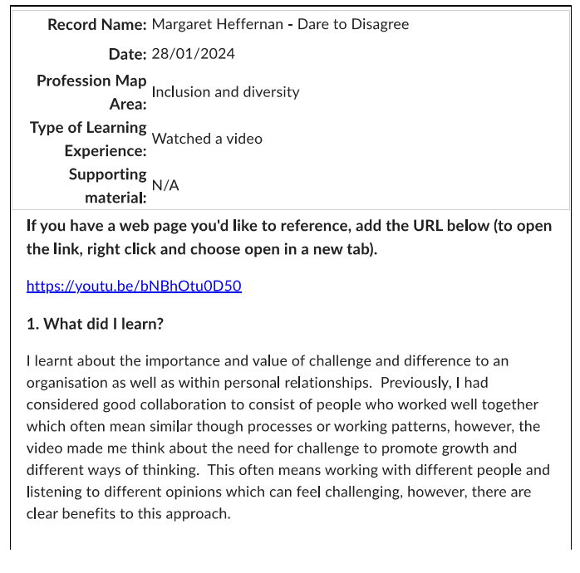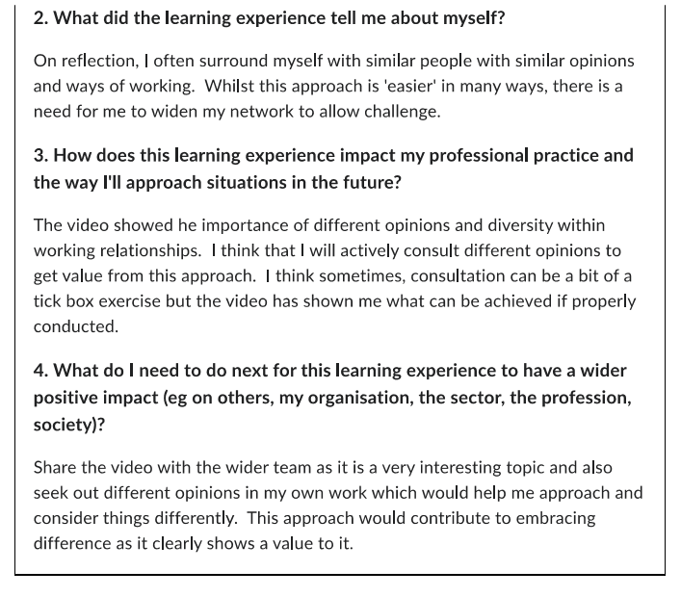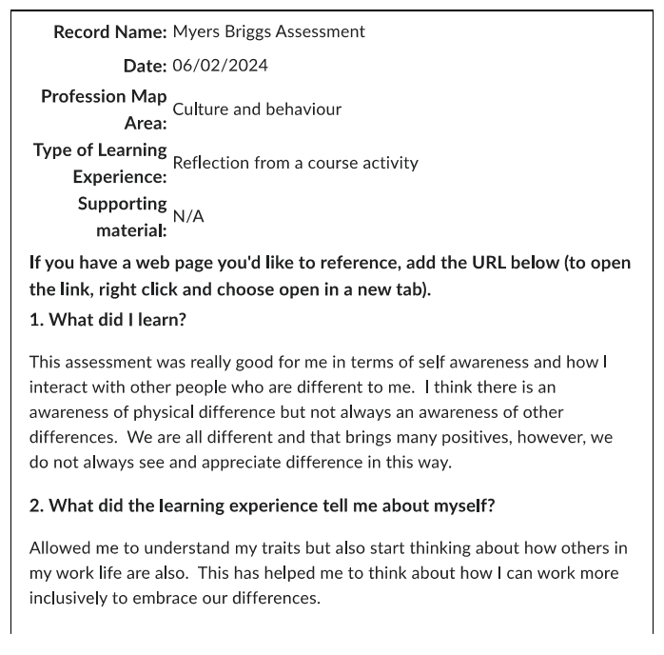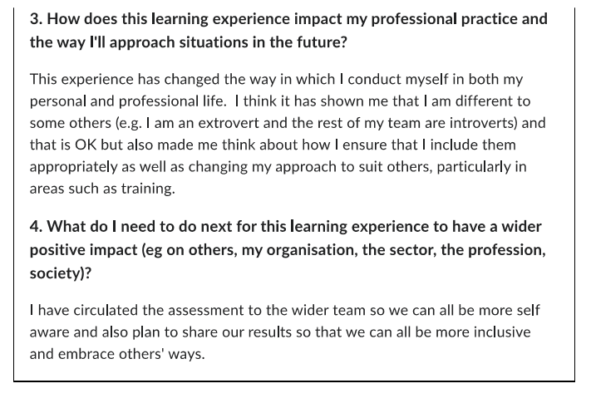

Bibliography
ACAS (2023) The Law – Whistleblowing at Work, available at The law - Whistleblowing at work - Acas (accessed 6 February 2024)
CIPD (2015) Ethical Decision Making: Eight Perspectives on Workplace Dilemmas. Available at ethical-decision-making-2015-eight-perspectives-on-workplace-dilemmas_tcm29-9564.pdf (cipd.org) (Accessed: 29 February 2024).
CIPD (2019) Rotten Apples, Bad Barrels and Sticky Situations, available at unethical-behaviour-in-the-workplace_report-2_tcm18-57022.pdf (cipd.org) (accessed on 15 February 2024)
CIPD (2019a) Building Inclusive Workplaces available at Building inclusive workplaces | CIPD (accessed 16 March 2024)
CIPD (2021) Technology and the Future of Work Factsheet available at Technology and the Future of Work | Factsheets | CIPD (accessed 10 March 2024)
CIPD (2022) Equality, Diversity and Inclusion in the Workplace factsheet, available at Equality, diversity and inclusion in the Workplace | Factsheets | CIPD (accessed 20 March 2024)
CIPD (2023) The Profession Map Full Standards (November 2023) available at profession-map-full-standards-november-2023.pdf (cipd.org) (accessed on 4 March 2024)
CIPD (2023a) People analytics: Guide for people professionals, available at https://www.cipd.org/uk/knowledge/guides/analytics-practitioner-guide/#how-is-hr-using-people-analytics (accessed 14 March 2024)
CIPD (2023b) Wellbeing at Work factsheet, available at Wellbeing at Work | Factsheets | CIPD (accessed 10 March 2024)
CIPD (2024), Profession Map available at Explore the Profession Map | CIPD (accessed 8 February 2024)
CIPD (2024a) The Profession Map – Professional values and purpose – Professional Values and Purpose, available at The Profession Map / Professional values and purpose | CIPD (Accessed 14 February 2024)
CIPD (2024b) What makes the ideal people professional? Available at What makes the ideal people professional? | CIPD (Accessed 14 February 2024)
CIPD (2024c) The Profession Map – Core Behaviours, available at The Profession Map / Core behaviours / Valuing people | CIPD (accessed 8 February 2024)
CIPD (2024d) Ethics at Work: An employer’s guide. Available at Ethics at work: An employer’s guide | CIPD (Accessed: 17 February 2024)
CIPD (2024e) The Profession Map – Core Behaviours – Professional Courage and Influence, available at The Profession Map / Core behaviours / Professional courage and influence | CIPD (accessed 14 March 2024)
CIPD (2024f) Ethics at Work: An Employers Guide, available at Ethics at work: An employer’s guide | CIPD (accessed 6 February 2024)
CIPD (2024g) Performance Review factsheet available at Performance Reviews | Factsheets | CIPD (accessed 14 March 2024)
CMI (2020) Setting SMART objectives, available at Setting Smart Objectives - CMI (managers.org.uk) (accessed 16 March 2024
IIA (2023) Risk in Focus 2024, available at ciia-risk-in-focus-2024_final-web.pdf (accessed 10 March 2024)
Karpman (1968) The Drama Triangle available at The Drama Triangle: Victim, Persecutor, Rescuer - Exploring your mind (accessed 12 March 2024)
MBTI (2024) The Myers Briggs Company: A positive framework for life-long people development available at Myers-Briggs Type Indicator® (MBTI®) | Official Myers Briggs Personality Test (themyersbriggs.com) (accessed 14 March 2024)
McKinsey’s (2018) Harnessing the power of performance management survey (Chowdhury, S, Hioe, E and Schaninger, B) available at Harnessing the power of performance management | McKinsey (accessed 20 March 2024)
Perkins, G. and Woodhams, C. (2022). Studying Human Resource Management. 3rd edition, Chapter 6. [Digital]: Kogan Page.
Pinterest, Hierarchy of Needs diagram available at https://www.pinterest.co.uk/drregier/attachment-how-we-connect/ (accessed 30 January 2024)
Ted Talk (2013), Hefferman, M, Dare to disagree available at https://youtu.be/bNBhOtu0D50 (accessed 14 March 2024)
Ted Talk (2019) Heffernan, M, The human skills we need in an unpredictable world, available at (https://youtu.be/w4OPtFCs_fw (accessed 10 March 2024)
Ted Talk (2020) ,Rosalind G Brewer: How to Foster True Diversity and Inclusion at Work, available at Rosalind G. Brewer: How to foster true diversity and inclusion at work (and in your community) | TED Talk (accessed 19 March 2024)

