Project Planning, Monitoring and Control. Assignment 1 (M3X8761)
Dylan Francis.

CONTENTS.

- INTRODUCTION.
- TASKS ASSOCIATED WITH THE CONSTRUCTION OF A COMMERCIAL BLOCK AND DURATIONS.
2.1 Site Investigation.
2.2 Earth Works.
2.3 Diaphragm Wall/Basement.
2.4 Raft Foundation.
2.5 Superstructure.
2.6 Roof Construction.
2.7 External Wall Finishes.

- RESOURCE SMOOTHING.
- REFERNCES.

- INTRODUCTION.

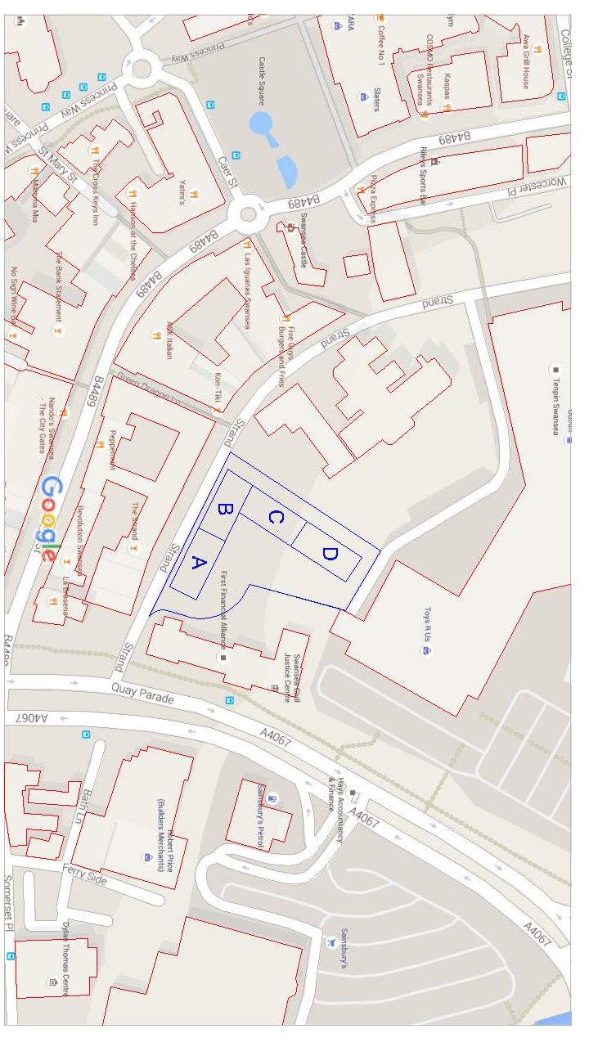
In this assignment I’ve been asked to produce a Gantt chart showing the tasks required to construct a commercial building block that is divided in four different sub-blocks, each block varies in height. To calculate the duration of the tasks that are required I have used “Spon’s architects and builders price book 2015” and recent developments I have worked on at CB3 Civil and Structural Consulting Engineers. Multiple working gangs have been introduced to complete tasks where I believe is necessary and with the consideration of the cost implication for extra labour, the correct balance of the two will produce the most efficient project schedule. The Gantt chart that I have produced has been created using a software called “Fast Track Schedule 10”, I will be submitting the Gantt chart via email to my tutor on the day of submission. Resource smoothing is something that I have consider and will explain this later on in report.

- TASKS ASSOCIATED WITH THE CONSTRUCTION OF A COMMERCIAL BLOCK.

2.1 Site Investigation.

- Topographical Survey- This will be carried out by a single person using a GPS system. To calculate the duration for this task I’ve used my own personal experience of working with varies geotechnical company’s as we progress projects.

- Geotechnical Report- This report will be carried out by a small team of geotechnical engineers who will look at the existing ground conditions to propose foundation types, in this instance it will be raft foundation. They will also produce CBR & Soak away test which will allow the civil engineers to progress their design. Again working on a range of different engineering projects weekly where geotechnical reports and mandatory to complete complex design, I’ve been able to give a duration for this task as shown in my Gantt chart. “Park Road 2017 Swansea” is a recent job that I’ve worked on with a similar m² of area.

2.2 Earth Works.

- Site Clearance- Vegetation/Rubble- Site plant will be used to remove and existing rocks and vegetation
- Top Soil Strip- Approx. 200mm Depending on GI Report- Site plant will be used to remove the first 200mm of top soil, using “Spon’s Architects and builders price book 2015” labour hours combined with the total m² of area I’ve been able to calculate the duration.

2.3 Diaphragm Wall/Basement.

- Drainage- Foul/Storm water systems will be constructed to connect to existing offsite connections. Using “Spon’s Architects and builders price book 2015” labour hours combined with approx. length & depth of pipe required I’ve been able to calculate the duration.
- Guide Walls. Using “Spon’s Architects and builders price book 2015” labour housing combined with a trench width of 400mm I’ve been able to calculate the duration.
- Trench excavation with the use of bentonite. “Spon’s Architect’s and builders price book 2015” labour housing combined with a trench depth of approx. 6 Meters I’ve been able to calculate the duration.
- Trench reinforcement.
- Concrete pour to connect wall sections.

2.4 Raft Foundation.

- Excavation- The existing ground must be excavated to a required depth to where the raft can begin to be constructed.
- Binder course- Binder course is added to deliver a level bed that will receive the reinforcement and concrete. Anon. (2012)
- SVP Popup’s- This is where connections will be made to the already constructed drainage system, and within the raft foundation for connections to toilets and sinks within the block.
- Reinforcement- The steel reinforcement (rebar) will be tied on site.
- Concrete pour- Offsite wagons will be brought to site to supply the correct strengthen of cement which was been provided by the structural engineer.
(Former British Legion, Mumbles 2017) This is a live project I am currently working on which consists of the construction of a retail food store with underground parking and residential flats. The chosen foundation method for this project is raft and is of a similar size to one of the four blocks in this task.

2.5 Superstructure.

- Erect main structural frame- The main structural frame will be brought to site by a pre fabrication company and will be erected and fixed on site.
- Pre cast concrete decks- These floor slabs consist of pre cast segments which are lifted into place to form each floor of the block.
- Wall panels- These panels allow for the building to form the first part of its final finishes, once the panels have been inserted the insulation and final external gladding can be added. Using “Spon’s Architects and builders price book 2015” labour hours combined with an approx. 300m² of area per floor which will require walls panels, I’ve been able to calculate the duration for this task.
- Insulation. Celotex boards will be added to provide thermal insulation to the building. (Celotex 2015)

(Briton Ferry School, Neath 2017) This is a live primary school project that I am working on in Briton Ferry, Neath. Using my experience of this job has allowed me to estimate the durations for these tasks.

2.6 Roof Construction.

- Roof panels- These panels allow for the building to form the first part of its final finishes, once the panels have been inserted the insulation and final external gladding can be added. Using “Spon’s Architects and builders price book 2015” labour hours combined with an approx. 500m²
- Insulation. Celotex boards will be added to provide thermal insulation to the building. (Celotex 2015)
2.7 External Wall Finishes.

- Cladding to external walls- The cladding sheets are added to give the blocks a desired look. Again using Spon’s Architects and builders price book 2015” labour hours combined with an approx. 300m^{2 of} area per floor which will require cladding, I’ve been able to calculate the duration for this task.
- Roof cladding- The cladding sheets are added to give the roof some context. Again using Spon’s Architects and builders price book 2015” labour hours combined with an approx. 500m² of where roof cladding is required, I’ve been able to calculate the duration for this task.

- RESOURCE SMOOTHING.

Resource smoothing can be used when there is a fixed end date to a projects timeline. Certain tasks can be relocated within a float to unsure that the project doesn’t run over (Anon A N/A). Within this assignment I’ve not allowed for resource smoothing within my Gantt chart, but I have identified possible methods of ensuring that the project does not run over if unforeseen problems occur onsite. Labours will be offered overtime on the weekends to keep the project schedule on track. Another possible area that I’ve identified within my Gantt chart which could be used to make up any lost time is the Christmas period.

The Graph below shows the 14 day shut down period I have allocated for Christmas 2017. Although the bar extends over this Christmas period it is not included in the total days that have been allocated to this task. As stated above if the project was behind schedule the workers could come in over this period to complete the task earlier than expected, allowing the project to be back on track in the new year.

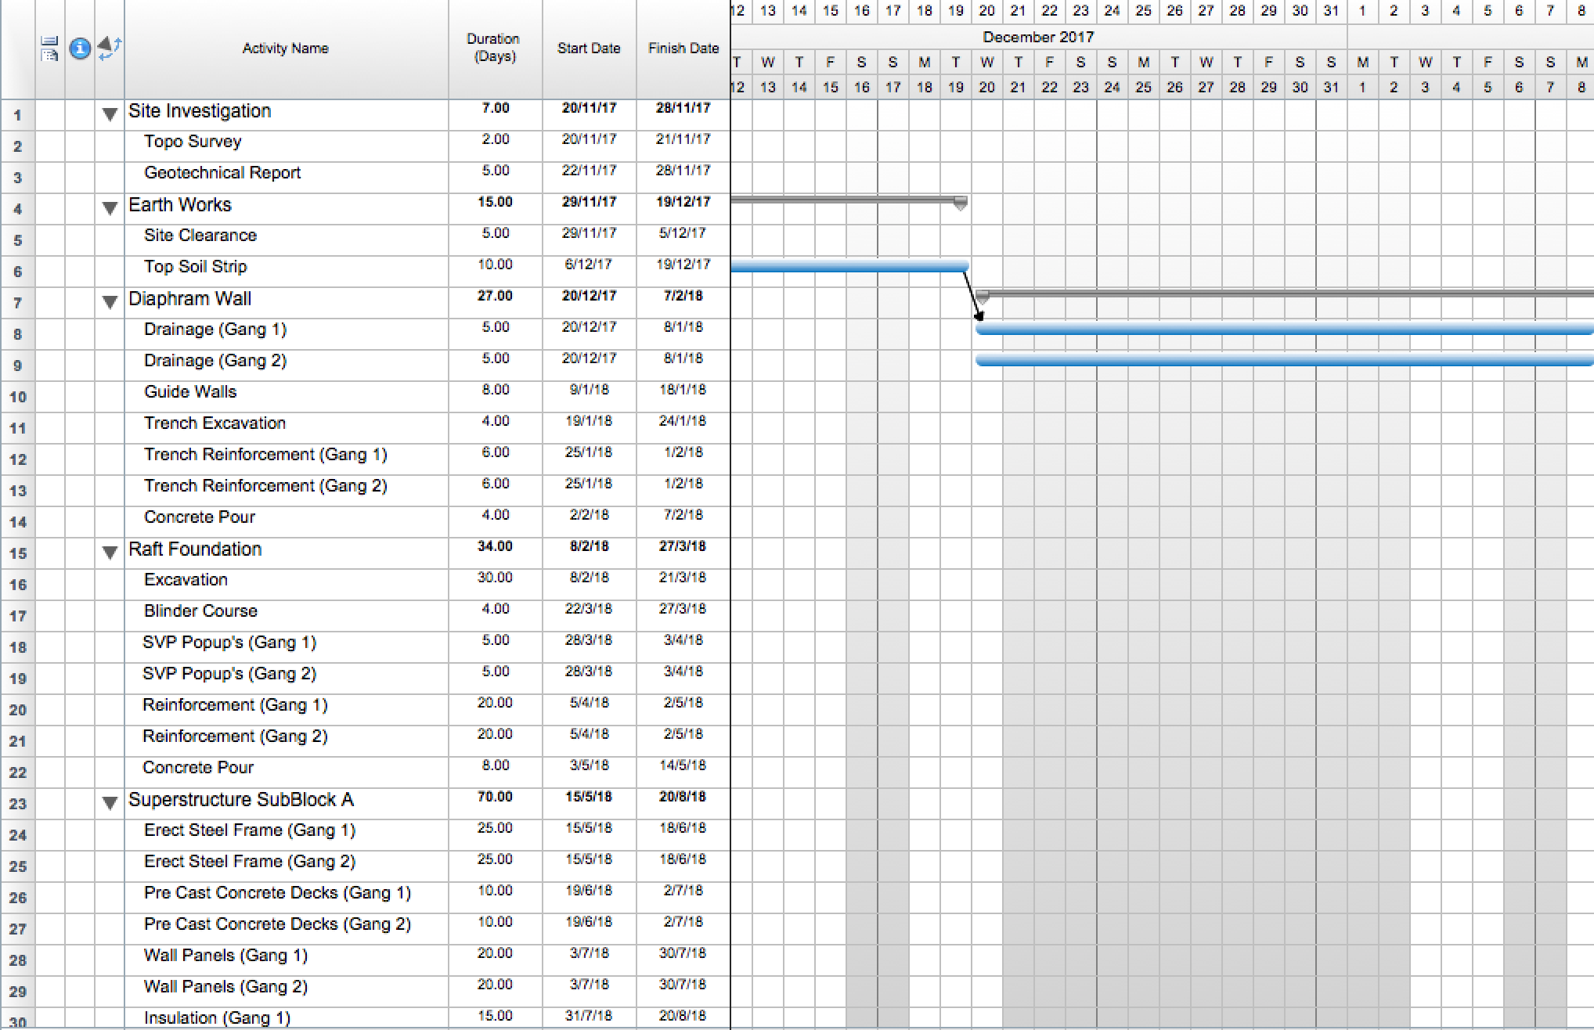

- REFRENCES

“Spon’s Architect’s and builders price book 2015” Published by Aecom (2014).

“Fast Track Schedule 10” Software available http://www.aecsoftware.com/project-management-software/fasttrack-schedule-mac/

“Park Road 2017 Swansea” This is a social housing development consisting of approx. 15 houses.

(Former British Legion, Mumbles 2017) This is a live project I am currently working on which consist of the construction of a retail food store with underground parking and residential flats. The chosen method of foundation for this project is raft and is of a similar size to one of the 4 blocks in the project.

Anon. (2012). Step by step: how to build a raft foundation. Available:
http://www.castles.com.ng/magazine/article/CONSTRUCTION/1238. Last accessed November 2017.

(Briton Ferry School, Neath 2017) This is a live primary school project that I am working on in Briton Ferry, Neath. Using my experience of this job it has allowed me to estimate the durations for our tasks.

Anon A (N/A). Resource Smoothing. Available: https://project-management-knowledge.com/definitions/r/resource-smoothing/. Last accessed November 2017.

