Programme: Business & Management BA

Module: Economics of Sustainability

Module Code: BMSP6007

Lecturer: Anthony Burns

Assignment Title: Assignment One

Student: George Parker 1704367

Submission Deadline: March 27th 2020
The industrial sector division which I am choosing to look at in regard to its surrounding environmental problems is fracking. Fracking also known as Hydraulic fracturing begins with the drilling down into the earths layers of shale beds through a borehole and then pumping the earth full of a high pressure water mixed with sand and chemicals, the amount of liquid pumped is roughly equivalent to 16 Olympic swimming pools. This then beaks up the layers of shale causing the shale gas trapped within closed pockets in the beds to escape and be forced back to the surface allowing with the contaminated water which allowing for the shale gas to be harvested and processed, with the contaminated water being taken away for treatment. The commonly used term ‘fracking’ comes from how the layers of rock are fractured apart during the process and ones all the shale gas is harvested from a borehole another is drilled and the process begins again ("Guidance on fracking: developing shale gas in the UK", 2020), (Clark, 2020).
Shale gas is a naturally occurring product which consists mostly of methane which can be processed allowing it to be used to provide energy for heating and cooking, shale gas can be found deep underground within pockets of shale rock. Unlike most other naturally occurring gases shale gas cannot pass through rock which is why fracking is used as there is no current alternative method for shale gas extraction ("What is fracking?", 2020), (Stephenson, 2020.).
Fracking is seen as a widely controversial process because the process comes with an abundance of risks and negative factors, fracking is widely opposed across the United Kingdom however despite this fracking is still supported by the government as a viable source of energy. A primary reason that fracking is a bad source of energy is that the process is unsustainable and there are many alternative sources of energy that our sustainable and do not require the use of fossil fuels ("Fracking and climate breakdown, Friends of the Earth", 2020), (UK AIR independent, 2020).
This sector of industry creates high levels of pollution for the environment which is not considered or calculated when entering the market, this pollution equated to an eventual market failure of the industry sector resulting from aspects such as the environmental and social costs which are not considered. This market failure can be seen bellow within the diagrams below.
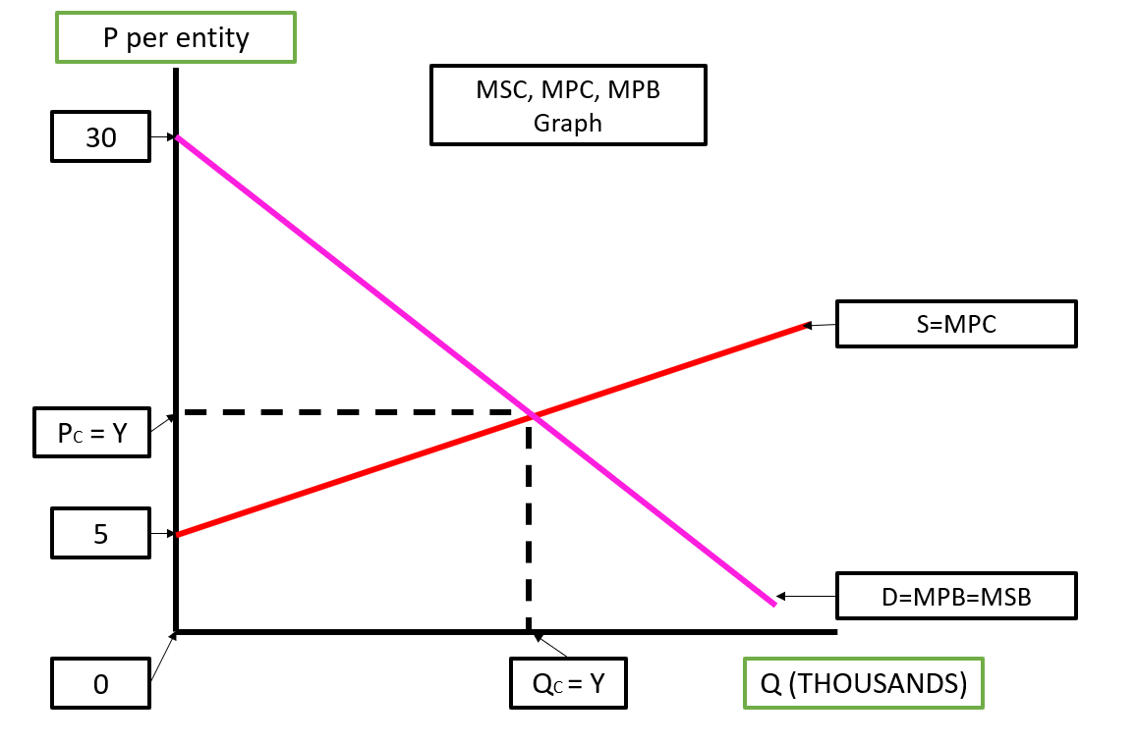
This diagram above shows price against quantity of a certain good and is also hypothetically representative of fracking, this diagram represents market failure as it fails to take into consideration the externality costs of fracking on the red line. This means the in the markets current situation it is broken.
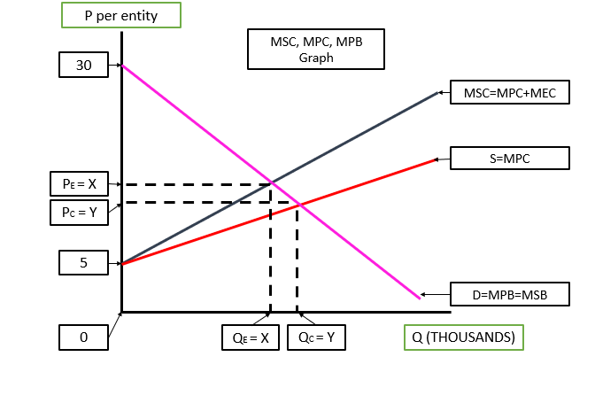
The diagram above shows the market with all externalities factored into it, this is represented by a dark blue line on a hight position than the red line, the line must be higher as for the new considerate costs are factored in such as pollution to ensure that the market does not fail. This line represents the marginal supply costs (MSC) and they are equal to marginal private costs (MPC) plus marginal externality costs (MEC), THE MEC are representative of the costs to the environment and their effects on us. The equilibrium price has changed and has increase to have a higher price and a lower quantity sold as a result of the costs to us, these problems in terms of fracking are water contamination not being considered, earthquakes occurring because of fracking and habitat change to humans and animals from the occurrence of fracking.
The United Kingdom’s fracking plans go directly against the commitment made to the Paris Climate change Agreement to end the use of fossil fuels as well fracking making the UK’s climate targets unattainable (UNFCCC, Paris Agreement, 2020). Fracking used in the place of sustainable green energy has no contribution towards combating climate change and global warming because fracking is a very inefficient way of sourcing gas in comparison to other renewable methods. Fracking is more often done because of its convenience and relatively more straight forward manner of production rather than using sustainable gas collection methods which require higher investments in both time and money ("CCC: Fracking would breach UK climate goals without tougher conditions | Carbon Brief", 2020), (Energy Policies of IEA Countries: The United States, 2019).
Fracking causes a risk on a local level to the environment as the by the process being carried out disrupts quiet and natural areas of the country though noise and environmental pollution which can have a knock-on effect on animal habitats causing major disturbances in the eco-system meaning that local wildlife may leave the area of die as a result of their native environment being permanently damaged by the fracking process (Citizen Engagement and Trust, 2020), (Adgate, Finkel & Shonkoff, 2020).
There is a monumental change in the way that we are able to use the environment as a result of fracking, after MPs rejected the outright ban of fracking in 2015 although there was an agreement for no fracking to occur in any national park it only took a matter of months for a rig to be authorized bellow a world heritage site and an area of outstanding natural beauty. These actions change how we are able to interact with the land causing us to move around drilling sites and avoid designated areas that are owned by the public and find way to safeguard animals effected by this change of environment. Even if the changes where minimal to the environment there would still be a cascading effect on the environment leading to an eventual large-scale disruption to the many animal species native to the environment (Tootill, 2013).
Through the process of fracking the water used to disturb the shale begs become contaminated and then a waste product once it has completed its function. This water is mixed with chemicals of which some are carcinogenic chemicals this means that some chemicals within the mixture can be a cause of cancer due to the chemicals ability to damage the genome or disrupt the cellular metabolic process. These carcinogenic chemicals may also not be immediately toxic, and this delay can make if difficult to link the cause to the effect, thus their effect can be very insidious. These chemicals can escape though fracking boreholes and go on to pollute water supplies which threaten the local human population, fish and other wildlife. This contamination is also spread to groundwater whilst the shale gas is being extracted the contaminated water is able to permeate into groundwater supplies and in England alone groundwater is used to supply a third of drinking water leading to the potential for high levels of exposure to damaging chemicals without knowing it. Although it is possible to find comparisons between different wells in regard to what is contained within each water solution used by different fracking companies these are often done by a third party and cannot be deemed 100% accurate. As a contrast rig providers have no legal obligation to publicise the water solution blend used within their fracking process, there is no obligation to share details with the public of any chemicals used and this translates to there being no possibility of a public review as the surrounding communities may have no idea of what is impacting their groundwater supply ("Environment Agency - Groundwater source protection zones", 2020), (Nikiforuk, 2015).
Within the UK only England supports the use of fracking and as a result 64% of England is currently being considered for possible fracking sites that equals 83,150 square kilometres. To follow these four of the six major UK energy suppliers are in support of fracking. This concerning majority means that by many people paying their energy bills are contributing towards pro-fracking energy suppliers that may lead to the further occurrence of fracking in the future as a result (THE CARBONIFEROUS BOWLAND SHALE GAS STUDY, 2020).
With investments made into furthering the fracking production industry there are less minds and less financial incentives being funnelled into renewable energy, investments in fracking may satisfy our short term needs but due to the issue of fracking being unsustainable the shale gas reserves will inevitably run out. Any investment into fracking will create greater negatives in years to come for the future generations to deal with making it an irresponsible method of energy harvesting unlike research into furthering renewable energy forms and techniques which will create solutions for future generations allowing a better more sustainable way of living where we work with and not against the planate. Although the harvesting of natural gas does emit 60% less carbon dioxide than other greenhouse gasses during combustion there is no comparison when likened to methods such as wind, solar or geothermal energy. These amongst other carbon neutral, renewable energy sources offer greater benefits overtime even other shorter periods of a matter of years to generations. And when this amount of time is given and resources and appropriately allocated more efficient methods can be found allowing of a further upsurge in benefits to the people and the planet. Whilst over time fracking become predestined to fail and create far more issues that solutions (Soeder & Borglum, 2019).
To cause the shale rock beds to release natural gas fracking rigs require 74,000 gallons of water be pumped at high pressure through the earth. This amount of water may not seem significant however over a rigs lifetime the amount of water consumed on average dramatically increases to about 30 million gallons of water, all so that we can have access to a cheap energy source. Relative to the amount of wate water produced by households in the U.S. at 900 billion gallons this is a drop in the ocean although it is still a dramatically large amount of water that is used especially when it is considered that less that 3% of all our plants water is drinkable and a large portion of this water goes towards fracking. There must be an alternative source that this drinkable water can go towards rather than fracking which could have a large positive impact on humanity such as using this water as equity for those who need it most in third world regions of the world where water is rare and clean drinking water is even rarer (Hydraulic fracturing for oil and gas, 2020).
Fracking is seen as such a grievous negative that if a fracking operation begins in a close proximity to a community the property values within said community immediately lowers. When purchasing property in an area effected by fracking the deed to the land can be split not giving the landowner access to every aspect of the land. There are the rights to both gas and minerals found on the land as well as water rights, and each of these rights can be split from each other on the property deed. If these are split id means that is an opportunity for someone else to purchase the rights if they already haven’t, once they hold this deed there is no obstacle for a company drilling on your land and do not require the property owners permission to do so. Active wells in close proximity to a home reduce the value of a property by more than 30% and carry greater costs to the families that live on these properties (Bamberger & Oswald, 2020.).
Fracking was previously suspended in the UK completely as a result of fracking activities causing earthquakes in several U.S. sates regularly reporting the side-effect of earthquakes from fracking. Many of the quakes occurred in regions that had no known faults in the earth with could cause a tumour, all of the recorded 21 quakes occurred in the midwestern states between the 1060s and the year 2000. All recorded earthquakes registered at 3.0 or lower on the Richter scale, none causing large scale damage however the like between fracking and quakes is a potential risk especially in the UK with is not prepared for any earthquakes resulting from their rarity making them an afterthought at best. Since the year 2000 the average number of earthquakes has risen on a continues bases to almost 200 per year and in the year 2015 there was over 1,000 of these events registered across regions of the U.S. where fracking commonly occurs. The larges quake to occur was in Oklahoma during 2016 which registered 5.6 on the Richter scale and was believed to have a strong link to fracking being the likely cause (guide to earthquakes from fracking, 2015)
There are many environmental solutions that can be looked at in ways of combating the negatives on fracking one of which is a product charge, a pollution charge is the addition of fees to the price of polluting products that generate negative externalities. These fees take the form of tax per unit produced for a product (Lori Bennear, 2020), (The Cost of Fracking, Environment Ohio, 2020), (Gullion, 2020).
The shale gas tax rate for onshore production has been set by the treasury at 30% and a tax rate of 62% for fracking operations in the north sea, this tax allows for governments to collect and contribute towards creating a positive environmental change as a result of the sale of shale gas ("'Generous' tax cuts for shale gas", 2020). To force this solution to work theoretically setting the level of tax equal to the MEC we can avoid market failure by forcing the market to increase prices allowing it to come into equilibrium. This can be seen within the diagram bellow with the distance between A and B representing the amount of tax generated as the result of the implementation of a Pigouvian tax.

Although there is not a Pigouvian tax in place for shale gas by implementing one it would theoretically work to negate or solve some of the effects that fracking has on the environment, however this my not be as successful in actuality as the process of fracking generates may issues such as ground water contamination during its process so any a taxation may not allow for the majority of problems to be overcome (Eskeland, 1999).Another form of eternality cost consideration is through abatement equipment subsidies, these are payments made to accompany towards lowering the cost of technology which in turn can lower the cost of externalities. If a subsidy is equal to the MEB it then becomes efficient which is known as a Pigouvian subsidy, this can be seen bellow with the distance between K and L representing the amount of subsidy needed to become efficient ("The Politics of Fossil Fuel Subsidies and their Reform", 2020).
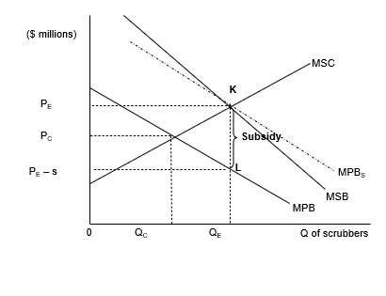
This model can be troublesome as the MEB measurement can be innocent as well as the decision of how and where to invest is made by the polluters so the most effective and environmentally positive path may not be taken. This approach has been done by the British government by providing a subsidy of £1bn to major oil companies towards abatement activities to create a cleaner environment, however this money was taken away form creating a green energy infrastructure in the UK (Ambrose, 2020), ("Too many subsidies in B.C. for fracking gas - David Suzuki Foundation", 2020).
In conclusion fracking creates high levels of pollutants through its harvesting process of shale gas and creates additional pollutants overtime, the abatements and taxation introduced have theoretically little changing result with this in mind and public opinion of fracking plummeting the shale gas industry is a highly negative industry the is solely driven by profit with no regard the environment the it takes during the process of fracking. However if a change is ever to occur it will result from these models and their importance in determining costs and at what level they are appropriate which means that these tools are incredibly effective and help to give a clear image in regards to the issues and surrounding dilemmas with fracking.
References
(Citizen Engagement and Trust, 2020). Retrieved 24 March 2020, from https://www.oecd.org/cfe/regional-policy/Global-shale-energy-development-TomMurphy.pdf
(THE CARBONIFEROUS BOWLAND SHALE GAS STUDY, 2020). Retrieved 24 March 2020, from https://assets.publishing.service.gov.uk/government/uploads/system/uploads/attachment_data/file/226874/BGS_DECC_BowlandShaleGasReport_MAIN_REPORT.pdf
(The Cost of Fracking, Environment Ohio, 2020). Retrieved 24 March 2020, from https://www.ourenergypolicy.org/wp-content/uploads/2012/10/The-Costs-of-Fracking-vOH.pdf
(UK AIR independent, 2020). Retrieved 24 March 2020, from https://uk-air.defra.gov.uk/assets/documents/reports/cat09/1807251315_AQEG_Shale_Gas_Extraction_Advice_Note_vfinal_for_publishing.pdf
(UNFCCC, Paris Agreement, 2020). Retrieved 24 March 2020, from https://unfccc.int/news/paris-agreement-triggers-divestment-from-coal-study
Adgate, J., Finkel, M., & Shonkoff, S. The human and environmental impact of fracking.
Ambrose, J. (2020). UK to use finance meant for green energy to support fracking in Argentina. Retrieved 24 March 2020, from https://www.theguardian.com/environment/2019/oct/22/uk-to-use-1bn-meant-for-green-energy-to-support-fracking-in-argentina
Bamberger, M., & Oswald, R. The real cost of fracking.
CCC: Fracking would breach UK climate goals without tougher conditions | Carbon Brief. (2020). Retrieved 24 March 2020, from https://www.carbonbrief.org/ccc-fracking-industry-must-meet-tough-conditions-achieve-climate-goals
Clark, D. (2020). Q&A: shale gas and fracking. Retrieved 24 March 2020, from https://www.theguardian.com/environment/2012/apr/17/shale-gas-fracking-uk
Energy Policies of IEA Countries: The United States 2019.
Environment Agency - Groundwater source protection zones. (2020). Retrieved 24 March 2020, from http://apps.environment-agency.gov.uk/wiyby/37833.aspx
Eskeland, G. (1999). Environmental Protection and Optimal Taxation. [Washington, D.C.]: [World Bank].
Fracking and climate breakdown | Friends of the Earth. (2020). Retrieved 24 March 2020, from https://friendsoftheearth.uk/climate-change/fracking
'Generous' tax cuts for shale gas. (2020). Retrieved 24 March 2020, from https://www.bbc.co.uk/news/business-23368505
Guidance on fracking: developing shale gas in the UK. (2020). Retrieved 24 March 2020, from https://www.gov.uk/government/publications/about-shale-gas-and-hydraulic-fracturing-fracking/developing-shale-oil-and-gas-in-the-uk
Gullion, J. Fracking the neighborhood.
Hydraulic fracturing for oil and gas.
Lori Bennear, P. (2020). Fracking Externalities and the Coase Theorem – Lori Bennear Research Group. Retrieved 24 March 2020, from https://sites.nicholas.duke.edu/loribennear/2011/09/05/fracking-externalities-and-the-coase-theorem/
Nikiforuk, A. (2015). Slick Water. New York: Greystone Books.
Progressive Management. (2015). 2015 guide to earthquakes from fracking, hydraulic fracturing, and shale gas.
Soeder, D., & Borglum, S. (2019). The Fossil Fuel Revolution. San Diego: Elsevier.
Stephenson, M. Shale gas and fracking.
The Politics of Fossil Fuel Subsidies and their Reform. (2020). Retrieved 24 March 2020, from https://www.booksetc.co.uk/books/view/-9781108416795
Too many subsidies in B.C. for fracking gas - David Suzuki Foundation. (2020). Retrieved 24 March 2020, from https://davidsuzuki.org/expert-article/too-many-subsidies-in-b-c-for-fracking-gas/
Tootill, A. (2013). Fracking the UK. [Place of publication not identified]: Alan Tootill.
What is fracking?. (2020). Retrieved 24 March 2020, from https://www.ecotricity.co.uk/our-green-energy/fracking/what-is-fracking

