Module: Problem Solving and Decision Making
Module code: BMSW4004

Contents
INTRODUCTION 3
The workplace Problem 4
ANALYSING INFORMATION 4
ROOT CAUSE ANALYSIS (RCA) 4
APPLYING SITUATIONAL ANALYSIS MODELS 6
RANGE OF ALTERNATIVE SOLUTIONS 7
EVALUATION OF ALTERNATIVE SOLUTIONS 7
IMPLEMENTING THE SOLUTION 8
Communication plan with stakeholders 9
Power & Interest Matrix 9
Communication Plan 11
MONITORING AND REVIEW TECHNIQUES 12
CONCLUSION 13
REFERENCES 14
APPENDIX 15

INTRODUCTION
Problem-solving skills refer to the ability to identify the problem, analyse it to get the possible solutions, and implement the best alternative from these solutions so that there exist no more challenges to the problem (Heerkens and Van Winden, 2021). Nowadays, business activities have been very complex and organisations are facing new challenges and problems. The competition is also increasing. To keep the market position, businesses have to retain capable employees with problem-solving skills. If the management of a company is more capable to address the major problem and solve it successfully, the company is likely to get a competitive advantage over other businesses facing the same type of problem (Galli, 2018). This report will identify the workplace problem of Hotel Marriott. Hotel Mariott is the largest and most prominent hotel in the world. The company has businesses in 139 countries around the world. Almost 120,000 employees work in the company as of 2021 (Statista, 2022). This huge number of employees works in 7,989 hotels and is responsible to provide the best service to the guests.

The workplace Problem
The tourism industry in the UK faces so many problems in the workplace such as bullying, harassment, discrimination, conflict, low motivation and job performance. The main problem that Hotel Mariott faces in the workplace is the low motivation of the employees. Low motivation can be for various reasons. The reasons are poor management, conflicts in the workplace, workload, unclear objectives etc. The effect of this problem will considerably reduce the profitability and performance of the hotel Mariott. When the workforce has the lower motivation, they prefer to move to other companies (Heerkens and Van Winden, 2021). So, employee turnover becomes higher. The evidence suggests that higher employee turnover negatively affects the company's profitability and performance (Shykina, 2019). Moreover, the existing employees do not perform as expected because of poor motivation drivers.

ANALYSING INFORMATION

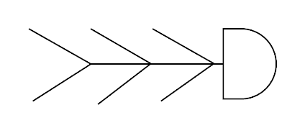
ROOT CAUSE ANALYSIS (RCA)
Figure 1 Fish bone diagram
Source: (Latha and Merlin, 2019)
Root cause analysis (RCA) is very important for identifying the causes of the problem (Heerkens and Van Winden, 2021). Without identifying the problems appropriately, nobody can suggest any solution to them. So, the root cause analysis will be required for hotel Marriott to analyse the possible causes of the low employee motivation. The fishbone diagram is applied here in which bones represent the causes and combining all of these causes the problem is created (Latha and Merlin, 2019). As hotel Mariott is facing a low employee motivation problem, the possible six causes can be a mismatch in job positions and responsibilities, stress and mental health of the employees, poor leadership, workplace conflict, job insecurity, and lack of rewards for good performance. The first cause is identified as a mismatch in job positions and responsibilities can happen when the recruitment policy of the company is not effective. The job requirements are not clear and so the employees are employed without considering their capabilities with the job position in that situation (Bonau, 2020). The employees face challenges in accomplishing the tasks because of the mismatch and so the motivation for doing the task gets lower. The second cause is stress and mental health of the employee which lowers the employee's motivation. High workload, poor work-life balance and other factors can influence the mental health and stress of the employees. High stress and poor mental health make the employee dissatisfied and lower their motivation for the workplace. Poor leadership is the third cause of the problem. Poor leadership fails to create a good relationship with the employees and guide the employees toward achieving the organisational goals. The management can not understand their needs and so fails to satisfy the workforce. Decisions flowing from the upper position go against the employees and it makes them dissatisfied with their responsibilities. So, the productivity of the company gets affected by the lower motivation. The fourth cause is workplace conflict. Conflict can arise from many areas of the business. It can come up with a new decision from the management, process, responsibilities, and work environment (Shykina, 2019). The employees facing conflict in the workplace go through anxiety and tension. They may make mistakes in that situation and so their performance can get decreased for a lack of proper guidelines. The lower motivation problem in the workplace can transpire from the cause. The fifth cause is job security. Employees find confidence in their job if job security is provided to them. They may lose interest in the organisation without having job security and career development opportunities (Bonau, 2020). Capable employees sometimes move to other organisations where exists a greater opportunity for career development and job security. Hotel Mariott might not have job security which lowered the motivation of the workforce. The sixth and final cause in the fishbone diagram is the lack of rewards for employees. Rewarding the employees encourage them to do challenging jobs and pursue achievements. Hotel Mariott may not have proper reward management for increasing the motivation of the workforce.

APPLYING SITUATIONAL ANALYSIS MODELS
SWOT Analysis framework evaluates the internal factors of the organisation. Using the framework, Hotel Mariott's internal situation is analysed here.
Strengths:
- The company has a global presence. It has been operating the business in 139 countries. The brand name is globally recognised and the global presence is the biggest strength of the company (Momin, 2022).
- Based on the market share and company performance, the company is considered the market leader in the industry.
- It has more loyal customers than any other business.
Weaknesses:
- The strict code of conduct creates dissatisfaction among employees. Moreover, high employee turnover for low motivation is the main weakness of the company (Neupane and Khanal, 2022).
- The data protection system is vulnerable, and it has caused distrust among the guests.
- Some of its poor management decisions and leadership acquired negative publicity.
Opportunities:
- The company can focus on emerging economies because the demand for hospitality services is continuously increasing in developing countries.
- It can expand the business into other areas that are related to the hospitality industry.
- The diversified market offering will ensure the business creates a strong position in the industry (Statista, 2022).
Threats:
- The industry is highly competitive. There exists a high possibility that the competitors may take the position from the company if it does not perform well.
- Economic recession and crisis can hit the company's profitability very hard. Recently, the covid-19 pandemic has caused huge losses to hotel Marriott (Momin, 2022).

RANGE OF ALTERNATIVE SOLUTIONS
Three alternative solutions to the low motivation problem are given below:
Solution 1: Undertake various motivation programs
Solution 2: Improve communication with the employees
Solution 3: Develop effective recruitment and selection procedures

EVALUATION OF ALTERNATIVE SOLUTIONS
The alternative solutions will be evaluated based on PMI. PMI is an acronym for plus, minus, and interesting factors.
PMI for Solution 1: The positive aspects of the motivation program are so many. Motivation can be given in two forms: internal motivation and external motivation. Internal motivation is given in a non-monetary form. If internal motivation is provided to the employees, the company will not need to increase the costs in the budget. Extrinsic motivation is normally given in the form of monetary rewards, promotions etc. Such rewards and monetary benefits directly impact the employee's psychology (Shykina, 2019). The workforce can be made satisfied within a short period. The negative aspects of the solution are as difficult to successfully implement, increases the costs of the business, and takes a longer time. The interesting factor of this solution can be said that most business organisations choose this solution.
PMI for Solution 2: Sometimes the workforce motivation gets lower of the need for employee engagement with the company. The employer does not have good communication with the employees. The positive side of improving communication between the employees with the company is that employees feel more enthusiastic about their job and they perceive positive ideas about the employees (Bonau, 2020). The negative sides to implementing the solution are that improving communication will change the organisational cultures, need a longer time, and be tough to achieve the solution. The interesting factor is an increase in employee participation in the workplace.
PMI for Solution 3: The positive sides of developing effective recruitment and selection procedures are that the company will get employees based on the requirements and needs. The job and the employee’s capabilities will be matched. So, employee satisfaction and motivation are higher in those workplaces where effective recruitment and selection procedures are implemented (Neupane and Khanal, 2022). The negative aspects of developing policies or guidelines for effective recruitment and selection process can be identified as it is not certain that the motivation level will be influenced by the solution, and the implementation is tougher and more time-consuming. The interesting factor is that capable and skilled employees have a greater motivation level in the workplace (Shykina, 2019).

IMPLEMENTING THE SOLUTION
The implementation of the plan or change can be made successful by using the ADKAR model which refers to awareness, desire, knowledge, ability, and reinforcement (Tang, 2019).
Awareness: The problem must be communicated to all the interested parties of the company. At first, they need to understand why they should desire the change.
Desire: The stakeholders' desire to accept the change assist the change management process (Galli, 2018). Desire is created when the employees are performing poorly because of low motivation.
Knowledge: The change can be successfully managed as everyone has learned his/her responsibility and role in the process (Tang, 2019). This knowledge is necessary to understand the workplace situation.
Ability: The abilities are created or managed by the stakeholders so that the planning is successfully implemented. If there is a scarcity of resources for the implementation of a possible solution, the resources should be managed by appropriate decision-making.
Reinforcement: In this stage, every factor and opportunity is utilised to make the change happen (Galli, 2018).

Communication plan with stakeholders
The key stakeholders of Hotel Marriotts are listed below:
1. Guests
2. Employees
3. Government
4. Investors
5. The regulatory bodies

Power & Interest Matrix
The employees have low power but high interest to change planning while the government and regulatory bodies have high power but low interest. Guests have low power but high interest. Increased motivation will deliver superior service to them consequently.
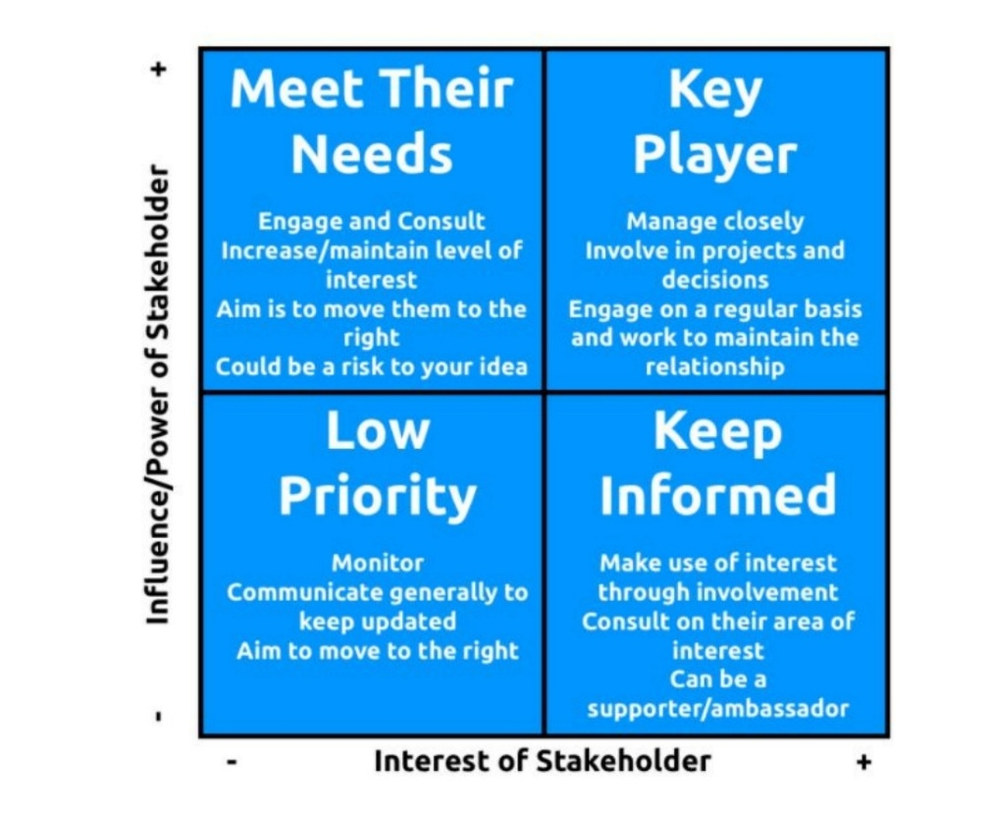
Figure 2 Power & Interest Matrix
Source: (Project Management, 2022)

Communication Plan
Stakeholders Communication Plan
Stakeholder | Power/Interest | Key Interest & Issue | Communication vehicle | Frequency | Comment
Employee | Interest | Rewards and achievement | Mail | Monthly | The focus is on them
Guests | Interest | Superior service quality | Mail or other online media | Daily | Contribute to the success
Government | Power & Interest | Ethical and appropriate business operations | Annual Report | Annually | Policies and guidance
Regulatory body | Power & Interest | Legislation and documentations | Annual Report | Annually | Guardian
Investors | Interest | Profitability | Annual Report | Annually | Influence the change management

MONITORING AND REVIEW TECHNIQUES
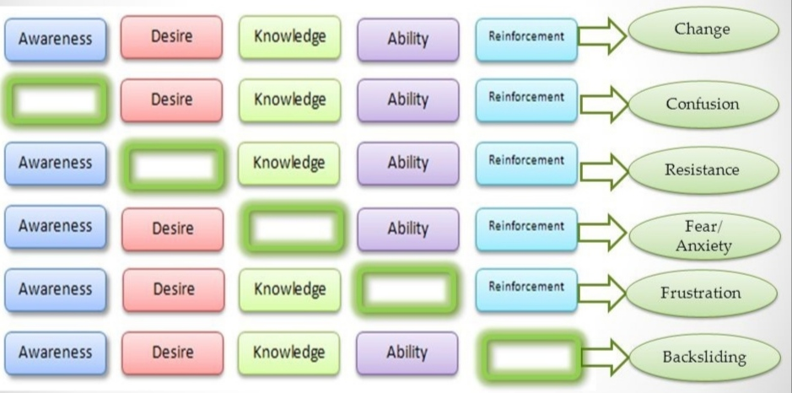
Figure 3 ADKAR Gap Model
Source: (Galli, 2018)
To successfully implement the change, the ADKAR gap model is very effective. The gap model shows various circumstances. If any component of the model is absent in the change process, a problem will arise to deter the change process (Tang, 2019). Five components of the model can ensure successful change management. The stakeholders are supposed to be confused if they are not aware of the situation. They will prefer to resist provided they are not desiring the change to happen (Galli, 2018). Some will suffer from anxiety, but the knowledge component can remove it. Developing the ability eliminates the frustration and finally, reinforcement will stop the backsliding of the change.

CONCLUSION
The low motivation of the workforce is an important problem in Hotel Marriott that needs to be addressed for keeping the business profitable and competitive in the long run. The hospitality industry has already been facing high employee turnover. In addition, low motivation will further make the scenario worse. So, motivation programs are needed in the business to increase the motivation of the workforce. The extrinsic and intrinsic factors of motivation can be analysed for implementing the change successfully.

REFERENCES
Bonau, S. (2020) “Strategic leadership, commitment and employee motivation: What influences attitudes towards the Workplace,” Köz-gazdaság, 14(4). Available at: https://doi.org/10.14267/retp2019.04.09.
Galli, B.J. (2018) “Change management models: A comparative analysis and concerns,” IEEE Engineering Management Review, 46(3), pp.124-132.
Heerkens, H. and Van Winden, A. (2021) Solving managerial problems systematically. Routledge.
Latha, V. and Merlin, A. (2019) “Fish bone diagram as a teaching tool,” The Journal of Nursing Trendz, 10(1). Available at: https://doi.org/10.5958/2249-3190.2019.00005.1.
Momin, A. (2022) Marriott SWOT analysis: Can the competition threaten the hotels?, PESTLE Analysis. Available at: https://pestleanalysis.com/marriott-swot-analysis/ (Accessed: December 26, 2022).
Neupane, R. and Khanal, T.R. (2022) “Evaluation of the impacts of training on employee performance in the UK hotel industry: An analysis of employees’ perspectives at Marriott International,” International Journal of Research -GRANTHAALAYAH, 10(3). Available at: https://doi.org/10.29121/granthaalayah.v10.i3.2022.4534.
Project Management (2022) Stakeholder analysis: Power/interest matrix - project management. Available at: https://www.projectmanagement.com/deliverables/347800/Stakeholder-Analysis--Power-Interest-Matrix (Accessed: December 25, 2022).
Shykina, O. (2019) “Research of operation of Marriott International Hotel Chain,” Pryazovskyi Economic Herald [Preprint], (6(17). Available at: https://doi.org/10.32840/2522-4263/2019-6-41.
Statista (2022) Topic: Marriott International, Statista. Available at: https://www.statista.com/topics/1872/marriott-international/ (Accessed: December 26, 2022).
Tang, K.N. (2019) Change management. In Leadership and change management (pp. 47-55). Springer, Singapore.

APPENDIX


