Andrew Davies
2213112@student.uwtsd.ac.uk
Advanced Software Development
Andrew Davies 2213112

Contents
Introduction 1
Dijkstra 1
A* 2
Analysis 3
Conclusion 3
Maze evaluation 4
Results 6
Improvements 7
Bibliography 7

Introduction

Dijkstra’s Algorithm and the A* Algorithm are both designed to find the optimal path between two nodes in a graph. A graph is a mathematical structure consisting of nodes connected by weighted edges that represent costs or distances [1]. There are fundamental differences in the way this path is determined by both algorithms. Dijkstra’s focus is on exploring all possible paths, determined by the edge weight of each node, before selecting the shortest route to target. Whereas A* uses heuristics, which is a method that guides the path by giving an estimate of the remaining distance to the target, which in turn allows the path to be guided by nodes that are most likely to lead to the optimal path [1]. This paper will focus on comparing both algorithms, delving deeper into the implementation, whilst critically evaluating the strengths and limitations. We’ll begin by looking at Dijkstra’s algorithm, starting with its main working principles.

Dijkstra

Dijkstra's algorithm is a relatively straightforward but effective method for finding the shortest path between nodes. It does so by methodically exploring all available paths, starting from the source node and then expanding outward, selecting the node with the smallest known distance from the source [1]. It will continue doing this until all available nodes or a set target has been reached.

Initially, the distance to the source is set to 0, while all other nodes are set to infinity which means they are unreachable at the start of the algorithm [2]. As the algorithm progresses, these distances should update when a shorter path is found [2]. The process of finding the shortest path involves evaluating the edge weight of neighbouring nodes and adding this to the current total. This process is called ‘relaxation’ [3]. If the calculated distance to a neighbouring node is smaller than what is currently stored, then the stored distance is updated to the newly calculated value.

To manage which neighbouring node to visit next, a priority queue is typically used. It is possible to store and manage the nodes within a vector if the graph is small, however, the time complexity for retrieving the smallest node with a priority queue is O(log n), compared to O(n) with a vector, making it a better option for larger graphs [4]. The priority queue must also keep track of when a shorter path to a node is discovered. This is necessary so that the algorithm has the most up to date distance so it can decide on which node to visit next. The algorithm also uses a container to track all visited nodes once they’ve been processed, this ensures that each node is only visited once.

The algorithm continues until all nodes have been visited or the shortest path to the target is found. The final path is traced by backtracking from the target node to the source using the parent container.

A*

Similar to Dijkstra, A* is also used to find the shortest path in a graph, however, it uses a heuristic function to prioritise the nodes that are more likely to lead to the target [1], instead of exploring all possible paths systematically.

A* calculates the cost function f(n) for each node n by adding together the sum of g(n), which is the cost from the start node to n, and h(n), which is a heuristic estimate of the cost from n to the target [5]. It can be represented with the following equation [5]:

f(n) = g(n) + h(n)

This equation is key to the A* algorithm as it helps us to prioritise paths that are most likely to lead the target node. Using the f(n) value, the algorithm explores the graph by always selecting the node with the lowest cost to expand next. This cost is determined by combining the actual cost of reaching the node from the start (g(n)) and the heuristic estimate of the cost to reach the target (h(n)) [6]. The heuristic formula that’s used is determined by the graph and the problem solved, for example, in a grid-based pathfinding problem, such as a maze, the best choice of heuristic might be the Manhattan distance [7], which accounts for vertical and horizontal movement or Euclidean distance [7], which accounts for diagonal movement, as they provide a effective estimate to target.

The algorithm maintains and updates two lists. The first list being an open list, which like Dijkstra, is implemented as a priority queue, to retrieve the node with the lowest f(n) cost, and then a closed list to track processed nodes. At each step, the node with the lowest f(n) value is selected and then its neighbours are analysed. Their f(n) and g(n), and their parent values are updated if a shorter path is found [8]. If the neighbours are not yet in the open list, they will be added.

The algorithm will repeat this process until the target node is selected from the open list. After this has been selected, like Dijkstra, we can reconstruct the shortest path by backtracking through the parent nodes.

Analysis

Having discussed the key principles of both algorithms, we’ll now proceed to critically evaluate their strengths and weaknesses, and suitability for different types of scenarios.

As previously mentioned, one of Dijkstra’s main strengths is the methodical approach it uses to find the shortest path. The algorithm always ensures an accurate and reliable result by exploring all possible paths. However, this isn’t always the case when using A*. With A* it’s possible that the target might not be found, if the chosen heuristic is inappropriate or overestimates the cost to target [9]. In these cases, A* may prioritise suboptimal paths or even fail to explore the paths that lead to the target [9].

Although Dijkstra guarantees the shortest path to target, the graph itself is reliant on having non-negative weights, as the algorithm assumes that once a node’s shortest path has been determined, it cannot be improved [4]. This makes the algorithm unsuitable for certain graphs and scenarios which are susceptible to negative edge weights. In these instances, an algorithm such as “The Bellman-Ford” might be more suitable, as it is specifically designed to handle graphs with negative edge weights [2]. A* is also an algorithm that relies on non-negative weights; therefore, the same limitation applies to it as well. This is due to its reliance on the heuristic function which assumes that all edge weights are non-negative, so that it can provide an accurate estimate of the remaining cost to target.

Despite A*’s heuristic being reliant on non-negative edge weights, the use of the heuristic can make A* significantly more efficient than Dijkstra’s algorithm [10]. The heuristic is used to guide us towards the target, therefore, reducing the number of nodes that need to be explored. In contrast, Dijkstra’s algorithm uses a more systematic approach where all paths are explored until the target is found. In terms of time complexity, both algorithms share a worst case scenario complexity of O((V + E) log V) [11], where V is the number of vertices and E is the number of edges. However, as long that an appropriate heuristic is chosen for A*, it should in practise perform significantly better compared to Dijkstra [10].

Conclusion

The choice between Dijkstra and A* depends on the specific requirement of the problem or scenario we’re facing. There are several factors to consider before selecting the appropriate algorithm including the structure of the graph and the choice of the heuristic. On one hand, Dijkstra is a safe choice if we want to prioritise accuracy and reliability as it guarantees the shortest path in graphs with non-negative edge weights. On the other hand, if speed and efficiency is the priority, then A* is the better option, provided that an appropriate heuristic can be used to guide the algorithm.

Maze evaluation

The goal was to develop a program capable of navigating a player through a maze automatically by following the shortest path. There were two possible algorithms to choose from: Dijkstra’s algorithm or A* algorithm. While Dijkstra’s algorithm can effectively solve the shortest path problem, A* was chosen due to the fixed grid size, known start and end positions, and the suitability of using a heuristic. With the start and end points always set at (18,1) and (1,18), and the consistent structure of the grid, the Manhattan distance heuristic could effectively be utilised to guide the player to the target, making A* a better suited algorithm for this scenario.

To begin, the GridStep class was created to represent each step within the grid. The class stores information relating to each grid cell, which includes its coordinates (x, y), cost from the start (g), estimated cost to the target (h) and the total cost (f = g + h). It also includes a pointer to its parent. The parent pointer connects each step to the step it came from, allowing the program to dynamically maintain a record of the path. This will enable us to backtrack and reconstruct the path, once the target has been reached.

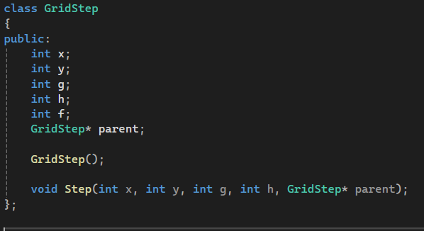

After implementing the GridStep class, the logic for the algorithm needed to be implemented. The navigate function begins by initialising the open and closed lists, which will keep track of the grid cells that have need to be explored and those that have already been explored.

The open list starts with the player’s starting position, which is represented as a GridStep object with its co-ordinates, initial cost, heuristic and parent pointer set appropriately. The closed list will start empty and will populate as the algorithm progresses.

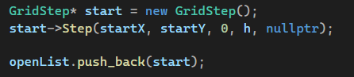

The following calculation sets the heuristic value for the starting position. This value represents the Manhattan distance between the starting position and the target position, which is an estimate of the remaining cost to reach the target.

As the algorithm begins, it iterates over the open list and selects the GridStep object with the lowest cost value. This object will be used as the step to explore next. This step is removed from the open list and then added to the closed list.

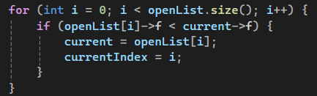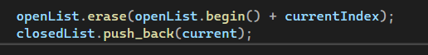

For the current step to be explored, we examine its four potential neighbours: up, down, left and right. Each neighbour is checked to see if it’s within the boundaries of the maze, that it isn’t a wall and is not already in the closed list. If these conditions are met then its cost from the start, h value, and total cost are calculated.

If the neighbour is not in the open list, we add it with its parent pointer set to the current step. If the neighbour is already in the open list but the new path is a lower cost, the neighbour’s cost values, and parent pointer are updated to reflect the better path.

We will continue this process until either the target position is reached, or the open list becomes empty, which would suggest that no valid path exists.

When the target is reached, we will reconstruct the path using the parent pointers of each GridStep, starting from the target position, going back to the starting position. This is then reversed to ensure that it represents the path starting from the start node.

Using this path, the player is moved step-by-step along the grid by comparing consecutive grid steps in the path. Depending on the relative position of the current step and the next step, the player is moved in one of four possible directions: left, right, up, or down.

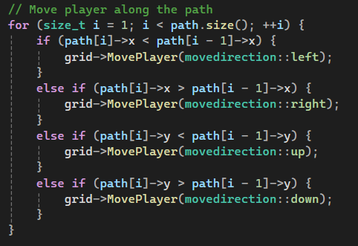

Once the player successfully reaches the target position, the program performs cleanup by deallocating the memory for all GridStep objects in the open and closed lists.

Results

After running the algorithm 10,000 times on three separate occasions, the following results were achieved:

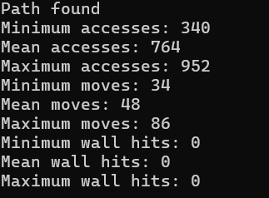

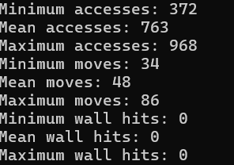

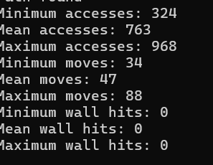

Improvements

The maze is currently set to a relatively small grid size. Due to the size of the grid, a vector was chosen to manage the open and closed lists. The computational time of iterating over the vectors to find the node with the smallest cost is minimal for such small grids. However, if we wanted to include dynamic grid sizing to allow the user to increase the size of the gird, this approach would be inefficient. To address this, a priority queue would be far more efficient to manage the open list, as it allows for quicker retrieval of the node with the lower cost.

Bibliography

[1] | D. R. a. L. Gustin, “Analysis of Dijkstra’s Algorithm and A* Algorithm in Shortest Path Problem,” Journal of Physics: Conference Series, vol. 1566, no. 1, 2020.
[2] | S. I. A. L. Abdul Manan, “Single source shortest path algorithm Dijkstra and Bellman-Ford Algorithms: A Comparative study,” INTERNATIONAL JOURNAL OF COMPUTER SCIENCE AND EMERGING TECHNOLOGIES, vol. 3, no. 2, pp. 25-28, 2019.
[3] | R. Sedgewick, Algorithms 4th Edition, Addison-Wesley, 2011.
[4] | T. L. C. Cormen, Introduction to Algorithms, MIT Press, 2009.
[5] | G. Tang, C. Tang, C. Claramunt, X. Hu and P. Zhou, “Geometric A-Star Algorithm: An Improved A-Star Algorithm for AGV Path Planning in a Port Environment,” IEEE, vol. 9, pp. 59196-59210, 2021.
[6] | S. E. a. S. Schrodl, Heuristic Search: Theory and Applications, Morgan Kaufmann, 2011.
[7] | A. A. A. I. P. K. Y. Daniil Kirilenko, “Generative models for grid-based and image-based pathfinding,” Artificial Intelligence, vol. 338, 2025.
[8] | S. K. S. a. S. Kumar, “COMPARATIVE ANALYSIS OF MANHATTAN AND EUCLIDEAN DISTANCE METRICS USING A* ALGORITHM,” Journal of Research in Engineering and Applied Sciences, vol. 1, no. 4, 2016.
[9] | S. H. n. G. M. Rhifky Wayadhi, “Greedy, A-Star, and Dijkstra’s Algorithms in Finding Shortest Path,” International Journal of Advances in Data and Information Systems, vol. 2, no. 1, pp. 45-52, 2021.
[10] | M. A. Milos Simis, “Dijkstra vs. A* – Pathfinding,” Baeldung CS, 18 March 2024. [Online]. Available: https://www.baeldung.com/cs/dijkstra-vs-a-pathfinding#:~:text=For%20those%20reasons%2C%20A*%20focuses,faster%20than%20Dijkstra%20or%20UCS.. [Accessed 27 December 2024].
[11] | “Time and Space Complexity of Dijkstra’s Algorithm,” Geeks for Geeks, [Online]. Available: https://www.geeksforgeeks.org/time-and-space-complexity-of-dijkstras-algorithm/. [Accessed 23 December 2024].

