
Title page
Student name: Nusrat Yasmin Shitara
Student number: 1712117
Module name: Developing Innovation and Creativity for Business Advantage
Module code: BMSW6102
Assignment title: Coursework (Innovative Product Plan)
Tutor name: Dr Md Nazmul Hasan
Date: 13-11-2020

Contents page
Contents
Section 1 - Innovative Product 3
Section 2 – E-commerce 7
Section 3 – Marketing 9
Conclusion 11
Reference list 11

Task 1
Covid19 Innovative product plan


Figure 1

Section 1 - Innovative Product
Innovation - introduction of new techniques, application of new processes and/or the creation of new value through the establishment of successful ideas.
PPE – Personal Protective Equipment, including protective items such as gloves, face masks and shields, eye protection, disposable aprons and gowns, is designed to help reduce the risks of people from coming into contact bacteria and other harmful substances.
The global COVID-19 crisis has had a major impact internationally, having many long and short term social, financial and emotional impacts on people. During this time, key workers and NHS staff have been working on the frontline in an effort to reduce the spread of COVID-19 and eventually overcome the virus. Due to this, there has been a shortage in PPE, with some forms of PPE not being as effective as others.
PPE is worn by key workers and NHS staff, working in high risk environments such as hospitals, GP surgeries, care homes and prisons, in an effort to stop the spread of COVID-19 and when used and worn correctly, can effectively saves lives. They are effective in stopping the spread of the virus as they stop people from coming into contact with the viral bacteria, in the air from coughing and sneezing and on skin and surfaces that people have touched.
The current PPE guidelines outline that people working within two metres of anyone with a suspected or confirmed case of COVID-19 should wear the following protective equipment; a surgical mask, eye protection and a disposable apron. However, with stocks of PPE running low nationwide, the government’s public health experts have said that some items should be reused if needed. With concerns that there is not enough PPE to be distributed to all those that need it, and the British Medical Association saying some supplies are at “dangerously low levels”, I have created improved PPE products. My innovation is an all in one bodysuit, named the ‘all in one bodysuit’, to protect individuals from head to toe. The full body bodysuit includes a built in full face shield and gloves to ensure that all skin surfaces and openings are covered to drastically reduce the risk of contamination and spread of COVID-19. This suit will be carried in four sizes; extra small, small, medium and large, to ensure that people of all sizes and heights are able to comfortably wear them and will be adjustable around the waist, wrists and ankles. The bodysuit is specifically designed for easy and quick wear, making it ideal for emergency situations where time is crucial. Items such as face masks and shields, gloves, aprons and gowns will also be available to buy, which can be worn in areas where individuals aren’t at such a high risk of catching or spreading COVID-19.
My products are available for purchase for anyone over the age of 18, although my products are directed towards the medical and healthcare industry, such as the NHS and private healthcare workers, in addition to key workers. My products will be sold on two major platforms, Amazon and Ebay, and will also be available for sale on my website. I will first introduce my products in the UK and if they are successful here, I will then consider extending my domain internationally and the other major countries of the world.
They way I have designed my protective bodysuit ensures that it can be used effectively post COVID-19, as it is protective against other diseases and viral infections and illnesses. I will also expand my business by selling plant based products such as plant based hand sanitizers and hand soaps. This will ensure that my products will still be in demand, even after the COVID-19 crisis is over.
I am working against some major competitors in the PPE industry, namely 3M United Kingdom Plc and Airflo Environmental Ltd. These companies are part of the British Safety Industry Federation (BSiF), which is a membership organisation for PPE companies, and ensures that the company’s products and services are safe and effective for use. I will apply to join the BSiF as it will give me access to a great client list of NHS workers and key workers that I can sell my products to. Furthermore, I will give NHS staff and key workers a 30% discount on all of my products on all of the platforms it will be sold on, as well as on my website. This discount is something that these two companies are not doing at the moment, and can aide in the development of my proposition and contribute to building simple value proposition. This will provide excellent customer value which I can profit off of, specifically by the creation of differentiation between my competitors and other companies in the PPE industry.
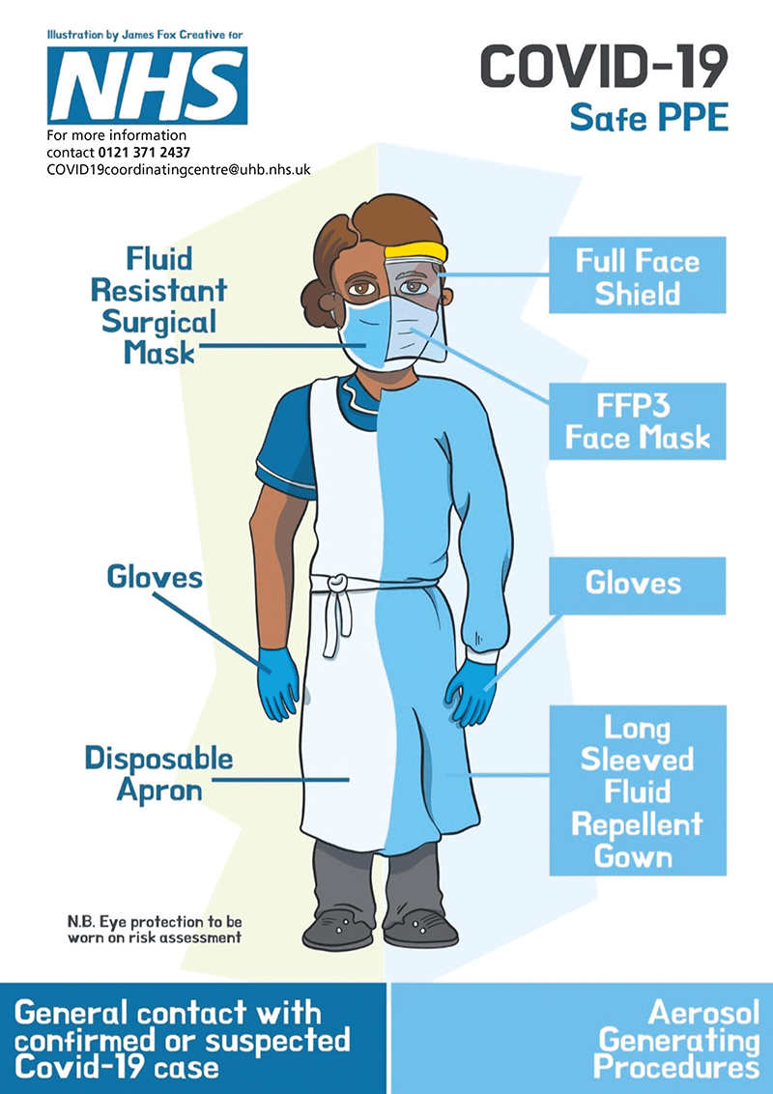

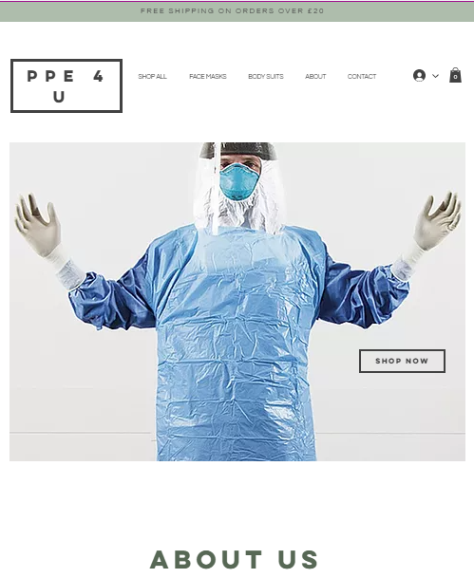
Figure 2

Figure 3

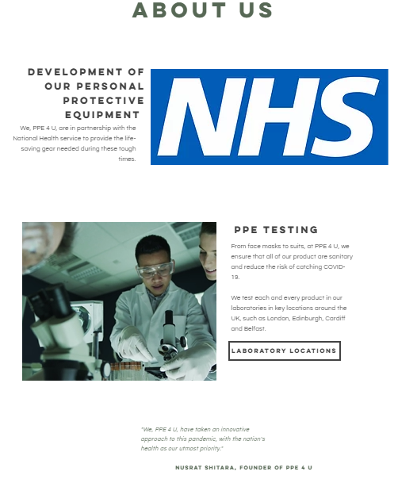

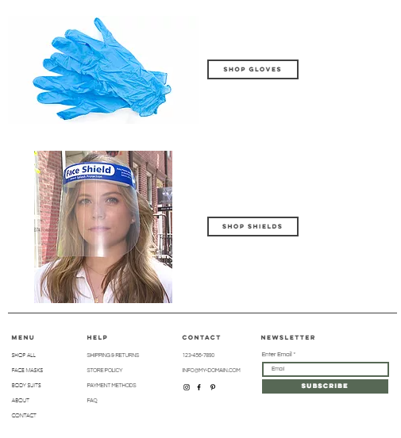

Figure 4

Figure 5
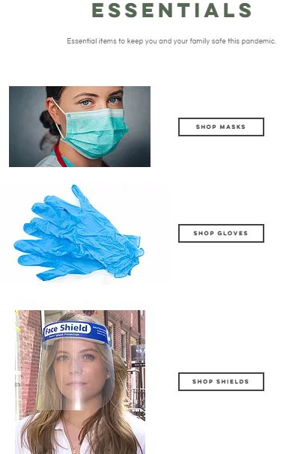

Figure 6

Section 2 – E-commerce

Figure 7
I have created my own website using wix.com which all of my products can be purchased through. My website is one of my most important marketing channels, where, if interested, consumers will come to learn more about my products and business. My website offers a great first impression and is clear and easy to navigate, meaning consumers will not get frustrated or lose interest if they struggle to find what they are looking for. The website will have clear descriptions, pictures and reviews of my products so that customers can find out about the product in detail. If a customer has any queries or questions about anything, I have a 24 hour live chat on my website, in which our staff will answer the questions to the best of their abilities, and even recommend other product if they are better suited to the customer’s needs. I will use SEMrush to audit my websites SEO performance, as they will flag and notify me of any errors on my site, saving me time and helping to constantly improve my business. Once customers find a product/products they want to purchase, they can add them to the basket and continue to checkout when they are ready to purchase. At this point the customer has the option to either make an account to make future transactions easier and receive special offers, or continue as a guest. If they choose to make an account, they would only need to enter essential information such as their name, email address, contact number, password and home address. By doing this, at the time of purchase, they only need to enter their payment details, either PayPal or credit/debit card. These customers can choose to save their payment details, if they wish to. For them to be able to do this, I will set up Secure Sockets Layer Encryption so that PayPal transactions can be done securely and safely. If the customer chooses to make the purchase as a guest, they would have to enter all these details in the moment and for all future purchases.
As for PayPal transactions, I will use PayPal Payments Standard, so customers are taken to the PayPal site when they choose to make a payment with PayPal. Once at the site, they only have to log in to their account using their username and password, with the rest of their personal information and data being retrieved from the PayPal database. Now the transaction is complete, the customer will be sent an email of their purchase and given a reference code for their purchase if any future problems occur.
For customers that choose to pay with credit or debit card, they must enter their card details along with the other personal information needed, depending on whether they have an account or are purchasing as a guest. Once entered, their bank must confirm and then the transaction is completed. They are then sent an email of their purchase and given a reference code for their purchase if any future problems occur.
Although PayPal enables secure, easy and quick transactions, it is not the preferred method for most online consumers with it making up only 19% of all online transactions. Credit and debit card are the two preferred methods of payment by online consumers, making up 47% and 36% of all online transactions, and with lower charges from merchant accounts that PayPal being at 0.3 – 1.0% VS2.9%.
Online payments have several advantages over manual payment methods, having low labour costs compared to using cheques, cash or money order. Online payments can be automatic and quickly provide feedback for both myself and the customers. Furthermore, they carry a low risk of theft as they payments generally go straight into the bank account, after processing delays.
With consumers putting their full trust into my brand by giving me their personal information and data, I will follow the General Data Protection Regulation by collecting information that is only necessary to make purchases and ensure all data is confidential and protected by security breaches.
I will also sell my products on Amazon, which is global technology company that focuses on e-commerce. Once I have chosen a professional selling plan and pay a subscription fee of £25 monthly, I will use a web interface, Seller Central, to market, list and price my products to Amazon and its customer base directly, as well as track my pricing, advertising, purchases and customer feedback and reviews. I will continue to add my products to the Amazon marketplace, specifying exactly how many of each product I will sell and give a brief description of each individual product.

Section 3 – Marketing

Figure 8
To promote my products, I will use various social media platforms such as Facebook and Instagram which offer valuable community-building opportunities. On Facebook I am able to target my advertisements towards certain locations, genders, ages, workplaces and job titles, as well as through key words that Facebook users have used or are associated with. In addition, Facebook also sends their advertisers feedback on ways they can improve their marketing skills, specifically providing insight on whether a product might be better suited to another audience on the platform. I will use ads objectives, starting with conversion, which focuses on attracting individuals to my website and products, which happens when customers complete my desired goals i.e. making a purchase. This also includes my websites product catalogue, which gives Facebook the ability to keep up with my most recent products, pictures and prices directly from my website. I will set my ad budget at £4 a day, totalling to £112 per month. Allowing Facebook to do this means that I don’t have to worry about spending time on maintaining my budget and setting. Furthermore, I will create a business account on Facebook and Instagram, uploading images, advertisements and information about my product, and allowing users to comment so I am able to interact with them and respond to any questions or queries they may have, increasing my customer engagement. By using Instagram, I will work with influencers and have them promote my products, such as the face coverings and gloves. This will bring customers to my website, where they will explore more of my products that are available, especially the protective bodysuit. There will also be direct links to my website on both platforms.
In order to make my social media marketing successful, I will need to make the content entertaining and engaging, and will do this by increasing my consumer engagement, using trending hash tags and analysing my performance. Though using social media platforms to advertise can be very time consuming, when used effectively, they can become one of the most successful channels of marketing.
I will also market through emails (email marketing), where customers have the choice to actively sign up to be added to a marketing email list, showing they are interested in the product. I will acquire users through them signing up on my website, and through email ad campaigns on Instagram and Facebook. This will help to build up a marketing email list, increasing my products’ popularity and allowing the products to get more positive feedback. Our emails will include offers and promotional/discount codes for my products to attract my customers and encourage them to make purchases. This is a high ROI channel of marketing with a medium cost.
I will use search engine marketing, using paid advertisements to advertise my business and products so that they appear as results on search engines. I will use Bing and Google to advertise my products towards consumers who are ready to make purchases at the time they see the ads. This is a medium/high ROI marketing channel with a low/medium cost.
Digital marketing is beneficial and advantageous as it provides instant and highly measurable results and the deliverance of Return on Investment (ROI) is great. It also has a global reach and can target and interact with audiences and consumers in real time.
Although word-of-mouth is not a very complex and strategic way of marketing, it is effective in sparking interest in customers and introducing them to my products and website. Word-of-mouth can help my products and website spread very quickly, from first being discussed with family and friends to extending out nationwide.
My products are available to anyone over the age of 18, owning a debit or credit card or PayPal account, though my products are targeted towards the medical and healthcare industry, consisting of NHS and private healthcare workers, in addition to key workers.

Conclusion
With the major impact the global COVID-19 crisis has had internationally, I am confident that my product will be successful. I have strategically utilised many marketing channels to ensure that my products reach my target audience on all platforms, keeping my consumers interested through good customer engagement which in turn provides excellent customer value and contributes to building simple value proposition, increasing the chances of them purchasing my products.

Reference list

Cardswitcher. (2020). The 10 Best Online Payment Systems in the UK (Updated 2020). [online] Available at: https://www.cardswitcher.co.uk/online-payment-systems/. [Accessed 11 Nov. 2020].
Health and Safety Executive Personal protective equipment (PPE) at work A brief guide. (n.d.). [online] Available at: https://www.hse.gov.uk/pubns/indg174.pdf.
@paypal. (2020). What is PayPal - How Does PayPal Work | PayPal UK. [online] Available at: https://www.paypal.com/uk/webapps/mpp/paypal-popup. [Accessed 10 Nov. 2020].
https://www.bing.com/search?q=what+is+ppe+nhs&qs=AS&pq=what+is+ppe&sk=LS1&sc=611&cvid=5CC6F0A7F2EA41D2B8E504E6B3A9C81A&FORM=QBRE&sp=2. [Accessed 1 Nov. 2020].
Cardswitcher. (2017). What Online Payment Systems Are Available in the UK? [online] Available at: https://www.cardswitcher.co.uk/what-online-payment-systems-are-available-in-the-uk/ [Accessed 6 Nov. 2020].
CMA. (2020). 5 Most Effective Digital Marketing Channels for Your Business. [online] Available at: https://cmasolutions.com/blog/5-most-effective-digital-marketing-channels-for-your-business/. [Accessed 2 Nov. 2020].
Dr Ken Hudson (2014). What is the best definition of innovation? | Dr Ken Hudson. [online] Dr Ken Hudson. Available at: https://drkenhudson.com/best-way-define-innovation/. http://mdi.com.pk/management/2018/05/three-types-innovation/[Accessed 6 Nov. 2020].
General Data Protection Regulation (GDPR). (2018). Personal Data | General Data Protection Regulation (GDPR). [online] Available at: https://gdpr-info.eu/issues/personal-data/. [Accessed 5 Nov. 2020].
Gotter, A. (2018). The 6 Marketing Channels You Should Prioritize in 2019 | Disruptive Advertising. [online] Disruptive Advertising. Available at: https://www.disruptiveadvertising.com/marketing/marketing-channels/. [Accessed 2 Nov. 2020].
GOV.UK. (n.d.). New personal protective equipment (PPE) guidance for NHS teams. [online] Available at: https://www.gov.uk/government/news/new-personal-protective-equipment-ppe-guidance-for-nhs-teams. [Accessed 2 Nov. 2020].
Health and Safety Executive (2019). Personal Protective Equipment (PPE). [online] Hse.gov.uk. Available at: https://www.hse.gov.uk/toolbox/ppe.htm. [Accessed 1 Nov. 2020].
https://17121172.wixsite.com/ppe4u [accessed 1 Nov. 2020.]
KARAM. (2020). Importance of PPE in the Healthcare Sector. [online] Available at: https://karam.in/importance-ppe-healthcare-sector/ [Accessed 7 Nov. 2020].
Metro. (2020). Coronavirus UK: What type of PPE is required for NHS staff and can it be reused? [online] Available at: https://metro.co.uk/2020/04/21/coronavirus-uk-type-ppe-required-nhs-staff-can-reused-12589437/ [Accessed 2 Nov. 2020].
Meyer, D.J.-U. (n.d.). What is Innovation? Introduction and Definition for Practitioners. [online] Innolytics Innovation. Available at: https://innolytics-innovation.com/what-is-innovation/. [Accessed 6 Nov. 2020].
Mysite. (n.d.). HOME. [online] Available at: https://17121172.wixsite.com/ppe4u [Accessed 13 Nov. 2020].

Palmer, D. (2018). What is GDPR? Everything you need to know about the new general data protection regulations. [online] ZDNet. Available at: https://www.zdnet.com/article/gdpr-an-executive-guide-to-what-you-need-to-know/. [Accessed 5 Nov. 2020].

Paypal.com. (2019). What are the benefits of using PayPal? [online] Available at: https://www.paypal.com/us/smarthelp/article/what-are-the-benefits-of-using-paypal-faq3704. [Accessed 10 Nov. 2020].
Personal protective equipment: What is PPE and why is it important? - CBBC Newsround. (n.d.). www.bbc.co.uk. [online] Available at: https://www.bbc.co.uk/newsround/52280887. [Accessed 2 Nov. 2020].
Personal protective equipment: What is PPE and why is it important? - CBBC Newsround. (n.d.). www.bbc.co.uk. [online] Available at: https://www.bbc.co.uk/newsround/52280887. [Accessed 4 Nov. 2020].
Pulse Today. (2020). PPE: Suppliers approved by the British Safety Industry Federation - April. [online] Available at: https://www.pulsetoday.co.uk/resource/covid-19-resources/ppe-suppliers-approved-by-the-british-safety-industry-federation/ [Accessed 1 Nov. 2020].
Pulse Today. (2020). PPE: Suppliers approved by the British Safety Industry Federation - April. [online] Available at: https://www.pulsetoday.co.uk/resource/covid-19-resources/ppe-suppliers-approved-by-the-british-safety-industry-federation/. [Accessed 6 Nov. 2020].
SafetySection.com. (2019). Classification Of Personal Protective Equipment (PPE). [online] Available at: https://safetysection.com/classification-of-personal-protective-equipment-ppe/ [Accessed 3 Nov. 2020].
Wolford, B. (2018). What is GDPR, the EU’s new data protection law? - GDPR.eu. [online] GDPR.eu. Available at: https://gdpr.eu/what-is-gdpr/.[Accessed 5 Nov. 2020].
www.google.com. (n.d.). background digital management - Google Search. [online] Available at: https://www.google.com/search?q=background+digital+management&tbm=isch&rlz=1C1AVFC_enGB870GB870&hl=en-US&sa=X&ved=2ahUKEwil-57z5_LsAhUK4RoKHeWPBIcQrNwCKAJ6BQgBEJAC&biw=1349&bih=657#imgrc=7f1olysA-gh [Accessed 13 Nov. 2020].
www.google.com. (n.d.). digital marketing - Google Search. [online] Available at: https://www.google.com/search?q=digital+marketing&rlz=1C1AVFC_enGB870GB870&source=lnms&tbm=isch&sa=X&ved=2ahUKEwjgsZO91PLsAhVdURUIHeznBnYQ_AUoAnoECAUQBA&biw=1366&bih=657#imgrc=eTn [Accessed 13 Nov. 2020].
www.google.com. (n.d.). healthcare%20innovation%20logo - Google Search. [online] Available at: https://www.google.com/search?q=healthcare%20innovation%20logo&tbm=isch&hl=en-US&rlz=1C1AVFC_enGB870GB870&sa=X&ved=0CM8BEKzcAigAahcKEwiw2LzR8fLsAhUAAAAAHQAAAAAQAg&biw=1349&bih=657#imgrc=C3IFbaNa8x9fWM [Accessed 13 Nov. 2020].
www.google.com. (n.d.). nhs ppe images - Google Search. [online] Available at: https://www.google.com/search?q=nhs+ppe+images&rlz=1C1AVFC_enGB870GB870&tbm=isch&source=iu&ictx=1&fir=6ywp4At3CqfCHM%252CHMDyqO3a64PpMM%252C_&vet=1&usg=AI4_-kT5Ob7-q0 [Accessed 13 Nov. 2020].
www.nexonhygiene.co.uk. (n.d.). Why PPE is important in healthcare? [online] Available at: https://www.nexonhygiene.co.uk/blog/2018/03/why-ppe-is-important-in-healthcare/. [Accessed 4 Nov. 2020].
www.osha.gov. (n.d.). Personal Protective Equipment - Overview | Occupational Safety and Health Administration. [online] Available at: https://www.osha.gov/personal-protective-equipment. [Accessed 1 Nov. 2020].
www.uhb.nhs.uk. (n.d.). PPE items. [online] Available at: https://www.uhb.nhs.uk/coronavirus-staff/ppe-items.htm [Accessed 10 Nov. 2020].
‌

