University of Wales Trinity Saint David
Wales Institute of Science and Art


Material Selection Report and GD&T Drawings
Engineering Design and Materials
ACHA4001

Scott Holden
2200027
January 2024
Contents
1 Introduction 1
1.1 Aims 1
2 Component design specification 2
2.1 Requirements 2
2.2 Manufacturing costs 2
2.3 Ease of Access 3
2.4 Reliability 3
2.5 Performance 3
3 Material selection 5
4 Manufacturing Process selection 6
5 Conclusion 7
6 References 8

No table of figures entries found.

Introduction
This report will detail various aspects of the design process of a control arm used on a BMW 2 Series. Included within the report are detailed aspects relating to the manufacturing – The design specification, the material selection, and the manufacturing methos that can be applicable to the chosen piece.
The design specification has been divided into sections to allow the reader to have a breakdown of the necessary design elements a chosen component may have to abide by. The material selection will give the reader an understanding on why certain materials are used for certain aspects and the manufacturing method used to create the desired component.

Aims
- This report is aimed at giving the reader an understanding of the process from design to manufacturing.
- Detail the process of deciding what is considered as necessary for the specification.
- Give the reader an understanding of different material choices that can be implemented for different applications.

Component design specification
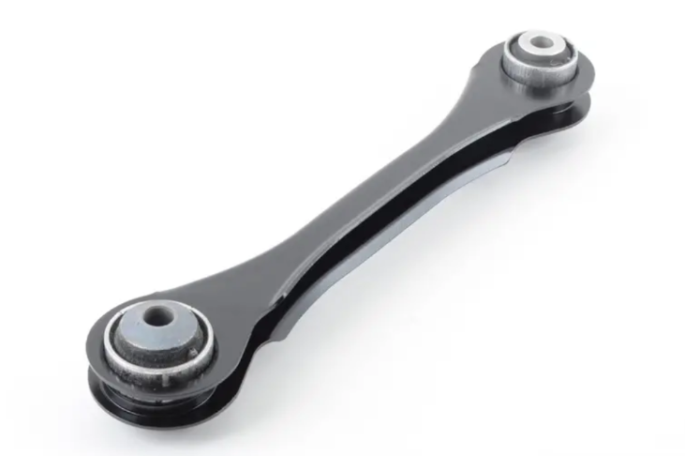
A rear control arm has been chosen to be specified in this report, taken from the 2017 BMW 2 Series. Designed to accommodate multiple drivetrain configurations with various driving characteristics. Used to maintain contact between the tires and the road and intended to work with other suspension components, a control arm connects the wheel hub assembly to the frame of the car. Front control arms are commonly referred to as A arms as they can resemble the shape on an A, but the rear on this vehicle only has two connection point son the control arm.
Figure 1 shows the rear control arm used on a BMW 2 Series.

As seen with the figure above, the control arm has two mounting points surrounded by rubber bushings, these points are to connect the top of the wheel hub assembly to the frame while the bushings are required to absorb vibration developed through the road surface.

Requirements
These necessary requirements have been chosen and will be detailed below.
- Manufacturing Cost
- Ease of access
- Reliability
- Performance

Manufacturing costs
For an inexpensive component, manufacturing costs must be made as low as possible, with the optimal material being used for cost and performance. As the majority of the applications for the component being road use for the general consumer, the manufacturing of the piece, the raw cost of the piece and the method of installation all play a major part in the chosen design and the decisions made concerning the part during development.
With the intended manufacturing process for the vehicle would include being ran through a robotic production line, a component that can be fitted remotely by robotics without the need for specialist tools and equipment, time and resources can be saved by continuing the production of the car without the need to stop. Along reducing the time taken to install a part to become a finished vehicle, another cost saving measure is designing the component to be used within other platforms, Such as the same control arm being used on the BMW 1 series and Z4, As the part can be utilised on other platforms, from a business view, the cost to design and manufacture would be divided across three different sales platforms rather than just one, as can be imagined, this also saves designers time and therefore another cost saving measure within the manufacturing space, this design philosophy is referred to as Design for manufacturing and assembly (DFMA) (Mascitelli, 2004)

Ease of Access
In order to minimise future costs to consumers, the relative ease of access for repair and maintenance for a component is critical, reducing the number of contact points for a component or reducing the shielding needed to be removed to gain access to a suspension piece is a simple way of gaining more access and reducing the time it takes to assemble the component into the car and reduce the repair and maintenance time taken upon a vehicle within it’s lifetime. As the average life expectancy of a modern vehicle is estimated around 180,000-200,000 miles, a compromise is made between the resistance to corrosion, wear and tear and general lack of maintenance for such parts, for these parts, the compromise usually comes down to function over form, meaning the component is expected to last the life of the car and have a less performance-oriented design philosophy.
With the repair of such parts handed to the customer and the road safety standards that cars must adhere to, the idea of replacing a control arm is usually placed in the category of replacing when it is needed rather than being listed as a service item, this allows the customer to put the emphasis of maintenance towards serviceable items.

Reliability
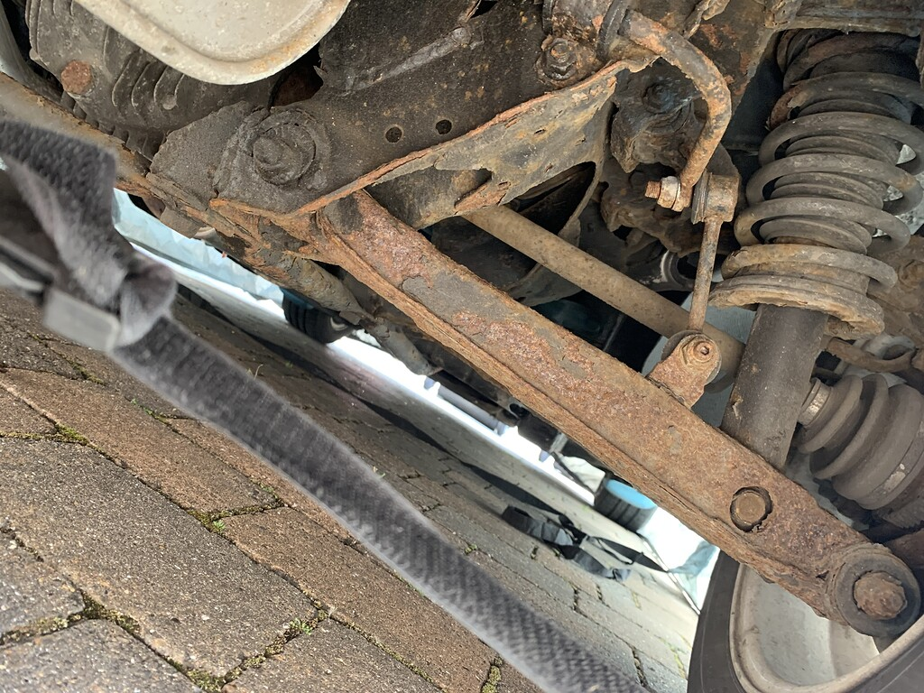
A component that is intended to last the life expectancy of a car is therefore designed to withstand the average corrosion and the average wear and tear an item such s a control arm is likely to face. With a control arm being exposed to the road conditions and the general weather, they are likely to have corrosion resistant coatings during the manufacturing process. These can include general paint, powder coat or using aluminium so they suffer less from rust.
Figure 2 shows a lower control arm that has suffered from considerable corrosion.

Performance
Due to the designed component needing to withstand the corrosion during a car’s lifetime, performance for a general road car is not considered within the same frame as a car that is designed with performance as its main focus rather than general day to day driving. Although these parts are not designed with the best performance, they are still designed to have an acceptable level of performance for the platforms it is intended to be used on. This idea can include weight reduction and an aerodynamic design being implemented into the design.

Material selection
This section will detail the selection process for this component detailing the reasons and impacts of using different materials on the environment and the necessary adjustments that may need to be made to the material selection depending on cost, availability, and environmental impact. The materials used in the manufacture of a control arm can incorporate, Mild steel, Aluminium alloy, and single and double stamped parts. The use of these materials depends on the intended use of the car, with the implementation of an aluminium alloy being used, weight and formability but its strength and hardness compared to steel is significantly less and therefore is harder to guarantee the safety of a component. (Tao Song, 2022)
Another aspect of material selection for large automotive manufacturers have been mandated to make their products recyclable, this includes designing the car to facilitate proper dismantling, and allow to the parts dismantled to be either recycled or reused (Parliment, 2000), this keeps the value of second-hand cars high as the support for new and second-hand parts is available.
Table 2 shows the material data for an Aluminium Alloy.
Table 1 shows the material data for Mild Steel.
(Mostefa, 2012)
Mild steel can suffer from rust and corrosion due to being a ferrous metal, but due to the basic design of a control arm, surface corrosion can be justified within the item’s lifespan, with a bigger concern being the strength compared to the aluminium alloy. Other materials can be used for a control arm such as Carbon fibre, being a specialty material to use for a control arm it is often reserved for either bespoke manufacturing or limited production runs. The rare use of this material can be placed upon the cost to manufacture these parts, with the raw cost being higher compared to mild steel and aluminium. Due to the design specification needing a stronger material compared to a lighter one that may give a better performance outlook, the stronger and cheaper material will be used to create the component. In this case, a mild steel will be used to create the component due to the increased strength and reliability compared to Aluminium.

Manufacturing Process selection
With the chosen material being mild steel, there are multiple ways to manufacture said component, these being detailed below.
Casting – Casting involves the material being placed in a furnace until molten and then placed into a mould for the liquid material to cool and take the shape of the toll it has been placed into, this is a relatively simple an inexpensive manufacture process, the significant cost with this process is the price of the tools used. With the tooling The die cast used in this process can incur costs between $2000 and beyond $20,000 (Castings, 2022) With the part being designed to be used on multiple vehicle platforms, the initial cot of tool making can be divided into the research and development costs of the respective platforms rather than the cost burden being placed onto the one platform. This allows the manufacturer to reduce the cost of this component as the initial investment into the cast will be recovered faster with more sales from using the multiple platform design philosophy.
Stamping – Metal stamping consists of three main elements, cutting Forming and finishing. This method requires specialist machinery for manufacturing, including large presses that form the material into the required shape through high impact force, these parts can then be finished using a coating such as powder coating or painting. This manufacturing method is expensive initially like casting with the initial investment being placed into the tools and machinery to stamp these components into the required shape. Due to the material being cut to size before stamping, less waste is generated. This method also allows a degree of flexibility in the design (ESI, 2024).
Forging – Forged components are often held in high regard for reliability and robustness in the automotive field, with forged pistons and crankshaft being a high-volume component to be forged. Commonly used in high power applications, forged components can also have a significant effect on performance, but this can be attributed to the excessive cost of these components. Forging consists of heating the component to the desired temperature and the hitting it with a hammer or a die to create the desired shape. A substantial portion of the excessive cost of this method is due to the specialist press and the expensive heating system needed to heat the components to the desired temperature. (Anna Dziubińska, 2016)

Conclusion
In order to meet the design specification laid out above, the chose material for the part will be Mild Steel, this is due to the inexpensive raw material cost and the strength and reliability this material will allow over the lifespan of the vehicle. Although aluminium would allow for a significant weight reduction across and therefore a improvement of performance for the car, the gains offered for this material are overshadowed by the benefits it gives to repair and maintenance that would be given to the end user, as the material costs are low it allows the part to be sold individually to the customer for a lower price.
With the straightforward design of the component, a casting manufacturing method is ideal, this allows the parts to be mass produced with little variations needed. The casting process for this component would introduce a large financial investment to pay for the tooling and the initial machinery but as stated above, these investments would be re-imbursed through the high volume of parts created and utilised. The casting process allows for the parts to be strong and ductile, essential in a control arm. As the casting process has a quick turnaround, this allows the manufacturer to produce a large stockpile of these components and allow them to be stored before being used. As the casting process could be delegated to a separate company, if this is the case, a large acquisition order for these parts would also lower the individual cost per piece compared to a smaller order.

References
Anna Dziubińska, A. G. M. D. M. B., 2016. THE FORMING OF MAGNESIUM ALLOY FORGINGS FOR AIRCRAFT AND AUTOMOTIVE APPLICATIONS. Advances in Science and Technology Research Journal , 10(31), p. 159.
Castings, O., 2022. Omnidec Castings. [Online]
Available at: https://omnidexcastings.com/metal-casting-tools/#:~:text=Investment%20casting%20tooling%20can%20be,up%20to%20and%20beyond%20%2420%2C000.
[Accessed 10 April 2024].
ESI, 2024. The Basics of Metal Stamping. [Online]
Available at: https://www.esict.com/what-is-metal-stamping/#:~:text=Stamping%20%E2%80%94%20also%20called%20pressing%20%E2%80%94%20involves,used%20to%20shape%20the%20metal.
[Accessed 20 04 2024].
Mascitelli, R., 2004. Lean Design Guidebook. s.l.:Technology Perspectives.
Mostefa, B. &. A. A. &. B. A. &. M. B., 2012. Effect of Hardening Induced by Cold Expansion on Damage Fatigue Accumulation and Life Assessment of Aluminum Alloy 6082 T6, s.l.: s.n.
Parliment, E., 2000. EUR-Lex. [Online]
Available at: https://eur-lex.europa.eu/legal-content/EN/ALL/?uri=CELEX%3A32000L0053
[Accessed 2024 04 10].
Tao Song, S. X. H., 2022. Analysis of material selection trend of the automobile control arm. Journal of physics , Volume 2390, p. 2.

