UNIVERSITY OF WALES TRINITY SAINT DAVID
BIRMINGHAM CAMPUS

Psychology in Health and Social Care
(BMHP4003_BIRM)

Student Name: Shirley Obeng Asare (2021249)

Assignment Title: Case Study Report

Lecturer’s Name: Rebecca Kavanagh

Table of Contents

Introduction 3
Social Identity Theory (SIT) 3
Attribution theory 4
Frustration aggression hypothesis (FAH) 6
Conclusion and recommendations 7
References 8

Introduction
The aim of this report is to understand and assess how a Practice Manager at the counselling unit can deal with a complaint from a member of staff regarding aggression from a service user. Most workplace settings have experienced different levels of experiences and exposure to aggression and abuse from service users, and the response of staff members has been varying. This phenomenon continues to rise in the social work sector. Over the past few years, more attention has been devoted to how co-workers manage problems associated with the psychology of people including aggression. A recent report suggests, for example, that suicide rate reduced by 26% for people who sought some form of therapy as against people who did not seek any help (Dufour, 2018). The report is intended to provide my fair assessment of the situation which might be basis of the decision of the Practice Manager to deal with the complaint. The report will consider how social Identity Theory (SIT), Attribution Theory (AT) and Fundamental Attribution Error (FAE) could be used to understand behaviour of the service user, and apply how a Practice Manager at a local counselling centre can deal with the complaint regarding a verbally abusive client.

Social Identity Theory (SIT)
One of the theories which helps to understand the behaviour of individuals is the Social Identity Theory (SIT). This theory was first developed by Taijel in 1978 and 1979 and was later updated by the Taijel and Turner in 1979. The SIT attempts to articulate why individuals view themselves as unique but see themselves as rivals or enemies in group context. The SIT explains how the social group influences the individual to behave in a particular way (Trepte, 2013). The theory attempts to explain that cognitive behaviour of individuals is influenced by groups and processes. The theorists assumed that the categorisation of one or another makes people discriminate against those who are not in the same group category (Trepte, 2006).
In dealing with the case of verbal assault by the service user, it is advisable for the manager to exercise some care and tact in addressing the issue, especially not to be too protective of the receptionist staff or become more sceptical of the service user and other participants. In line with the theory, there is the likelihood that there could be psychological motivation for people (e.g., service user) within a group to be labelled in a particular way. This may limit the ability of the receptionist staff to assess and address the behaviour of the service user (Minto et al., 2016).
The SIT highlights intergroup bias, meaning that it is likely for the receptionist staff to stereotype the service user because of his association with social care institution especially if it is established that the behaviour aligns with the core values, group norms and rules of the organisation. However, according to Hopkins (1997), it is appropriate for the receptionist staff to recognise the impact of group association on the behaviour towards the service user.
As suggested by Tajfel (1972), naturally people will assign with certain social categories which will make them reject the uniqueness of individuals. So, there is the likelihood that the service user might have compared his uniqueness and identity with that of the receptionist staff and would have compelled him to behave in that manner. The theory also highlights the behaviour of people as genuine sources of information to guide behaviour. So, it is assumed that the behaviour of the service user might have triggered an equal response from the receptionist staff or the other way round.

Attribution theory
The source of attribution theory in psychology was discovered by Fritz Heider in 1958 when he began to discuss the psychology of interpersonal relationships (Harvey and Weary, 1984). The thinking behind the theory was perceived causality, meaning that, the behaviour of an individual may be attributed to a particular reason or cause. So, the attribution theory attempted to explain the various factors which contributes to supposed causes of actions and behaviours (Harvey and Weary, 1984). The theory indicates that explanations of why things happen may be due to some specific reasons or causes (Welner, 2010). Human beings generally have the tendency to discuss and understand their behavioural experiences. In the case study scenario, the service user abusing the receptionist staff or the receptionist staff responding to the abusive service user in such a manner, may want to find out the cause of the behaviours, using their own theories and assumptions so that they can find solutions for the behaviour in future, and identify how they can behave towards them next time. So, when explaining their own behaviours, they are most likely to emphasise situational (external) factors or may emphasise dispositional (internal factors) as grounds for their behaviours. The example below may explain what may have happened between the service user and the receptionist staff.
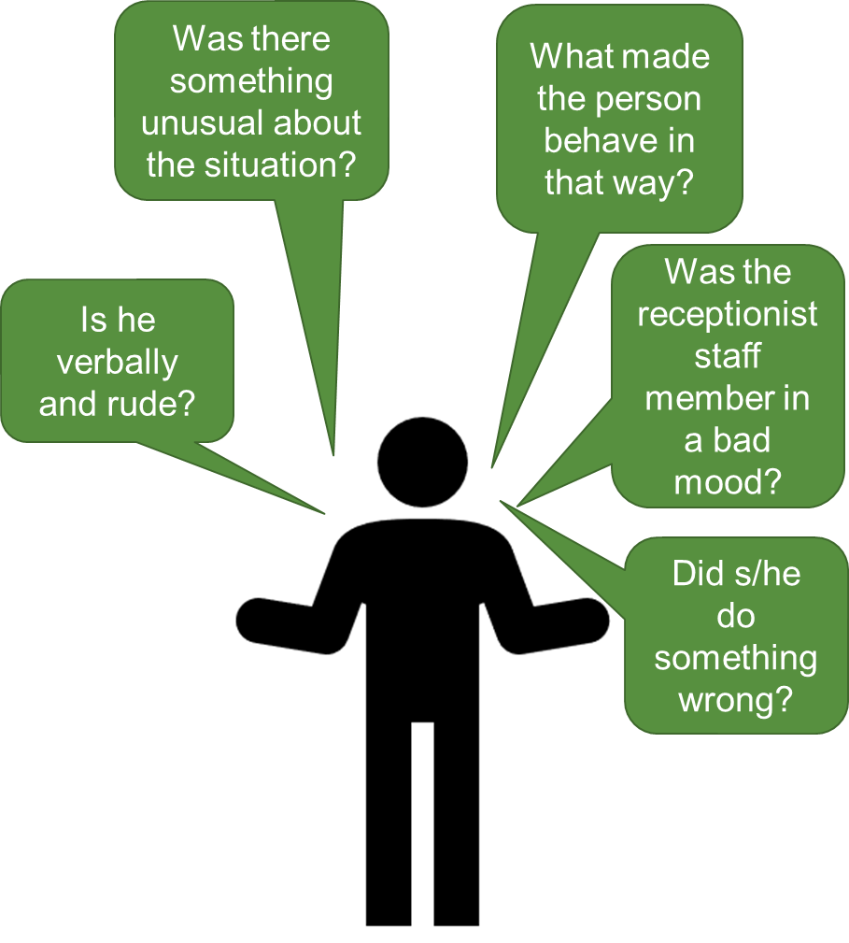
Figure 1. A diagram to show application of attribution theory.

Heider offers three principles which underline the so-called naïve psychology, which is the observable behaviours of people. This includes:
- The behaviour of people is not accidental: may be based on incentives to behave. What this means for the case study is that the abusive behaviour of the service user may be due to some remote causes and motivations which need to be investigated. On the other hand, the behaviour of the receptionist staff member might have been caused by a certain motivation, which could be the abusive behaviour of the service user in the first instance.
- Information: people would want to gather enough information or evidence about an issue to produce any causal theories. The manager should be aware that the receptionist staff member might have gathered enough evidence concerning the abusive service user before behaving the way he did. It could also happen that the service user did not initiate the verbal assault out of the blue; he might be acting on information or evidence from the business context. But it is appropriate to consider the pattern of behaviours in several situations or examples with different people and situation before there can be a proper determination of the true character of the person.
- Beliefs: People may assign behaviour internally or externally, meaning that a person behave the way he does because of some internal character or personality of the person. For the case study, it may be that the service user a personal disposition towards aggression and that motivates him/her to behave that way. The receptionist staff member may also have his own personal character / attitude towards abusive people and that might have caused that reaction. At the same time, people may attribute the behaviour externally, meaning that the environment in which the person finds him/herself influences to a greater degree the behaviour of the individual. For the service user and receptionist staff member, the condition and situation of the environment may have fuelled aggressive behaviours.

Frustration aggression hypothesis (FAH)
Aggression has been defined in so many ways by different people. This indicates how complex aggression may be addressed. For example, in more recent times, Anderson and Huesmann (2003) define aggression as “behaviour carried out towards another with the intent to cause harm”, whilst Baron and Byrne (2000) define aggression as “the intentional infliction of a form of harm on others”. These two definitions of aggression emphasise an intention to cause harm to someone, and not instances in boxing or a sport which has different motivations when harm is recorded.
There are generally two theories which seek to explain aggression. This includes biological theories of aggression which explains that aggression is based on the tendency of an individual with some genes, hormones or character within him or her to cause harm. The Social theory of aggression has three other theories. These are Frustration Aggression Hypothesis (FAH), Aggressive Cues Model (ACM) and General Aggression Model (GAM). The FAH was first developed by Dollard et al (1939) who explained that aggression is the result of a person who has experienced some form of frustration. They are of the view that when an individual experiences frustration, the tendency to be aggressive is high.
According to Miller (1941), every aggression or aggressive behaviour may be attributed to frustration that the individual has experienced. Therefore, it is mostly likely that the verbally abusive behaviour of the service user might have gone through a period of frustration before encountering the receptionist staff. It could be frustration from the quality of service, pain, family problems, and other issues not even related to the service environment. This can also be said of the behaviour of the receptionist staff who might have gone through periods of frustrations either from the work experience, workload, family, social group, or interaction with clients.
Also, according to Bateson (1941), people get aggressive to each other when their cultures are different and seem to oppose to each other. For example, if the service user had experienced a new work culture which is being experienced at the counselling, he is likely to get frustrated and aggressive at the same time. It has also been established that when people feel embarrassed or weakened in their experiences, they usually show aggression to whoever they encounter (Kasim, 2014). So it may be that the experience the service user had was that of embarrassment and diminishing in his or her ego. Lastly, there is the view that people might be aggressive when there is some anxiety, anger, and punishment (Fox and Spector, 1999). This view might explain the behaviour of the service user as he might experience anger or anxiety, leading to frustration and aggression.

Conclusion and recommendations
The discussions of the psychological theories used for addressing the complaint regarding the abusive behaviour of the service user show that the behaviour may be directly related to social group, a particular cause or reason and frustration experience that he might have had. Thought it might be difficult to explain with certainty what the real causes of the behaviour might be, it may be appropriate for the Practice Manager undertake thorough investigation of the complaint from the member of staff and ask for more questions. Undertaking a thorough investigation might help the counselling centre identify probable causes and reasons for aggression and help them provide a better counselling service for the service user and other users in the future. Based on this, I recommend that the complaint by the member of staff may be upheld pending further investigation.

References
Anderson, C.A., & Huesmann, L.R. (2003). Human aggression: A social-cognitive view. In M.A. Hogg & J. Cooper (Eds.), Handbook of social psychology (pp. 296-323). London: Sage Publications.

Baron, R.A., & Byrne, D. (2000). Social psychology: Understanding human interaction (9th ed.). Boston: Allyn & Bacon.

Bateson, G. (1941). IV. The frustration-aggression hypothesis and culture. Psychological Review, 48(4), p.350.
Brown, R. (2000). Social identity theory: Past achievements, current problems and future challenges. European journal of social psychology, 30(6), pp.745-778.

Dollard, J., Doob, L.W., Miller, N.E., Mowrer, O.H., & Sears, R.R. (1939). Frustration and aggression. New Haven:Yale University Press.

Dufour, G. (2018). Working with suicide in multi-disciplinary teams.

Fox, S. and Spector, P.E. (1999). A model of work frustration–aggression. Journal of organizational behavior, 20(6), pp.915-931.

Gutierres, S.E. and Reich, J.W. (1988). Attributional analysis of drug abuse and gender: Effects of treatment and relationship to rehabilitation. Journal of Social and Clinical Psychology, 7(2-3), pp.176-191.

Harvey, J.H. and Weary, G. (1984). Current issues in attribution theory and research. Annual review of psychology, 35(1), pp.427-459.

Hopkins, K.M. (1997). Supervisor intervention with troubled workers: A social identity perspective. Human Relations, 50(10), pp.1215-1238.

Kasim, S.N. (2014). An Analysis of Frustration-Aggression Described in EL James’s “Fifty Shades of Grey” (Doctoral dissertation, Universitas Islam Negeri Alauddin Makassar).

Maruna, S. and Mann, R.E. (2006). A fundamental attribution error? Rethinking cognitive distortions. Legal and Criminological Psychology, 11(2), pp.155-177.
Miller, N.E., 1941. I. The frustration-aggression hypothesis. Psychological review, 48(4), p.337.

Minto, K., Hornsey, M.J., Gillespie, N., Healy, K. and Jetten, J. (2016). A social identity approach to understanding responses to child sexual abuse allegations. PloS one, 11(4), p.e0153205.

Trepte, S. (2013). Social identity theory (pp. 273-290). Routledge.

Turner, J. C. (1982). Towards a cognitive redefinition of the social group. In H. Tajfel (E d.), Social identity and intergroup relations. Cambridge: Cambridge University Press.
Weiner, B., 2010. Attribution theory.

