
CELEBRATING LANGUAGE AND CULTURE – BELONGING TO WALES (ECIE 5004)
BY SAMANTHA MORRIS (student – 2115614)

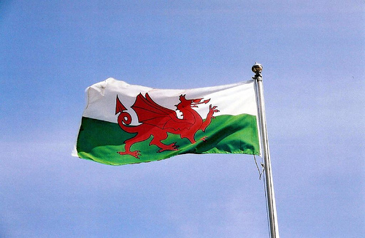

CONTEXT

Page 3 Introduction to Wales and Education

Page 4 Education and policies

Page 6 – 7 History of Welsh language

Page 8. Appendix 3

Page 9 Welsh in use in daily use in flying start

Page 10. Appendix 4

Page 11 Appendix 5

Page 12. Appendix 6

Page 13. Appendix 7

Page 14 - 15 Story and craft activity.

Page 18-19 Flying start and its policies on the Welsh language

Page 20 References

CELABRATING WALES AND ITS LANGAUGE AND CULTURE

BELONGING TO WALES

Introduction to Wales and education

Wales as a nation that is a very passionate country and researching this topic has given me more of an insight to my birthplace and the language.
So, I had to start within my working daily world, and being in the social services and education sector I had realised that using the Welsh language was a daily with out even noticing in doing so.

Appendix 1
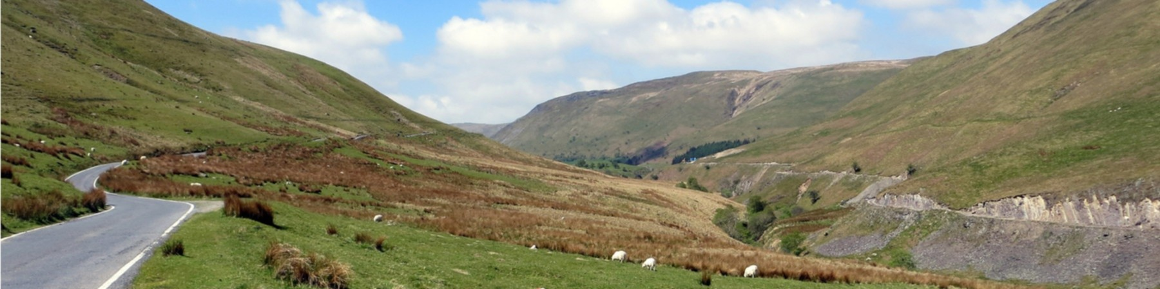
This Photo by Unknown Author is licensed under CC BY-SA

Education and policies

Firstly, with the policies within the Welsh education sector were very dedicated in promoting the language and its expansion to educate more.
Within the curriculum of Wales this expands but explaining on what it expects and hopes to full fill within a set target as it mentions within local authorises schools and Welsh medium schools that Wales has a set goal to achieve one million Welsh speakers to speak the language Welsh by 2050. This challenge is set out by the local authorities to support education within schools with their individual planning (WESPs). (gov. Wales, 2023).
All organisations who were included in such a promotion of the welsh language within welsh medium provisions these include schools, local authorities, teaching unions, Estyn, practioners, and others. (gov. Wales).
At the time of this publication the education minister and welsh language were Jeremy Miles MS, mentioned that all learners to be given the opportunity of becoming bilingual citizens and he also believed that welsh belongs to us all and that he wanted to give people a chance to able to learn welsh and to be happy to use the welsh language in all walks of life. The minister was confident that this is achievable. (p2, Guidance on school categories according to welsh medium provision. Gov.wales, 2023).
After announcing these plans and publication of the guidance and its achievements that could be obviously structures were needed to implement this.
The challenge began with 2013, where local authorities were expected to plan a strategy in education which was (WESPs). Then with (Sections 84-87of school standards and organisation (Wales) Act 2013. Within this guidance the provisions to help with planning through Welsh- medium in education and standards to improve teaching welsh language with the local authorities. (gov. Wales), (2023).
This would be also a financial challenge to promote the education of welsh language and the welsh government budget was drafted for 2022-2023 and was published on 20th December 2021, that the total cost for such a task which would be £43.6m which was allocated for the provision for Welsh language and an added resource budget for £18.8bn. (gov. Wales), (2023).

History of Welsh language

Welsh is so important to the culture of Wales so where did this beautiful language begin?
British language and the Celtic language spoken by ancient Britons. Welsh language is believed to have been spoken around 600BC. (p2, historic.uk.com), (2023).
There are many written guesses.
Wales has a history of education stated ruled education to local funded. Even in the 1950’s to 1960’s was parliament within schools and other education environments. Throughout the United Kingdom was focused on the history of education in the industrial revolution and became apparent in education with concerns especially throughout Wales with the mining culture being more finically stable than education did decrease the importance of the Welsh education system.
Looking further into Wales and its culture that has been a comprehensive change where in the 1970’s in Wales government and its policies became beneficial ln a financial way where incentives were introduced through employment to be diverse and new especially in industrial and this impacted on the social environment where communities could afford to develop and created opportunities.
This helped. Culturally within Wales and its international identity with promotion of the Eisteddfod at Llangollen which seemed to have the ability to have drawn attention worldwide ton compete and participate and set Prescence was the Welsh National Opera where and by doing so this then helped develop the Classical side of music and the creation of St David’s Music Hall which launched its doors to open in 1982. (A history of Wales in education, Gareth Elwyn Jones, Gordon Wynne Roderick), (2003) (p173).
Education had its own challenges also from devolution and its rejection within Wales in 1979 politically where a new government was developed. In education and the comprehensive schools and a report followed named The Loosemoore Report, where this exposed that pupils who left school across Wales left with 0 pass was 25 percent. It also highlighted that underachievers seem to be left with less support on comparison with pupils who had higher capabilities to achieve higher results. (pp198).
So in 1990 further research into this revealed that Wales had a lot of deprivation within its social abilities within school and on its comparison also seem to highlight that Wales wasn’t performing to its rival schools in England.
This exposed that in 1990s that funding had eased off from rural areas under the governments commands therefore set struggles which in communities and seemed to have knock on effect where families prioritised financially, and education became second to actual survival to pay bills. (pp199).
Wales seemed to be falling behind until a glimmer of hope emerged in the form of the The National assembly in 2001, where published document called The Learning Country and its contribution in this document it mentioned Diploma’s, extensions to modern education, as well as accounts for individuals to learn. This went on promoting still today where adult learners in further education can enrol to achieve higher qualifications and help with restricted communities where it can adapt to accommodate whoever decides to want or need to archive this. (p201).
Wales still has challenges within its education sector and this will seem to always continue and with the advanced side which was when technology started to evolve Wales on comparison to England was slightly behind regarding funding and availability.
Wales has a strong rural culture and education where Welsh is the first language compared to cities. Plus, technology wasn’t implemented and funded or even accessible to most rural areas until late 1990’s.
Over the decades Wales evolved and so did its fashion where America had influences where education was promoting adult education to further. This was mainly universities and colleges.
There seems to be no timeline defined where Welsh in education was a specialised date. Only speculation from when it all began, ( p198- p233),(A history of education in Wales, Gareth Elwyn Jones and Gordon Wynne Roderick,) (2023).

Appendix 2

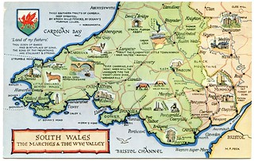
This Photo by Unknown Author is licensed under CC BY-NC-ND
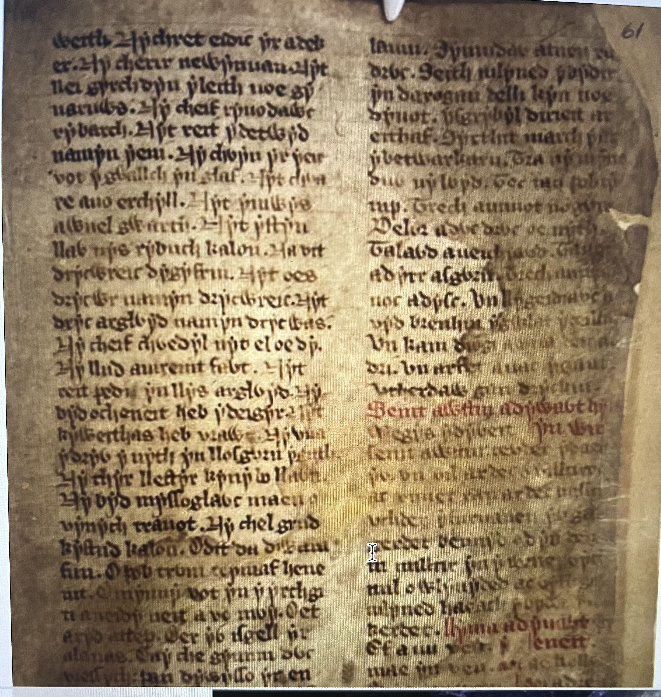

Appendix 3

Welsh in use in daily activities in a flying start setting.

Flying start is a early years setting funded by Welsh government to provide childcare provisions for 2-3 year-old’s in poorer communities.
This isn’t always broadly available yet to all areas but hopefully this provision will be made to all.

This Photo by Unknown Author is licensed under CC BY-NC-ND

Appendix 4

Flying start in Wales have they own promoting Welsh in education in activities within the setting. As is not curriculum basing its not strictly implement however flying start dose promote Welsh within the setting from bilingual signs, song activities, welcome boards, and Welsh word of week. We must be mindful of age as the children are only 2-3 years and verbally still developing so not to be too overwhelming and let them learn through free flow play.

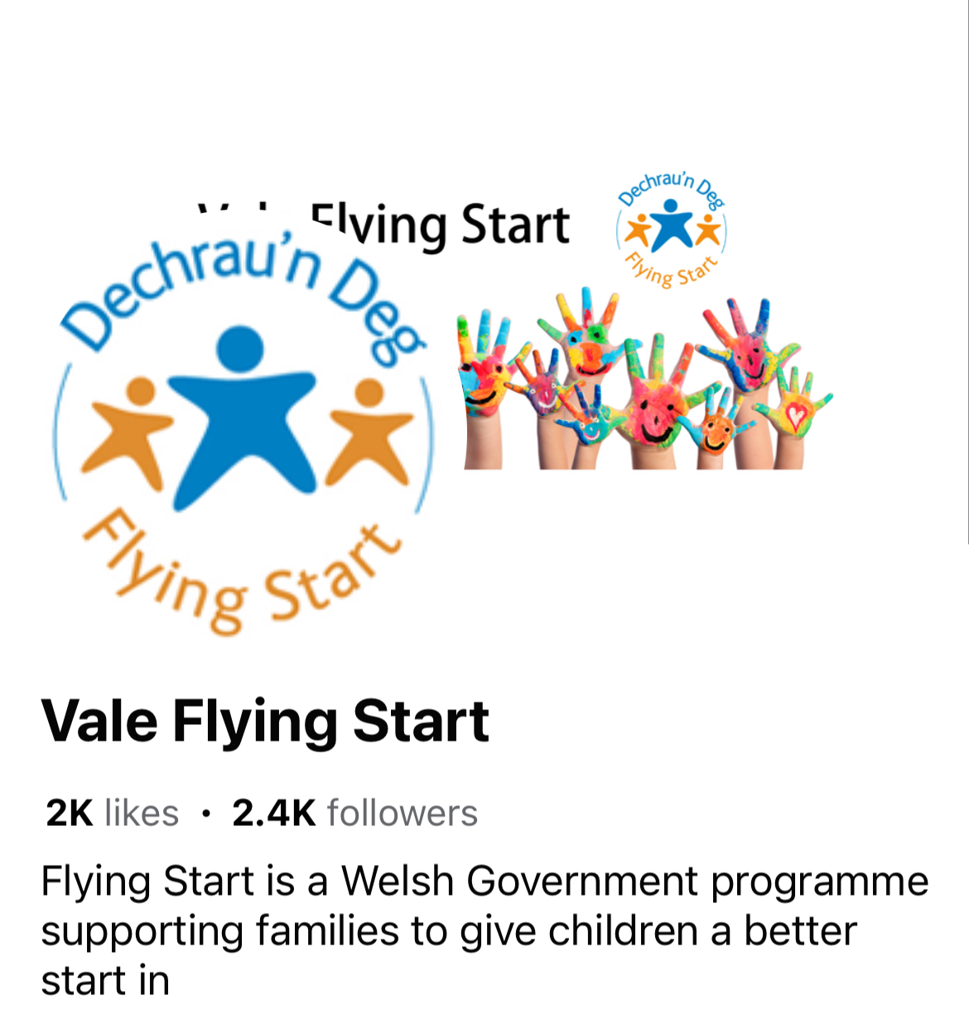

Appendix 4

Activities within the setting

Activities which promote the Welsh language in the setting are seasonal themes such as Christmas theme and its words and songs for example in appendix 5 and 6.

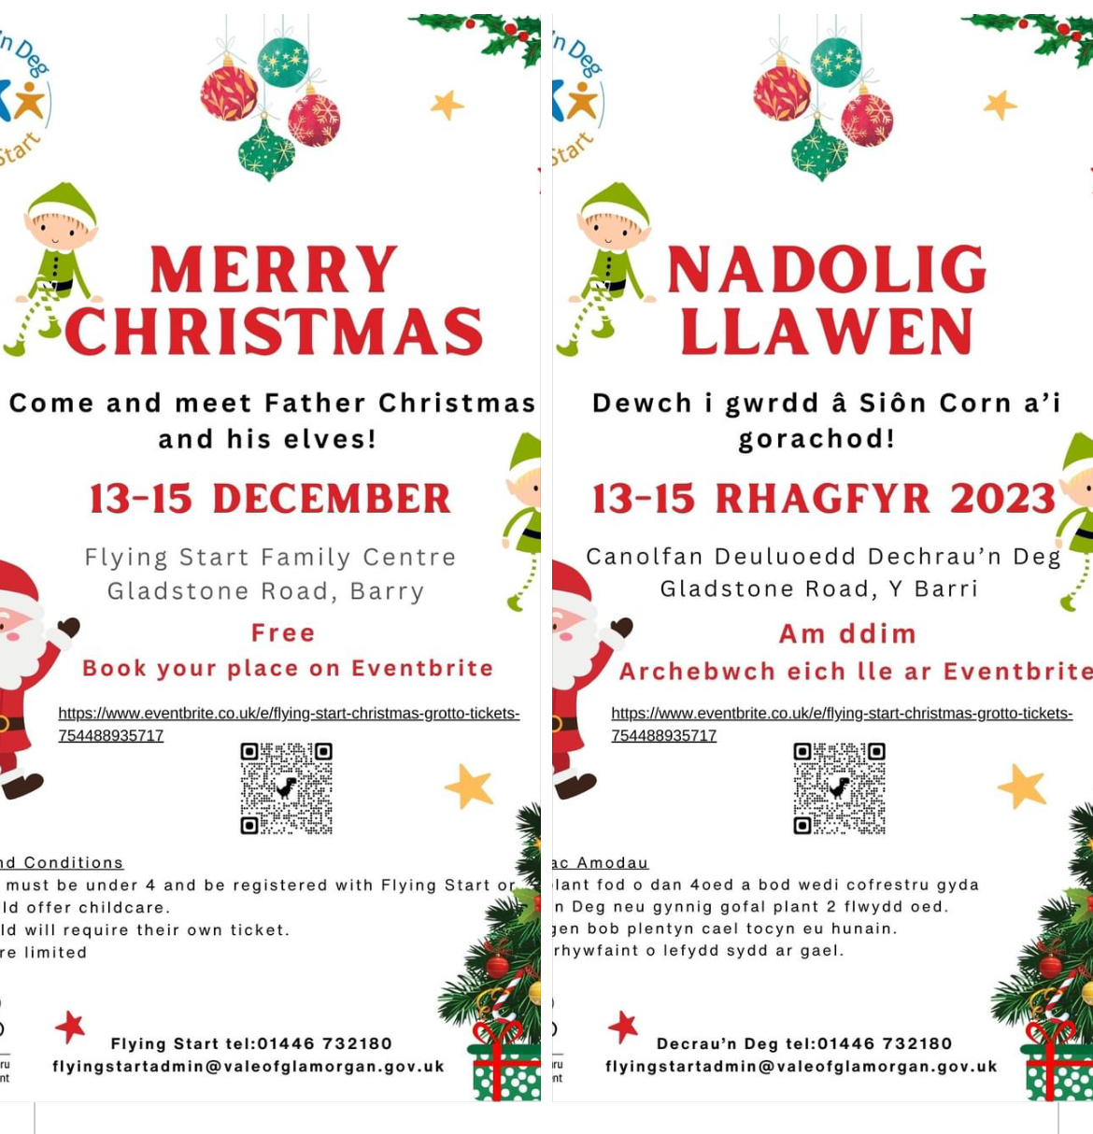
Appendix 5

Poster promoting Welsh language in flying start settings with advertising an advent.
The appendix 4 shows an example of one poster which are printed in both English and Welsh. This shows a brief example of how flying start promotes through newsletter.

Appendix 6
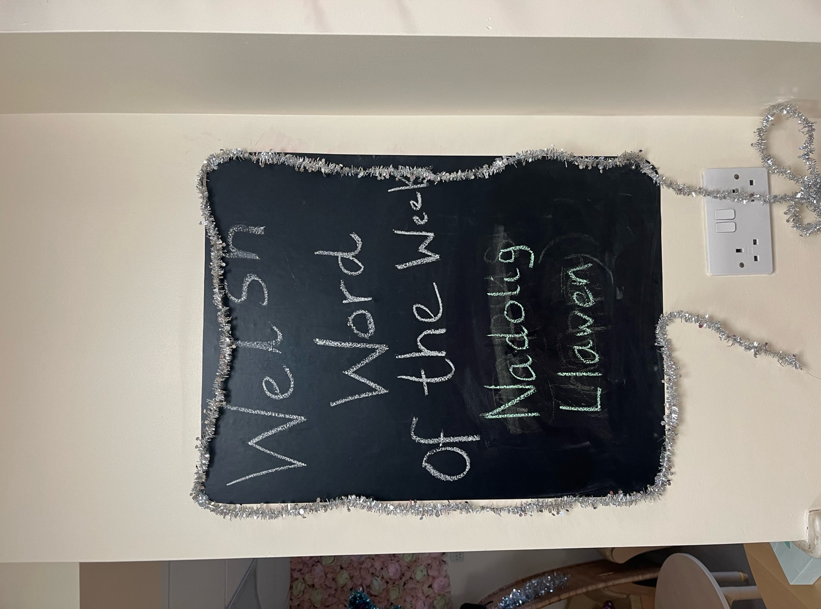
Flying start 2023

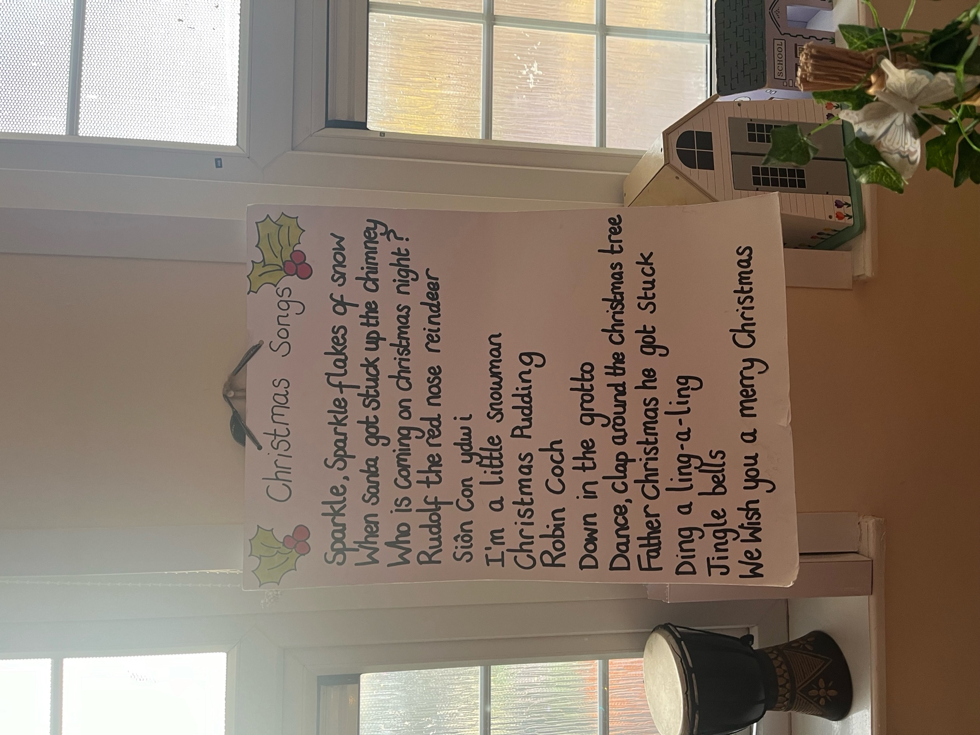

Appendix 7 flying start 2023

Story and art activity

In the setting we also have Dewi Sant, Santes Dynwen, shwmae Day, amongst daily songs and greetings.
To promote Welsh, we also have we offer all our policies in bilingual text and every publication that we advertise are in bilingual text from letters to posters, so this incorporates Welsh in the setting and makes parents, guardians more aware of the language.
We invite parents, and guardians to attend story and craft sessions where they see the children in the setting environment actually singing Welsh songs and crafts.

We also do story time in both Welsh and English from three bears to other books.
This initials numbers and counting size and even shapes or animals in Welsh and English.

In appendix 9 and 10 the pictures show three bears and three bowls, three spoons. The story was based on the goldilocks and the three bears, and in Welsh Elen Benfelen a’r Tri Arth.

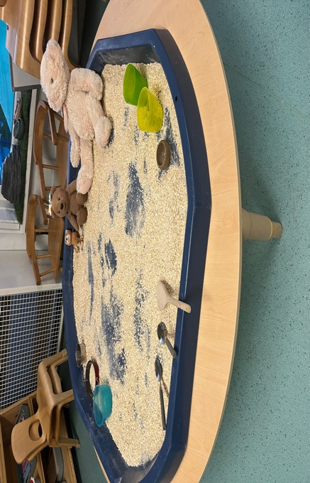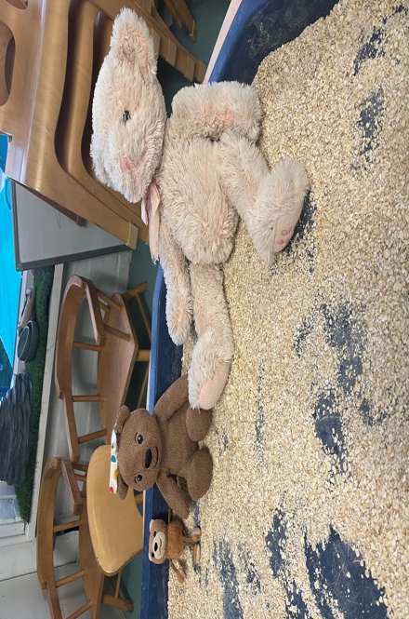

Appendix 9 (flying start 2023)

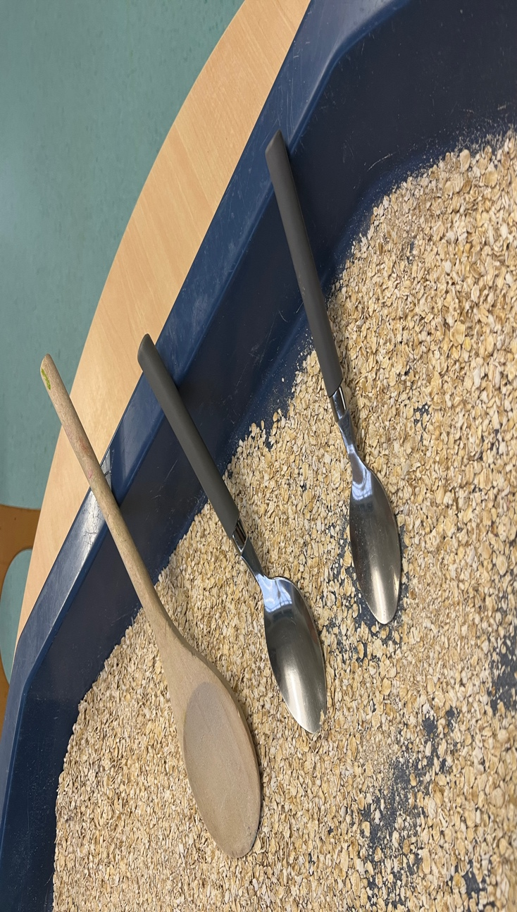
Appendix 10 (flying start 2023)

The children were read the story in English and Welsh words were added to activity from tri as in numbers of objects such as bears, spoons bowls. This was done for the children to understand and be able to repeat by themselves with an understanding.
Other activities are planned within flying start from story, tuff art trays and Welsh words added within the activity so a basic understanding without being overwhelmed and made fun so the children can also interact.

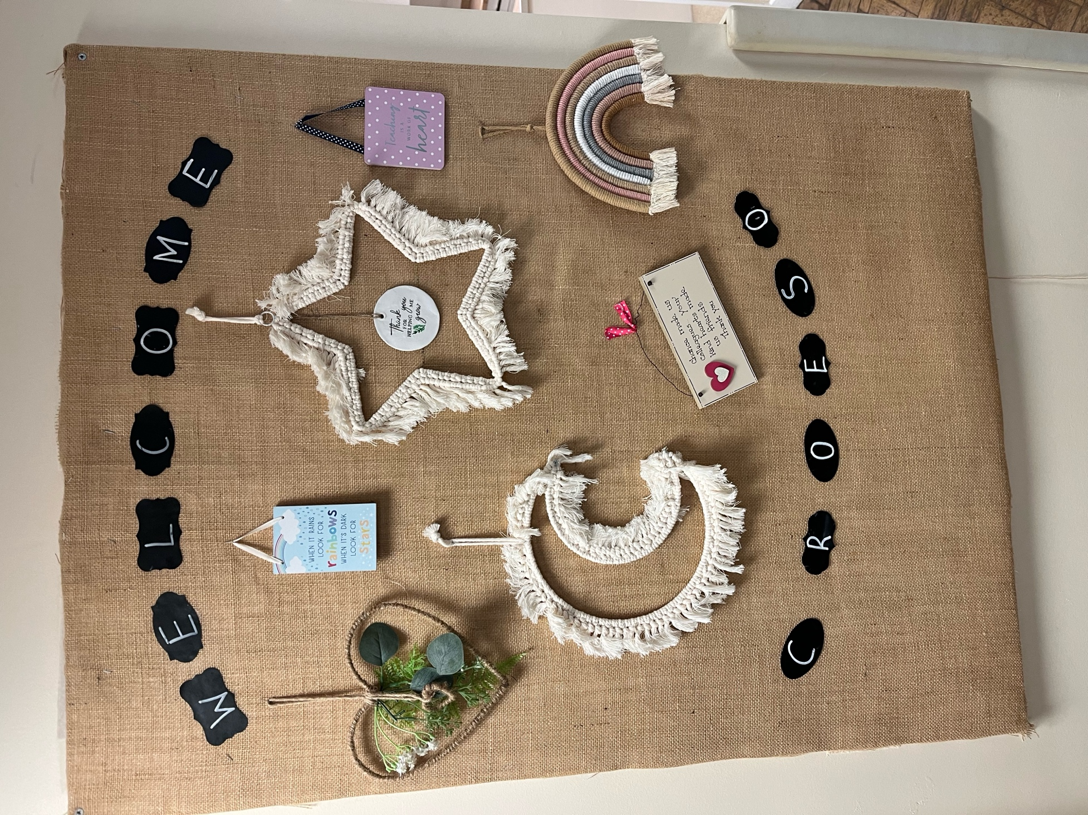

Appendix 8 flying start 2023

Welcome board visible to parents and visitors on arrival to the setting. We also have children with cultural pictures with there own languages we also embrace.
The setting is all inclusive cultural and non-exclusion environment where every child is allowed to be expressive through play and where they made to feel safe.
Flying start promotes individual uniqueness and helps build the child development through play.

We do explain things signal wordly such as kitchen as cegin, water as dwr, and dog as ci and many more. (see appendix 6).
We do within songs and seasonal themes (see appendix5).

FLYING START AND IT POLICIES ON THE WELSH LANGAGE

Flying start through the Welsh government mentions in its policies that it recognises that language is a key skill of understanding the world and culture from well-developed speech, language, and communication.
This helps with developing skills with family, friends and social development in the community and learning.
Children develop in the early years with a level of communication where they are influenced to learning how they re spoken to and what respondence they achieve by being spoken to, (gov.co), (Tamis-LeMonda et al, 2001).
Flying start under the guidance promotes bilingualism and goes on to mention when a child or adult can understand via language and mentions regardless of what level of language they speak. (gov. wales,2023, p6).
Flying start and Wales with home learning environment from supporting parents and guardians, from speech, language, and communication through development. The Welsh government ‘Learning to talk’ through key messages based on activities and strategies. (gov. Wales), (p9).
Policies also mention that poverty has an impact on a child’s speech and language development skills, and this provides a best with support enhance language and speech development within their own environment.
(Hart and Riley (1995).(p10).
Flying start promotes inclusion and it’s a supportive setting for children and families.
Its early years setting, and it’s made to be not overwhelming for all.
Flying start is only based in Wales and it expanded in 2023 where private educators such as nurseries can apply to be under the flying start umbrella, however this is only funding and title but adds more availability towards other communities throughout Wales in providing free childcare up to 30 hours per month on a part time status and Welsh assembly funded.
This wasn’t available in 1980’s to early 1990’s where this provision started in 2007 with the Welsh assembly. Welsh assembly produced the flying start as their flag ship and the government programme as 2016 – 2021.
They discovered that through Welsh assembly (Senedd Cymru, outreach, p5), the outreached requirement which its identity’s that children living outside the postcode of flying start and to extend out would benefit others to. The plans were set out for the future of an expansions to out of post coded areas to help every child.
The evidence became apparent that children outside the postcode were also deprived and needed flying start provisions. Through Senedd Cymru and outreach this a raised issue. (pp6).
The Senedd Cymru, research mentioned through outreach that programme was highlighting free meals were needed and part time free education and brought to the attention that out of post coded areas also had income supported funding and flying start was based around deprived areas and this was recently implemented via private childcare sectors now called flying start extended. This provision hopefully will include free childcare to all but however the support units aren’t based in these extended practioners whereas pre-existing flying start provisions have health visitors on majority sites and based near or within a school, so transitions are easier for the children and families for the start in mainstream education.
Flying start also have provisions in place such as speech, language, and communication, and other organisation.

REFERENCES

Gov.Wales/Welsh in education
Cymaerg 2050; A million Welsh speakers (2017).
Rapid review of the welsh in education strategic plans- 2017-2020 (2017).
Business. Senedd. Wales, (WESPs).
Welshlanguagecomonssioner.Wales
Flying start, Outreach, Senedd Cymru, 2023.

