
/.

Design, Implementation, and Evaluation of a Security Information and Event Management (SIEM) Solution Using Simulated Cyber Incidents

By: Callum J Warwick (1809785)
Supervisor: Munyaradzi Nicholas Murira

Project submitted as part of the requirements for the award of BSc (Hons) Computing (Computer Networks and Cybersecurity)

Date Started: March 2024
Date of Submission: 29th April 2025

Table of Contents

Contents
DECLARATION 1
FORM OF CONSENT 1
Abstract 2
Chapter 1: Introduction 3
Aim 4
Objectives 4
Chapter Conclusion 4
Chapter 2: Research and Review of Literature 5
Introduction 5
Introduction to SIEM Systems 5
SIEM Incident Response 6
Review into why organisations have SIEM solutions. 7
Testing SIEM solutions 8
SIEM Simulated Incident 8
MITRE ATT&CK Framework 8
Atomic Red Team 9
Red Canary Threat Detection Report 9
Logging Made Easy (LME) 10
Sysmon 10
Further Considerations 11
Chapter Conclusion 12
Chapter 3: Research and Development Methodologies 13
Introduction 13
Project Plan 13
Research Onion 14
Research Philosophy 14
Research Approach 15
Research Strategy 15
Experiment 16
Validity / Reliability / Generalisability 16
Validity 16
Reliability 17
Generalisability 17
Development Methodology 18
Experiment Requirements 19
Hardware / Software Requirements: 19
Experiment Inputs: 20
Chapter 4: Design and Implementation 21
Introduction 21
Sprint 1 - Design: Network Topology 21
Implementation: LME 2.0 Core Service Installation 22
Sprint 2 - ELK Stack Server 22
Post LME Install Actions 25
Sprint 5 - Implementation: LME SIEM Testing – Threat Detection Rules & Alerts 29
MiniKatz (T1059.001) 29
Nmap Ping Sweep (T1046-3) 33
Kali Linux – Metasploit Reconnaissance (PSExec) 36
Sprint 6 – Detection Tuning and Remediation Recommendations 39
Minikatz 39
NMAP Port Scanning 40
Kali Linux (PSExec) 41
Sprint 6: Recommendations Conclusion 42
Chapter 5 – Evaluation 43
Chapter 6 – Conclusion 44
Chapter 7 – Reflection 45
Chapter 8 - References 46
Chapter 9 - Appendix 52

DECLARATION

I, Callum John Warwick declare that I am the sole author of this Project; that all references cited have been consulted; that I have conducted all work of which this is a record, and that the finished work lies within the prescribed word limits.

This work has not previously been accepted as part of any other degree submission.

FORM OF CONSENT

I, Callum John Warwick hereby consent that my Project, submitted in candidature for the B.Sc. (Hons) Computing (Computer Networks & Cybersecurity) degree, if successful, may be made available for inter-library loan or photocopying (subject to the law of copyright), and that the title and abstract may be made available to outside organisations.

Abstract

This report explores the design, implementation and evaluation of a Security Information and Event Management (SIEM) solution. This will be developed to enhance the detection and response capabilities of Carmarthenshire County Council (CCC). The primary focus of this project is to develop a SIEM platform for log file ingestion of Windows workstation and servers. This will be done to centralise the log file information into one place, which can then be analysed by the SIEM itself. Suspicious activity will then be alerted, following the rules created by the SIEM and by the researcher. Experimental elements will also be used to test the SIEMs performance and effectiveness in a simulated real-life incident, however the focus will be on research and development of incident detection and response.
To evaluate the SIEM itself, this report will include simulated incidents, which will be conducted using Red Canary’s Atomic Red Team framework. This framework is a widely recognised open-source testing suite, which is closely aligned with the MITRE ATT&CK framework. These tests will include a variety of tactics and techniques such as Credential Dumping via Minikatz, network reconnaissance using NMAP ping sweeps, and lateral movement through PSExec and Kali Linux. The SIEMs effectiveness will then be assessed through key performance indicators, which as detection accuracy and alert response times. From these results, recommendations and evaluations will be provided on how effective the SIEM solution was for detecting these simulated alerts.
Overall, this dissertation demonstrates the feasibility of building a SIEM solution tailored to modern threat landscapes and best practises. Highlighting the need for further research and the testing of detection logic and response procedures for cyber related incidents.

Chapter 1: Introduction

In response ever developing cyber challenges CCC are undertaking a crucial project to introduce a SIEM software solution. SIEM solutions have become a staple for cybersecurity, due to their ability to monitor large sections of an organisations network assets for threats and unusual behaviour [1]. This is because the Security Operations Centre (SOC) dashboard provides quick and simple access to cybersecurity professionals, who can access vast amounts of log file information from one place. The dashboard or SOC is also able to correlate events and provide full Identity mapping of network traffic [2]. The ability to quickly identity devices will be vital to the network in the event of a cyber-attack, as more time can be spent on the remediation rather than locating where on the network the cyberattack is taking place. SIEM solutions are now a commonly used Intrusion Detection System (IDS), that can be placed to monitor any section of the network. They can also monitor changes to company digital documents and Active Directory (AD) services. Unmonitored changes to the organisations AD, could mean that users have access to areas that they shouldn’t, leading to possible data breaches or further cyber disruption [3].
This project is being undertaken to enhance CCC’s cybersecurity infrastructure and streamline detection and responses. The overall goal for the project is to research and implement a suitable SIEM solution that can parse log file information from endpoint devices and servers. Research will be undertaken to locate the best possible solution, and documentation provided as to what processes have been taken to implement. There will also be a further analysis and experimentation of the SIEM solution to measure its effectiveness and recommendations provided on the results found.
While this is a project for CCC, the researcher is also working with University of Wales Trinity Saint David. This report will show case the work and studies that have been completed such as developments in cybersecurity and Ethical Hacking. The researcher will be using the skills developed as part of these units to complete the report, while also completing thorough research to further develop and implement a suitable SIEM solution that meets the Councils requirements and meets the academic requirements for the University, showing how all modern cybersecurity and academic guidelines are being followed.
The main research question for this project will be: How can CCC fortify its cybersecurity infrastructure to mitigate emerging threats and bolster defensive capabilities? To answer this question and deliver the most efficient response possible, the researcher is proposing the following aims and objectives:

Aim

The aim of this project is to design, implement and evaluate a SIEM solution that can be used within CCC’s network. With the objective of having the solution tested against simulated cyber incidents, thereby assessing its effectiveness in enhancing organisational cybersecurity posture.

Objectives

- Complete a comprehensive Literature Review to understand the current and predicted future landscape of SIEM technology, methods and standards of testing and looking at the state of the marketplace. This will also include a review and discussion of any previously completed projects of SIEM installations and testing.
- Locate and document suitable methods for testing SIEM solutions. These will act as the simulated cyber incidents that the SIEM will be tested against.
- Provide a comprehensive plan on SIEM implementation and testing. This includes the development methodologies for research and testing.
- Outline and document the experiential elements, highlighting challenges and improvements where available.
- Design the overall SIEM architecture, which will be tailored to the cybersecurity needs of CCC. This will then be used to install and implement into the chosen testing environment.
- Design and implement the chosen simulated tests and detection rules for the SIEM. As these will be simulated incidents, there will also be documentation provided on what remediation actions will be taken as if the incident was live and real.
- Once the simulated incident tools are run and detections start to appear, data will be gathered on detection accuracy, response times, and the SIEMs overall effectiveness. This will then be gathered ready for analysis. The data will be evaluated to see if the SIEM solution was working as intended and how accurate the detections were.

Chapter Conclusion

In the following chapters the researcher will be continuing research and document SIEM solutions, as well as provide the planning and implementation of the solution itself. In Chapter 2, the researcher will be completing a literature review on SIEM solutions, as well as any other material in cybersecurity threat detection and incident response. Chapter 3 will contain the methodologies for the report and what development and experimental methods will be used to design, implement and test the SIEM solution chosen for the project. Chapter 4 will contain the design, implementation and testing of the SIEM solution. Chapters 5-7 will then be an evaluation, conclusion and reflection of the project, where the researcher will detail what has happened during the report and detail whether the findings were successful.

Chapter 2: Research and Review of Literature

Introduction

This literature review will include an overview of SIEM systems, Incident Response capabilities, a review into why SIEM solutions have started to become more widely used, as well as a section on how they are tested. There will also be a section discussing the chosen SIEM that CCC are going to use, which is Logging Made Easy (LME). The researcher will be using skills learned on an Ethical hacking course completed with the University, as well as further research to see how this kind of simulated attack has been completed in the past.
At the end of this review, the researcher is hoping to have all the required information to be able to make decisions on how the rest of the project is going to be carried in the next sections of the report.

Introduction to SIEM Systems

A SIEM system is designed to provide a real-time analysis of system logs for connected devices within an organisations network [4]. A log file is usually a string of text or binary showcasing what process a particular device has completed or failed to do, whether this be sending or receiving data, updating itself or communicating with other internal or external services [5]. Each time a log is generated and sent over to the SIEM system, it is then analysed for suspicious activity or malicious practises. Each time a log file is suspected of malicious activity, the SIEM will then provide a notification to the SOC, which is the dashboard interface that security professionals would access and is a part of the SIEM software. The SIEM framework will then action the threat where needed [6].
A SIEM is broken up into two different parts. One is Security Information Management (SIM) and Security Event Management (SEM) [7]. The SIM is designed to handle the long-term storage of log files, so that they can be re-gathered and analysed further if required. Whereas the SEM is there for the real-time analysis of log files, this is the process that would provide the notification to the SOC that something has been detected [8].
The main function of a SIEM in cybersecurity is to monitor security events of an organisations network. Many different types of devices can be connected to the SIEM. These can be Firewalls, Virtual Machines and Servers, Intrusion Detection Systems (IDS) and various other internal software applications that are able to export log files.

SIEM Incident Response

Incident Response is a massive part of the installation process [9]. This is both due to the need for better preparing the organisation to protect key assets, and to also comply with GDPR and other key security governance [10]. For an organisation to comply with GDPR, it is required that there be an Incident Response plan for what should occur if an incident takes place, failure to deal with these incidents could lead to a cybersecurity breach, which in turn could leave the organisation liable to a fine or further legal action.
An Incident Response plan should consider 4 key areas [11]:
- Preparation
- Detection and Analysis
- Containment, Eradication & Recovery
- Post Incident Activity
Preparation – The start of the Incident Response process is how the organisation will prepare. In terms of SIEM technology this would be dependent on what network systems the SIEM is covering, and which logs are required to get the most valuable information. Having too many logs come through could cause bandwidth or storage issues as there would be too much traffic hitting the hosting server, and having too few logs could mean that valuable information is missed [12].
Detection and Analysis – The next stage is how the SIEM should handle incidents it detects. The SIEM can either be configured to scan for anomalies where machine learning combined with a list of known vulnerabilities can pick out events that shouldn’t be occurring on the network. Anomaly detection is important to detect cyber-attacks that may not have a pattern or to immediately detect an abnormal event [13]. There are also event correlation features, where machine learning can detect a pattern of events that could be classed as suspicious [14].
Containment, Eradication & Recovery – Once the Incident has been identified the SIEM will then act. If the incident is not severe but still needs to be alerted, then the SIEM system can be configured to email the appropriate parties all the information gathered. However, if a severe alert has occurred, then the SIEM can also be configured to either immediately delete / terminate the effected files or traffic that has been detected, or to quarantine the effected data for further analysis. This would therefore mean that the incident is mitigated automatically. The relevant parties can then also be notified via email of what has happened and what the SIEM system has done, to allow for immediate action to further mitigate the incident [15].
Automating the incident response process as much as possible is beneficial to the organisation, this is due to there being less need for human intervention, which in turn means that those resources can then be used elsewhere [16]. However, notifying the security professionals via email or other means is still important as the system may not always make the right decision, this could mean targeting traffic that isn’t malicious or underplaying a possible cyber incident. So, it is important that the opportunity to interrogate and intervene is granted to ensure that the best course of action is taken.
Post Incident Activity – After the incident has been reported and the proper processes have taken place to remove / mitigate, the final part of Incident Response process is to analyse and provide recommendations on how this incident can be prevented in future. SIEM solutions can generate reports based on the full incident details, this will provide the source, user / device details, any known vulnerabilities used as well as any other information that may be related [17]. This information can then be used to put further measures into place on the necessary devices or systems, which is a key step in limiting the number of cyber threats that occur in the future.

Review into why organisations have SIEM solutions.

There has been an increase in use of SIEM solutions, due to their ability to make security threats more visible, and they can streamline processes. Such as the development of Endpoint Detection technology (EDR), as details in a report by Fortra [18]. EDR works by monitoring machine behaviour on the network, in the event of suspicious activity, the EDR service can be configured to automatically stop this activity on the host or endpoint or deliver a notification to the system for further inspection.
SIEM technology is also more accessible to smaller organisations, many vendors now employ a Software as a Service (SaaS) model, meaning that organisations can pay for their usage, which means that smaller organisations with less traffic pay less than larger organisations. A study completed by Gartner [19], found that this new model for SIEM solutions has made acquiring far less complex and is a big reason why organisations now see the SIEM solutions as a viable cybersecurity asset.
Another reason why an organisation may want to use a SIEM would be to stay up to date with compliance. A regulation that all organisations must comply with is GDPR. SIEM technology can help ensure that the organisation meets this compliance through its logging services. SIEMs can be configured to keep logs for permission, credential and security group changes on the network, and alert if a change is made that is suspicious [20]. Having the SIEM for compliance may also help relationships with other organisations, if stakeholder organisations wanted to work with the authority, having the SIEM will show that the authority remains cybersecurity and data security compliant, could make these stakeholders feel more confident in allowing the authority to use their services.

Testing SIEM solutions

Past research in this field shows that to test the functionality of the SIEM solution, you must first have it running in a controlled environment and have controlled events that would cause the SIEM solution to produce a log and an alert. Once an alert has been generated, it can then be documented and compared to see how quickly it was produced and what information the alert was able to provide [21]. There are a wide range of simulated attacks that can be completed, a report completed by ‘Plos one’ stated that they were able to test their SIEMs through a simulated Distributed Denial of Service (DDos) attack and a controlled custom malware installation to see if the EDR and Anti-Virus logs were able to detect. These simulations were then implemented and the Events Per Second (EPS) were recorded to see which SIEM was the most efficient [22]. Following these tests, the report detailed that they were able to successfully compare the SIEM solutions, showing which solution was slower at producing the alerts and gathering the logs.
Comparing event severity is also an important part of SIEM testing, another report shows a test where a SIEM solution detected malicious IP addresses being accessed, the events were then collated alongside the severity and the overall percentage that the relevant IP address appeared in the EPS results [23]. This report clearly shows how many times the IP addresses were accessed alongside the percentages, allowing clear and easy analysis of the specified data.

SIEM Simulated Incident

MITRE ATT&CK Framework

The MITRE ATT&CK Framework is a globally recognised open-source database setup to classify different cyberattacks and intrusion techniques. Providing documentation on how these techniques can be executed and how they can be defended against [24]. The framework separates Tactics, Techniques and Procedures (TTPs) into their own matrix frameworks. These TTPs are then fully documented, detailing behaviours, application, attack chain information and methods of detection. This framework is therefore mandatory for SIEM solution testing, as the detection methods provided by the MITRE framework can be implemented into the SIEM detection model. This then can provide a baseline for testing certain environments and seeing if the SIEM responds adequately to what is being tested. A report completed by Charleton University in 2023 [25] showed that using the MITRE ATT&CK framework had many advantages when they were testing their own SIEM solution. These advantages include implementing the provided detection documentation for various techniques and seeing if the outcome from the SIEM is correct, in the event of one of these techniques being used on the network. The report also mentions using open-source tools for this testing, these tools are Atomic Read Team and Caldera. These tools provide an emulation solution to use and test the techniques mentioned in the MITRE ATT&CK framework in a safe and secure environment. The report concluded that using these methods was an effective way of testing SIEM solutions and their detection rate. The researcher will therefore consider these findings when outlining the methods of testing for this report.

Atomic Red Team

A solution that would provide a suitable testing platform would be the Atomic Red Team framework [26]. The Atomic Red Team packages are maintained and managed by the Red Canary organisation. Red Canary and Atomic Red Team are a group of volunteers that come together and come up with simulated incident solutions that parallels with the information found on the MITRE ATT&CK framework. The Atomic Red framework is a list of folders with the TTP IDs present. Comparing the IDs to the Tactics shown on the MITRE framework it allows the researcher to test the SIEM solution with a particular attack technique and see if the desired outcome is achieved. The desired outcome for this report would be to see if the SIEM rules are working correctly and to see how efficient they are if generated. Performing a Red Team test could also be useful for detecting gaps in the organisation security, these gaps can then be reported and patched further, so that they are not present in the event of a live cyber incident. A dissertation report completed by the Southeast Technological University used the Atomic Red Team tools to be able to create a ‘SIEM/SOAR Testbed’ [27]. Atomic Red team was mentioned as a suitable testing tool for testing SIEM solutions, due to the vast library of TTP’s that it contains. Red Canary also publishes a list of the most used attack Techniques, which the researcher will be looking at as part of this report to ensure the testing remains current with what threat actors are using. Other testing tools such as ‘Detection Lab’ were mentioned in this report, they may be considered as part of this report also.

Red Canary Threat Detection Report

Each year the Red Canary organisation publish a Threat Detection report which details cybersecurity threat detection trends, and which tools, techniques and methods have been used [28]. The researcher has decided to use this report to help decide which techniques to use to test the new SIEM solution. Using the Atomic Red Team tool detailed above for the real scenario, using tools and techniques with current real-world relevance would ensure more accurate testing for the SIEM solution, and ensuring that the SIEM is up to date with threat detection requirements. The report details that the biggest threat trend was Ransomware. While also using protocol and credential manipulation tools for lateral movements around the network. Tools such as ImPacket and Minikatz.
Artificial Intelligence (AI) is another trend for threat detection. The reason for this is because both defending and attacking parties have started to automate tasks using AI. By automating certain tasks, such as phishing lure applications generation and employee impersonation, attackers can create the infrastructure and plans for Ransomware quicker and more effectively. For defenders, AI is being used to automate log processing to better streamline threat hunting and alerts.
The report also mentions that Phishing and Identity Attacks are the most used methods for initial access to organisation networks. Phishing techniques allow for internal access to be granted, while also enabling the use of evasion tactics to enable attackers to continue with lateral movement around the network. Identity Attacks provide attackers with another layer of evasion, as accessing internal employee credentials enables certain traffic around the network to be missed by IDS and SIEM software as normal traffic.
The report also details trending MITRE ATT&CK TTPs. These TTPs are a part of the Atomic Red Team framework and can therefore be used with the SIEM. These are mainly execution methods, such as PowerShell execution (T1059.001), Windows Management Instrumentation (WMI) (T1047), Rundll2 (T1218.001). Other techniques include email forward rules (T1114.003), this would be a good test to cover the previously mentioned rise in email phishing attempts by threat actors.

Logging Made Easy (LME)

LME is an open source SIEM solution provided by the Cybersecurity and Infrastructure Security Agency (CISA) [29]. CISA enhanced its detection facilities and making the installation process more accessible to organisations with limited resources. They have provided all the installation notes from CISA’s GitHub [30].
The software itself has two main components:
- ELK Server – Linux based, this contains the database for the log file information, as well as the Elasticsearch, Logstash and Kibana (ELK) dashboard from where the log file information and alerts are analysed.
- Client – The devices that contain the logs that will be forward for further analysis, a Sysmon client is deployed out to these devices, this will be forwarded using the Elastic agent, provided by the dashboard itself. These will be endpoint devices and some servers that need to be supervised for irregular traffic.

Sysmon

Sysmon is a service and driver that can be installed to run on Windows devices. This service then gathers system activity through Windows Event Viewer, even between system reboots [31]. The service itself does not act on or analyse the events and data it is attempting to gather, it is designed to only gather and parse the events and logs to another source [32]. Sysmon can gather a wide range of log information, with very little configurations, the different tasks it is able to perform are each assigned to numbers, for example ‘Process Creation’ is set to ‘1’ and process terminated is set to ‘5’ [33]. This is dictated using a configuration file, that would be added as part of installation to client machines. LME recommend 2 different configurations for Sysmon deployment ‘SwiftOnSecurity’ [34] and ‘Olaf Hartong’s Modular’ [35], the configuration file creation will be fully documented along with the deployment in Chapter 4 of the report. Additionally, a report completed by the University of Puerto Rico, which used Sysmon to detect the ‘WannaCry’ malware, also used the configurations recommended by LME which is ‘SwiftOnSecurity’ [36]. The report was able to successfully use this configuration to detect the ransomware, by successfully creating a rule from the SIEM dashboard and installing the Sysmon service onto the test device [37].

Further Considerations

The researcher has also viewed previous reports and research completed in the SIEM implementation and testing field. These reports showcase actions taken by other Universities and whether these actions were successful or unsuccessful in the aims and goals they were trying to achieve.

- A report completed by the KTH Institute of Technology in 2022 showcases the implementation of a Kibana based SIEM Solution [38]. The title and scope of the research was to test if open-source SIEM solutions could be used for smaller companies, who wouldn’t necessarily be able to afford a more expensive SIEM solution to protect their network and infrastructure. The main goal was to compare an open-source SIEM solution with a commercially available solution, to see if the costs and effectiveness were suitable to those organisations with smaller security budgets. The report stated that positivism was used as the main methodology for gathering data, since real numerical data was needed to measure the log detection rates of each SIEM. This will be heavily considered as the researcher will be needing similar data when it comes to testing the implemented SIEM. The report conducted that a lot of work was needed on the open source SIEM to be able to match the scale of the commercial FortiSIEM solution. This will also be considered for this report, as Kibana is the dashboard being used in this report. The cost and time needed to create the rules will be added into the conclusion.

- This report was completed by the University of Oslo. It showcases research and testing completed for testing attacks also using a Kibana dashboard and Elasticsearch framework to gather alerts, detecting alerts and corelating events [39]. In this report, they used many different testing methods that the researcher would also like to consider as part of the report. Following the attack TTP report completed by Red Canary, the researcher may also look at nmap and port scanning, to see if a more well-rounded testing simulation can be achieved. This testing method allowed the report creator to get all the results they needed, and allowed them to identify areas for improvement, such as the log correlation methods through Elasticsearch and the overall noisiness of log detections and rules if they are not created using the correct formats and clearing away as much noise as possible from some of the more generic rules and logs.

Chapter Conclusion

Following this literature review, the researcher has investigated various topics surrounding SIEM solutions, such as the installation of them and what the best practises are for testing and threat detections. This information lays the foundations for moving onto the methodologies and implementation sections of the report, where further information on how the new SIEM solution will be implemented for CCC.

Chapter 3: Research and Development Methodologies

Introduction

The researcher will provide context on the methodologies used for this project. At the end of this section, the researcher hopes that there will be a clear understanding of what needs to be done for this project to run effectively. There will also be a section providing the hardware and software used, with justifications on why these were used.

Project Plan

Following the above schedule, the researcher believes that all aims and objectives will be completed. By the end of the report, the researcher hopes that the desired outcome is achieved, and that as many recommendations are provided as possible.

Research Onion

Research Philosophy

The researcher has decided to use a combination of philosophies for this project. These are Pragmatic and positivist. The reason for this is due to the larger focus of development and implementation of the SIEM solution, using practical methodologies with numerical data being used as part of the implementation and testing phase of the project. The researcher believes that having a flexible approach to data gathering will be beneficial to achieving the aims and objectives [40]. The only downside to using a pragmatic approach would be the possible lack of theoretical depth. This is why the researcher has completed a comprehensive literature review.
Positivist compliments pragmatism well in this instance, enabling the researcher to create a framework for evaluating the SIEM effectiveness, using numerical data. Thisbe measured using the detection accuracy and response times generated by simulated incidents. The researcher believes that another advantage of using the positivist philosophy is its high reliability and validity. This is because the data collection methods can be repeated multiple times, to see if the same result is achieved [41]. However, there may be some disadvantages that the researcher needs to consider, such as positivism can sometimes provide an inability to generate results outside of the experiment being completed. This can sometimes generate one sided argument data [42]. To get around this, the researcher will also be using phenomenological data to compare with what has been generated by the SIEM. This will be research completed to help provide recommendations on incident detection and response.

Research Approach

In this report the researcher has decided to use the Deductive approach. Deductive research allows for better measuring of concepts quantitively, which will be some of the data gathered for this project [43]. This is instead of the usual un-structured approach that is typical of inductive research [44]. Similarly to the above, to counter any validity issues with the numerical data, there will also be an introduction of different data types to help backup the data gathered from the experiment.

Research Strategy

The researcher has decided to use an Agile Development Strategy. Agile Development emphasizes frequent progress, flexibility and continuous improvement. The researcher believes that the adaptability is critical to this project, as the needs and implementation of the SIEM will change as the project goes on. Agile development will cater for the incremental improvements needed for the SIEM itself, which will prove important especially when it comes to designing the solution and implementing rules for detection. The types of tests needed may also update depending on the needs of CCC [45]. This project can therefore be divided into multiple sprints. Agile also allows refinements to be made based on the results achieved. However, the researcher is aware that proper time management and organisation is needed for Agile development to work effectively. This means that the researcher will endeavour to meet the deadlines set as part of the project plan and outline any times where deadlines have been extended due to further troubleshooting.

Experiment

Despite this project being more focused towards development, there will be a need for experimental data, these data formats are detailed below:
- Detection rates – This will be measured using alerts generated by the SIEM, where the response will be measured through true / false positives or negatives. The rate of each will be measured to see how many threats are detected successfully, and how many were not.
- Response times – This will be measured by timing how long it takes for the log file to be generated and alerted from when the simulated incident occurs. This will be numerical data that can be measured from when the log file was generated and when an alert is sent from the itself. This data can then be gathered in the form of a table.

Validity / Reliability / Generalisability

Validity

The validity of the data gathered is to ensure that when the results are analysed in the concluding sections of this report, that there were no impacting factors that may tamper with the data and therefore the results [46]. The researcher will outline the measures taken to ensure that the data remains valid throughout this report and SIEM installation:
- Data Collection Validity – Data collected from the SIEM will always be used from a central log database. By centralizing logs in a uniform database, this project eliminates the risk of discrepancies in data format or content, ensuring consistency regardless of whether logs are generated by workstations or servers.
- Data Gathering Validity – For the gathering of data, the researcher has outlined a list of test devices that will be first connected to the SIEM. This test environment is a range of workstations and servers that will help the researcher get a better idea of how the SIEM interconnects and works with CCC’s network. This will remain the same throughout the report, to help ensure that when the simulated security incidents are started that different hardware, or configurations do not impact the Sysmon logs generated through to the SIEM. Moreover, the simulated incidents that will be used will also remain the same.

Reliability

To ensure that the data is reliable, the researcher will document all hardware and software used. The reason for this would be because CCC’s network will function differently to other organisations, who may want to repeat this experiment using the same or different equipment and be able to compare the results [47].

Generalisability

The researcher believes that the experiment and parameters used are generalised because this type of experiment for testing SIEM solutions is typical from other organisations. Despite the above where the test environment won’t be the exact same as this project, the equipment used will still be commonplace for most if not all organisations. The manufacturer of equipment will differentiate; however, the network setup will be similar. This makes the experiment generalised as despite there being differences in equipment, the experiment itself can still be configured in the same manor, using simulated incidents on a test network [48].
Another way that the results are generalised will be the vulnerability and cybersecurity framework information that should be generated as part of the logs within the SIEM. With the varying simulated incidents that will be used, such as malware infections, phishing, and other insider threats. The SIEM should respond with the right information based on the software or method used for the incident. The information gathered can be compared to what documentation there is available on cybersecurity frameworks such as National Institute of Standards and Technology (NIST), International Organisation for Standards (ISO 27001) and the MITRE ATT&CK framework [49]. These organisations all provide information on various cyber incidents and the types of vulnerabilities exploited. Therefore, the information reported back from the SIEMs can also be compared to what is available from them.

Development Methodology

The researcher employs a hybrid development methodology, combining the Agile Framework and Cluster Analysis Data Mining. As detailed above the agile framework has been chosen due to its flexibility with software development and installations [50]. As previously mentioned, the SIEM development can be separated out into separate sprints, these sprints will each focus on different distinct tasks [51]. For example:
Sprint 1: Design the topology for the ELK Stack SIEM services, ensuring that the design caters for the test environment and log gathering.
Sprint 2: Install the ELK Stack Services onto the Linux server.
Sprint 3: Configure Elastic Agents & Sysmon logs across the test environment, ensuring that there is consistent log collection from each endpoint.
Sprint 4: Develop the indexing and log file filtering strategies to enable more effective data gathering for the detection rules
Sprint 5: Develop the initial detection rules in the SIEM, these will provide the baseline for how the simulated incidents need to be run.
Sprint 6: Based on the results found, fine tune the alerting mechanisms to provide any efficiencies needed for the alerting. Advise will also be provided on what mechanisms will be needed to mitigate the attacks if they were happening within the live environment.
The researcher will be closely following the project plan; to show clearly the how much time is needed per task, and to provide a deadline for the task to be completed.
Alongside Agile, Cluster Analysis Data Mining will also provide a well-planned data and variable collection method, providing a focus on grouping and analysing the information to better spot patterns and similarities [52]. The researcher believes that this will provide a more organised and planned method for collecting the data, to avoid any confusion from the many variables that need to be considered and analysed [53].

Experiment Requirements

Hardware / Software Requirements:

All hardware and software have been considered using the prerequisite specification requirements for LME [54].

ELK Stack Server:
Hardware:
- 2 CPUs
- 16GB RAM
- 200GB Hard Disk
- Virtual Network Card
Software:
- Linux Ubuntu Live Server 20.04.6 (64-bit)
- VMWare
- ELK Dashboard Service
- LME Database

Test Server:

Hardware:
- 4 CPUs
- 8GB RAM
- 100GB Hard Disk
- Virtual Network Card
Software:
- Windows Server 2022 (64-bit)
- VMWare
- Sysmon Client

Test Laptop 1:

Hardware:
- Intel i5 13th Gen (1.30 GHz)
- 16GB RAM
- 500GB Kloxia SSD drive
- Intel AX211 160MHz Wireless Card
Software:
- Windows 11 23H2
- Sysmon Client

Test Laptop 2:

Hardware:
- Intel i5 13th Gen (1.30 GHz)
- 16GB RAM
- 500GB Kloxia SSD drive
- Intel AX211 160MHz Wireless Card
Software:
- Windows 11 23H2
- Sysmon Client

Experiment Inputs:

Minikatz password dumping process detection (T1059.001) which covers MITRE ATT&CK execution tactic. The researcher also plans to use a pre-built internal instance of Kali Linux, which will provide further reconnaissance tests such as using nmap and recon-ng on the test workstations mentioned above. The testing session will be targeting the above pre-agreed test workstations where each test will have the opportunity to run remotely. Any prerequisites needed by Atomic Red will be run using the Windows Remote Management service (WinRM).

Chapter 4: Design and Implementation

Introduction

In this chapter the researcher will be showcasing and documenting the implementation process completed for Logging Made Easy. This will contain screenshots of the SIEM being installed and configured. Once the SIEM and the test environment has been fully installed, the researcher will then be documenting the testing process completed.
Once the implementation and testing has been completed, the researcher will then provide recommendations. These recommendations will be further improvements and resolutions to common faults that had occurred during the installation and testing.

Sprint 1 - Design: Network Topology
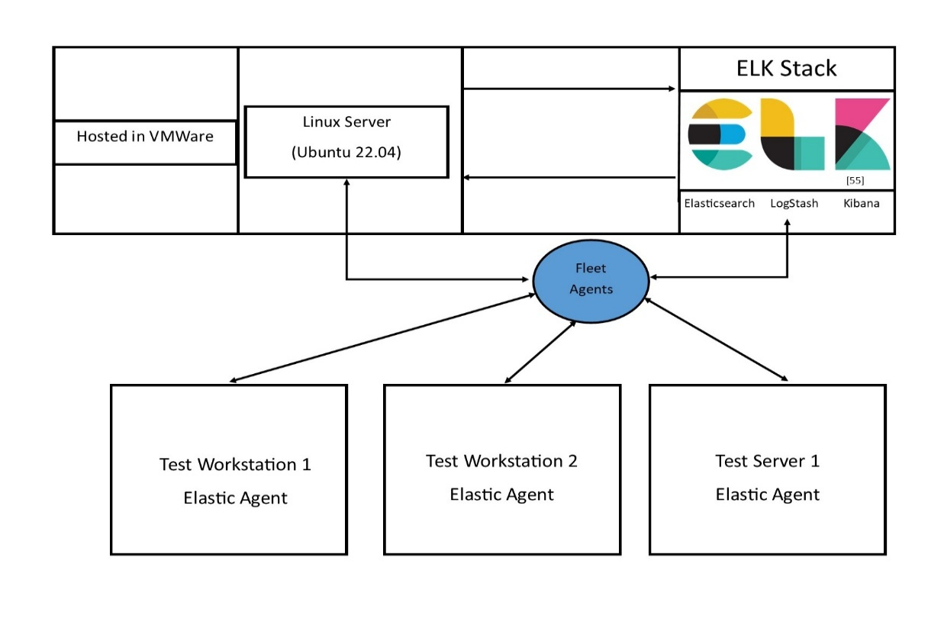

Figure 1 - Network Topology for the ELK Stack server and Elastic agents

Figure 1 shows the design of the centralised log management setup for the LME ELK Stack services, along with the Elastic Agents configured through a Fleet within the Kibana dashboard. The core components of the setup are the Linux based server, which will host the LME installation packages, and will be configured using a suitable IP address for the Kibana dashboard and Elastic agents to be able to communicate effectively.
The diagram shows how data will flow between the various nodes within the topology. Elastic agents are installed, which will gather Sysmon logs and system metrics, and distribute in JSON format, this then will display them as part of the fleet. The Kibana dashboard will then index these logs, displaying the workstation name and source as part of the log information within Kibana itself [56].
The Linux server hosting the ELK stack services will be isolated within the internal network, ensuring that all traffic is internal only. There isn’t a need to design log information to come from external sources.

Implementation: LME 2.0 Core Service Installation

Sprint 2 - ELK Stack Server

The ELK Stack Server is where the core LME 2.0 server files are installed and will be the server that hosts the Kibana dashboard and SIEM configurations.

Installing LME program files and Kibana dashboard

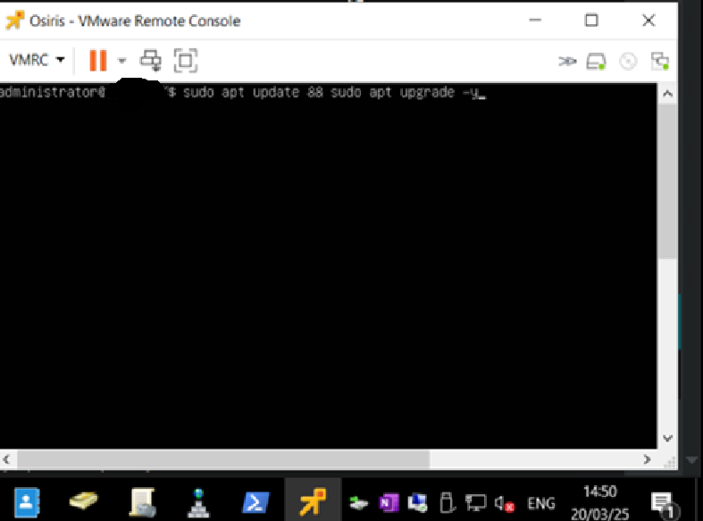

Figure 2 – Updating all systems applications in the Ubuntu catalogue

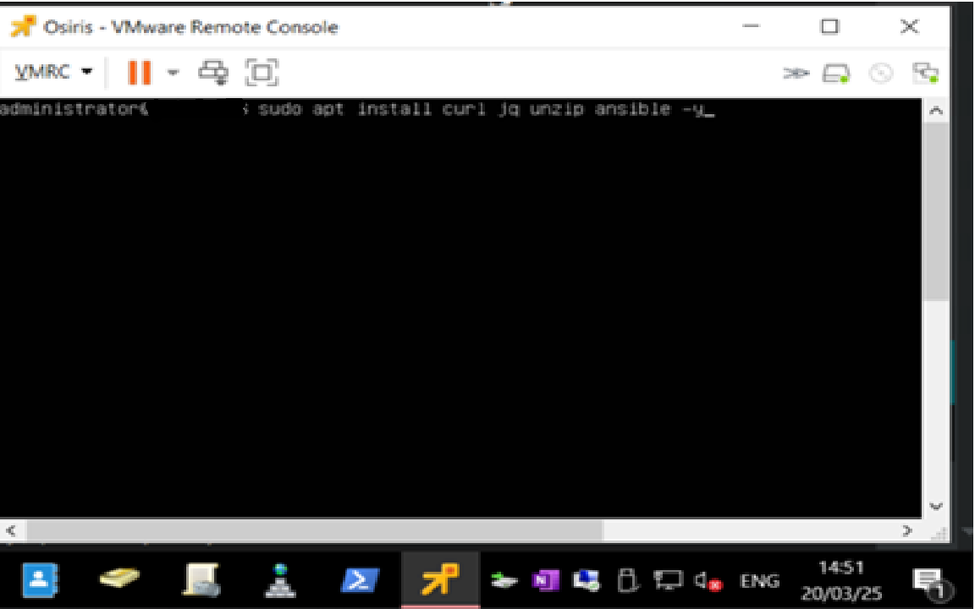

Figure 3 – Install Ansible client for LME
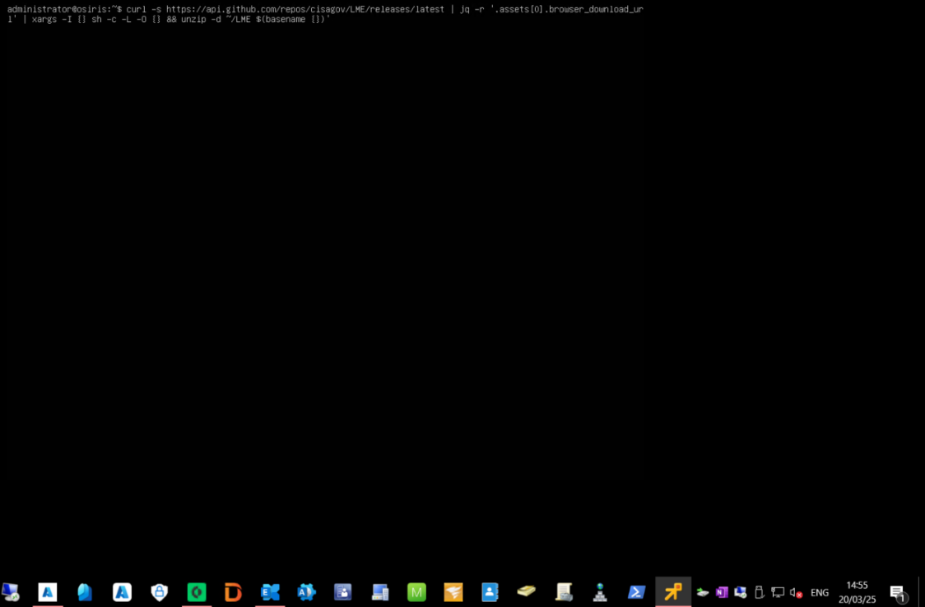

Figure 4 – Installing the LME core files direct from GitHub

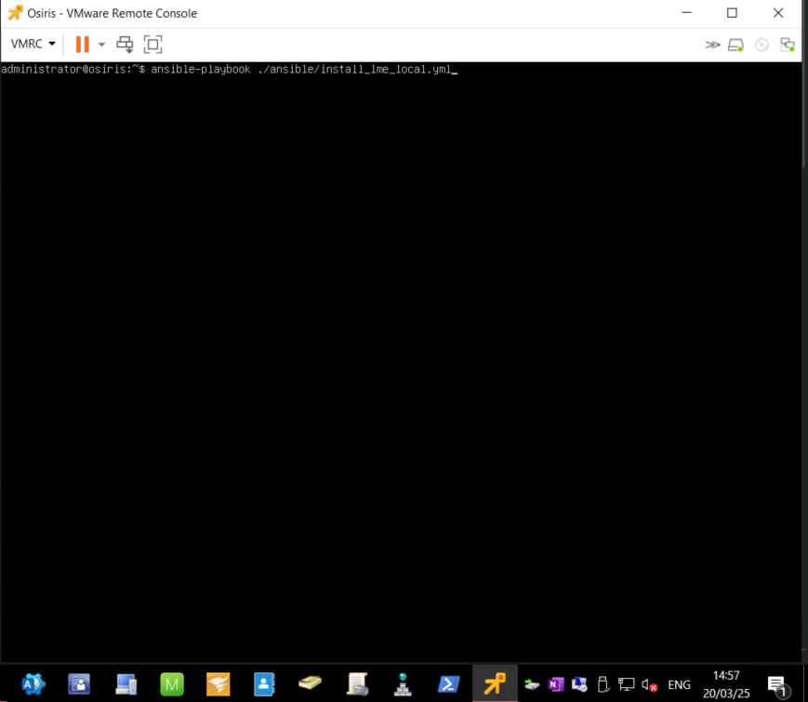

Figure 5 – Installing the LME local script using ansible playbook

Figures 2-5 showcase the installation of Ubuntu 24 onto a Virtual Machine (VM), and the commands necessary to install LME 2.0. These commands pull the installation files direct from GitHub and apply them locally to the server.
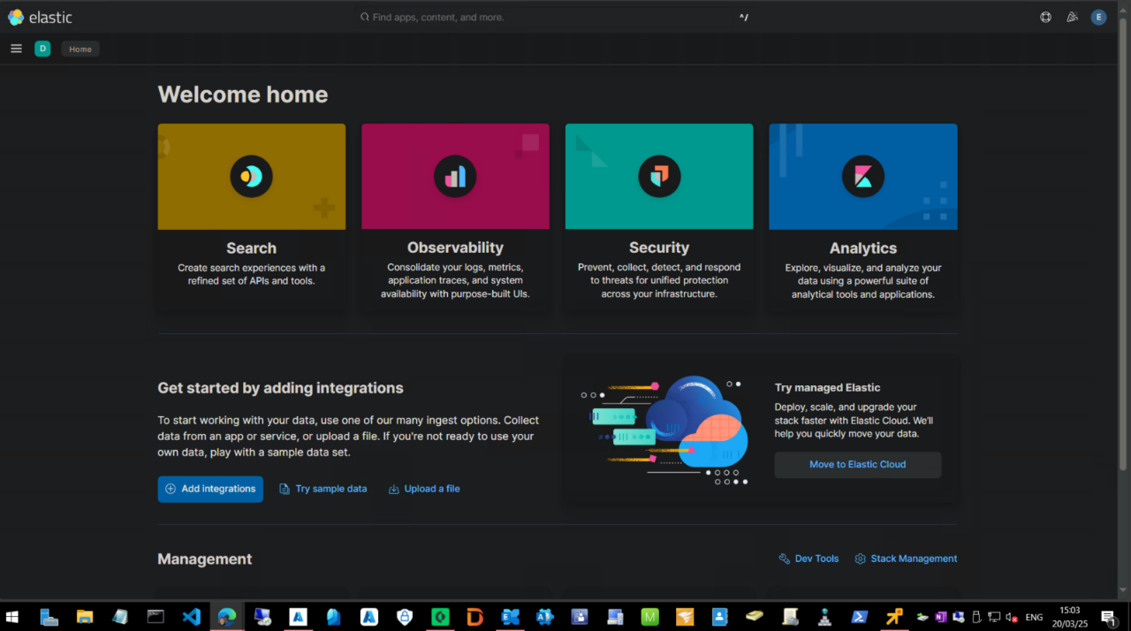

Figure 6 – Kibana Homepage
Figure 6 then shows that the researcher was successfully able to sign into the Elasticsearch dashboard.

Post LME Install Actions

Sprint 3 - Sysmon Client and Configuration Setup

Sysmon is a log file format that will enable the researcher to gather system information to pass into LME’s dashboards. Sysmon itself is readily available from Microsoft’s website, Figure 7 showcases the files that have been exported ready for installation.
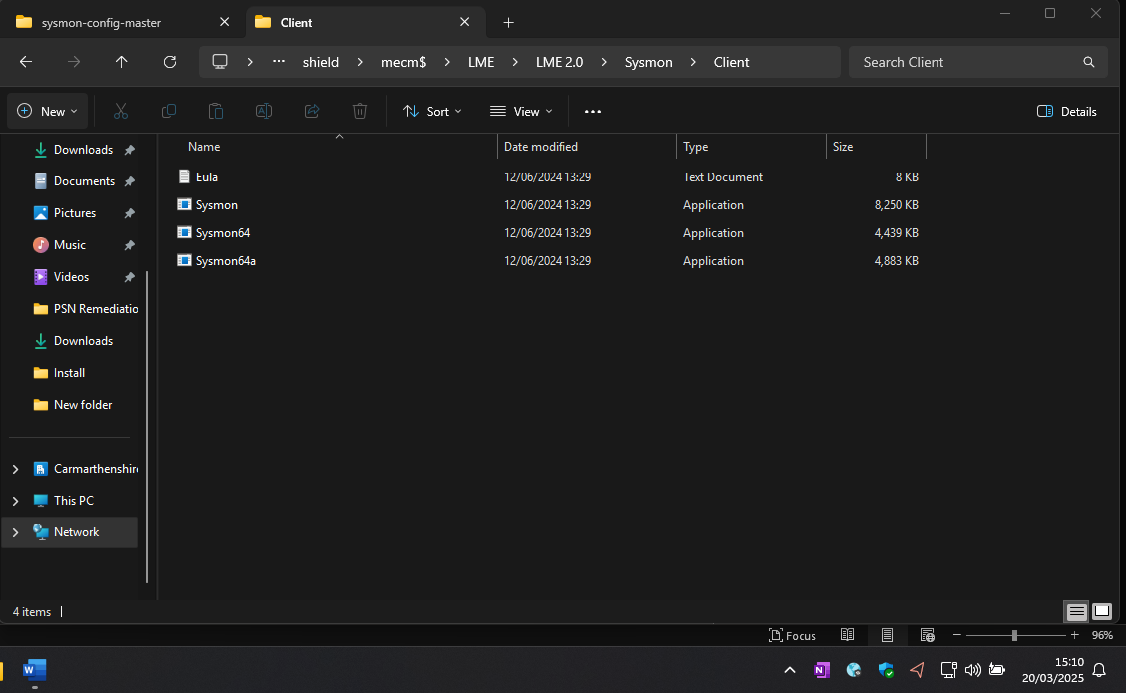

Figure 7 – Sysmon Package Files
The researcher has decided to use the SwiftOnSecurity’s Sysmon configurations, as recommended by Cisagov’s GitHub page [57]. This can then be used alongside the Sysmon installer, using the installation command shown in Figure 8.
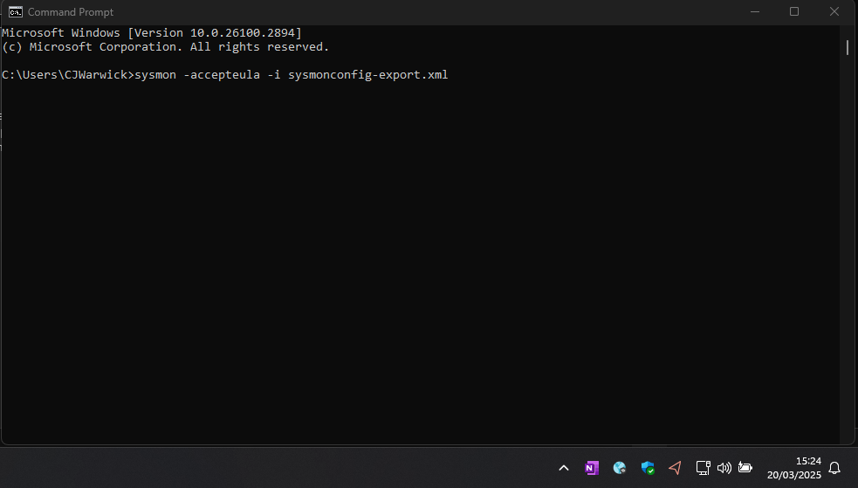

Figure 8 – Sysmon install command
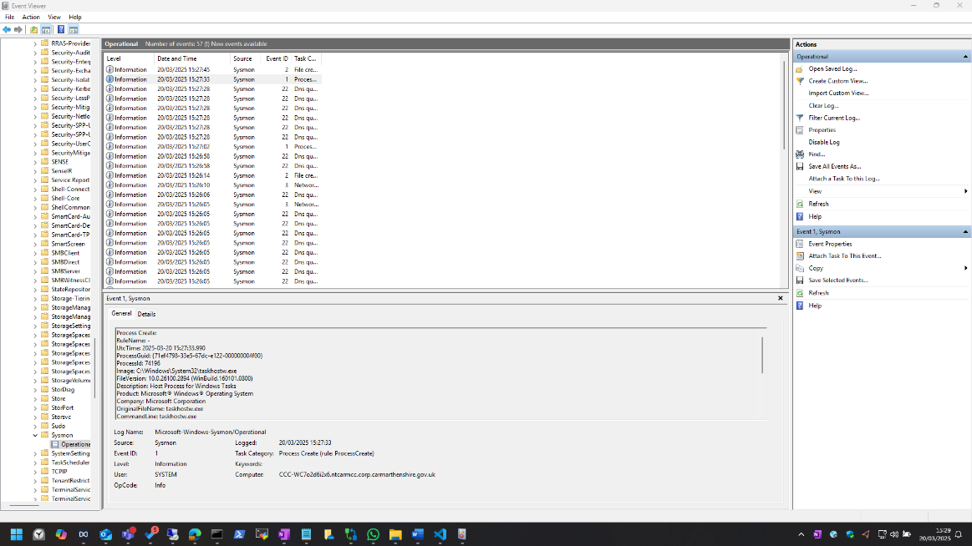

Figure 9 – Sysmon logs appearing in Event Viewer

Elasticsearch Agent
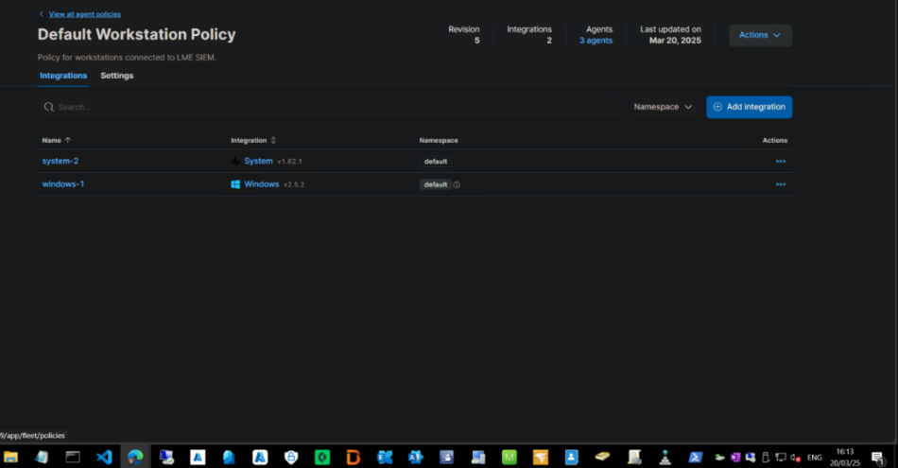

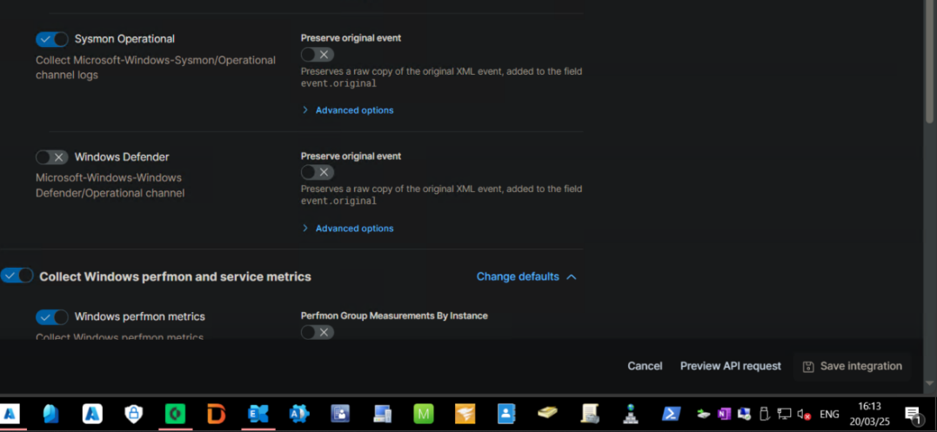
Figure 10 – Default Workstation Policy for agent installation

Figure 11 – Sysmon Windows Integration – Enabling option in configuration
Figure 10 shows the ‘Fleet’ section of the Kibana dashboard. This is where workstations and servers can be added and monitored within Kibana. Figure 11 shows the Integration being added and ‘Sysmon Operational’ being switched on. Once this has been switched on, Elasticsearch will have everything it needs to start ingesting Sysmon logs from our Windows workstations.

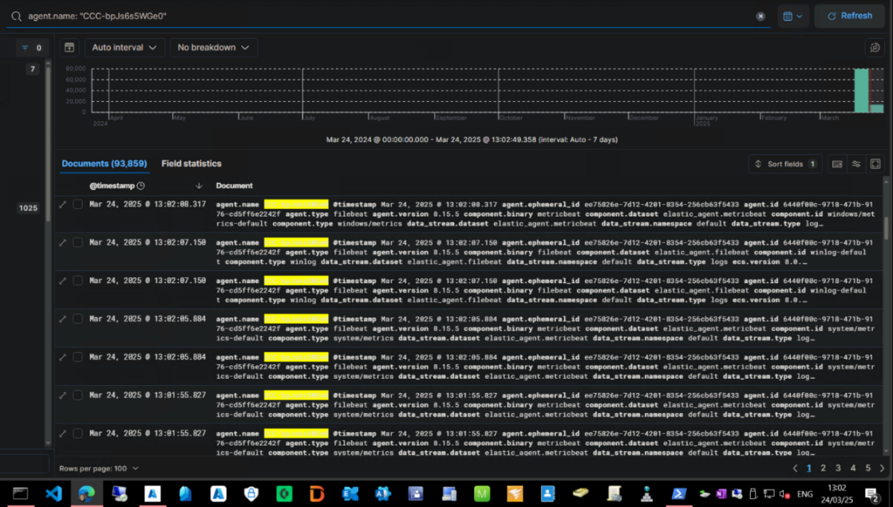

Figure 12– Kibana Discover Tab – Further Sysmon logs being ingested

By looking at the Discover tab within Kibana and searching for the workstation hostname, the researcher can see that Sysmon logs are now being ingested into Kibana. This can be seen in Figure 12. This process was then replicated onto all other test workstations.

Sprint 4- Kibana Log Indexing

For each log that is ingested through Elasticsearch and into the Kibana dashboard. They are tagged and assigned using an index. When creating custom threat detection rules in Kibana, the types of logs and the indexes assigned are required to ensure that the rule can scan for the right logs. Kibana provides an Index Management tab as part of the dashboard, which can be used to manage and maintain each index [58].
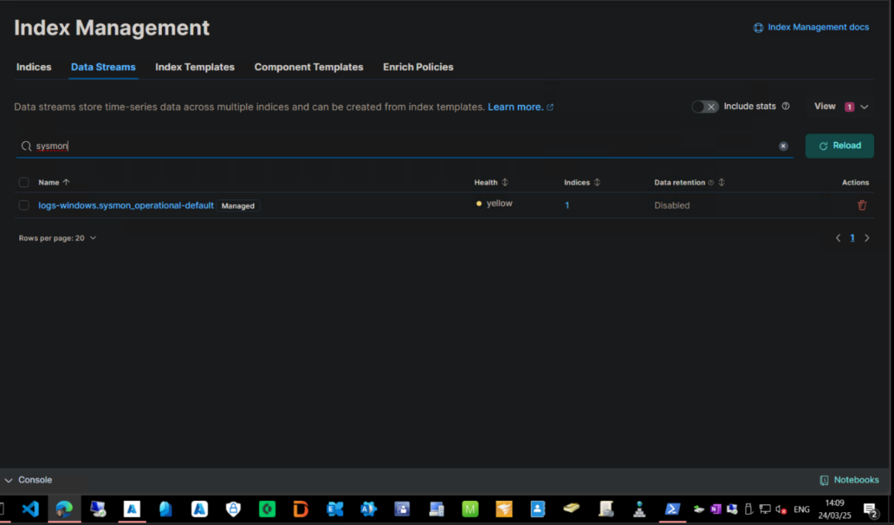

Figure 13 – Index Management – Sysmon Index

Figure 13 shows a search in the ‘Data Streams’ tab of the Index Management section of Kibana. A search for Sysmon related indexes reveals a custom-made index for LME, which is shown above. The researcher will now need to use this index for any custom rules created to test LME and Elasticsearch’s functionality.
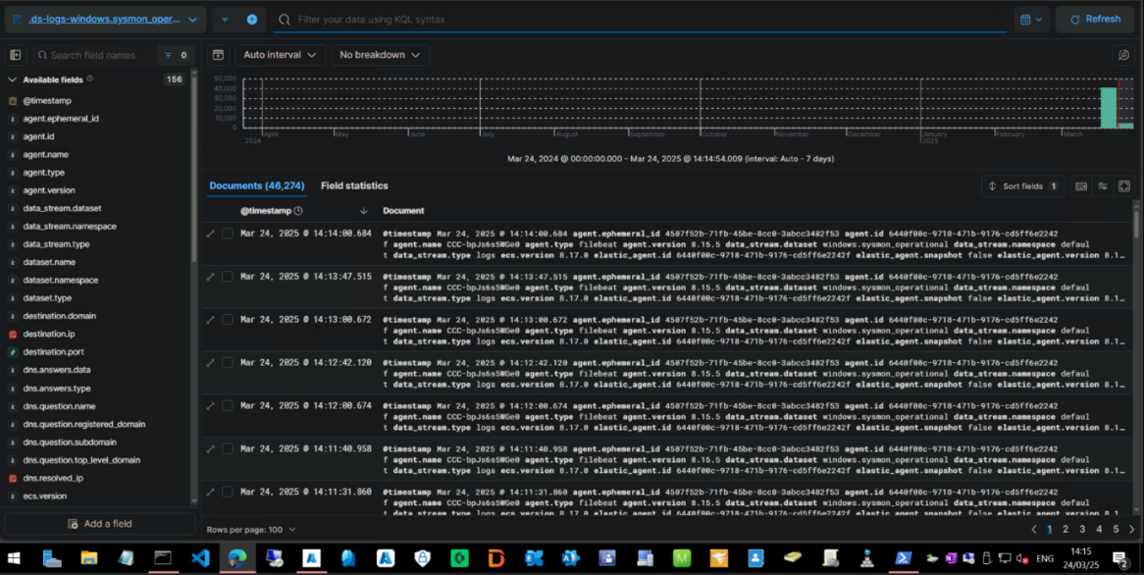

Figure 14 – Kibana Discover – Index log testing using LME Sysmon Index

Sprint 5 - Implementation: LME SIEM Testing – Threat Detection Rules & Alerts

The test environment is now ready for testing. Each test command will be run 3 times on each test workstation, to see if the alert appears on the Kibana dashboard. The researcher will then measure the timestamp of the log alert to see how long this took to appear from when the test was run. Further to that, the researcher will also confirm that the alert was triggered using the right events. A screenshot of the custom rule and it’s Kibana Query Language (KQL) scheme will be shown by each test.

MiniKatz (T1059.001)

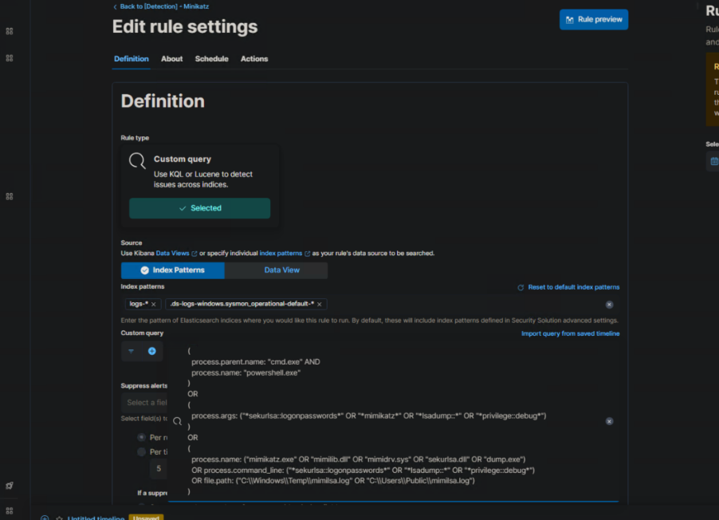

Figure 15 – Detection KQL rule for Minikatz and it’s processes in PowerShell

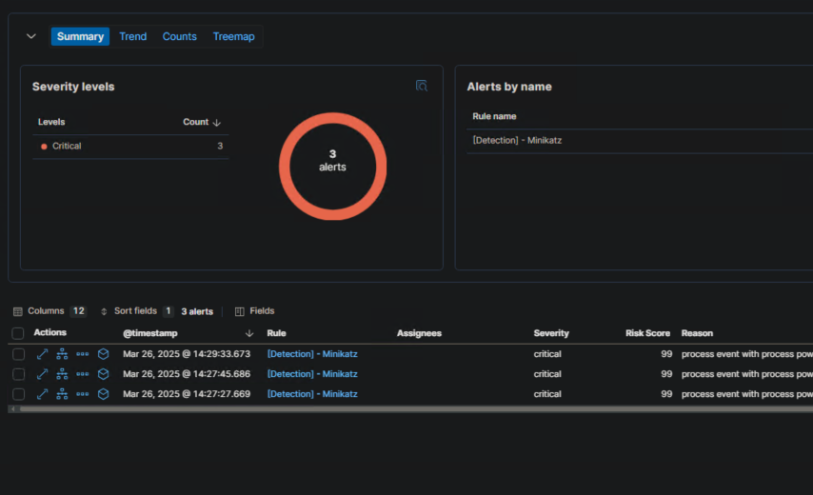

Figure 16 – Detections being made for Minikatz on test workstation

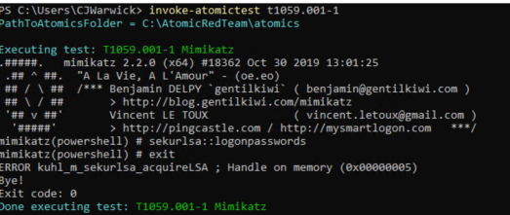

Figure 17 – Atomic Test being run, command running sucessfully

Test Number | Time of test (HH:MM:SS) | Timestamp of log (HH:MM:SS) | Time Difference (s)
 | 14:38:00 | 14:38:30 | 30
Test Workstation 1 | 14:49:22 | 14:49:36 | 14
 | 14:54:00 | 14:54:24 | 24
 | 15:14:23 | 15:15:01 | 38
Test Workstation 2 | 15:29:01 | 15:29:40 | 39
 | 15:35:05 | 15:35:54 | 49
 | 16:02:06 | 16:02:36 | 30
Test Workstation 3 | 16:25:00 | 16:26:05 | 65
 | 16:30:01 | 16:31:30 | 89
Table 1 - Detection Rates for the Minikatz Detection Rule

Figure 15 shows the detection rule that was created to detect for Minikatz processes. The rule searches for logs containing the Minikatz process, along with the ‘lsadump’ process, which is common for Minikatz instances [59]. Other detections that need to be considered is the ‘minilsa.log’ file which Atomic Red test ‘T1059.001-1’ will automatically put into ‘C:\Windows\Temp’, this command in PowerShell can be seen in Figure 17. This log file is generated after the Minikatz instance has been run and can also be used as part of the detection [60].
The above results were generated, the researcher believes that the detection rule was successful, since on each occasion of the atomic test being run, a log file was generated, and an alert was provided on the Kibana dashboard. The average time it took for an alert to be generated in the dashboard was 42s.

Conclusion

The SIEM was able to respond quickly to Minikatz, however in some cases such as for workstation 3 there were some anomalies in the detection taking longer than expected. This detection however relies heavily on process naming, which may not be completely accurate for detecting the application. If an attacker were to rename the minikatz process or file name then this may cause issues with the detection. As an example, rules can be created that can scan for processes attempting to use the LSASS service. The only downside is that these features are locked to paid versions of Kibana dashboard.


Figure 18 – Detection Log for Minikatz

Nmap Ping Sweep (T1046-3)

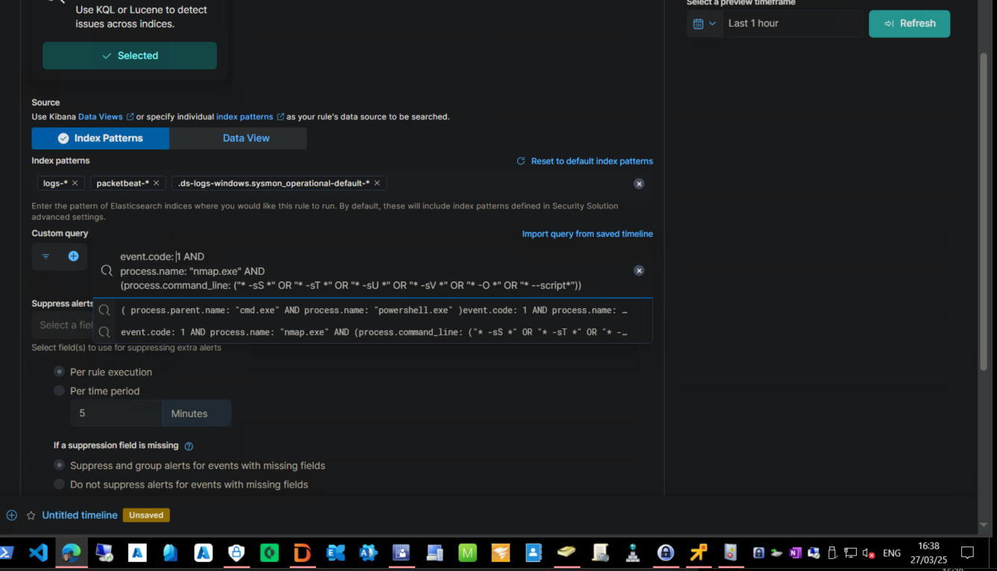

Figure 19 – Detection Rule for Windows Nmap process
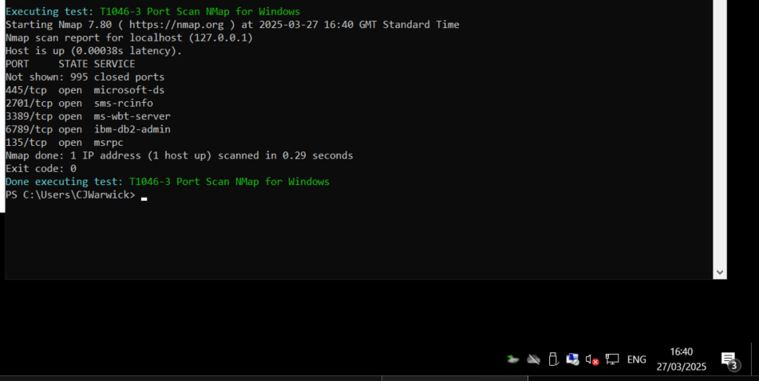

Figure 20 – Atomic test for Windows Nmap port scanning

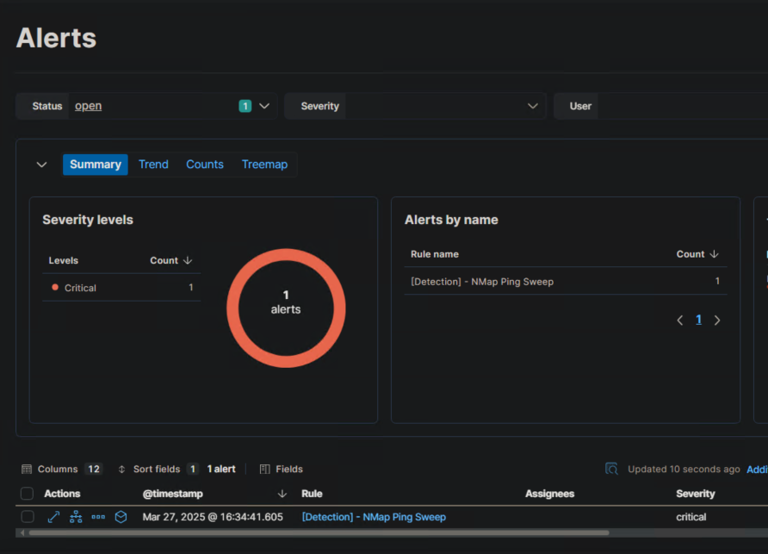

Figure 21 – Detection Rule being detected by Kibana

Test Number | Time of test (HH:MM:SS) | Timestamp of log (HH:MM:SS) | Time Difference (s)
 | 16:15:03 | 16:16:01 | 58
Test Workstation 1 | 16:17:00 | 14:17:10 | 10
 | 16:18:04 | 16:18:26 | 22
 | 16:20:00 | 16:20:37 | 37
Test Workstation 2 | 16:25:16 | 16:25:36 | 20
 | 16:30:05 | 16:30:40 | 35
 | 16:32:45 | 16:32:55 | 10
Test Workstation 3 | 16:33:02 |  | N/A
 | 16:40:08 | 16:41:00 | 52
Table 2 - Detection Rates for the Nmap Ping Sweep Detection Rule

The detection for NMAP can be seen in Figure 19. The detection is looking for the ‘nmap’ process being run in a Sysmon log. Usually relating to event ID 3 [61]. Figure 20 shows the Atomic Red command test for ‘T1046-3’ which has been told to scan a subnet containing a single workstation.
The same tests were run on the 3 test workstations. Most of the times this was run a log file and alert was generated, the alert for this can be seen in Figure 21. However, on test workstation 3 one was missed. This was relating to a network traffic issue, where the device had changed Access Points and when the log file was run, there wasn’t a Sysmon event generated for the dashboard to alert. Therefore overall, the detection rule was successful in detecting nmap port and subnet scanning. The average time for an alert to be generated was 30.5s, this wasn’t including the test where we were unable to receive a log file and alert through.

Conclusion

While the SIEM was overall successful in detecting NMAP, the detection was based largely on volume thresholds and detecting anomalies. This however could cause some issues with the detection, as stealthier port scanning tools could navigate through the network and not be detected. Also, the 25 second response times could be considered slow for larger networks. To improve detection an additional rule could be created to focus more on granular signature-based detections. This includes other behaviours and characteristics of NMAP and other reconnaissance tools. Enabling a packet capture tool within Kibana for deeper network traffic will assist further in detecting NMAP and other port scanning tools.

Kali Linux – Metasploit Reconnaissance (PSExec)
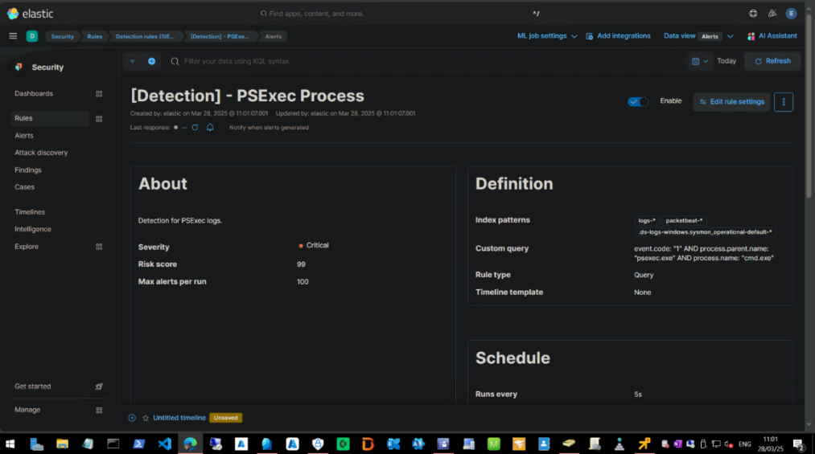

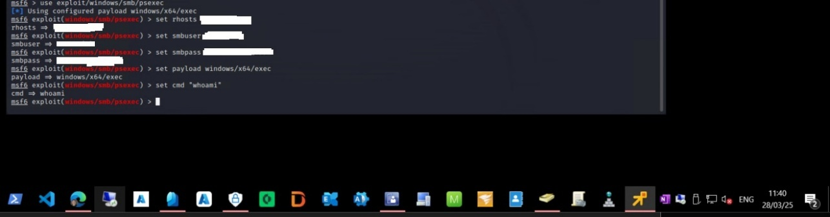
Figure 22 – Detection KQL for psexec - detection for Metasploit

Figure 23 – Metasploit command being run
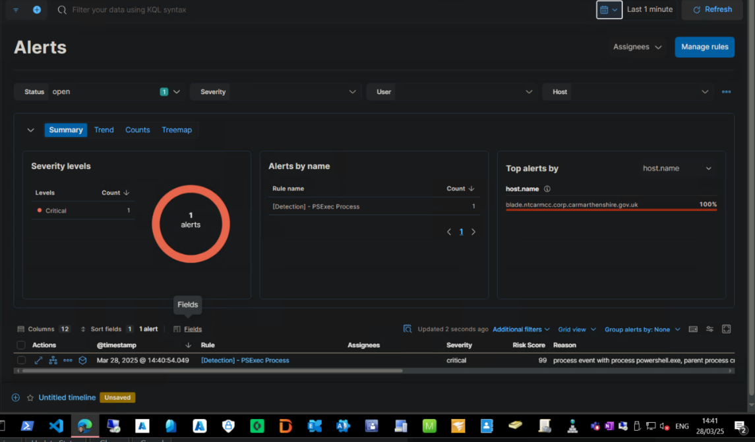

Figure 24 – Detection Rule for Metasploit PSExec

Test Number | Time of test (HH:MM:SS) | Timestamp of log (HH:MM:SS) | Time Difference (s)
 | 14:40:03 | 14:40:54 | 51
Test Workstation 1 | 14:42:06 | 14:42:36 | 30
 | 14:43:00 | 14:43:24 | 24
 | 14:44:00 |  | N/A
Test Workstation 2 | 14:45:02 | 14:45:36 | 34
 | 14:30:01 |  | N/A
 | 15:10:59 | 15:11:40 | 41
Test Workstation 3 | 15:12:10 | 15:12:50 | 40
 | 15:15:21 |  | N/A
Table 3 - Detection Rates for the Metasploit PSExec Detection Rule

Metasploit is a penetration testing tool, containing a wide range of exploit tools which can be used to target hosts or subnets of organisation devices [62]. One tool is PsExec, which can be used by a threat actor to execute processes remotely on compromised workstations. Therefore, the researcher was going to use this as a detection for the use of remote process creation through Metasploit. The detection rule for this can be seen in Figure 28, where the researcher which is looking for the ‘psexec.exe’ process started through command prompt.
The test results for the 3 test workstations can be seen above. Sysmon logs did create log files that contained ‘whoami’ or ‘psexec.exe’, however not on every occasion. Reading through the logs, the windows operating system generates logs for ‘whoami’ naturally as part of its general usage. This was why the process was chosen as it was a default windows process that would not have any impact on the workstations themselves, as they were all connected to CCC’s network. The results do show that the detection was infrequent. The average time for a log file to be generated was 36.6s.

Conclusion

The logging of PSExec activity confirms that the Sysmon correlated data is working as intended. However, the cases where alerts were not generated pose significant concerns. To further strengthen detections further rules, need to be created that detect new software and service installations from unusual IP addresses or uses outside of work hours. Further enhancing rules to include further unusual behaviours in service creation could lead to more efficient responses and will also replicate a use case scenario for a real-life use of PSExec.

Sprint 6 – Detection Tuning and Remediation Recommendations

Minikatz

Minikatz is a credential dumping tool used to extract credentials from workstations, which a threat actor can then use for further system access within an organisations network. Minikatz itself is designed to target the Local Security Authority Subsystem Services (LSASS) process, which manages user authentication and credentials. One remediation would be to enable Credential Guard for Windows [63]. Credential Guard is designed to run LSASS secrets, which separates the process into its own isolated container, which Minikatz or other credential dumping and hash related tools will be unable to access. This is a proactive measure to prevent the tools from running before they are detected by the SIEM. Credential guard is deployable via InTune via a configuration policy, Group policy objects (GPO’s), Registry changes. This would be a consideration by CCC, as the necessary tools for deployment are available. Another method is using another Microsoft solution called ‘Local Administrator Password Solution’ (LAPS) [64]. Since Minikatz requires administrator rights to be able to access the LSASS process, having a system that will scramble local administrator passwords will prevent administrator password hashes from being exported, it also makes it more difficult to initially get the administrator rights to be able to run Minikatz as threat actors would need deeper access to the network such as through Active Directory or InTune cloud. Finally, having Multi Factor Authentication (MFA) on a user account would also assist with a compromised account [65]. In the event of someone attempting to sign in, a threat actor would also need to complete a secondary form of authentication, such as through a text message or authenticator app on mobile device. CCC are in the process of rolling out both LAPS and MFA onto all workstations and user accounts, so these remediations will soon be in place already.
An example case study of when Minikatz was used was the Petya and NotPetya ransomware tools, which impacted many organisations in 2017. One of the organisations effected was ‘Maersk’, which is a Danish shipping company. It was detailed that 76 of their ports systems were impacted [66]. Both variants of the Petya ransomware use Minikatz to extract and apply stolen credentials to encrypt company files that the user accounts would have access to. One of the lessons learned from this case study was that Maersk was able to recovery quicker through its details and regular backups. They also had rigorous resiliency from having Data Centres in multiple locations which would enable system access to be diverted to non-injected locations and a strong incident plan for cyber incidents, which they explain is fully rehearsed and documented clearly for its employees and security professional staff.

NMAP Port Scanning

NMAP is a ping sweeping tool which will confirm which IP addresses are active and not active from an IP range. The reason why this would be valuable to threat actor is to limit down the scope of what devices are available, and especially with an NMAP attack, it can reveal what types of devices that the IP address is linked to. Having the ability to know what devices are in use enables the threat actor to build a map of the target organisations network, enabling for further research into how they are going to carry their attack and what routes or vulnerabilities are best for gaining access and navigating the network. Firewalls play a big part in prevention for NMAP, and other ping sweep methods. Limiting ‘Internet Control Message Protocol’ (ICMP) traffic to only required services is one method, as the ping command uses ICMP packets to generate a response, if an ICMP acknowledge packet is received back to the source IP then the IP address is live. Firewall rules can be created to limit required ports for network scanning [67], or oftentimes firewall providers build in modules and configurations to automatically provide protection against recognisance tools such as NMAP, such as Palo Alto’s PanOS [68]. firewalls can be set to automatically block suspicious IP addresses, limiting how much the ping sweep can reach. The same goes for blocking all unneeded traffic ports for the network. If there are open ports then these can be used by a threat actor to conduct a ping sweep, or they could potentially use this port as a method of entry.
An example case study of when NMAP was used for network reconnaissance was Equifax’s Data Breach in 2017, where the personal information for 143 million people was stolen [69]. NMAP was used to scan Equifax’s network for open ports, available IP addresses and vulnerabilities, where an eventual vulnerability in a web application framework for Apache was used to gain access to their internal services. Once access had been gained, the attackers then located plain-text passwords on a workstation and used these credentials for further access. Monitoring tools were present that were designed to detect this traffic; however, the TLS encryption certificate had not been renewed and therefore it did not work correctly. The key takes away from this case study for Equifax was that they did not segment their network enough [70]. Segmenting the network would have made it more difficult for the attackers to move as freely as they did when they had internal access. This can be done by separating networks into different IP addresses or dividing the wide area network (WAN) into smaller Local Area Networks (LAN).

Kali Linux (PSExec)

Kali Linux itself is a Debian based operating system, which is designed for offensive security. The operating system is built with tools and packages that can be used for cyber incidents, mainly this is for penetration testing. However, Kali Linux is a valuable tool for a threat actor to use, as it is freely available and installable on most hardware, making it versatile. In this project, the researcher used PSExec, which is a tool for remotely running processes on connected workstations and servers. It can be used in malware or by a threat actor to remotely install software, gather log information and run scripts or packages (including Minikatz) [71]. There are measures that can be put in place to limit the use of PSExec or to prevent in the event of a SIEM alert. Microsoft provide a feature as part of Windows Defender that can block PSExec and WMI services from being run, so this can be enabled to prevent the processes from being used. This can work, however in instances where an organisation creates and manages software, update and other management deployments, disabling WMI and other remote management services can cause issues or cause these deployments to fail altogether. Another option may be to enforce User Account Control for remote actions on the network. If a threat actor gained access to the network via a compromised account, they would then need an administrator account to be able to connect to a remote machine [72]. This combined with the use of LAPS mentioned earlier in the report for Minikatz would further complicate remote access from being provided.
PSExec is commonly used in cyber incidents, for lateral movement around once initial access has been granted. One recent example would be the CostaRicto campaign, who were a cyber espionage group that targeted several organisations in between 2019 and 2020 [73]. The group would gain access to services through stolen credentials and then setup a remote tunnel to the network via the use of Secure Shell (SSH). Once a connection had been made, they would then import their custom malware and manoeuvre it around to other workstations using PSExec [74].

Sprint 6: Recommendations Conclusion

This researcher highlighted critical areas for detection, prevention and response strategies, particularly focusing on credential theft, network reconnaissance and lateral movement. These findings also were able to validate what CCC has already implemented or if in the process of implementing, for example LAPS and UAC is already pre-enforced, MFA is in the process of being implemented and all users will be enrolled in the next few months. The network is also being re-designed with segmentation being considered at all opportunities; this will ensure that all lateral movement is restricted where possible. However, further recommendations can be provided, such as the use of credential guard and LSASS protection, as well as some ASR related rules for app and process protection.
The researcher believes that these recommendations following the installation of the SIEM solution will ensure that CCC have the best possible ability to detect and prevent cyber incidents and suspicious behaviour on their network.

Chapter 5 – Evaluation

Overall, the data provided by this project has proven that the researcher and CCC have managed to successfully implement and test the provided SIEM solution. Testing has been conducted that follows cybersecurity trends and industry standards to ensure that the SIEM itself is functioning and detect threats relevant to current threat actor methods. The researcher believes that the data provided in Chapter 3 & 4 does backup the research completed, as it remains in line of what previous projects found in the literature review. Research on incident response processes and methods has played a significant role in how the SIEM has been setup, dictating what detection rules were used and how the alerts were investigated. This can be shown in the screenshots provided where the ELK stack services were setup, and when the individual testing rules were provided. The researcher believes that the Aims and Objectives of the project were met. The aim was to conduct comprehensive research that would enable the implementation of a SIEM solution into CCC’s network. Once the SIEM has been implemented, it will then be tested using safe simulated incidents, which has been all carried out in Chapter 4. The researcher believes that this project will enable CCC to further develop its incident response capabilities, through either developing LME further or through the introduction of the Cymru SOC services, which is currently being pushed by the Welsh Government [75]. In terms of what was expected, the results provided are what was expected by the researcher when the project was started. The SIEM and testing incidents were customised to cater for the existing network infrastructure of CCC, so differences in data compared to previous projects as details in the literature review were expected, these differences include the use of different testing methods such as not being able to run certain atomic tests due to malware concerns or other IDS systems interfering with the testing itself. If the researcher was to replicate this project, they would include a testing environment outside of the internal facing SIEM environment. This may be creating a SIEM instance using workstations and servers not internal to the council. The reason for this would be to allow the testing of detection rules and running other different simulated incidents that could not be run on the Council’s infrastructure. It would also allow for the same incidents to be run, providing confirmation that the outcome received was the correct outcome.

Chapter 6 – Conclusion

The researcher and CCC have completed comprehensive research into SIEM solutions, and what the recommendations are for implementing and testing. This research along with the facilities already available within the CCC organisation proved adequate for being able to successfully implement the SIEM solution and test alongside the live council infrastructure and services. There were a few drawbacks however, one thing was that there wasn’t any budget provided to the project, as it was purely for researcher purposes. Having a premium version of the Kibana dashboard would have allowed for further testing, as this would allow integrations into SMTP services, Webhooks for notifications, Webhooks for device and user management (possible automation into disabling effected users etc.) and other services such as SNMP or IDS packages, some of which the council use as other monitoring and IDS services. Due to the testing environment being on the internal network with the council, there were also limitations in what tests could be run and what services could be used. This restricted the researcher in what could be done within the SIEM, as considerations would need to be made in case these testing simulations impacted live services and caused issues to the services users and members of the public, an example of this being password spraying attacks or certain Atomic red tests that contain malware properties. This was mentioned in Chapter 5, where the researcher could have investigated a separate environment to test these atomic tests against the SIEM, however this was not able to be completed as part of this project. Finally, another piece of work which could have been completed was the comparisons in other cybersecurity or IDS services currently being used by the council. Some of these services also provided alerts when the atomic tests were run, which were investigated separately. A comparison however of how the other cybersecurity services within the council would have also been beneficial to see how the SIEM compares with enterprise level services, however this was also not able to be completed as part of this project. Finally, the researcher believes that this project does allow for further research to be completed in this field. Intrusion detection is at the forefront of preventing cyber incidents within organisations, as they provide organisations the opportunity to investigate and terminate threats before threat actors can achieve their desired outcomes. Further research into the efficiencies or implementing a SIEM and testing to ensure that the desired results are achieved will be replicated across many more organisations. The more research that can be completed in this field will benefit all cybersecurity professionals; to allow them and the organisations they represent the opportunity to detect new and more sophisticated cyber threats.

Chapter 7 – Reflection

The researcher feels that they have developed a wide range of skills. Prior to starting this project, the researcher had never worked with SIEM solutions, so the literature review and other research completed was extremely beneficial for personal development. The skills working with the range of operating systems, such as Windows and installing / configuring Sysmon for log management had not been personally attempted before. Also, the opportunities to use Ubuntu and Kali Linux during Chapter 4 assisted in providing quality training in these operating systems, as the researchers professional background has mainly been with Windows and Windows server operating systems. Working with the MITRE ATT&CK framework and Canary Red’s Atomic Red services was the most beneficial to the researcher, as it allowed for further research and development into the cybersecurity field. Researching the different atomic tests and the events relating to their detection will be extremely beneficial to the researcher, as these skills can be immediately implemented into the workplace, either through the current SIEM or into other IDS services used by the council.
Overall, the researcher is pleased to have had the opportunity to complete this project and believes that the skills gathered and developed are invaluable for further progression and further development.

Chapter 8 - References

[1] – Author: O. Podzins, A.Romanovs, Name: “Why SIEM is Irreplaceable in a Secure IT Environment?” Publisher: ResearchGate, [Online PDF], [Accessed: 11th April 2024], Available:
[2] – Author: Prof. Dr. K. O. Detken, T. Rix, Prof. Dr. C. Kleiner, B.Hellmann, L.Renners, Name: “SIEM approach for a higher level of IT security in enterprise networks” [Online PDF], [Accessed: 1st February 2024], Available: Microsoft Word - IDAACS_15_Abstract-Camera-final_KD.docx (detken.net)
[3] – Author: G. Grillenmeier, Name: “Protecting Active Directory against modern threats”, [Online PDF], [Accessed: 1st February 2024], Available: Protecting Active Directory against modern threats - ScienceDirect
[4] – Author: J. Babbin, D.Kleiman, Dr. E. F. Carter Jr, J. Faircloth, M.Burnett, Published: 27th January 2006, Publisher: Syngress, Name: "Security Log Management - Identifying Patterns in the Chaos", [Accessed: 2nd February 2024], Available: Security Log Management - Google Books
[5] – Author: M. Krause, H. F. Tipton, Published: 2009, Publisher: CRC Press, Volume: 3, Edition: Sixth, Name: "Information Security Management Handbook", [Accessed: 15th May 2024], Available: Information Security Management Handbook, Volume 3 - Google Books
[6] – Author: L. Aversa, Published: 31st May 2023, Publisher, Walter de Gruyter GmbH, Name: "Security for Containers and Kubernetes - Learn How to Implement Robust Security Measures in Containerized Environments (English Edition)", [Accessed: 4th February 2024], Available: Security for Containers and Kubernetes - Google Books
[7] – Author: K. Hermans, Published: 2023, Publisher: Cybellium Ltd, Name: “Mastering SIEM”, [Accessed: 10th February 2024], Available: Mastering SIEM - Google Books
[8] – Author: B. A. Sabbagh, Name: "Cybersecurity Incident Response - A Socio-Technical Approach", [Online PDF], [Accessed: 11th February 2024], Available: FULLTEXT01.pdf (diva-portal.org)
[9] – Author: Dr. Erdal Ozkaya, Published: 26th February 2021, Publisher: Packt Publishing, Name: "Incident Response in the Age of Cloud - Techniques and Best Practices to Effectively Respond to Cybersecurity Incidents", [Accessed: 15th February 2024] Available: Incident Response in the Age of Cloud - Google Books
[10] – Author: T. Hsu, Published: 30th July 2018, Publisher: Packt Publishing, Name: "Hands-On Security in DevOps - Ensure Continuous Security, Deployment, and Delivery with DevSecOps", [Accessed 15th February 2024], Available: Hands-On Security in DevOps - Google Books
[11] – Author: S. Anson, Published: 29th January 2020, Publisher: Wiley, Name: "Applied Incident Response", [Accessed: 15th February 2024], Available: Applied Incident Response - Google Books
[12] – Author: A. R. Muhammad, P. Sukarno, A. A. Wardana, Name: "Integrated Security Information and Event Management (SIEM) with Intrusion Detection System (IDS) for Live Analysis based on Machine Learning", [Online PDF], [Accessed: 15th February 2024], Available: main.pdf (sciencedirectassets.com)

[13] – Author: G. Johansen, Published: 29th January 2020, Publisher: Packt Publishing, Edition: Second, Name: "Digital Forensics and Incident Response - Incident Response Techniques and Procedures to Respond to Modern Cyber Threats", [Accessed: 16th February 2024], Available: Digital Forensics and Incident Response - Google Books
[14] – Author: E. C. Thompson, Published: 20th September 2018, Publisher: Apress, Name: "Cybersecurity Incident Response - How to Contain, Eradicate, and Recover from Incidents", [Accessed: 2nd March 2024], Available: Cybersecurity Incident Response - Google Books
[15] – Author: H. Karlzen, T. Sommestad, Name: "Automatic incident response solutions: a review of proposed solutions’ input and output", [Online PDF], [Accessed: 15th March 2024], Available: Automatic incident response solutions: a review of proposed solutions' input and output (acm.org)
[16] – Author: A. Lekidis, V. Mavroeidis, K. Fysarakis, Name: "Towards Incident Response Orchestration and Automation for the Advanced Metering Infrastructure", [Online PDF], [Accessed 15th March 2024], Available: 2403.06907 (arxiv.org)
[17] – Author: F. Howarth, Published: March 2022, Published: Bloor Research, Name: "The many flavours of threat detection and response", [Online PDF], [Accessed: 16th March 2024], Available: The Many Flavors of Threat Detection and Response - Alert Logic
[18] – Author: M. Schneider, A. Davies, Published: 25th June 2024, Publisher: Gartner, Name: "Critical Capabilities for Security Information and Event Management", [Online PDF], [Accessed 20th March 2024], Available: 2022 Gartner® Critical Capabilities for Security Information and Event Management | Splunk
[19] – Author: Exabeam, Name: "10 SIEM Use Cases in a Modern Threat Landscape", [Online], [Accessed: 20th March 2024], Available: 10 SIEM Use Cases in a Modern Threat Landscape (exabeam.com)
[20] – Author: A. Mercer, Name: "Security Information and Event Management for Small and Medium-Sized Enterprises", [Online PDF], [Accessed: 20th March 2024], Available FULLTEXT02 (diva-portal.org)
[21] - Author: J. Manzoor, A.Waleed, A. F. Jamali, A. Masood, Published: 28th March 2024, Name: "Cybersecurity on a budget: Evaluating security and performance of open-source SIEM solutions for SMEs", [Online PDF], [Accessed: 1st April 2024], Available Cybersecurity on a budget: Evaluating security and performance of open-source SIEM solutions for SMEs | PLOS ONE
[22] – Author: K. P. Fouzas, Name: "Evaluation of the open source HELK SIEM through a series of simulated attacks", [Online PDF], [Accessed: 1st April 2024], Available: file.pdf (uoa.gr)
[23] – Author: C. Maimbo, Name: Exploring the Applicability of SIEM Technology in IT Security, [Online PDF], [Accessed 1st April 2024], Available Microsoft Word - Exploring the Applicability of SIEM Technology in IT Security.docx (aut.ac.nz)
[24] – Author: IBM, Name: "MITRE ATT&CK framework", [Online], [Accessed: 25th January 2025], Available: What is the MITRE ATT&CK Framework? | IBM
[25] - Author: J. Chukwu, Published: 2023, Name: "Leveraging the MITRE ATT&CK Framework to Enhance Organizations Cyberthreat Detection Procedures", [Online PDF], [Accessed: 15th April 2024], Available: https://repository.library.carleton.ca/downloads/rb68xd14n
[26] – Author: Red Canary Co, Publisher: GitHub, Name: "Small and highly portable detection tests based on MITRE's ATT&CK.", [Online], [Accessed: 25th January 2025], Available: GitHub - redcanaryco/atomic-red-team: Small and highly portable detection tests based on MITRE's ATT&CK.
[27] – Author: D. Murphy, Published: 24th April 2024, Name: "SIEM/SOAR TESTBED IMPLEMENTATION FOR USE IN UNDERGRAD AND POSTGRAD MODULES", [Online PDF], [Accessed: 26th January 2025], Available: SIEM/SOAR Testbed implementation for use in undergrad and postgrad modules
[28] – Author: Red Canary, Published: 13th March 2024, Name: “2024 Threat Detection Report – Techniques, Trends & Takeaways”, [Online PDF], [Accessed: 26th January 2025], Available: 2024ThreatDetectionReport_RedCanary.pdf
[29] – Author: Cybersecurity & Infrastructure Security Agency, Name: "Logging Made Easy", [Online], [Accessed: 1st June 2024], Available: Logging Made Easy | CISA
[30] – Author: cisagov, Publisher: Github, Name: "Logging Made Easy (LME) is a no cost, open source platform that centralizes log collection, enhances threat detection, and enables real-time alerting, helping small to medium-sized organizations secure their infrastructure." [Online], [Accessed: 10th February 2025], Available GitHub - cisagov/LME: Logging Made Easy (LME) is a no-cost and open logging and protective monitoring solution serving all organizations.
[31] – Author: Microsoft, Last Updated: 23rd July 2024, Name: "Sysmon v15.15", [Online], [Accessed: 17th February 2025], Available: Sysmon - Sysinternals | Microsoft Learn
[32] – Author: R. Chetwyn, M. Eian, A. Josang, Name: "Modelling Indicators of Behaviour for Cyber Threat Hunting via Sysmon", [Online PDF], [Accessed: 17th February 2025], Available: Modelling Indicators of Behaviour for Cyber Threat Hunting via Sysmon (acm.org)
[33] – Author: S. Demmer, Name: "Detecting „Living-off-the-Land” Attacker Techniques in Microsoft Windows Using publicly available technology to spot modern adversaries", [Online PDF], [Accessed: 17th Feburary 2025], Available: https://phaidra.fhstp.ac.at/detail/o:4260.pdf
[34] – Author: SwiftOnSecurity, Publisher: Github, [Online], [Accessed: 1st June 2024}, Available: sysmon-config/sysmonconfig-export.xml at master · SwiftOnSecurity/sysmon-config · GitHub
[35] – Author: O. Hartong, Publisher: Github, [Online], [Accessed: 1st June 2024], Available: sysmon-modular/sysmonconfig.xml at master · olafhartong/sysmon-modular · GitHub
[36] - Author: SwiftOnSecurity, Publisher: Github, Name: "sysmon-config | A Sysmon configuration file for everybody to fork", [Online], [Accessed: 1st June 2024}, Available: SwiftOnSecurity/sysmon-config: Sysmon configuration file template with default high-quality event tracing
[37] – Author: H. M. Lopez, Published: 2021, Publisher: Ploytechnic University of Puerto Rico, Name: "Detection of WannaCry using Splunk and Sysmon", [Online PDF], [Accessed: 1st June 2024], Available: Computer Science
[38] – Author: R. Bjork, Published: 2022, Publisher: KTH Royal Institute of Technology, Name: "Feasibility to implement a SIEM based on Open-source applications", [Online PDF], [Accessed: 15th February 2025], Available FULLTEXT01.pdf
[39] – Author: M. Korneliussen, Published: 2021, Publisher: University of Oslo, Name: "Implementation of a SecurityInformation Event Management System in an Industrial Control System", [Online PDF], [Accessed: 15th February 2025], Available: Implementation-of-a-Security-Information-Event-Management-System-in-an-Industrial-Control-System.pdf
[40] – Author: W. K. Brotby, G. Hinson, Published: 2026, Publisher: CRC Press, Name: “Pragmatic Security Metrics”, [Accessed: 1st April 2025], Available: PRAGMATIC Security Metrics - Google Books
[41] – Author: L. Pham, Published: April 2018, Publisher: ResarchGate, Name: "A Review of key paradigms: positivism, interpretivism and critical inquiry.", [Online PDF], [Accessed: 20th June 2024], Available: A-Review-of-key-paradigms-positivism-interpretivism-and-critical-inquiry.pdf (researchgate.net)
[42] – Author: V. Chirkov, Published: 19th November 2015, Publisher: Routledge, Name: "Fundamentals of Research on Culture and Psychology - Theory and Methods", [Accessed: 20th June 2024], Available: Fundamentals of Research on Culture and Psychology - Google Books
[43] – Author: M. Z. Reyes, Published: 2004, Publisher: Rex Book Store, Name: "Fundamentals of Research on Culture and Psychology - Theory and Methods", [Accessed: 20th June 2024], Available: Social Research - Google Books
[44] - Author: K. Glaser, Published: 17th October 2014, Publisher: Cambridge Scholars Publishing, Name: "Inductive or Deductive?: The Impact of Method of Instruction on the Acquisition of Pragmatic Competence in EFL", [Accessed: 21st June 2024], Available: Inductive or Deductive?: The Impact of Method of Instruction on the ... - Karen Glaser - Google Books
[45] –Author: l. Rosser, P. Marbach, G. Osvalds CSEP, D. Lempia, Published: 2013, Publisher: INCOSE, Name: "Systems Engineering for Software Intensive Projects Using Agile Methods", [Online PDF], [Accessed: 30th June 2024], Available: Manuscript Instructions/Template
[46] – Author: J. Lawson, J. Erjavec, Published: 3rd November 2016, Publisher: CRC Press, Name: "Basic Experimental Strategies and Data Analysis for Science and Engineering", [Accessed: 1st July 2024], Available: Basic Experimental Strategies and Data Analysis for Science and Engineering - Google Books
[47] – Editors: H. Wainer, H. I. Braun, Published: 4th July 2013, Publisher: Taylor & Francis, Name: "Test Validity", [Accessed: 1st July 2024], Available: Test Validity - Google Books
[48] – Author: E. Elsayed, Published: June 2012, Publisher: ResarchGate, Name: "Overview of Reliability Testing", [Online PDF], [Accessed: 2nd July 2024], Available: untitled (researchgate.net)
[49] – Author: The MITRE Corporation, Name: ATT&CK, [Online], [Accessed: 1st August 2024], Available: MITRE ATT&CK®
[50] – Author: K. C. Martin, Published: 14th June 2021, Publisher: Kevsbooks, Name: “
The Agile Software Tester: Software Testing In The Agile World”, [Accessed: 30th March 2025], Available: The Agile Software Tester: Software Testing In The Agile World - Google Books
[51] – Author: M. Cohn, Published: 20th October 2009, Publisher: Pearson Education, Name: "Succeeding with Agile - Software Development Using Scrum", [Accessed: 30th March 2025], Available: Succeeding with Agile - Google Books
[52] – Editor: H. Gao, J. Li, O. R. Zaiane, R. Alhajj, X. Li, Published: 14th August 2007, Publisher: Springer Berlin Heidelberg, Name: "Advanced Data Mining and Applications - Third International Conference, ADMA 2007, Harbin, China, August 6-8, 2007 Proceedings", [Accessed: 1st August 2024], Available: Advanced Data Mining and Applications - Google Books
[53] – Author: J. Han, M. Kamber, J. Pei, Published: 9th June 2011, Publisher: Elsevier Science, Name: "Data Mining: Concepts and Techniques", [Accessed: 2nd August 2024], Available: Data Mining: Concepts and Techniques - Google Books
[54] – Author: cisagov, Publisher: Github, Name: "Prerequisites", [Online], [Accessed: 10th February 2025], Available: LME/docs/markdown/prerequisites.md at main · cisagov/LME · GitHub
[55] – Author: Kinsey Matthews, Last Updated: 18th November 2022, Publisher: Medium, Name: "A Simplified Guide to the ELK Stack", [Online], [Accessed: 7th April 2025], Available: A Simplified Guide to the ELK Stack | by Kinsey Matthews | DevOps.dev
[56] – Author: C. Rohde, M. Koch, L. Stojko, Published: September 2023, Name: "Using an Elastic Stack as a Base for Logging and Evaluation of Public Displays", [Online PDF], [Accessed: 1st June 2024], Using an Elastic Stack as a Base for Logging and Evaluation of Public Displays
[57] – Author: cisagov, Publisher: Githib, Name: "Downloading and Installing LME", [Online], [Accessed: 10th February 2025], Available: https://github.com/cisagov/LME/tree/main?tab=readme-ov-file#3-downloading-and-installing-lme
[58] – Author: Elastic, Name: "Index management in Kibana", [Online], [Accessed: 6th March 2025], Available: Index management in Kibana | Elasticsearch Guide [8.17] | Elastic
[59] – Author: Red Canary, Name: “Minikatz”, [Online], [Accessed: 10th March 2025], Available: Mimikatz | Red Canary Threat Detection Report
[60] – Author: Elastic, Name: "Mimikatz Memssp Log File Detected", [Online], [Accessed: 10th March 2025], Available: Mimikatz Memssp Log File Detected | Elastic Security Solution [8.17] | Elastic
[61] – Author: S. Monk, Published: 7th January 2022, Name: "Understanding Sysmon Events using SysmonSimulator", [Online], [Accessed: 11th March 2025], Available: Understanding Sysmon Events using SysmonSimulator | RootDSE
[62] – Author: M. Buckbee, Published: 24th February 2022, Publisher: Varonis, Name: "What is Metasploit? The Beginner's Guide", [Online], [Accessed : 13th March 2024], Available: What is Metasploit? The Beginner's Guide
[63] – Author: Microsoft Learn, Last Updated: 25th February 2025, Name: "Configure Credential Guard", [Online], [Accessed: 31st March 2025], Available: Configure Credential Guard | Microsoft Learn
[64] – Author: Microsoft, Last Updated: 11th March 2025, Name: "What is Windows LAPS?", [Online], [Accessed: 31st March 2025], Available: Windows LAPS overview | Microsoft Learn
[65] – Author: Microsoft, Last Updated: 2nd October 2024, Name: "Set up multifactor authentication for Microsoft 365", [Online], [Accessed 1st April 2025], Available: Set up multifactor authentication for users - Microsoft 365 admin | Microsoft Learn
[66] – Author: D. Collyer, Published: 18th October 2024, Publisher: SOS Intelligence, Name: “Case Study: Maersk’s Response to the NotPetya – How Cybersecurity Best Practises Mitigated a Major Cyberattack”, [Online], [Accessed: 1st April 2025], Available: Case Study: Maersk's Response to NotPetya – How Cybersecurity Best Practices Mitigated a Major Cyberattack - SOS Intelligence
[67] – Author: Trend, Last Updated: 23rd April 2024, Name: "How do I block NMAP port scans?", [Online], [Accessed: 2nd April 2025], Available: How do I block NMAP port scans?
[68] – Author: Palo Alto, Last Updated: 26th March 2025, Name: "Configure Reconnaissance Protection", [Online], [Accessed: 2nd April 2025], Available: Configure Reconnaissance Protection
[69] – Author: Sweat-Digital, Published: 23rd June 2023, Name: "Footprinting with Nmap: A Detailed Exploration for Security Professionals", [Online], [Accessed 3rd April 2025], Available: Footprinting with Nmap: A Detailed Exploration for Security Professionals - sweat-digital.com
[70] – Author: Breachsense, Published: 8th December 2024, Name: "Equifax Data Breach Explained: A Case Study", [Online], [Accessed: 3rd April 2025], Available: Equifax Data Breach Case Study: Causes and Aftermath.
[71] – Author: T. Lambert, Last Updated: 1st October 2024, Publisher: Red Canary, Name: "Threat Hunting for PsExec, Open-Source Clones, and Other Lateral Movement Tools", [Online], [Accessed: 10th April 2025], Available: Threat hunting for PsExec and other lateral movement tools
[72] – Author: ExtraHOP, Published: 5th November 2020, Name: "What Is PsExec and How to Protect Against Lateral Movement", [Online], [Accessed: 10th April 2025], Available: https://www.extrahop.com/blog/psexec-explanation-and-lateral-movement
[73] – Author: The MITRE Corporation, Last Updated: 16th April 2025, Name “CostaRicto”, [Online], [Accessed: 17th April 2025], Available: CostaRicto, Campaign C0004 | MITRE ATT&CK®
[74] – Author: Blackberry, Published: 12th November 2020, Name: "The CostaRicto Campaign: Cyber-Espionage Outsourced", [Online], [Accessed: 17th April 2025], Available: The CostaRicto Campaign: Cyber-Espionage Outsourced
[75] – Author: Welsh Government, Last Updated: 10th May 2024, Name: "UK’s first national security operations centre launches in Wales", [Online], [Accessed: 20th April 2025], Available: https://www.gov.wales/uks-first-national-security-operations-centre-launches-in-wales

Chapter 9 - Appendix

Appendix 1 - Ubuntu Server Operating System installation
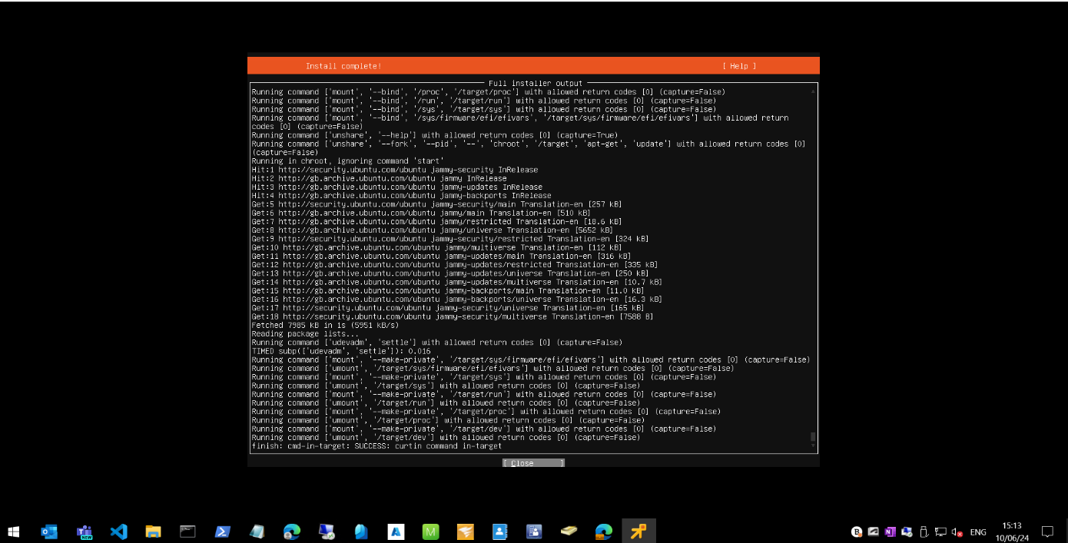

Appendix 2 – Ubuntu server installation competition

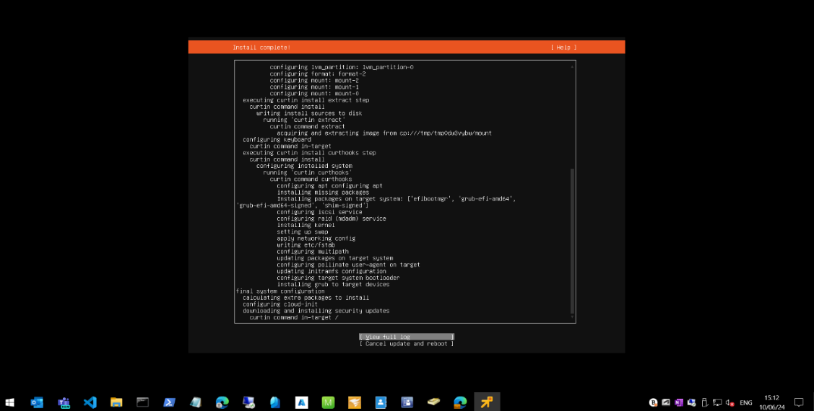

Appendix 3 – SwifOnSecurity Symon XML configuration
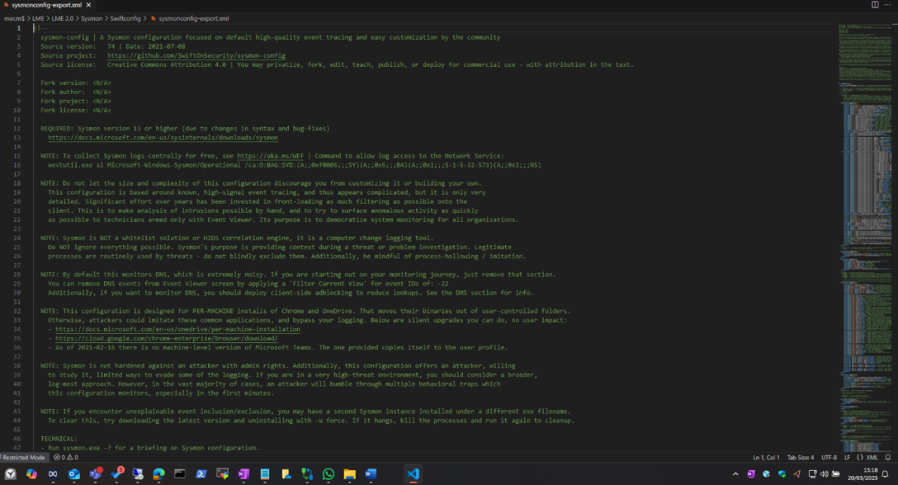

Appendix 4 - Agent and service installation on test workstation
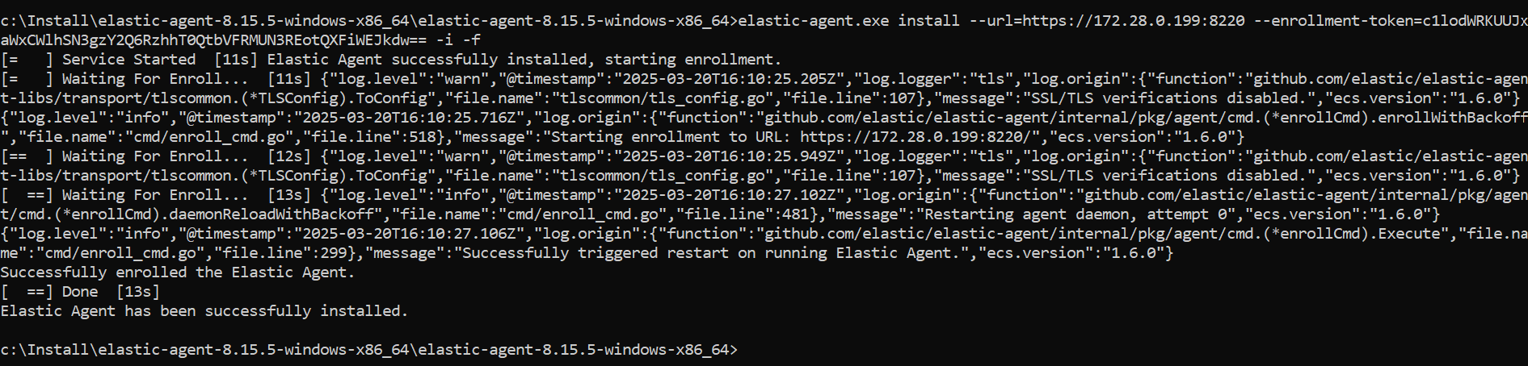

Appendix 5 – Elasticsearch Agent Service Running


