

Proposal for Modernising Information Systems at AKPerog LTD.

Student Name: Katiuscia Rodrigues Casagrande
Student ID: 2331413
Module Code: LCLM5004
Module Name: Managing Business Information
Lecturer: Amer Kareem Dian Mayasari

26 November 2025

Table of Contents
1. INTRODUCTION 2
2. EVALUATION OF EXISTING SYSTEMS 3
3. RECOMMENDED SOLUTION 5
3.1 How the Solution Improves Operations 6
4 IMPLEMENTATION PLAN 7
4.1 Potential Challenges and Mitigation Strategies 8
5 CONCLUSION 10
6 REFERENCES 11

INTRODUCTION

AKPerog Ltd. is a company that distributes electronics and is growing quickly. It includes 30 stores in real life and a shop website. The company has recorded a lot of sales increase in the past year, both online and in stores. This puts them in a better position to grow nationally. Even when the company has been doing well, antiquated information systems that don't work well are bad for both the company's performance and consumer happiness. As can be seen from the circumstances, AKPerog has trouble keeping track of its inventory, maintaining its relationships with clients, making judgements based on data that isn't completely supported, not following the rules, and not connecting its systems across departments.
These problems have caused product shortages, missed sales, dissatisfied customers, and too much paperwork for employees to handle. Not having real-time data and tools that work together has made it harder to make strategic decisions, which has hurt growth. This plan's purpose is to look at the challenges that are happening now and come up with a modern, scalable IT solution that meets AKPerog Ltd.'s business demands in the short and long run. This study recommends the implementation of an Enterprise Resource Planning (ERP) system that incorporates Customer Relationship Management (CRM) functionalities. The proposed answer is aimed to help everyone in the firm make decisions based on facts, make things operate more smoothly, make sure that rules are followed more carefully, and improve customer service.

EVALUATION OF EXISTING SYSTEMS

AKPerog is using a lot of various technologies right now to keep track of clients, sales, finances, and inventory. These systems don't talk to each other. Keeping track of inventories by hand is done with spreadsheets and physical checks. Customer information is saved in distinct databases that are run by different teams. Also, the finance team and the shop managers make sales reports by hand using spreadsheets. Because these systems don't sync in real time and don't have a central database, the organisation has to cope with mistakes, redundant effort, and old information that is passed around.
Because the process is done by hand, there are always differences in stock between shops and the online store. According to Laudon & Laudon (2020) stores that don't have automatic inventory methods are more likely to have dissatisfied customers because they are unable to finish their online shopping because the store doesn't have enough items in stock, and it can make harder to plan purchases and cost more to run a business.

There are so many places where AKPerog stores customer information that it's impossible to keep track of what customers have bought or run focused marketing campaigns. The marketing won't work as well and will be more generic and ineffective if they don't have a linked CRM (Chatterjee et al., 2022). Also, customer service staff can't answer questions right away because they don't have all the facts they need. AKPerog is having trouble to keep customers and giving them appropriate service because they lack information and to change it a good CRM system is needed.

Putting together sales data by hand on sheets can go wrong and take a long time. This makes it hard for managers to see trends right away or make choices based on correct, up-to-date information. (Galliers and Leidner, 2013) Spreadsheets that are set in stone make it harder to be flexible with research and make good predictions. This is not good for a company that is expanding.

Not having secure access controls and unified data management makes it much more likely that you will not follow the GDPR - General Data Protection Regulation. (Almeida, Shmarko and Lomas, 2022). The organisation is open to data breaches and possible legal penalties if there are no audit trails or encrypted systems. AKPerog doesn't have the strong data governance systems that modern enterprises need.

Parts of the business use different software that doesn't connect with other parts. The people who work there have to move files between offices by hand, which takes a long time and could go wrong. To get rid of these problems and make everything work better, we need combined information systems (Bocij, Greasley and Hickie, 2019) AKPerog's present IT systems are ancient, have a lot of issues, and can't keep up with how fast the company is developing. The business needs a modern, all-in-one system that can save time, check data, and let everyone in the company see all of its processes at once.

RECOMMENDED SOLUTION

It is recommended that AKPerog Ltd. implement a cloud-based Enterprise Resource Planning (ERP) system with integrated Customer Relationship Management (CRM) capabilities. ERP systems bring together several important corporate operations into one central platform. Some of these functions are sales, finance, purchasing, inventory, and human resources. Many recent ERP systems, such as Microsoft Dynamics 365, SAP Business One, and Oracle NetSuite, have built-in CRM functionality or integrate well with CRM products.

The integration will help alignment with business needs. With an integrated ERP-CRM system, AKPerog can store all its business information in one place, automate its tasks, and make sure that all its teams have access to the correct information at the right time. This helps the business achieve some of its most essential goals, like making sure it has the correct supplies, providing better customer service, processing orders more quickly and making smarter choices.

An ERP system reads barcodes or RFID (radio-frequency identification) tags, keeps stock in sync in real time, and sets up automatic recall points to maintain track of inventory. Muketha (2019) teaches us that this improve operational efficiency and there is a significantly lower chance that the amount of stock in stores and online will be different, and customers won't be able to get their money back since they were told wrong information regarding stock. When the tasks are automated, it’s possible acquire products, fill orders, and report on money faster.

Customer relationship management can be enhanced by storing all customer information in a single location using a CRM solution. This helps in creating more targeted advertising and marketing strategies, as well as providing better customer service (Nowacki and Twarozek, 2024). It will allow employees to view a complete list of items purchased and promptly answer customer questions. CRM systems can help in building customer loyalty, making them loyal to the company if used correctly.

ERP systems come with extensive analytics and forecasting features, as well as screens that show information as it happens. If the people in control know how customers act, how well the store is performing, and how sales trends evolve over time, they can make better decisions. AKPerog may plan and take advantage of market prospects this way.

It is possible to subscribe to cloud-based ERP solutions and pay for them over time. Initially, this represents savings, and as the company grows, it is possible to add more features. If AKPerog opens more stores or enters more markets, the system can handle more transactions without major adjustments. Cloud-based solutions can help save money and make IT infrastructure less complex over time (Johansson, Andersson and Gustavsson, 2025).

Some of the security features that come with new ERP systems that follow the GDPR are managing user jobs, encrypting data, maintaining audit logs, and keeping data safe. One-way access restrictions make it less likely that those who shouldn't be able to see client data will be able to (Stallings, 2023).

How the Solution Improves Operations

This solution improve the operations in many different ways. It will be possible to check how much is in stock at any given time and have a decent indication of how much demand there will be after you maintain track of your inventory. A single database makes the customer service easier to help clients, learn more about them, and get them to come back. Sales and finance don't have to worry about typos in files anymore because of automatic reports. This helps the month-end closing go by faster. The responsibility as a data manager is to keep the company data safe and in one place, and to make rules about who may see it. Business data tools and real-time screens can help plan for the future. AKPerog will probably become a cleaner, more efficient, and customer-focused organisation with the help of an ERP-CRM system.

IMPLEMENTATION PLAN

Figure 1: Steps to implement the system

Step 1: Choosing a solution that works for the group should be the first step. Cost, security, and ease of configuration are important aspects to consider. To understand what the company needs, major ERP vendors such as SAP, Microsoft, and Oracle should be carefully examined from a technical standpoint.

Step 2: It is important to migrate data such as customer records, sales history, and store records, and discard unnecessary old information. It is crucial to clean the data to eliminate errors and unnecessary copies.

Step 3: Now the system needs to be set up so it works for the company. The ERP system should be able to connect to the ways that AKPerog does things. Setting up automatic reports, security permissions, CRM interfaces, and inventory processes are all part of this.

Step 4: The company’s current tools must be able to work with the ERP system. If it is necessary should be able to connect it to the e-commerce site, point-of-sale (POS) systems, and financial apps when you need to. APIs (application programming interface) make it easy for systems to talk to each other, and APIs are used to connect modern ERPs to other systems.

Step 5: Teaching employees how to use the system properly. They need to learn how to follow the new ways of doing things. To do this, inventory stuff need to learn how to record and keep track of things, customer service teams need to learn how to utilise CRM interfaces, and financial teams need to learn how to use automated reporting. People are less reluctant when they have full training.
Step 6: Making a proof copy of the system. To see how well the method works, it should first be put in place in a few stores. It can be used in all shops once it has been tried out and proven to work well.

Step 7: The last step is to follow through with the plan and keep an eye on it at all times. Once the system is up and running, it should be checked often to make sure it is still working right. Maintenance chores, fixing problems, and getting ready for future updates must always be done by IT staff.

Potential Challenges and Mitigation Strategies

The proposed ERP-CRM system will make business more fluid, involve customers more, ensure data accuracy, help people comply with regulations, and provide real-time data to assist them in making important decisions. The execution strategy shows how to build the system in a planned way, including how to reduce risks, train users, and facilitate its implementation. The system migration presents potential challenges, and therefore, it is necessary to find strategies to mitigate any resistance to change.

Established theoretical models are used to successfully adopt integrated ERP-CRM systems. Good training and communication on change management can help address employee resistance (Chen, 2021). The Technology Acceptance Model (TAM) can be used to find out if the people who work at AKPerog would accept and use the new ERP-CRM system. TAM says that user adoption depends mostly on two things: how beneficial the system is and how easy it is to use (Weibe, 2024). In other words, how much employees think it will help them do their jobs better and how easy it is to understand and utilize. If they think the new system is hard to use or not needed, they could be resistant to change, but if the company explains how the system can benefit them and trains them, the implementation could be more successful.
As demonstrated, companies integrate ERP and CRM systems in order to simplify many processes In addition, customer responsiveness and strategic agility is improved. However, this integration is influenced by multiple internal and external factors. According to Kowsar and Rahman (2022) the Technology–Organization–Environment (TOE) model teaches that internally, the success if these integration initiatives can be affected by senior management support, IT infrastructure capacity, employee training, and cross-functional coordination significantly affect the success of integration initiatives. On the other hand, outside factors like vendor support, governmental compliance, and competitive pressure affect when and how much is adopted.

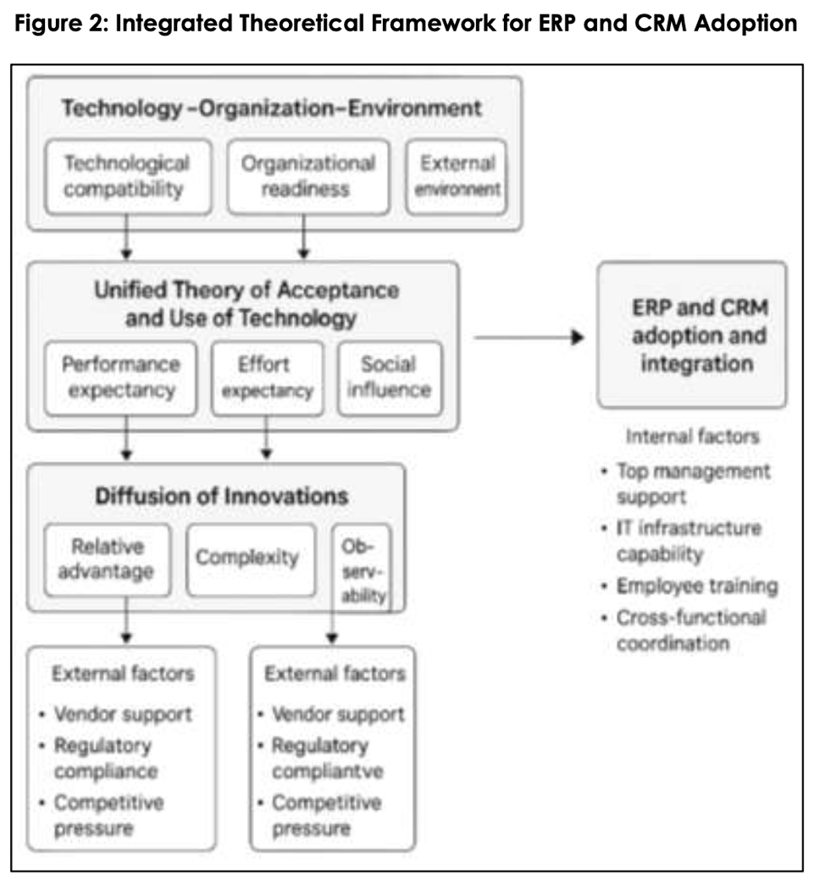
Fonte: Kowsar and Rahman, 2022.

Problems with migration data are minimized through rigorous data cleansing and verification. Implementation costs can be kept under control by choosing a cloud-based ERP subscription service. The waiting time during implementation will be reduced by phased adoption and simultaneous system execution (Nowacki and Twarozek, 2024). By investing in modern and integrated information systems, AKPerog will be able to improve its market competitiveness and offer a quality experience to its customers, thus positioning itself to sustain future growth.

CONCLUSION

Based on this study, AKPerog Ltd. faces many challenges caused by a lack of operational efficiency. This is because the information system is basically manual and outdated, failing to connect data efficiently. It is evident that this impacts the company's performance and customer satisfaction. Without accurate data, profit margins, inventory, and decision-making, capacity are seriously compromised. To mitigate these problems and take the company to a new level of management, the adoption of a cloud-based Enterprise Resource Planning (ERP) system with integrated Customer Relationship Management (CRM) functionalities is recommended.

REFERENCES

Almeida, D., Shmarko, K. and Lomas, E. (2022). The ethics of facial recognition technologies, surveillance, and accountability in an age of artificial intelligence: a comparative analysis of US, EU, and UK regulatory frameworks. AI and Ethics, 2(3), pp.377–387. doi:https://doi.org/10.1007/s43681-021-00077-w.

Bocij, P., Greasley, A. and Hickie, S. (2019) Business information systems: technology, development and management for the modern business. 6th ed. Harlow: Pearson.

Chatterjee, S., Chaudhuri, R., Vrontis, D. and Thrassou, A. (2022). Examining the role of social CRM capability in online marketing communication. Journal of Marketing Communications, 29(2), pp.1–19. Available at: doi:https://doi.org/10.1080/13527266.2022.2154064.

Chen, L. et al. (2021) ‘How Does Employee Infusion Use of CRM Systems Drive Customer Satisfaction? Mechanism Differences Between Face-to-Face and Virtual Channels’, MIS quarterly, 45(2), pp. 719–754. Available at: https://doi.org/10.25300/MISQ/2021/13265.

Galliers, R.D. and Leidner, D.E. (2013) Strategic information management: challenges and strategies in managing information systems. 3rd ed. Saint Louis: Taylor and Francis.

Johansson, B., Andersson, F. and Gustavsson, M. (2025) ‘Replacing on-premise ERP with cloud ERP solutions – Reasons and Drivers’, Procedia computer science, 256, pp. 521–529. Available at: https://doi.org/10.1016/j.procs.2025.02.148.

Laudon, K.C. and Laudon, J.P. (2020) Management information systems: managing the digital firm. Sixteenth edition. Harlow, England: Pearson Education Limited.

Md Masud Kowsar and Md Arifur Rahman (2022) “Enterprise resource planning and customer relationship management integration: a systematic review of adoption models and organizational impact”, Review of Applied Science and Technology, 1(02), pp. 26–52. doi:10.63125/tn7g2v08.

Muketha, G.M. (2019) Metrics and models for evaluating the quality and effectiveness of ERP software. Edited by G.M. Muketha and E.M. Micheni. Hershey, Pennsylvania: IGI Global. Available at: https://doi.org/10.4018/978-1-5225-7678-5.

Nowacki, K. and Twarozek, M. (2024) Salesforce CRM Administration Handbook: A Comprehensive Guide to Administering, Configuring, and Customizing Salesforce CRM. First edition. Birmingham, England: Packt Publishing Ltd.

Stallings, W. (2023) Cryptography and network security principles and practice. Eighth edition. Harlow: Pearson. Available at: https://ezproxy.uwtsd.ac.uk/login?url=https://www.vlebooks.com/product/openreader?id=TrinityStD&accId=8886856&isbn=9781292437491&uid=^u.

Weibe, A. (2024). A Qualitative Investigation of the Technology Acceptance Model in the U.S. Cooperative Extension Service on the Adoption of Customer Relationship Management Systems. Doctoral Dissertations and Projects, [online] 745. Available at: https://digitalcommons.liberty.edu/doctoral/5394/.

