3/28/2021
Andreea Esanu (1713835)
Lecturer name: Dr Amare Desta

Knowledge and Information Management of Amazon.com
BMSW 5106
Table of Contents
Introduction 2
Knowledge and Information Management 4
KM Technique used by Amazon.com 4
What is Knowledge Management? 5
Tacit and explicit knowledge 9
Conclusion 11
References 12

Executive summary
As we know knowledge is something that we acquired through experience or education by perceiving, discovering, and learning. Knowledge enhances awareness, or understanding of subject, facts, information, or skills. Anton Chekhov says ` Knowledge is of no value until you put it into practice`. All our knowledge begins with senses, therefore as long as we live our brain creates a strong base of knowledge helping it to function smoothly and effectively. But there is knowledge management which is a process of creating, sharing, using and managing the knowledge and information of an organization. Therefore, it is important to gain knowledge and know how to apply that knowledge to reduce uncertainty, improving decision behaviour.

Introduction
During the course of a lifetime, an individual is developing continuous understanding of the challenges of how to manage knowledge and information and apply into systems within an organisation. As the report title says, “Knowledge and Information Management of Amazon.com”, the main purpose of this paper is to demonstrate the ability to understand and comprehend the term and the level of importance of knowledge management in terms of Amazon`s knowledge assets and their potential knowledge management challenges. In order to provide the key knowledge management processes this paper is suggesting few practical models that attempts to provide a simple framework for establishing organizational knowledge. These models suggest a contingency view of knowledge management proving that each company has a unique knowledge resources in order to manage its understanding for organisational development.
Amazon is the world`s largest online retailer was founded by Jeffrey Bezos in 1994 when he quits his job and start working on launching the Amazon out of his garage. Even if with the pandemic situation that affected all business around the world and global economy, Amazon became the essential service for many customers, meeting their needs during the coronavirus crisis. Therefore, during this crisis, Amazon faced knowledge management challenges in order to strengthen their knowledge management practices.
Knowledge management is a process that involves collection of knowledge (facts, information, skills that you quired through education, awareness, understanding of a subject) in order to convert it into ease of use across the organisation to improve employee performance. There are two types of knowledge tacit knowledge and explicit knowledge, basically the knowledge management process also involves the process of accumulate the tacit knowledge and converting it into explicit knowledge.
To underpin my report there are few key knowledge management theories, such as WIIG Model, Von Krogh and Roos Model. The main outcome from this report is to understanding, analysing and applying at higher levels the knowledge management in order to describe the specific changes in companies leading to its success.

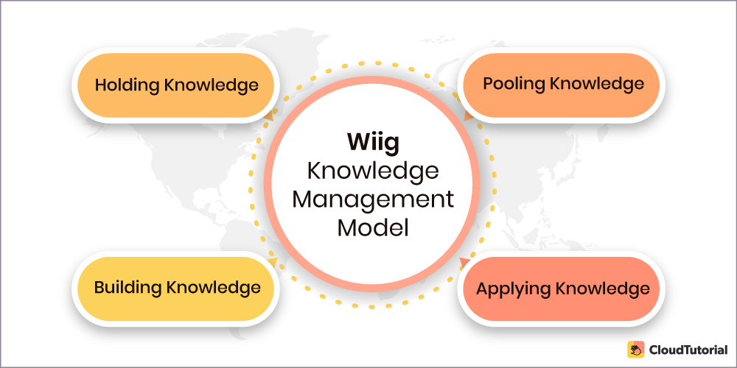
Source: https://www.thecloudtutorial.com/knowledge-management-models/
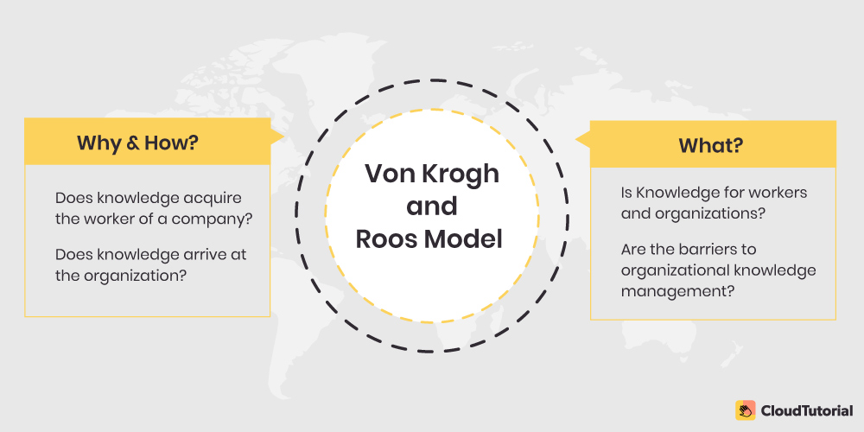
Source: https://www.thecloudtutorial.com/knowledge-management-models/
The Wiig model of knowledge management is a process through which the company can know something from a particular point. This model suggest that the knowledge management process has to be perfect and reasonable in order to make useful and valuable knowledge.

Knowledge and Information Management

KM Technique used by Amazon.com
The story of Amanozon.com – How a bookstore conquered the internet. As we all know, Amazon become one of the largest online marketplaces, who also sells its own line of technology products, e-readers. The customers can buy items from Amazon directly or from third party sellers through Amazon. Applying in context of Amazon the knowledge management represent an important factor for Amazon success.
Sales products online, massive customer base, they selling their products reaching the global market, they have an excellent app system, they use KM to attract customers` attention, an excellent delivery system and fast.

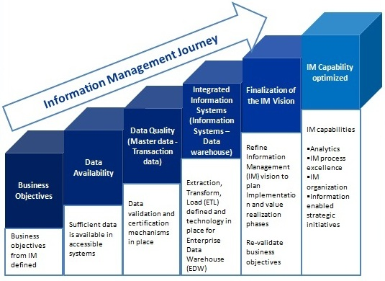
Image source: https://www.i-scoop.eu/information-management/information-management-definition-enterprise-content-management/
Information management is an intensive terminology which is almost part of the DNA for anyone who dealing with data and information. As we can see in the diagram above, there is an information management journey in order to bring business management as its highly strategic function. First, we have to identify business objectives from information management defined, then the data availability to know if sufficient data is available in accessible systems, which the next step is data quality that includes data validation and certification mechanism in place, after is integrated information systems (extract, transform, load technology in place for enterprise data Wearhouse). The next step is finalization information management vision, means that we must refine information management vision to plan. Here are implementation and value realization phases, where must be re-validate business objectives. The final step is information management capability optimised such as: analytics, information management process excellence and organization, where information enabled strategic initiatives.
Amazon utilises specialised information systems in its business processes in order to accomplish competitive advantage through improved efficiency in the collection, storage, and analytics of their customers` personal information. Amazon operates in two-piece information management software: simple data storage service that is connected to its database, and the Amazon Web services that allows access to e-commerce platform. They use knowledge graphs to represent the hierarchical relationships between the product types, also between creators and content on Amazon Music and Prime Video, including general information for Alexa`s question-answering service (Wei, 2020).

What is Knowledge Management?
According to Duhan (1998), knowledge management is a disciple that promotes an integrated approach to identifying, capturing, evaluating, retrieving, and sharing all of an enterprise’s information assets. These assets may include database, documents, policies, procedure and previously un-captured expertise and experience in individual workers. On the short terms, KM objective is about supporting creation, managing knowledge of and in organisations and improve its efficiency. Therefore, knowledge management comes from experience, tactics, ideas, putting the information into ease of use.
Why KM it’s so important for any organisation including Amazon.com? Well, here we’ve got some answers. First of all, there are 3 ways to use Amazon, such as:
- Shopping- where you can buy everything you want
- Selling- Amazon allows third parties to sell their products through their website (you can sell everything from books to electronics or clothes)
- Technology products- Amazon it’s a manufacturer cutting edge with digital devices, and the well-known product is the Kindle a specialized e-reader, also the Fire Tablet and Fire TV.
In this case KM helps Amazon in satisfying customers and achieving competitive advantage. Jeff Bezos said himself that ` We see our customers as invited guests to a party, and we are the hosts. It`s our job every day to make every important aspect of the customer experience a little bit better`. And that’s where knowledge management helps. Amazon uses KM principles and practices to add a substantial value for their customers in different ways such as:
- A single portal for everything: every purchase and every business we do with them running thru same portal, and in this way provides to customers and employees a standard, familiar, and easy to use access to knowledge in all form.
- Consistent presentation- amazon shows data for each product from an outstanding content management in order to track and archive each and every information.
- Feedback: being customer focused mindset, Amazon places feedback right on the product front page, giving to the readers many ways to sort the information how they like, improving their service by allowing the customers to rate reviewers.
- Accessibility: Amazon app is available any time and anywhere on any device
Amazon have always had industry-leading logistical capabilities. Back in 2005 they started to make very modes profits, but they weren’t growing fast, so they had to try something else. Therefore, they came up with the idea to offer free 2 days shipping on the selected products. They called `Amazon Prime`.

Amazon Prime is a paid subscription program offered by Amazon, available in numerous countries giving to users’ additional services. Here are some benefits as an Amazon Prime member:
- Delivery- unlimited one day delivery to UK addresses on millions of eligible items no extra cost, it ships in the same day and arrives in the next day; unlimited Same-Day (evening delivery) on eligible items and postcode at no extra cost; unlimited Priority Delivery to the Republic of Ireland on eligible items at no extra cost; Amazon Day where you can choose a weekly delivery day for the items you buy throughout the week; Amazon fresh is included, offering same-day and next-day fresh delivery at no extra cost (fresh grocery, local products and selected Amazon favourites); Morrisons on Amazon for same-day and next day delivery of many fresh or frozen groceries and household essentials.
- Video and photos- Prime Video offers unlimited streaming of movies and TV episodes; you can add Prime Video Channels to you TV channel subscriptions for a low monthly subscription fee; Prime Photos which offers secure, unlimited photo storage in Amazon Cloud Drive
- Music- Prime Music allows Amazon Prime customers to stream, store, manage, and listen to music anywhere from the cloud; Amazon Music Unlimited offers a vast collection of songs and thousand of expert- programmed playlists and stations, available to all customers (UK members can get a discount monthly plan)
- Books- Kindle First gives Prime members early access to download a new book every month at no additional cost from the Kindle First picks; with Prime Reading you can borrow books, magazines, and more from the Prime Reading catalogue.
- Prime Wardrobe- is a Prime-excusive program where you can try before you buy, including clothes, shoes, watches and accessories across women`s, men`s, kids and baby categories; you have 7 days to try on the items and they charge only for the items you decide to keep.
- Prime student- is a program for higher education students studying in UK and Ireland where they get a six-month trial on Amazon Prime, and after six months they paid half of it.
Amazon Prime includes many other discounts and offers in Prime Gaming, Prime Early Access, Amazon Family, Amazon Household. As we can see the concept of Amazon Prime become a giant e-commerce that count more than 200 million subscribers globally (Spangler, 2021). During the coronavirus pandemic the Amazons` sells has grown and became an essential service for many consumers and it doubled its quarterly profits to $5.2bn (£3.95bn), compared with $2.6bn at the same point in 2019 (Harris ,2020). But this situation become a problem for the staff because they hired more people, and they couldn’t keep the distances between them as the government requires. Some of the staff even quitted their jobs (a vice president at Amazon Web Services) because Amazon didn’t do enough to keep them safe from the virus as they continued to work at a dizzying pace. In 2020 the company added 36,400 people in the three months ended June 30, bringing its head count to 876,800, an increase of 34% year over year (Palmer, 2020). Anyway, Amazon has adopted a number a safety measures to ensure a safe work environment for hundreds of thousands of employees who continued to come to work. They also have a system to identify anyone who came in contact with individuals who`ve tested positive, by reviewing camera footage. They also build up a plan to test the frontline warehouse workers, even those without symptoms.
In addition, with all measures to keep Wearhouse employees safe, some calls from warehouse workers suggest that the company should improve the paid sick leave policies and to close the warehouse for cleaning when they have positive cases.
To go back, the Amazon Prime, was the second biggest decision made by Amazon and that`s because the first one was ` Amazon Web Services`, which is a cloud computing company that host websites and applications for customers and other businesses. Through this web services they rent out servers based on your needs, also they offer a very affordable way for businesses to post on large scale websites. Half of Amazon marketplace is populated by small businesses owners and people who make a living of selling things online. The past years when Amazon sees that a product is selling well on their website, they create their own version of that product and undercut the original seller. This has made the small business owner difficult to compete to Amazon website.

There are few benefits that customers across all industries can take advantages, such as: low cost (pay as you pricing with no upfront expenses), agility and instant elasticity (allows you to quickly innovate, no waiting months for hardware), open and flexible (you are free to chose the development platforms or programming model suitable for your business), secure (durable technology platform with industry-recognized certifications and audits: PCI DSS Level 1, ISO 27001, FISMA Moderate, FedRAMP, HIPAA, and SOC 1 (formerly referred to as SAS 70 and/or SSAE 16) and SOC 2 audit reports (AWS, n.d). Customers can run on Amazon Website Service following solutions: Application Hosting, Backup and Storage, Content delivery, Websites, Enterprise IT, Database.
Therefore, knowledge management development practices are an essential prerequisite used by Amazon.com, and the main outcomes that Amazon has been achieving with the use of these procedures is increasing customers satisfaction and achieving competitive advantages.

Tacit and explicit knowledge
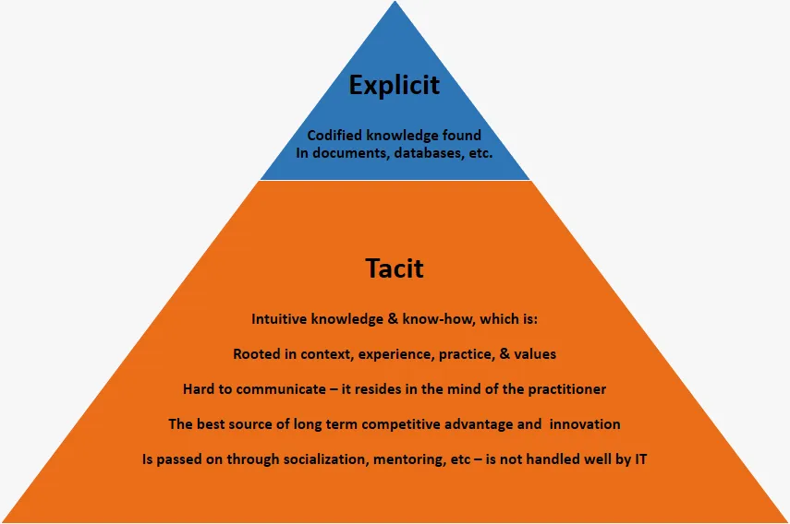
Image source: https://knowledgemanagement5.wordpress.com/tacit-knowledge/tacitexplicit-knowledge/
As we can see in the image above, we can define tacit knowledge as a collection of life`s experience, education, and training that we acquired, and we have imbedded in ourselves. We might not know, but our brain is recording and storing some experience such as the process of analysing what is happening around us with our senses. It is difficult to communicate, and it resides in the mind of the practitioner. The best source for long-term competitive advantage and innovation is tacit knowledge. On the other hand, explicit knowledge is codified knowledge found in documents, database, books. One cannot exist without another, and to maintain the growth of the business must be learnt how to effectively transfer knowledge. Explicit knowledge can be easily transferred without the knowing of the subject.
The SECI model, as we can see in the image below, is a conceptual model developed by Nonaka in 1991 and expanded by Nonaka and Takeuchi in 1995.
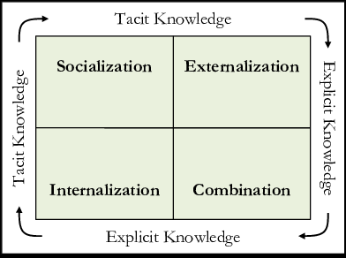
Image source: https://www.researchgate.net/figure/The-SECI-model-based-on-tacit-and-explicit-knowledge-conversions_fig1_301650589
The SECI model consists in four types of knowledge conversion: socialization (tacit to tacit), externalization (tacit to explicit), combination (explicit to explicit) and internalization (explicit to tacit). The necessity for social interaction in the knowledge development process described by Nonaka and Takeuchi (1995) is evident in development phases of Amazon. For Jeff Bezos the hire process is very important aspect in his business. He doesn’t hire someone for the sake of filling an open role. As he once said that ` I rather interview 50 people and no hire anyone than hire the wrong person` (Deutschman,2004). He constantly introduces small but innovative futures to improve a superlative experience for customers. His insistence on continuously hiring better people is one of the reasons why Amazon will be one of the world’s most successful companies. He also creates a sense of community by giving shares to the staff in the idea to urging the employees to contribute to the well being of the company. Therefore, from Nonaka and Takeuchi model framework we can deduct that the focused point was on socialization and externalisation. Tibben et all 2006, argue that `even tough the goal was the creation of new technology for an e business the fundamental operator of this process was the innovation that Bezos achieved through the management of context and relationships`. Another way for Amazon to use tacit knowledge is through their web technologies. When you say Amazon web technologies automatically you think about success. These technologies, in e-business context, make to the problematic aspect of knowledge management- socialization and externalisation. The search engines of Amazon are very sophisticated in such way that personal knowledge of their customers has been snatched from their private areas and use by Amazon to access it for exploitation by the company. These search engines combined with its customers interface relates to the ability of Amazon to collect personal information of the customers where is processed and codified into a productive use within a larger context Amazon and its related companies. When a customer is on Amazon website, they keep a record for all its activities while the customer is there. Also, they use cookies in order to track the customer preferences. A browser cookie is a small piece of data sent from a website and stored on your computer while browsing that website. You can always change your cookies preferences. Because preferences are non-identifiable information of an individual customer, here is taking place the transformation from tacit knowledge to explicit knowledge.
As I said above, Amazon adds value to their customers by using feedback and reviews. All Amazon customers are provided with the opportunity to share their opinions about a product and the experience they had during the purchase. This type of interaction where personal experience is shared can be identified in Nonaka and Takeuchi socialisation process of tacit-tacit knowledge. These techniques give to Amazon a competitive edge. It is very important to observe how Jeff Bezos and his technology developer are using fundamental aspects of knowledge management.
In conclusion, with the research from above the application of Nonaka and Takeuchi knowledge management framework is useful for making a better sense of Amazon success in online business.
There are some areas where Amazon can improve in the future in order to overcome the challenges. First one should be to expand globally, such as in Scandinavian countries where the population in that area are well connected as they have highly salaries. Amazon needs to diversify into area that are higher margin ones. With the offering that he has with its AWS, a possible strategy will be to increase the cloud-based offerings.

Conclusion
To sum up everything that has been state so far, knowledge management plays a crucial role in every organisation because it boosts the efficiency of the organisation`s decision making ability. The purpose of knowledge management in Amazon is to share perspectives, ideas, experience and information and help business to achieve their goals through their websites. It is important to acquire knowledge through our life in order to improve our work environment and to have a better understand about what is happening in the world. It is important to have an effective knowledge management system, that not only protects revenue, but this system helps in increasing productivity, and promoting innovation. Therefore, Amazon`s success comes from a strong customer experience and their knowledge management tactics and technique.

References
About AWS. (n.d.). Retrieved April 30, 2021, from AWS: https://aws.amazon.com/about-aws/
Alavi, M., & Leidner, D. (2001, March). Review: Knowledge Management and Knowledge Management Systems: Conceptual Foundations and Research Issues. MIS Quarterly, 25, 30. doi:https://doi.org/10.2307/3250961
Amazon Prime. (n.d.). Retrieved April 30, 2021, from Amazon.co.uk: https://www.amazon.co.uk/gp/help/customer/display.html/ref=vnid_G6LDPN7YJHYKH2J6?nodeId=G6LDPN7YJHYKH2J6
Anderson, D. (n.d.). Hiring Lessons from Jeff Bezos and Amazon. Retrieved April 30, 2021, from Recruiterbox: https://recruiterbox.com/blog/hiring-lessons-from-jeff-bezos-and-amazon
Deutschman, A. (2004, Januay 8). Inside the Mind of Jeff Bezos. Retrieved April 30, 2021, from FASTCOMPANY: https://www.fastcompany.com/50661/inside-mind-jeff-bezos
Harris, J. (2020, November 18). How Amazon became a pandemic giant – and why that could be a threat to us all. Retrieved April 30, 2021, from The Guardian: https://www.theguardian.com/technology/2020/nov/18/how-amazon-became-a-pandemic-giant-and-why-that-could-be-a-threat-to-us-all
Knowledge Management. (n.d.). Retrieved April 30, 2021, from Wikipedia: https://en.wikipedia.org/wiki/Knowledge_management
Mutwiri, W. (n.d.). Amazon Business Information Systems. Data Acquisition and Management in its Value Chain. Retrieved April 30, 2021, from GRIN: https://www.grin.com/document/538135
Palmer, A. (2021, September 29). How Amazon managed the coronavirus crisis and came out stronger. Retrieved April 30, 2021, from CNBC: https://www.cnbc.com/2020/09/29/how-amazon-managed-the-coronavirus-crisis-and-came-out-stronger.html
Rosenberg, M. (2014, July 29). The Knowledge Management Genius of Amazon.com. Retrieved April 30, 2021, from Learning solution: https://learningsolutionsmag.com/articles/1480/the-knowledge-management-genius-of-amazoncom
Spangler, T. (2021, April 15). Amazon Prime Tops 200 Million Members, Jeff Bezos Says. Retrieved April 30, 2021, from Variety: https://variety.com/2021/digital/news/amazon-prime-200-million-jeff-bezos-1234952188/
Tibben, W., Sangal, K., & Gonsalves, S. (2006). Unlocking the secrets of Amazon: understanding tacit knowledge and its. International Journal of Knowledge, Culture and Change, 5. Retrieved April 30, 2021, from https://ro.uow.edu.au/cgi/viewcontent.cgi?referer=https://www.google.com/&httpsredir=1&article=10306&context=infopapers
Wei, H. (2020, 19 March). Combining knowledge graphs, quickly and accurately. Retrieved April 30, 2021, from Amazon Science: https://www.amazon.science/blog/combining-knowledge-graphs-quickly-and-accurately
Wright, K. (2005). Personal knowledge management: supporting individual knowledge worker performance. Knowledge Management Research & Practice, 3(3). doi:https://doi.org/10.1057/palgrave.kmrp.8500061
Younes, M. (2015, October 26). Types of Knowledge (Explicit, Tacit & Embedded). Retrieved April 30, 2021, from LinkeIn: https://www.linkedin.com/pulse/types-knowledge-explicit-tacit-embedded-dr-mohamed-younes

Davenport, Thomas H. (1994), Saving its Soul: Human Centered Information Management. Harvard Business Review, March-April, 72 (2) pp. 119-131. Duhon, Bryant (1998), It's All in our Heads. Inform, September 12 (8).

