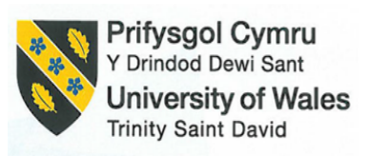

BA (Hons) International Hotel Management

Marketing Essentials
Module code: BMIH4005
Marketing Plan & Presentation slide
Student name: Claudia Butnariu
Student ID: 2239415

Table of Contents
Introduction 4
Situation Analysis 4
5 C’s 4
Company SWOT analysis 4
Customers: Segmentation and Targeting 4
Competitors: Bowman’s strategy clock 5
Collaborators 6
PESTLE analysis 6
Marketing mix 7
Objectives 9
SMART target 9
Strategy 10
Tactics 11
Action 13
Control 15
Conclusion 16
References 17
Appendix 19
Tactics 23

Introduction
The purpose of the marketing plan is to attract more customers towards the hotel and make more brand awareness of the hotel. The report will discuss the Ibis Hotel’s marketing plan for the improvement of its brand awareness. The report will also discuss the SWOT, Perceptual positioning map, Bowman’s strategy clock, Segmentation and Targeting. The report will discuss Ansoff’s matrix for a better understanding of the organisation. The report will also discuss the tactics and strategies for the marketing plan and development. The report will also discuss the Gannt Chart for the marketing plan and activities.

Situation Analysis

5 C’s

Company SWOT analysis
Strength:  1. The hotel has a strong global network.  2. The hotel provides the customers with good customer service and a satisfactory programme to the customers. | Weakness:  1. The targeted customer channel of the hotel is not that diverse and big, it targets only the travellers.
Opportunity:  1. the hotel chain has the capability of entering into a new market for business (IBIS, 2023).  2. the hotel also has the opportunity to ally with various local-level competitors. | Threat:  1. the increasing number of budget-friendly hotels globally and locally.  2. the change in rrrrrrrr preferences and trends.

Customers: Segmentation and Targeting
The targeted customers of Ibis hotels are price-conscious travellers. Consumers searching for hotels that are conveniently close to tourist destinations, shopping malls, and entertainment venues. They hope to draw in budget-conscious travellers by providing reasonable rates and value-added services (Jobber and Ellis-Chadwick, 2019). Ibis hotels also cater to business travellers who need convenient lodging while on the road. To appeal to this market, they also offer features like free Wi-Fi, well-equipped workstations, and simple access to transit hubs.

Competitors: Bowman’s strategy clock
The competitors of Ibis are Premier Inn, Travelodge and Holiday Inn Express.
Ibis
HIE
PI
Unsafe and not secured
Less
branches
Lots of branches
Safe and secure

Collaborators
Ibis is a member of the AccorHotels Group, a prestigious hotel chain. Through this partnership, Ibis will have access to the network's resources, marketing know-how, and loyalty programme (ALL - Accor Live Limitless from AccorHotels). To distribute its hotel inventory and attract a larger audience, Ibis works with a number of OTAs, including Booking.com, Expedia, and Agoda. Through these alliances, clients may reserve Ibis hotels on well-known websites, enhancing visibility and accessibility (Buttle, et al., 2019).

PESTLE analysis
Political factors
Ibis conducts business and has set a number of rules and guidelines for the company. These include zoning restrictions, licencing requirements, tax laws, and labour laws.
Economic factors
The demand for hotel rooms can be impacted by the general economic environment, which includes elements like GDP growth, inflation rates, currency rates, and consumer spending trends.
Social factors
The demand for various types of lodgings can be influenced by sociocultural variables such as shifting travel choices, demographic changes, and consumer lifestyles.
Technological factors
The hotel has adopted various technological apparatus for the efficiency of its operations (Smith and Zook, 2019). For example, the hotel has introduced online applications for their services, website booking, data analysis and many more.
Legal factors
The hotel follows the basic legal factors for business safety and for maintaining the rules of the country UK. For example, human rights issues, wages, working hours and many more.
Environmental Factor
Sustainability and environmentally friendly practices are becoming increasingly important in the hotel sector. Ibis has addressed environmental challenges like waste management, energy efficiency, and ethical sourcing.

Marketing mix
Product
Ibis provides customers with affordable and comfortable services to the customers for better experiences. The hotel also provides the customers with free WiFi and a work dash bord to the customers.
Prices
Ibis tries to offer inexpensive lodging, focusing on travellers on a tight budget. The pricing strategy aims to provide value while preserving profitability.
Place
Ibis is a well-known brand with hotels distributed over the world, including the UK (Kotler and Armstrong, 2001). In order to give visitors easy access, they carefully select locations close to transport hubs, city centres, and well-known attractions.
Promotion
To increase brand awareness and market its products, Ibis runs advertising campaigns across a variety of media, including television, online platforms, print media, and outdoor advertising.

Objectives

SMART target
1. To increase the brand awareness of Ibis Hotel by 10% in 1 year.
2. To increase the targeted customer reach and diversity by 15% in 1 year.
3. To increase the revenue of the company by 5% within 1 year.

Strategy
Ibis provides affordable and effective services through their hotel services all over the UK. The company tries to increase their business value by improving their different product and services. The company can use the Ansoff matrix to increase its marketing value. It includes some business strategies such as market penetration, product development, market development and diversification.
Market penetration: Different companies use this strategy by focusing on their existing products (Tien, 2020). The company have to understand the gaps in its previously planned marketing strategies and needs to make changes to its existing product and services. It will increase the sale of existing products. Ibis hotels can provide different offers or include holiday discounts on their existing services.
Diversification: Companies use the strategy to analyse the best areas to improve and make effective changes in their products and business (Hong, 2020). It can include launching new services in new markets. Ibis can open new outlets in new cities thus people of that place can have their attractive services.

Tactics
The communication mix in marketing describes different tools that organisations use to communicate with their customers and targeted audiences. The strategy includes advertising, product packaging, social media marketing, sale promotions, events, direct marketing and other areas (Ofosu-Boateng and Agyei, 2020). It helps a company, to deliver important information about its business, objective, services and offers. Thus, it can attract more potential customers.
Ibis hotels and their services mainly attract travellers and the number of their competitors are increasing. The company has to follow some communication strategies thus it can expand its services in different areas and can compete with other competitors.
Advertising: The company can use different promotional activities for their products and services. They can deliver their company benefits, offers and other information through audio-visual advertisements. They can also use different applications, media platforms such as Instagram, Facebook and their own websites to convey business-related information. It will influence potential customers to have the convenience of its services.
Direct marketing: Using this communication process companies can directly approach about their services and other activities to their existing customers (Rahayu et al., 2018). The company can use email to deliver new business ideas and offers of the company to their previous customers. It can attract old customers to take their services for the future also. Through the good experiences of existing customers, the company can also attract new targeted customers.
Public relations: Companies can develop their relationship with the public by maintaining a brand reputation. Thus, companies have to properly maintain relations with their customers, investors, production, government and community. Ibis hotels can use different non-paid platforms such as social media, press conferences, speech writing, clearing doubts and others (Hubspot, 2023). It can help the company to be connected with the public and maintain a good brand image by exchanging business-related information and offers.
Currently, the company uses different social media platforms, and emails to communicate with customers (Kunst, 2023). They post about their activities and services thus it can attract more customers. Social media platforms include various people with different perception thus, the company have to promote their services and activities by simplifying the subjects and focusing on attractive offers and discounts. It will encourage customers to take their services and experience the benefits.

Action
Objective | 3 months | 3 months | 3 months | 3 months
To increase the brand awareness of Ibis Hotel by 10% in 1 year.
Marketing
campaign
To increase the revenue of the company by 5% within 1 year.
Market
research
Creating app
for booking
To increase the targeted customer reach and diversity by 15% in 1 year.
Marketing with various platforms

Control
The success of this action in achieving the organisation’s objective can be measured by the response of the customers (GOV.UK, 2023). The organisation is implementing the marketing plan and the objectives for attracting more customers towards their brand. Therefore, the success and the attitude of the customers can be determined by increasing rate of the revenue, brand awareness, and customer diversity.

Conclusion
The report has discussed the Ibis Hotel’s marketing plan for obtaining the objective of increasing its brand awareness. Through their hotel services, Ibis offers efficient and reasonably priced services throughout the UK. The corporation works to improve its various products and services in an effort to boost its commercial worth. The various instruments that firms employ to communicate with their clients and key audiences are referred to as the "communication mix" in marketing. Advertising, product packaging, social media marketing, sale promotions, events, direct marketing, and other tactics are all part of the plan.

References
Buttle, F., Bowie, D., Brookes, M. and Mariussen, A., (2016). Hospitality Marketing. Taylor & Francis.
GOV.UK, (2023). IBIS UK LIMITED. [Online] Available at: https://find-and-update.company-information.service.gov.uk/company/04216663 [Accessed 23th May 2023].
Hong, B., Luo, T. and Lei, X., (2020). Late-stage diversification of natural products. ACS central science, 6(5), pp.622-635.
Hubspot, (2023). How to Do PR: The Ultimate Guide to Public Relations in 2023. [Online]
Available at: https://blog.hubspot.com/marketing/public-relations[Accessed 25 may 2023].
IBIS, 2023. IBISWorld for the UK. [Online] Available at: https://www.ibisworld.com/united-kingdom/ [Accessed 20th May 2023].
Jobber, D. and Ellis-Chadwick, F., (2019). EBOOK: Principles and Practice of Marketing, 9e. McGraw Hill.
Kotler, P. and Armstrong, G., (2001). Principles of marketings.
Kunst, A., (2023). Ibis brand profile in the UK 2022. [Online] Available at: https://www.statista.com/forecasts/1335566/ibis-hotels-brand-profile-in-the-uk [Accessed 23th May 2023].
Ofosu-Boateng, I. and Agyei, S.D., (2020). EFFECT OF CUSTOMER SATISFACTION AND MARKETING COMMUNICATION MIX ON CUSTOMERS’LOYALTY IN THE GHANAIAN BANKING INDUSTRY. European Journal of Management and Marketing Studies, 5(4).
Rahayu, A.U., Herawaty, I., NR, S., Prafitriyani, A.S., Afini, A.P. and Kautsar, A.P., (2018). Marketing 4.0: a digital transformation in pharmaceutical industry to reach customer brand experience. Farmaka, 16(1), pp.80-85.
Smith, P.R. and Zook, Z., (2019). Marketing communications: Integrating online and offline, customer engagement and digital technologies. Kogan Page Publishers.
Tien, N.H., (2020). Analysis of Lotte’s Market Penetration Strategy in Vietnam FMCG Industry. International journal of educational research and studies, 2(2), pp.20-23.

Appendix
Business Overview of Ibis
Slides:
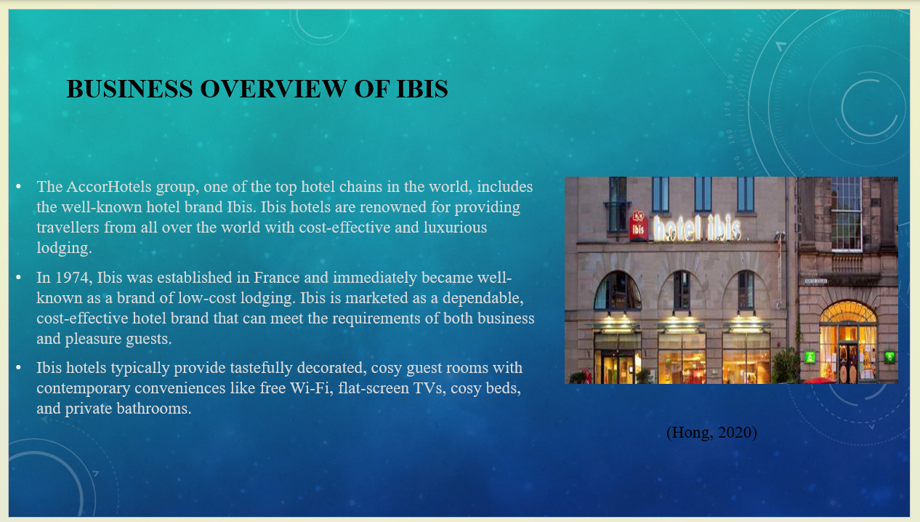
Notes:
The AccorHotels group, one of the top hotel chains in the world, includes the well-known hotel brand Ibis. Ibis hotels are renowned for providing travellers from all over the world with cost-effective and luxurious lodging. In 1974, Ibis was established in France and immediately became well-known as a brand of low-cost lodging. It grew internationally over time and rose to prominence in the world hospitality market. Ibis is marketed as a dependable, cost-effective hotel brand that can meet the requirements of both business and pleasure guests. One of the biggest networks of budget hotels worldwide, the brand runs more than 1,200 properties. Ibis provides a range of hotel accommodations to cater to different traveller needs. This comprises Ibis Budget, which offers basic lodging at even lower rates, and Ibis Styles, which delivers a more distinctive and design-focused experience. Ibis hotels typically provide tastefully decorated, cosy guest rooms with contemporary conveniences like free Wi-Fi, flat-screen TVs, cosy beds, and private bathrooms. Additional amenities including restaurants, bars, conference rooms, and fitness centres may be present in some sites. Ibis offers quick accommodation booking, hotel information access, and reservation management through its user-friendly website and mobile app. Additionally, they are frequently engaged on social media websites.

Strategy
Slide:
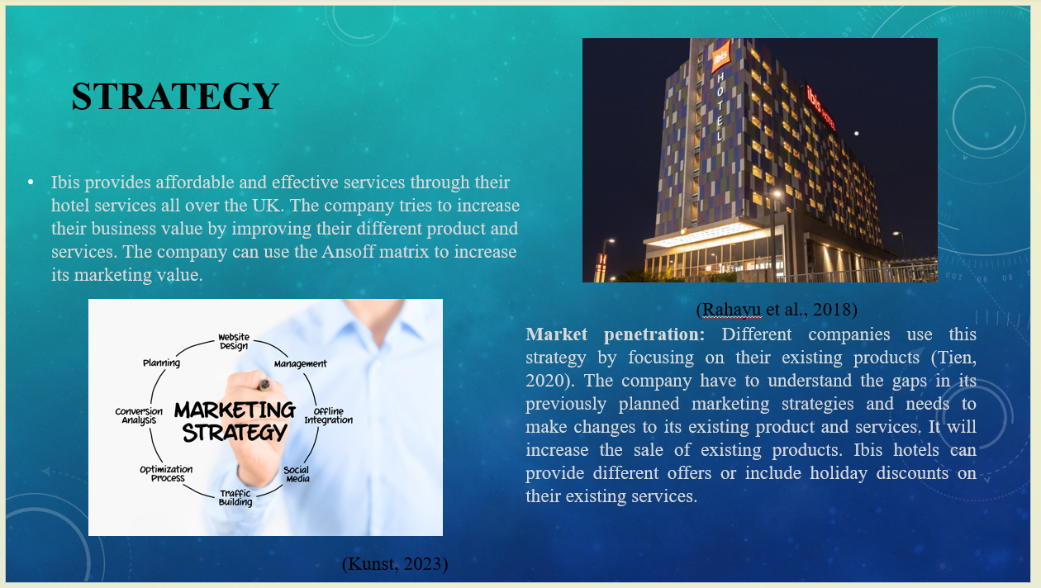
Notes:
Ibis provides affordable and effective services through their hotel services all over the UK. The company tries to increase their business value by improving their different product and services. The company can use the Ansoff matrix to increase its marketing value. It includes some business strategies such as market penetration, product development, market development and diversification.
Market penetration: Different companies use this strategy by focusing on their existing products (Tien, 2020). The company have to understand the gaps in its previously planned marketing strategies and needs to make changes to its existing product and services. It will increase the sale of existing products. Ibis hotels can provide different offers or include holiday discounts on their existing services.

Tactics
Slide:
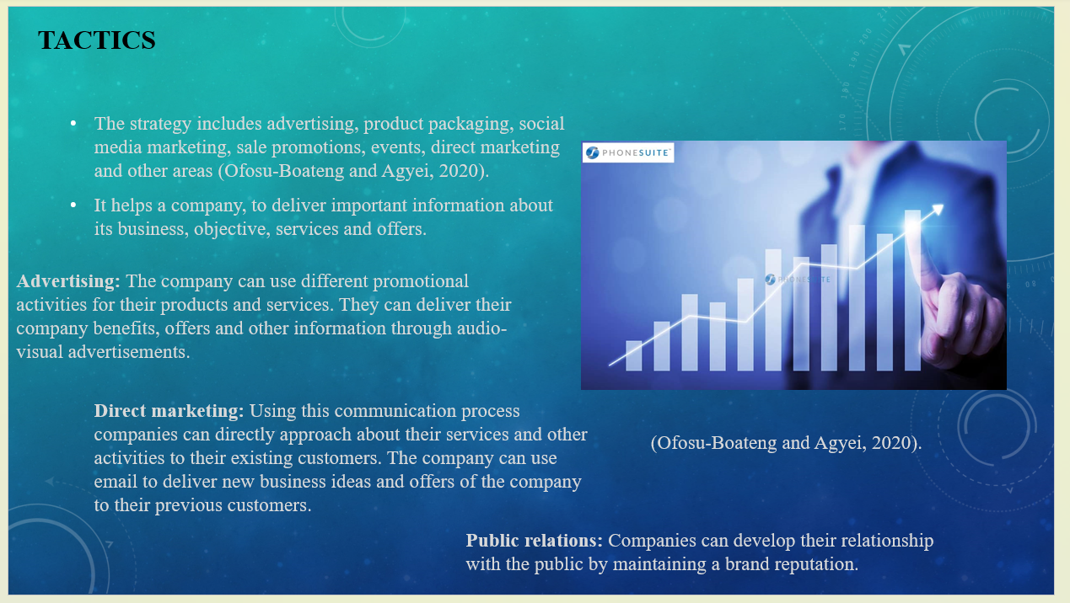
Notes:
The communication mix in marketing describes different tools that organisations use to communicate with their customers and targeted audiences. The strategy includes advertising, product packaging, social media marketing, sale promotions, events, direct marketing and other areas (Ofosu-Boateng and Agyei, 2020). It helps a company, to deliver important information about its business, objective, services and offers. Thus, it can attract more potential customers.
Ibis hotels and their services mainly attract travellers and the number of their competitors are increasing. The company has to follow some communication strategies thus it can expand its services in different areas and can compete with other competitors.
Advertising: The company can use different promotional activities for their products and services. They can deliver their company benefits, offers and other information through audio-visual advertisements. They can also use different applications, media platforms such as Instagram, Facebook and their own websites to convey business-related information. It will influence potential customers to have the convenience of its services.
Direct marketing: Using this communication process companies can directly approach about their services and other activities to their existing customers. The company can use email to deliver new business ideas and offers of the company to their previous customers. It can attract old customers to take their services for the future also. Through the good experiences of existing customers, the company can also attract new targeted customers.
Public relations: Companies can develop their relationship with the public by maintaining a brand reputation. Thus, companies have to properly maintain relations with their customers, investors, production, government and community. Ibis hotels can use different non-paid platforms such as social media, press conferences, speech writing, clearing doubts and others (Hubspot, 2023). It can help the company to be connected with the public and maintain a good brand image by exchanging business-related information and offers.
Currently, the company uses different social media platforms, and emails to communicate with customers. They post about their activities and services thus it can attract more customers. Social media platforms include various people with different perception thus, the company have to promote their services and activities by simplifying the subjects and focusing on attractive offers and discounts. It will encourage customers to take their services and experience the benefits.

Action
Slide:
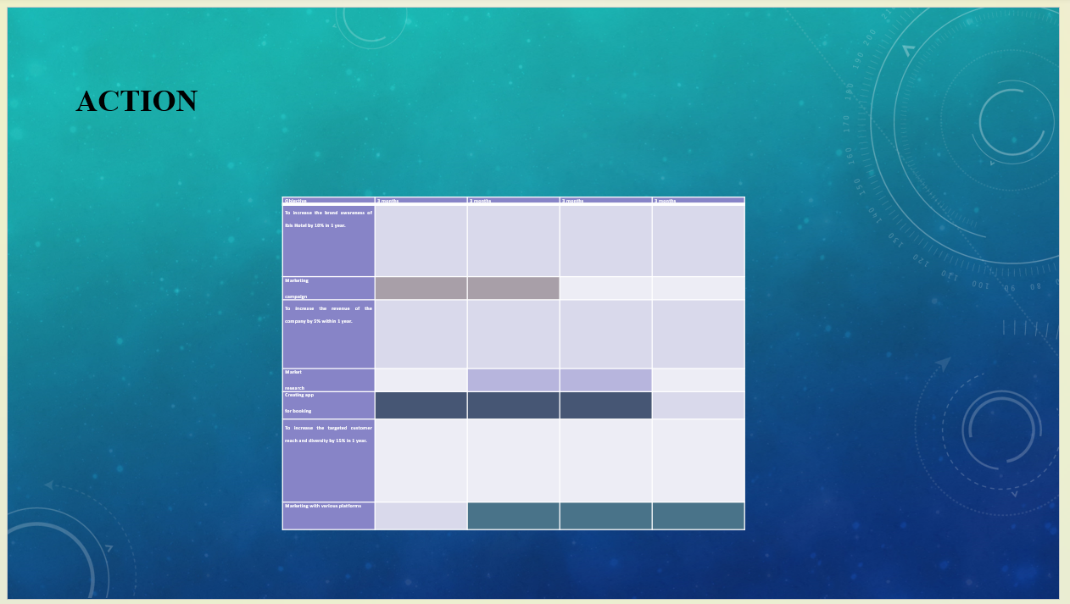
Notes:
Objective | 3 months | 3 months | 3 months | 3 months
To increase the brand awareness of Ibis Hotel by 10% in 1 year.
Marketing
campaign
To increase the revenue of the company by 5% within 1 year.
Market
research
Creating app
for booking
To increase the targeted customer reach and diversity by 15% in 1 year.
Marketing with various platforms

