University of Wales Trinity Saint David

Problem Solving and Decision Making
Teacher Name : Mushfiqur Rahman

MODULE CODE: BMSK4004
Student’s Name: Tawhihur Rahman
Student ID: 1707410
Contents
1 A complex problem in the workplace including its scope and impact 3
1.1 Context 3
1.2 Scope and Impact 3
2 Analysis information on the identified problem, to help inform the decision making process 4
3 A range of alternative solutions to the problem 8
3.1 Alternatives Regarding Place 8
3.2 Alternatives Regarding Food Menu Selection 8
4 A decision-making technique to evaluate a range of solutions to identify the most appropriate option 9
5 A plan for implementing the solution 11
5.1 Aims and Objective Specifications 11
5.2 Situation Analysis 11
5.2.1 PESTLE 11
5.2.2 Five Forces Analysis 13
5.2.3 SWOT Analysis 15
5.3 Implementation Plan 16
6. Communication of the plan to stakeholders 22
7. Appropriate monitoring and review techniques to ensure successful implementation of the solution 24
7.1 Key Performance Indicators (KPI) 24
7.2 360 Feedbacks and Independent Survey 24
Reference 25

1 A complex problem in the workplace including its scope and impact

1.1 Context
The hospitality industry is one of the most attractive industries in the UK. The industry is rapidly growing mainly because of the increased tourist's trend, the presence of the people from the diversified background and also the trend of the UK people to try out foods of diversified ranges and tastes. A newly proposed restaurant named “Indian Spice” is expected to be established in the West London area. The restaurant will offer traditional Indian foods sustaining the indigenous tastes. The main target customers will be the British Indians living in the west London area. There are around the 542857 Indians living in the London which constitutes 6.8% of the total London Population (Barwick, & Barwick, 2017). There are around 350 Indian restaurants all over the London but these are not adequate enough to meet the demand for the huge Indian communities and visitors coming from India (Davidson, 2017).

1.2 Scope and Impact
The Indian community is the largest ethnic group living in the West London area. There are around 50 Indian restaurants in this area. The idea to establish a new Indian restaurant is an exciting idea but the problem is where to set up and how to successfully establish the restaurant. The scope of this proposed problem includes the selection of the proper location, analysing the feasibility of the project, sourcing the required resources for the successful launching of the restaurant, implementation details required for the new restaurant establishment and also details ideas and knowledge regarding restaurant operation. To solve the problem of selecting the perfect location for the evaluation of the place, the cost-benefit analysis and also the other relevant problem solving and appraisal tools are also included in the project's scope. The impact of the proposed Indian restaurant will be that it will allow the Indian community living in the West London area to have access to the authentic Indian cuisine and also to enjoy the traditional Indian dishes with ease. The new restaurant will also offer traditional Indian spice cuisine to the British nationals and other visitors who want to explore the Indian dishes as well.

2 Analysis information on the identified problem, to help inform the decision-making process
The problem here is to set up an Indian Restaurant in the West London area selecting a suitable location and also arrange everything rightly to successfully establish the business. Restaurant segment of the UK is highly growing and profitable segment if little uniqueness and differentiation can be brought within. There are around 83635 restaurants and mobile food cart across the UK. This number has increased a great deal over the years and is expected to increase which can be understood from the below chart:
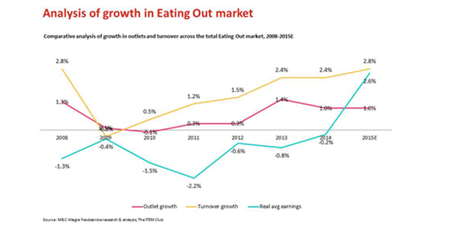
Figure 1: Growth of eating out
source: (Ashworth, and Groningen, 2017)
From the above chart, it can be seen it is very much clear that the growth in eating out has been immense so it is quite logical that the number of the restaurants in the UK have also increased to cope up with the rising demands of the people. There are numerous factors that are contributing to the increased restaurant establishment across the UK and the key reasons for that can be understood as below:
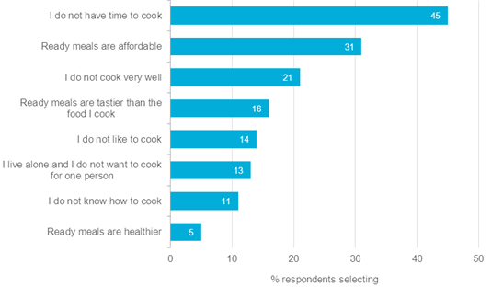
Figure 2: Factors leading to increased restaurant trend
source: (Deng, et al, 2017)
From the above image, it can be seen that people's lack of time to cook, availability and affordability of the ready cooked products and taste and also the quality of the ready cooked meals have contributed to this upward trend. This trend has led to the influence people to try out foods from different countries and have influenced the rise of a restaurant based on other countries foods. The Indian community is the largest community in the UK among the foreigners and the population of the Indian community is also growing at a fast rate which can be understood from the below chart:
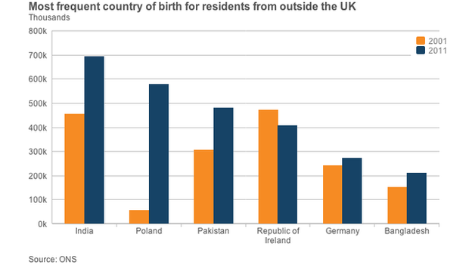
Figure 3: Growth of the Indian Community
Source: (Law, 2017).
From the above chart, it is very much clear that the Indian population has largely grown in the UK and is expected to grow further hence the prospect for the Indian restaurant is also higher. Moreover, the number of visitors from India in the UK are also expected to rise further which can be understood from the below chart:
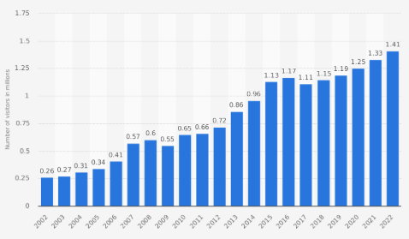
Figure 4: Indian visitors trend in the UK
Source: (Petrova, and Hristov, 2017).
The above chart shows the increased trend of the Indian people visiting the UK and the future also shows the ever-increasing trend. The newly proposed restaurant will grow because of the rise of these supportive factors.
Irrespective of all the positives there are challenges for the newly proposed restaurant as well. a study reveals that 20% of the newly proposed restaurant has failed to continue their operations and 90% of these restaurants have failed because of the poor selection of the place, lack of differentiation and also lack of feasibility analysis (Baron, 2017). The challenge for the new restaurant is to select a place where there are less similar competitors and there are enough demands for the Indian foods. Another challenge for the restaurant is that the ranges of foods they should launch as there will ample similar alternatives offering similar ranges of foods and so the restaurant must differentiate itself to allow sustainable operations.

3 A range of alternative solutions to the problem
For solving a problem appropriately, a range of alternatives should be developed so that if one option doesn't work better other backup plans can come to address the problem. In this situation for establishing the proposed Indian restaurant appropriately, there should be a range of alternatives regarding the location selection and foods menu selection. The range of alternatives solutions appropriate to the context are discussed below:

3.1 Alternatives Regarding Place
There are two alternative choices of locations for the establishment of the proposed Indian restaurant. First one is obvious which is to set up the restaurant where there are lots of Indian people live. The biggest concentration of the Indian community is living in the West London are preferably in the Southall or Wembley areas and so the initial preferences for setting up the new restaurant should one of these two places but there is a problem associated with this (Baum, 2015). As a large number of British Indian people are living these two areas hence there are ample Indian restaurants in these two locations and so it won't be easy for "Indian Spice" to make a market for them as they will face a tough competition though there are ample customers available for them in these two areas. Another alternative for the newly proposed business can be the areas near universities situated in the West London and the reason for that there is a large number of South Asian students are studying in these universities and they always look for their traditional foods. Identification of a University area where there are lots of students and there are no near Indian restaurant can help the business to attract the customers initially and if they can serve better and make a name for themselves they can grow in the future and can expand in the areas where there are large Indian communities.

3.2 Alternatives Regarding Food Menu Selection
There are varieties of Indian cuisines available for "Indian Spice" to offer. The new business should be careful regarding the menu its menu selection. Indian cuisine offers a variety of large food menus hence it won't be possible for the new business to offer all as there are costs and huge resources requirements associated with it and the risk factors will be higher (Beaumont, et al, 2016). The restaurant should be selective enough in launching the menus that they have the competitive advantage in and there are enough demands in the market at the same time as well. For that, there should be enough market research and analysis to select the menus that go with the restaurant resources and that are mostly demanded by the customers. The restaurant can make itself specialised in one type of menu such as “Kebab” or can launch “diversified menus” according to the market research results.

4 A decision-making technique to evaluate a range of solutions to identify the most appropriate option
There are some alternatives regarding the selection of two main issues for establishing the restaurant named “Indian Spice”. There are two alternatives regarding the place selection the first one near the Indian community such as Southall or Wembley and the 2nd alternative is near the University of West London area. The comparison of these two alternatives are below:
Criteria | Southall or Wembley Area | University Area
Presence of the Competitors | High | Low
Presence of the Indian Community | High | Low
Availability of Raw Materials | High | Medium
Availability of the Human Resources | Medium | High
Demand for Indian Cuisines | High | Medium
The Southall or Wembley area presents higher demand and higher resources availability and also high presence of the Indian communities but the major problem is the competition and this will allow narrower chance for the new business to establish themselves unless they have unique resource to attract the customers which can’t be possible considering it will be start-up (Blair, and Hitchcock, 2017). The feasible option for the company should be establishing the restaurant in the University area though there is the moderate presence of the resources and demand in this area. Few things can work to the selection of this place as the business will be only Indian restaurant nearby, there will be enough Indian students and their possible visitors and also there are opportunities that British nationals and people from other communities may opt to try Indian cuisine. So the business should be set in the “University Area”.
The second alternative is whether the company should go on to launch a single menu like "kebab" or should the offer "Diversified Cuisine". The comparison of these two options are below:
Criteria | Single Menu “Kebab” | Diversified Menu
Cost Advantage | High | Low
Demand | Moderate | Moderate
Competitive pressure | High | Low
Opportunity for Diversification | Low | High
Economies of Scale | High | Low
Though the Indian Kebab is to some extent different compared to the British Kebab and steak still there are substitute products and people look for differentiation in terms of trying out the different cuisines hence choosing one product will not do for the new business. Choosing to launch the diversified products can help the company to attract customers and allow them with differentiated experiences at the same time. However, there will be fewer economies of scale in this option and moreover, there will be fewer opportunities for cost saving but the diversification and differentiation opportunities will be higher. However, the business shouldn't go for launching random menus rather they should conduct sound research to launch the menus that are demanded by the customers. a survey conducted by Burton et al (2017) reveals that the most demanded Indian menus are the Indian chicken curries, lam items, spice items, sweeteners and traditional light foods. The business can initially launch these items and they should go for further diversification to attract new customers.

5 A plan for implementing the solution
For successfully launching there should be an organised plan and the management related person should make the proper implementation for the plans as the success is directly connected with it. The plan for launching the new Indian restaurant will follow the following steps:

5.1 Aims and Objective Specifications
The aim is to successfully launch the project within the agreed period of time in the selected area enabling the selected menus as planned. The objectives are:
- To allow the company to pass the initial hurdles and establish their physical location successfully
- To attract all 80% of the customers in the targeted areas within the first 1 year
- To allow the company spread their branches in Wembley and Southall within 1 year
- To maintain operational excellence for the sustainable future

5.2 Situation Analysis
For the proper establishment of the proposed restaurant, the internal and external environmental audit is very much important for the company and the management must assess the factors that can create an influence on the business. The situation analysis in the context of the restaurant is below:

5.2.1 PESTLE
To evaluate the external environment of the business PESTLE framework is used as it helps to find out the issues of the outside environment that are not within the control of the company but can affect the business operations significantly. The application of the PESTLE framework in the given context is below:
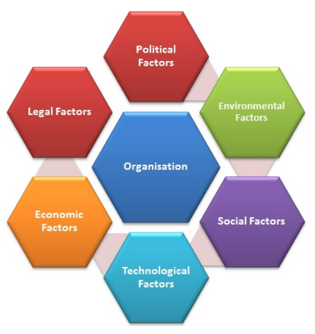
Figure 5: PESTLE Framework
Source: (Cahill, 2017).
Political: The political issues include the political condition inside the country, the labour laws, trade treaties, government views regarding the business and so on. As it will be an Indian restaurant hence there might some regulatory challenges and also the change in the labour laws can affect the business operations significantly. Moreover, the Brexit issues will allow less EU nationals to enter in the country as this can affect the business as these people look for cheaper foods and opt to try new cuisine often (Caprotti, 2017). The Brexit issue is going to create an impact on the number of visitors that will also have an adverse impact on the business.
Economic: The economic environment delineates how well a business will be run. Economies factors include the rate of unemployment, income and savings trend, the growth of GDP, inflation and so on. If there is less unemployment and people have enough money to spend the business will grow if not the business will be adversely affected as people are not going to eat outside the home. Hence, stable economy is important for the proposed business growth. The inflation will affect the raw material price and hence will also adversely affect the profit margin if it rises.
Social: The social issues have the biggest impact on the restaurant business as these delineate the eating habit and also determine the people's likes and preferences. As the people of the UK are looking to take away foods and there have been a growing and stable trend regarding the consumption of foreign cosines the proposed Indian restaurant is expected to grow. If this social trend changes the business will have fewer customers for them hence favourable social trend is important.
Technological: In the high tech business world the implications of the technologies have a significant implication on the business operations. Transaction processing software's, automated inventory control system, payroll software, digital media marketing and also so many technologies related changes are taking place in the restaurant business (Cherunilam, 2017). The newly proposed business must cope up with these issues accordingly so that the sustain the competitive pressure in the market properly.
Legal: The newly proposed business must comply and abide by some established laws and regulations. The business must comply with the General Food Regulations of 2004 and also must abide by the food safety act of 1990. The business will also need to comply with the UK labour law of 1998 and must abide by the minimum wage laws, workplace safety and security law of 2006 and so on (Delta, 2016). Breach of these can result in penalties and harm of reputations for the company in the long run.
Environmental: The environmental issues are needed to be addressed carefully as these have an impact on the CSR image of the company. Under this, the newly proposed business should abide by the laws regarding the lack of use of plastic related products in their restaurant and should have a proper waste management system accordingly.

5.2.2 Five Forces Analysis
Before launching a business, the attractiveness and details of ideas regarding the dynamics of the industry should be gained. The industry analysis of the proposed business is done below with the help of five forces framework:
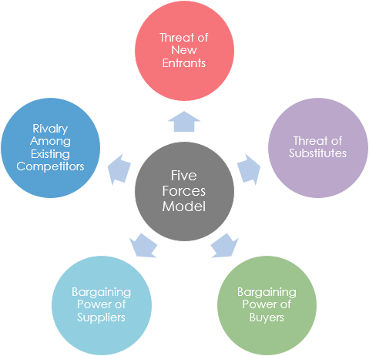
Figure 6: Five Forces Analysis
Source: (Dibb, and Simkin, 2017).
The threat of the new entrants: High
The degree of the threats from the new entrants is connected with the entry barriers in an industry. Although the UK restaurant industry is highly concentrated the entry barriers are very much lower in this case mainly because there is fewer capital required for establishing a restaurant, there is no monopoly power and anybody using their personal skills can start a restaurant. Moreover, as the proposed business will be the first Indian restaurant in the university area hence the entry barrier will be higher.
Threats from the Substitutes: Higher
There are amble substitute products around as there are ample Chinese, British, Japanese and other continentals’ restaurants around the UK and around the university areas hence the customers can easily replace their choices with. There are no switching costs associated with it as well (Ellson, 2017). However, the company can still make business as Indian customers are expected to stay loyal to them.
Bargaining Power of the Buyers: High
The bargaining power of the buyers is higher mainly because the buyers have the same quality alternatives available at their doorstep and there are lower switching costs associated as well. There is an ample range of alternatives to restaurants to try out as well. These issues have made the bargaining power of the buyers higher.
Bargaining Power of the Suppliers: Moderate
The bargaining power of the suppliers is moderate mainly because there is an available supplier's presence and also the restaurants tend to buy at a time. In most, cases the restaurants make and prepare ingredients on their own for serving their dishes. Moreover, the raw materials availability also has contributed to make the suppliers power lower.
Rivalry among the Existing Competitors: Moderate
The rivalry among the existing competitors is very much intense in the other regular segment of the restaurant industry but for an Indian restaurant, it is relatively moderate mainly because there have been not enough Indian restaurants to dine the people for the ever-growing Indian community. There are enough gaps in the marketing and the newly proposed business can really bank on those.

5.2.3 SWOT Analysis
The management of the start-up should have a precise idea regarding their own strengths, opportunities, threats and also weaknesses to operate their business operations accordingly in order to gain competitive advantages. The SWOT analysis for the company is below:
Strength:  Unique idea  Differentiated products offering  Personal expertise  Organised feasible idea  Competent Human Resource Team | Weaknesses:  Ambiguity regarding the demand for the proposed menu.  Lack of experience.  Inconsistent supply chain network.
Opportunity:  Expanding in the Indian community concentrated areas,  Launching of new menus  Creating an online presence | Threats:  Excessive regulations can make the operations costlier.  Competition from the other restaurants.

5.3 Implementation Plan
The implementation plan includes the details work breakdown structure, the schedule integrating the Gantt Chart, the budget breakdown, risk analysis and also the network diagram for the project. The key tasks of the project can be presented in a simplified manner through the preparation of the work breakdown structure. The WBS for the proposed project is below:
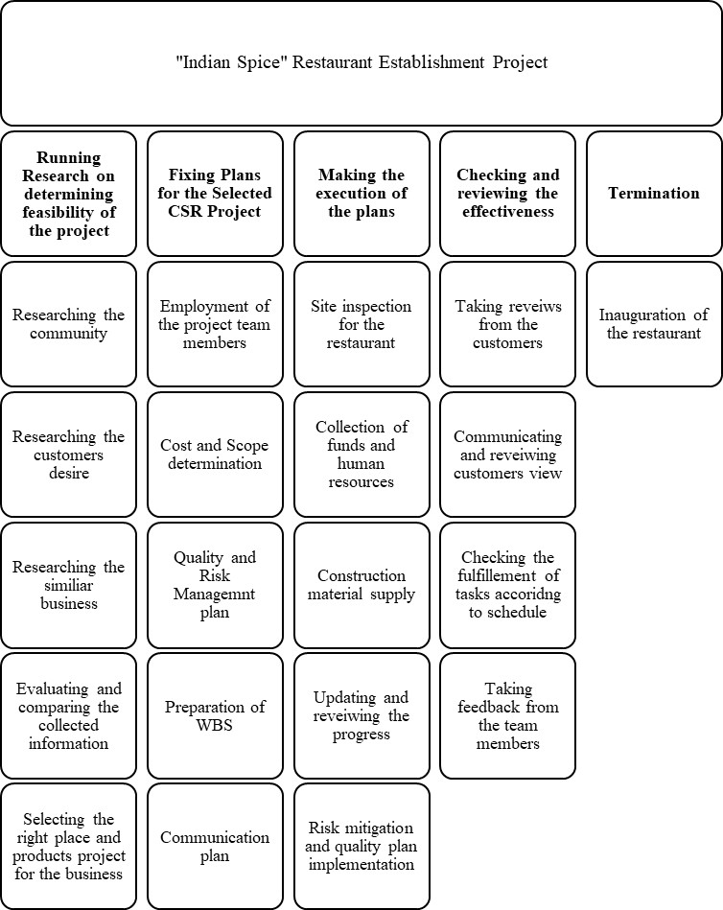
Figure 7: WBS
Source: Author
The project schedule according to the WBS of the project is demonstrated below:
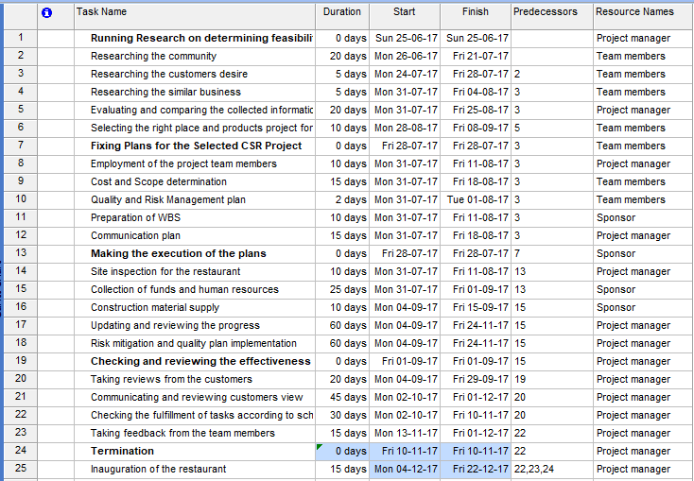
Figure 8: Schedule
Source: Author
The Gantt chart showing the appropriate time frame of the proposed restaurant project is demonstrated below:
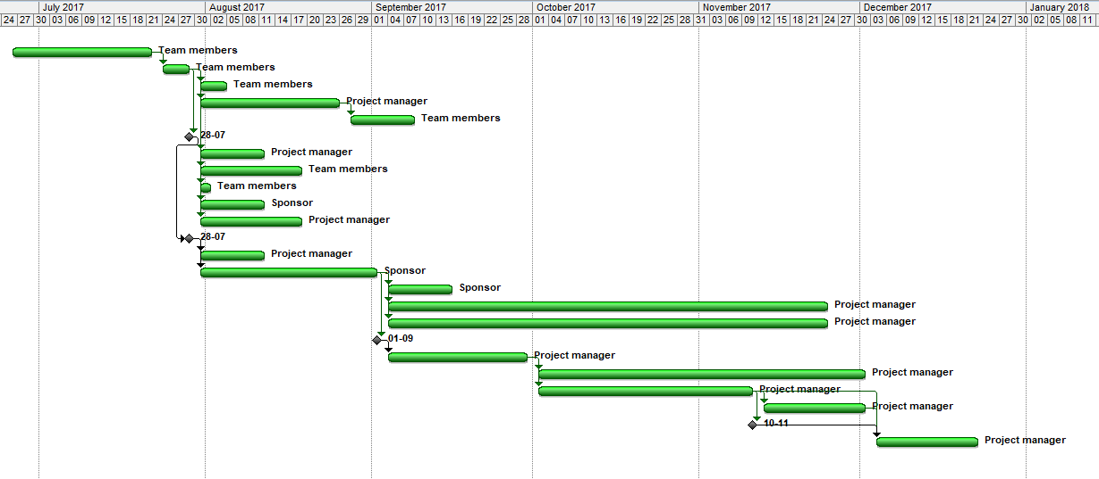
Figure 9: Network
Source: Author
The Gantt chart showing the relationship between the tasks and their predecessors can be demonstrated in the following diagram:
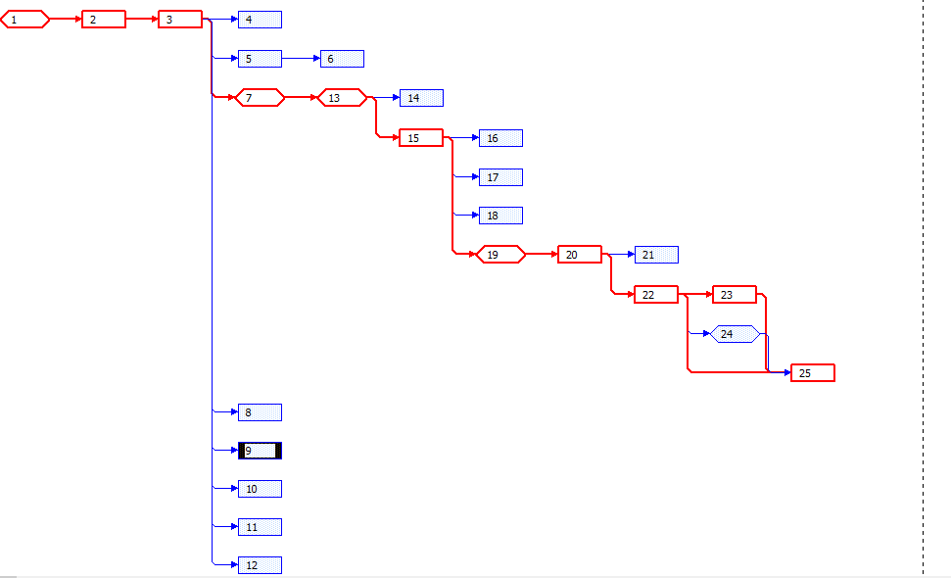
Figure 10: Network Diagram
Source: Author
The above network diagram shows that the critical tasks for the successful establishment of the restaurants are the activity number 1, 2, 3, 7, 12, 15, 19, 20, 22, 23 and 25 that signifies the least time required from the implementation of this project are 0+20+5+0+0+25+0+20+30+15+15=130 days.
There can be risks having different degrees of probabilities and impact associated with the launching of this new restaurant. The risk analysis for the proposed project is provided below with the help of the following risk matrix:
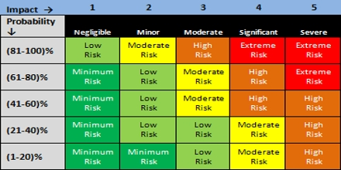
Figure 11: Risk Matrix
Source: (Kaarbøe, et al, 2018).
Risk Sources | Probability | Impact | Recommended Actions
Financial Risk | 61-80% | 4 | Identifying and managing the required fund from the pre-specified sources and preparation of the well-thought budget.
Human Resources Risks | 81-100% | 5 | Carrying out the skill audit to mark and manage the required human resources.
Technical Risks | 41-60% | 3 | Training and developing the team workers
The budget for this project is demonstrated below:
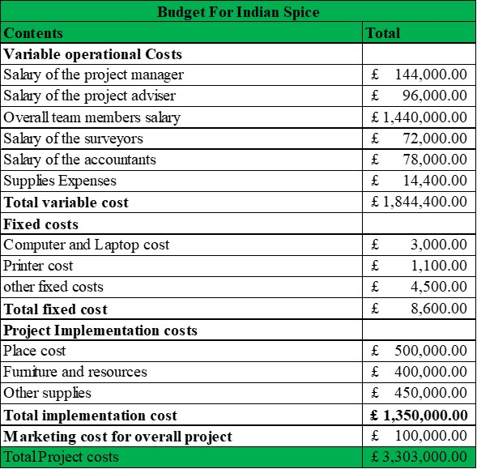
The budget costs breakdown is demonstrated below:

Figure 12: Budget breakdown
Source: Author
The above chart shows that most of the costs are variable and the implementation costs at 56% and 41% of the budget will be spent behind these two issues respectively.

6. Communication of the plan to stakeholders
There will be stakeholders holding the different level of powers and interests associated with the project and all of these stakeholders are needed to be communicated well to meet up their information needs. The stakeholders of the project can be both internal and external. The internal stakeholders will be the owners, employees and legal advisors. The external stakeholders are the pressure groups, customers, media, suppliers and so on. For keeping all the related stakeholders updated a stakeholder log will be used which is demonstrated below:
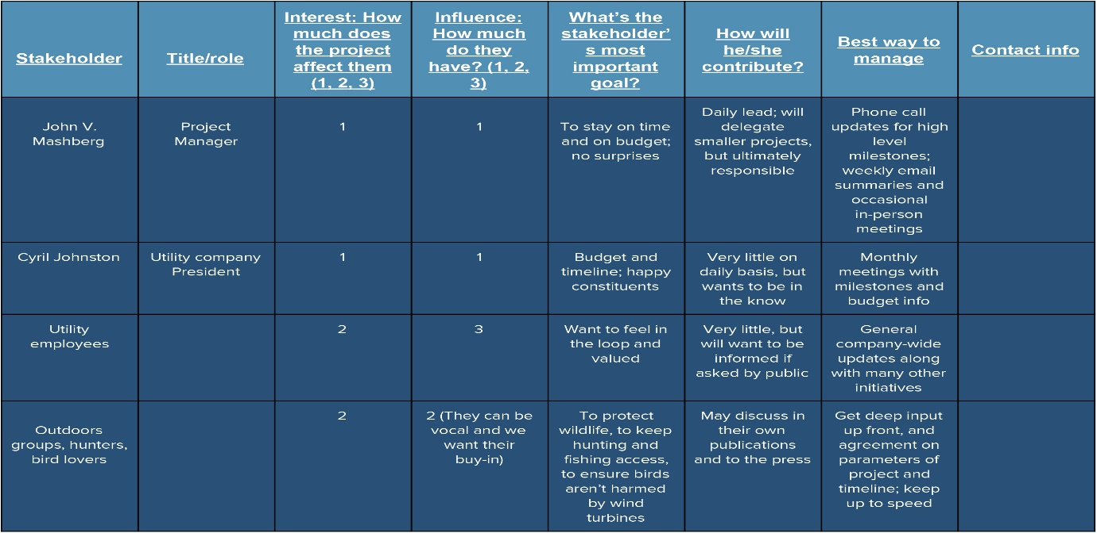
Figure 13: Stakeholder communication example
Source: (Ellson, 2017).
The information needs will be met according to the power and interest of the individual stakeholders which will be identified using the following matrix:
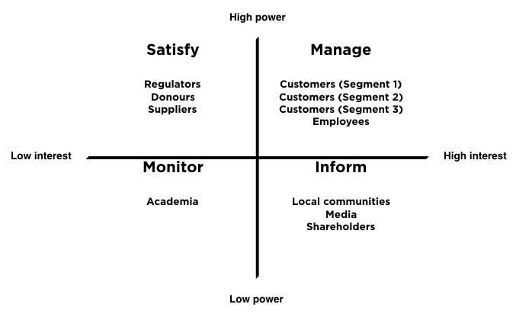
Figure 14: Stakeholder matrix
Source: Author
From the above image it can be seen that the customers, employees and investors have both high powers and interest and they need to be managed carefully such as the customer's quarries are needed to be met instantly, investors should be informed regarding the status of the project and employee's compensation and benefits needs should be maintained. To manage the needs of the stakeholders both upward and downward communication tools will be used and both formal and informal communication tools will be used. For example, workshops, meetings and discussion sessions can be arranged for formal communication and for informal communication phone calls and social media networks can be used (Dibb, and Simkin, 2017).

7. Appropriate monitoring and review techniques to ensure successful implementation of the solution
To find out the success of the project appropriate implementation of the monitoring and reviewing techniques are important. The following monitoring and reviewing techniques will be used for the appraisal of the successful implementation of the Indian restaurant:

7.1 Key Performance Indicators (KPI)
The success of the restaurant will be judged against the pre-set indicators which are below:
Indicators | 1st quarter | 2nd quarter | 3rd quarter | 4th quarter
Sales Growth | 5% | 8% | 13% | 20%
New Customer Acquisition | 15% | 25% | 35% | 60%
Customer Satisfaction Rate | 70% | 85% | 95% | 98%
Market Share | 5% | 7% | 11% | 15%
If the proposed Indian restaurant can meet the above benchmark within the first year it will be assumed as successful and if not, it the improvement plan will be proposed.

7.2 360 Feedbacks and Independent Survey
The business will allow 360 feedbacks to judge the project success under which the responses from the individuals from every department and every level of the new restaurants will be taken and their reviews will be evaluated to make the success criteria and prepare the further improvement plan. The independent survey through the interview and close-ended survey questionnaire will also be conducted to check the success of the project accordingly.
The newly proposed restaurant is definitely an exciting idea of the above-mentioned issues can be maintained and implemented well. In the long run, the proposed restaurant can sustainably grow and expand as per the expectations if the above-mentioned issues are strictly handled.

Reference
Ashworth, G. and Groningen, R. (2017). Tourism and urban development: Towards a theory of urban tourism, and its application to the case of Venice, Italy. Tourism Management, 13(3), pp.345-346.
Baron, D. (2017). Business and its environment. Upper Saddle River, N.J.: Pearson Education.
Barwick, J., & Barwick, J. (2017). Tourism and Hospitality. Abbotsford, Vic.: Echidna.
Baum, T. (2015). Strategic management. Los Angeles: Sage.
Beaumont, J., Pedersen, L. and Whitaker, B. (2016). Managing the environment. Oxford: Butterworth Heinemann.
Blair, A. and Hitchcock, D. (2017). Environment and business. London: Routledge.
Burton, P., Parker, G. and Lawley, B. (2017). 42 rules of product marketing. Cupertino, CA: Super Star Press.
Cahill, D. (2017). Lifestyle market segmentation. New York: Haworth Press.
Caprotti, F. (2017). Environment, Business and the Firm. Geography Compass, 6(3), pp.163-174.
Cherunilam, F. (2017). Business environment. 1st ed. Mumbai [India]: Himalaya Pub. House.
Davidson, R. (2017). Tourism and Hospitality and Hospitality. London: Pitman.
Delta, S. (2016). Business strategy and the environment. Environment International, 19(3), p.310.
Deng, J., Arano, K., Pierskalla, C. and McNeel, J. (2017). Linking Urban Forests and Urban Tourism: A Case of Savannah, Georgia. Tourism Analysis, 15(2), pp.167-181.
Dhaliwal, N. (2015). Tourism and Hospitality and Hospitality London: Vintage Books.
Dibb, S., and Simkin, L. (2017). Market Segmentation Success. Hoboken: Taylor and Francis.
Ellson, T. (2017). Culture and positioning as determinants of strategy. Houndmills, Basingstoke, Hampshire: Palgrave Macmillan.
Kaarbøe, K., Gooderham, P. and Nørreklit, H. (2018). Managing in dynamic business environments.
Law, C. (2017). Quality management in urban tourism. Tourism Management, 19(2), p.186.
Petrova, P. and Hristov, D. (2017). Collaborative Management and Planning of Urban Heritage Tourism: Public Sector Perspective. International Journal of Tourism Research, 18(1), pp.1-9.

