  - By becoming a member of the people profession and joining the CIPD they are in the governing body if failing to meet its standards it can be ceased (Smith and Mitchell, 2022). The CIPD professional map sets a benchmark for the people profession (CIPD, 2024). The map includes all areas relevant to people professionals, Purpose and values, Core behaviour, Core knowledge and Specialist knowledge which is dependent on the role they are delivering. Regardless of the size of an organisation the purpose of a people profession is to set a standard which are all based on principles of valuing people, and to provide guidance and challenge organisational leaders to develop cultures in the workplace that support good work and overall recognise the value of the people working in an organisation (CIPD, 2025a). This can involve working with stake holders, line managers, and must involve the senior professionals in the organisation. If all are not involved in the process the standards could fail to reach the wider business, this is the case of Nexxobyt and at the current moment all teams are not aligned so the employee lifecycle and training across the business is varied (Smith and Mitchell, 2022). The recruitment process at Nexxobyt needs to be more robust, so that the right people come into the business and the same interview process is used by all team leaders. This is a key part of promoting equality and diversity in the workplace. At Nexxobyt as a senior team, good work needs promoting across the business, this is to ensure development and training are fair in all departments. When people are learning for growth, it could lead to better enhanced prospects for the individual within the company (Rees and French 2013). Which will benefit the employee succession plan for Nexxobyt. Regular performance reviews need to be conducted with all employees, they need to understand their expectations in their job role, be managed so they are motivated in the workplace and have access to resources and support they need to carry out their work successfully (CIPD, 2025b). As a business it is rapidly changing and expanding, for this to be sustainable and to keep valuable employees in the business, we will plan effective learning interventions for all employees that will support the organisations objectives (Hayden, 2025) . All team leaders will undertake training on a fortnightly basis which will be instructor lead and will be designed to develop and change current behaviour that is currently being portrayed at Nexxobyt.

  - A personal value that will benefit Nexxobyt is fairness, treating people well or as if you wanted to be treated. Whilst in a people professional role, the displaying of fairness across Nexxobyt display’s professionalism and can gain respect in any workplace by creating an inclusive organisational culture. By having this personal value, it will promote equality, diversity and inclusion at Nexxobyt this personal value will make everyone feel safe and give people a sense of belonging (Ali, 2024). By fairness consistently applied in Nexxobyt it will create a positive culture where everyone has equal access to employment, learning and development opportunities, and promotion opportunities which could be advertised in weekly newsletters or team communication boards. Everyone in Nexxobyt has the right to be treated fairly and be free of any direct or indirect discrimination, bullying or harassment (Ali, 2024). According to Great places to work (2021), When employees are treated fairly in an organisation regardless of age, race or religion they not only take better pride in the work that they do, but they look forward to going to work on a daily basis and stay longer with the organisation (Smith and Mitchell, 2022).
Another personal value that will benefit Nexxobyt is achievement. By having achievement as a personal value it will help Nexxobyt achieve a strong drive for results, by having this value it will help navigate problems and obstacles and overall improve the company’s processes. People practitioner plays a key role in standard setting (Reese and French 2013). By introducing regular performance reviews through line managers, they will play a role with engagement and performance of all their team setting clear objectives to meet company targets (Taylor and Woodham, 2022). Achievement will help drive and take responsibility for the training and learning provided by Nexxobyt, ensuring everyone has the capability and training to do their jobs well for Nexxobyt to achieve great results.
By applying both fairness and achievement in Nexxobyt it will provide a more structured environment where policies will be applied throughout the company to involve a greater focus on results and the overall role of the line manager ( Reese and French, 2013) Whilst achievement will focus on the direction that the company is moving in, the fairness will ensure that the individual will be treated with a process that is acceptable to everyone.

  - People professionals are required to usually be at the centre of any change management, during a period of change this is where people are most likely to be stressed, this means that effective communication is even more important (Smith and Mitchell, 2022). By communicating clearly and being the voice of Nexxobyt they can build a shared sense of purpose which is aligned to the organisational strategy, it will drive a two-way dialogue between the people professional and senior leaders by including them in the process they will receive support from the senior team. By communicating clearly, it allows employees to stay connected to their workplace whilst understanding what the overall goal is of the organisation ultimately, they will develop a sense of belonging in Nexxobyt and how they can contribute further to the companies’ wider purpose and future goals (CIPDa, 2024). Communication plays a key role to ensure messages are clear around all people management and employment issues.

As a people professional if you don’t communicate effectively through change individuals who have not been communicated to may resist the change that they are planning which could disrupt the implementation and increase your current workload as there will be more navigation needed with certain individuals (CIPDa, 2024). Failure to communicate properly could have a negative effect on the employee engagement and motivation throughout Nexxobyt which can cause problems with production and overall staff morale throughout the organisation (CIPDb, 2025). Trust is also a massive impact and when making decisions for significant change to happen effectively if communication lacks trust maybe hard to get from senior teams. If communication is not addressed with those that are affected by the change, they will lack trust with the people professional (CIBDb, 2025).

  - Inclusivity in a workplace is key to an organisation’s success and happy workforce. By the manager creating a discriminating culture makes an overall difference to how people are feeling in the workplace, being in a senior role discrimination is exemplified by leadership by excluding people from opportunities and showing favouritism to employees (Green, 2019). To approach this as a people professional at Nexxobyt, firstly create a talk to the team, encourage them to speak up, creating a process to help people at Nexxobyt, after speaking to employees if more people are clarifying what you have heard already have a private one to one with the manager recording all notes of the meeting, highlighting the manager’s job role and responsibilities in black and white to their employees moving forward to promote inclusivity, during this meeting talk to the manager about promoting codes of ethics and conduct as they are generally effective in an organisation when they are actually used, it’s about fairly applying these in Nexxobyt moving forward and if they are not followed there would be consequences if they were abused (Green, 2019). As a people professional it is key to offer the manager continuous support and guidance speaking to them on a frequent basis and monitoring their performance moving forward. This instant wouldn’t have raised further unless the manager fails to improve following the meeting.

When illegal behaviour is potentially taking place at Nexxobyt as a people professional include company directors in what is happening at an operational level, generally an expected outcome for this type of behaviour which should fall under a disciplinary process, and therefore conduct a formal investigation with the employee potential leading with dismissal from the company. However, due to Nexxobyt not having any clear or robust procedures in place there is potentially no fear of the employee for exposure, so this staff member could believe that the activity they were undertaking on work premises was acceptable (CIPDd, 2025). This would need to be addressed with the employee concerned in a recorded meeting, asking questions about the accusations, immediately asking the employee to stop his behaviour and put in place a robust policy strengthening the zero tolerance to employee fraud and nurture a culture of ethical behaviour and integrity. Also using a carefully planned approach after speaking to the individual, share this instance with all existing employees which would then focus on future prevention of illegal activity and introducing an anti-fraud internal culture that promotes future honesty and integrity throughout Nexxobyt (Young, 2024).

For Nexxobyt to operate ethically a people professional needs to implement an ethics programme to bring values to life, which will include a code of ethics, this will guide future behaviours in the workplace. An ethical value that will benefit Nexxobyt is Deontology approach to ethics. By implementing robust procedures and policies to be adhered to in the team, In deontology goodness and badness is evident in the action regardless of the result (Mullins, 2019). This ethic emphasises the rightness or wrongness of an action. At Nexxobyt by constantly applying a Deontology approach in ethics you will be able to influence the ethical climate to encourage team to act and behave in an ethical manner. The ethics will become more principled, and team should stick to following rules and regulation leading to a reduction in unethical choices and dysfunctional behaviour (Russel and Weeks, 2024). If unethical choices are made by someone then having a Deontology approach to this could mean that there are consequences for the action that has been taken, such as a disciplinary procedure. When this is implemented, this will articulate expected behaviours for all employees to follow. To continuously enforce the ethics programme regular communications to employees with the people professional will help provide valuable insight in Nexxobyt (Young, 2024).

2.1 In general a workforce is more likely to act unethical if they perceive that their organisation policies and procedures are inconsistent and not fair for everyone (Russel and Weeks, 2024). If people are not treated fairly this could cause a rising number of grievances, poor performance and surveys resulting in that they lack trust of their senior management team. The human psychological implications of not being treated fairly in the workplace means employees feel that they are constantly watching their back, it can create a strain on an individual and reduce their overall commitment to their work which will decrease the productivity in the organisation (Russel and Weeks, 2024).

According to Great places to work (2021) those organisations that aren’t inclusive will risk losing money and fall behind their competitors. However, those companies that succeed will create tremendous value in their team and the workforce will thrive. According to Heffernan what happens between each other counts, information passes over between people. By including everyone in the process you get more productivity out of employees. By being more inclusive you do not need to compete, success is not achieved by being dependent on high performers in an organisation, by helping each other and creating an inclusive environment by getting to know each other an organisation can achieve great momentum (Heffernan 2015).

According to Maslow’s theory the five needs of a Human from bottom to top are physiological. Without satisfying the psychological needs the body can’t function optimally. This theory suggests that a person is motivated to satisfy the lower levels of the triangle before being driven to achieve the higher level. The second part of the triangle refers to the employment, once an employee feels secure in their job the next part of Maslow’s theory is social and involves feelings of belonging. By creating an environment where people feel valued, included and treated individuals will feel like they belong and feel that the have a sense of purpose. People generally often engage in a profession which gives them a sense of value (Mcleod,2025).

Sirota’s three factor theory of employee motivation highlights that fairness is of particular importance in a workplace, fairness is a useful tool to use when potentially delivering bad news over a potential promotion. If they first accept the news because it was a fair process to reach the decision, opposed to an unhappiness they could experience if the bad news was decided through favouritism or a biased decision (Sirota, 2005). Achievement is another factor in Sirota’s theory, many people in an organisation feel better if their achievements are recognised, by celebrating someone’s achievements it will make them feel more valued and this is beneficial to employers and employees (Sirota, 2005).

The benefits overall as an individual when people feel valued, included and fairly treated they will enjoy working in their job role and generally be more motivated to come to work daily and perform more successfully which will create positive environment. The benefit to the business is that Nexxobyt will become a more attractive place to work for future candidates, current employees would stay with the business longer, and by creating more robust policies and procedures at Nexxobyt you will increase the overall worth and benefit to the business (Heffernan, 2015).

2.2 To ensure that the new staff learning and development policy is fair and inclusive the steps that would need to be taken firstly, approach this design is by assessing the learning needs in Nexxobyt. Without establishing the needs of everyone in the business there is a risk that the design will be meaningless and individuals’ needs for development won’t be included (Perkins 2022). The development required in the new policy can vary on the skill, knowledge, behaviour and the attitude. To access all the core learning needs at Nexxobyt the people professional can utilise staff surveys, appraisal data and include line managers feedback (Perkins 2022). During the development process all managers and seniors of the business will be on board by having one to ones with all staff members asking questions about training needs and what opportunities individuals would like to see at Nexxobyt (Cassady 2022). The people professional could gather a group of people together at least one from every department to be the voice and ask them questions on what training and development need they think that Nexxobyt needs. Once all the evidence has been gathered the people professional can then design the right policy and training needs for Nexxobyt. When the new design has been put into place it needs to be formally communicated to all employees, all managers will have one to ones with employees to promote the training. After the policy has been active for three months, all employees of Nexxobyt will receive a survey asking if they think that the new policy is fair and inclusive for everyone. The people professional can also gather the thoughts from the voice group. By listening and reading what everyone has said the people professional will then be able to tell if it is inclusive and fair for all employees. The people professional can also access if there is an improvement to the ethical culture. The ethical climate is highly influenced by in this case new robust policies and practises (Young 2024).

2.3 I have sought feedback from my line manager about my performance around inclusivity and the current observations he has seen which can help me and others develop further, naturally an extrovert and in group discussions I can be more forward and upcoming with my ideas preventing other people to share theirs as I can overtalk and be quite dominant. He provided specific situations and scenarios to me when this had happened. He also provided the below feedback:

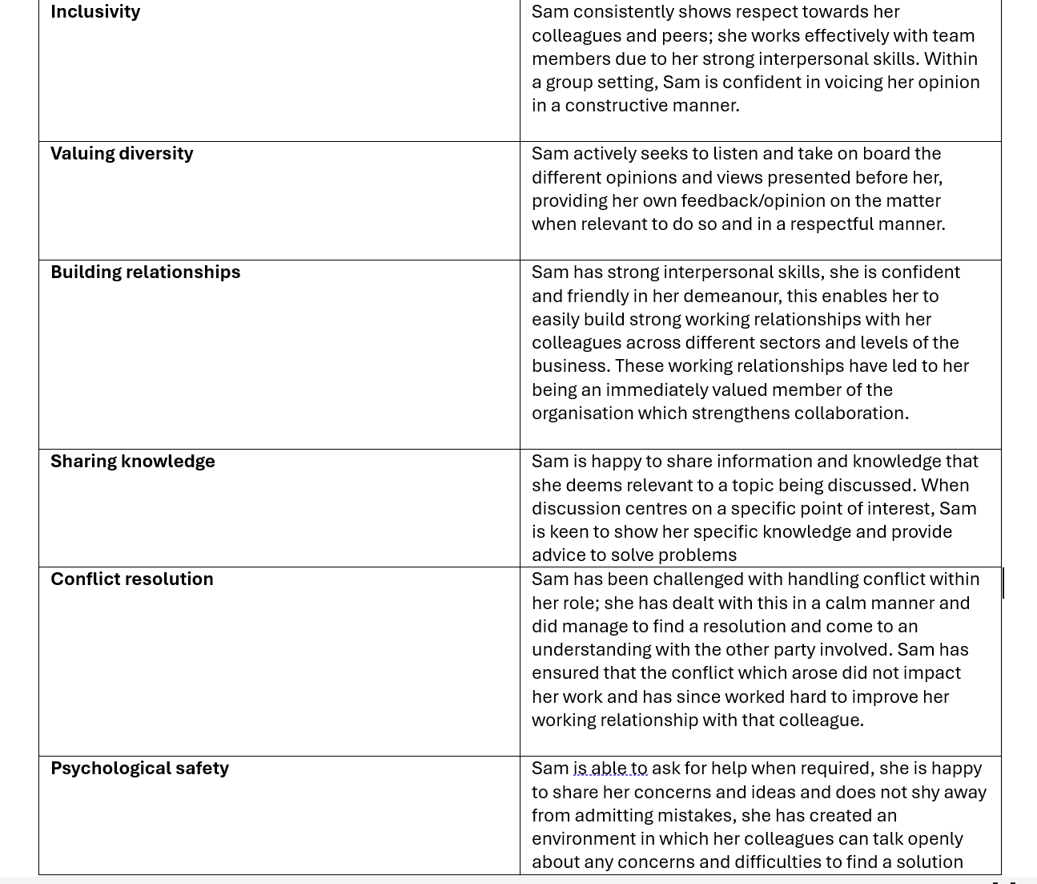

The feedback overall from my line manager was very positive on how I conduct myself in a work setting. As a self-reflection I do actively seek people’s thought process when there are changes to the business. I can have a habit to naturally sway towards similar people in my organisation; I need to spend time with others to increase my potential in the company and create better relationships with people in our head office team by communicating more with them by building a level of trust with them. There is also currently a voice council and as of, yet I have not utilised this to help the company improve by using my background experience and knowledge, I need to be more forthcoming and have confidence to voice my opinion in a professional manner through the networks that are provided. I have also been involved with some small conflicts when change has happened not me personally, but I have supported colleague by giving them advice on how best to deal with the situation. When presented with conflict I work hard to ensure that the conflict does not come between working relationships.

3.1 The people practitioner role is evolving by going from traditionally a rule-based legal and process-driven work, it is one where it has increasingly focused on supporting wellbeing and advancing equality, diversity and inclusion. This shift means that practitioners are now making more informed and value aligned judgements (Paramaguru, 2025), in addition the role has also gone more strategic (Mason, 2024). The people practitioner now sits on the board with the stakeholders rather than solely reporting to a line manager they are part of the decision making and formulates plans for the improvement of the organisation by interpreting workforce data, aligning company.

The implications that this has for my personal development is that I will need to work on my leadership skills and develop my knowledge further on employee wellbeing and EDI. I will also need to develop my skillset on analysing figures and formulating a plan from the data collation as this is not usually part of my job role so I will need to expose myself to tasks for these to continually develop.

3.2 An area of strength for myself in relation to people practise is always listening to how people are affected by change and getting their point of view. This strength will help me provide support when it comes to an individual’s wellbeing, as I am always giving out advice on best working practises and how people can collaboratively work together. In terms of a development area for myself is to recognise in a group setting is not to be too powerful and allow others to voice their opinion rather than overtaking the meeting, in addition to communicating I can use my leadership skills I have gained whilst delivering strategy objectives in an organisation, however being mindful of my feedback and my reflections I need to ensure this is projected professionally and I remain inclusive by broadening my horizons by communicating with everyone in the company. A weakness for myself would be my skillset on analysing figures and formulating an action plan from the data provided to align feedback to the future company goals. Although I am a very good communicator another weakness for myself is swaying more towards people that are quite like myself, in order for me to be more inclusive in the workplace I need to ensure that I am spending time equally, to make sure I am working with everyone and building trust across the company.

3.3 One of the activities I will undertake in the next six months is to have a look at the CIPD’s material on wellbeing so I am able to provide advice to line managers on how they can support well being in their team. I have chosen this as the people practitioner role is evolving, I want to be more confident in providing the right advice to employees to ensure wellbeing is being looked after in the business I am currently working in. The second activity that I will undertake is sourcing a range of evidence including data, research and stakeholder feedback around pay and fairness in my job role that I can use to make a case for change in the company. This will allow me to develop my analysis skills and my communication, I will then develop a report for the company with how employees are currently feeling when it comes to fairness and pay and what effects it may have if no change is made in the business.

3.4

Below are activities that I have personally carried out in a work setting, both activities that I undertook overall increased a positive attitude for me in the workplace and overall effected my well being and increased my performance in the workplace.
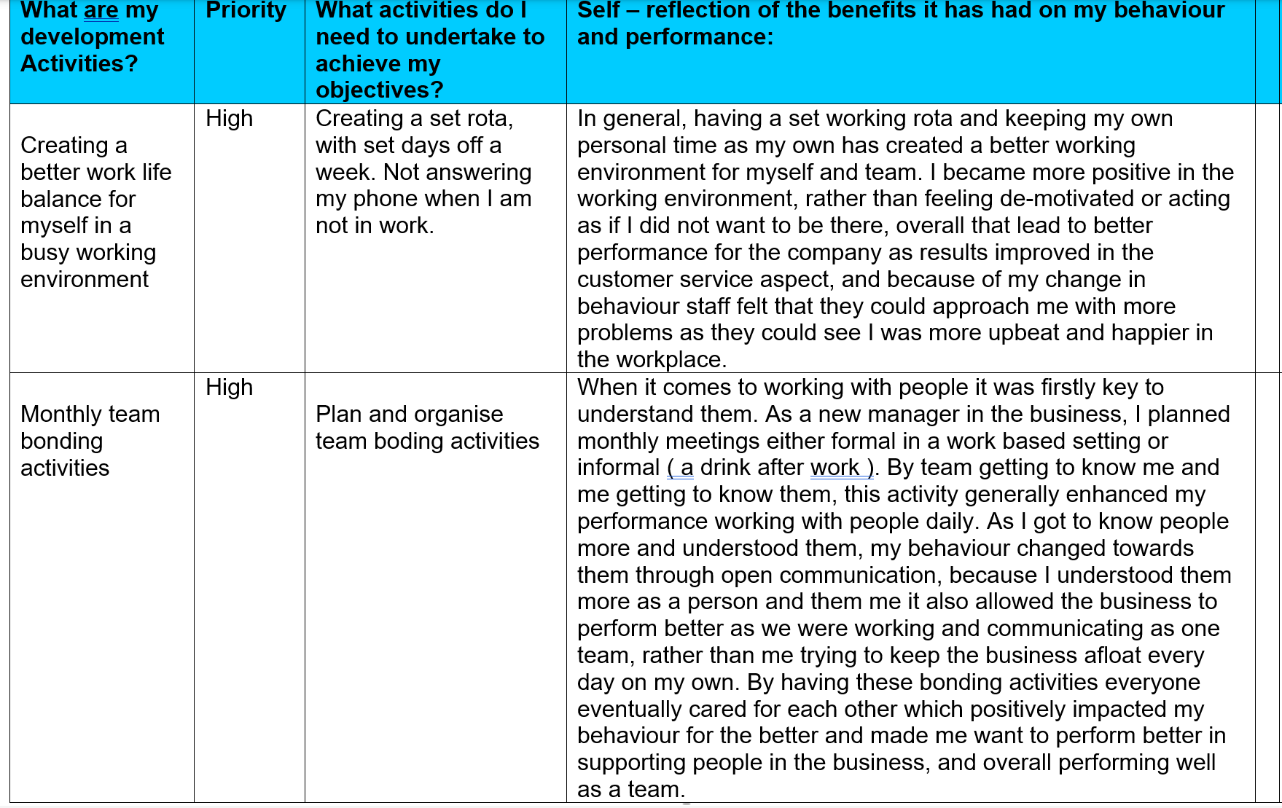

Bibliography
Ali,L. (2024) Equality, diversity and inclusion (EDI) in the workplace, Available at: https://www.cipd.org/uk/knowledge/factsheets/diversity-factsheet/ (Accessed on October 2025)
Cassady, N. (2022) Evidence based L&D – Transfer of learning [podcast] Available at: https://www.cipd.org/en/knowledge/podcasts/transfer-of-learning/ (Accessed October 2025)
CIPD (2019) Building inclusive workplaces, Available at: https://www.cipd.org/uk/knowledge/evidence-reviews/building-inclusive-workplaces/ (Accessed October 2025)
CIPD (2024) CIPD Professional map, Available https://www.cipd.org/globalassets/media/comms/the-people-profession/profession-map-pdfs/profession-map-nov-2024.pdf ( Accessed on October 2025)
CIPD (2024a) Employee communication, Available at https://www.cipd.org/uk/knowledge/factsheets/employee-communication/#why-is-employee-communication-important ( Accessed October 2025)
CIPD (2025a) HR & Standards factsheet, Available at - https://www.cipd.co.uk/knowledge/strategy/hr/standards-factsheet (Accessed on October 2025)
CIPD (2025b) Managing change, Available at - https://www.cipd.org/uk/knowledge/factsheets/change-management-factsheet/ ( Accessed October 2025)
CIPD (2025c) Performance management: An introduction, Available at - https://www.cipd.org/uk/knowledge/factsheets/performance-factsheet/ ( Accessed October 2025)
CIPD (2025d) Staff fraud and dishonesty, Available at - https://www.cipd.org/uk/knowledge/guides/staff-fraud/ (Accessed October 2025)
Great places to work (2021) Why is diversity & inclusion in the workplace important? – Available at https://www.greatplacetowork.com/resources/blog/why-is-diversity-inclusion-in-the-workplace-important ( Accessed October 2025)
Green, M. (2019) Creating ethical workplaces [podcast] 4th June 2019, Available at - https://www.cipd.org/uk/knowledge/podcasts/ethical-workplaces/ (Accessed October 2025)
Hayden,D. (2025) Methods of delivering learning interventions, Available at - https://www.cipd.org/uk/knowledge/factsheets/learning-methods-factsheet/ (Accessed on October 2025)
Heffernan,M. (2015) Forget the peeking order at work, Available at - https://www.ted.com/talks/margaret_heffernan_forget_the_pecking_order_at_work
Mason, H. (2024) The evolving people profession: HR & Compliance Centre research of HR teams, Available at - https://hrcentre.uk.brightmine.com/survey-analysis/the-evolving-people-profession-hr-and-compliance-centre-research-of-hr-teams/167036/?utm_source=google&utm_medium=organic&utm_campaign=SEO&utm_content=SEO – (Accessed November 2025)
Mcleod,S. (2025) Maslow’s Hierachy of needs, Available at - https://www.simplypsychology.org/maslow.html (Accessed on October 2025)
Mullins,L and Mclean,J (2019) Organisational behaviour in the workplace – 12th Edn. Harlow, United kingdom : Pearson education limited
Perkins, G. (2022) Human resource management – 3rd Edn. London, New York, India: Kogan Page.
Rees,G. and French,R. (2013) Leading, managing and developing people – 4thEdn. London: Chartered institute of personal and development.
Paramaguru, T. (2025) Analysis – Evolution of the people profession – Available at - https://www.cipd.org/uk/views-and-insights/thought-leadership/insight/evolution-people-profession ( Accessed November 2025)
Russel,T and Weeks,A (2024) Ethics at work an employers guide – Available at - https://www.cipd.org/uk/knowledge/guides/ethics-work-guide/ ( Accessed October 2025)
Sirota, D., Mischkind, L.A. and Meltzer, M.I. (2005). The Enthusiastic Employee – Available at - https://changingminds.org/explanations/needs/sirota_three_factor.htm (Accessed November 2025)
Smith,J. and Mitchell,J. (2022) Studying human resource management – 3rd Edn. London, New York, India: Kogan Page.
Taylor,S. and Woodhams,C. (2022) Studying human resource management – 3rd Edn. London, New York, India: Kogan Page.
Young,J. (2024) Ethical practise and the role of people professionals – Available at - https://www.cipd.org/uk/knowledge/factsheets/ethics-role-hr-factsheet/ (Accessed October 2025)

