Student Name: Jess Parry
P Number: 1701355
Programme of Study: BA Fine Art: Studio, Site & Context
Module: M4X01559
Seminar Tutors: Simon Kilshaw & Jenn Kirby

Word Count (excluding any form of references) - 1231

"Rhythm of the Language"
The title of this Essay is a quotation taken from the modernised version of the book, originally written by Wassily Kandinsky 'Sounds'. This book, during my deconstructive research of compositions and commentaries, has played a crucial role, along with other research sources I will develop on further in this discussion.
Throughout this piece of writing that proposes the concepts of our imaginary exhibition, I will be discussing Artists including a Composer, which have all influenced the collaborative zine element of our imaginary exhibition including historical perspectives. However, one Artist and one Composer have really gained my interest.
Also, I will be discussing our chosen metaphorical (idealised) space where the proposed exhibition includes the format and structure.
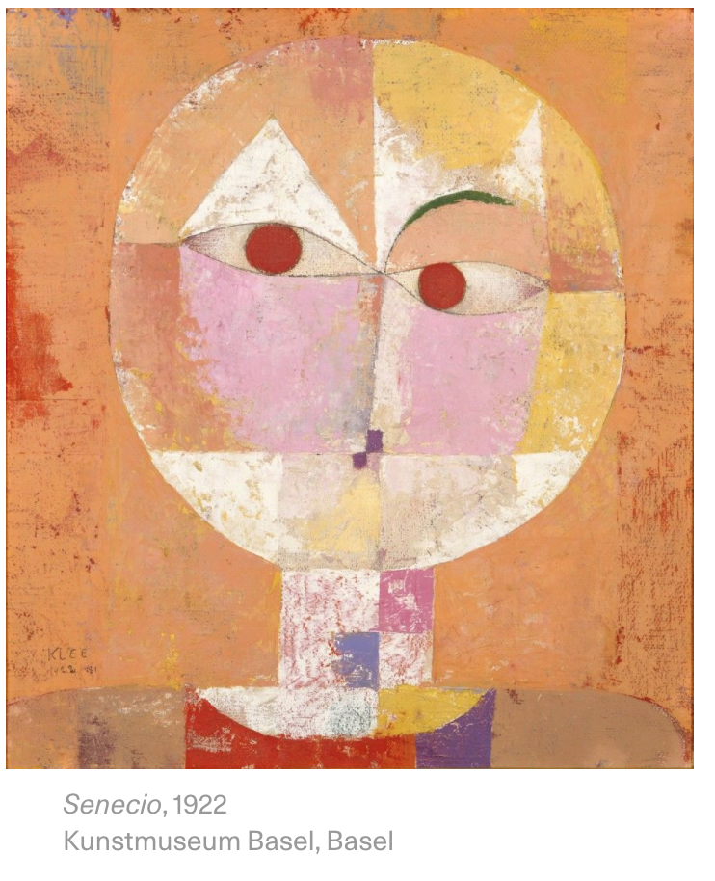

Paul Klee, (1922), Senecio, [Oil on Canvas]

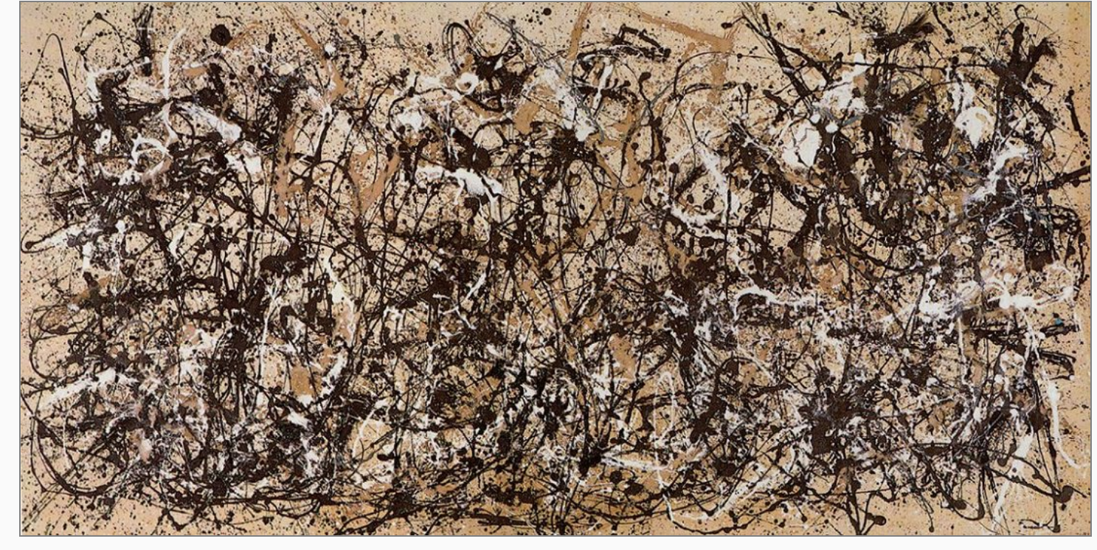

Jackson Pollock, (1950), Autumn Rhythm (Number 30), [Enamel Paint on Canvas]

Through collaborative discussion, our proposed idea for the imaginary exhibition is to explore Expressionist Visual Artists such as Jackson Pollock, Wassily Kandinsky and Paul Klee. We've concluded on using Artists from the art period of Expressionism, as from research Expressionism is when the Artists capture their inner emotions, so we felt that through their expressive, painterly, gestural impressions to the sounds, along with the use of evocative colours, this would visually produce some really intriguing graphic scores in the contemporary day. A graphic score is a contemporary approach to music notations. Our concept is they will all visually translate the sounds they hear from three other Composers to create their own representations of graphic scores. Our metaphorical space is exploring the relationship between the visual arts and music and the quotation stated by Gerard McBurney, a writer from The Guardian, "Musical metaphors", I feel personally will be captured in the contemporary day during the end performance of the imaginary exhibition. Considering format and structure, the imagined exhibition will physically take place in a large, open-plan warehouse moving away from the traditional white-wall gallery space. During a period of three weeks, there will be a collaboration between an Artist and a Composer per week, for example Wassily Kandinsky and Iannis Xenakis. They will not be physically in contact during the week of experimentation and preparation but will be in the same space separated by a partition. On the 6th and final day of the residency they will meet in the flesh and perform.
Considering curation and composition, the Composer will be placed centrally within the open space, and the Artist will represent the sounds, capturing the essence in the form of a contemporary graphic score in the space, using their specialised mediums.
This is our proposed idea for our collaborative imaginary exhibition.

Developing upon the one Artist and one Composer, the Expressionist Wassily Kandinsky and the Composer Iannis Xenakis I believe will make a really captivating collaborative duo.

According to Gerard McBurney, a writer from The Guardian, he described Kandinsky as "the Painter of Sound and Vision". Through developed, deconstructive commentaries a conclusive response will be coherently stated at the end of my discussions.
This Writer had also stated that Kandinsky had worked with a Composer, "Arnold Schoenberg". Further research into this developed my understanding into how the Composer had heavily influenced Kandinsky's work, through the Artist beginning to title his work musically. Also, this research alone has given me crucial evidence showing that Kandinsky has once worked in a collaborative duo before and most significantly with a Composer, which is ideal for our imaginary exhibition.

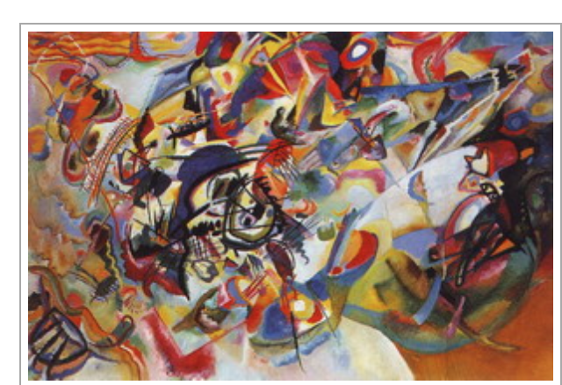

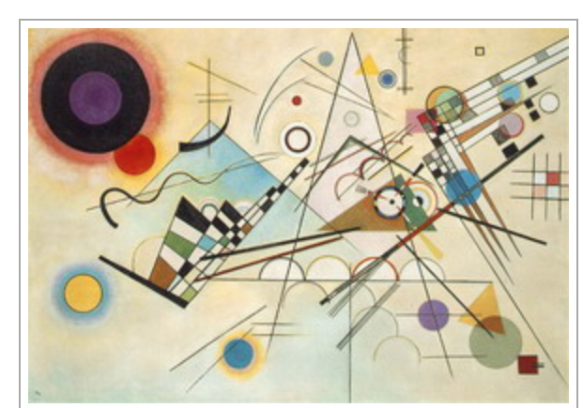
Wassily Kandinsky, (1913), Composition VII, [Oil on Canvas]

Wassily Kandinsky, (1923), Composition VIII, [Oil on Canvas]

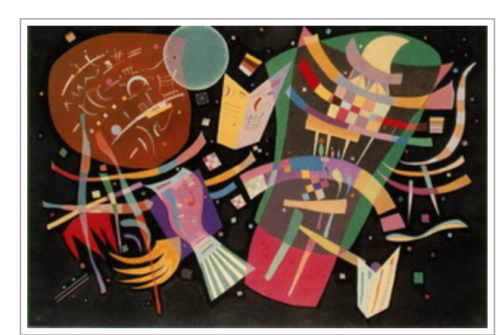

Wassily Kandinsky, (1939), Composition X, [Oil on Canvas]

The researched photos illustrate Kandinsky's paintings. Their titles have intrigued me when discussing Kandinsky's strong relationship and influence with music. Gerard McBurney once again stated that Kandinsky used universal titles that include "Compositions, Improvisations and Impressions". These words are related to musical terminologies and all show to me an evident influence strongly emphasising a relationship to music within Kandinsky's practice.
Also, from that article ''the Painter of Sound and Vision'' as I've previously stated, Kandinsky's "impressions were specifically written in response to hearing music". This quotation alone by McBurney has given me a strong, raw developed understanding of Kandinsky as being heavily inspired by music within his practice and is ideal for our imagined exhibition.

Through extensive research into Kandinsky, I've also discovered that he has produced his own graphic score which is his own visual interpretation of a piece by Beethoven.
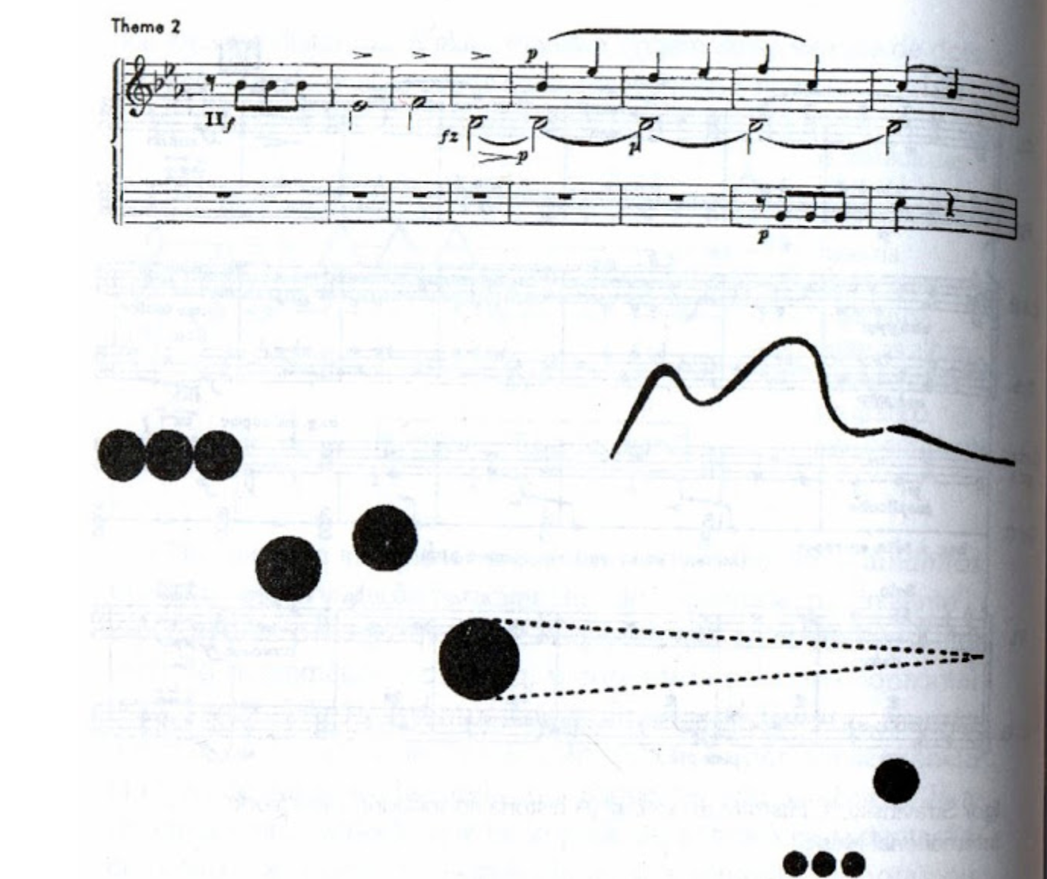

This discovery supports my exploration into Kandinsky and his musical influences and supports the collaborative imagined exhibition of this Artist producing his own graphic score. Although, through deconstruction visually the graphic score isn't what I expected it to be via the lack of Kandinsky's signature painterly style. Reflecting upon our imagined exhibition, Kandinsky's approach appears to be unpredictable when producing a graphic score, as this researched interpretation by Kandinsky appears to be very traditional.
Reflecting upon the previous reference to Wassily Kandinsky's book 'Sounds' the research I've gathered from deconstructing that book is that it explores Kandinsky's use of poetry and how his woodcut prints in that book can be translated into the form of text. The poem in that book called "Hills" has really captivated my attention and its expressive relationship to sound. In that poem, the words such as ''...red. He has had a big drum...drumming", "irregular strokes" and "tempo" stood out to me as areas of strong interpretations and discussions.
The colour red (signifier) and its metaphorical, symbolic language (signified) and the way the line itself has been constructed interests me. Through deconstruction, the red to me is the strong colour the Artist appears to have suggested as anger and is possibly the colour the Artist sees when listening to the sound of the drumming. The sound of the drum too from this suggestive use of red may have been quite aggressively playing too. Iannis Xenakis has included percussions in his sound pieces and I can imagine possibly a lot of red will be used within Kandinsky's graphic scores. From other research into this Artist, Kandinsky believed himself to have suffered synaesthesia of where he would listen to a certain sound and see a colour that represented the sound.
Also, from that poem I feel that the Artist's immediate response to sound is in the form of "irregular strokes", creating an expressive abstraction and distortion. As well as this, the musical description of "tempo" emphasised to me that the use of sound is commonly what inspired the Artists works making him an ideal participant for our imaginary exhibition. It makes me visualise and question what possible paintings/ graphic scores Kandinsky would produce when representing the percussions from Iannis Xenakis.

According to Elizabeth R. Napier the translator of the modernized version of Kandinsky's book 'Sounds' (1981), she states that "the poems of Sounds, were written in Kandinsky's residence". With our concept for the imagined exhibition, we are using a residency programme and this has signified that this Artist has worked with sounds during a residency. Our imagined exhibition is a contemporary revival of this historical contextual finding.

Kandinsky's paintings that I've researched support the title of this body of writing both visually and conceptually - "rhythm of the language". Developing further, the rhythm I strongly believe is the musical influence and inspiration. The language, I feel is his visual translation of the musical sounds, creating his own metaphorical visual representational language.

From my coherent, extensive research that commentates and deconstructs Kandinsky and his heavily embodied influence and inspiration from music, I most definitely agree with The Guardian's writer Gerard McBurneys comment, as he described Kandinsky as "the Painter of Sound and Vision'.

References

The Editors of Encyclopaedia Britannica, (2018), Expressionism, Britannica. Available at: https://www.britannica.com/art/Expressionism
(Accessed: 2nd April 2018)

Düchting, Hajo. Kandinsky. Basic Art Series 2.0. Taschen.

Duchting, Hajo, (1993). Wassily Kandinsky, 1886-1944: A Revolution in Painting. Taschen.

Original -
Kandkinsky, Wassily, (1912). Sounds. Verlag, Piper of Munich.

Quotations:
"The poems of Klange, written during the seminal years of Kandinsky's residence in Munich"
"rhythm of the language"

Translated -
R.Napier, Elizabeth, (1981). 'Introduction', Sounds. London: Yale University Press: , 2, & 3

Quotations:
"...red. He has a big drum...drumming."
"irregular strokes"
"tempo"

Poem-
Kandinsky, Wassily, (1912). Hills, Sounds. Verlag, Piper of Munich.

(2008-2018), Wassily Kandinsky.
Available at: http://www.wassilykandinsky.net/
(Accessed: 2nd April 2018)

Image References:
(2008-2018), Wassily Kandinsky, Compositions.
Available at: http://www.wassilykandinsky.net/compositions.php
(Accessed: 2nd April 2018)

(2012), Totally History, Composition VII.
Available at: http://totallyhistory.com/composition-vii/
(Accessed: 3rd April 2018)

Spector, Nancy, (2018), Guggenheim, Collection Online.
Available at :https://www.guggenheim.org/artwork/1924
(Accessed: 3rd April 2018)

(2008-2018), Wassily Kandinsky, Composition x.
Available at: http://www.wassilykandinsky.net/work-62.php
(Accessed: 3rd April 2018)

Quotations:
"Wassily Kandinsky: : the Painter of Sound and Vision"
"generic titles: Compositions, Improvisations, and Impressions"
"Several Impressions were specifically written in response to hearing music"
"musical metaphor"
"Composer Arnold Schoenberg"

McBurney, Gerard, (24th June 2006), 'Wassily Kandinsky: the Painter of Sound and Vision', The Guardian, Pages 1,2,3 out of the 5 page article, Art, [Online].
Available at: https://www.theguardian.com/artanddesign/2006/jun/24/art.art
(Accessed: 2nd April 2018)

Buja, Maureen, (21st February 2016), Interlude, Music & Art: Schoenberg and Kandinsky.
Available at: http://www.interlude.hk/front/music-art-schoenberg-kandinsky/
(Accessed:3rd April 2018)

Image Reference:
H.Tobinga, Edson, (15th January 2011), Musica Para Ser Vista (Music to Be Seen), Available at: http://musicaparaservista.blogspot.co.uk/2011/01/beethoven-por-kandinsky.html
(Accessed: 2nd April 2018)

Polyphonie X, (2015), Iannis Xenakis - Percussion Works 1/3.
Available at: https://www.youtube.com/watch?v=GgFHlRcXUM0
(Accessed: 2nd April 2018)

Polyphonie X, (2015), Iannis Xenakis - Percussion Works 2/3.
Available at: https://www.youtube.com/watch?v=jqF6NwRon0k
(Accessed: 2nd April 2018)

Polyphonie X, (2015), Iannis Xenakis - Percussion Works 3/3.
Available at: https://www.youtube.com/watch?v=4xC1-jOB1mw
http://www.moderecords.com/catalog/171_173xenakis.html(Accessed: 2nd April 2018)

Image Reference:
Iannis Xenakis Composer, Architect, Visionary.
Available at:http://www.drawingcenter.org/en/drawingcenter/5/exhibitions/355/iannis-xenakis/
(Accessed: 2nd April 2018)

(2018), Boydell & Brewer.
Available at: https://boydellandbrewer.com/the-percussionist-s-art-hb.html
(Accessed: 2nd April 2018)

Battle, Laura, (27th September 2013), 'Graphic Scores: Lively Alternative Ways of Writing Down Music', Financial Times, Music, [Online],
Available at: https://www.ft.com/content/7b14f656-243d-11e3-8905-00144feab7de
(Accessed: 2nd April 2018)

Ferreira, Rute, (28th January 2018), 'Jackson Pollock: the Face of Abstract Expressionism', Daily Art Magazine, 20th Century, [Online].
Available at: http://www.dailyartmagazine.com/jackson-pollocks-paintings/
(Accessed: 2nd April 2018)

Image Reference:
(2011), Jackson Pollock Biography, Paintings & Quotes.
Available at: https://www.jackson-pollock.org/autumn-rhythm.jsp
(Accessed: 2nd April 2018)

Smithfield, Brad, (24th April 2017), 'Swiss-German Expressionist painter, Paul Klee, made over 10,000 pieces of art in his lifetime', The Vintage News, [Online].
Available at: https://www.thevintagenews.com/2017/04/24/swiss-german-expressionist-painter-paul-klee-made-over-10000-pieces-of-art-in-his-lifetime/
(Accessed: 2nd April 2018)

Image Reference:
Gotthart, Alexxa, (April 25th 2016), 'A Brief History of Bauhaus Master and Father of Abstraction Paul Klee', Artsy Magazine, Art, [Online].
Available at: https://www.artsy.net/article/artsy-editorial-what-you-need-to-know-about-paul-klee
(Accessed: 2nd April 2018)

Visual-Arts-Cork, Paul Klee Biography of Swiss Expressionist Painter, Printmaker
Available at: http://www.visual-arts-cork.com/famous-artists/paul-klee.htm
(Accessed: 3rd April 2018)

