Made by : Olesea Pecica
Student ID: 2027757
Module: Marketing Fundamental

Swot and Pestle analysis of Marriott International Company
Introduction
The COVID-19 outbreak has detrimental effects on both health and the economy. As the impact of COVID-19 spreads globally, governments and businesses are most concerned about the safety of their population. While this focus continues, the impact on economic development and business profitability will call for significant sell-offs in global equity markets. Due to the devastating impact of COVID-19 on travel around the world, worldwide revenue per number available (RevPAR) decreased by 60% compared to 2019 and its global share was 35.5% year-over-year. Net growth in numbers in 2020 will be 3.1%. However, the global trend has rebounded significantly from its historical lows in April in the second half of the year, driven by demand for travel to places where driving is possible. About 6% of more than 7,600 properties worldwide were closed on February 15, 2021, or more than 25% on April 26, 2020.
Global utilization increased from 12% in April to 32% in December. Global RevPAR was down 62% year-over-year in December compared to a 90% decline in April 2020 in April 2019. As an important risk mitigation strategy, technological innovation is expected to play a major role in the recovery of the hospitality industry after the 2020 coronavirus pandemic. On the other hand, the effect on consumer decision-making behavior is unknown. The purpose of this study was to investigate the effect of expected interactions and expected cleanliness on perceived health risks and hotel reservation intentions, with a particular focus on technological innovations to reduce customer interactions and improve cleanliness.
Three pilot studies were conducted using an online consumer sample. Studies have shown that lower levels of predictable interactions across technological systems result in lower perceived health risks. Perceived health risk mediates the relationship between expected contact and hotel reservation intention. Additionally, the impact of anticipated interactions on perceived health risks is mitigated by the high level of anticipated cleanliness achieved with improved purification techniques. It is noteworthy that the proposed mechanism of perceived risk has proven superior in post-pandemic situations. Theoretical and practical conclusions are considered here. Of course, many recovery methods are documented worldwide. What is happening in mainland China, for example, is very different from what is happening in Europe. The good news is we've seen this on the mainland. A prime example is China, where reservations and occupancy have increased significantly, primarily driven by demand for leisure and temporary business travelers and group guests. In mainland China, the RevPAR for December was down less than 10% year-over-year and in February it was down 87% year-over-year. During the year, tremendous progress has been made in mitigating the effects of sluggish demand, improving financials and restoring balance sheets. This increased cash flow, increased average debt maturity, reduced operating costs and lower investment costs. In February, it stopped buying treasury stock and paying dividends. In addition, from the second quarter of 2020, treasury stock purchases have been suspended and quarterly dividend payments have been suspended.

Content
Marriott International is a global operator, franchisor, and licensor of hotels, homes and timeshare real estate across a range of brands and service levels. They own very few of our assets that align with our focus on management, franchising and licensing.
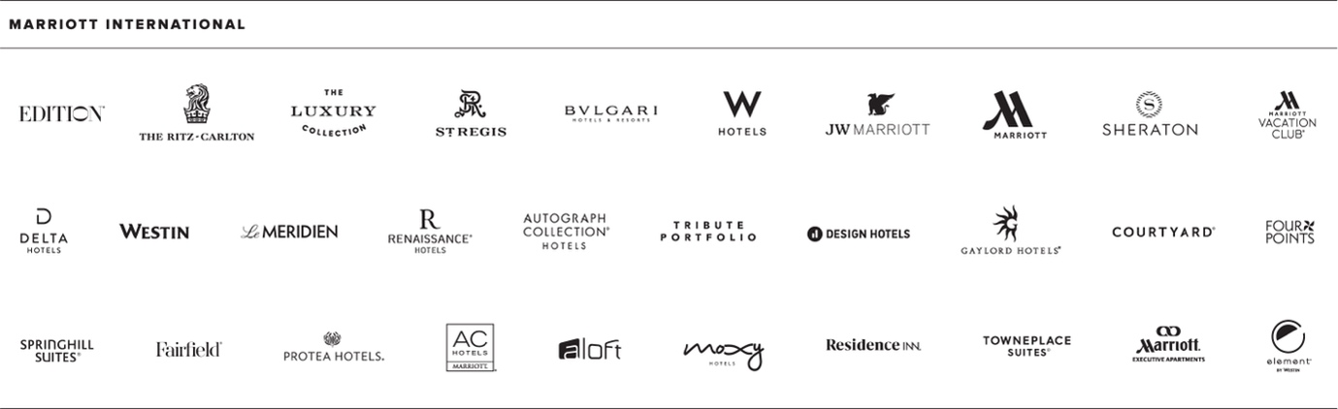

They are continuing to take considerable measures to mitigate the negative financial and operational consequences of COVID19 for our hotel owners and our own firm, and they are dedicated to taking care of customers and employees. We have made significant changes to our business and improved our financial condition, while remaining focused on how to best position ourselves for longterm recovery and growth. They developed ways to help hotel owners and franchisees in lowering cash outlays and minimising expenses, as well as a multipronged platform to improve cleaning standards and hospitality standards for the health and safety of guests and associates. At the corporate level, significant savings were realised in general and administrative costs, as well as capital and other investment spending. They are virtually finished with the abovementioned property restructuring programme, and they have implemented and are continuing to develop restructuring techniques to achieve cost savings unique to each of the companyoperated properties. They believe that the business is well positioned now and in the future with the steps they have taken and any additional measures they may take to adapt operations and plans to the changing situation, as well as the power of the Marriott Bonvoy loyalty programme, our strengthened liquidity position, and a global team of associates. COVID19 has had a substantially unfavourable influence on business and financial outcomes, and this impact may continue to worsen for an unknown period of time. COVID19 has been and continues to be a complex and evolving situation, with governments, public institutions, and other organisations imposing or recommending, and businesses and individuals implementing, at various times and to varying degrees, restrictions on various activities or other actions to combat its spread, such as restrictions and bans on travel or transportation; limits on the size of inperson gatherings; and closures of, or occupancy of, or other operating licensors
COVID-19 and its aftermath have had a significant impact on travel and hotel room demand, which continues to affect our, operational and financial performance. The extent to which COVID-19 will affect business, operational and financial results will be determined by the factors described above and many other evolving factors that we cannot accurately predict or estimate, such as the duration and scale of COVID-19. availability and distribution of effective vaccines or therapies; The impact of COVID-19 on global and regional economies and economic activity, including duration and extent of impact, availability and distribution of effective vaccines or therapies. Impact of COVID-19 COVID-19 has had a profound impact on businesses, Marriott Corporation, and the hospitality industry. COVID19 went into effect in Greater China in January 2020 and spread rapidly to the rest of the Asia Pacific and European markets, and was fully implemented globally by March 2020. The immutable dollar across the RevPAR global comparison system plummeted as the virus spread across the globe. Although global share and RevPAR have already improved from the very low levels reached in April 2020, a significant increase in COVID-19 cases has slowed recovery in Q4 2020 and January 2021 in most regions. Commission income and real estate and rental real estate income declined sharply in 2020, and travel and accommodation demand is not expected to rebound significantly until effective vaccination is widely adopted.
- • 4,444 system-wide fixed dollar equivalents worldwide, compared to the same period in 2019, RevPAR was 23% in Q1 2020, 84% in Q2 2020, 66% in Q3 2020 and 64% in Q4 2020. % decreased. As of 15 February 2021, approximately 6% of our hotels were closed internationally. This is an increase from over 25% of the high on April 26, 2020. However, the recovery process is inconsistent. The spread of COVID-19 has slowed and will continue to slow recovery, dampening demand. Travelers are still a major driver of demand. • global fixed dollar equivalent for the entire system Compared to the same period in 2019, RevPAR was down 23% in Q1 2020, 84% in Q2 2020 and 66% in Q3 2020. 64% in Q4 2020. Globally, approximately 6% of hotels were closed as of February 15, 2021, up from a high of over 25% on April 26, 2020. However, the recovery process is difficult. The spread of COVID-19 has slowed and will continue to impede recovery, reducing demand. Travelers continue to be a major driver of demand. • Significant reductions in corporate general and administrative expenses, reimbursement of expenses incurred on behalf of owners and franchisees, capital expenditures and other investment expenses, and restructuring plans as described in Section COVID19 Impacts; • Improving conditions and resolving credit limit pending share repurchases and suspending dividend payments; • The attractiveness of a line of credit, as described in the “Liquidity Sources of Lines of Credit” section; • Eliminate leveraged commitments through a quarterly review by Q4 2021 as described in credit line changes, specifically in the Liquidity Sources section of our Credit Lines.
- • Redemption of the aggregate amount of US$853 million of corporate bonds due in 2022 and the cumulative principal of approximately US$853 million of senior bonds as described in Liquidity Sources. Section, • Raising $920 million in cash by renegotiating existing contracts for co-branded credit cards issued in the United States as described in section Cobra Analyze the impact. Liquidity needs may affect your ability to raise funds. They believe that their current line of credit, access to cash and capital markets are sufficient to meet their liquidity requirements. Marriott has also made quick asset changes to help fight COVID-19. And because conventional centers were not available during the summer, the company repurposed conference rooms to host more than 150 blood donations.
In March and April, when the impact of COVID-19 became apparent, Marriott had to make a large workforce decision. Like many other tourism-related companies, we had to lay off our employees. "It was the toughest job I've ever done in my 30 years in the profession," says King, "because the impact on our employees was caused by something we had absolutely no control over." “Marriott is an international business of messengers, housekeepers, clerks and cooks.” Our ability to help people build careers in our organizations is at the heart of our DNA. Our top priority is to get our team back to work. Marriott began to lead with a thoughtful strategy, creating a network of Marriott alumni to connect current and former employees. Marriott HR quickly collaborated with prominent HR organizations to create a regional website to help employees find part-time or full-time positions. To help Marriott contact center workers move to New York State amid rising unemployment calls, King worked with Deloitte to cut vacation time. (New York City received nearly 1.4 million applications in the six weeks of the spring.) Marriott employees who had previously processed cancellations were retrained in seven days to begin processing New York City unemployment claims. With a growing list of contactless initiatives such as keyless access to hotels and room service delivered via text message, Marriott is in a position to trust both during and after the outbreak. According to King, the entire customer journey involves hundreds of digital and physical touchpoints with customers during a typical hotel stay, requiring a cross-functional approach to responding to which elements will become the new expectations of hotel guests.

PESTLE analysis is a useful technique for determining the impact of variables such as political, economic, social, technological, legal, and environmental considerations on Marriott's business model, growth trajectory, business model, and market strategy. The hotel business faces a number of political and legal challenges because of its global importance. Trump's immigration policies, for example, pose serious political risks to businesses as a whole. International relations, Brexit, terrorism, military conflicts, political instability, and other significant political events may affect Marriott.

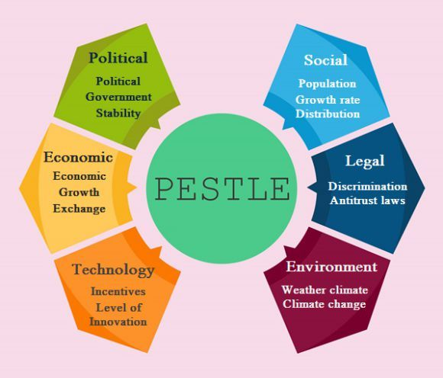

Although Marriott is a financially strong brand, economic downturns such as weak economic conditions in the countries in which it operates, currency fluctuations, and changes in government policies in areas such as trade, travel and immigration can have a negative impact on the company. Marriott's financial performance and growth. Most of today's customers are self-sufficient, tech novice, millennials and tech-savvy travelers with easy access to apps or websites. Marriott is committed to social responsibility through Serve 360, a program inspired by the 2025 Sustainable Development and Social Performance Goals to address some of the world's most pressing social, environmental and economic challenges. Marriott is committed to social responsibility through Serve 360, a program inspired by the 2025 Sustainable Development and Social Performance Goals to address some of the world's most pressing social, environmental and economic challenges.

Political | Economical
1. Ripple effect of travel ban, anti immigrant statements and expanded wall along Mexican border  2. Uncertain political landscape of EU | 1. Currency fluctuations affecting tourism  2. Intense airline competition
Social | Technological
1. Terrorism  2. Increase in consumer spending and experiential travel  3. Different region, different demand for lodging and experiences  4. Activities and lighting up the guest experience | 1. Innovations driving competitive advantage
Legal | Environmental
1. Achieve standardisation in the face of legal compliances | 1. Integration of various norms  2. Increasing consumer preference for sustainable hospitality

Tourism plunged in 2016 due to persistent terrorism and its impact on relations despite several countries introducing cheap air travel, low oil prices and visitor-friendly visa policies. In Europe, tourism spending decreased in France, Belgium and Turkey. Spending by tourists arriving in Egypt has declined since the recession in 2015, and the number of international tourists has fallen by more than 60% from its 2008 peak. As the travel and tourism industries in these countries struggled, many other regions have benefited by providing them as "safe havens". alternative direction. These countries include Bulgaria, Cyprus, Malta, Portugal and Spain. The business segment, which includes everything from travel to bike rental, is a growing segment of the hospitality business that is not dominated by any single company or organization. Travelers may be associated with activities they already want to do, such as sporting events or theme parks, or they may be associated with entirely new experiences they are not aware of, such as activities that are unique to a particular location (region and culture). ) ... ... This multi-billion dollar hospitality sector (activity sector) offers a unique experience, providing fantastic opportunities to attract travelers attention and money. Many hotels, private property, online travel agencies (OTAs) and other third-party organizations are interested in this industry. Marriott International decided to capitalize on this growing trend by integrating events and travel into its rewards program. The fuel price will be the largest environmental risk to Marriott's operations. Falling gasoline prices can lower travel costs while increasing demand for hotel rooms. The sharp rise in fuel costs, especially aircraft, will undoubtedly pose significant risks to Marriott.
Marriott's long-term environmental impact may include higher electricity rates as a result of efforts to limit the use of coal in power plants to minimize greenhouse gas emissions. Climate change could harm Marriott's business, raising sea levels, flooding resorts, or triggering storms that drive tourists away from beaches. Rising temperatures from global warming could close ski resorts or render some beach resorts uninhabitable. These changes may result in a forced closure or relocation of the hotel.

Major Competitors :
- InterContinental Hotels Group (IHG)
- Hilton Hotels and Resorts
- Hyatt Hotels Corporation
- Wyndham Worldwide Corporation
- Accor Hotel

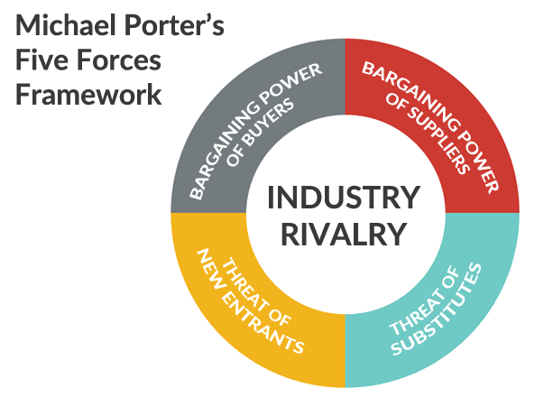
Porter's Five Forces Model is a complex strategic paradigm that shifts strategic decisions from simple assessments of existing competition. Porter Five Forces is Marriott International, Inc. You can gain a long-term competitive advantage in the hospitality industry. Marriott International, Inc.'s Manager Porter Five Forces can be used to develop strategic positions in the hospitality business, as well as explore lucrative opportunities in the hospitality sector.

Recommendations and conclusion

Transparency is one strategy that governments can use to reduce uncertainty and increase public confidence. Because time is of the essence in responding to a disaster, government efforts must be made public as soon as possible. To address the ambiguity surrounding the spread of the virus, governments must continue to provide as much information as possible about the evolution of the epidemic. For example, you can empower people as much as possible by using campaigns, creating specific epidemic or crisis management websites, and providing contact information and information. Governments around the world, including the United States, have begun to intervene, but the return to pre-crisis levels will be slow and gradual. Hotel owners and operators can prepare for future activities and the post-COVID-19 tourism environment at this point. Stakeholders also need to change their business in the short and long term and reduce the vulnerability of their business to future government regulations, even if the hospitality industry reopens. They should also seek to innovate their activities in terms of preserving social distancing and a clean environment. Global hotel chain owners and hotel service providers must work together to meet stringent food handling and preparation requirements. Travel agents can travel with flexible rebooking options and free health insurance. Shareholders can strengthen their investment strategy by focusing more on the nature and uncertainty of the economic measures introduced to combat the epidemic, recognizing that these measures will have a negative impact on hotel performance. As a result, hotel investors should keep an eye on the shift in the uncertainty index of Baker and his colleagues due to the pandemic. They may use strategies such as short positions, derivatives, futures, or other financial instruments that have little or no relation to hospitality and tourism performance to protect the value of their assets.

References:
  - David Yechiam Aharon, et all, Covid-19, government measures and hospitality industry performance.Avalaible at: https://journals.plos.org/plosone/article?id=10.1371/journal.pone.0255819, accessed on 28 of December.
  - Fern Fort University, Marriott International, Inc. Porter Five Forces Analysis, accessed on 29th of December, available at: http://fernfortuniversity.com/term-papers/porter5/analysis/2964-marriott-international--inc-.php
  - The Wall Street Journal by Deloitte, In the Face of Pandemic, Marriott Leans on its Values, accesed on 24th of December, available at: https://deloitte.wsj.com/articles/in-the-face-of-a-pandemic-marriott-leans-on-its-values-01611259330
  - Pestle analysis, Pestle Analyses of Marriott International, accessed on 27th of December, available at: https://pestleanalysis.com/pestle-analysis-of-marriott/
  - Marriott International Swot&Pestle Analysis, Company profile – Marriott International, accesed on 27th of December, available at: https://pestleanalysis.com/pestle-analysis-of-marriott/
  - Alice Hancock, Financial Times, September 5 2021, accesed on 27th of December, available at: https://www.ft.com/content/8acbe8d0-f1d0-4cb9-a15b-518a817455a4
  - Marriott International Launches Global Cleanness Council to Promote Even Higher Standards of Cleanliness in the Age of COVID-19, April 2020, accessed on 27th of December, available at: https://news.marriott.com/news/2020/04/21/marriott-international-launches-global-cleanliness-council-to-promote-even-higher-standards-of-cleanliness-in-the-age-of-covid-19

